Proposal for amendments to Regulation No. 60
(Two-wheeled motorcycles and mopeds - identification of controls, tell-tales and indicators)

The text reproduced below was prepared by the expert from IMMA to amend the requirements for identification of controls, tell-tales and indicators on two-wheeled motorcycles and mopeds. It is based on GRSG-108-47 and takes into account the suggestions made during the 108th GRSG meeting.
The modifications to the current text of UN Regulation No. 60 are marked in bold for new or strikethrough for deleted characters.
I. Proposal

Insert two new paragraphs starting at 5.3.1.1., to read:

"5.3.1.1. It shall be ensured that no substantial deviations in the shape and orientation of the provided symbols are permitted, notably that any customised appearance of the provided symbols shall be prohibited.

5.3.1.2 Small irregularities concerning line thickness, the marking application and other relevant tolerances shall be accepted, as provided in paragraph 4 of ISO 2575:2010/amd1:2011 (design principles).”

Paragraph 5.5.4., amend to read:

"5.5.4. Each symbol used for the identification of a tell-tale, control or indicator shall be in a colour that stands out clearly against the background."

II. Justification
- This proposal takes into account the comments raised by GRSG experts on GRSG-108-47 and the content is identical to new text as specified in annex VIII of RVFSR as supported in Europe at the MCWG September 2015 session.
- Currently, no provisions exist in UN Regulation No. 60 that describe the correct representation of the symbols. Stricter design requirements should be given in order to ensure a correct and uniform application of the symbols.
The design principles used in ISO 2575 offer a suitable set of requirements and ensure that the requirements are in line with those of UN Regulation No. 121:
5.2.2. To identify a control, a tell-tale or an indicator not included in Table 1 or ISO 2575:2004, the manufacturer may use a symbol of its own conception. Such symbol may include internationally recognized alphabetic or numeric indications. All symbols used shall follow the design principles laid down in paragraph 4. of ISO 2575:2004.

- Reproduction of the Regulation itself and constraints in production processes can lead to small differences in appearance of the symbol on actual vehicles. Such irregularities do however not endanger the correct understanding of the symbol and should therefore not lead to interpretation differences at the time of type approval.
Some examples of small irregularities that are found on actual vehicles:
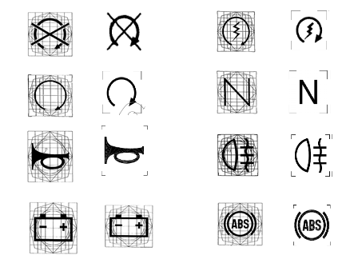

- Other types of identification such as embossed or engraved symbols can also stand out clearly against a background. The obligation to use colour is not necessary and is also not present in Regulation No. 121.
_____________________

