Statistical information about fires in different bus categories and Classes.
Precedents
GRSG discussed at its 107th session – on the basis of German informal document (GRSG-107-13) – the status of the fire suppression system. The expert from Germany proposed that this device shall be obligatory in M3/Class III only, and optional in other Classes. GRSG agreed to resume consideration on this subject on its May 2015 session (see paragraph 6. of the report ECE/TRANS/WP.29/GRSG/86). The information given in this document is for consideration by GRSG experts.
Below there is a chapter from an extended study in which detailed analysis is presented about a data-set containing information about 1497 bus accidents. This chapter is dealing with bus fires being a typical bus accident type.
Bus fires
Basically, there are two different kinds of bus fire:
- direct fire, when the fire starts in the bus without any outside effect. These bus fires can be put into two subcategories:
- when the fire is detected in early stage (by the driver, passengers, people from the street, or a fire detector) so the driver stops the bus and passengers can evacuate through the service doors.
- when the fire reaches a full grown stage before recognizing it (high temperature, smoke, failure in the door opening system, panic, etc.), and the passengers cannot evacuate the bus.
- fire in combined accident, when the fire is the consequence of a previous accident (rollover, collision, etc.) which is an outside effect.
Table VI contains only direct fire figures in the fourth column, (98 events) showing the distribution in relation to bus categories. The fires in combined accidents – among other combined accidents – are shown in the fifth column (13 after rollover and 28 after frontal collision, altogether 41 events from the total 185 combined accidents). Table XIII gives some information about the hazard of the different fire categories, - on the basis of accident casualty rates – including the fires in combined accidents, too. Figures 9 and 10 give examples about bus fires.
Some comments to Table XIII.
- the figures in the three lines may be assumed as statistical samples, but not representative ones. In spite of that they represent clear differences between the different fire categories.
- the casualty rate is negligible when the fire is recognized in early stage, independently from the bus categories (city, tourist, small bus, etc.). Generally the injuries are the consequence of the evacuation (wrong step out, passengers pushing each other, etc.) and not of the fire.
- when dealing with bus fires, fire prevention, an important decision shall be made: are all these bus fires accidents or only those, in which occupants were injured? Only the human losses shall be considered, or the material losses, too (seriously damaged or completely destroyed bus, damage in environment)? Here it is proposed: the fire as accident should cover both kinds of losses.
- the casualty rates are considerable high in case of full grown stage fires. This fire is typical in long distance and tourist coaches (DD included) as well as in small buses, but never happens in city buses. It happens very often in night hours, when the passengers are sleeping.
- the fire in combined accident is one of the most dangerous accident types. The casualty rates are extremely high and it is impossible to separate which casualty is the consequence of the first accident and which is caused by the fire. The bus generally burns out completely.
Table VI:
Bus category | R | FC | RSC | F | CA | CT | S | Total
Class I City | 9 | 81 | 5 | 41 | 4 | - | 11 | 151
Class II Interurban | 84 | 139 | 14  6 | 21 | 30 | 8 | 11 | 307
Class III Tourist | 205 | 99 | 6 | 19 | 43 | 4 | 4 | 380
Double decker (DD) | 29 | 12 | -  - | 3 | 3 | 1 | 5 | 53
Small bus (SB) | 88 | 150 | 10 | 2 | 18 | 8 | 4 | 280
Other | 23 | 18 | 1 | 4 | 16 | 4 | 1 | 67
Not known | 107 | 56 | 1 | 8 | 71 | 8 | 5 | 256
Σ | 545 | 555 | 37 | 98 | 185 | 33 | 41 | 1494

Table XIII:
Casualty rates  Type of fire  fire |  | Number  of events | Accident casualty rates (ACR_{x})
 |  |  | Fatality  rate (R_{F}) | Injury  rate (R_{I}) | All casualty  rate (R_{A})
Direct fire, recognized in | early stage | 70 | 00,0 | 0,5 | 0,5
 | full grown stage | 26 | 13.6 | 5,1 | 18,7
Fire in combined accident |  | 41 | 26,2 | 16,2 | 42,4

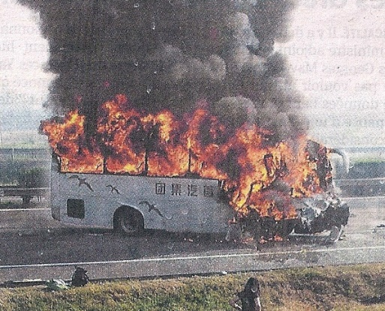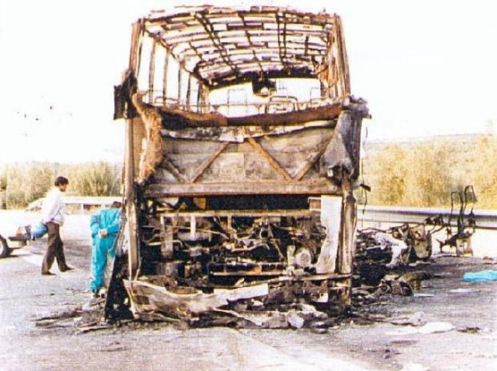
Fig.9. Fire in full grown stage Fig.10.Fire after frontal collision
The distribution of fire sources among the direct fires (98 events):
Engine compartment (36 events) 37 %
Electrical, short circuit (out of engine compartment) 15 %
Brake, tyre overheating 6 %
Human error, vandalism 8 %
Other technical fault 4 %
Unknown 30 %
100 %

As a supplement to Table VI, the distribution of the engine compartment fires among the bus categories:
Class I (City bus) 20 55 %
Class II (interurban coach) 8 22 %
Class III (Tourist coach) 4 11 %
Double decker (DD) 2 6 %
Small bus 1 3 %
Other 1 3 %
36 100 %
It is interesting to mention that 69 % of the engine compartment fires happened in the period May – September (5 mouths, warm weather circumstances) and all the major bus categories are included (roughly proportionally) in “summer fires”.
Who extinguished the fire?
In all bus fires Fire in engine compartment
Driver 24 % 31 %
Fire brigade 21 % 33 %
Bus completely burned out 48 % 28 %
Outside help (from the street) 3 % 3 %
No information 4 % 5 %
100 % 100 %
Almost in every case the driver started to extinguish the fire.
Some thoughts for consideration
- What is the main goal of the installation of the automatic fire suppression systems? To increase only the passenger’s safety, or protect also the vehicle and the environment (material losses)?
- to increase the passenger’s safety, it is enough to use a reliable warning system in the engine compartment (and also in the compartment of the heating device)
- to avoid the great value material losses and damages the automatic fire suppression systems are very useful tools.
- The engine compartment is the most frequent fire source in buses and coaches. It is reasonable to prevent the expansion of the fire in the very early stage.
- All bus categories have fire in the engine compartment, so there is no strong argument to require automatic fire suppression system only in Class III coaches. In a first step, the basic question (see above in para.1.) shall be decided and after that the obligatory-optional use is solved automatically.
Earlier Hungarian information presented in GRSG
The following informal documents were presented by Hungary in relation with bus fires:
GRSG-91-10 Bus fires and evacuation tests (2006)
GRSG-90-16 Fire safety in buses (2006) Prepared together with Sweden
GRSG-90-5 Bus fires in city buses (2006)
_______________

