|  |  |  |  |
| --- | --- | --- | --- |
|  | United Nations | ECE/TRANS/WP.15/AC.1/2015/39 | |
| _unlogo | **Economic and Social Council** | | Distr.: General  29 June 2015  Original: English |

**Economic Commission for Europe**

Inland Transport Committee

**Working Party on the Transport of Dangerous Goods**

**Joint Meeting of the RID Committee of Experts and the  
Working Party on the Transport of Dangerous Goods**

Geneva, 15–25 September 2015

Item 6 of the provisional agenda

**Tanks**

Carriage of dangerous goods in MEGCs loaded on a vehicle equipped with a hydraulic hook lift hoist

Transmitted by the government of Norway [[1]](#footnote-2), [[2]](#footnote-3)

Introduction

1. During the last meeting of WP.15 in May (ninety-eighth session), informal document INF.17 from Norway concerning hook lift vehicles for tanks and MEGCs transporting dangerous goods on road was briefly discussed.

(<http://www.unece.org/fileadmin/DAM/trans/doc/2015/dgwp15/ECE-TRANS-WP15-98-GE-inf17e.pdf>)

2. In this document several questions were raised relating to the fastening requirements for these systems in normal condition of carriage. These were related both to the fastening requirements in section 9.7.3 in ADR and the requirements for tanks/tank-containers of being capable of adsorbing the forces as defined in RID/ADR 6.8.2.1.2.

3. As stated in the report from the meeting (ECE/TRANS/WP.15/228) the questions required more reflection, possibly after a prior discussion in the working group on tanks of the Joint Meeting. In this document, Norway invites the working group on tanks to take part in a discussion on what requirements shall apply to MEGCs and their fastenings.

Requirements in RID and ADR for MEGCs

4. Section 6.8.2 in RID/ADR sets out the requirements applicable to fixed tanks (tank-vehicle)/tank-wagons, to demountable tanks, tank-containers, tank swap-bodies intended for the carriage of substances of all classes and battery-vehicle/battery-wagons and MEGCs for gases of Class 2. Sections 6.8.3 to 6.8.5 contain special requirements supplementing or modifying the requirements of Section 6.8.2.

5. 6.8.3.1.5 requires, for the construction of battery-vehicles/battery-wagons and MEGCs, that the elements and their fastenings shall be capable of absorbing under the maximum permissible load the forces defined in 6.8.2.1.2. There are no requirements that MEGCs and their fastenings shall be capable of absorbing these forces, as it is the case with tank-containers (6.8.2.1.2) and UN MEGCs (6.7.5.2.8).

6. For road transport, the provisions related to cargo securing in ADR 7.5.7.1 also applies for loading, stowage and unloading of MEGCs on to and from vehicle (ADR 7.5.7.4). In addition, there are fastening requirements in ADR section 9.7.3. However, it is not clear if these requirements are limited to tank-vehicle, battery-vehicle and vehicles carrying demountable tanks.

Discussion

7. Transport of dangerous goods, Class 2, in MEGCs on vehicles with hock lifts are already in use in Norway (see pictures below). When the elements, which are linked to each other by a manifold, are not permanently fixed to the vehicle, it is not considered as a battery-vehicle. As the competent authority for ADR/RID in Norway, we ask the working group on tanks for their opinion on following questions:

* Loading a MEGC on to a vehicle, does only the cargo securing in 7.5.7.1 apply, or does the fastening requirements in ADR 9.7.3 apply?
* Does the MEGCs (multi-element gas containers) have to meet the definition of a container?

Examples:

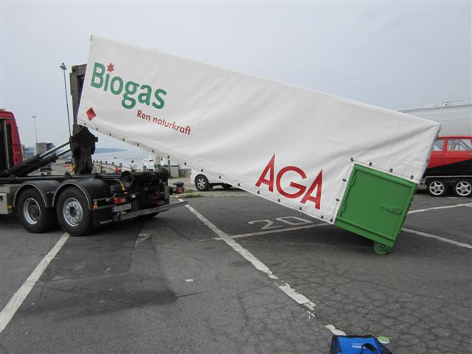

A MEGC being unloaded from a truck by the hooklift hoist

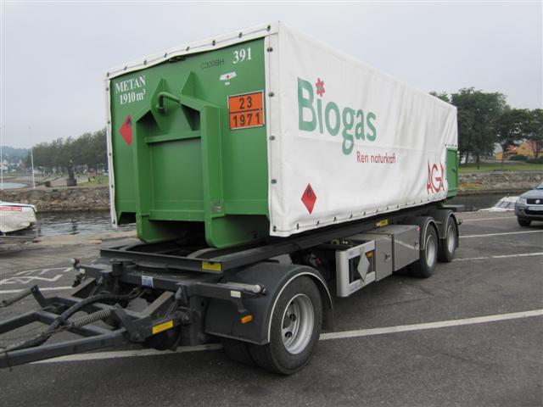

A hooklift MEGC mounted on a trailer

1. In accordance with the programme of work of the Inland Transport Committee for 2014–2015 (ECE/TRANS/240, para. 100, ECE/TRANS/2014/23, cluster 9, para.9.2). [↑](#footnote-ref-2)
2. Circulated by the Intergovernmental Organisation for International Carriage by Rail (OTIF) under the symbol OTIF/RID/RC/2015/39. [↑](#footnote-ref-3)