UNITED  NATIONS |  | E
 | Economic and Social  Council | Distr.  GENERAL  ECE/TRANS/WP.29/GRE/2009/30  16 January 2009  ENGLISH ONLY
ECONOMIC COMMISSION FOR EUROPE
INLAND TRANSPORT COMMITTEE
World Forum for Harmonization of Vehicle Regulations

Working Party on Lighting and Light-Signalling

Sixty-first session
Geneva, 30 March - 3 April 2009
Item 12(e) of the provisional agenda

OTHER BUSINESS

Proposal for draft amendments to Regulation No. 87
(Daytime running lamps)

Proposal for Supplement 15 to Regulation No. 87

Submitted by the expert from Germany ∗/

The text reproduced below was prepared by the expert from Germany in order to amend the text of Annex 2 of Regulation No. 87 regarding the size of the approval mark. The modification to the current text of the Regulation, including Supplement 14 to the Regulation, is marked in strikethrough and bold characters.

A. PROPOSAL

Annex 2
EXAMPLE OF ARRANGEMENT OF THE APPROVAL MARK
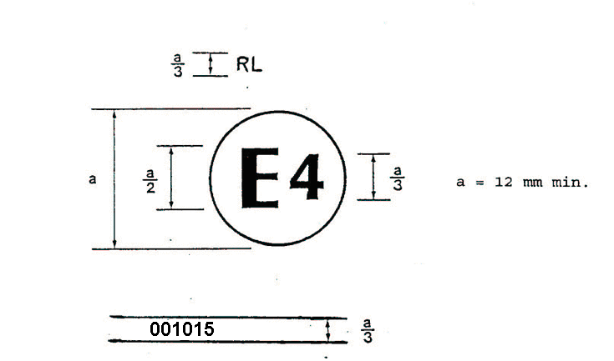
a = 12 5 mm min.
Figure 1

B. JUSTIFICATION
The amendment in this proposal is intended to align the provisions regarding the size of the approval mark with other existing regulations. In these regulations (e.g. R 6, R 7, R 38, …), a size of 5 mm for the approval mark is regarded sufficient.
Taking into account that, recently, the apparent surface of the daytime running lamp was reduced from 40 cm² to 25 cm², the still existing "big" approval mark covers a rather large area of the lens.

- - - - -

/ In accordance with the programme of work of the Inland Transport Committee for 2006-2010 (ECE/TRANS/166/Add.1, programme activity 02.4), the World Forum will develop, harmonize and update Regulations in order to enhance performance of vehicles. The present document is submitted in conformity with that mandate.

