UNITED  NATIONS |  | E
 | Economic and Social  Council | Distr.  GENERAL  ECE/TRANS/WP.29/GRSP/2007/XXX 2007  Original: ENGLISH

ECONOMIC COMMISSION FOR EUROPE

INLAND TRANSPORT COMMITTEE

World Forum for Harmonization of Vehicle Regulations

Working Party on Passive Safety

REGULATION No. 44
(Child Restraint System)

Proposal for draft amendments to Regulation No. 44

Submitted by the experts from CLEPA

As reported in documents ECE/TRANS/WP.29/GRSP/41 paragraphs 47 the text reproduced below was prepared by the expert from CLEPA in order to propose to GRSP a revision of the horizontal plane requirements.

A. PROPOSAL

7.1.4.4.1.1. Amend to read “ Forward facing child restraints: the head of the manikin shall not pass beyond the planes BA and DA as defined in Figure 1 below, except for boosters seats when using the largest dummy P10 in relation to DA plane.

B. JUSTIFICATION
This document provides additional information to the previous data included in document TRANS/WP.29/GRSP/2006/9. The additional data are aimed at supporting the revision of the horizontal plane requirements 7.1.4.4.1.1. only for boosters. The reason for focussing on this type of restraints is that the corresponding child population (age 4 to 12) shows a higher risk of injury compared to the younger population, which generally travel in rear facing or forward facing integral seats. According to a study undertaken by CHOP (1) as child grows the risk of being injured in crashes rises: 3 times higher for the 4-12 year class of age than the 0-3 years population. More importantly this part of children population is exposed to risk of injuries, where abdominal injuries are predominant. A recent investigation was conducted within CHILD project on European accident data in frontal impacts involving children restrained with different systems. In the sample involving children restrained with boosters (2) it was shown that the injuries of AIS 2+ (moderate) to abdomen accounts for 34% , those to the head 20% and extremities 28%. In terms of serious injuries, AIS 3+ then abdomen comes into the first place. This data highlights the need to pay a particular attention to the prevention of these injuries, which are mainly due to submarining, or lap belt syndrome, as illustrated in Figure 1.

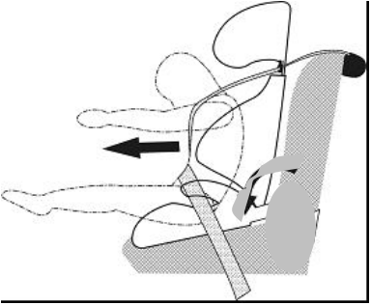

Figure 1: Illustration of lap belt syndrome or submarining.

Booster seat role in preventing or mitigating this problem is essential.

On the other hand the anthropometry of the child’s pelvis shows a smaller height of the iliac wing than that of the adults. In case of loading by the belt in an accident the role of the child’s iliac wing will have a limited effect to maintain the belt bellow the iliac crest. An illustration of this is shown in Figure 2.
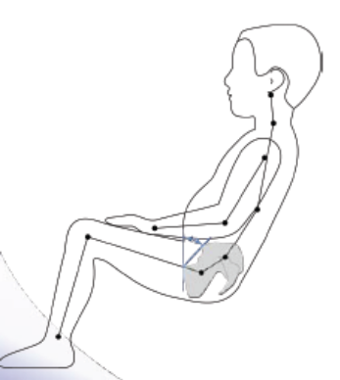

Figure 2.

Investigation into Vehicle Pulse Responses from EuroNCAP frontal tests

A study was conducted on the deceleration pulses obtained from EuroNCAP tests, involving 2 successive generations of the same models. The data was collected from frontal impact tests that were conducted on 3 car categories: super mini, family and MPV. To facilitate the interpretation of the deceleration data, these were translated into simplified pulses with initial and major deceleration plateaux. Figure 3 represents pulses as obtained from 6 vehicles, i.e. 2 vehicles per category. It can be seen that the 2nd deceleration plateau (17G) of a 2004 car is now attained by the first deceleration plateau of a 2005 super mini category.

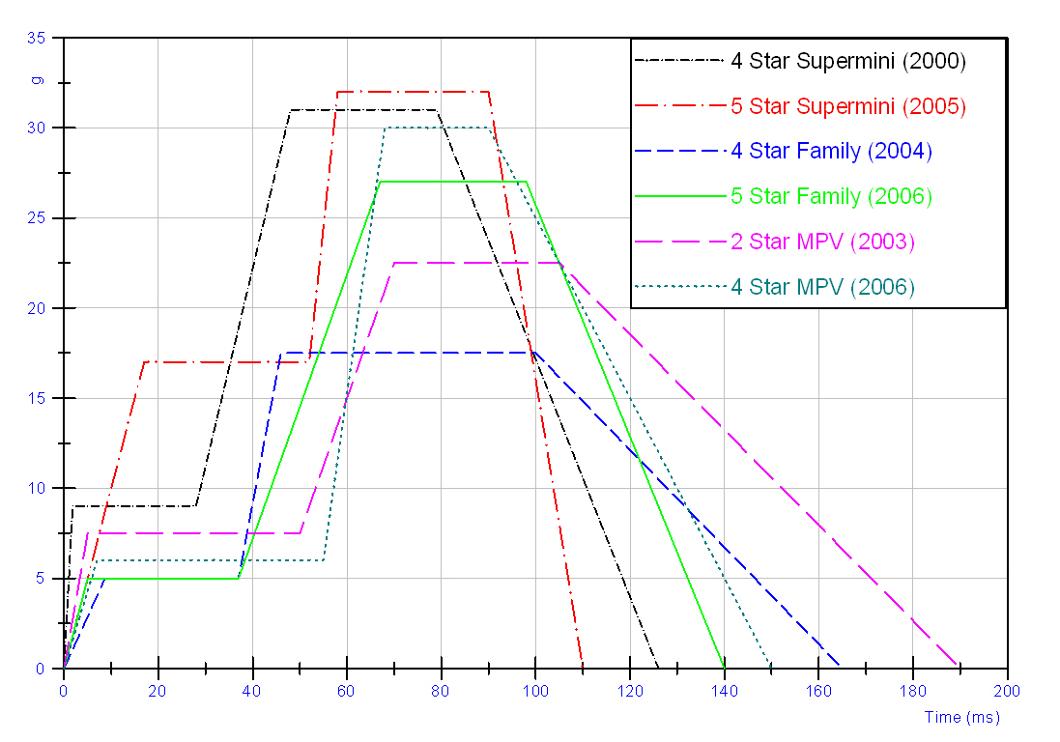
Figure 3 - Simplified deceleration pulses (B pillar) from various EuroNCAP tests (2000 to 2006

As a consequence of the structural integrity criteria, most of recent cars display a 2nd deceleration plateau at or above the 30 G level in the EuroNCAP offset tests, Figures 4 through 6 illustrate deceleration pulses as function of time for a super mini vehicle (4), a family vehicle (5) and an MPV (6). For the super mini vehicle the comparison pulses show a slightly higher 2nd plateau but a significant 1st plateau which is the double of that of the 2000 model. For the family and MPV as shown in Figures 5 and 6, the 2nd plateau is much higher for the 2006 models with an increase of 34% to 47%.

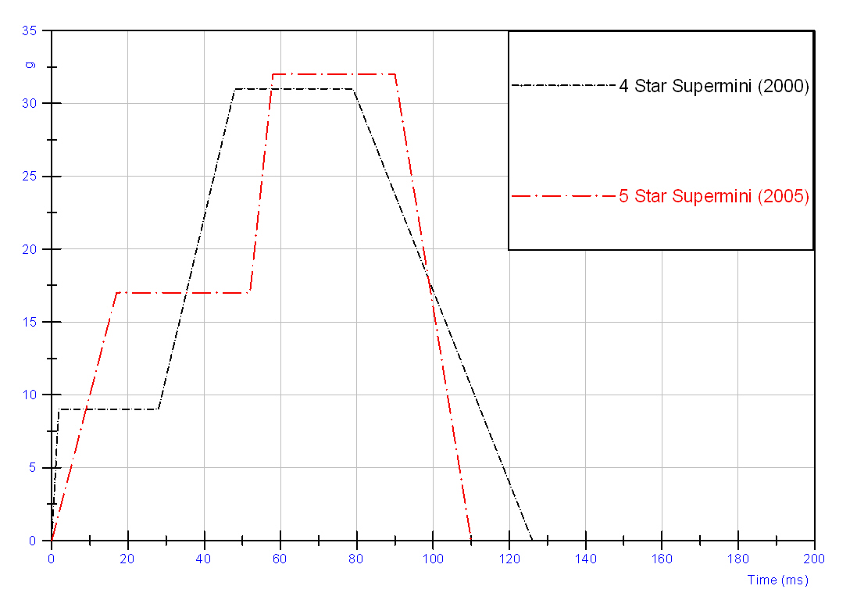

Figure 4- Simplified deceleration pulses (B pillar) from super mini car tests, comparison of 2000 and 2005 models

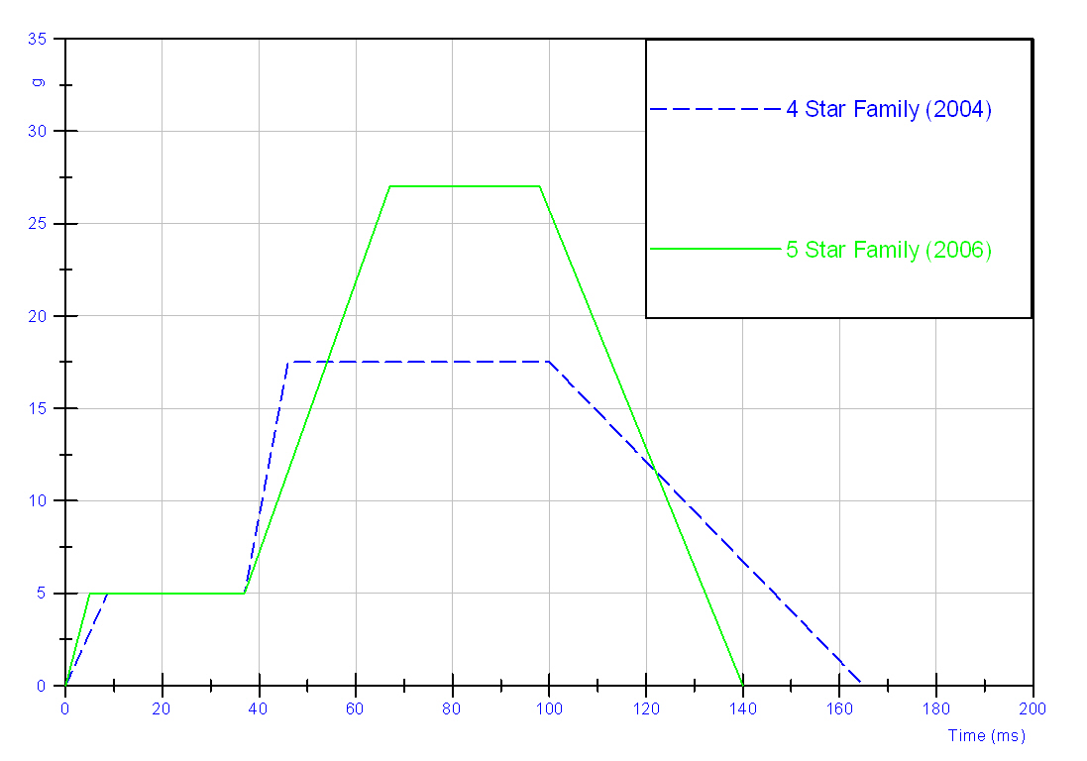
Figure 5 - Simplified deceleration pulses (B pillar) from family car tests, comparison of 2004 and 2006 models

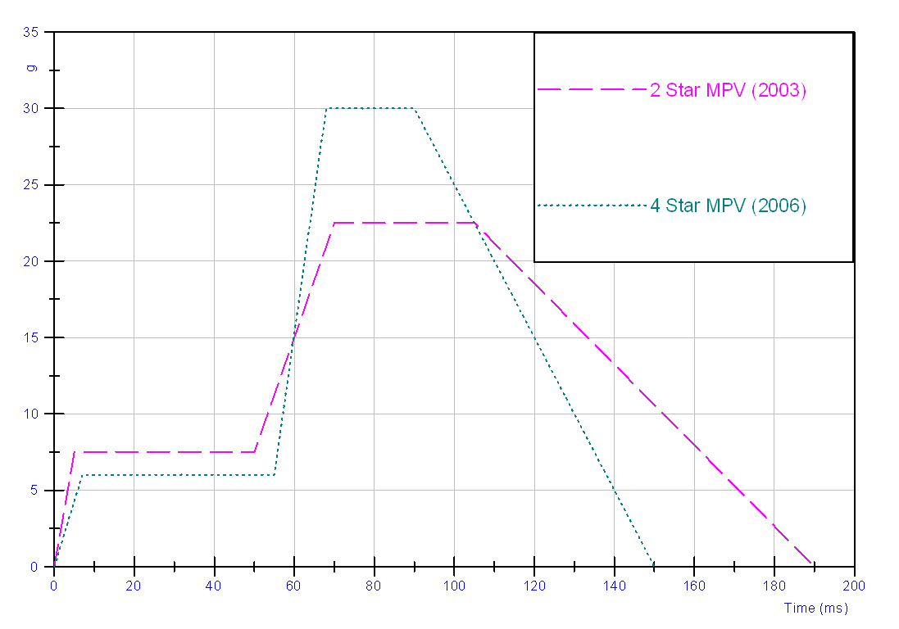

Figure 6 - Simplified deceleration pulses (B pillar) from MPV tests, comparison of 2003 and 2006 models

Although the number of cases is low, the data from the simplified deceleration pulses show a real trend in the increase of vehicle stiffness. The effect of this situation on occupant protection in case of impact translates into higher occupant loads . Figure 7 shows the time history of the chest acceleration of the P3 dummy. The data was obtained from tests involving the same CRS model (ISOFIX) and MPV models from 2003 and 2006. In the case of the 2006 test the chest acceleration of the P3 shows a 35% increase (peak to peak) The head acceleration, not shown here, has increased by 14%.

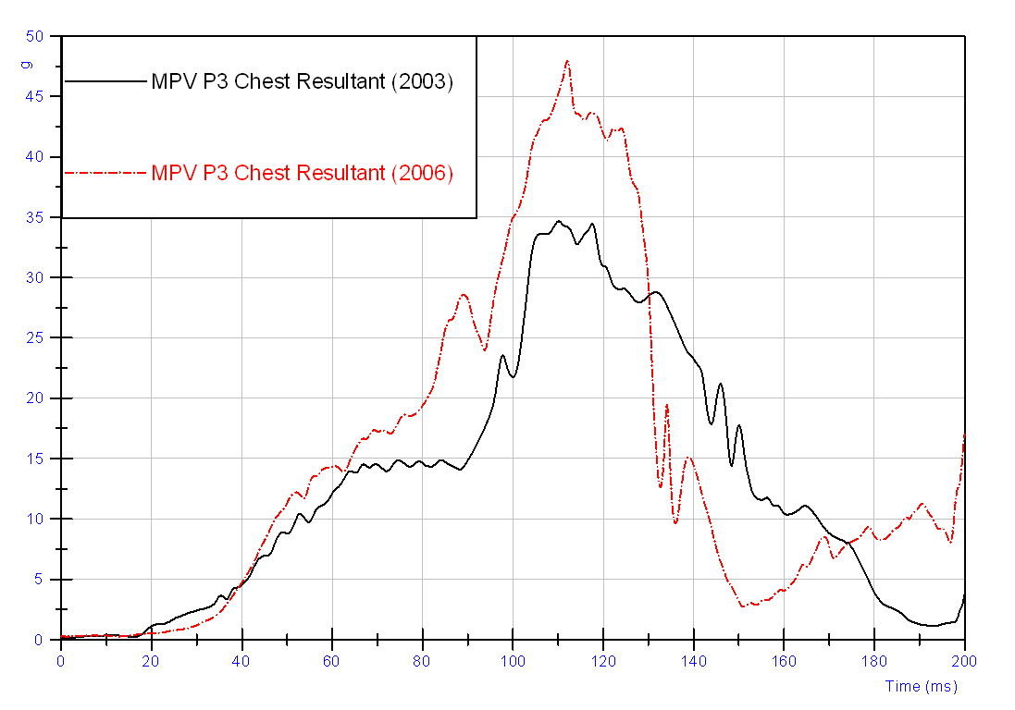

Figure 7 - P3 child dummy chest resultant acceleration time history , in MPV 2003 and 2006 EuroNCAP tests (same CRS).

EU Directive 2003/20/ EC
EU Directive specifies that children under 1,5 m should be attached with appropriate restraint systems. Considering the data as indicated in the table 1 below (3) , the 1,5 m standing height would translate into a seating height of 779 mm for a 95° percentile 10-year old child. Taking into account the R44 bench , this height becomes 731, thus living only 69 mm of space below the 800 mm horizontal plane.
It the present context of increasing vehicle stiffness in Europe, this design space is considered as a design limitation. In practice, a minimum height of 100 mm is required to adjust the booster designs to present vehicle deceleration pulse and to provide sufficient height for the pelvis and an efficient belt path. Such a height makes the 1,5 m stature requirement non applicable with the present 7.1.4.4.1.1. as we will have a total height pf 831 mm. With more loads acting on the child in case of a severe accident, there is a risk that present solutions will reach their limits.

Age | Percentile | Standing Height | Seating Height | Seating Height expressed in R44 sled
10 | 50 | 1402 | 720 | 676
10 | 95° | 1509 | 779 | 731

Table 1: Data from 2006 French National Anthropometric Survey (first 4 columns).

General conclusion
As previous proposition from Clepa to increase the 800 mm plane was not agreed by GRSP, the one option left to consider both Directive 2003/20 and the tendency for higher occupant loading in recent cars is to suppress the requirement of the horizontal plane for only booster seats and this for the test with the largest dummy.

REFERENCES

1) PCPS Fact and Trend Report – The Children’s Hospital pf Philadelphia, 2005.
2) Alan Kirk et Al. « Analysis of CHILD Data Related to Frontal Impacts ». Protection of Children in Cars, 7th – 8th December 2006.
3) French National Anthropometric Survey – Institut Français du Textile et de l’Habillement, 2006.

- - - -

