Draft Global Technical Regulation on Head Restraints

B. Text of Regulation
1. Scope and Purpose: This gtr specifies requirements for head restraints to reduce the frequency and severity of injuries caused by rearward displacement of the head.
2. Application:
[This standard applies to all Category 1-1 vehicles; Category 1-2 vehicles with a Gross Vehicle Mass of up to 3,500 kg; and Category 2 vehicles with a Gross Vehicle Mass of up to 3,500 kg.]
[This standard applies to all Category 1-1 vehicles; Category 1-2 vehicles with a Gross Vehicle Mass of up to 4,500 kg; and Category 2 vehicles with a Gross Vehicle Mass of up to 4,500 kg.]
[This standard applies to all Category 1-1 vehicles; to all Category 1-2 vehicles with a Gross Vehicle Mass of up to 3,500 kg; to Category 1-2 vehicles with a Gross Vehicle Mass greater than 3,500 kg up to 4,500 kg that are equipped with head restraints, to all Category 2 vehicles with a Gross Vehicle Mass of up to 3,500 kg; and to Category 2 vehicles with a Gross Vehicle Mass greater than 3,500 kg up to 4,500 kg that are equipped with head restraints.]

3. Definitions:
3.0 Adjustable head restraint means a head restraint that is capable of movement independent of the seatback between at least two positions of adjustment intended for occupant use.
3.1. Backlight means rearward-facing window glazing located at the rear of the roof panel.
3.2. Backset means the minimum horizontal distance between the front surface of the head restraint and the rear surface of the head restraint measurement device, as measured in accordance with paragraph 7.1.3.
3.3. Head restraint means, at any designated seating position, a device that limits rearward displacement of a seated occupant's head relative to the occupant’s torso that has a height equal to or greater than 700 mm at any point between two vertical longitudinal planes passing at 85 mm on either side of the torso reference line, in any position of backset and height adjustment, as measured in accordance with paragraph 7.1.1.
3.4. Head restraint measurement device (HRMD) means the H-point machine with the head form, as defined in annex 11, appendix 1, attached with sliding scale at the back of the head for the purpose of measuring backset.
3.5. Three-dimensional H-point machine (H-point machine) means the device used for the determination of "H-points" and actual torso angles. This device is defined in annex 11.
3.6. Head Restraint Height means the distance from the [H-point] [R-point], measured parallel to the torso reference line to the top of the head restraint on a plane normal to the torso reference line.
3.7. Intended for occupant use means, when used in reference to the adjustment of a seat and head restraint, adjustment positions used by seated occupants while the vehicle is in motion, and not those intended solely for the purpose of allowing ease of ingress and egress of occupants; access to cargo storage areas; and storage of cargo in the vehicle.
3.8. H-point means the pivot centre of the torso and thigh of the three-dimensional H-point machine when installed in a vehicle seat in accordance with annex 11. Once determined in accordance with the procedure described in annex 11, the "H" point is considered fixed in relation to the seat-cushion structure and is considered to move with it when the seat is adjusted.
3.11. R-point or Seating Reference Point (SRP) means a design point defined by the vehicle manufacturer for each designated seating position and established with respect to the three-dimensional reference system as defined by annex 10. The R-point:
3.11.1. Establishes the rearmost normal design driving or riding position of each designated seating position in a vehicle;
3.11.2. Has coordinates established relative to the designed vehicle structure;
3.11.3. Simulates the position of the centre pivot of the human torso and thigh;
3.11.4. Is defined in annex 11 of this gtr.
3.12. Top of the head restraint means the point on the head restraint centreline with the greatest height.
3.13. Torso-line means the centreline of the probe of the 3-DH machine with the probe in the fully rearward position.
3.14. Actual torso angle means the angle measured between a vertical line through the H point and the torso line using the back angle quadrant on the 3-DH machine. The actual torso angle corresponds theoretically to the design torso angle.
3.15. Design torso angle means the angle measured between a vertical line through the R point and the torso line in a position which corresponds to the design position of the seat back established by the vehicle manufacturer.
4. General Requirements
4.1. Whenever a range of measurements is specified, the head restraint shall meet the requirement at any position of adjustment as intended for occupant use.
4.2. In each vehicle subject to the requirements of this regulation, a head restraint that conforms to paragraphs 5.1.1 through 5.1.4 and either paragraphs 5.1.5. and 5.2. or paragraph 5.3. of this regulation shall be provided at each front outboard designated seating position.
4.3. For vehicles equipped with rear outboard and/or front centre head restraints, the head restraint shall conform to paragraphs 5.1.1. through 5.1.4. and either pargraph 5.2. or paragraph 5.3. of this regulation.
4.4. For vehicles equipped with rear centre head restraints, the head restraint shall conform to paragraphs 5.1.2. through 5.1.4. and either paragraph 5.2. or paragraph 5.3. of this regulation.
4.5. This regulation does not apply to auxiliary seats such as temporary or folding jump seats or to side-facing or rear-facing seats.
4.6. At designated seating positions incapable of seating a 50th percentile male Hybrid III or BioRID II test dummy, the applicable head restraint shall conform to paragraphs 5.1 and 5.2 of this regulation.
4.7. Relationship between the H-point and the R-point. When the seat is positioned in accordance to the manufacturer's specifications, the "H" point, as defined by its co-ordinates, shall lie within a square of 50 mm side length with horizontal and vertical sides whose diagonals intersect at the "R" point, and the actual torso angle shall be within 5 degree of the design torso angle.
[4.7.1 If these conditions are met, the "R" point and the design torso angle, shall be used to demonstrate compliance with the provisions of this Regulation.
4.7.2. If the "H" point or the actual torso angle does not satisfy the requirements of paragraph 4.7. , the "H" point and the actual torso angle shall be determined twice more (three times in all). If the results of two of these three operations satisfy the requirements, the conditions of paragraph 4.7.1. shall apply.]

4.7.3. If the results of at least two of the three operations described in paragraph 4.7.2. do not satisfy the requirements of paragraph 4.7., or if the verification cannot take place because the vehicle manufacturer has failed to supply information regarding the position of the "R" point or regarding the design torso angle, the centroid of the three measured points or the average of the three measured angles shall be used and be regarded as applicable in all cases where the "R" point or the design torso angle is referred to in this gtr.]

5. Performance requirements
5.1. Dimensional requirements. Each front outboard head restraint shall conform to paragraphs 5.1.1. through 5.1.5. of this regulation; each front centre head restraint shall conform to paragraphs 5.1.1, through 5.1.4. of this regulation; each rear outboard head restraint shall conform to paragrphs 5.1.1 through 5.1.4. of this regulation; each rear centre head restraint shall conform to paragraphs 5.1.2. through 5.1.4. of this regulation:
5.1.1. Minimum Height: Each front outboard head restraint shall conform to paragraph 5.1.1.1. of this regulation; each front centre head restraint shall conform to paragraph 5.1.1.2. of this regulation; each rear outboard head restraint shall conform to paragraph 5.1.1.4. of this regulation:
5.1.1.1. Front outboard designated seating positions. When measured in accordance with paragraph 7.1.1, the top of a head restraint located in a front outboard designated seating position shall have a height of: (a) not less than 800 mm in at least one position of head restraint adjustment; and (b) not less than 750 mm in any position of head restraint adjustment. See exception in paragraph 5.1.1.3 of this regulation.
5.1.1.2. Front centre designated seating positions equipped with head restraints. When measured in accordance with paragraph 7.1.1, the top of a head restraint located in the front centre designated seating position shall have a height not less than 750 mm in any position of adjustment. See exception in paragraph 5.1.1.3 of this regulation.
5.1.1.3. Exception. The requirements of paragraphs 5.1.1.1. and 5.1.1.2 of this regulation do not apply if the interior surface of the vehicle roofline, including the headliner, physically prevents a head restraint, located in the front outboard designated seating position, from attaining the required height. In those instances in which this head restraint cannot attain the required height, when measured in accordance with paragraph 7.1.1, the maximum vertical distance between the top of the head restraint and the interior surface of the roofline, including the headliner, shall not exceed 25 mm in the lowest position of seat adjustment; in any horizontal position of seat adjustment; and the highest position of head restraint adjustment intended for occupant use. Notwithstanding this exception, when measured in accordance with paragraph 7.1.1, the top of a head restraint located in a front outboard designated seating position shall have a height of not less than 700 mm in the lowest position of adjustment intended for occupant use.
5.1.1.4. Rear outboard designated seating positions equipped with head restraints. Except as provided in paragraph 5.1.1.5. of this regulation, when measured in accordance with paragraph 7.1.1, the top of a head restraint located in a rear outboard designated seating position shall have a height not less than 750 mm in any position of adjustment.
5.1.1.5. Exception. The requirements of paragraph 5.1.1.4 of this regulation do not apply if the interior surface of the vehicle roofline, including the headliner, or backlight physically prevent a head restraint, located in the rear outboard designated seating position, from attaining the required height and or folding to allow egress/ingress. In those instances in which this head restraint cannot attain the required height, when measured in accordance with paragraph 7.1.1, the maximum vertical distance between the top of the head restraint and interior surface of the roofline, including the headliner, or the backlight shall not exceed 25 mm in the lowest position of seat adjustment; in any horizontal position of seat adjustment; and the highest position of head restraint adjustment intended for occupant use.
5.1.2. Minimum width. When measured in accordance with paragraph 7.1.2., the lateral width of a head restraint shall be not less than 170 mm between two vertical longitudinal planes passing at 85 mm on either side of the torso reference line.
[5.1.3. Gaps within head restraint. If a head restraint has any gap greater than 60 mm when measured in accordance with paragraph 7.1.3, the maximum rearward displacement X of the headform shall be less than 102 mm when the head restraint is tested at that gap in accordance with paragraph 7.2.3.]
5.1.4. Gaps between head restraint and the top of the seat back. When measured in accordance with paragraph 7.1.4., there shall not be a gap greater than 60 mm between the head restraint and the seat if the head restraint is not adjustable vertically between in-use positions. When measured in accordance with paragraph 7.1.4, there shall not be a gap greater than 25 mm between a vertically adjustable head restraint and the seat, with the head restraint adjusted to its lowest height position.
5.1.5. Minimum backset for front outboard designated seating positions. For adjustable restraints, the requirements of this regulation shall be met with the top of the head restraint in all height positions of adjustment between 750 mm and 800 mm, inclusive. If the top of the head restraint, in its lowest position of adjustment, is above 800 mm, the requirements of this regulation shall be met at that position. If the front outboard head restraint is not attached to the seat back, the head restraint cannot be adjusted such that the backset is more than [55 mm]. If the measuring reference point is the H-point, the head restraint shall conform to paragraph 5.1.5.1; if the measuring reference point is the R-point, the head restraint shall conform to paragraph 5.1.5.2.:
5.1.5.1. When measured in accordance with paragraph 7.1.5.1., the backset shall not be more than [55 mm][70 mm].
5.1.5.2. When measured in accordance with paragraph 7.1.5.2, the backset shall not be more than [40 mm][55 mm].

5.2. Static performance requirements. Each head restraint shall conform to paragraphs 5.2.1. through 5.2.5. of this regulation:
5.2.1. Energy absorption. When the front surface of the head restraint is impacted in accordance with paragraph 7.2.1., the deceleration of the head form shall not exceed 785 m/s² (80 g) continuously for more than 3 milliseconds.
5.2.2. Adjustable head restraint height retention. When tested in accordance with paragraph 7.2.2., the mechanism of the adjustable head restraint shall not fail in such a way as to allow downward movement of the head restraint by more than 25 mm.
[5.2.3. Displacement and Backset Retention. If a head restraint has a fixed backset then the head restraint shall conform to paragraph 5.2.3.1. If a head restraint has an adjustable backset, based on the determination of each Contracting Party or regional economic integration organization, the head restraint shall conform to either paragraph 5.2.3.1 or paragraph 5.2.3.2.
5.2.3.1. Displacement. When the head restraint is tested in the rearmost (relative to the seat) position of horizontal adjustment in accordance with paragraph 7.2.3., the head form shall not be displaced more than 102 mm perpendicularly and rearward of the displaced extended torso reference line during the application of a 373 ± 7.5 Nm moment about the [R-point][H-point].
5.2.3.2. Displacement and Backset Retention.
5.2.3.2.1.When the head restraint is tested in any position of backset adjustment in accordance with paragraph 7.2.3., the head form shall:
5.2.3.2.2. Not be displaced more than 25 mm during the application of the initial reference
moment of 37 ± 0.7 Nm;
5.2.3.2.3. Not be displaced more than 102 mm perpendicularly and rearward of the displaced extended torso reference line during the application of a 373 ± 7.5 Nm moment about the H-point; and
5.2.3.2.4.Return to within 13 mm of its initial reference position after the following sequence
occurs: application of a 373 ± 7.5 Nm moment about the H-point; reduction of the moment to 0 Nm; and by re-application of the initial reference load 37 ± 0.7 Nm.]
5.2.4. Head restraint strength. When the head restraint is tested in accordance with paragraph 7.2.4., the load applied to the head restraint shall reach 890 N and remain at 890 N for a period of 5 seconds.
5.3. [Dynamic performance requirements . When tested during forward acceleration of the dynamic test platform, in accordance with paragraph 7.3., at each designated seating position equipped with a head restraint, the head restraint shall conform to paragraph 5.3.1. Based on a determination by each Contracting Party or regional economic integration organization, either a Hybrid III 50th percentile male dummy or a BioRID II 50th percentile male dummy shall be used to determine compliance.
5.3.1. Injury criteria.
If a Hybrid III dummy is used the head restraint shall meet the requirement of paragraph 5.3.1.1.. If a BioRID II dummy is used, the head restraint shall meet the requirements of paragraph 5.3.1.2..
5.3.1.1. Hybrid III Requirements.
5.3.1.1.1. Angular rotation. Limit posterior angular rotation between the head and torso of the 50th percentile male Hybrid III test dummy to [12] [20] degrees for the dummy in all outboard designated seating positions;
5.3.1.1.2. Head injury criteria. Limit the maximum HIC₁₅ value to 500. HIC₁₅ is calculated as
follows: For any two points in time, t₁ and t₂, during the event which are separated by not more than a 15 millisecond time interval and where t₁ is less than t₂, the head injury criterion (HIC₁₅) is determined using the resultant head acceleration at the centre of gravity of the dummy head, a_{r}, expressed as a multiple of g (the acceleration of gravity) and is calculated using the expression:
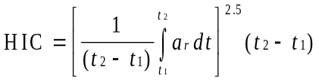]
5.3.1.2. BioRID II Requirements. [To be provided by France]
5.3.1.2.1. Upper Neck Shear Force (Fx). The upper neck loadcell of the BioRID records shear force. If the instrumentation is configured in accordance with SAE J211, positive shear should be indicative of a head-rearwards motion. Limit the maximum Upper Neck Shear Force (Fx) of the Biorid IIg (or latter version) test dummy to a maximum of [300]N.
Fx channel should be filtered at CFC 1000 and so peak value Fxmax is determined considering only the portion of data from Tzero until the time there is no more contact of the head with the head restraint (T-HRC).
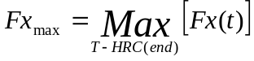

5.3.1.2.2. Head injury criteria. Limit the maximum HIC₁₅ value to 500. HIC₁₅ is calculated as follows: For any two points in time, t₁ and t₂, during the event which are separated by not more than a 15 millisecond time interval and where t₁ is less than t₂, the head injury criterion (HIC₁₅) is determined using the resultant head acceleration at the centre of gravity of the dummy head, a_{r}, expressed as a multiple of g (the acceleration of gravity) and is calculated using the expression:

5.4. Non-use positions. A driver head restraint shall not have a non-use position.
5.4.1. A front outboard passenger head restraint may be adjusted to a position at which its height does not comply with the requirements of paragraph 5.1.1.1. of this regulation. However, in any such position, the front outboard passenger head restraint shall meet paragraph 5.4.3.1 of this regulation.
5.4.2. All rear head restraints and any front centre head restraint may be adjusted to a position at which its height does not comply with the requirements of paragraph 5.1.1.2. and paragraph 5.1.1.4. of this regulation. However, in any such position, the head restraint shall also meet one additional requirement from a set of several alternative test requirements. Based on a determination by each Contracting Party or regional economic integration organization, the set of alternative test requirements may be:
(a) At the choice of the manufacturer: paragraph 5.4.3.1 or paragraph 5.4.3.2 or paragraph 5.4.3.3 or paragraph 5.4.3.4 of this regulation, or
(b) At the choice of the manufacturer: paragraph 5.4.3.1 or paragraph 5.4.3.2 or paragraph 5.4.3.3 or paragraph 5.4.3.4. or paragraph 5.4.3.5 of this regulation.
5.4.3 Alternative requirements. All of the items described in paragraphs 5.4.3.1 through 5.4.3.5 are permitted as additional features.
5.4.3.1 In all designated seating positions equipped with head restraints, except the driver’s designated seating position, the head restraint shall automatically return from a non-use position to a position in which its minimum height is not less than that specified in paragraphs 5.1.1.2. and 5.1.1.4. of this regulation when a 5th percentile female Hybrid III test dummy is positioned in the seat in accordance with paragraph 7.4. At the option of the manufacturer, instead of using a 5th percentile female Hybrid III test dummy, human beings may be used as specified in paragraph 7.4.
5.4.3.2 In rear and front centre designated seating positions equipped with head restraints, the head restraint shall, when tested in accordance with paragraph 7.4., be capable of manually rotating either forward or rearward by not less than 60 degrees from any position of adjustment intended for occupant use in which its minimum height is not less than that specified in paragraphs 5.1.1.2 or 5.1.1.4. of this regulation.
5.4.3.3 When measured in accordance with paragraph 7.4., the lower edge of the head restraint (H_{LE}) shall be not more than [400 mm], but not less than 250 mm from the R-Point and the thickness (S) shall not be less than [25 mm].
5.4.3.4 When tested in accordance with paragraph 7.4, the head restraint shall cause the torso reference line angle to be at least 10 degrees closer to vertical than when the head restraint is in any position of adjustment in which its height is not less than that specified in paragraphs 5.1.1.1., 5.1.1.2., or 5.1.1.4. of this regulation and its backset is not more than that specified in paragraph 5.1.5. of this regulation.
5.4.3.5[The head restraint shall be marked with a label in the form of a pictogram which may include explanatory text. The label shall either provide an indication when the head restraint is in a non-use position or provide information to enable an occupant to determine whether the head restraint is in a non-use position. The label shall be durably affixed and located such that it is clearly visible by an occupant when entering the vehicle to the designated seating position. Examples of possible designs of pictograms are shown in Figure 1.]
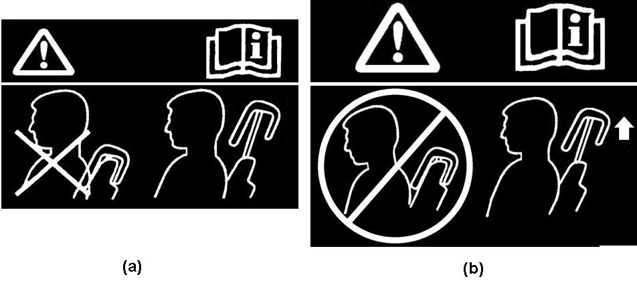
Figure 1
5.5. Removability of head restraints. The head restraints shall not be removable without a
deliberate action distinct from any action necessary for upward head restraint adjustment.
6. Test conditions. Demonstrate compliance with paragraphs 5.1 through 5.5 of this regulation with any adjustable lumbar support adjusted to its most rearward nominal design position. If the seat cushion adjusts independently of the seat back, [position the seat cushion such that the [lowest][highest] H-point position is achieved with respect to the seat back.

7. Test Procedures.
7.1. Dimensional Requirements.
7.1.1. Height of Head Restraints. Compliance with paragraphs paragraphs 5.1.1.1., 5.1.1.2., 5.1.1.3., 5.1.1.4., and 5.1.1.5. is demonstrated in accordance with annex 1.
7.1.2. Minimum Width. Compliance with paragraph 5.1.2. is demonstrated in accordance with annex 2.
7.1.3. Gaps within head restraints. Compliance with paragraph 5.1.3. is demonstrated in accordance with annex 4.
7.1.4. Gaps between head restraint and top of seat back. Compliance with paragraph 5.1.4. is demonstrated in accordance with annex 4.
7.1.5. Minimum Backset for front outboard designated seating positions.
7.1.5.1. Compliance with paragraph 5.1.5.1. is demonstrated in accordance with annex 3.
7.1.5.2. Compliance with paragraph 5.1.5.2. is demonstrated in accordance with annex 3.
7.2. Static Performance Requirements.
7.2.1 Energy Absorption. Compliance with paragraph 5.2.1. is demonstrated in accordance with annex 5.
7.2.2. Height Retention. Compliance with paragraph 5.2.3. is demonstrated in accordance with annex 6.

7.2.3. Backset Retention and Displacement. Compliance with paragraph 5.2.4. is demonstrated in accordance with annex 7.

7.2.4. Head Restraint Strength. Compliance with paragraph 5.2.5. is demonstrated in accordance with annex 7.

7.3. Dynamic Performance Requirements. Compliance with paragraph 5.3. is demonstrated in accordance with annex 8.

7.4. Non-Use Positions. Compliance with paragraph 5.4. is demonstrated in accordance with annex 9.

Annex 1

Minimum Height Measurement Test procedure
1. Purpose: To validate paragraph 3.3 and demonstrate compliance with paragraph 5.1.1 by measuring the height of the head restraint.
2. Procedure for height measurement. Measure the height of the head restraint in accordance with paragraphs 2.1. and 2.2. of this annex, using the scale incorporated into the manikin specified in annex 11 or an equivalent scale, which is positioned laterally within 15 mm of the head restraint centreline. If the seat back is adjustable, it is adjusted to a position specified by the vehicle manufacturer. If there is more than one inclination position closest to the position specified by the manufacturer, set the seat back inclination to the position closest to and rearward of the manufacturer specified position. If the head restraint position is independent of the seat back inclination position, compliance is determined at a seat back inclination position specified by the manufacturer.
2.1. Height measurement for front outboard head restraints.
2.1.1. For head restraints in front outboard designated seating positions, adjust the top of the head restraint to the highest position, other than allowed by paragraph 5.3., and measure the height as shown in Figure 2.
2.1.2. For head restraints located in the front outboard designated seating positions that are prevented by the interior surface of the vehicle roofline from meeting the required height as specified in paragraph 5.1.1.3., measure the clearance between the top of the head restraint and the interior surface of the roofline, [with the seat adjusted to its lowest vertical position intended for occupant use], by attempting to pass a 25 mm sphere between them. Adjust the top of the head restraint to the lowest position and measure the height.
2.2. Height measurement for front centre and rear outboard head restraints.
2.2.1. For head restraints in all designated seating positions equipped with head restraints, adjust the top of the head restraint to the lowest position, other than allowed by paragraphs 5.3. and 5.4., and measure the height as shown in Figure 1-1.
2.2.2. For head restraints located in rear designated seating positions that are prevented by the interior surface of the vehicle roofline or rear backlight from meeting the required height as specified in paragraph 5.1.1.5., measure the clearance between the top of the head restraint or the seat back and the roofline or the rear backlight, with the seat adjusted to its lowest vertical position intended for occupant use, by attempting to pass a 25 mm sphere between them.

[Insert drawing ECE R.17, Annex 4, Figure 1]

Figure 1-1

[Alternative Proposal from OICA]

Annex 1

Minimum Height Measurement Test Procedure

1. Height measuring apparatus. The height measurement apparatus consists of (see Figure 1-1 below):
1.1 A straight edge AE. The lower point A is placed at the R point location. The line AE shall be parallel to the design torso angle.
1.2. A straight edge FG, perpendicular to the line AE and in contact with the top of the head restraint.

2. Procedure for height measurement. Demonstrate compliance with paragraph 5.1.1. of the regulation in accordance with paragraphs 3. and 4. of this annex, using the height measurement apparatus defined in paragraph 1 of this annex. The seat shall be adjusted such that its H-point coincides with the R- point, in accordance with the requirements of paragraph 4.7 of this regulation. If the seat back is adjustable, it is set at the design seat back angle. The height of the head restraint shall be the distance between point A and the intersection of lines AE and FG.

3. Height measurement for front outboard head restraints

3.1. If adjustable, adjust the top of the head restraint to the highest position and measure the height. If adjustable, adjust the top of the head restraint to the lowest position intended for normal use and measure the height

3.2. For head restraints that are prevented by the interior surface of the vehicle roofline from meeting the required height as specified in paragraph 5.1.1.1. of this regulation, the requirements of paragraphs 5.1.1.3. of this regulation shall be assessed by the following procedures:
3.2.1. Adjust the head restraint to its maximum height and measure the clearance between the top of the head restraint and the interior surface of the roofline or the rear backlight, by attempting to pass a 25 mm sphere between them.
3.2.2. Adjust the top of the head restraint to the lowest position of adjustment intended for normal use and measure the height in accordance with paragraph 2. of this annex.

4. Height measurement for front center and rear outboard head restraints

4.1. For head restraints in all designated seating positions equipped with head restraints, if adjustable, adjust the top of the head restraint to the lowest position of adjustment intended for normal use, [other than any non-use position described in paragraph 5.4 of this regulation] and measure the height in accordance with paragraph 2. of this annex.

4.2 For head restraints that are prevented by the interior surface of the vehicle roofline or rear backlight from meeting the required height as specified in paragraphs 5.1.1.2. or 5.1.1.4. of the regulation, the requirements of paragraphs 5.1.1.3 and 5.1.1.5 shall be assessed by the following procedure:
4.2.1 Adjust the head restraint to its maximum height and measure the clearance between the top of the head restraint or the seat back and the interior surface of the roofline or the rear backlight, by attempting to pass a 25 mm sphere between them.

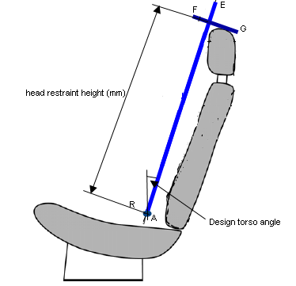

Figure 1-1

Annex 2

Minimum Width Measurement Test procedure
1. Purpose: Measure the width of the head restraint to demonstrate compliance with paragraph 5.1.2. of this regulation.
2. Procedure for width measurement. Using [calipers], measure the maximum dimension perpendicular to the vehicle vertical longitudinal plane of the intersection of the head restraint with a plane that is perpendicular to the torso reference line of manikin, defined in annex 11, and 68 ± 3 mm below the top of the head restraint, as shown in Figure 2-1.

[Insert ECE R.17 Annex 4, Figure 2]

Figure 2-1

Annex 3

Minimum Backset Measurement Test Procedure
Using H-point as the Reference Point

- Purpose. Demonstrate compliance with paragraph 5.1.5 by measuring the backset of the head restraint using the three-dimensional H-point machine, defined in annex 11, and the HRMD. This procedure uses the H-point as the initial reference point.
- Seat setup. If the seat back is adjustable, it is set at an initial inclination position closest to design angle as measured by the three-dimensional H-point machine. If there is more than one inclination position closest to design angle, set the seat back inclination to the position closest to and rearward of the design angle.
3. Procedure for backset measurement. Position the HRMD, as defined in annex 11, laterally within 15 mm of the head restraint centreline. Adjust the front outboard head restraint so that its top is at any height between and inclusive of 750 mm and 800 mm and its backset is in the maximum position other than allowed by paragraph 5.3. If the lowest position of adjustment is above 800 mm, adjust the head restraint to that position. Extend the sliding scale on the back of the head until it contacts the head restraint and take backset measurement.

[OICA proposed language]

Annex 3

Minimum Backset Measurement Test Procedure
Using R-point as the Reference Point

1. Backset measuring apparatus. The backset measurement apparatus consists of (see Figure 3-1 ):
1.1. A straight edge (lower arm) AB. The lower point A is placed at the R point location. Point B is located at a distance of is 505mm from the R point. The line AB shall be parallel to the design torso angle.
1.2. A straight edge (upper arm) BC. Point C is located at a distance of 205mm vertically up from point B.
2. Procedure for backset measurement. Demonstrate compliance with paragraph 5.1.7. of this regulation using the backset measurement apparatus defined in paragraph 1. of this annex and the following procedures:
2.1 Adjust the seat such that its H-point coincides with the R- point, in accordance with the requirements of paragraph 4.7 of this regulation.
2.2 Adjust the seat back to its design angle.
2.3. Adjust the front head restraint so that its top is at any height between and inclusive of 750mm and 800mm. If the lowest position of adjustment is above 800mm, adjust the head restraint to that lowest position of adjustment.
2.4. In the case of head restraint with adjustable backset, adjust the head restraint at the most rearward position, such that the backset is in the maximum position.
2.5. Establish point D on the head restraint, point D being the intersection of a line drawn from point C horizontally in the X direction, with the front surface of the head restraint.
2.6 . Measure the distance CD. The backset shall be the measured distance CD minus 73mm.

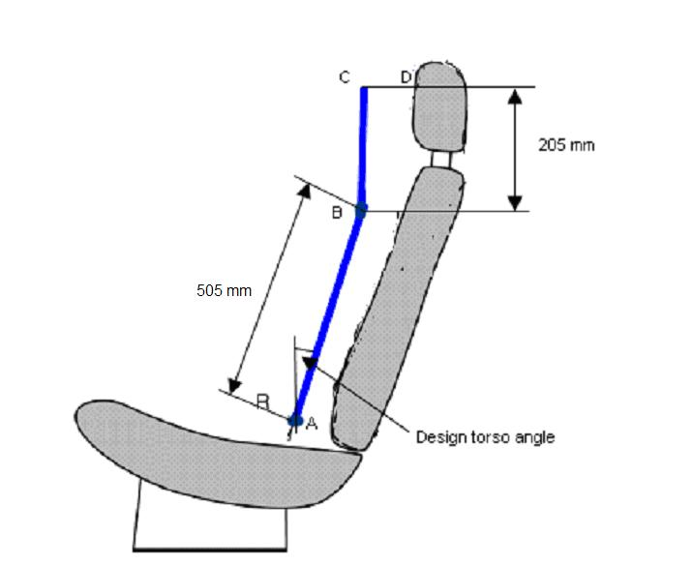

Figure 3-1

Annex 4

Gap Evaluation Test Procedure
1. Purpose. Evaluate the gaps within a head restraint and between the bottom of the head restraint and the top of the seat back. Demonstrate compliance with paragraph 5.1.3.with the procedures of paragraphs 2.1 through 2.3 and paragraphs 4.1 through 4.7 of this annex. Demonstrate compliance with [paragraph 5.1.4.] in accordance with the procedures of either paragraphs 2.1. through 2.3. or paragraphs 3.1. through 3.2 of this annex, at the manufacturer’s option, with the head restraint adjusted to its lowest height position and any backset position intended for occupant use.
2. Gap measurement using a sphere. The area of measurement is anywhere on the front surface of the head restraint between two vertical longitudinal planes passing at 85 mm on either side of the torso reference line.
2.1. Applying a load of no more than 5 N against the area of measurement specified in paragraph 1.2. of this annex, place a 165 ± 2 mm diameter spherical head form against any gap such that at least two points of contact are made within the area. The surface roughness of the head form is less than 1.6 μm, root mean square.
2.2 Determine the gap dimension by measuring the straight line distance between the inner edges of the two furthest contact points, as shown in Figures 4-1 and 4-2.
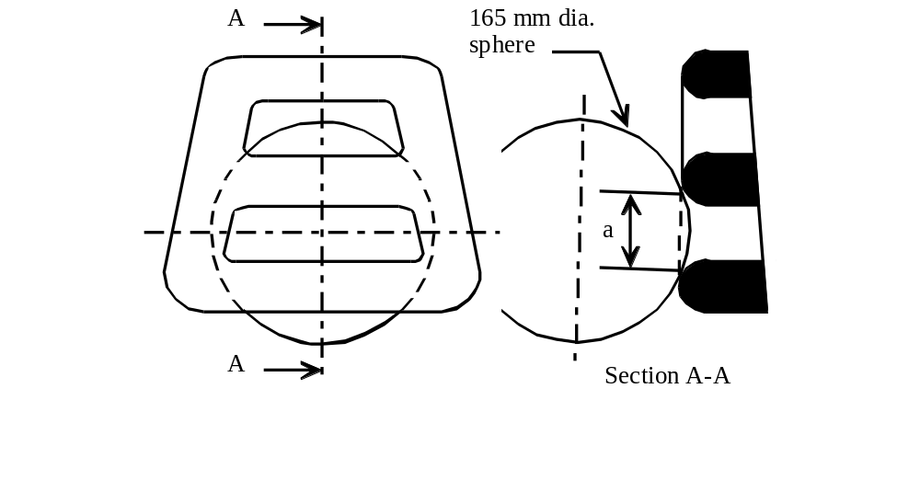
Figure 4-1 - Measurement of a vertical gap “a”.

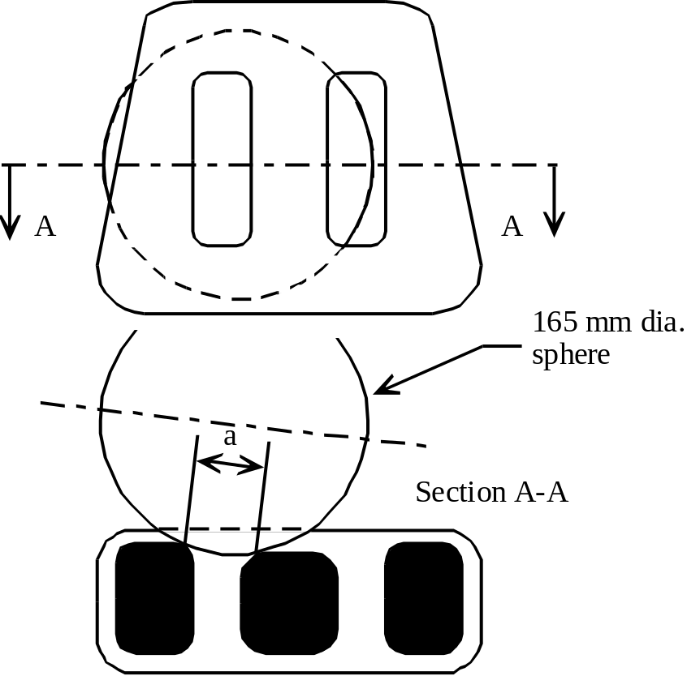

Figure 4-2 - Measurement of a horizontal gap “a”.

3. Linear measurement of gap.
3.1. Procedure for height measurement. Measure the gap between the bottom of the head restraint and the top of the seat back using the scale incorporated into the manikin specified in annex 11 or an equivalent scale, which is positioned laterally within 15 mm of the head restraint centreline. If the seat back is adjustable, it is adjusted to a position specified by the vehicle manufacturer. If there is more than one inclination position closest to the position specified by the manufacturer, set the seat back inclination to the position closest to and rearward of the manufacturer specified position. If the head restraint position is independent of the seat back inclination position, compliance is determined at a seat back inclination position specified by the manufacturer.
3.2. Adjust the top of the head restraint to the lowest position and measure the gap as shown in Figure 4-3.
[Insert height measurement drawing with included gap lines]

Figure 4-3

4. Procedure for determining rearward displacement for head restraint at gap greater than 60 mm.
4.1 Seat set-up. If the seat back is adjustable, it is adjusted to a position specified by the vehicle manufacturer. If there is more than one inclination position closest to the position specified by the manufacturer, set the seat back inclination to the position closest to and rearward of the manufacturer specified position. If the head restraint position is independent of the seat back inclination position, compliance is determined at a seat back inclination position specified by the manufacturer. Adjust the head restraint to the highest position of vertical adjustment intended for occupant use. Adjust the head restraint to the rearmost backset position.
4.2. In the seat, place a test device having, when viewed laterally, the back pan dimensions and torso reference line (vertical centre line) of the three dimensional H-point machine as specified in annex 11 with the head room probe in the full back position;
4.3. Establish the displaced torso reference line by creating a posterior moment of 373 ± 7.5 Nm about the [R-point][H-point] by applying a force to the seat back through the back pan at the rate between 2.5 Nm/second and 37.3 Nm/second. The initial location on the back pan of the moment generating force vector has a height of 290 mm ± 13 mm. Apply the force vector normal to the torso reference line and maintain it within 2 degrees of a vertical plane parallel to the vehicle longitudinal centreline. Constrain the back pan to rotate about the [R-point][H-point]. Rotate the force vector direction with the back pan.
4.4. Maintain the position of the back pan as established in paragraph 4.3 of this annex. Using a 165 ± 2 mm diameter spherical head form with a surface roughness of less than 1.6 μm, root mean square, establish the head form initial reference position by applying, perpendicular to the displaced torso reference line, a rearward initial load passing through the centre of gravity of the smallest of the sections of the gap, along transversal planes parallel to the reference line that will produce a 36.5 ± 0.5 Nm moment about the [R-point][H-point].
4.7 Increase the initial load at the rate between 2.5 Nm/second and 37.3 Nm/second until a 373 ± 7.5 Nm moment about the [R-point][H-point] is produced. Maintain the load level producing that moment for not less than 5 seconds and then measure the rearward displacement of the head form relative to the displaced torso reference line.
Annex 5
Energy Absorption Test Procedure
1. Purpose: Evaluate the energy absorption ability of the head restraint by demonstrating compliance with paragraph 5.2.1. of this regulation in accordance with this annex.
2. Seat set-up: The seat shall be either mounted in the vehicle or firmly secured to the test bench, as mounted in the vehicle with the attachment parts provided by the manufacturer, so as to remain stationary when the impact is applied. The seat-back, if adjustable, shall be locked in the design position specified by the vehicle manufacturer. If the seat is fitted with a head restraint, the head restraint shall be mounted on the seat-back as in the vehicle. Where the head restraint is separate, it shall be secured to the part of the vehicle structure to which it is normally attached.
3. Procedures for energy absorption. The adjustable head restraints shall be measured in any height and backset position of adjustment.
3.1. Test equipment
3.1.2. Use an impactor with a semispherical head form of a 165 ± 2 mm diameter and a surface roughness of less than 1.6 μm, root mean square for the impacting part of the impactor. The head form and associated base have a combined mass such that at a speed of 24.1 ± 0.5 km/h at the time of impact an energy of 152 ± 6 Joule will be reached.
3.1.2. Instrument the impactor with an acceleration sensing device whose output is recorded in a data channel that conforms to the requirements for a 600 Hz channel class filter as specified in ISO Standard 6487 (2002); The axis of the acceleration-sensing device coincides with the geometric center of the head form and the direction of impact. As an alternative the impactor can be equipped with 2 accelerometers sensing in the direction of impact and placed symmetrically in comparison to the geometric centre of the spherical head form. In this case the deceleration rate shall be taken as the simultaneous average of the readings on the two accelerometers.
3.2. Accuracy of the test equipment. The recording instruments used shall be such that measurements can be made with the following degrees of accuracy:
3.2.1. Acceleration:
Accuracy = + 5 % of the actual value;
Cross-axis sensitivity = < 5 % of the lowest point on the scale.
3.2.2. Speed:
Accuracy: + 2.5 % of the actual value;
Sensitivity: 0.5 km/h.
3.2.3. Time recording: The instrumentation shall enable the action to be recorded throughout its duration and readings to be made to within one one-thousandth of a second;
the beginning of the impact at the moment of first contact between the headform and the item being tested shall be detected on the recordings used for analyzing the test.
3.3. Test procedure
3.3.1. Propel the impactor toward the head restraint. At the time of impact, the longitudinal axis of the impactor is within ±2 degrees of being horizontal and parallel to the vehicle longitudinal axis and the impactor speed is not more than 24,1 km/h.
3.3.2. Impact the front surface of the seat or head restraint at any point with a height greater than 635 mm from the [R-point][H-point] and within a distance of the head restraint vertical centreline of 70 mm and measure the acceleration.

Annex 6
Height Retention Test Procedure
1. Purpose. Demonstrate compliance with paragraph 5.2.2 of this regulation in accordance with this annex.
2. Procedures for height retention.
2.1. Seat set-up. Adjust the adjustable head restraint so that its top is at any of the following height positions at any backset position:
2.1.1. For front outboard designated seating positions:
2.1.1.1. The highest position; and
2.1.1.2. Not less than, but closest to 800 mm; and
2.1.2.1.For rear outboard and front centre designated seating positions
2.1.2.2. The highest position; and
2.1.2.3. Not less than, but closest to 750 mm.
2.2. Orient a cylindrical test device having a 165 ± 2 mm diameter in plane view (perpendicular to the axis of revolution), and a 152 mm length in profile (through the axis of revolution) with a surface roughness of less than 1.6 μm, root mean square, such that the axis of the revolution is horizontal and in the longitudinal vertical plane through the longitudinal centreline of the head restraint. Position the midpoint of the bottom surface of the cylinder in contact with the head restraint.
2.3. Increase the load at the rate of 250 ± 50 N/minute to at least 500 N and maintain this load for not less than 5 seconds.
2.4. Reduce the load to 0 N and determine the position of the cylindrical device with respect to its initial reference position.
2.5. Measure the vertical distance measured between the lowest point on the underside of the head restraint and the top of the seat back.
2.6. If the design of the head restraint is such that it is not possible to measure to the top of the seat then the vertical measurement shall be taken by marking a horizontal line across the front of the seat back at least 25 mm below the lowest point of the head restraint and the measurement shall be taken from this line to the underside of the head restraint.

[Annex 7]
Displacement, Backset Retention, and Strength Test Procedures
1. Purpose. Demonstrate compliance with paragraph 5.2.3.1 of this regulation with paragraph 1.2. of this annex. Demonstrate compliance with paragraph 5.2.3.2 of this regulation with paragraph 1.3 of this annex. Demonstrate compliance wit paragraph 5.2.4 of this regulation with paragraph 1.4. of this annex.
1.2. Procedures for displacement. The load vectors that generate moment on the head restraint are initially contained in a vertical plane parallel to the vehicle longitudinal centreline.
1.2.1. Seat set-up. Adjust the head restraint to the highest position of vertical adjustment intended for occupant use. Adjust the head restraint to in the rearmost (relative to the seat) position of horizontal adjustment backset position.
1.2.2. In the seat, place a test device having, when viewed laterally, the back pan dimensions and torso reference line (vertical centre line) of the three dimensional H-point machine, as specified in annex 11, with the head room probe in the full back position.
1.2.3. Establish the displaced torso reference line by creating a rearward moment of 373 ± 7.5 Nm about the [H-point][R-point] by applying a force to the seat back through the back pan at the rate of 2.5 Nm/second to 37.3 Nm/second. The initial location on the back pan of the moment generating force vector has a height of 290 mm ± 13 mm. Apply the force vector normal to the torso reference line and maintain it within 2 degrees of a vertical plane parallel to the vehicle longitudinal centreline. Constrain the back pan to rotate about the [H-point][R-point]. Rotate the force vector direction with the back pan.
1.2.4. Maintain the position of the back pan as established in paragraph 1.2.3. of this annex. Using a 165 ± 2 mm diameter spherical head form with a surface roughness of less than 1.6 μm, root mean square, establish the head form initial reference position by applying, perpendicular to the displaced torso reference line, a rearward initial load at the seat centreline at a height 65 ± 3 mm below the top of the head restraint that will produce a 36.5 ± 0.5 Nm moment about the [H-point][R-point].
1.2.5. [If the presence of gaps prevents the application of the force, as described in paragraph 1.2.4 of this annex at 65 ± 3 mm from the top of the head restraint, the distance may be reduced so that the axis of the force passes through the centre line of the frame element nearest to the gap.]
1.2.6. Increase the initial load at the rate between 2.5 Nm/second and 37.3 Nm/second until a 373 ± 7.5 Nm moment about the [H-point][R-point] is produced. Maintain the load level producing that moment for not less than 5 seconds and then measure the rearward displacement of the head form relative to the displaced torso reference line.
1.3 Procedures for backset retention and displacement
1.3.1. Adjust the head restraint to the highest position of vertical adjustment intended for occupant use.
1.3.2. [Adjust the head restraint to any backset position.]

1.3.3. In the seat, place a test device having the back pan dimensions and torso reference line (vertical centre line), when viewed laterally, with the head room probe in the full back position, of the three dimensional H-point machine;
1.3.4. Establish the displaced torso reference line by creating a posterior moment of 373 ± 7.5 Nm about the [H-point][R-point] by applying a force to the seat back through the back pan at the rate between 2.5 Nm/second and 37.3 Nm/second. The initial location on the back pan of the moment generating force vector has a height of 290 mm ± 13 mm. Apply the force vector normal to the torso reference line and maintain it within 2 degrees of a vertical plane parallel to the vehicle longitudinal centreline. Constrain the back pan to rotate about the [H-point][R-point]. Rotate the force vector direction with the back pan.
1.3.5. Maintain the position of the back pan as established in paragraph 1.3.4. of this annex. Using a 165 ± 2 mm diameter spherical head form with a surface roughness of less than 1.6 μm, root mean square, establish the head form initial reference position by applying, perpendicular to the displaced torso reference line, a rearward initial load at the seat centreline at a height 65 ± 3 mm below the top of the head restraint that will produce a 36.5 ± 0.5 Nm moment about the [H-point][R-point]. Measure the rearward displacement of the head form during the application of the load.
1.3.6. [If the presence of gaps prevents the application of the force, as described in paragraph 1.3.5. of this annex at 65 ± 3 mm from the top of the head restraint, the distance may be reduced so that the axis of the force passes through the centre line of the frame element nearest to the gap.]
1.3.7. Increase the initial load at the rate of 2.5 Nm/second to 37.3 Nm/second until a 373 ± 7.5 Nm moment about the [H-point][R-point] is produced. Maintain the load level producing that moment for not less than 5 seconds and then measure the rearward displacement of the head form relative to the displaced torso reference line.
1.3.8. Reduce the load at the rate of 2.5 Nm/second to 37.3 Nm/second until 0 Nm. Wait [2][10] minutes. Re-load to 37 ± 0.7 Nm about the [H-point][R-point]. While maintaining the load level producing that moment, measure the rearward displacement of the head form position with respect to its initial reference position; and
1.4. Strength. Increase the load specified in paragraph 1.2.6. or paragraph 1.3.8. of this annex at the rate between 5 N/second and 200 N/second to 885 N ± 5 N and maintain the applied load for not less than 5 seconds.

Annex 8
Dynamic Performance Test Procedure
1. Purpose. Demonstrate compliance with paragraph 5.3 in accordance with this annex, using a 50th percentile male Hybrid III test dummy or the BioRID II dummy.
2. Test Equipment.
2.1. An acceleration or deceleration test sled.
2.2. 50th percentile male test dummy.
2.2.1. Hybrid III.
2.2.1.1. Three accelerometers shall be in the head cavity to measure orthogonal accelerations t the centre of gravity of the head assembly. The three accelerometers shall be mounted in an orthogonal array, and the intersection of the planes containing the sensitivity axis of the three sensors will be the origin of the array.
2.2.1.2. Angular Displacement sensor.
2.2.2. BioRID II.
2.2.2. BioRID II Requirements
These tests should be conducted with a BioRID IIg or later revision dummy. The dummy should comply with both spine stature and dynamic response specifications before the test.
2.2.2.1 Spine Curvature Check – With the pelvis adapter plate placed on a level surface with the occipital condyle (OC) angle at 29.5° (±0.5), the T2 angle at 37° (±0.5), and the neck plate laterally level (±0.5), the distance in (X) between the H-Point and the OC pin should be 156 mm (±3) and the distance in (Z) between the H-Point and the OC pin should be 609 mm (±3). (see figure and table below)
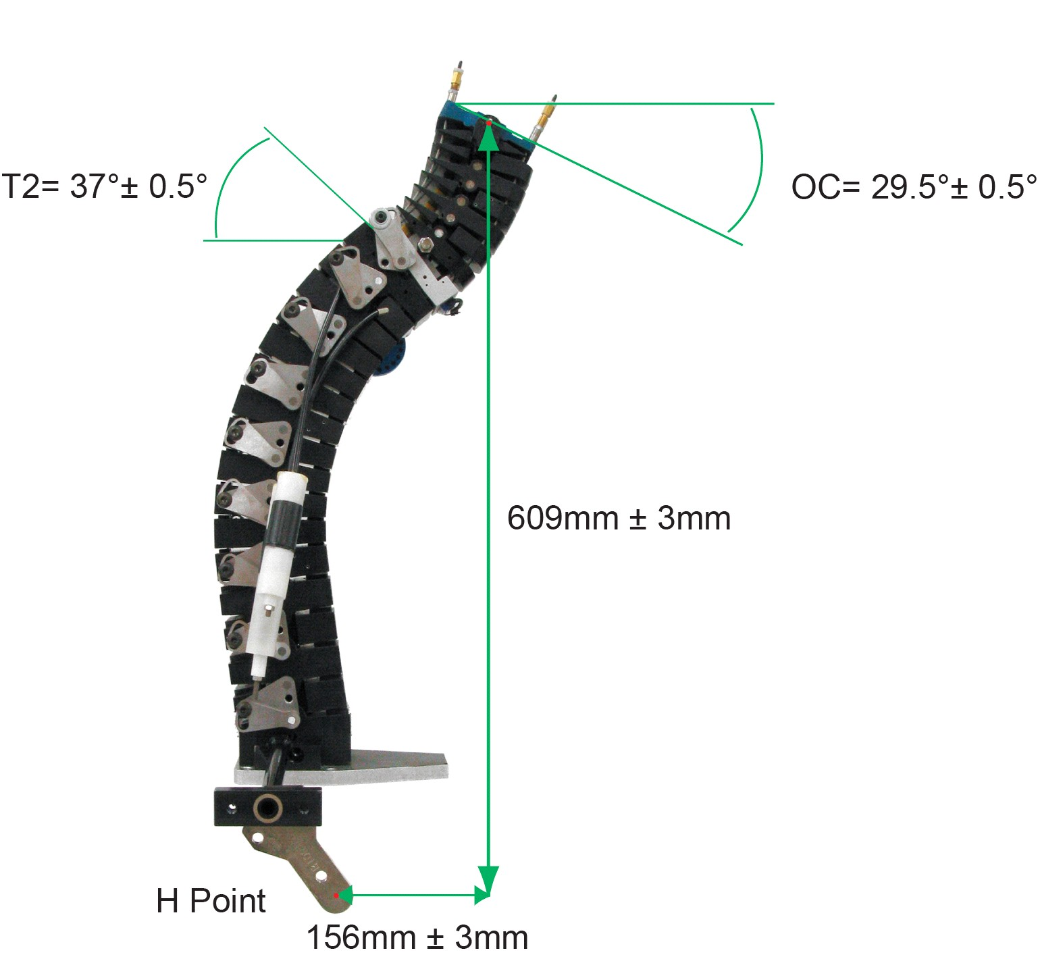

Spine Curvature Check
Table : Spine Curvature Specifications

Measurement | Specification
Angle of occipital interface plate relative to horizontal | 29.5°± 0.5°
Angle of T2 vertebra relative to horizontal | 37.0°± 0.5°
Angle of neck plate (lateral) | 0°± 0.5°
H-point indicator to occipital condyle pin (horizontal) | 156 mm ± 3mm
H-point indicator to occipital condyle pin (vertical) | 609 mm ± 3mm

2.2.2.2 Calibration – The dynamic response of BioRID is checked by attaching the spine, torso and head to a mini-sled that is impacted through foam by a 33.4 kg probe and a velocity of 4.76±0.1 m/s. The specified response of the dummy and detailed test specifications are described in Test Procedure: Calibration of BioRID II available from Denton ATD, Inc. Generally, if the dummy’s spine curvature changes so that it does not meet the dimensional specifications described in section 2.2.2.1, then likely it will no longer meet the dynamic response specifications.

2.2.2.4 Instrumentation – The instrumentation required to perform the evaluation is a triaxial accelerometer located at the CoG of the dummy head and the upper neck load force sensor located at the top of the dummy spine.

2.2.2.5 Data Acquisition and Processing – The measurement data shall be recorded according to ISO 6487 or SAE J211/1. Table below specifies the channel frequency classes for each necessary measurement. Measurement data shall be considered for evaluation until the point in time at which the head leave the contact from the head restraint or at 300 ms after T-zero, whichever occurs first.
Position | Measurement | Filtering
Head X | Acceleration | CFC 60
Head Y | Acceleration | CFC 1000
Head Z | Acceleration | CFC 1000
Neck Load Force X | Force | CFC 1000

2.3. Equipment for measuring and recording sled accelerations.
3. Procedures for test set-up.

3.1. Mount the vehicle on a dynamic test platform so that the longitudinal centreline of the vehicle is parallel to the direction of the test platform travel and so that movement between the base of the vehicle and the test platform is prevented. Instrument the platform with an accelerometer and data processing system. Position the accelerometer sensitive axis parallel to the direction of test platform travel.
3.2. Remove the tires, wheels, fluids, and all unsecured components. Remove or rigidly secure the engine, transmission, axles, exhaust, vehicle frame and any other vehicle component necessary to assure that all points on the acceleration vs. time plot measured by an accelerometer on the dynamic test platform fall within the corridor described in Figure 8-1 and Table 8-1.
3.3. Place any moveable windows in the fully open position.
3.4. Seat Adjustment. At each designated seating position, using any control that primarily moves the entire seat vertically, [place the seat in the mid position]. Using any control that primarily moves the entire seat in the fore and aft directions, place the seat midway between the forwardmost and rearmost position. If an adjustment position does not exist midway between the forwardmost and rearmost positions, the closest adjustment position to the rear of the midpoint is used. Adjust the seat cushion and seat back,to [manufacturers specified design position]. If the specified position of the [H-point][R-point] can be achieved with a range of seat cushion inclination angles, adjust the seat inclination such that the most forward part of the seat cushion is [at its lowest position] with respect to the most rearward part. If the head restraint is adjustable, adjust the top of the head restraint to a position midway between the lowest position of adjustment and the highest position of adjustment. If an adjustment position midway between the lowest and the highest position does not exist, adjust the head restraint to a position below and nearest to midway between the lowest position of adjustment and the highest position of adjustment. Adjustable lumbar supports are positioned so that the lumbar support is in its lowest position.
3.5. Seat Belt Adjustment. Prior to placing the seat belt around the test dummy, fully extend the webbing from the seat belt retractor(s) and release it three times to remove slack. If an adjustable seat belt D-ring anchorage exists, place it in the adjustment position closest to the mid-position. If an adjustment position does not exist midway between the highest and lowest position, the closest adjustment position above the midpoint is used.
3.6. Dress and adjust each test dummy as follows:
3.6.1 Each Hybrid III test dummy is clothed in a form fitting cotton stretch short sleeve shirt with above-the-elbow sleeves and above-the-knee length pants. The weight of the shirt or pants shall not exceed 0.06 kg each. Each foot of the Hybrid III test dummy is equipped whose weight is 0.51 ±0.09 kg.
Limb joints are set at 1g, barely restraining the weight of the limb when extended horizontally. Leg joints are adjusted with the torso in the supine position.
3.6.2 Each BioRID II test dummy should be dressed with two pairs of close-fitting, knee-length, spandex (e.g. lycra) pants and two close-fitting, short-sleeved spandex shirts. The under layer of clothes should be worn with the shiny/smooth side of the fabric facing out and the over-clothes with the shiny/smooth side against the underclothes (i.e. dull side facing out). In addition, the dummy may wear a short-sleeved cotton shirt over its spandex shirts. The dummies feet should be shod with size 11 (45 European or 27.9 cm) Oxford-style, hard-soled, work shoes (e.g. MIL-S-13192P).
3.7. Hybrid III Test dummy positioning procedure. Place a test dummy at each designated seating position equipped with a head restraint.
3.7.1. Head. The transverse instrumentation platform of the head is level within 1/2 degree. To level the head of the test dummy, the following sequence is followed. First, adjust the position of the H point to level the transverse instrumentation platform of the head of the test dummy. If the transverse instrumentation platform of the head is still not level, then adjust the pelvic angle of the test dummy. If the transverse instrumentation platform of the head is still not level, then adjust the neck bracket of the dummy the minimum amount necessary from the non-adjusted “0” setting to ensure that the transverse instrumentation platform of the head is horizontal within 1/2 degree. The test dummy remains within the limits specified in Footnote 2 after any adjustment of the neck bracket.
3.7.2. Upper arms and hands. Position each test dummy as specified below:
3.7.2.1.The driver's upper arms shall be adjacent to the torso with the centrelines as close to a vertical plane as possible.
3.7.2.2. The passenger's upper arms shall be in contact with the seat back and the sides of the torso.
3.7.2.3. The palms of the drivers test dummy shall be in contact with the outer part of the steering wheel rim at the rim's horizontal centreline. The thumbs shall be over the steering wheel rim and shall be lightly taped to the steering wheel rim so that if the hand of the test dummy is pushed upward by a force of not less than 2 pounds and not more than 5 pounds, the tape shall release the hand from the steering wheel rim.
3.7.2.4 The palms of the passenger test dummy shall be in contact with the outside of the thigh. The little finger shall be in contact with the seat cushion.
3.7.3. Upper Torso. Position each test dummy such that the upper torso rests against the seat back. The midsagittal plane of the dummy shall be aligned within 15 mm of the head restraint centreline. If the midsagittal plane of the dummy cannot be aligned within 15 mm of the head restraint centreline then align the midsagittal plane of the dummy as close as possible to the head restraint centreline.
3.7.4. Lower Torso. The H-points of the driver and passenger test dummies shall coincide within 13 mm in the vertical dimension and 13 mm in the horizontal dimension of a point 6.5 mm below the position of the H-point determined by the manikin defined in annex 11.
3.7.5. Pelvic Angle. As determined using the pelvic angle gage which is inserted into the H-point gaging hole of the dummy, the angle measured from the horizontal on the 76 mm flat surface of the gage shall be 22.5 ± 2.5 degrees.
3.7.6. Legs. Position each test dummy as follows:
The upper legs of the driver and passenger test dummies shall rest against the seat cushion to the extent permitted by placement of the feet. The initial distance between the outboard knee clevis flange surfaces shall be 269 mm. To the extent practicable, the left leg of the driver dummy and both legs of the passenger dummy shall be in vertical longitudinal planes. To the extent practicable, the right leg of the driver dummy shall be in a vertical plane. Final adjustment to accommodate the placement of feet in various passenger compartment configurations is permitted.
3.7.7. Feet.
3.7.7.1 Driver’s position.
3.7.7.1.1. If the vehicle has an adjustable acceleration pedal, adjust it to the full forward position. Rest the right foot of the test dummy on the undepressed accelerator pedal with the rearmost point of the heel on the floor pan in the plane of the pedal. If the foot cannot be placed on the accelerator pedal, set it initially perpendicular to the lowest leg and then place it as far forward as possible in the direction of the pedal centreline with the rearmost point of the heel resting on the floor pan. If the vehicle has an adjustable accelerator pedal and the right foot is not touching the accelerator pedal when positioned as above, move the pedal rearward until it touches the right foot. If the accelerator pedal still does not touch the foot in the full rearward position, leave the pedal in that position.
3.7.7.1.2. Place the left foot on the toeboard with the rearmost point of the heel resting on the floor pan as close as possible to the point of intersection of the planes described by the toeboard and the floor pan and not on the wheelwell projection. If the foot cannot be positioned on the toeboard, set it initially perpendicular to the lower leg and place it as far forward as possible with the heel resting on the floor pan. If necessary to avoid contact with the vehicle's brake or clutch pedal, rotate the test dummy's left foot about the lower leg. If there is still pedal interference, rotate the left leg outboard about the hip the minimum distance necessary to avoid the pedal interference. For vehicles with a foot rest that does not elevate the left foot above the level of the right foot, place the left foot on the foot rest so that the upper and lower leg centrelines fall in a vertical plane.
3.7.7.2 Front Passenger's position.
3.7.7.2.1 Vehicles with a flat floor pan/toeboard. Place the right and left feet on the vehicle's toeboard with the heels resting on the floor pan as close as possible to the intersection point with the toeboard. If the feet cannot be placed flat on the toeboard, set them perpendicular to the lower leg centrelines and place them as far forward as possible with the heels resting on the floor pan.
3.7.7.2.2 Vehicles with wheelhouse projections in passenger compartment. Place the right and left feet in the well of the floor pan/toeboard and not on the wheelhouse projection. If the feet cannot be placed flat on the toeboard, initially set them perpendicular to the lower leg centrelines and then place them as far forward as possible with the heels resting on the floor pan.
3.7.7.3. Rear Passenger’s position. Position each test dummy as specified in paragraph 2.7.7.2 of this annex, except that feet of the test dummy are placed flat on the floorpan and beneath the front seat as far forward as possible without front seat interference. If necessary, the distance between the knees can be changed in order to place the feet beneath the seat.
3.8 Biorid II : positioning procedure

3.8.1 Set the head restraint to the test position and measure the head to head restraint distance using the HRMD backset probe and marking the head restraint at the point of contact with the backset probe.

    - Remove the HRMD and SAE J826 mannequin, then install BioRID in the subject seat:

      - The H-Point of the BIORID should be located 20mm forward (± 10mm) and 6 mm below (± 10mm) the location recorded in step 2.

      - The pelvis angle should be 26.5° from horizontal (± 2.5°).

      - The instrumentation plane of the head should level (± 1°).

      - The distance between the head restraint and the back of the head (backset) should be 15mm greater (± 5mm) than the backset recorded in section 3 when measured horizontally from the marked point of contact for the HRMD backset probe.

      - The centre line of the knees and ankles should be to 200mm (± 10mm) apart.

      - The upper arms should be in contact with the seat back with elbows bent so that small fingers of both hands are in contact with the vehicle seat and the palms are facing the dummy’s thighs. Attaching the dummy hands to the steering control is not recommended.

      - The BioRID should be set-up taking advantage of the tolerance bands for pelvis angle and H-point location in order to minimise the difference between actual and target backset. Use of the backset tolerance should be undertaken once all other tolerance values are used.

      - Other seat adjustment variables, dummy feet positioning, safety belt usage and positioning should be referenced to the appropriate test procedure.

BioRID SetUp Summary

Location | Measure | Tolerance
H-Point (X-axis) | +20mm (Forward) | ± 10mm
H-Point (Z-axis) | +6mm (Lower) | ± 10mm
Pelvis Angle | 26.5° | ± 2.5°
Head Plane | 0° (Level) | ± 1°
Back Set | +15mm (Forward) | ± 5mm

4.1. Accelerate the dynamic test platform to 17.3 ± 0.6 km/h. All of the points on the acceleration vs. time curve fall within the corridor described in Figure 8.1 and Table 8.1 when filtered to channel class 60, as specified in the [SAE Recommended Practice J211/1 (rev. Mar 95)]. Measure the maximum posterior angular displacement.
4.2 [An active head restraint is to be activated at _X_ms ± x ms from the time that 0.25 g is measured on the dynamic test platform.]
5.1. Calculate the angular displacement from the output of instrumentation placed in the torso and head of the test dummy and an algorithm capable of determining the relative angular displacement to within one degree and conforming to the requirements of a 600 Hz channel class, [as specified in SAE Recommended Practice J211/1, (rev. Mar 95)]. No data generated after 200 ms from the beginning of the forward acceleration are used in determining angular displacement of the head with respect to the torso.
5.2. Calculate the HIC₁₅ from the output of instrumentation placed in the head of the test dummy, using the equation in paragraph 5.3.3. of this regulation and conforming to the requirements for a 1000 Hz channel class as specified in [SAE Recommended Practice J211/1 (rev. Mar 95)]. No data generated after 200 ms from the beginning of the forward acceleration are used in determining HIC.

Reference Point | Time (ms) | Acceleration (m/s²)
A | 0 | 10
B | 28 | 94
C | 60 | 94
D | 92 | 0
E | 4 | 0
F | 38.5 | 80
G | 49.5 | 80
H | 84 | 0

Table 8.1 – Sled pulse corridor reference point locations.

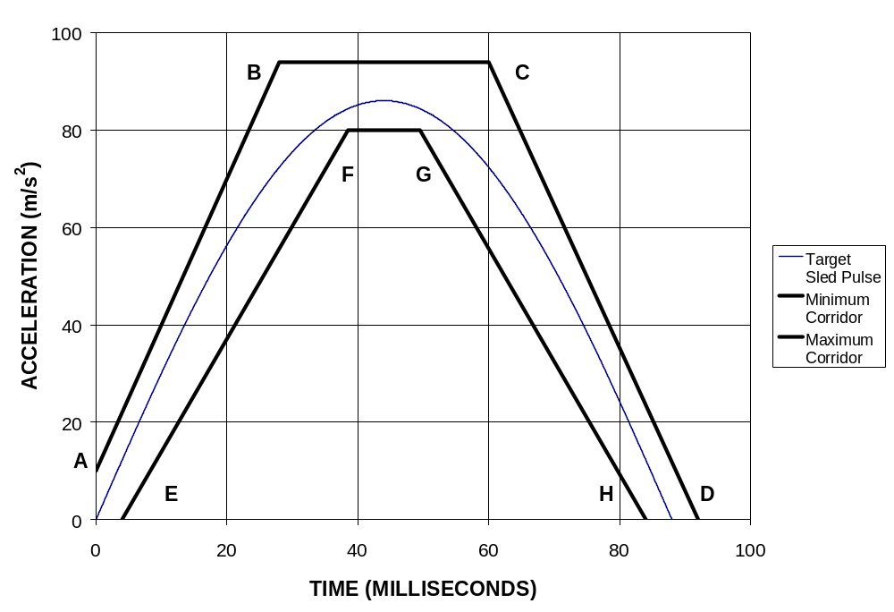

Figure 8.1 - Sled pulse acceleration corridor. The target acceleration with time expressed in milliseconds is a = 86 Sin(πt/88) m/s², for V = 17.3 ± 0.6 km/h. The time zero for the test is defined by the point when the sled acceleration achieves 2.5 m/s² (0.25 G’s).

Annex 9
Non-use position Test Procedure
1. Purpose. Procedures for folding or retracting head restraints in all designated seating positions equipped with head restraints, except the driver’s designated seating position.
2. Procedures to test automatic return head restraints. Demonstrate compliance with paragraph 5.4.3.1, with the ignition “on”, and using a 5th percentile female Hybrid III test dummy in accordance with paragraph 2.1. of this annex, or a human surrogate in accordance with paragraph 2.2. of this annex. Compliance shall be determined at a temperature of 21°C to 22°C.
2.1. 5th percentile Hybrid III Dummy.
2.1.1. Position the test dummy in the seat such that the dummy's midsaggital plane is aligned within the 15 mm of the seating position centreline and is parallel to a vertical plane parallel to the vehicle longitudinal centreline.
2.1.2. Hold the dummy’s thighs down and push rearward on the upper torso to maximize the dummy’s pelvic angle.
2.1.3. Place the legs as close as possible to 90 degrees to the thighs. Push rearward on the dummy’s knees to force the pelvis into the seat so there is no gap between the pelvis and the seat back or until contact occurs between the back of the dummy’s calves and the front of the seat cushion such that the angle between the dummy’s thighs and legs begins to change.
2.1.4. Note the position of the head restraint. Remove the dummy from the seat. If the head restraint returns to a retracted position upon removal of the dummy, manually place it in the noted position. Determine compliance with the height requirements of paragraph 5.1.1. by using the test procedures of annex 1.
2.2. Human surrogate. A human being who weighs between 47 and 51 kg, and who is between 140 and 150 cm tall may be used.
The human surrogate shall be dressed in a cotton T-shirt, full length cotton trousers, and sneakers. Specified weights and heights include clothing.
2.2.1. Position the human in the centre of the seat with the pelvis touching the seat back and the back against the seat back.
2.2.2. Verify the human’s midsagittal plane is vertical and within ± 15 mm of the seating position centreline.
2.2.3. Verify the transverse distance between the centres of the front of the knees is 160 to 170 mm. Centre the knee separation with respect to the seat centreline.
2.2.4. If needed, extend the legs until the feet do not contact the floor pan. The thighs are resting on the seat cushion.
2.2.5. If the human contacts the interior move the seat rearward until a maximum clearance of 5 mm is achieved or the seat is in the closest detent position which does not cause human contact.
2.2.6. Passenger foot positioning.
2.2.6.1. Place feet flat on the toe board, or
2.2.6.2. If the feet cannot be placed flat on the toe board, the feet are perpendicular to the lower leg, and the heel is as far forward as possible and resting on the floor pan, or
2.2.6.3. If the heels do not touch the floor pan, the legs are vertical and the feet parallel to the floor pan.
2.2.7. Passenger arm/hand positioning.
2.2.7.1. Place the human’s upper arms adjacent to the torso with the arm centrelines as close to a vertical longitudinal plane as possible.
2.2.7.2. Place the palms of the human in contact with the outer part of the thighs.
2.2.7.3. Place the little fingers in contact with the seat cushion.
2.8. Start the vehicle engine or place the ignition in the “on” position, whichever will turn on the suppression system, and close all vehicle doors. Wait 10 seconds, and then check whether the air bag is suppressed.
2.9. Return the ignition switch to the “off” position.
3. 60° Rotation evaluation. Procedures for the rear and front centre designated seating positions to demonstrate compliance with paragraph 5.4.3.2.

3.1. Place the head restraint in any position meeting the requirements of paragraph 5.1.1.2. or paragraph 5.1.1.4;
3.1.1. Mark a line on the head restraint with one end at the point of rotation. Measure the angle or range of angles of the head restraint reference line as projected onto a vertical longitudinal vehicle plane;
3.1.2. Fold or retract the head restraint to a position in which its minimum height is less than that specified in paragraph 5.1.2 or paragraph 5.1.4;
3.1.3. Determine the minimum change in the head restraint reference line angle as projected onto a vertical longitudinal vehicle plane from the angle or range of angles measured in paragraph 3.1.1. of this annex.
[4. Discomfort Metric. Procedures for the rear and front centre designated seating positions to demonstrate compliance with paragraph 5.4.3.3. of this regulation.
4.1. All lines, including the projection of the reference line, shall be drawn in the vertical median design torso reference plane of the seat, the intersection of such plane with the seat determining the contour of the head restraint and of the seat-back (see figure 9-1).
4.2. Adjust the head restraint to its non-use position.
4.3 Determine the height H_{LE} of the lower edge of the head restraint as shown in Figure 9-1.

4.4. The projection of the reference line of the manikin is then, in the seat concerned, drawn in the plane specified in paragraph 4.1. of this annex. The tangent T_{H} to the bottom of the head restraint is drawn perpendicular to the reference line.
4.5. The distance "H_{LE}" from the R-point to the tangent T_{H} is the height to be taken into consideration in implementing the requirements of paragraph 5.4.3.3. of this regulation.
4.6. Measure S at the lower edge of the head restraint as shown in Figure 9-1.
4.7. The projection of the reference line of the manikin is, in the seat concerned, drawn in the plane specified in paragraph 4.1 above. A tangent T_{S} is drawn above and parallel to the tangent T_{H}, as specified in paragraph 4.5, with a distance of not more than [25 mm] above. A parallel P to the torso reference line passing through the intersection of tangent T_{S} with the surface of the head restraint is drawn in the same plane. The distance “S”, measured perpendicular to the torso reference line, from parallel P to the surface of the seat back at this position is the thickness to be taken into consideration in implementing the requirements of paragraph 5.4.3.3. of this regulation.]

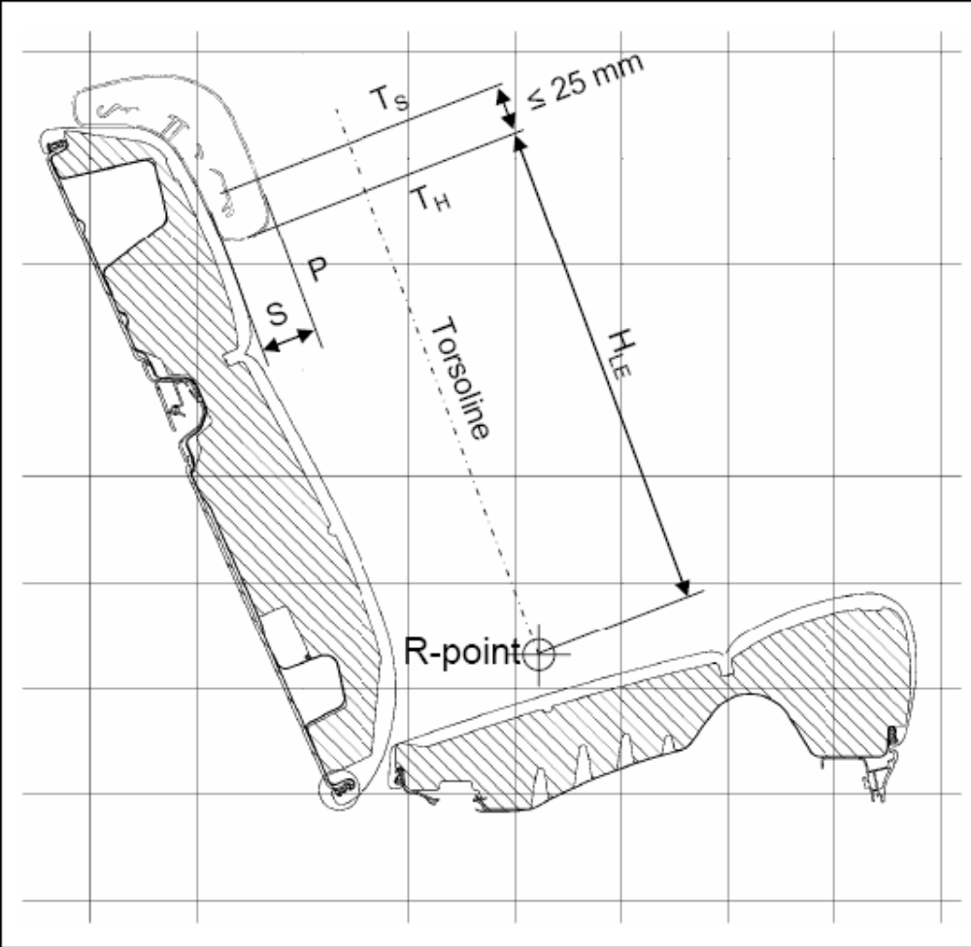
Figure 4

5. 10° Torso Reference Line Change. Procedures for the rear and front centre designated seating positions to demonstrate compliance with paragraph 5.4.3.4..
5.1. Place the head restraint into any position meeting the requirements of paragraph 5.4.3.4. of this regulation;
5.2. Measure the torso reference line angle with the three dimensional H-point machine defined in annex 11;
5.3. Fold or retract the head restraint to any position in which its minimum height is less than that specified in paragraph 5.1.1. of this regulation or in which its backset is more than that specified in paragraph 5.1.5 of this regulation; and
5.4. Again measure the torso reference line angle.

Annex 10
THREE-DIMENSIONAL REFERENCE SYSTEM

1. The three dimensional reference system is defined by three orthogonal planes established by the vehicle manufacturer (see figure 10-1). */
2. The vehicle measuring attitude is established by positioning the vehicle on the supporting surface such that the co ordinates of the fiducial marks correspond to the values indicated by the manufacturer.
3. The coordinates of the "R" point and the "H" point are established in relation to the fiducial marks defined by the vehicle manufacturer.

_______________
*/ The reference system corresponds to ISO standard 4130 : 1978.
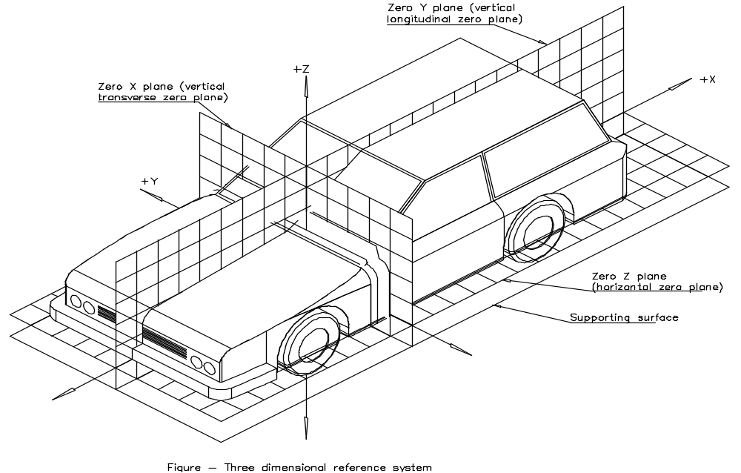
Figure 10-1 - Three-dimensional reference system

Annex 11
PROCEDURE FOR VALIDATION OF THE "H" POINT AND "R" POINT RELATIONSHIP FOR SEATING POSITIONS IN MOTOR VEHICLES

1. Purpose. The procedure described in this annex is used to establish the "H" point location and the actual torso angle for one or several seating positions in a motor vehicle and to verify the relationship of measured data to design specifications given by the vehicle manufacturer.
2. Definitions. For the purposes of this annex:
2.1. Reference data means one or several of the following characteristics of a seating position:
2.1.1. the "H" point and the "R" point and their relationship,
2.1.2. the actual torso angle and the design torso angle and their relationship.
2.2. Three dimensional 'H' point machine (3-D H machine) means the device used for the determination of "H" points and actual torso angles. This device is described in appendix 1 to this annex;
2.3. Centre plane of occupant (C/LO) means the median plane of the 3-D H machine positioned in each designated seating position; it is represented by the coordinate of the "H" point on the "Y" axis. For individual seats, the centre plane of the seat coincides with the centre plane of the occupant. For other seats, the centre plane of the occupant is specified by the manufacturer;
2.4. Three dimensional reference system means a system as described in annex 10;
2.5. Fiducial marks are physical points (holes, surfaces, marks or indentations) on the vehicle body as defined by the manufacturer;

2.6. Vehicle measuring attitude means the position of the vehicle as defined by the coordinates of fiducial marks in the three dimensional reference system.
3. Procedure For "H" Point And Actual Torso Angle Determination
3.1. The vehicle shall be preconditioned at a temperature of 20° ± 10° C to ensure that the seat material reaches room temperature.
3.2. The vehicle shall be at the measuring attitude defined in paragraph 2.6. of this annex.
3.3. The seat, if it is adjustable, shall be adjusted first to the rearmost normal driving position, as indicated by the vehicle manufacturer, taking into consideration only the longitudinal adjustment of the seat, excluding seat travel used for purposes other than normal driving positions. Where other modes of seat adjustment exist (vertical, angular, seat back, etc.) these will be then adjusted to the position specified by the vehicle manufacturer. For suspension seats, the vertical position shall be rigidly fixed corresponding to a normal driving position as specified by the manufacturer.
3.4. The area of the seating position contacted by the 3-D H machine shall be covered by a muslin cotton, of sufficient size and appropriate texture, described as a plain cotton fabric having 18.9 threads per cm² and weighing 0.228 kg/m² or knitted or non woven fabric having equivalent characteristics.

If the test is run on a seat outside the vehicle, the floor on which the seat is placed shall have the same essential characteristics (tilt angle, height difference with a seat mounting, surface texture, etc.) as the floor of the vehicle in which the seat is intended to be used.

3.5. Place the seat and back assembly of the 3-D H machine so that the centre plane of the occupant (C/LO) coincides with the centre plane of the 3-D H machine. At the manufacturer's request, the 3-D H machine may be moved inboard with respect to the C/LO if the 3-D H machine is located so far outboard that the seat edge will not permit levelling of the 3-D H machine.
3.6. Attach the foot and lower leg assemblies to the seat pan assembly, either individually or by using the T bar and lower leg assembly. A line through the "H" point sight buttons shall be parallel to the ground and perpendicular to the longitudinal centre plane of the seat.
3.7. Adjust the feet and leg positions of the 3-D H machine as follows:
3.7.1. In the case of front outboard seats:
3.7.1.1. Both feet and leg assemblies shall be moved forward in such a way that the feet take up natural positions on the floor, between the operating pedals if necessary. Where possible the left foot shall be located approximately the same distance to the left of the centre plane of the 3-D H machine as the right foot is to the right. The spirit level verifying the transverse orientation of the 3-D H machine is brought to the horizontal by readjustment of the seat pan if necessary, or by adjusting the leg and foot assemblies towards the rear. The line passing through the "H" point sight buttons shall be maintained perpendicular to the longitudinal centre plane of the seat.
3.7.1.2. If the left leg cannot be kept parallel to the right leg and the left foot cannot be supported by the structure, move the left foot until it is supported. The alignment of the sight buttons shall be maintained.

3.7.2. In the case of rear outboard seats:
For rear seats or auxiliary seats, the legs are located as specified by the manufacturer. If the feet then rest on parts of the floor which are at different levels, the foot which first comes into contact with the front seat shall serve as a reference and the other foot shall be so arranged that the spirit level giving the transverse orientation of the seat of the device indicates the horizontal.
3.7.3. In the case of other seats:
The general procedure indicated in paragraph 3.7.1. of this annex shall be followed except that the feet shall be placed as specified by the vehicle manufacturer.
3.8. Apply lower leg and thigh weights and level the 3-D H machine.
3.9. Tilt the back pan forward against the forward stop and draw the 3 D H machine away from the seat back using the T bar. Reposition the 3 D H machine on the seat by one of the following methods:
3.9.1. If the 3-D H machine tends to slide rearward, use the following procedure. Allow the 3-D H machine to slide rearward until a forward horizontal restraining load on the T bar is no longer required i.e. until the seat pan contacts the seat back. If necessary, reposition the lower leg.
3.9.2. If the 3-D H machine does not tend to slide rearward, use the following procedure. Slide the 3-D H machine rearwards by applying a horizontal rearward load to the T bar until the seat pan contacts the seat back (see figure 11-2 of appendix 1 to this annex).
3.10. Apply a 100 ± 10 N load to the back and pan assembly of the 3-D H machine at the intersection of the hip angle quadrant and the T bar housing. The direction of load application shall be maintained along a line passing by the above intersection to a point just above the thigh bar housing (see figure 11-2 of appendix 1 to this annex). Then carefully return the back pan to the seat back. Care must be exercised throughout the remainder of the procedure to prevent the 3 D H machine from sliding forward.
3.11. Install the right and left buttock weights and then, alternately, the eight torso weights. Maintain the 3-D H machine level.
3.12. Tilt the back pan forward to release the tension on the seat back. Rock the 3-D H machine from side to side through 10 degrees arc (5 degrees to each side of the vertical centre plane) for three complete cycles to release any accumulated friction between the 3 D H machine and the seat.
3.12.1. During the rocking action, the T bar of the 3-D H machine may tend to diverge from the specified horizontal and vertical alignment. The T bar must therefore be restrained by applying an appropriate lateral load during the rocking motions. Care shall be exercised in holding the T bar and rocking the 3-D H machine to ensure that no inadvertent exterior loads are applied in a vertical or fore and aft direction.
3.12.2. The feet of the 3-D H machine are not to be restrained or held during this step. If the feet change position, they should be allowed to remain in that attitude for the moment.
3.12.3. Carefully return the back pan to the seat back and check the two spirit levels for zero position. If any movement of the feet has occurred during the rocking operation of the 3-D H machine, they must be repositioned as follows:
3.12.4. Alternately, lift each foot off the floor the minimum necessary amount until no additional foot movement is obtained. During this lifting, the feet are to be free to rotate; and no forward or lateral loads are to be applied. When each foot is placed back in the down position, the heel is to be in contact with the structure designed for this.
3.12.5. Check the lateral spirit level for zero position; if necessary, apply a lateral load to the top of the back pan sufficient to level the 3 D H machine's seat pan on the seat.
3.13. Holding the T bar to prevent the 3-D H machine from sliding forward on the seat cushion, proceed as follows:
3.13.1. Return the back pan to the seat back;
3.13.2. Alternately apply and release a horizontal rearward load, not to exceed 25 N, to the back angle bar at a height approximately at the centre of the torso weights until the hip angle quadrant indicates that a stable position has been reached after load release. Care shall be exercised to ensure that no exterior downward or lateral loads are applied to the 3-D H machine. If another level adjustment of the 3-D H machine is necessary, rotate the back pan forward, re level, and repeat the procedure from paragraph 3.12. of this annex.
3.14. Take all measurements:
3.14.1. The coordinates of the "H" point are measured with respect to the three dimensional reference system.
3.14.2. The actual torso angle is read at the back angle quadrant of the 3-D H machine with the probe in its fully rearward position.
3.15. If a rerun of the installation of the 3-D H machine is desired, the seat assembly should remain unloaded for a minimum period of 30 minutes prior to the re run. The 3-D H machine should not be left loaded on the seat assembly longer than the time required to perform the test.
3.16. If the seats in the same row can be regarded as similar (bench seat, identical seats, etc.) only one "H" point and one "actual torso angle" shall be determined for each row of seats, the 3-D H machine described in appendix 1 to this annex being seated in a place regarded as representative for the row. This place shall be:
3.16.1. In the case of the front row, the driver's seat;
3.16.2. In the case of the rear row or rows, an outer seat.

Annex 11 - Appendix 1
DESCRIPTION OF THE THREE-DIMENSIONAL "H" POINT MACHINE */
(3-D H machine)

1. Back and seat pans. The back and seat pans are constructed of reinforced plastic and metal; they stimulate the human torso and thigh and are mechanically hinged at the "H" point. A quadrant is fastened to the probe hinged at the "H" point to measure the actual torso angle. An adjustable thigh bar, attached to the seat pan, establishes the thigh centreline and serves as a baseline for the hip angle quadrant.
2. Body and leg elements. Lower leg segments are connected to the seat pan assembly at the T bar joining the knees, which is a lateral extension of the adjustable thigh bar. Quadrants are incorporated in the lower leg segments to measure knee angles. Shoe and foot assemblies are calibrated to measure the foot angle. Two spirit levels orient the device in space. Body element weights are placed at the corresponding centres of gravity to provide seat penetration equivalent to a 76 kg male. All joints of the 3-D H machine should be checked for free movement without encountering noticeable friction.

___________________________
*/ For details of the construction of the 3-D H machine refer to Society of Automotive Engineers (SAE), 400 Commonwealth Drive, Warrendale, Pennsylvania 15096, United States of America. The machine corresponds to that described in ISO Standard 6549 : 1980.

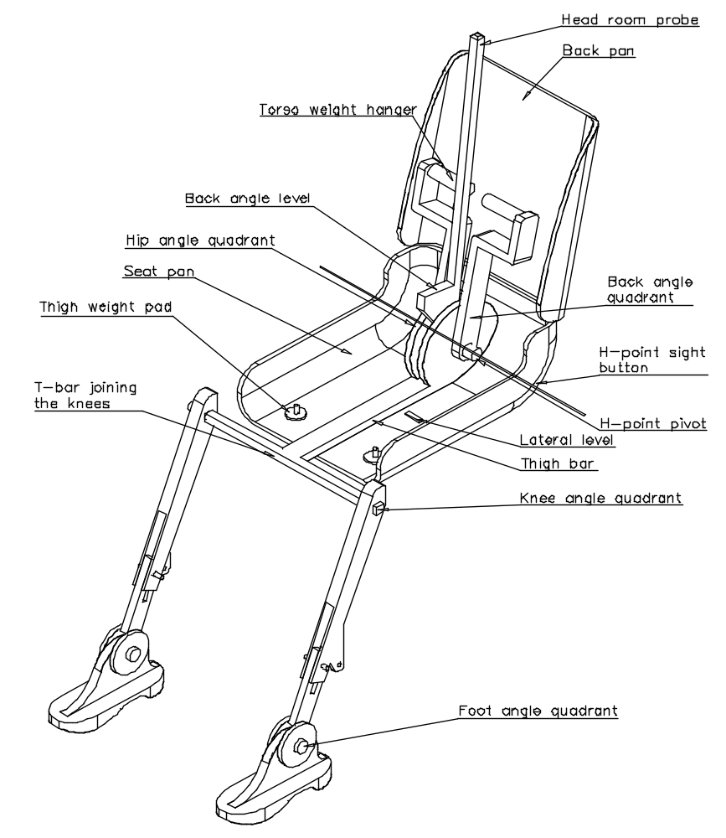
Figure 11-1 - 3-D H machine elements designation

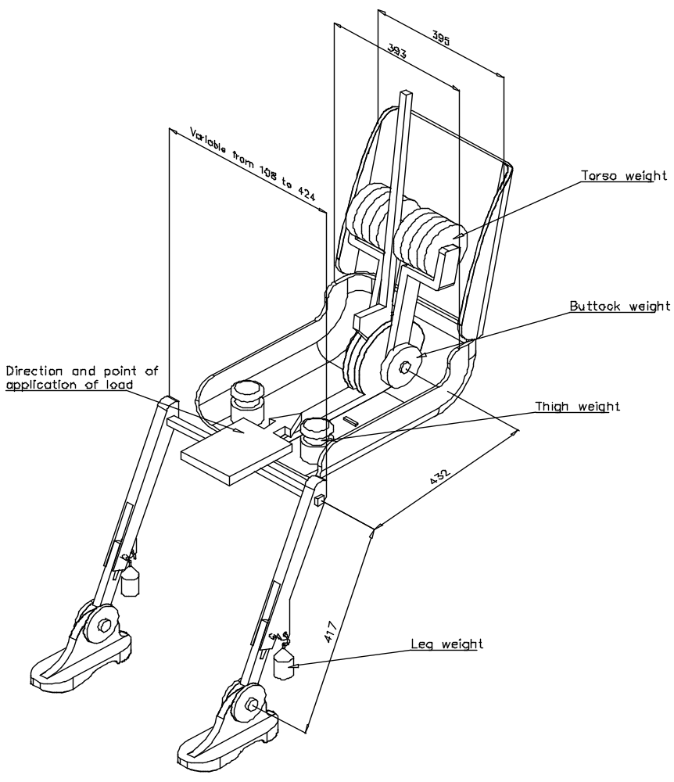
Figure 11-2 - Dimensions of the 3-D H machine elements and load distribution
(Dimensions in millimeters)

Annex 11 – Appendix 2
Head Restraint Measuring Device

1. Purpose. Set-up of the head restraint measuring device to measure backset using the H-point as the initial reference point.
2. Procedures for set-up.
2.1. Remove the head room probe from the three-dimensional H-point machine.
2.2. Set up H-point machine as described in annex 11, paragraphs 3.4. through 3.10..
2.3. Install the right and left buttock weights. Install four of the torso weights used in annex 11, paragraph 3.11, and the two larger HRMD chest weights; alternating left to right. The HRMD torso weights shall be installed last and with the flat side down.
2.4. Attach the HRMD head form (as shown in figure 11-3) to the three-dimensional H-point point machine.
2.5. The head form portion of the HRMD shall be levelled by loosening the rear knob and repositioning the head using the incorporated bubble level; the knob shall then be re-tightened by hand.

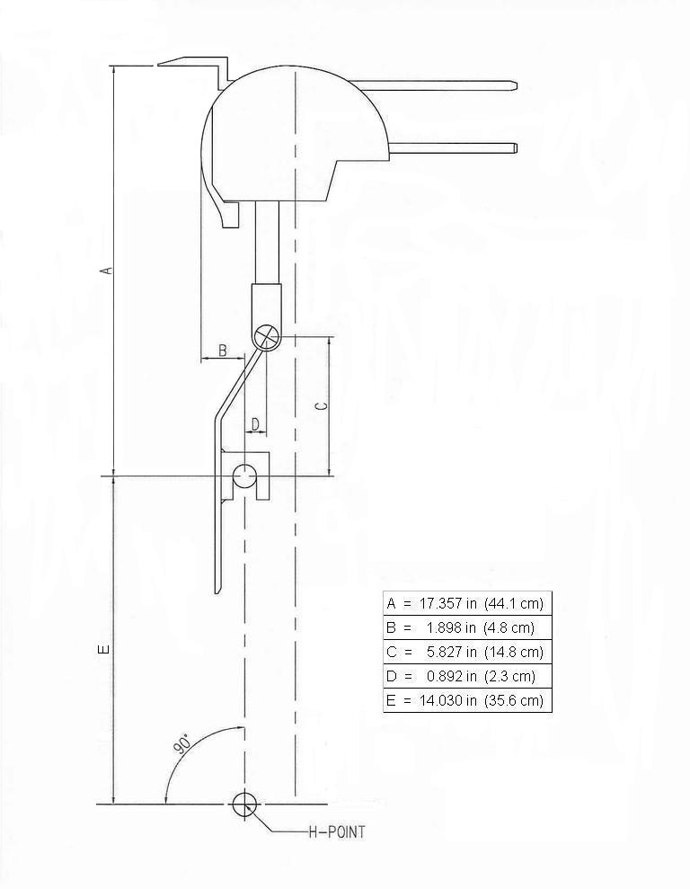
Figure 11-3
Annex 12
BioRID II

BIORID II is DENTON ATD property.

[? The H-points of the driver and passenger test dummies shall coincide within 1/2 inch in the vertical dimension and 1/2 inch in the horizontal dimension of a point 1/4 inch below the position of the H-point determined by using the equipment and procedures specified in SAE J826 (APR 1980) except that the length of the lower leg and thigh segments of the H-point machine shall be adjusted to 16.3 and 15.8 inches, respectively, instead of the 50th percentile values specified in Table 1 of SAE J826.]
http://ecfr.gpoaccess.gov/cgi/t/text/text-idx?c=ecfr&sid=f71ca7d062d9b2fa66b9ddb3fec6e0e3&rgn=div5&view=text&node=49:5.1.2.3.36&idno=49#49:5.1.2.3.36.2.4.64.

