PROPOSAL FOR AMENDMENT TO REGULATION NO. 17
(Strength of Seats)

Transmitted by the expert from Consumers’ International

‘TEST PROCEDURE FOR DEVICES INTENDED TO PROTECT

THE OCCUPANTS AGAINST DISPLACEMENT OF LUGGAGE’

Background
Test work, carried out by TRL (ESV paper 332/Amsterdam, 2001) and ANEC (Technical Report, 2003), has revealed that weaknesses of the rear seat backs in cars can cause serious or even fatal injuries for occupants not only in the rear of a car.
Although annex 9 to Regulation No. 17 is in place for new car models from 2000, and for all new cars from 2002, there is still room for improvement.
The test described in annex 9 consists of a dynamic test on a test bench, with two 17kg blocks in the boot. The pulse is the same as in Regulation No. 44 (child restraints): with a peak deceleration of 20 to 28g. The test mainly controls the forward movement of the rear seat back.
Consumers International would like to draw the meetings’ attention to the following issues that are currently not covered by this regulation:
- Wearing a seat belt (also in the back of the car) is obligatory in many countries nowadays. Yet, the rear seat back test in Regulation No. 17 does not include passenger dummies on rear seats, and the pass/fail criteria mainly relate to the forward movement of the backrest. Accident studies report of occupants being squeezed between their seat belt preventing them from moving forward and a backrest that is pushed forward by the luggage in the boot. TRL mimicked this mechanism by carrying out the tests of Regulation No.17 with belted rear occupants on the back seats. Belt loads were considerable and stronger seat backs were recommended.
- The European New Car Assessment Program (EuroNCAP) generates comparative test results on the crash safety of cars. Since its start in 1997, this program has had a big influence on the safety design of passenger cars. As the program carries out more severe (and more realistic) frontal impacts than the EU Directive requires, car manufacturers had to improve the design of their cars in order to improve their ratings. Under the influence of EuroNCAP, passenger compartments of cars became stronger. But these stronger car bodies can generate higher pulses in frontal impacts, leading to increased forces on seat belts and occupants. Moreover, other energy absorbing parts, like the backrest that is loaded by luggage in the boot, will have to withstand higher forces due to the bigger amount of energy of the luggage. Summing up: EuroNCAP influences car design, but not in the luggage area (yet).
- The test of Regulation No. 17 does not take into account the luggage capacity of the car. The same 2x17 kg mass is used for small and big booted cars and much below the maximal allowable load. Family cars for instance are permitted to carry several hundreds of kilograms in the boot plus occupants on all seats.
The ANEC Test
Based on the findings summarised above, ANEC performed in 2002/2003 tests that highlighted the differences between the mild legislative requirements and more realistic accident situations. These tests also highlighted the differences in rear seat design in current production cars. Two car bodies (robust and less robust design) underwent two tests, the first using the pulse and luggage prescribed in Regulation No. 17, and the second using the EuroNCAP pulse for the particular vehicle and an amount of luggage that is more in line with capacity of the cars (four small suitcases - weighing a total of 90 kg). In all tests, child and small adult dummies were seated in the back of the car and dummy and belt loads were measured.
The tests show that rear seats are rarely strong enough to fully withstand the force from luggage placed in the boot of a car that is thrown forward when the vehicle is involved in a frontal impact.
Even when luggage is well below the maximum recommended by carmakers, it can knock the rear seats forward during a frontal impact, the tests revealed. And once the luggage is thrown forward, it can hit car passengers with lethal force, as sadly shown in accident reports. Flying luggage can even threaten occupants in front seats.
Applying the EuroNCAP test specifications for frontal impact, which impacts the vehicles at 64 km/h, the ANEC crash test showed that the hinges holding the seats in place would be released or broken. The test illustrated situations in which the loading of the occupants was needlessly increased as the luggage forced the seat back forwards in the crash. In one of the tests, the luggage itself broke into the passenger compartment, potentially threatening other occupants.
Consumers International Proposal
Based on above stated, UNECE GRSP is asked to strengthen Regulation No. 17 for rear seat strength. As consumers have a right to expect the strength of the barrier between the luggage compartment and the passenger compartment to be sufficient to keep additional loading from luggage away from the occupants, Consumers International proposes to agree on the following starting points for improving Regulation No. 17, annex 9:
Making the test and the test criteria more realistic:
- A (more demanding) test pulse that is relevant to serious injury accidents in that vehicle model will be used
- Introduction of belted rear seat occupants
- Consideration of the luggage capacity of the vehicle
- Additional criteria (like maximum belt load) to be defined
For the next GRSP-session more detailed proposals can be drafted, taking on board the outcome of the initial discussion, based on this document.

TOUGHER BACK SEAT SAFETY STANDARDS NEEDED

Rear seats in cars need to be improved to ensure the safety of passengers, the consumer rights group ANEC urged today as it published the results of its crash tests. The tests show that rear seats are rarely strong enough to fully withstand the force from luggage placed in the boot of a car that is thrown forward when the vehicle is involved in a frontal impact. | 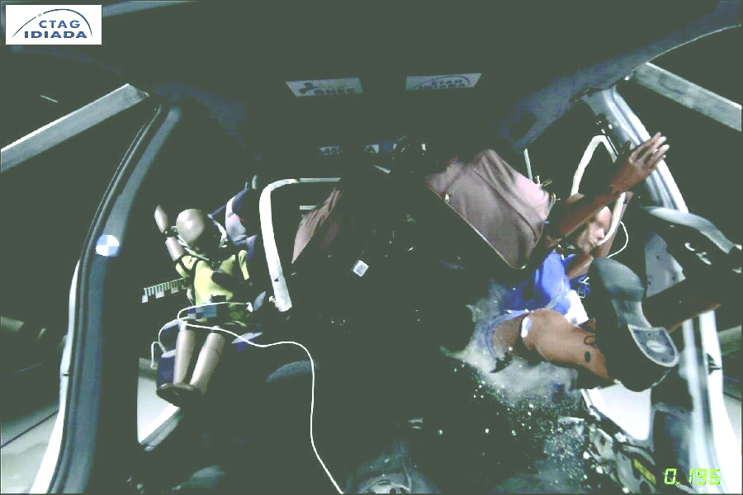
Even when luggage is well below the maximum recommended by carmakers, it can knock the rear seats forward during a frontal impact, the tests reveal. And once the luggage is thrown forward, it can hit car passengers with lethal force, as sadly shown in accident reports. Flying luggage can even threaten occupants in front seats.
“These tests prove that the current standards are simply not enough to guarantee the safety of passengers in the back seats of an average vehicle,” said ANEC Secretary-General Gottlobe Fabisch. “Consumers have a right to expect the strength of the barrier between the luggage compartment and the passenger compartment to be strong enough to protect them from luggage. Unless basic safety requirements are fitted into new vehicles in Europe, passengers – and in particular children – will be exposed to an unnecessary risk in the event of a frontal-impact accident.”
The current European Union standards on rear seats are based automatically on those drafted by the United Nations Economic Commission for Europe (UN ECE). But the UN ECE Regulation No. 17 on rear seat strength testing is too weak to cope, the ANEC tests show.
ANEC tests were conducted using the mild UN ECE-R17 standard, and a more realistic specifications, as seen in the European New Car Assessment Program (EuroNCAP). EuroNCAP has already had major success in influencing other aspects of car safety, but although it has conducted frontal impact crashes, so far they have never included luggage simulation.
The crash tests for ANEC used cars with split foldable rear seats, and placed four small suitcases - weighing a total of 90kg - in the boot. Applying the EuroNCAP test specifications for frontal impact, which impacts the vehicles at 64km per hour, it was found the hinges holding the seats in place would be released or broken. The test illustrated situations in which the loading of the occupants was needlessly increased as the luggage forced the seat back forwards in the crash. In one test, the luggage itself broke into the passenger compartment, potentially threatening other occupants.
ANEC says the relevant UN and EU committees responsible for rear seat legislation should ensure that safety provisions are strengthened. And the EuroNCAP Assembly and Technical Working Group should consider how its influence could be used to improve this area of design.
As for carmakers, their rear seats should be designed with some reflection of the luggage capacity of the vehicle. And ANEC warns that until car manufacturers improve the strength of their rear seat backrests, consumers should try to limit their risks by:
- placing heavy luggage on the boot floor, as close as possible against the backrest;
- tying down luggage with strong ropes, using the fixing lugs in your car, to keep the luggage in place during an impact.
- closing seat belts when there are no rear passengers, as they may help to keep the backrest in place, thus protecting front occupants.
ANEC is the European Association for the co-ordination of consumer representation in standardisation. With more than 150 consumer experts and many consumer representatives attending the work of European standards committees, ANEC is also directly represented in the three European standards bodies (CEN, CENELEC and ETSI). ANEC is financed by the European Commission and EFTA.
The ANEC Traffic Safety Working Group tries to influence car safety standards from the consumer point of view. Over the years the group has successfully pushed for improved standards, including frontal and side impact regulations for passenger cars, and regulations governing seat belts and child restraints.

Testing of Rear Seat Strength in Cars
February 2003
Prepared by Ronald Vroman (Consumentenbond),
Peter Gloyns (VSC), James Roberts (VSC)
on behalf of ANEC

Table of Contents
European Association for the Co-ordination of Consumer Representation in Standardisation, AISBL
Av. de Tervueren 36, box 4 – B-1040 Brussels, Belgium - phone +32-2-743 24 70 - fax +32-2-706 54 30
e-mail: anec@anec.org - internet: www.anec.org
ANEC2003/TRAF/005

Testing of Rear Seat Strength in Cars 5
Introduction 5
Summary 5
State of Affairs 5
Current Legislative Situation 5
TRL Study 6
EuroNCAP 6
Summing up 7
ANEC Tests 7
Description 7
Main Findings 8
‘R17’ tests 8
Realistic tests 9
Conclusions 10

Testing of Rear Seat Strength in Cars

Introduction
The ANEC Traffic Working Group tries to influence car safety standards from the consumer point of view. Over the years, the group has successfully pushed standards (often lowest common denominators to avoid trade barriers) to a higher level, generating higher levels of protection. Examples are the Frontal and Side Impact Regulations for passenger cars, the 03 revision of ECE 44 (Child Restraints)
More than once test experiences of consumer organisations were used to support the consumer position in standardisation discussions.
This test tries to highlight shortcomings in current legislation concerning rear seat strength in cars. By testing different designs of current production models we hope to demonstrate that in the existing car fleet there are differences in performance and that more demanding requirements are needed and achievable.

Summary
Accident studies indicate that a number of fatalities and serious injuries are caused by serious weaknesses of the rear seat back in cars. In October 2002, ANEC launched a research project whose findings confirm the danger that luggage can present to car occupants in the event of an accident. In one of the ANEC crash tests, the luggage actually broke the rear seats and was projected towards the front thus injuring the car occupants sitting in the back of car and possibly those sitting in the front too. The ANEC research project shows that there is an urgent need for more stringent regulations for rear seats.
The International Regulation on rear seat strength testing (UN ECE-R17) is not very demanding in terms of test criteria. In the ANEC crash test, we tested two cars (representing a robust and a less robust design) and carried out the test according to the international regulation as well as according to a more realistic test. In the realistic test, the crash pulse was higher (the same as in the EuroNCAP test on the car concerned) and there was more luggage in the boot of the car compared with the minimum luggage simulation in the regulation test. ANEC also placed (child and small female) dummies in the back of the car, in order to obtain some information about the danger for car occupants. High-speed films and digital pictures of the crash tests clearly demonstrate the danger that the luggage in the car boot presents to the car occupants in real life accidents.
ANEC will use the test results to lobby the European Commission, EuroNCAP and UN-ECE GRSP and WP29, the international committee dealing with car safety, in order to achieve more severe test specifications for rear seat strength.

State of Affairs

Current Legislative Situation
The only requirements for the strength of rear seat backs can be found in ECE Regulation17, ‘Approval of seats, anchorages and head restraints’.
This regulation includes a test to evaluate the strength of the seat back together with that of the hinges and latches of the backrest. This test was a compromise after lengthy debates in the responsible ECE bodies GRSP and WP29. Already at that time consumer organisations argued for more stringent rules, as accident statistics indicated injury risks.
The agreed test itself consists of a dynamic test on a test bench, with two 17kg blocks in the boot. The pulse is the same as in ECE 44 (child restraints): with a peak deceleration of 20 to 28g
Note that the legislative test does not include passengers (dummies) on the rear seat, does not take into account the luggage capacity of the car (same test for micro cars and large estates –(station wagons) small and big booted cars). Moreover the pass fail criteria for this test are mild: there are ONLY geometric requirements (relating to the backrest forward movement). Consumer groups always have been arguing that the requirements are not compatible with the space required by young children seated in the back.
A popular statement in car manufacturers circles in favour of this mild legislation is to declare that most of the time the boot of a car is empty and / or no rear passengers are sitting in the car, although they are quite happy to market the luggage carrying capacity from one vehicle over another. Consumer groups have the opinion that the car should be safe in any mode of operation it is designed for. It makes no sense to sell family cars that are not suitable for family use. As long as accident statistics clearly indicate shortcomings, and as long as we buy sacks of garden soil, flat-packed furniture or go camping with our family with a camping kit in the boot, appropriate safety measures must be there.
This part of ECE Regulation17 was introduced in 1998 and is applicable on new car models from August 2000, and on all new cars from August 2002

TRL Study

A study presented by the Transport Research Laboratory (TRL, UK) reports fatalities and seriously injured children due to failing backrests. Occupants are squeezed between their seat belt that prevents them from moving forward and the backrest that is pushed forward by the luggage in the boot.
This mechanism was mimicked in an R17 test procedure as described above, but additionally belted rear occupants were put on the back seats. This R17 testing with occupants showed considerable belt loads during the impact, which indicates increased injury risk. The study recommends stronger vehicle back seats, tougher criteria and the use of child seats (only CRS held in with the seat belts – which are not very good!) as long as possible as these reduce the risk of crushing from luggage loading.

EuroNCAP
The European New Car Assessment Program generates comparative test results on the crash safety of cars. Since it started in 1997, this program has had a big influence on the safety design of passenger cars. As the program carries out more severe (and more realistic) frontal impacts than the EU Directive requires, car manufacturers had to improve the design of their cars in order to improve their ratings. And they did: Under the influence of EuroNCAP passenger compartments of cars became stronger. But these stronger car bodies can generate higher pulses in frontal impacts, leading to increased forces on seat belts and occupants. Moreover, other energy absorbing parts, like the backrest that is loaded by luggage in the boot, will have to withstand higher forces due to the bigger amount of energy of the luggage.
For the problem area we are dealing with here, EuroNCAP does not deliver any benefits. The program does not take into account luggage in its crash specifications and ratings, and consequently manufacturers are not encouraged to improve.
Summing up

Summarising the actual situation we see that:
- There are worrying data from accident studies due to luggage loading of rear occupants
- Only a mild legislative test is carried out for type approval
- EuroNCAP influences car design, but not in the luggage area.

ANEC Tests

Description

Based on the findings summarised above, ANEC decided to perform some tests that would highlight the differences between the mild legislative requirements and more realistic accident situations, as well as differences in rear seat design in current production cars.
Therefore two car bodies were selected with an estimated robust and less robust design. Both cars were equipped with split folding backrests. The cars were ex-frontal impact Euro NCAP, but the relevant parts for this test were intact. Each car had to undergo two tests, first using the R17 prescribed pulse and luggage, and secondly using the EuroNCAP pulse for the particular vehicle and an amount of luggage that is more in line with capacity of the cars. The luggage in the realistic test consisted of sacks of garden soil, wrapped in little suitcases to protect the sacks from tearing during the impact. This is an amount of luggage that is well below the maximum weight allowed by the vehicle manufacturer, and not unrealistic when we observe a Saturday afternoon parking place of a garden centre. And comparable masses are loaded at DIY shops, furniture shops or airports etc.
In all tests child and small adult dummies were seated in the back of the car and dummy and belt loads were measured.

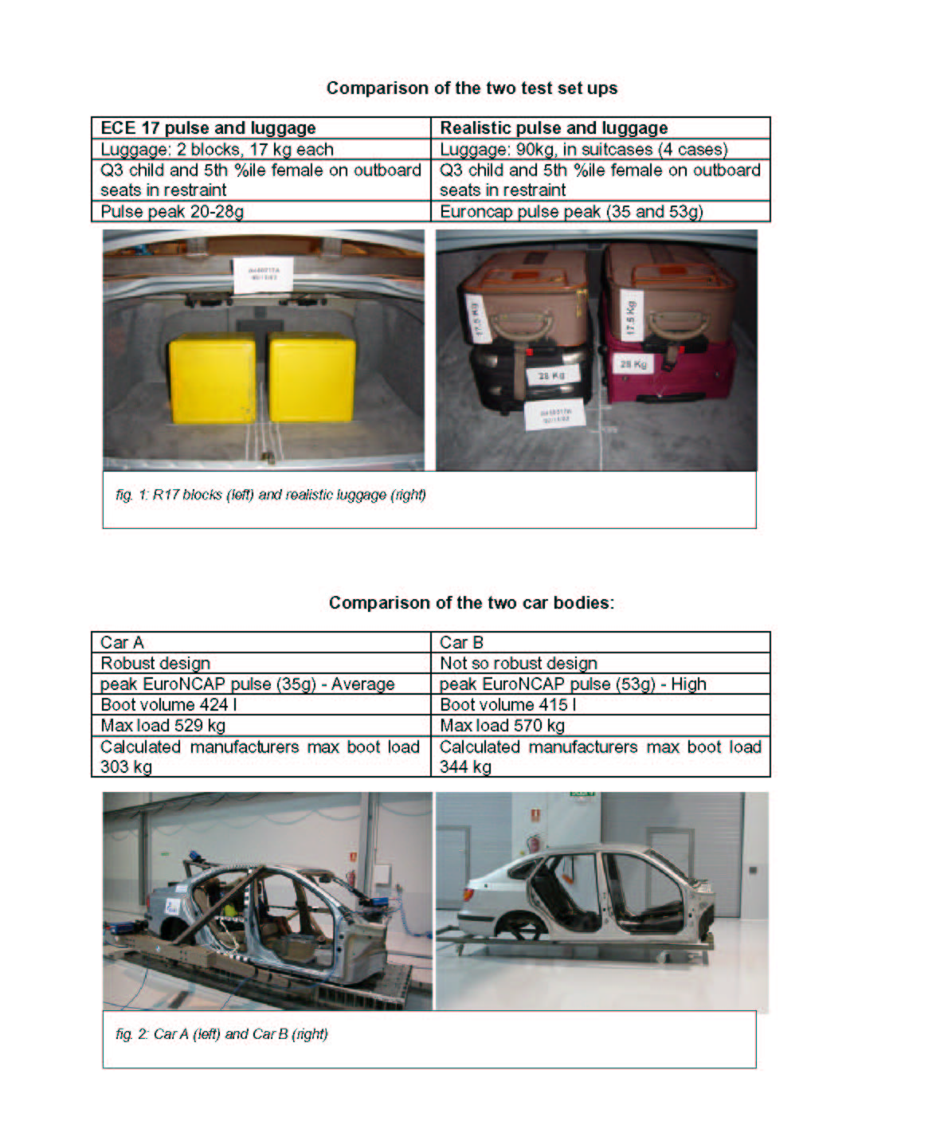

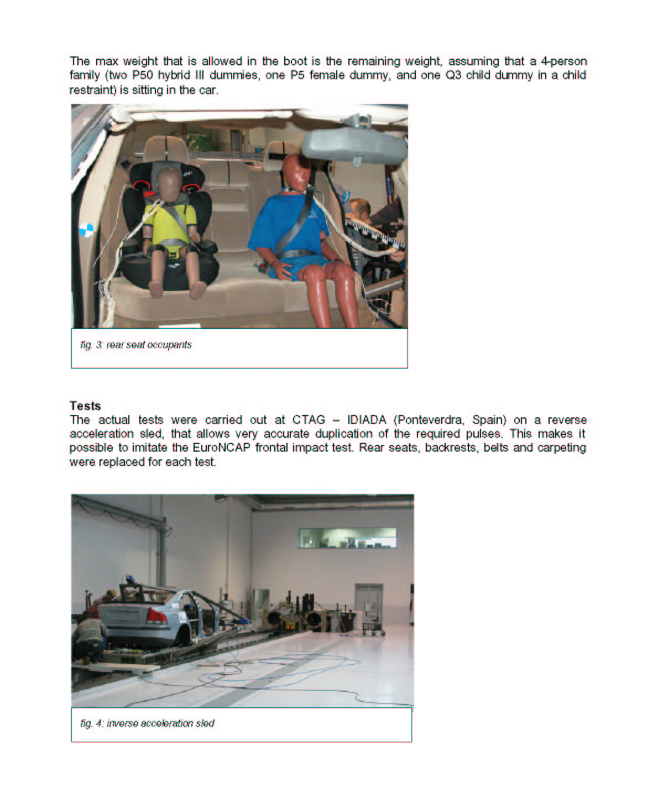

Main Findings

‘R17’ tests
The test on Car A using the Regulation 17 pulse and luggage blocks, illustrated a vehicle that could keep loading from luggage off all three rear seat occupants at this severity.
The equivalent test on Car B illustrated a situation in which the outboard occupants were again protected from additional loading from luggage. The centre rear seat position experienced the greatest seat back deflection induced by the luggage loading, but still it is probable that the deflection would not load either the AF5 or Q3 dummies in the centre position. The excursions of the dummies were still greater than that of the seat back. Even in this mild test the centre hinge was distorted
Analysis of the deflections of these seat backs at this severity, together with dummy excursions at pelvis and shoulder level, would allow comment on the excursion planes specified in R17. This information is not available at the moment, but will be included in the follow up of this project.
Realistic tests
The EuroNCAP pulse test, with realistic luggage, in Car A illustrated a situation in which a strong seat back section kept luggage loading off the AF5 dummy. Note this seat benefited from additional support provided by the stowed pre-tensioned centre rear belt. This could be used as a general example of how such loads can be controlled within current car design.
For Car A, the peak vehicle deceleration in the EuroNCAP test was 36% higher than that used in the R 17 test. The mass of the luggage load was 160% higher in the “realistic” test. The spacing between the luggage and the seat back was the same in both the realistic and R 17 tests. Even at this load, the car was well below its fully rated load.
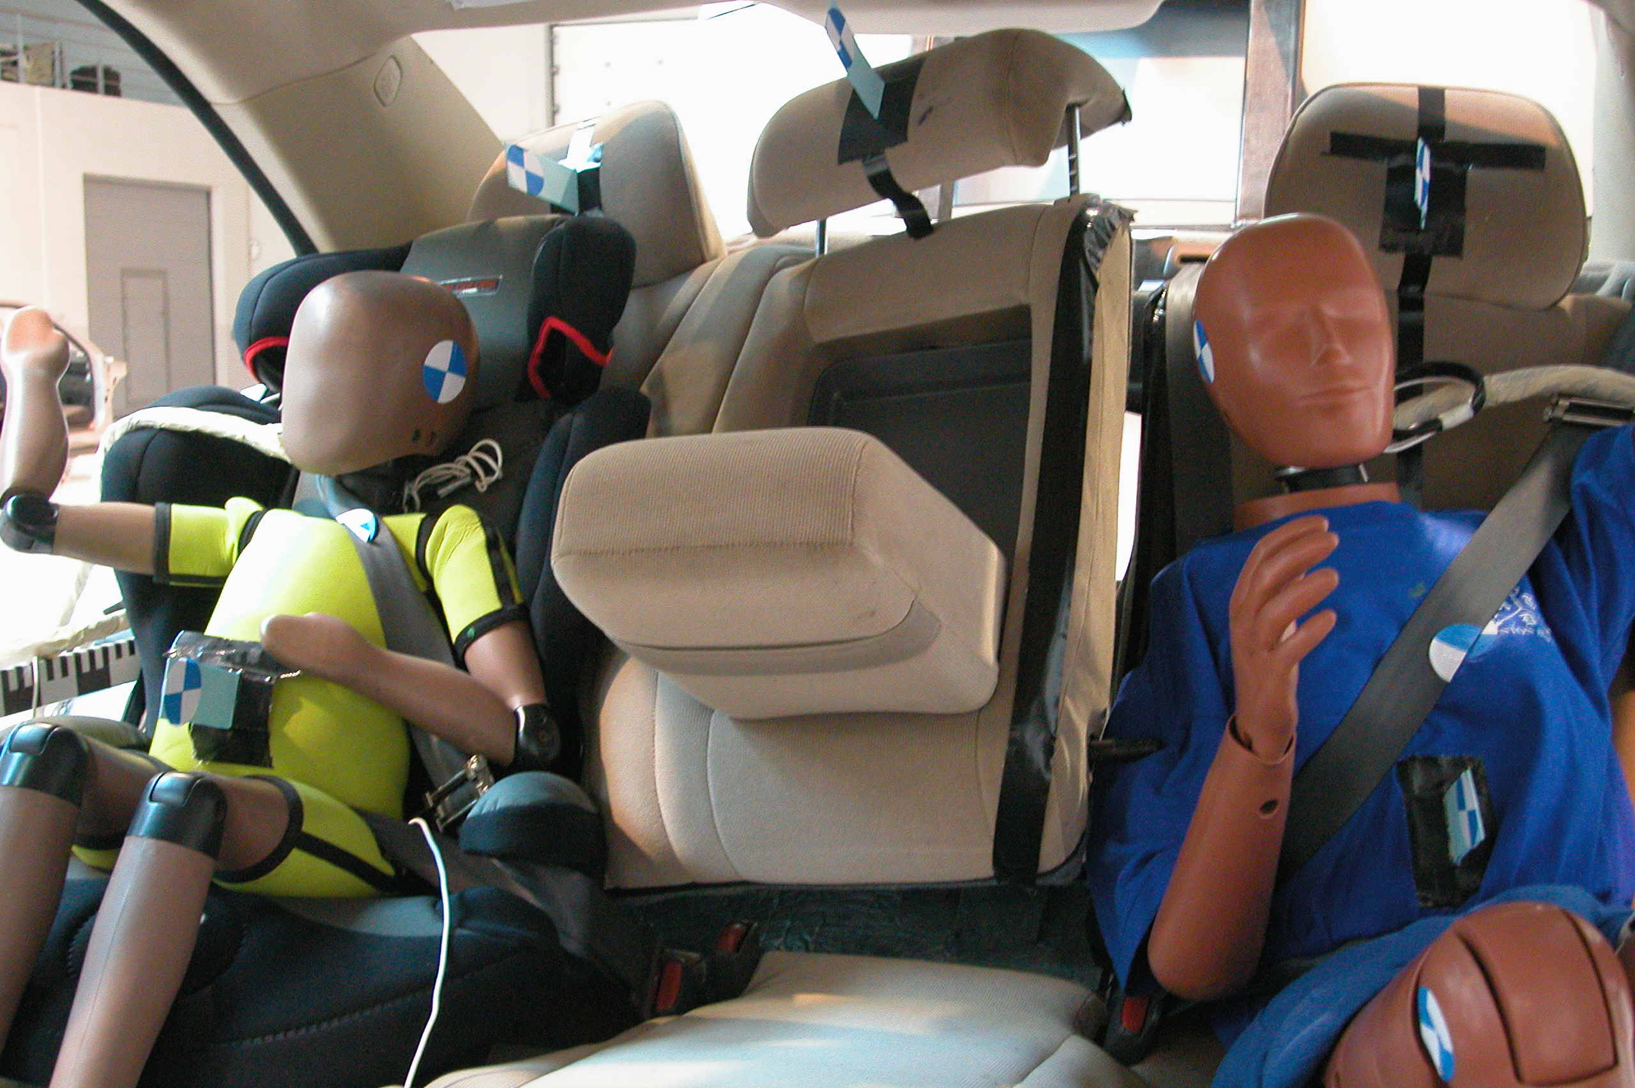
The Q3 dummy in Car A with realistic luggage and a EuroNCAP pulse did experience additional loading. The seat back hinges both released. Again the result should be used as a general example of the undesirability of additional loading. It is important to acknowledge that the outboard hinge mounting that failed had been subjected of two previous impact loads.
fig. 5: Car A post impact
fig. 6: Car B post impact
The peak of Car B EuroNCAP pulse was 116% higher than that used in Regulation 17. This illustrates that a single low pulse applied to all vehicles has little relationship to the pulse likely to be experienced in a severe injury impact for a given vehicle. (Please see table of EuroNCAP peak vehicle pulses at end of this report)
In Car B with realistic luggage and the EuroNCAP pulse, both the AF5 and the Q3 dummy were subjected to major additional loading.
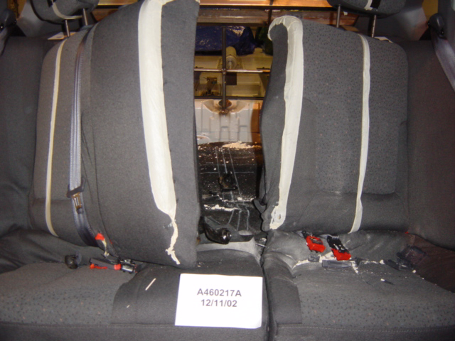
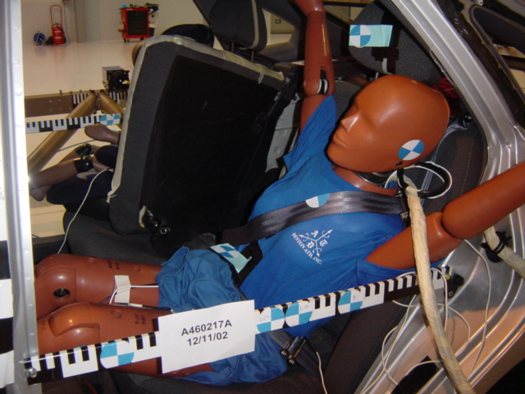
The central seat back hinges released and allowed the luggage to enter the passenger compartment where it could threaten the front seat occupants, as well as those in the rear.
fig.7: Car B post impact
The seat back central hinges released under the realistic luggage loading. It is notable that these hinges distorted even in the R 17 test, and were replaced prior to the realistic test.
Conclusions
These tests illustrate big differences between the ECE R17 test procedure on the strength of seat back rests and real accident situations. The tests illustrate that with foreseeable luggage loads and crash pulses relevant to serious injury accidents, current seat back designs allow occupants in the rear to experience undesirable additional loading from luggage in the boot.
Any test of luggage retention should include:
- Some reflection of the luggage capacity of the vehicle
- A test pulse that is relevant to serious injury accidents in that vehicle model
The consumer has a right to expect the strength of the barrier between the luggage compartment and the passenger compartment to be sufficient to keep such additional loading from luggage away from the occupants.

____________________

Discussions on car safety regulations take place at the Economic Commission for Europe of the United Nations (UN-ECE), where the safety expert group (GRSP) advises the parental committee WP29 on the decisions to take. ECE regulations generally are copied into EU Directives.
Paper 332, M Le Claire, The influence of rear loading on the protection of child car occupants in child restraints; Conference for the Enhanced Safety of Vehicles (ESV), Amsterdam, June 2001.

