Informal document No. 9
(45th GRPE, 13-17 January 2003,
agenda item 3.)

Note by the secretariat: As part of the secretariat's efforts to reduce expenditure, this voluminous informal document No. 9 will not be distributed during the 45th GRPE session. Delegates are kindly requested to bring their copies of this document to the meeting.

Worldwide Harmonised Motorcycle Emissions Certification Procedure

Draft Technical Report

UN/ECE-WP 29 - GRPE
WMTC Working Group

Author: Heinz Steven
RWTÜV Fahrzeug GmbH
Institute for Vehicle Technology
28. December 2002
Content Page
1 Introduction 3
2 Objective 3
3 Structure of the Project 4
4 Cycle Development 5
4.1 Approach 5
4.2 In-use Driving Behaviour Data 6
4.3 Fleet Composition and Vehicle Use 9
4.4 The Reference Database 12
4.5 Modification of the Draft Test Cycle and Final Version 15
5 Gearshift Procedure Development 19
6 Driveability Tests 24
7 Vehicle Classification 25
8 Weighting Factors for an Overall WMTC Emissions Result 27
9 Emissions Validation Tests 27
9.1 General Information 27
9.2 Results of the Emissions Validation Programme 32
10 Test Protocol 41
11 Round Robin Test 41
12 Off Cycle Emissions 41
13 Summary and Conclusions 41
14 Literature 42
Annex A - Description of the Modification Work on the WMTC Cycle
Annex B - Final Cycle Version
Annex C - Test Protocol

Introduction
At its beginning (1999) WMTC was a tripartite project between the Netherlands Ministry of the Environment (VROM), TNO Automotive and the International Motorcycle Manufacturer Association (IMMA). Within this tripartite project VROM looked after the political aspects of generating a worldwide test cycle. TNO Automotive, funded by VROM, did the development work and the technical management of the project. IMMA contributed by the collection of in-use driving behaviour data worldwide.
In a later stage (May 2000) the project was brought under the umbrella of the UN/ECE WP 29. Under the guidance of WP 29, the Group of Experts on Pollution and Energy (GRPE) mandated the ad-hoc group WMTC with the development of a "World-wide Harmonised Motorcycle Emissions Certification/Test ProCedure” and to establish it in the framework of the 1998 Agreement on Global Technical Regulations (GTR). Since October 2000 RWTÜV Fahrzeug GmbH joined the WMTC group. RWTÜV Fahrzeug developed a gearshift procedure closely linked to the test cycle. This work was funded by the German Bundesanstalt für Straßenwesen (Bast). Since May 2001 RWTÜV Fahrzeug got the responsibility for the cycle development work, the development of the test protocol and the coordination of the validation programme by order of the Netherlands Ministry of the Environment (VROM) and with support by the German Federal Ministry of Transport, Building and Housing (BMVBW).
The WMTC group was formed by members of the following countries/organisations:
- AECC,
- European Commission,
- Germany,
- IMMA,
- Japan,
- Netherlands,
- Spain,
- Switzerland,
- UK,
- USA

Objective
The objective of the research program is to develop a worldwide-harmonised motorcycle emissions test procedure , consisting of:
- a test cycle,
- a gearshift procedure,
- sampling, measurement and analysis procedures (with support from/in collaboration with ISO)

The test procedure needs to be:
- representative of world-wide on-road vehicle operation,
- able to provide the highest possible level of efficiency in controlling on-road emissions,
- corresponding to state-of-the-art testing, sampling & measurement technology,
- applicable in practice to existing and foreseeable future exhaust emissions abatement technologies,
- capable of providing a reliable ranking of exhaust emission levels from different engine types,
- consistent with the development of appropriate emission factors,
- inclusive of adequate cycle-bypass prevention provisions.
The test procedure has to cover the cycle and the accompanying gearshift procedure for the test bench measurements and the prescription of test bench settings like determination of road load resistance, inertia mass, cooling requirements, exhaust gas sampling procedure and other test bench specifications.

Structure of the Project
The development of the cycle and the gearshift procedure belongs to the tasks of the WMTC group; the prescription of test bench settings was developed in working group 17 of ISO TC22 in close liaison with the WMTC group. Table 1 gives an overview of the tasks of the whole project.
In the work schedule of the WMTC group two validation steps were foreseen after the development of test cycle and gearshift procedure. A first step, in which the driveability was evaluated and a second step, in which the emissions measurement results were evaluated and compared with results from existing certification procedures. The development work and the two validation steps are finished. Finally a round robin test is foreseen starting in Spring 2003.

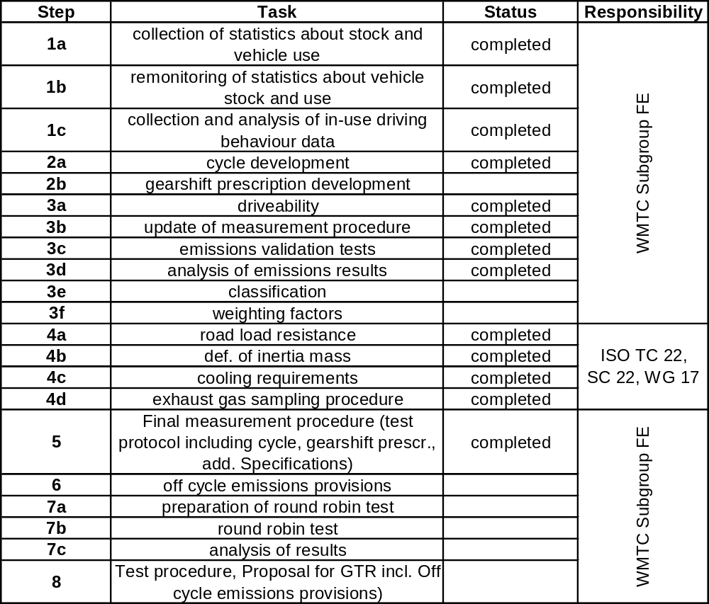
Table 1: The Structure of the whole project

Cycle Development

Approach
The basis of the cycle development was the collection and analysis of driving behaviour data and statistical information about motorcycle use for the different regions of the world. These data had to include all relevant real life vehicle operations and built the basis for the cycle development. In a second step the in-use driving behaviour data were combined with the statistics on vehicle use in order to create a reference database that is representative for worldwide motorcycle driving behaviour. This was achieved using a classification matrix for the most important influencing parameters. In the final classification matrix three different regions (Europe, Japan, USA), three different vehicle classes and three different road categories were included.
The next step was to compact this reference cycle into a test cycle of the desired length. A computer search programme then selects a number of modules (speed/time sequences between two stops) to represent by approximation this length. The statistical characteristics of this number of modules are then compared to those of the database. The comparison is done on the basis of the chi-squared method, an accepted statistical criterion.
Finally a first draft of the World-wide Motorcycle Test Cycle (WMTC) was produced. It was foreseen that this first draft needed to be modified on the basis of an evaluation concerning driveability and practical points concerning the measurement procedure. Since this process is iterative by nature, several adaptation rounds including the driveability tests were carried out.
A flow chart of the development process is shown in Figure 1.

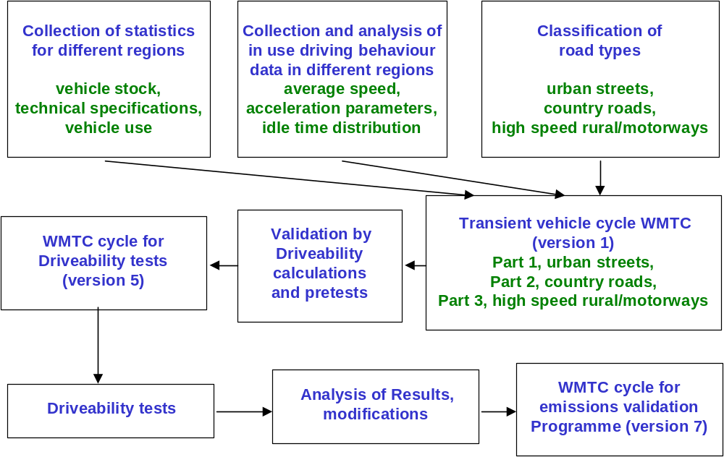
Figure 1: Flow chart of the cycle development work

In-use Driving Behaviour Data
The basis of the cycle development was the collection and analysis of driving behaviour data and statistical information about motorcycle use for the different regions of the world. These data had to include all relevant real life vehicle operations and built the basis for the cycle development. In a second step the in-use driving behaviour data were combined with the statistics on vehicle use in order to create a reference database that is representative for worldwide motorcycle driving behaviour. This was achieved using a classification matrix for the most important influencing parameters. In the final classification matrix three different regions, three different vehicle classes and three different road categories were included.
The in use driving behaviour data used for the WMTC project consist of the following subsets:
- Data measured in Europe
  - 1994, ACEM-group. The measurements were carried out in Paris and Pisa,
  - 1994, JAMA-group. The measurements were carried out in Amsterdam and Frankfurt.
  - 1999, ACEM. The measurements were carried out in the area around Pisa (Italy), the area around Mandeure (France) and the area around Munich (Germany).
  - Technische Fachhochschule Biel in Switzerland, in and around Biel.
  - Technical University of Darmstadt (Germany), around Darmstadt.
- Data measured in Japan
  - 1992, JMOE project. The measurements were carried out in the Tokyo area.
  - 1997, JAMA project. The measurements were carried out in the Tokyo area.
  - 2000, JAMA/JARI project. The measurements were carried out in the Tokyo area including highway. The data is only used for the gearshift model.
- Data measured in China
  - In the Ji Nan area by the Tianjin Motorcycle Technical Center of the Tianjin Internal Combustion Engine Research Institute, belonging to the Tianjin University in China.
- Data measured in the USA
  - 1999, USMMA run, The measurements were carried out in Birmingham, Alabama.
The time duration and the total mileage of these in-use data subsets are shown in Table 2. Table 3 gives an overview about the vehicle sample.

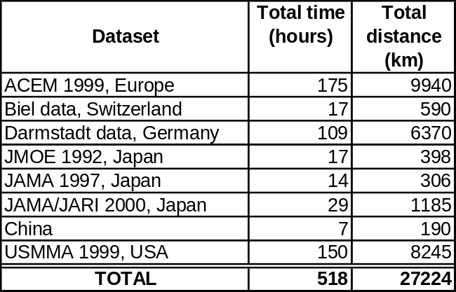
Table 2: Duration and mileage of the in-use data subsets

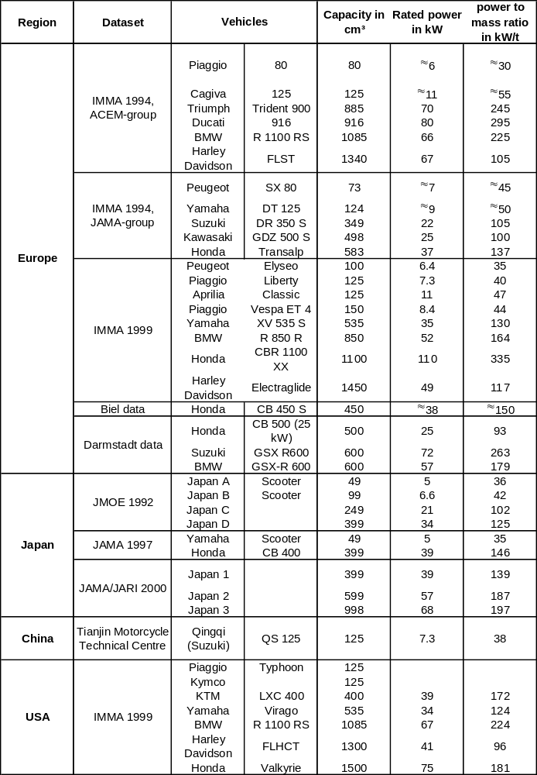
Table 3: The vehicle sample of the in-use driving behaviour database

Fleet Composition and Vehicle Use
The content of this chapter is adopted from [1]
Vehicle Stock
From the industrial partners statistical data have been received as to the respective local vehicle fleets in different regions of the world. One should bear in mind, however, that the available data are not very ‘hard’. One obvious problem with statistics from widely different sources is that usually they are not coherent. It has been attempted to limit the data to motorcycles of more than 50 cc, although it is not always clear whether the available statistics include or exclude the class below 50 cc. From an evaluation of the statistical data received, sufficient conclusions can nevertheless be derived as to the composition of the vehicle fleet in different regions of the world.
- Europe has a fleet that mainly consists of either small capacity vehicles, mainly scooters, on the one hand, and of large sports and touring bikes on the other, with few vehicles in between. The distribution is very country dependant. Generally speaking northern countries possess a large percentage of big bikes, whereas southern countries tend to have mainly small vehicles.
- Japan has a similar share of small vehicles as Europe, but has a more or less equal number in the middle category. Really big bikes are rare in Japan.
- The USA has mainly big bikes (most of them really big) and very few in the small and middle categories.
The situation is shown in Figure 2.

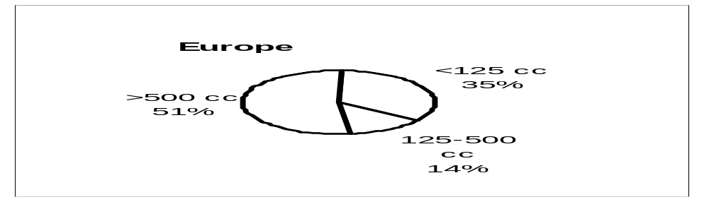
Figure 2: The composition of the fleet in Europe Japan and the USA in 1997. Note that the subdivision is not equivalent for all three regions, due to the structure of the available data. (from [1])

The total fleet size for Europe (that is including non-EU members Switzerland and Norway), Japan and USA and the total annual mileage are shown in the following figure.

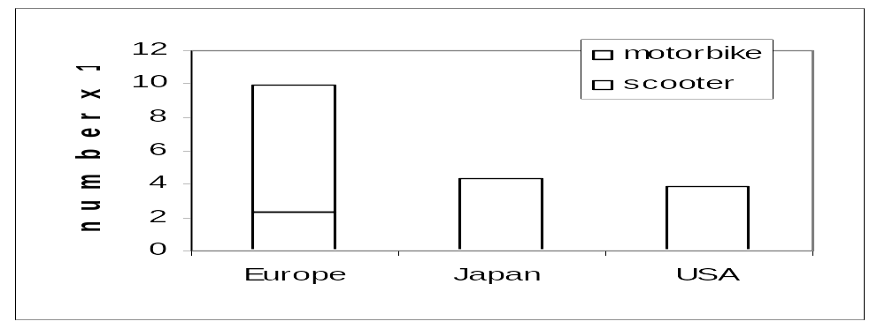
Figure 3: The total fleet size in the three regions, numbers of vehicles (left) and total annual mileage (right), (from [1])

For Japan and the USA no figures about scooters are available.
Vehicle Use
One obvious problem when comparing the use on different road types in different parts of the world, is that the definitions, and often even the road types themselves, do not compare on a 1:1 basis. So any comparison can only be approximate. The following information was supplied by the IMMA members.
The characteristic use in Europe depends heavily on the class and the country. According to a user’s survey by a major scooter manufacturer the small machines (mainly scooters) are almost exclusively used in an urban environment. The average trip length is small. This is the main pattern in south-European countries. According to a survey by the TU Darmstadt [2] the big machines are mainly used for recreational trips. The average trip length is large. This use is mainly on country roads, because the users are enthusiasts that like a challenging route. This agrees with available information from the Netherlands and it seems to be the dominant use in north-European countries.

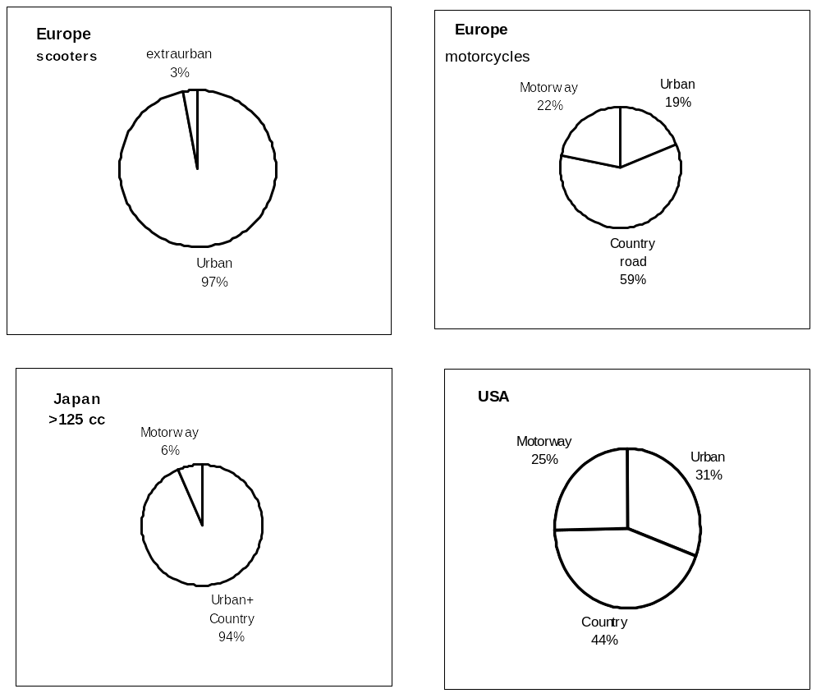
Figure 4: Characteristic use per type of road (from [1], but corrected for US data)

The information that is available about Japan suggests that the majority of the mileage is performed on secondary roads, including urban roads. The maximum speed on country roads is 60 km/h. On motorways since October 2000 the posted speed is 100 km/h; before that date it was 80 km/h. Vehicles below 125 cc are not allowed on motorways, but even for bigger bikes the motorway share is small. Commuting and shopping are important motives in Japan. For the class < 125 cc ‘business’ is an important motive as well (26 %), whereas for the classes above 125 cc recreational use is an important motive (34 % for the class 125-250 cc, and 49 % for the class >250 cc). The total annual mileages are low, suggesting small average trip lengths and low average speeds.
In the USA there is a larger share of urban use than in Europe and a smaller share of country roads. The use of motorways is roughly equal to that in Northern Europe. The annual mileages are relatively low and so are, presumably, the trip lengths.

Annual mileages are difficult to obtain, but the following table gives some indications.

Class | Region | Annual mileage
Engine capacity  < 150 cm³ | Europe  Japan  USA | 2500 – 5000 km  Approx. 1400 km  3000 – 3500 km
Engine capacity  150 – 450 cm³ | Europe  Japan  USA | Approx. 3500 km  Approx. 2300 km  3750 – 4250 km
Engine capacity  > 450 cm³ | Europe  Japan  USA | Approx. 5000 km  Approx. 2400 km  5000 – 5500 km
Table 4: Approximate annual mileages per capacity class and region (from [1], but corrected for US data)

The Reference Database
It was originally planned to create the reference database by combining the in-use driving behaviour data with the statistics on vehicle use (see Figure 5). This should be done using a classification matrix for the most important influencing parameters. In the classification matrix three different regions, three different vehicle classes and three different road categories should be included.
The reference database would then have been a combination of representative in-use data expressed in terms of vehicle speed for each cell of the classification matrix and with the corresponding weighting factors.
But since the data about vehicle use were not reliable enough and since the WMTC group could not find a compromise for the vehicle classification the following alternative approach was chosen:
The cycle should be designed as consisting of three parts, each part representing a separate road category. Part 1 should be a low speed part, mainly representative for urban traffic; part 2 should be a medium speed part and represent slower country road type of traffic, and part 3 should be a high-speed part and represent faster country roads and motorways. Part 1 should incorporate a cold start.

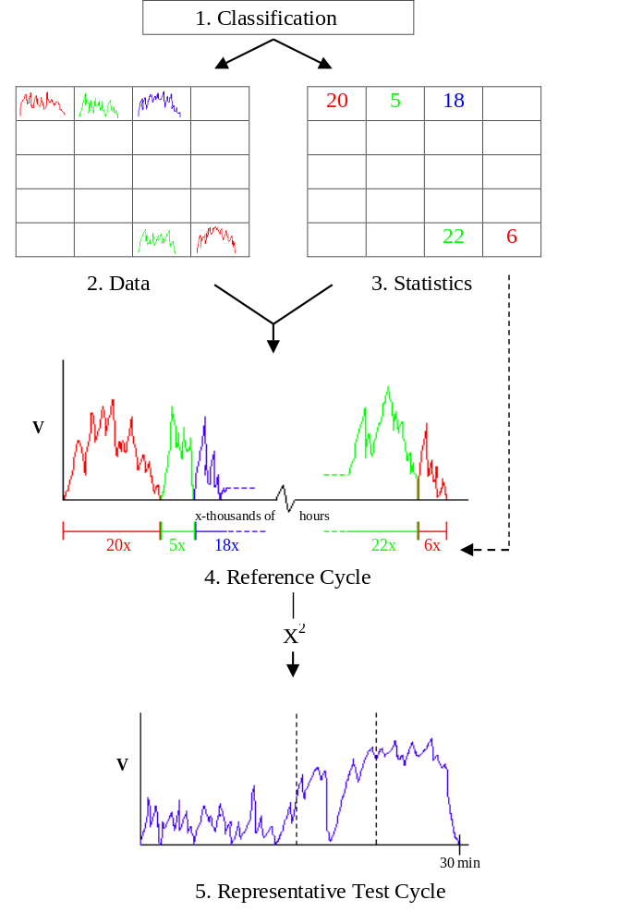
Figure 5 Flowchart for the construction of a test cycle out of a large randomly distributed database, from [1].

By measuring the emissions separately for each part, this approach allows to perform validation tests with a provisional vehicle classification and take into account vehicle use statistics by applying weightings to the results for each part. Consequently the in-use data were separated into 3 classes corresponding to the above mentioned 3 road categories.
Since information of road categories was not available for all in-use data and since the classification may vary from region to region, it was attempted to characterise the road categories, for a vehicle for which these categories were known, on the basis of the length of vehicle speed modules and the average speed of these modules. A module is a speed sequence between two stops. This was not very successful, partly because of the routes chosen. A second attempt on the basis of average speed and maximum speed per module looked more promising. There was a reasonable distinction between the road categories. The main overlap was between fast country and motorway traffic, but this was acceptable, as both categories should build one single class.
Eventually an approach was chosen that characterises the modules on the basis of speed distribution. This approach was used earlier for a similar problem in characterising the road use of hybrid driven passenger cars. To this end for every module the share of speeds was calculated below 60 km/h, between 60 and 90 km/h and above 90 km/h. Subsequently the following allocation was used:

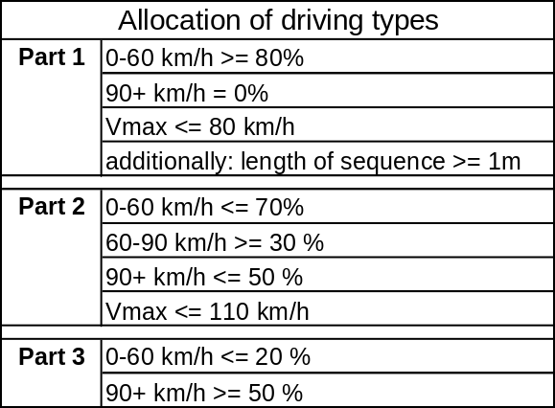
Table 5: Allocation of driving types for the three cycle parts

This approach was selected as a pragmatic solution to the problem. The additional requirement of Part 1 was included to prevent ‘creeping’ from being selected as a representative driving mode. Subsequently this way of allocation was applied to all data.
The second step then was to compact these reference cycles into test cycle parts of the desired length in time, which was set to 600 s for each part. A computer search programme was the developed by TNO that selected a number of modules (speed/time sequences between two stops) to represent by approximation this length. The statistical characteristics of this number of modules were then compared to those of the corresponding database.
The comparison was done on the basis of the chi-squared method for the acceleration versus speed matrix (v*a-matrix). The selection of modules with the lowest value for chi-squared was then selected as the ideal combination. So first the ideal lengths of the various modules were determined, and then the most representative modules corresponding with those lengths were selected. After the module selection the stops were added. The total stop time was taken from statistics. This total stop time was then divided into stops on the basis of the statistical distribution of the stop lengths in the in-use database. Finally a first draft of the World-wide Motorcycle Test Cycle (WMTC) was produced.

Modification of the Draft Test Cycle and Final Version
It was foreseen that the first draft needed to be modified on the basis of an evaluation concerning driveability and practical points concerning the measurement procedure. Since this process is iterative by nature, several adaptation rounds including the first step of the validation programme were carried out.
The following modifications were made during the validation phase and the driveability tests:
- Deletion of an ultra short module with operational speeds below 20 km/h in part 1,
- Separation of an extremely long module in part 1 into 3 parts that were more representative for urban driving,
- Replacement of 3 part 1 modules by more representative modules,
- Correction of the idle time distribution for part 1,
- Rearrangement of the rank order of the modules in part 1 with respect to cold start requirements,
- Smoothing of ripples in the quasi constant cycle phases of parts 2 and 3 to delete unrealistic fluctuations in the speed signal caused by the speed measurement uncertainty,
- The maximum speed of part 3 was set to 125 km/h,
- The acceleration time pattern was smoothed in order to delete unrealistic high changes of the acceleration rate that could cause driveability problems like tyre slip,
- The highest deceleration values were reduced to take into account that only the drive wheel brake is working on the roller bench.
- To reduce the risk for tyre slip the da/dt values were limited to -0.8 m/s²/s <= da/dt <= +0.8 m/s²/s. Consequently the vehicle speed pattern were modified until da/dt falls into that range.
- A special part 1 cycle, called “part 1, 50 cc” was created for low powered motorcycles, whose technical specifications are close to mopeds, by limiting the top speed of part 1 to 50 km/h and limiting the acceleration/deceleration values to +2/-2 m/s².
Although version 7 of the WMTC cycle was based on a smoothed acceleration pattern to avoid excessive changes in acceleration over time, the question of tyre slip was raised again at the WMTC meetings in Madrid (17.12.2001) and Geneva (16.1.2002). Consequently an additional analysis of this problem was executed. This analysis was based on the results of 4 vehicles (2 from the US and 2 from Japan), for which second by second data of roller speed as well as tyre speed had been delivered for the WMTC as well as for the US FTP and TRIAS/ECE R 40. The latter was only measured in Japan. The Japanese vehicles belong to Pclass 1 and 2, the US vehicles to Pclass 3 (see chapter 9). The word “Pclass” stands for the provisional classification used for the emissions validation tests (see chapter 7).
The tyre slip was calculated as difference between tyre speed and roller speed divided by the roller speed and expressed in %. That means tyre slip gives positive values, tyre lock negative values. In addition the change of acceleration rate per second was calculated for the acceleration values of the set speed.
The majority of tyre slip values >= 50% occurred during the transition from standstill to driving, surprisingly not only for the WMTC but also for the US FTP and the TRIAS/ECE R 40. The analysis results show that the dynamics of the WMTC do not cause higher risks for tyre slip than existing certification cycles. As already concluded from interim results and the analysis of the answers to the questionnaire about the tyre slip, the problem is related to individual tyre/roller combinations (see chapter 6). Nevertheless it was decided in the WMTC group that the tyre slip risk should be minimised for the WMTC by limiting the change of acceleration rate in order to improve driveability, independent of the situation for existing cycles.
During the WMTC FE meeting in Tokyo in April 2002 the Japanese delegation proposed to create a special version of part 1 with a top speed of 50 km/h for low powered motorcycles whose technical specifications are close to mopeds. Since there is only one module in part 1 with vehicle speeds above 50 km/h (module 3), only this module was modified. The first part was replaced by a module taken from in-use measurements of vehicle 6 (this module was closest to the existing one) and the second part was lowered in speed to fulfil the limitation of 50 km/h.
All modifications done in the adaptation rounds are described in detail in Annex A - Description of the Modification Work on the WMTC Cycle. Tables containing version 8 are shown in Annex B – Final Cycle Version.
The final result that will be used for the round robin test starting in Spring 2003 is shown in Figure 6 to 9. Each part is 600 s long. Part 1 representing urban driving consists of 8 modules interrupted by standstill at idling. The top speed is 60 km/h. Part 2 representing driving on secondary rural roads consists of 2 modules, the top speed is 95 km/h. Part 3 representing primary rural roads and motorways consists of 1 module, the top speed is 125 km/h.
The characteristics of the WMTC driving cycle(s) are shown in Table 6 and Table 7. The definitions for the driving modes are given in Table 8.
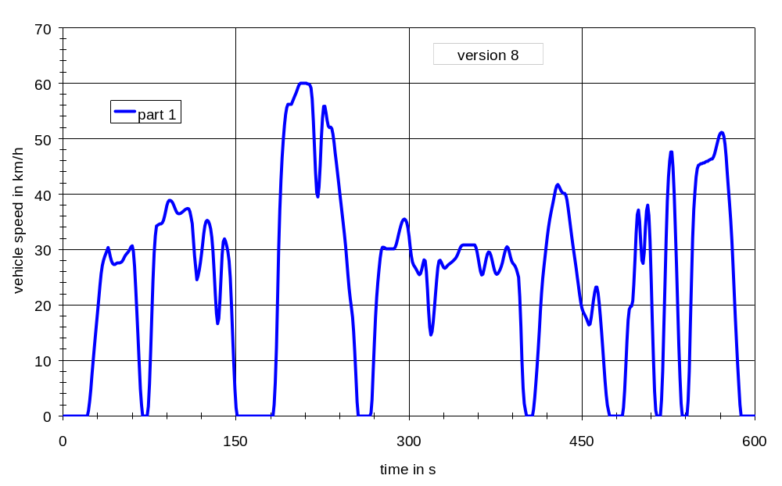
Figure 6: WMTC driving cycle, part 1

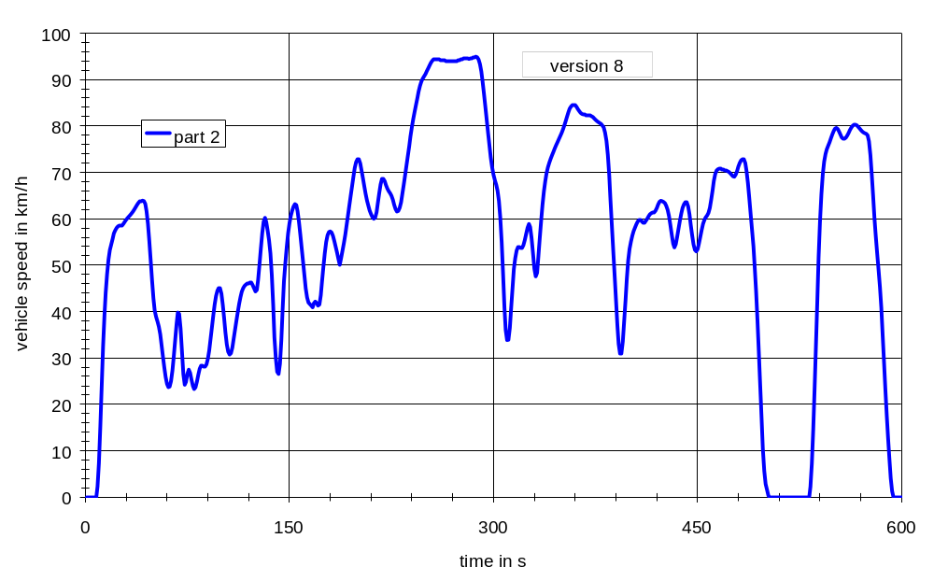
Figure 7: WMTC driving cycle, part 2

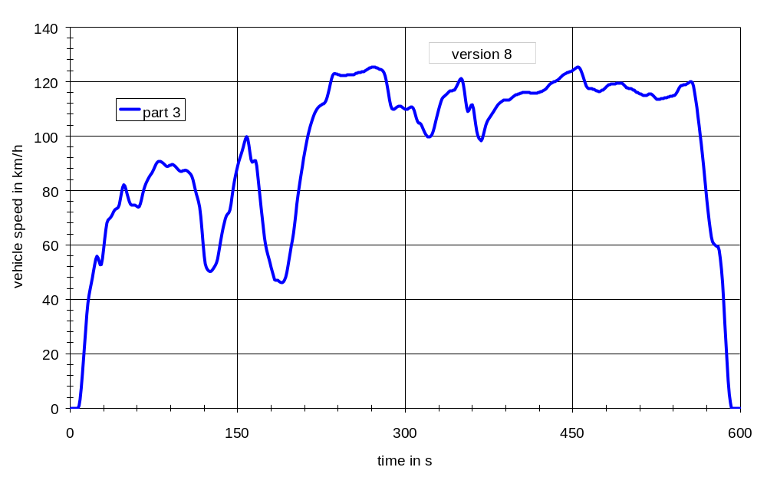
Figure 8: WMTC driving cycle, part 3

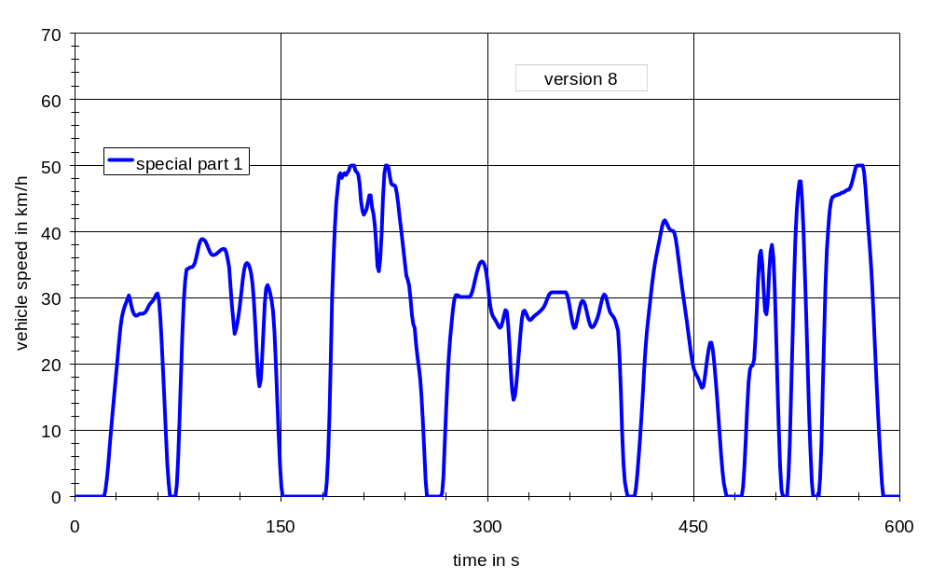
Figure 9: WMTC driving cycle, part 1, reduced speed, for low powered motorcycles whose technical specifications are close to mopeds
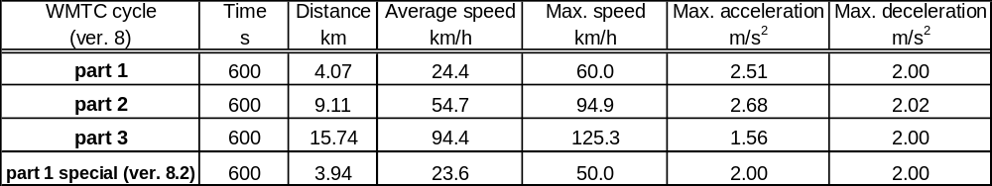
Table 6: Characteristics of WMTC driving cycle (1)

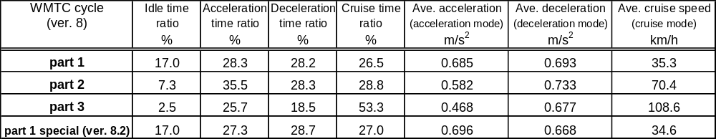
Table 7: Characteristics of WMTC driving cycle (2)

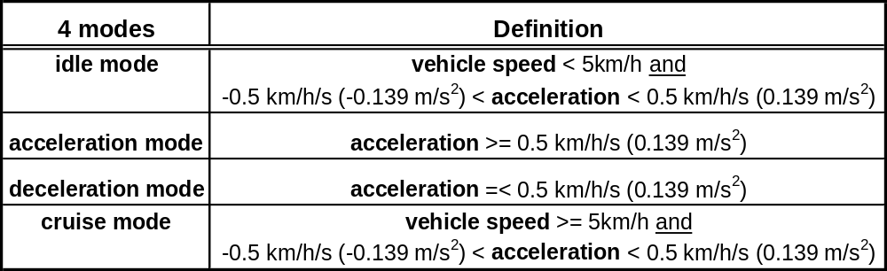
Table 8: Definition of driving modes

Gearshift Procedure Development
The development of the gearshift procedure was based on an analysis of the gearshift points in the in-use data. In order to get generalised relations between technical specifications of the vehicles and gearshift speeds the engine speeds were normalised to the utilisable band between rated speed and idling speed.
In a second step the end speeds (vehicle speed as well as normalised engine speed) for upshifts and downshifts were determined and collected in a separate table. The averages of these speeds for each gear and vehicle were calculated and correlated with technical specifications of the vehicles.
A flow chart of the development procedure is shown in Figure 10.
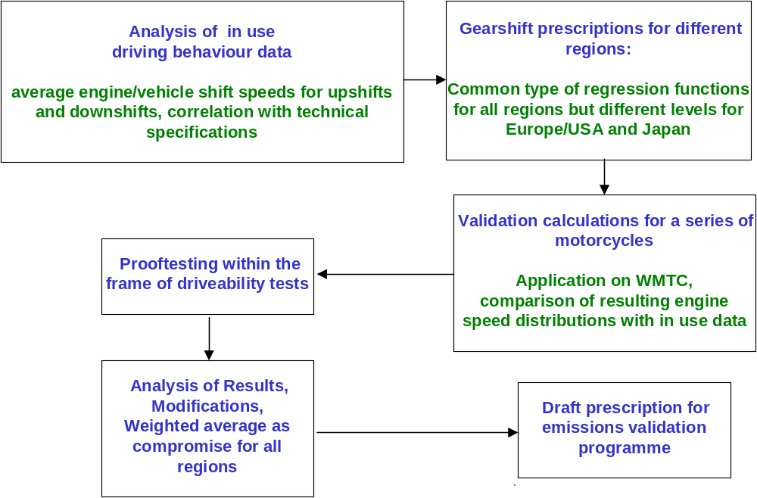
Figure 10: Flow chart of the gearshift prescription development

The results of these analyses and calculations can be summarised as follows:
- The gearshift behaviour is engine speed related rather than vehicle speed related.
- The best correlation between gearshift speeds and technical data was found for normalised engine speeds and the power to mass ratio (rated power/(kerb mass + 75 kg), see Figure 11.
- The residual variations cannot be explained by other technical data or by different transmission ratios. They are most probably assigned to differences in traffic conditions and individual driver behaviour.
- The best approximation between gearshift speeds and power to mass ratio was found for exponential functions, see Figure 11.
- The gearshift function for the first gear is significantly lower than for all other gears.
- The gearshift speeds for all other gears can be approximated by one common function.
- No differences were found between 5speed and 6speed gearboxes.
- The gearshift behaviour in Japan is significantly different from the equal-type gearshift behaviour in Europe and in USA, see Figure 11.

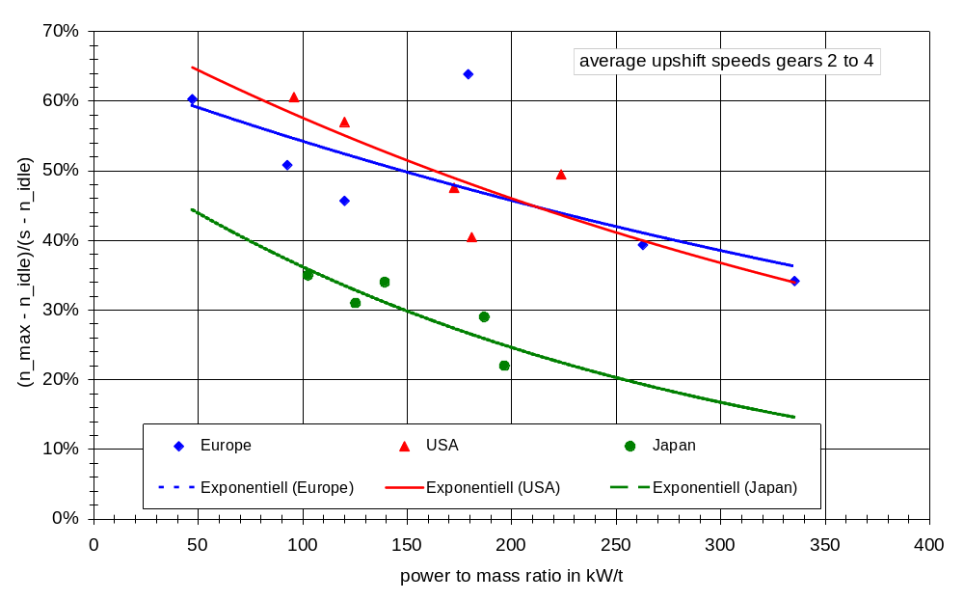
Figure 11: Correlation between normalised max engine speeds for upshifts and power to mass ratio

In order to find a balanced compromise between the three regions a new approximation function for normalised upshift speeds vs. power to mass ratio was calculated as weighted average of the EU/US curve (with 2/3 weighting) and the Japanese curve (with 1/3 weighting), see Figure 12. Based on this, the gearshift prescriptions can be summarised as follows:
Max. engine speeds during acceleration phases:
1. gear: n_norm_max = 0,5753*exp(-0,0019*pmr) - 0,10 Equation 1
all other gears: n_norm_max = 0,5753*exp(-0,0019*pmr) Equation 2
explanations:
pmr = Pn/(m0 + 75 kg) in kW/t
n_norm = (n – n_idle)/(s – n_idle)
Pmr – power to mass ratio
Pn – rated power
m0 – kerb mass
n – engine speed, n_idle – idling speed, s – rated speed
Min. engine speeds during acceleration phases:
n_norm_min_acc(i) = n_norm_max(i-1)*r(i) / r(i-1) Equation 3
r(i) – gear ratio or ratio between engine speed and vehicle speed in gear i
Min. engine speed for deceleration or cruising phases:
n_norm_min_dec(i) = n_norm_min_acc(i-1)*r(i) / r(i-1) Equation 4
r(i) – gear ratio or ratio between engine speed and vehicle speed in gear i
Additional specifications:
- The equations above define lower limits for the engine speed. The resulting engine speed values can be rounded to multiples of 100 min-1 for practical applications. Higher shift speeds are permitted in any cycle phase in order to improve the driveability or in order to reduce the amount of test bench measurements for a vehicle family,
- No gearshift if a deceleration phase follows immediately after an acceleration phase,
- No downshift to 1. gear during deceleration down to standstill,
- Minimum time span for a gear sequence: 2 seconds,
- Clutch disengaged, if v < 10 km/h.
To give the test engineer more flexibility and to assure driveability the gearshift regression functions should be treated as lower limits. Higher shift speeds are permitted in any cycle phase.
These prescriptions were used in the emissions validation programme. The definitions for acceleration, deceleration and cruising phases are given in Table 8. Figure 13 shows an example for a gearshift sketch for a small vehicle. The solid lines demonstrate the gear use for acceleration phases; the dotted lines show the downshift points for deceleration phases. During cruising phases the whole speed range between downshift speed and upshift speed may be used. In order to avoid driveability problems this instruction had to be supplemented by additional requirements some of them are general, some are assigned to particular cycle phases.

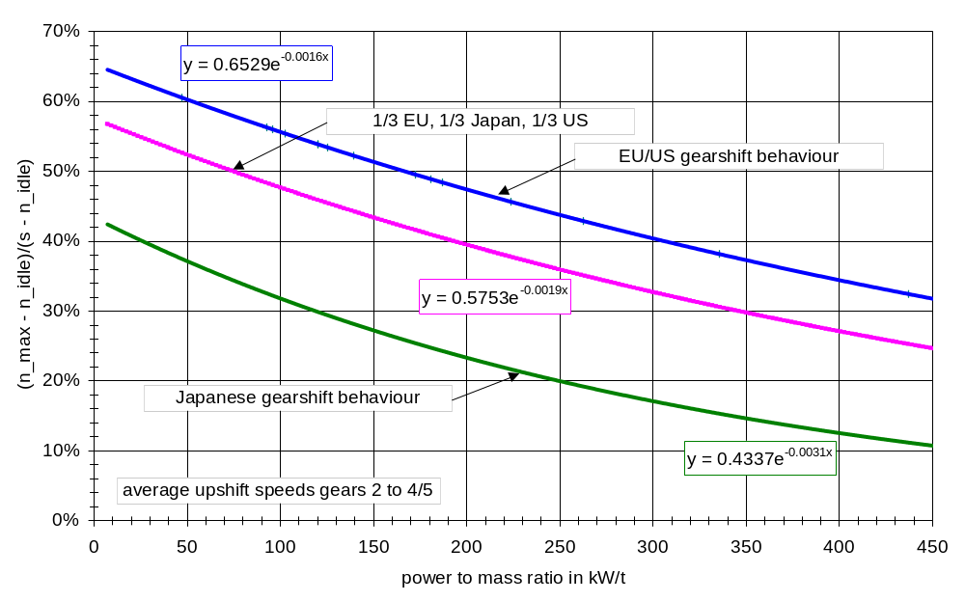
Figure 12: The final approximation function for upshift speeds in gears higher than 1 (1/3 EU, 1/3 Japan, 1/3 US)
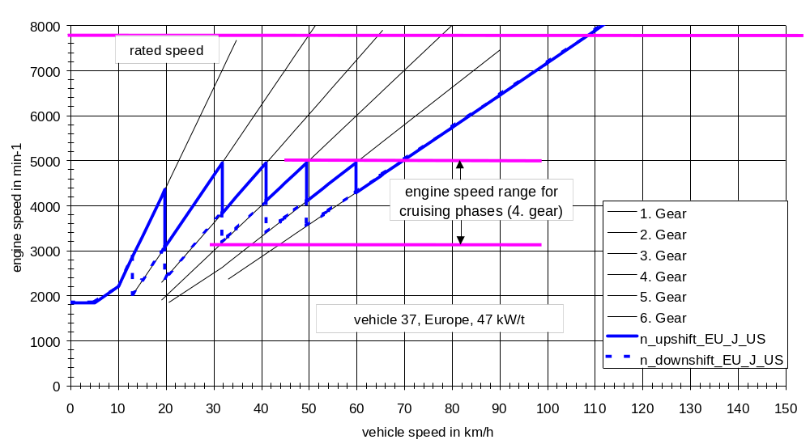
Figure 13: Example of a gearshift sketch for a small vehicle

Calculation example:
An example of input data necessary for the calculation of shift speeds is shown in Table 9. The upshift speeds for acceleration phases for the 1. gear and higher gears are calculated with equations 1 and 2. The denormalisation of engine speeds can be executed by using the equation n = n_norm * (s – n_idle) + n_idle.
The downshift speeds for deceleration phases can be calculated with equation 4. The n/v values in Table 10 can be used as gear ratios. These values can also be used to calculate the affiliated vehicle speeds (vehicle shift speed in gear i = engine shift speed in gear i / n/v_i). The corresponding results are shown in Table 10 and Table 11.

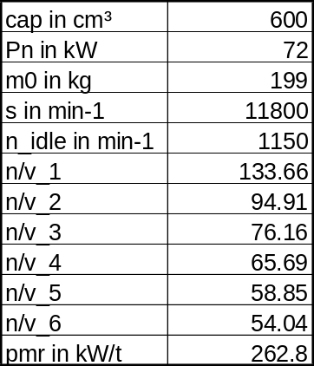
Table 9: Input data for the calculation of engine and vehicle shift speeds
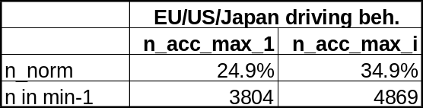
Table 10: Shift speeds for acceleration phases for the 1. gear and for higher gears (according to Table 9)

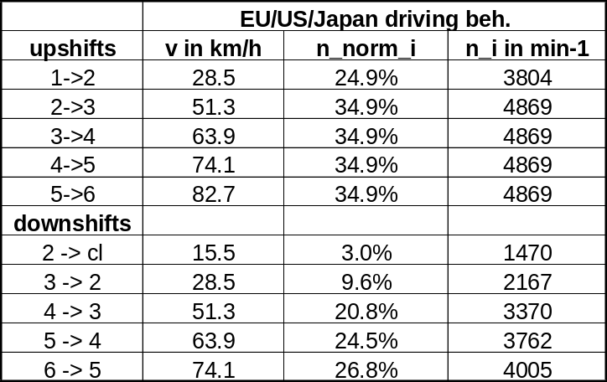
Table 11: Engine and vehicle shift speeds according to Table 10

In a further step the possibility of a simplification of the above-described gearshift algorithms was examined by additional analyses and calculations. It should especially be checked whether engine shift speeds could be replaced by vehicle shift speeds. The analysis showed that vehicle speeds could not be brought in line with the gearshift behaviour of the in-use data.

Figure 14: Definition of power to mass ratio classes for a simplified gearshift prescription

Driveability Tests
Right after the WMTC cycle and the corresponding gearshift procedure were developed measurements were carried out on roller benches in order to validate the driveability of the cycles and the functionality of the gearshift procedure.
In order to run these tests a test protocol was developed on the basis of the test protocol of the US certification procedure FTP. Some modifications were necessary due to the different design of the WMTC cycle (higher vehicle speeds, 3 parts) and the gearshift procedure. The gearshift protocol represented EU/US gearshift behaviour because the Japanese gearshift behaviour database was not complete at that time.
In total the results (roller speed data) of 27vehicles were delivered, 18 from Europe, 6 from Japan and 2 from the US.
The driveability problems that were reported can be focussed on tyre slip, wheel lock and traceability problems due to poor power in case of low power vehicles. In addition some malfunctions of the gearshift calculation sheet were detected.
The problem with tyre slip and traceability was biggest for part 1 and smallest for part 3. It is obviously related to the individual roller-tyre combination. An additional questionnaire was sent out to all participants in order to get further information about the roller benches as well as about the tyres used for the measurements. The results of the questionnaire show big variations in technical specifications (diameter, max. power, max. speed) of the roller benches. The tyre slip problem could neither be related to tyre type or size nor to vehicle specifications. It is tyre related rather than roller bench related but the available tyre information is not suitable to show a clear picture about the influencing parameters. No tyre slip problems were reported for roller benches with “textured” surfaces. The results of the questionnaire do not suggest further reductions of the cycle dynamics during acceleration phases. The risk of tyre slip can be reduced by textured roller surfaces.
The wheel lock problem is partly caused by the fact that only the rear wheel break can be used during deceleration on a roller test bench and partly related to the tyre characteristics like the tyre slip problem. As there is no significant influence of the deceleration on the emissions the wheel lock problem can be reduced by a reduction of the deceleration values.
The poor power problem can only be avoided when the cycle dynamics are adjusted to the vehicles at the lower end of the power to mass ratio scale. But this solution would not be in line with practical use. Nevertheless countermeasures to the poor power problem should be further investigated.

Vehicle Classification
The vehicle classification is one of the important issues of the WMTC development process. For practical reasons the following first provisional classification of vehicles was made by TNO within the frame of the cycle development work:
- C-class I: vehicles with an engine capacity of < 150 cm³
- C-class II: vehicles with an engine capacity of 150 cc – 450 cm³
- C-class III: vehicles with an engine capacity of > 450 cm³
During the analysis of the driveability validation test results some conflicts with practical use and technical possibilities revealed for this classification. On one hand there is a series of vehicles on the European market that would be classified as C-class I or C-class II although their max. speed exceeds the max. speed of the corresponding cycle parts substantially (see Table 12). On the other hand there are also vehicles of C-class 2 and C-class 3 whose max. speed is below the max. speed of the corresponding cycle parts.

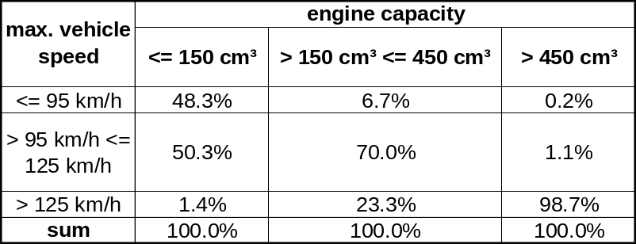
Table 12: Vehicle type distribution for engine capacity and max. vehicle speed classes (data source: KBA statistics of type approval values)

For that reason some alternatives based on power to mass ratio and max. vehicle speed as substitute or additional criteria were discussed but the FE-group could not find a compromise. It was decided to postpone a final decision till the analysis of the emissions validation test results will have been finished.
For the emissions validation tests the following provisional classification was used in order to get as much information as possible about the “border” areas:
- Pclass I: vehicles with a max. speed of less than 80 km/h,
- Pclass II: vehicles with a max. speed of 80 km/h or higher but less than 120 km/h,
- Pclass III: vehicles with a max. speed of 120 km/h or higher
Max. speed is the maximum vehicle speed as declared by the manufacturer.
Since the existing classifications for motorcycle type approval in all three regions use engine capacity classes, the FE group reached an agreement that the classification system should be based on engine capacity and maximum vehicle speed.
It was also agreed that the lower limit for class I is formed by engine capacity of more than 50 cm³ and max. speed of more than 50 km/h, that special class I is defined by engine capacity of up to 50 cm³ and max. speed of more than 50 km/h but not more than 60 km/h and that vehicles with an engine capacity below 150 cm³ should belong either to class I or class II but not to class III.
The proposals for a max. speed border between class I and class II on one hand and class II and class III on the other hand that are currently under discussion are justified by two contrasting philosophies about the driveability capabilities. Some members of the group argue that the classification must be defined in a way that the traceability is guaranteed for any cycle part, while some others would accept deviations from the cycle trace resulting in full throttle operation for about 10% of the total cycle time in order to reproduce the practical use and in order to cover a wider area of the engine map. These contrary philosophies result in different proposals for max. speed borders between class I and II (80 km/h versus 120 km/h) and class II and class III (120 km/h versus 140 km/h).

Weighting Factors for an Overall WMTC Emissions Result
Another open question besides the vehicle classification is the calculation of an overall emissions result for class 2 and class 3 vehicles. As already mentioned in chapter 4.4 it is necessary to apply weightings to the emissions results of the different cycle parts in order to calculate an overall result that reflects the statistics of vehicle use, because otherwise the equal time length of 600 s for each cycle part leads to a coincidental weighting of 14% for part 1, 31% for part 2 and 55% for part 3 that is not in line with practical use .
At the 8th WMTC FE meeting in Ann Arbor JARI presented a calculation method that is based on the following in-use parameters:
- annual mileage for different road category,
- average one trip (engine start to stop) distance,
- equivalent cold start ratio
The equivalent cold start ratio is estimated by the soak time distribution and cold start factors. The cold start factor is 100% for soak times > 6 hours and is 0% when the coolant temperature reaches the temperature at hot condition. The equivalent cold start ratio is calculated by summarising the soak time frequency (derived from traffic surveys) multiplied with the cold start factor.
The weightings for the different cycle parts are derived from the annual mileage for different road categories. The weighting for part 1 is then splitted into a weighting for part 1, cold and part 1, hot. The weighting for part 1, cold is derived from the average one trip distance, the distance driven in part 1 and the equivalent cold start ratio. The weighting for part 1, hot is the difference between the total weighting for part 1 (derived from the annual mileage for urban use) and the weighting for part 1, cold.
The FE group agreed on the use of the Japanese approach for the weighting calculation. The Japanese delegates made also a proposal for a simplification in order to skip the measurement of part 1, hot for class II and class III vehicles, which was accepted by the majority of the FE group. But, since equivalent reliable statistical data about cold start ratios, average trip length and annual mileage distribution for different road categories are missing for the two other regions (Europe and US) and since the calculation method reacts very sensitive on variations of these values, a common proposal for the weightings is still an unresolved issue.

Emissions Validation Tests

General Information
One important step for the whole project was the emissions validation programme.
The following decisions/recommendations were made with respect to the emissions validation programme by the WMTC group:
- Cycle version 7 (the latest version at that time) should be used for the bench tests, part 1 should be measured with cold start first and then repeated at the end in warm condition.
- In case of poor power the cycle trace should be followed as good as possible.
- The following provisional vehicle classification (indicated in tables and figures as “Pclass”) should be used for the emissions validation programme:
  - Cycle part 1 is mandatory for all vehicles,
  - Part 2 should be driven if v_max >= 80 km/h,
  - Part 3 should be driven if v_max >= 120 km/h.
v_max is the maximum vehicle speed as declared by the manufacturer.
- The gearshift procedure as described in chapter 5 should be applied. The use of higher engine speeds were allowed for driveability or practicability reasons.
To be able to start this programme in September 2000 updates of the test protocol, the gearshift procedure and the results delivery format were carried out and distributed amongst the participants of this programme. 21 scooters and 38 motorcycles were announced to be measured within this programme.
The following cycles were mandatory:
  - Draft WMTC cycle for emissions validation programme, latest version,
  - Appropriate regional certification cycle according to the corresponding measurement procedure
For Europe the test cycle as described in COM 2000 314 final Commission proposal for amendment of 97/24, sec. 5.3.1, Appendix 1 should be used. Additional cycles like the European passenger car test cycle (98/69/EC, NEDC) for Europe were recommended. It was also recommended to measure additional conditions that can be used for off cycle emissions provisions.
The following guidelines were given for the road load settings:
It was recommended to perform coast down measurements on the road and use the results for the specification of load settings. If coast down measurements were not possible the settings of the US-FTP specifications should be used. If the max. speed of a vehicle as declared by the manufacturer was below 130 km/h and this speed could not be reached on the roller bench with the US-FTP test bench settings, they had to be adjusted until the max. speed was reached.
The following results should be delivered:
  - Technical data of the vehicle including max. speed,
  - Bag results of the emissions for each part of the WMTC and other test cycles,
  - Roller speed with 1 Hz resolution, drive wheel speed if possible
  - Engine speed for vehicles with automatic gearbox (1 Hz resolution,
  - Emissions with 1 Hz resolution,
  - Temperatures at exhaust tailpipe and CVS metering device (1 Hz resolution),
  - Temperature, barometric pressure and humidity of test cell,
  - Humidity of dilution air.
The results of 54 vehicles were delivered.
  - only bag results: 3 vehicles,
  - bag results and roller speed (second by second): 19 vehicles,
  - bag results, roller speed and engine speed (second by second): 8 vehicles,
  - bag results, roller speed and emissions (second by second): 11 vehicles,
  - bag results, roller speed, engine speed and emissions (second by second): 9 vehicles,
  - bag results, roller speed, drive wheel speed and emissions (second by second): 2 vehicles,
  - bag results, roller speed, drive wheel speed, engine speed and emissions (second by second): 2 vehicles
The following problems occurred in some cases:
  - Some participants were not able to measure emissions with 1 Hz resolution,
  - The road load setting requirements were not fulfilled,
  - The provisional vehicle classification was not met,
  - The speed tolerances were not met,
  - Only bag results were delivered,
  - The wrong cycle version was used. (This vehicle was excluded from the analysis).
But 90% of the results could be used for further analysis. Table 13 shows an overview of the vehicle sample distribution for different regions and provisional vehicle classes. 83% of the vehicles were measured in Europe.

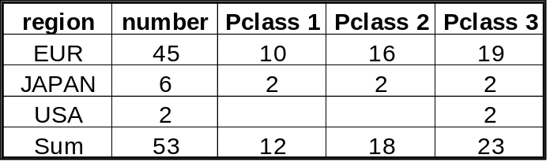
Table 13: Vehicle sample for the emissions validation test programme

Table 14 gives an overview of the distribution of engine type and reduction system within the vehicle sample, Table 15 shows the participating institutes/organisations and Table 16 contains the technical data of the vehicles.
It has to be pointed out that road load settings based on coast down measurements on road were recommended. If such coast down results were not available the settings of the US-FTP specifications should be used. But, these settings are no more up-to-date as the ISO/TC22/WG17 has shown on the basis of new measurements in Japan. In it’s final report the ISO group presented a new list with updated settings. The differences between FTP and ISO/TC22/WG17 settings are depending on vehicle mass and speed. For 11 vehicles the road load settings of the US FTP were not appropriate, most of them are trial and enduro vehicles. It can be expected that for these vehicles the differences are significant.
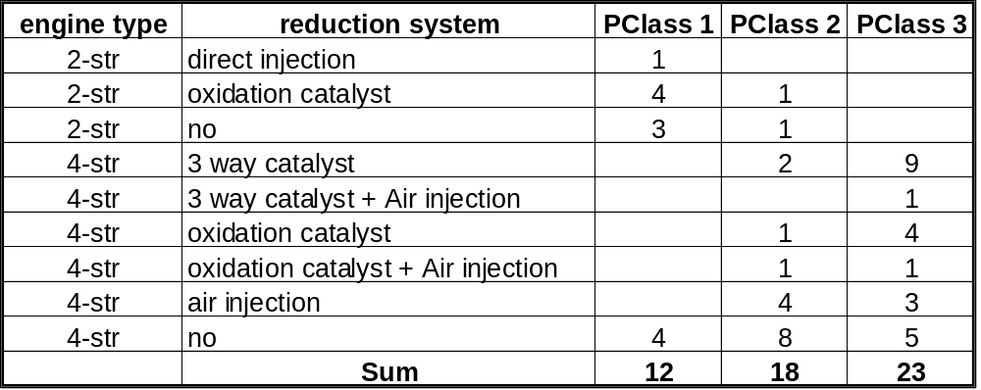
Table 14: Distribution of engine type and reduction system within the vehicle sample

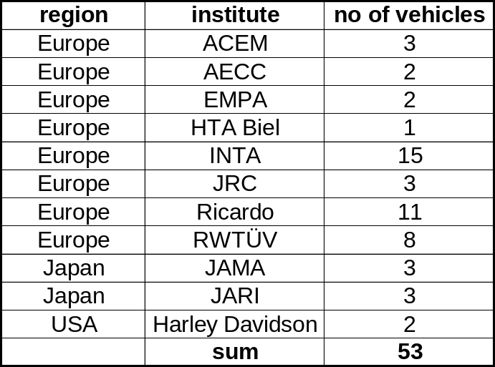
Table 15: Institutes/organisations participating on the emissions validation test programme

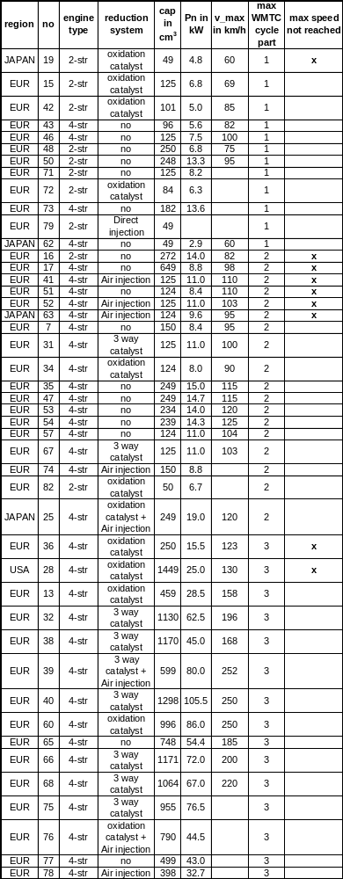
Table 16: Technical data of the vehicles

Results of the Emissions Validation Programme
The results of the emissions validation tests are given in Table 17 to Table 20 in g/test and in Table 21 to Table 24 in g/km. Since the vehicle classification and the weightings are still under discussion the results for the WMTC are shown for each cycle part separately, no overall WMTC result was calculated and no comparison with the results of the regional cycles was carried out.
NEDC denominates the European passenger car test cycle (98/69/EC), TRIAS denominates the Japanese type approval test cycle that is a modified version of the ECE R 40.
A more detailed analysis of the validation test results can be summarised as follows:
The emissions variance is
  - Dependent of individual engine control technique,
  - Dependent of emission level,
  - Independent of traceability,
  - Not different from others if max. roller speed is below max set speed
High variances in emissions results within each vehicle group (engine type/reduction system) due to individual vehicle design, high overlap in range between different groups
The high variances of the emissions results indicate that there is a substantial optimisation potential in some cases. As a consequence substantially lower variances can be expected if the reduction systems are optimised in accordance to the WMTC.

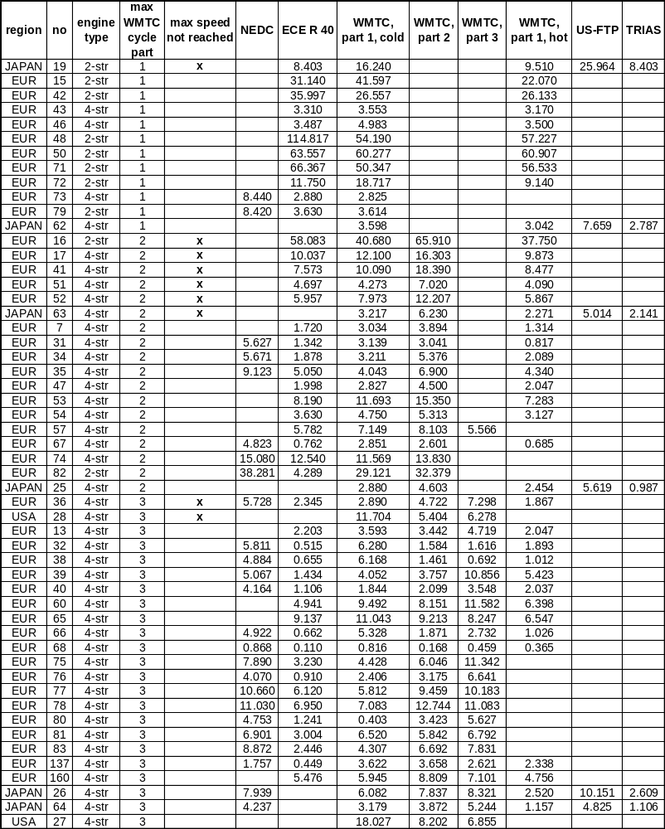
Table 17: Results of the emissions validation tests for HC in g/test

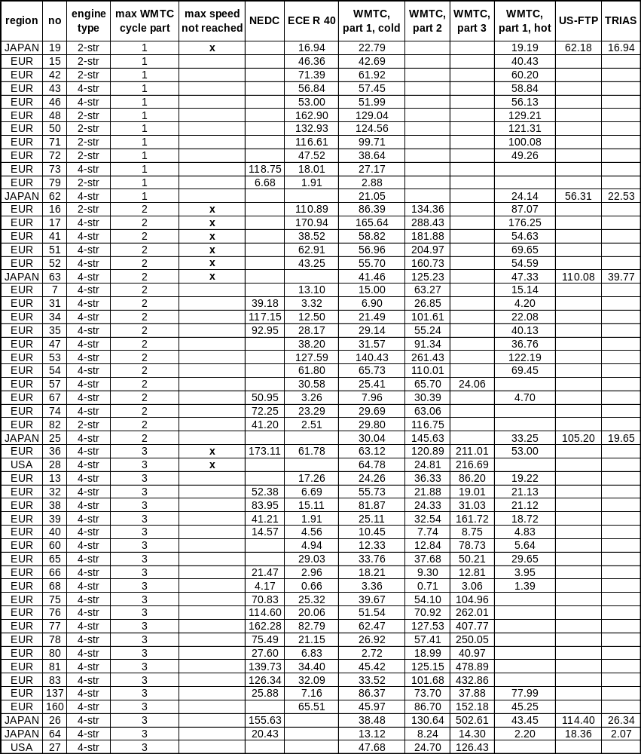
Table 18: Results of the emissions validation tests for CO in g/test

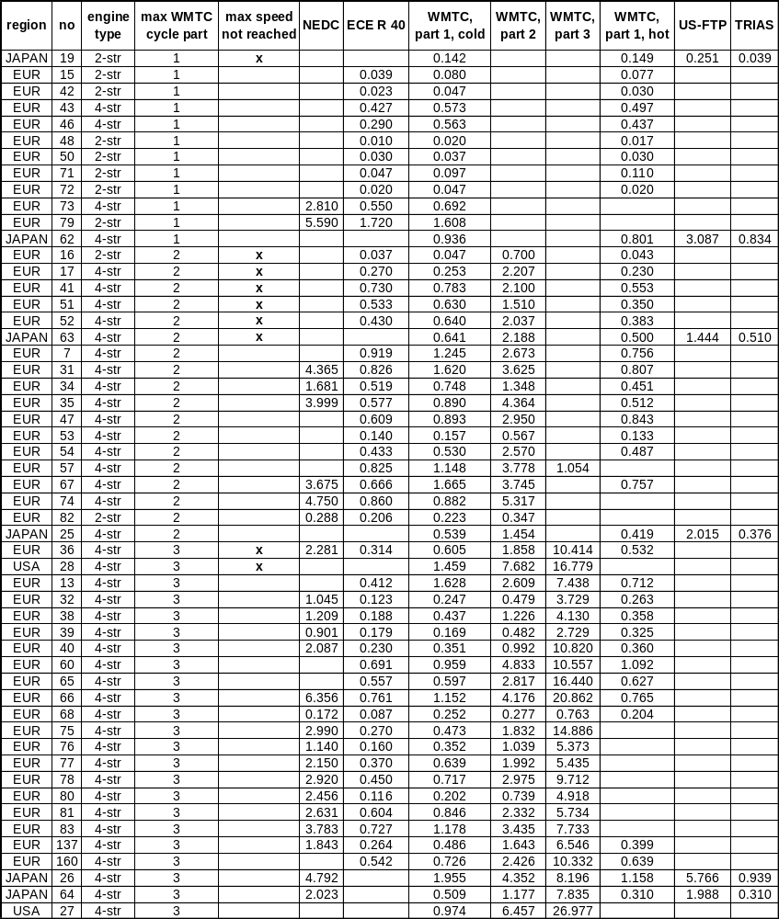
Table 19: Results of the emissions validation tests for NOx in g/test

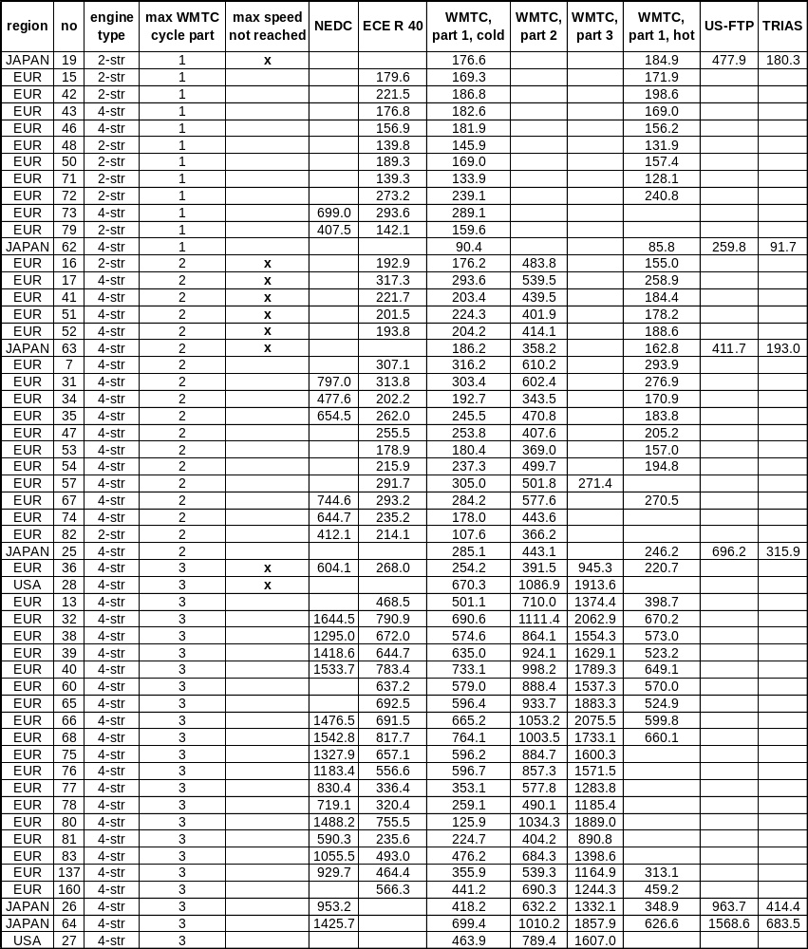
Table 20: Results of the emissions validation tests for CO2 in g/test

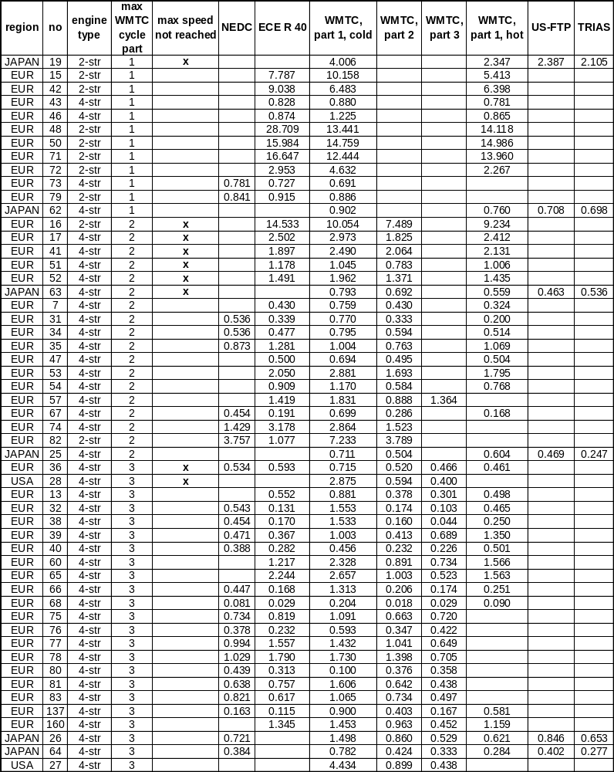
Table 21: Results of the emissions validation tests for HC in g/km

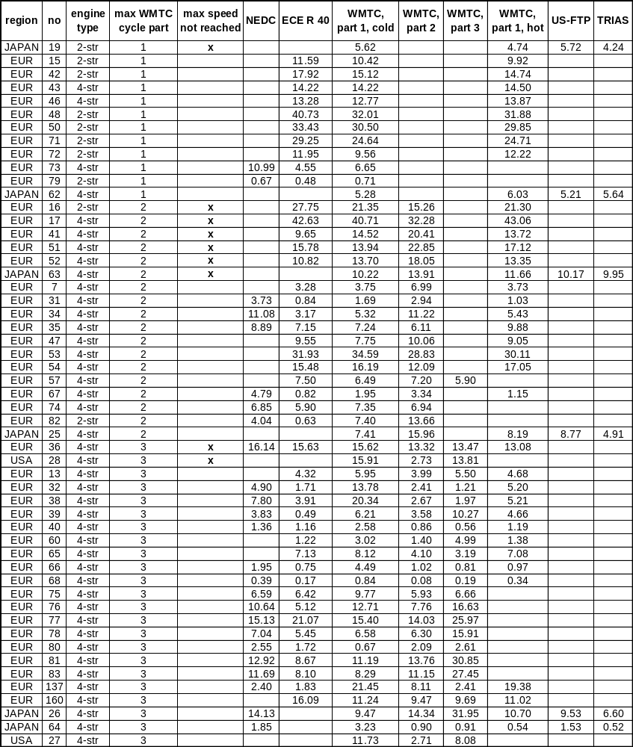
Table 22: Results of the emissions validation tests for CO in g/km

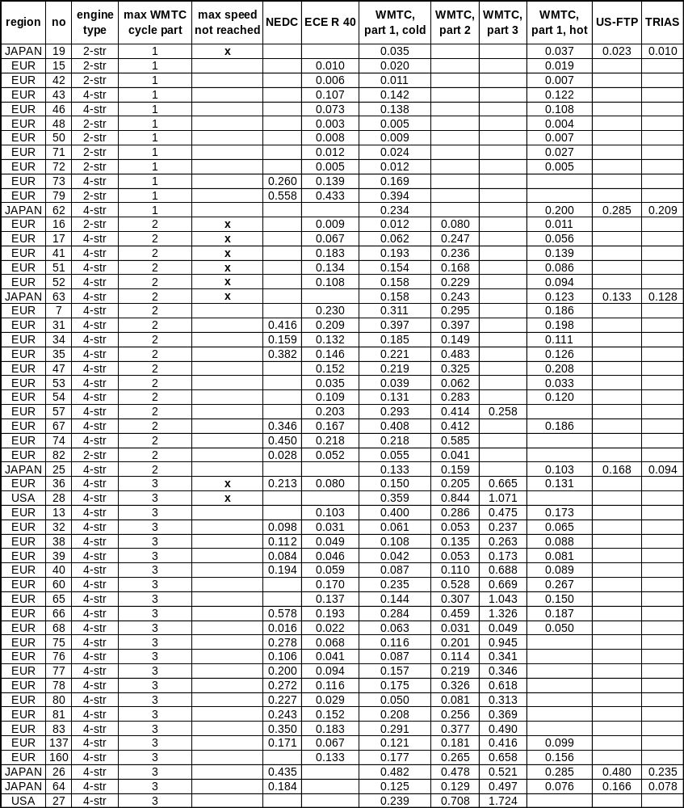
Table 23: Results of the emissions validation tests for NOx in g/km

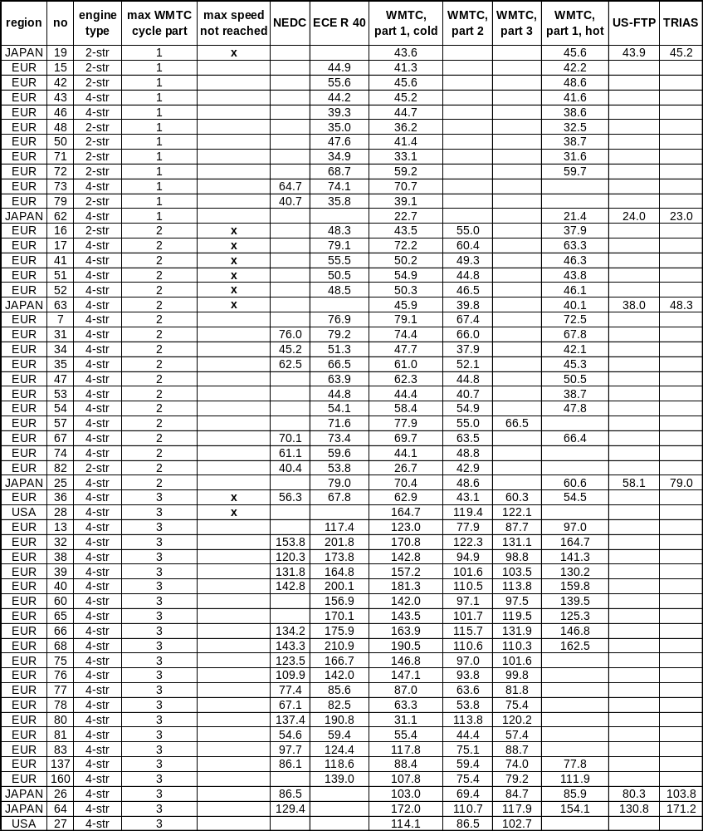
Table 24: Results of the emissions validation tests for CO2 in g/km

Test Protocol
An update of the test protocol was worked out on the basis of the state of the discussion in the WMTC group so far and on the basis of the ISO work on updating ISO 11486 (Motorcycles - Chassis dynamometer setting method) and ISO 6460 (concerning the gas sampling and cooling aspects). This protocol is intended to build the basis for the preparation of the round robin test and is added as Annex C.

Round Robin Test
It is planned to start the round robin test in April 2003. A draft outline of the test foresees to test three vehicles (one per class) in different laboratories in all three regions. The aim is to get experience about the interpretation/application of the WMTC test procedure in different laboratories and to get reliable data for the calculation of the reproducibility of the WMTC test procedure. Results can be expected in the second half of 2003.

Off Cycle Emissions
The discussion has already been started, but this issue is subject of future work. It was recommended by JAMA to intensify the discussion in order to increase the margin for a vehicle classification compromise. Generic aspects and definitions that are worked out in the parallel working HDV- off cycle emission group (GRPE informal group) will be considered for the discussions in the WMTC group.

Summary and Conclusions
The developed test cycle and the accompanying gearshift procedure were tested in several laboratories in all three regions with respect to driveability. They form a good balance between representativity of in-use driving and bench test requirements like reproducibility. The dynamics of the WMTC cycle reflect the average driving behaviour for motorcycles in real live operation.
The final result that will be used for the round robin test starting in Spring 2003 is cycle version 8 with an added special part 1 for 50 cc vehicles.
The road load settings and other test conditions like cooling fan specifications were updated according to the outcome of the ISO work (see updated test protocol).
Although the requirements of the emissions validation programme were not fully met, there are enough valid results left for future analysis. All current reduction systems are represented in the vehicle sample; reduction systems were a bit underrepresented in provisional class 2, whereas the major part of the provisional class 3 vehicles was equipped with reductions systems.
Vehicle classification and weighting of the results are still open issues. The state of the current discussion is shown in this report.
With the developed test cycle, gearshift prescriptions and test protocol a world wide harmonised emissions test procedure for motorcycles can be established. The preparatory work for the start of the round robin test is finished. The major part of the emissions validation test results can be used for a comparison with regional emissions test procedures. With respect to the development of a GTR the open questions of vehicle classification and weighting of results need to be solved and off cycle emission provisions need to be discussed.

Literature
[1] R R.C. Rijkeboer,
WMTC – Final report, TNO Report 01.OR.VM.034.1/RR, by order of the Netherlands Ministry of the Environment (VROM), May 2001
[2] F. Schröder:
“Betriebsweise, Emissionen und Kraftstoffverbrauch von Motorrädern”. Thesis of the Technical University Darmstadt. Published as part of the series Fortschritt-Berichte VDI, Reihe 12, Nr. 435, May 2000
Annex A - Description of the Modification Work on the WMTC Cycle
The following modifications were carried out based on technical discussions in the WMTC group and preliminary tests by the industry.
TNO Automotive did first modifications on the WMTC cycle that are mainly related to the improvement of the driveability. These modifications concern cycle parts below 20 km/h, the smoothing of ripples for the cruising parts caused by vehicle speed measurement uncertainties and the max. speed of part 3 of the cycle. A detailed description of these modifications is given in [1].
The resulting cycle was named “version 3” and is shown in Figure 15 to Figure 17.

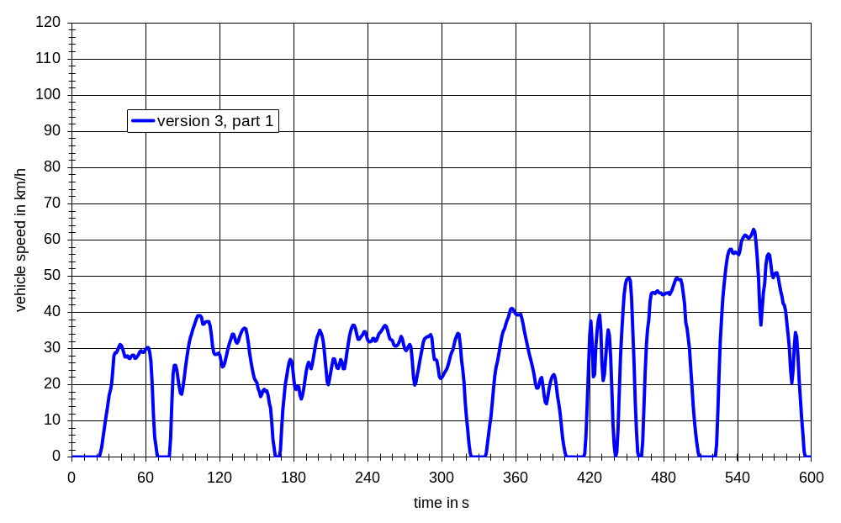
Figure 15: Cycle version 3, part 1

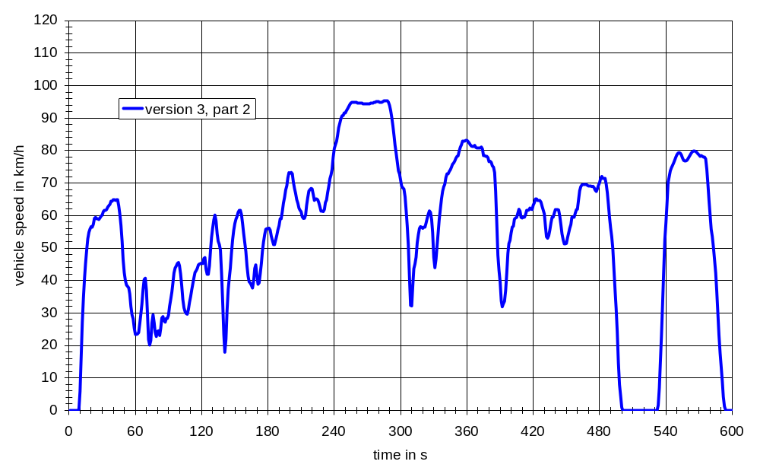
Figure 16: Cycle version 3, part 2

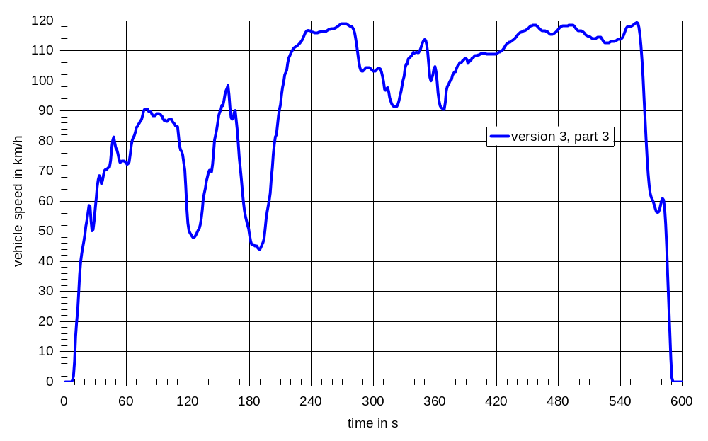
Figure 17: Cycle version 3, part 3

RWTÜV Fahrzeug carried out further modifications on the basis of discussions and decisions in the WMTC group.
The following modifications were done in a second step:
Part 1:
- Modules 2, 3 and 5 of part 1 were replaced by more representative ones (length, average speed and dynamics were kept),
- The rank order of the modules was changed (module 8 was shifted to the 2nd position),
- The top speed of module 8 was limited to 60 km/h,
- The idle time distribution was brought in line with the statistics.
Part 3:
- The top speed was increased to 125 km/h.
These modifications resulted in version 4.
Furthermore an analysis of the acceleration pattern showed unrealistic “jumps” in some cycle phases. Smoothing the acceleration pattern and recalculating the vehicle speed pattern from the smoothed acceleration pattern eliminated these „jumps“. This results in version 5. Version 5 was used for the driveability validation tests and is shown in Figure 18 to Figure 20.

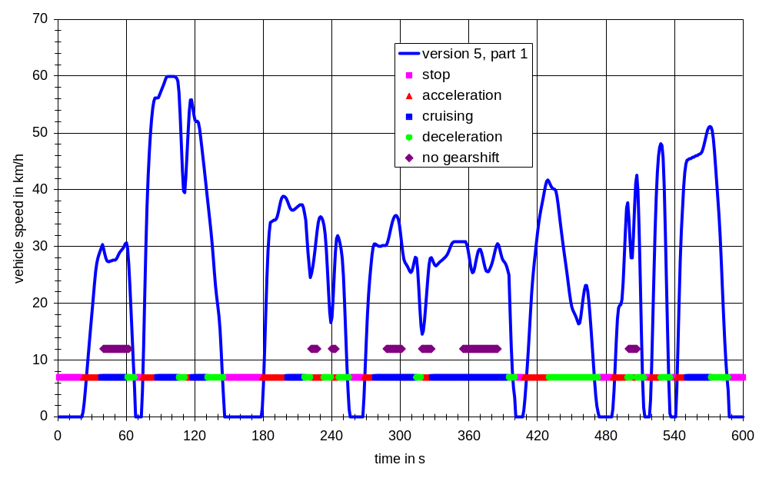
Figure 18: Cycle version 5, part 1
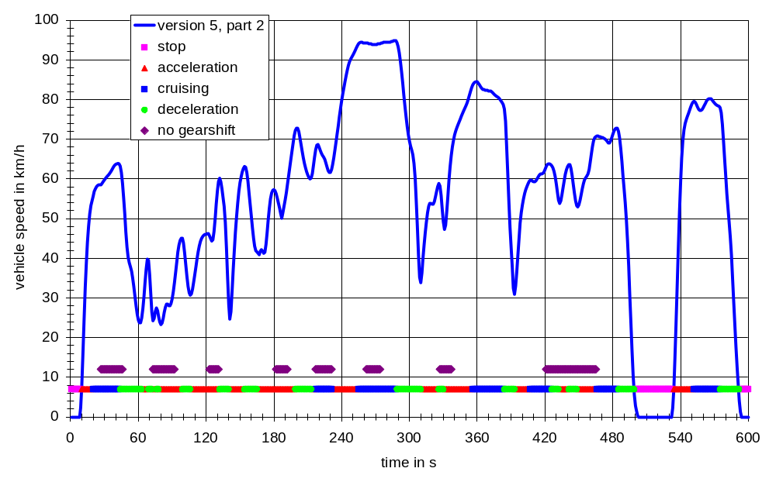
Figure 19: Cycle version 5, part 2

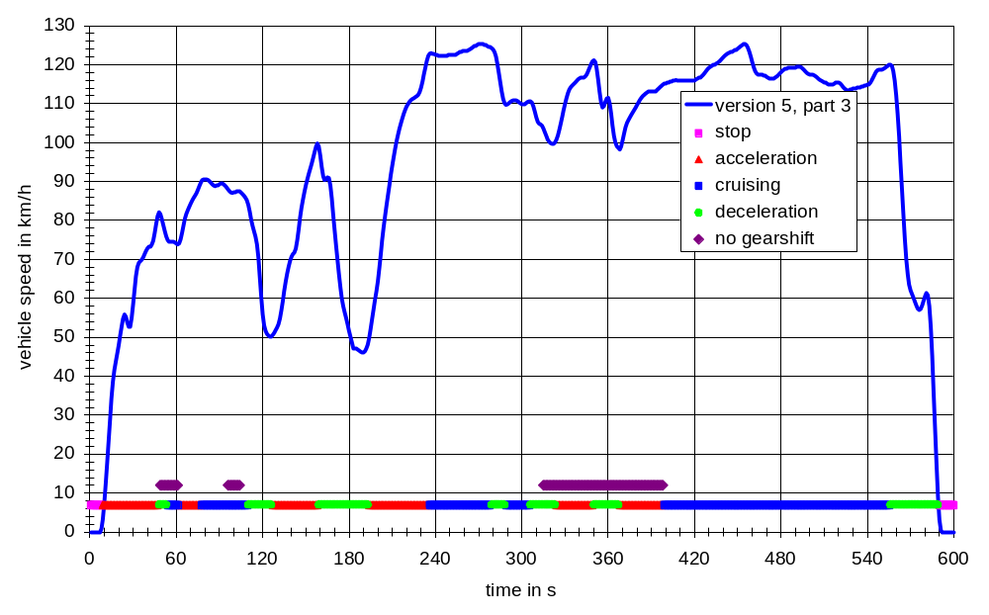
Figure 20: Cycle version 5, part 3

Since vehicle speed pattern and gearshift procedure are closely linked, the elimination of malfunctions in the gearshift procedure resulted in cycle version 6.
As an outcome of the driveability validation tests the following modifications led to version 7 which is now the basis for the emissions validation:
In part 1 the modules 2 and 3 were exchanged to get a more realistic pattern for the cold start phase.
To reduce the risk of wheel lock cycle phases with excessive decelerations were modified so that the following limitations are fulfilled:
- vehicle acceleration <= -2m/s²
- acceleration * vehicle speed <= -30 m²/s³
The second criterion (acceleration*vehicle speed) was necessary because there were still some sections in the cycles with acceleration values above -2 m/s² that caused wheel lock in some cases. The modified cycles (version 7) are shown in Figure 21 to Figure 23.

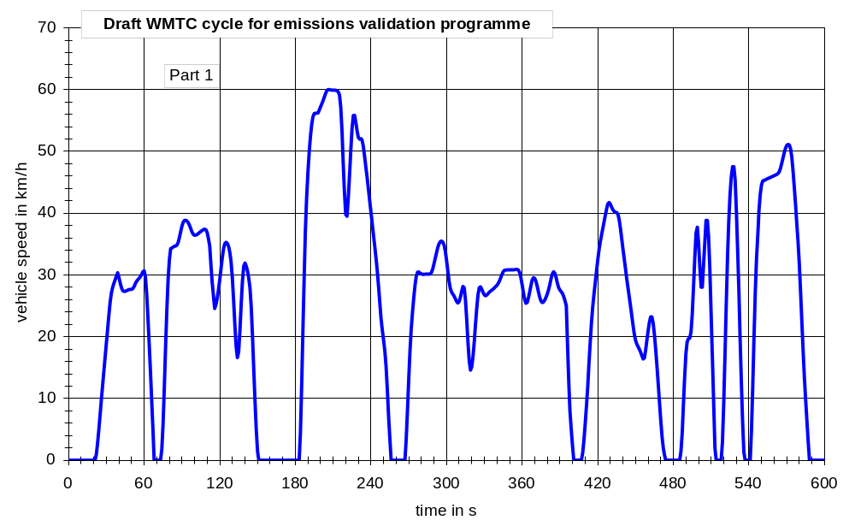
Figure 21: Cycle version 7, part 1

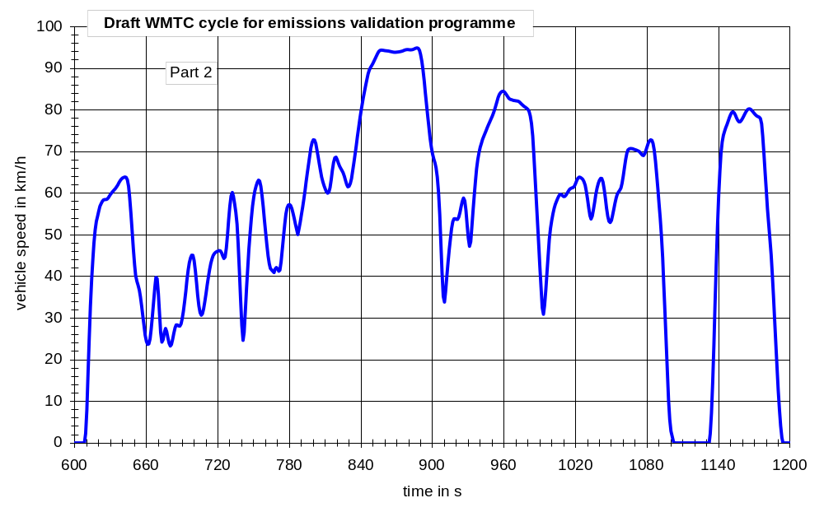
Figure 22: Cycle version 7, part 2

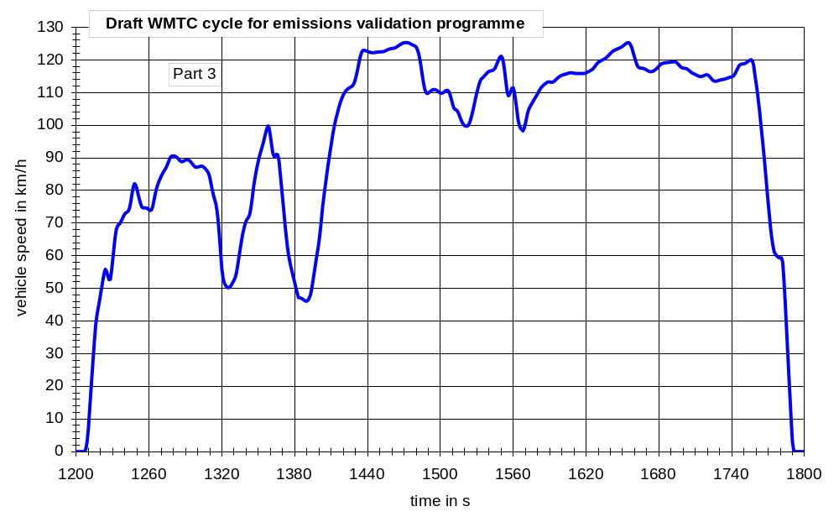
Figure 23: Cycle version 7, part 3

Although the results of a detailed analysis of the tyre slip phenomenon showed that the dynamics of the WMTC do not cause higher risks for tyre slip than existing certification cycles it was decided in the WMTC group that this risk should be minimised for the WMTC to improve driveability, independent of the situation for existing cycles.
A renewed analysis showed that the transitions from standstill to ride and vice versa become smooth enough if da/dt is between -0.8 m/s²/s and +0.8 m/s²/s. Consequently the vehicle speed pattern were modified until da/dt falls into that range.
Since it is logical to apply the same criterion also for phases in ride condition where da/dt is outside this range (in cases where a deceleration is immediately followed by an acceleration and vice versa), these cycle phases were modified accordingly.
The results are shown in the following figures.

Figure 24: Cycle version 8, part 1

Figure 25: Cycle version 8, part 2

Figure 26: Cycle version 8, part 3

During the WMTC FE meeting in Tokyo in April 2002 the Japanese delegation requested a special version of part 1 with a top speed of 50 km/h for low powered motorcycles whose technical specifications are close to mopeds.
Since there is only one module in part 1 with vehicle speeds above 50 km/h (module 3), only this module was modified. The first part was replaced by a module taken from in-use measurements of vehicle 6 (this module was closest to the existing one) and the second part was lowered in speed to fulfil the limitation of 50 km/h.
The result is shown in the following figure.

Figure 27: Cycle version 8, part 1, reduced speed, with top speed limited to 50 km/h for low powered motorcycles with 50 cm³ engine capacity whose technical specifications are close to mopeds

Annex B – Final Cycle Version
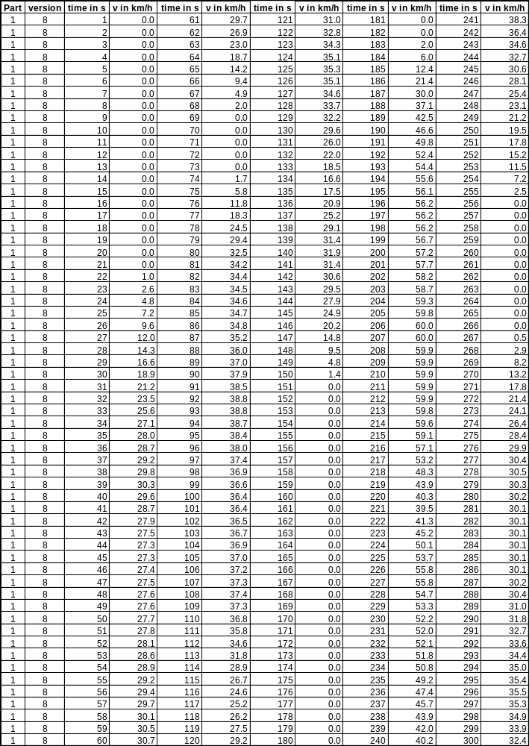
Table 25: WMTC, part 1, version 8, 1 to 300 s
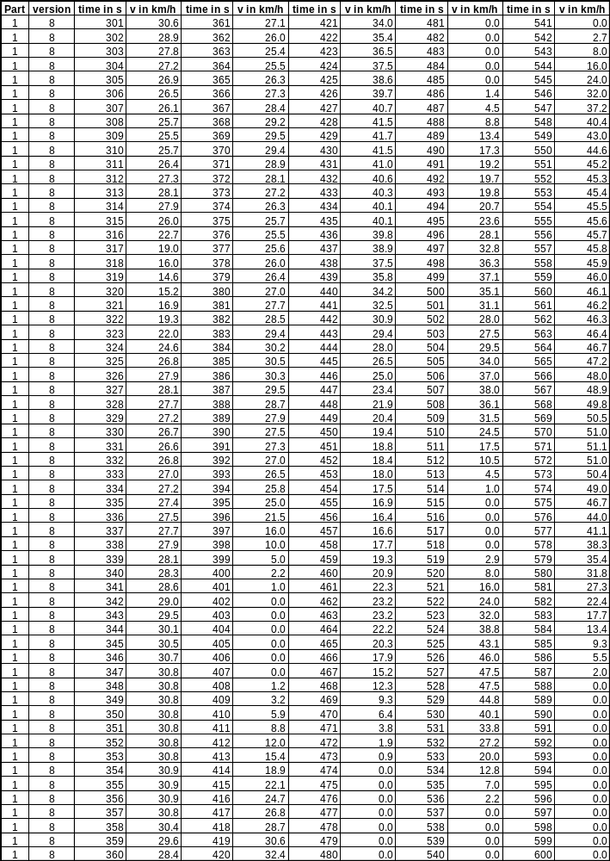
Table 26: WMTC, part 1, version 8, 301 to 600 s
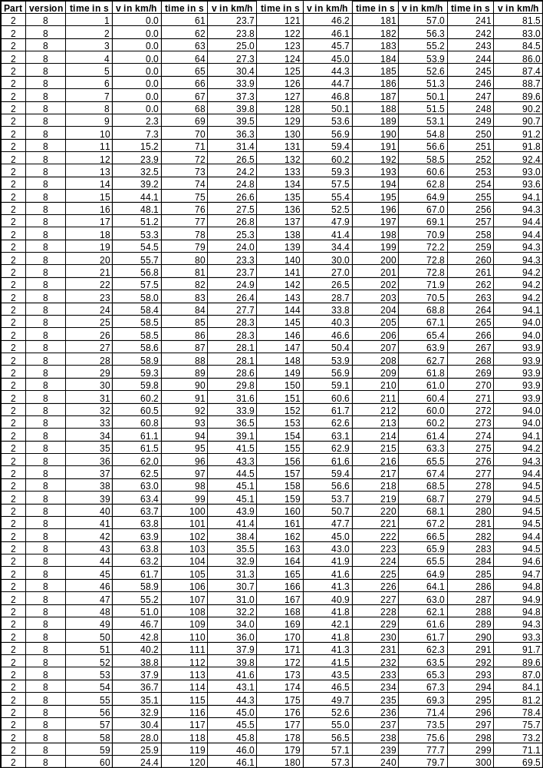
Table 27: WMTC, part 2, version 8, 1 to 300 s
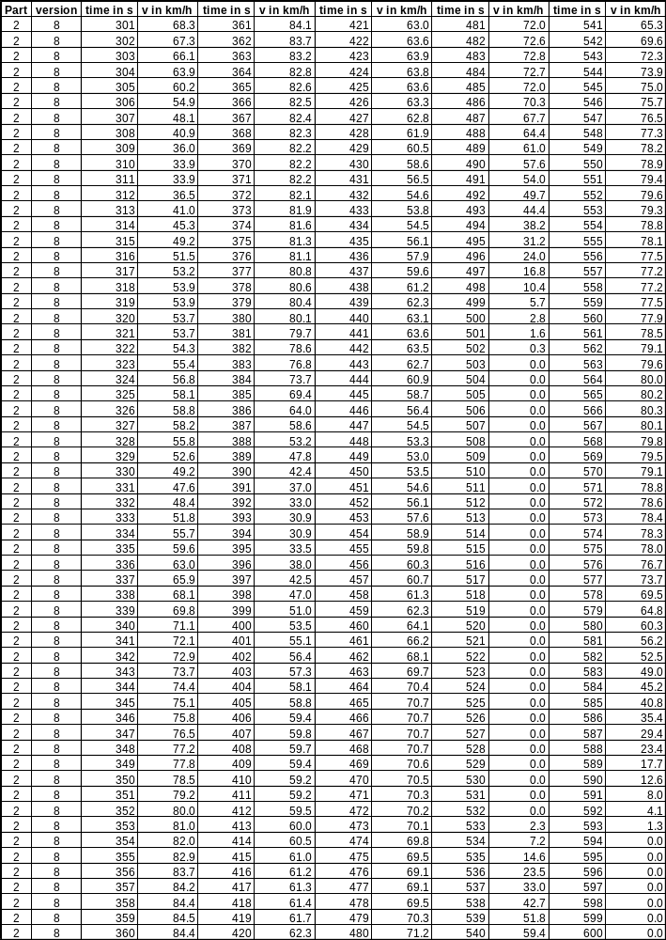
Table 28: WMTC, part 2, version 8, 301 to 600 s
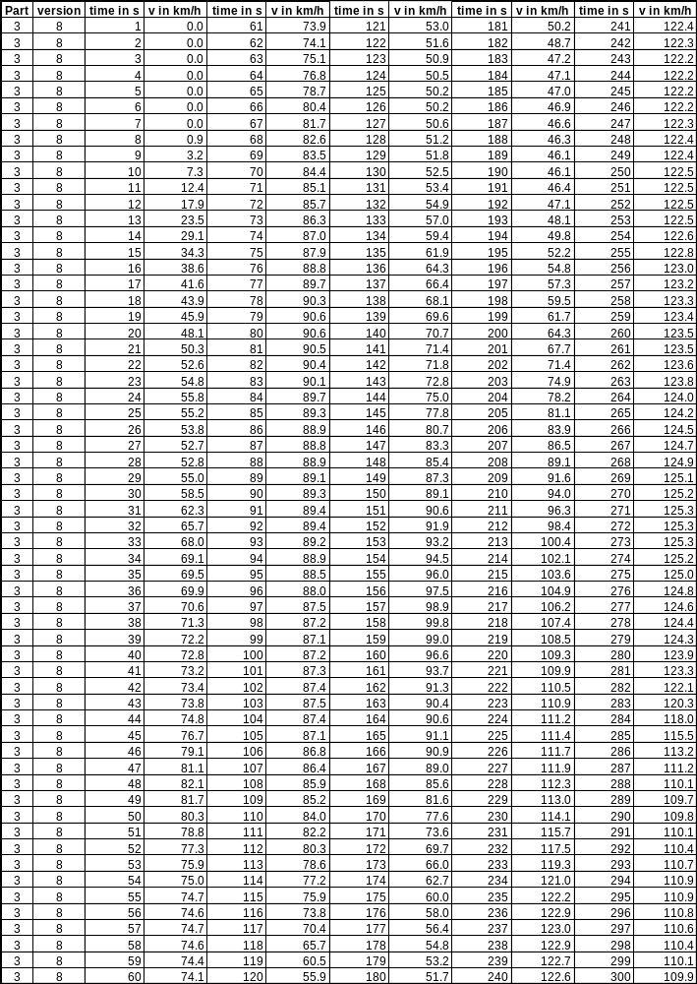
Table 29: WMTC, part 3, version 8, 1 to 300 s
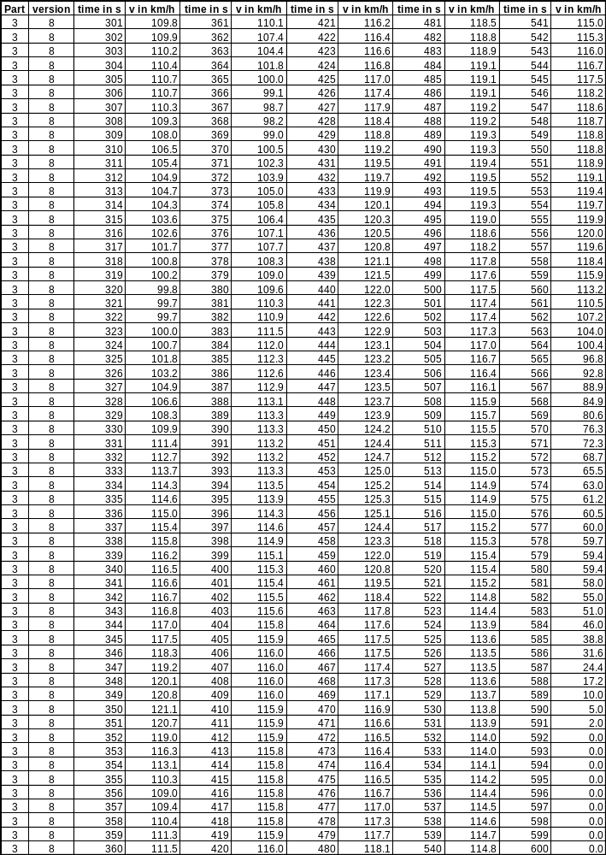
Table 30: WMTC, part 3, version 8, 301 to 600 s
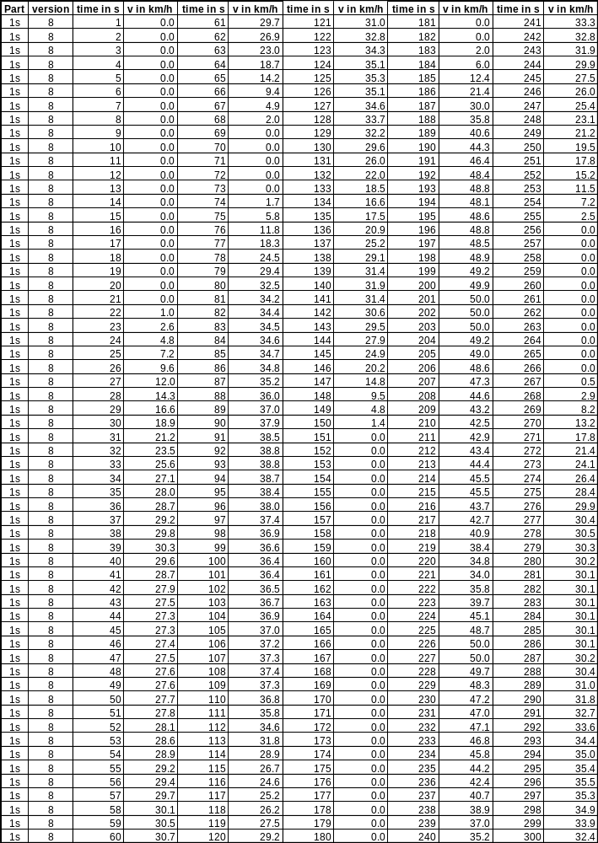
Table 31: WMTC, part 1, reduced speed, version 8, 1 to 300 s
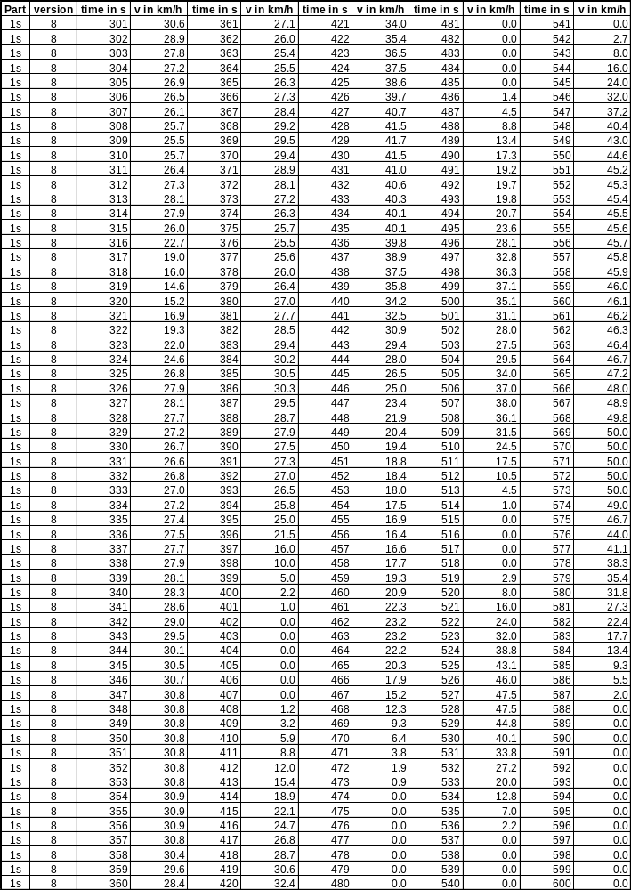
Table 32: WMTC, part 1, reduced speed, version 8, 301 to 600 s
Annex C – Test Protocol
With Appendix A – US-FTP Subpart F, Emission Regulations for 1978 and Later New Motor-cycles; Test Procedures

Test Bench Measurement Specifications
The test bench measurement specifications are based on the US FTP procedure as specified in subpart F. Subpart F is attached to this protocol. The following chapters contain modifications or updates, mainly based on the work of ISO/TC22/SC22/WG17 with respect to work on updating ISO 11486 (Motorcycles - Chassis dynamometer setting method) and ISO 6460 (concerning the gas sampling and cooling aspects).

Emission Components
The following emission components have to be measured:
- HC
- NO_{x}
- CO
- CO₂

Exhaust Gas Measurement System
The gas-collection device is described below (proposal of ISO/TC22/SC22/WG17 for revision of ISO 6460).
- This device shall be a closed type device that can collect all exhaust gases at the motorcycle exhaust outlet(s) on condition that it satisfies the back pressure condition of ±125mm H2O. An open system may be used as well if it is confirmed that all the exhaust gases are collected. The gas collection shall be such that there is no condensation which could appreciably modify that nature of exhaust gases at the test temperature.
- A connecting tube between the device and the exhaust gas sampling system. This tube, and the device shall be made of stainless steel, or of some other material which does not affect the composition of the gases collected and which withstands the temperature of these gases.
- A heat exchanger capable of limiting the temperature variation of the diluted gases in the pump intake to ±5°C throughout the test. This exchanger shall be equipped with a preheating system able to bring the exchanger to its operating temperature (with the tolerance of ±5°C) before the test begins.
- A positive displacement pump to draw in the dilute exhaust mixture. This pump is equipped with a motor having several strictly controlled uniform speeds. The pump capacity shall be large enough to ensure the intake of the exhaust gases. A device using a critical flow Venturi may also be used.
- A device to allow continuous recording of the diluted exhaust mixture entering the pump.
- Two gauges; the first to ensure the pressure depression of the dilute exhaust mixture entering the pump, relative to atmospheric pressure, the other to measure the dynamic pressure variation of the positive displacement pump.
- A probe located near to, but outside the gas collecting device, to collect, through a pump, a filter and a flowmeter, samples of the dilution air stream, at constant flow rates throughout the test.
- A sample probe pointed upstream into the dilute exhaust mixture flow, upstream of the positive displacement pump to collect, through a pump, a filter and a flowmeter, samples of the dilute exhaust mixture, at constant flow rates, throughout the test.
- The minimum sample flow rate in the two sampling devices described above and in (g) shall be at least 150 l/h.
- Three way valves on the sampling system described in (g) and (h) to direct the samples either to their respective bags or to the outside throughout the test.
- Gas-tight collection bags for dilution air and dilute exhaust mixture of sufficient capacity so as not to impede normal sample flow and which will not change the nature of the pollutants concerned.
- The bags shall have an automatic self-locking device and shall be easily and tightly fastened either to the sampling system or the analyzing system at the end of the test.
- A revolution counter to count the revolutions of the positive displacement pump throughout the test.
NOTE1 Good care shall be taken on the connecting method and the material or configuration of the connecting parts because there is a possibility that each section (e.g. the adapter and the coupler) of the sampling system becomes very hot. It the measurement cannot be performed normally due to heat-damages of the sampling system, an auxiliary cooling device may be used as long as the exhaust gases are not affected.
NOTE 2 Open type devices have risks of incomplete gas collection and gas leakage into the test cell. It is necessary to make sure there is no leakage throughout the sampling period.
NOTE 3 If a constant CVS flow rate is used throughout the test cycle that includes low and high speeds all in one (i.e. Part 1, 2 and 3 cycles of WMTC validation test step 2 mode), special attention should be paid because of higher risk of water condensation in high speed range.
The exhaust gas analytical system shall comply with the requirements of the US certification procedure. (see Subpart F, Sec. 86.511-90. See also Sec. 86.514-78 for the requirements for analytical gases.)
The measurement system has to be calibrated as described in the regional certification procedures.

Fuel and Engine Lubricant Specifications
Each region has its own specifications for the fuel and engine lubricants. The US specifications are described in Subpart F, Sec. 86.513-94, the European specifications are described in Annex II, of 97/24 Ch. 5 EC, the Japanese specifications in TRIAS 23-6-1999
Each region should use its own specifications. For the European part of the validation program, it is quite clear that advanced fuel specs are the most appropriate. Therefore the 2000 reference fuel of directive 98/69/EC should be used, but with a reduced aromatics content (max 35%v/v) and a reduced Sulphur content of max 50 ppm.
It should be clarified by an additional step to what extend differences in the fuel specification influences the emissions results.

Dynamometer

General
The following requirements are copied from the US certification procedure (Subpart F, Sec. 86.508-78).
- The dynamometer shall have a single roll with a diameter of at least 0.400 meter.
(b) The dynamometer shall be equipped with a roll revolution counter for measuring actual distance travelled.
- Flywheels or other means shall be used to stimulate the inertia specified in Chapter 5.
- Cooling fan specifications as proposed by ISO/TC22/SC22/WG17 for revision of ISO 6460:
Throughout the test, a variable speed cooling blower shall be positioned in front of the motorcycle, so as to direct the cooling air to the motorcycle in a manner which simulates actual operating conditions. The blower speed shall be such that, within the operating range of 10 to 50 km/h, the linear velocity of the air at the blower outlet is within ±5 km/h of the corresponding roller speed. And at the range of over 50 km/h, the linear velocity of the air shall be within ±10%. At roller speeds of less than 10 km/h, air velocity may be zero.
The above mentioned air velocity shall be determined as an averaged value of 9 measuring points which are located at the centre of each rectangle dividing whole of the blower outlet into 9 areas (dividing both of horizontal and vertical sides of the blower outlet into 3 equal parts). Each value at those 9 points shall be within 10% of the averaged value of themselves.
The blower outlet shall have a cross section area of at least 0,4 m2 and the bottom of the blower outlet shall be between 5 and 20 cm above floor level. The blower outlet shall be perpendicular to the longitudinal axis of the motorcycle between 30 and 45 cm in front of its front wheel. The device used to measure the linear velocity of the air shall be located at between 0 and 20 cm from the air outlet.
- The dynamometer shall comply with the tolerances in Subpart F, Sec 86.529.

Dynamometer calibration (see Subpart F, Sec. 86.518-78)
- The dynamometer shall be calibrated at least once each month or performance verified at least once each week and then calibrated as required. The dynamometer is driven above the test speed range. The device used to drive the dynamometer is then disengaged from the dynamometer and the roll is allowed to coast down. The kinetic energy of the system is dissipated by the dynamometer. This method neglects the variations in roll bearing friction due to the drive axle weight of the vehicle.
- Calibration shall consist of coasting down the dynamometer for each inertia load combination used. Coast down times for the interval from 70 to 60 km/h shall be within the tolerances specified in Sec. 86.529. The dynamometer adjustments necessary to produce these results shall be noted for future reference.
- The performance check consists of conducting a dynamometer coast down at one or more inertia-horsepower settings and comparing the coast down time to the table in Figure F98-9 of chapter 5. If the coast down time is outside the tolerance, a new calibration is required.
The max. speed of the FTP75 cycle is 91 km/h. The max. speed of part 3 of the WMTC is significantly higher (125 km/h). Therefore shall be examined in step 1 whether the speed range for the coast down has to be extended to higher speeds.
It is recommended to perform on road coast down measurements for validation reasons.

Road Load Force and Inertia Weight Determination

Actual Vehicle Road load Measurements
See chapters 7 to 9 of ISO/WD 11486, ISO/TC22/SC22/WG17 REPORT TO WMTC FE

Chassis dynamometer setting using the running resistance table
See chapter 10 of ISO/WD 11486, ISO/TC22/SC22/WG17 REPORT TO WMTC FE
If the max. speed of a vehicle as declared by the manufacturer is below 130 km/h and this speed cannot be reached on the roller bench with the test bench settings defined by table 4 of ISO/WD 11486, the coefficient b has to be adjusted so that the max. speed will be reached.

Test Procedures, Overview (See Subpart F, Sec. 86.527-90)
- The overall test consists of prescribed sequences of fuelling, parking, and operating conditions.
- The exhaust emission test is designed to determine hydrocarbon (gasoline-fuelled, natural gas-fuelled and liquefied petroleum gas-fuelled motorcycles), carbon monoxide and oxides of nitrogen mass emissions while simulating real world operation. The test consists of engine start ups and motorcycle operation on a chassis dynamometer, through a specified driving schedule. A proportional part of the diluted exhaust emissions is collected continuously for subsequent analysis, using a constant volume (variable dilution) sampler.
- Except in cases of component malfunction or failure, all emission control systems installed on or incorporated in a new motorcycle shall be functioning during all procedures.
- Background concentrations are measured for all species for which emissions measurements are made. For exhaust testing, this requires sampling and analysis of the dilution air.

Drive Instructions

General
- The motorcycle must be presented in good mechanical condition. It must have been run in and driven at least 1 000 km before the test.
- The vehicle shall be driven with minimum throttle movement to maintain the desired speed. No simultaneous use of brake and throttle shall be permitted.
- If the vehicle cannot accelerate at the specified rate, the vehicle shall be operated with the throttle fully opened until the vehicle speed reaches the value prescribed for that time in the driving schedule.

Vehicles with Automatic Transmission (see Subpart F, Sec. 86.528-78)
- Vehicles equipped with transfer cases, multiple sprockets, etc., shall be tested in the manufacturer's recommended configuration for street or highway use.
- All tests shall be conducted with automatic transmissions in "Drive" (highest gear). Automatic clutch-torque converter transmissions may be shifted as manual transmissions at the option of the manufacturer.
- Idle modes shall be run with automatic transmissions in "Drive'' and the wheels braked.
- Automatic transmissions shall shift automatically through the normal sequence of gears;
- The deceleration modes shall be run in gear using brakes or throttle as necessary to maintain the desired speed.

Vehicles with Manual Transmission
- Idle modes shall be run with manual transmissions in 1. gear with the clutch disengaged.
- For acceleration phases manual transmissions shall be shifted from 1. to 2. gear when the engine speed reaches a value according to the following formula:
n_max-acc(1) = (0,5753*exp(-1,9*(Pn/(m0 + 75 kg)) - 0,10)*(s - n_idle) + n_idle
Pn - rated power in kW
m0 – kerb mass in kg
n – engine speed in min⁻¹
n_idle – idling speed in min⁻¹
s - rated engine speed in min⁻¹
- Upshifts for higher gears have to be carried out during acceleration phases when the engine speed reaches a value according to the following formula:
n_max_acc(i) = (0, 5753*exp(-1,9*(Pn/(m0 + 75 kg)))*(s - n_idle) + n_idle
Pn - rated power in kW
m0 – kerb mass in kg
n – engine speed in min⁻¹
n_idle – idling speed in min⁻¹
s - rated engine speed in min⁻¹ at max. power
i – gear number (>= 2)
- The minimum engine speeds for acceleration phases in gear 2 or higher gears are accordingly defined by the following formula:
n_min_acc(i) = n_max_acc(i-1)*r(i)/r(i-1)
r(i) – ratio of gear i
- The minimum engine speeds for deceleration phases or cruising phases in gear 2 or higher gears are defined by the following formula:
n_min_dec(i) = n_min_acc(i-1)*r(i)/r(i-1)
r(i) – ratio of gear I
When reaching these values during deceleration phases the manual transmission has to be shifted to the next lower gear (see Figure 28).

Figure 28: Example for gearshift points

- There are fixed allocations for acceleration, cruising and deceleration phases (see excel spreadsheet “gearselection_0_v8_EU_J_USA”)
- Gearshifts are prohibited for indicated cycle sections (see excel spreadsheet “gearselection_0_v8_EU_J_USA”)
- Downshifts to the 1. gear are prohibited for those modes which require the vehicle to decelerate to zero.
- Manual transmissions gear shifts shall be accomplished with minimum time with the operator closing the throttle during each shift.
- For those modes that require the vehicle to decelerate to zero, manual transmission clutches shall be disengaged when the speed drops below 10 km/h, when engine roughness is evident, or when engine stalling is imminent.
- While the clutch is disengaged the vehicle shall be shifted to the appropriate gear for starting the next mode.
In general it is allowed to use higher shift speeds than indicated in the calculation sheet.
For vehicles with a very low max. speed and low power to mass ratio it may happen, that the calculation sheet skips gears during acceleration and deceleration phases. The phases where this may occur are indicated in the figures of the spreadsheet. In case of gear s kipping appropriate corrections have to be made by the user either by decreasing the minimum time span for a gear from 3 s to 2 s or by using higher engine speeds.
All deviations from the shift points of the calculation sheet have to be indicated in the results form.
For other cycles please refer to the gearshift prescriptions of the corresponding measurement procedure. If this procedure allows alternatives that one chosen for the test has to be reported.

Test Sequence

General Requirements (see Subpart F, Sec. 86.530-78)
  - Ambient temperature levels encountered by the test vehicle throughout the test sequence shall not be less than 20 °C (68 °F) nor more than 30 °C (86 °F). The vehicle shall be approximately level during the emission test to prevent abnormal fuel distribution.

Vehicle Preparation (see Subpart F, Sec. 86.531-78)
- The manufacturer shall provide additional fittings and adapters, as required to accommodate a fuel drain at the lowest point possible in the tank(s) as installed on the vehicle and to provide for exhaust sample collection.

Vehicle preconditioning (see Subpart F, Sec. 86.532-78)
- The vehicle shall be moved to the test area and the following operations performed:
  - The fuel tank(s) shall be drained through the provided fuel tank(s) drain(s) and charged with the specified test fuel to half the tank(s) capacity.
  - The vehicle shall be placed, either by being driven or pushed, on a dynamometer and operated through the WMTC cycle part 1. The vehicle need not be cold, and may be used to set dynamometer horsepower.
- Practice runs over the prescribed driving schedule may be performed at test points, provided an emission sample is not taken, for the purpose of finding the minimum throttle action to maintain the proper speed-time relationship, or to permit sampling system adjustments.
- Within five (5) minutes of completion of preconditioning, the vehicle shall be removed from the dynamometer and may be driven or pushed to the soak area to be parked. The vehicle shall be stored for not less than 12 hours prior to the cold start exhaust test or until oil Tª, cooling Tª or spark plug Tª equals the air temperature of the soak area.
- In no case shall the vehicle be stored for more than 36 hours prior to the cold start exhaust test.

Dynamometer Procedure

General (see Subpart F, Sec. 86.535-90)
- The following vehicle classification reflects the WMTC Chairman’s proposal and should be used as long as the vehicle classification is still under discussion.
Depending on the engine capacity and the max. speed of the vehicle as declared by the manufacturer the following parts of the WMTC have to be run:
WMTC part 1, special engine capacity up to 50 cm³, v_max higher than 50 km/h, but not higher than 60 km/h
WMTC part 1: engine capacity higher than 50 cm³,
WMTC part 2: engine capacity higher than 50 cm³, but lower than 150 cm³:
v_max 80 km/h or higher,
engine capacity equal to or higher than 150 cm³:
v_max below 120 km/h
WMTC part 3: engine capacity equal to or higher than 150 cm³,
v_max 120 km/h or higher
v_max is the maximum vehicle speed as declared by the manufacturer.
- The dynamometer test consists of consecutive parts, a "cold'' start part using the WMTC part 1 followed by WMTC part 2 (if requested in (a)), WMTC part 3 (if requested in (a)) and part 1 in "hot'' condition. The emissions of each part have to be sampled in a separate bag.
If a motorcycle has to be tested in all 3 parts of the WMTC and the measurement device is equipped with no more than 3 bags, use the 3 bags for part 1 (cold start), part 2 and part 3. Then establish a hot soak period of 10 min to reset one bag and start part 1 in hot condition. The same procedure is used in the US-FTP (see 3.8.3 and Subpart F, Sec. 86.537-90 (b)
- Engine startup (with all accessories turned off), operation over the driving schedule, and engine shutdown make a complete cold start test. Engine startup and operation over the WMTC part 1 complete the hot start test. The exhaust emissions are diluted with ambient air and a continuously proportional sample is collected for analysis during each phase. The composite samples collected in bags are analysed for hydrocarbons, carbon monoxide, carbon dioxide, and for oxides of nitrogen. A parallel sample of the dilution air is similarly analysed for hydrocarbon, carbon monoxide, carbon dioxide, and for oxides of nitrogen.
- The vehicle speed, as measured from the dynamometer roll, shall be used. A speed vs. time recording, as evidence of dynamometer test validity, shall be supplied.
- The drive wheel tires must be inflated to the manufacturer's recommended pressure, 15 kPa (2.2 psi). The drive wheel tire pressure shall be reported with the test results.
- If the dynamometer has not been operated during the two-hour period immediately preceding the test, it shall be warmed up for 15 minutes by operating at 50 km/h (31 mph) using a nontest vehicle, or as recommended by the dynamometer manufacturer.
- If the dynamometer horsepower must be adjusted manually, it shall be set within one hour prior to the exhaust emissions test phase. The test vehicle shall not be used to make this adjustment. Dynamometers using automatic control of preselectable power settings may be set anytime prior to the beginning of the emissions test.
- The driving distance, as measured by counting the number of dynamometer roll revolutions, shall be determined for all parts of the test.

Engine Starting and Restarting (see Subpart F, Sec. 86.536-78)
  - The engine shall be started according to the manufacturer's recommended starting procedures. The initial 20 second idle period shall begin when the engine starts.
  - Choke operation.
  - Vehicles equipped with automatic chokes shall be operated according to the instructions in the manufacturer's operating instructions or owner's manual including choke setting and "kick-down'' from cold fast idle. The transmission shall be placed in gear 15 seconds after the engine is started. If necessary, braking may be employed to keep the drive wheels from turning.
  - Vehicles equipped with manual chokes shall be operated according to the manufacturer's operating instructions or owner's manual. Where times are provided in the instructions, the point for operation may be specified, within 15 seconds of the recommended time.
  - The operator may use the choke, throttle etc. where necessary to keep the engine running.
  - If the manufacturer's operating instructions or owner's manual do not specify a warm engine starting procedure, the engine (automatic and manual choke engines) shall be started by opening the throttle about half way and cranking the engine until it starts.
  - If, during the cold start, the vehicle does not start after 10 seconds of cranking, or ten cycles of the manual starting mechanism, cranking shall cease and the reason for failure to start determined. The revolution counter on the constant volume sampler shall be turned off and the sample solenoid valves placed in the "standby'' position during this diagnostic period. In addition, either the CVS blower shall be turned off or the exhaust tube disconnected from the tailpipe during the diagnostic period.
- If failure to start is an operational error, the vehicle shall be rescheduled for testing from a cold start. If failure to start is caused by vehicle malfunction, corrective action (following the unscheduled maintenance provisions) of less than 30 minutes duration may be taken and the test continued. The sampling system shall be reactivated at the same time cranking is started. When the engine starts, the driving schedule timing sequence shall begin. If failure to start is caused by vehicle malfunction and the vehicle cannot be started, the test shall be voided, the vehicle removed from the dynamometer, corrective action taken (following the unscheduled maintenance provisions), and the vehicle rescheduled for test. The reason for the malfunction (if determined) and the corrective action taken shall be reported.
- If the vehicle does not start during the hot start after ten seconds of cranking, or ten cycles of the manual starting mechanism, cranking shall cease, the test shall be voided, the vehicle removed from the dynamometer, corrective action taken in accordance with Subpart E, Sec. 86.428 or 86.429, and the vehicle rescheduled for test. The reason for the malfunction (if determined) and the corrective action taken shall be reported.
  - If the engine "false starts'', the operator shall repeat the recommended starting procedure (such as resetting the choke, etc.)
  - Stalling
- If the engine stalls during an idle period, the engine shall be restarted immediately and the test continued. If the engine cannot be started soon enough to allow the vehicle to follow the next acceleration as prescribed, the driving schedule indicator shall be stopped. When the vehicle restarts, the driving schedule indicator shall be reactivated.
- If the engine stalls during some operating mode other than idle, the driving schedule indicator shall be stopped, the vehicle shall then be restarted and accelerated to the speed required at that point in the driving schedule and the test continued. During acceleration to this point, shifting shall be performed in accordance with chapter 7.3.
- If the vehicle will not restart within one minute, the test shall be voided, the vehicle removed from the dynamometer, corrective action taken, and the vehicle rescheduled for test. The reason for the malfunction (if determined) and the corrective action taken shall be reported.

Dynamometer test runs (see Subpart F, Sec. 86.537-90)
      - The vehicle shall be allowed to stand with the engine turned off (see chapter 8.3) for required time). The vehicle shall be stored prior to the emission test in such a manner that precipitation (e.g., rain or dew) does not occur on the vehicle. The dynamometer test consists of consecutive parts The complete dynamometer test consists of consecutive parts as described in 9 (a9 and (b).
- The following steps shall be taken for each test:
  - Place drive wheel of vehicle on dynamometer without starting engine.
  - Activate vehicle cooling fan.
  - For all vehicles, with the sample selector valves in the "standby'' position connect evacuated sample collection bags to the dilute exhaust and dilution air sample collection systems.
  - Start the CVS (if not already on), the sample pumps and the temperature recorder. (The heat exchanger of the constant volume sampler, if used, and sample lines should be preheated to their respective operating temperatures before the test begins.)
  - Adjust the sample flow rates to the desired flow rate and set the gas flow measuring devices to zero.
  - For gaseous bag samples (except hydrocarbon samples), the minimum flow rate is 0.17 cfm (0.08 l/s).
  - (ii) For hydrocarbon samples, the minimum FID (or HFID in the case of methanol-fuelled vehicles) flow rate is 0.066 cfm (0.031 l/s).
- Attach the flexible exhaust tube to the vehicle tailpipe(s).
- Start the gas flow measuring device, position the sample selector valves to direct the sample flow into the "transient'' exhaust sample bag, the "transient'' dilution air sample bag, turn the key on, and start cranking the engine.
- Fifteen seconds after the engine starts, place the transmission in gear.
- Twenty seconds after the engine starts, begin the initial vehicle acceleration of the driving schedule.
- Operate the vehicle according to the WMTC driving cycles.
- At the end of the part 1 in “cold” condition, simultaneously switch the sample flows from the 1. bags and samples to the 2. bags and samples, switch off gas flow measuring device No. 1 and, start gas flow measuring device No. 2. At the end of part 2, simultaneously switch the sample flows from the 2. bags and samples to the 3. bags and samples, switch off gas flow measuring device No. 2 and, start gas flow measuring device No. 3. Before starting a new part, record the measured roll or shaft revolutions and reset the counter or switch to a second counter. As soon as possible, transfer the exhaust and dilution air samples to the analytical system and process the samples according to Subpart F, Sec. 86.540, obtaining a stabilised reading of the exhaust bag sample on all analysers within 20 minutes of the end of the sample collection phase of the test.
- All parts of the test shall be sampled in different bags.
- Turn the engine off 2 seconds after the end of the last part of the test.
- Immediately after the end of the sample period, turn off the cooling fan.
- Turn off the CVS or disconnect the exhaust tube from the tailpipe(s) of the vehicle.
- Disconnect the exhaust tube from the vehicle tailpipe(s) and remove the vehicle from dynamometer.
- Repeat the steps in paragraph (b) (2) through (11) of this section for the part 1 test in hot conditions, except only 3 evacuated sample bags, 3 methanol sample impingers, and 3 formaldehyde sample impingers are required. The step in paragraph (b)(8) of this section shall begin between 9 and 11 minutes after the end of the sample period for the tests of part 1 (cold condition), part 2 and part 3.
- At the end of the deceleration which is scheduled to occur at 505 seconds, simultaneously turn off gas flow measuring device No. 1 and position the sample selector valve to the "standby'' position. (Engine shutdown is not part of the hot start test sample period.) Record the measured roll or shaft revolutions.
- As soon as possible, transfer the hot start "transient'' exhaust and dilution air bag samples to the analytical system and process the samples according to §86.540 obtaining a stabilized reading of the bag exhaust sample on all analyzers within 20 minutes of the end of the sample collection phase of the test. Obtain methanol and formaldehyde sample analyses, if applicable, within 24 hours of the end of the sample period (if it is not possible to perform analysis on the methanol and formaldehyde samples within 24 hours, the samples should be stored in a dark, cold (~ 0 °C) environment until analysis).
- Disconnect the exhaust tube from the vehicle tailpipe(s) and remove the vehicle from dynamometer.
- The CVS or CFV may be turned off, if desired.
- For comparison and analysis reasons besides the bag results also second by second data of the emissions (diluted gas) have to be monitored. For the same reasons also the temperatures of the cooling water and the crankcase oil as well as the catalyst temperature shall be recorded.
- Each test shall be repeated at least twice

Exhaust Sample Analysis.
The exhaust sample analysis shall be carried out as described in Subpart F, Sec. 86.540-90.

Records required (see Subpart F, Sec. 86.542-90)
The following information shall be recorded with respect to each test:

- Test number,
- System or device tested (brief description),
- Date and time of day for each part of the test schedule,
- Instrument operator,
- Driver or operator,
- Vehicle: Make, Vehicle identification number, Model year, Transmission type, Odometer reading at initiation of preconditioning, Engine displacement, Engine family, Emission control system, Recommended idle RPM, Nominal fuel tank capacity, Inertial loading, Actual curb mass recorded at 0 kilometres, and Drive wheel tire pressure.
- Dynamometer serial number: As an alternative to recording the dynamometer serial number, a reference to a vehicle test cell number may be used, with the advance approval of the Administrator, provided the test cell records show the pertinent instrument information.
- All pertinent instrument information such as tuning-gain-serial number-detector number-range. As an alternative, a reference to a vehicle test cell number may be used, with the advance approval of the Administrator, provided test cell calibration records show the pertinent instrument information.
- Recorder Charts: Identify zero, span, exhaust gas, and dilution air sample traces.
- Test cell barometric pressure, ambient temperature and humidity.
Note: A central laboratory barometer may be used; Provided, that individual test cell barometric pressures are shown to be within ±0.1 percent of the barometric pressure at the central barometer location.
- Pressure of the mixture of exhaust and dilution air entering the CVS metering device, the pressure increase across the device, and the temperature at the inlet. The temperature should be recorded continuously or digitally to determine temperature variations.
- The number of revolutions of the positive displacement pump accumulated during each test phase while exhaust samples are being collected. The number of standard cubic meters metered by a critical flow venturi during each test phase would be the equivalent record for a CFV-CVS.
- The humidity of the dilution air.
Note: If conditioning columns are not used (see Subpart F, Sec. 86.522 and 86.544) this measurement can be deleted. If the conditioning columns are used and the dilution air is taken from the test cell, the ambient humidity can be used for this measurement.
- The emissions results for each part of the test.
- The driving distance for each of the four parts of test, calculated from the measured roll or shaft revolutions.
- The actual vehicle speed pattern of the test.
- The second by second emission values.

Calculations; Exhaust Emissions
The final reported test results shall be computed as described in Subpart F, Sec. 86.544-90 but for each part of the test separately (no weighted overall result).
Appendix A

US FTP, Subpart F
Emission Regulations for 1978 and Later New Motorcycles; Test Procedures

Subpart F ⎯ Emission Regulations for 1978 and Later New Motorcycles; Test Procedures

SOURCE: 42 FR 1137, Jan. 5, 1977, unless otherwise noted.

§ 86.501-78 Applicability.
(a) This subpart contains the motorcycle test procedures specified in subpart E.
(b) Provisions of this subpart apply to tests performed by both the Administrator and motor vehicle manufacturers.

§ 86.502-78 Definitions.
(a) The definitions in § 86.402-78 apply to this subpart.
(b) [Reserved]

§ 86.503-78 Abbreviations.
(a) The abbreviations in § 86.403-78 apply to this subpart.
(b) [Reserved]

§ 86.504-78 Section numbering.
(a) The section numbering system described in § 86.404-78 is used in this subpart.
(b) [Reserved]

§ 86.505-78 Introduction; structure of subpart.
(a) This subpart describes the equipment required and the procedures to follow in order to perform exhaust emission tests on motorcycles. Subpart E sets forth the testing requirements and test intervals necessary to comply with EPA certification procedures.
(b) Three topics are addressed in this subpart. Sections 86.508 through 86.515 set forth specifications and equipment requirements; §§ 86.516 through 86.526 discuss calibration methods and frequency; test procedures and data requirements are listed (in approximate order of performance) in § 86.527 through 86.544.

§ 86.508-78 Dynamometer.
(a) The dynamometer shall have a single roll with a diameter of at least 0.400 metre.
(b) The dynamometer shall be equipped with a roll revolution counter for measuring actual distance traveled.
(c) Flywheels or other means shall be used to stimulate the inertia specified in § 86.529.
(d) A variable speed cooling blower shall direct air to the vehicle. The blower outlet shall be at least 0.40 m² (4.31 ft²) and shall be squarely positioned between 0.3 m (0.98 ft) and 0.45 m (1.48 ft) in front of the vehicle's front wheel. The velocity of the air at the blower outlet shall be within the following limits (as a function of roll speed):

Actual roll speed | Allowable cooling air speed
0 km/h to 5 km/h  5 km/h to 10 km/h  10 km/h to 50 km/h  50 km/h to 70 km/h  Above 70 km/h | 0 km/h to 10 km/h.  0 km/h to roll speed + 5 km/h.  Roll speed + 5 km/h.  Roll speed + 10 pct.  At least 63 km/h.

(e) The dynamometer shall comply with the tolerances in § 86.529.

[42 FR 1137, Jan. 5, 1977, as amended at 42 FR 56738, Oct. 28, 1977]

§ 86.509-90 Exhaust gas sampling system.
(a)(1) General. The exhaust gas sampling system is designed to measure the true mass emissions of vehicle exhaust. In the CVS concept of measuring mass emissions, two conditions must be satisfied: the total volume of the mixture of exhaust and dilution air must be measured and a continuously proportioned volume of sample must be collected for analysis. Mass emissions are determined from the sample concentration and totalized flow over the test period.
(2) Vehicle tailpipe to CVS duct. For methanol fueled vehicles, cooling of the exhaust gases in the duct connecting the vehicle tailpipe to the CVS shall be minimized. This may be accomplished by:
(i) Using a duct of unrestricted length maintained at a temperature above the maximum dew point of the exhaust, but below 121 °C (250 °F); heating and possibly cooling capabilities are required; or
(ii) Using a short duct (up to 12 feet long) constructed of smooth wall pipe with a minimum of flexible sections, maintained at a temperature above the maximum dew point of the exhaust, but below 121 °C (250 °F), prior to the test and during any breaks in the test and uninsulated during the test (insulation may remain in place and/or heating may occur during testing provided maximum temperature is not exceeded); or
(iii) Using smooth wall duct less than five feet long with no required heating. A maximum of two short flexible connectors are allowed under this option; or
(iv) Omitting the duct and performing the exhaust gas dilution function at the motorcycle tailpipe exit.
(3) Positive displacement pump. The Positive Displacement Pump-Constant Volume Sampler (PDP-CVS), Figure F90-1 satisfies the first condition by metering at a constant temperature and pressure through the pump. The total volume is measured by counting the revolutions made by the calibrated positive displacement pump. The proportional samples are achieved by sampling at a constant flow rate. For methanol-fueled motorcycle sample lines for the methanol and formaldehyde samples are heated to prevent condensation. The temperature of the sample lines shall be more than 3 °C (5 °F) above the maximum dew point of the sample, but below 121 °C (250 °F). (Note: For 1990 through 1994 model year methanol-fueled motorcycles, methanol and formaldehyde sampling may be omitted provided the bag sample (hydrocarbons and methanol) is analyzed using a HFID calibrated with methanol.)

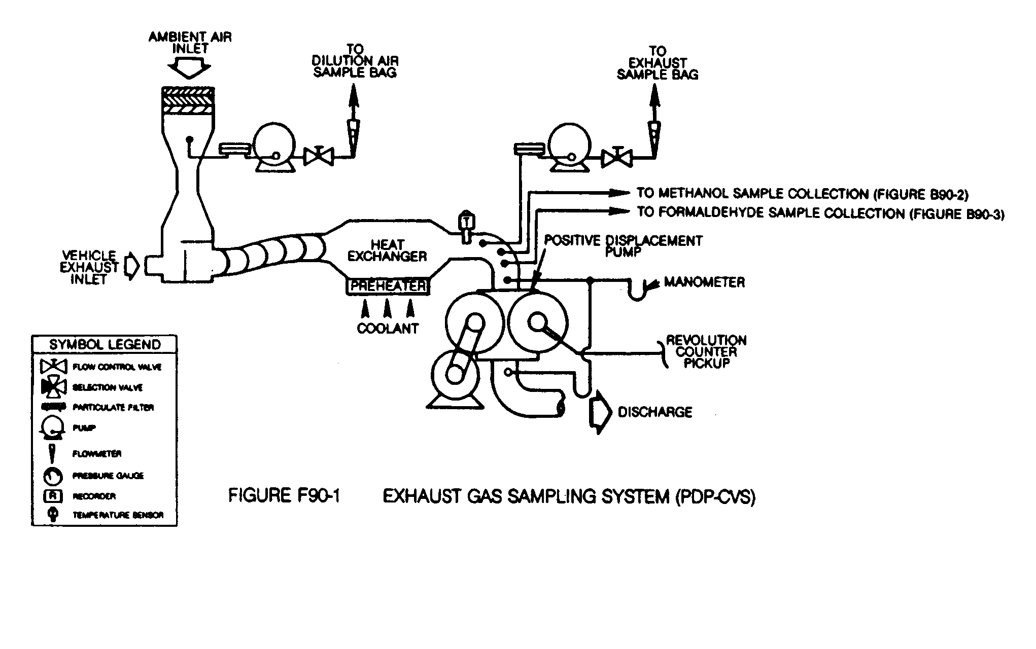

(4) Critical flow venturi. The operation of the Critical Flow Venturi⎯Constant Volume Sampler (CFV-CVS) sample system, Figure F90-2, is based upon the principles of fluid dynamics associated with critical flow. Proportional sampling throughout temperature excursions is maintained by use of small CFVs in the sample lines, which respond to the varying temperatures in the same manner as the main CFV. For methanol-fueled motorcycles, the methanol and formaldehyde sample lines are heated to prevent condensation. The temperature of the sample lines shall be more than 3 °C (5 °F) above the maximum dew point of the sample, but below 121 °C (250 °F). Care must be taken to ensure that the CFVs of the sample probes are not heated since heating of the CFVs would cause loss of proportionality. (Note: For 1990 through 1994 model year methanol-fueled motorcycles, methanol and formaldehyde sampling may be omitted provided the bag sample (hydrocarbons and methanol) is analyzed using a HFID calibrated with methanol.) Total flow per test is determined by continuously computing and integrating instantaneous flow. A low response time temperature sensor is necessary for accurate flow calculation.

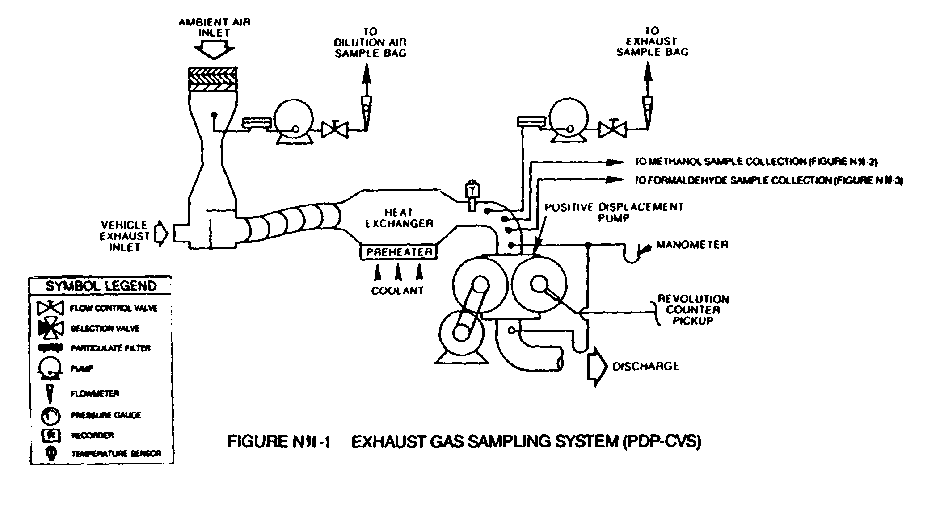

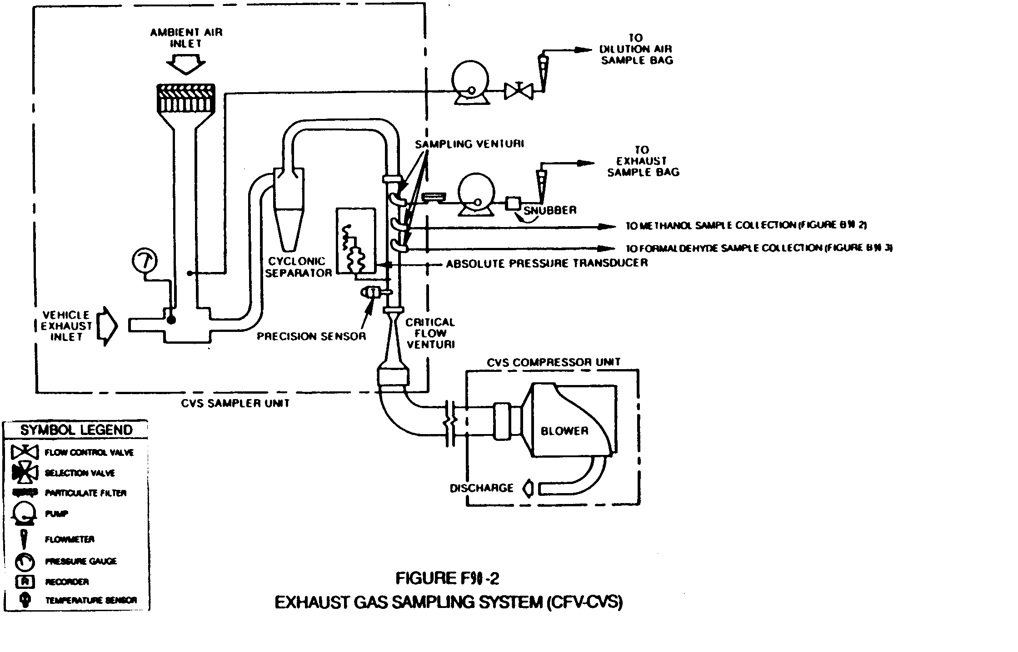

(5) Electronic Flow Control. The Critical Flow Venturi⎯Electronic Flow Control--Constant Volume Sampler (CFV-EFC-CVS) system is identical to the CFV-CVS system described in paragraphs (a)(4) and (c) of this section, except that it maintains proportional sampling for methanol and formaldehyde by measuring the CVS flow rate, and electronically controlling sample flow rates. It is recommended that sample volumes be measured by separate flow meters. For methanol-fueled motorcycles, the samples lines for the methanol and formaldehyde samples are heated to prevent condensation. The temperature of the sample lines shall be more than 20 °F (11 °C) above the maximum dew point of the sample, but below 121 °C (250 °F).
(6) Other systems. Other sampling systems may be used if shown to yield equivalent results, and if approved in advance by the Administrator (e.g., a heat exchanger with the CFV-CVS or an electronic flow integrator without a heat exchanger, with the PDP-CVS).
(b) Component description, PDP-CVS. The PDP-CVS, Figure F90-1, consists of a dilution air filter and mixing assembly, heat exchanger, positive displacement pump, sampling systems including, probes and sampling lines which, in the case of the methanol-fueled motorcycles, are heated to prevent condensation (heating of the sample lines may be omitted, provided the methanol and formaldehyde sample collection systems are close coupled to the probes thereby preventing loss of sample due to cooling and resulting condensation in the sample lines), and associated valves, pressure and temperature sensors. The PDP-CVS shall conform to the following requirements:
(1) Static pressure variations at the tailpipe(s) of the vehicle shall remain within +1.25 kPa (+5.02 in H₂O) of the static pressure variations measured during a dynamometer driving cycle with no connection to the tailpipe(s). (Sampling systems capable of maintaining the static pressure to within +0.25 kPa (+1.00 in. H₂O) will be used by the Administrator if a written request substantiates the need for this closer tolerance.)
(2) The gas mixture temperature, measured at a point immediately ahead of the positive displacement pump, shall be within +-5 °C (9 °F) of the designed operating temperature at the start of the test. The gas mixture temperature variation from its value at the start of the test shall be limited to +5 °C (9 °F) during the entire test. The temperature measuring system shall have an accuracy and precision of +1 °C (1.8 °F).
(3) The pressure gauges shall have an accuracy and precision of +0.4 kPa +3 mm Hg).
(4) The location of the dilution air inlet shall be placed so as to use test-cell air for dilution and the flow capacity of the CVS shall be large enough to completely eliminate water condensation in the dilution and sampling systems. Control of water condensation with methanol-fueled vehicles is critical. Additional care may also be required to eliminate water condensation when testing natural gas and liquefied petroleum gas-fueled vehicles. (Procedures for determining CVS flow rates are detailed in ''Calculation of Emissions and Fuel Economy When Using Alternative Fuels, '' EPA 460/3-83-009.) Dehumidifying the dilution air before entering the CVS is allowed. Heating the dilution air is also allowed, provided:
(i) The air (or air plus exhaust gas) temperature does not exceed 121 °C (250 °F).
(ii) Calculation of the CVS flow rate necessary to prevent water condensation is based on the lowest temperature encountered in the CVS prior to sampling. (It is recommended that the CVS system be insulated when heated dilution air is used.)
(iii) The dilution ratio is sufficiently high to prevent condensation in bag samples as they cool to room temperature.
(5) Sample collection bags for dilution air and exhaust samples (hydrocarbons and carbon monoide) shall be of sufficient size so as not to impede sample flow. A single dilution air sample, covering the total test period, may be collected for the determination of methanol and formaldehyde background (methanol-fueled motorcycles).
(6) The methanol sample collection system and the formaldehyde sample collection system shall each be of sufficient capacity so as to collect samples of adequate size for analysis without significant impact on the volume of dilute exhaust passing through the PDP. The systems shall also comply with the following requirements that apply to the design of the systems, not to individual tests:
(i) The methanol system shall be designed such that if a test motorcycle continuously emitted the maximum allowable level of methanol (based on all applicable standards) the measured concentration in the primary impinger would exceed either 25 mg/l or a concentration equal to 25 times the limit of detection for the GC analyzer.
(ii) The formaldehyde system shall be designed such that if a test motorcycle continuously emitted formaldehyde at a rate equal to twenty percent of the maximum allowable level of THCE (i.e., 1.0 g/km for a 5.0 g/km standard), or the maximum formaldehyde level allowed by a specific formaldehyde standard, whichever is less, the concentration of formaldehyde in the DNPH solution of the primary impinger, or solution resulting from the extraction of the DNPH cartridge, shall exceed either 2.5 mg/l or a concentration equal to 25 times the limit of detection for the HPLC analyzer.
(iii) The methanol and formaldehyde systems shall be designed such that the primary impinger collects at least 90 percent of the analyte in the samples. The remaining analyte shall be collected by the secondary impinger. This requirement does not apply to dilution air samples, since they do not require secondary impingers, or to samples in which the concentrations approach the limit of detection.
(c) Component description, CFV-CVS. The CFV-CVS sample system, Figure F90-2, consists of a dilution air filter and mixing assembly, a cyclone particulate separator, unheated sampling venturies for the bag samples, and for the methanol and formaldehyde samples from methanol-fueled vehicles, samples lines heated to prevent condensation for the methanol and formaldehyde samples from methanol fueled vehicles (heating of the sample lines may be omitted provided, the methanol and formaldehyde sample collection systems are close coupled to the probes thereby preventing loss of sample due to cooling and resulting condensation in the sample lines), a critical flow venturi, and assorted valves, and pressure and temperature sensors. The CFV sample system shall conform to the following requirements:
(1) Static pressure variations at the tailpipe(s) of the vehicle shall remain within +1.25 kPa (5.02 in H₂O) of the static pressure variations measured during a dynamometer driving cycle with no connection to the tailpipe(s). (Sampling systems capable of maintaining the static pressure to within +0.25 kPa (1.00 in H₂O) will be used by the Administrator if a written request substantiates the need for this closer tolerance.)
(2) The temperature measuring system shall have an accuracy and precision of +1 °C (1.8 °F.) and a response time of 0.100 second to 62.5 percent of a temperature change (as measured in hot silicone oil).
(3) The pressure measuring system shall have an accuracy and precision of +0.4 kPa (+3 mm Hg).
(4) The location of the dilution air inlet shall be placed so as to use test-cell air for dilution and the flow capacity of the CVS shall be large enough to completely eliminate water condensation in the dilution and sampling systems. Control of water condensation with methanol-fueled vehicles is critical. Additional care may also be required to eliminate water condensation when testing natural gas and liquefied petroleum gas-fueled vehicles. (Procedures for determining CVS flow rates are detailed in ''Calculation of Emissions and Fuel Economy When Using Alternative Fuels,'' EPA 460/3-83-009.) Dehumidifying the dilution air before entering the CVS is allowed. Heating the dilution air is also allowed, provided:
(i) The air (or air plus exhaust gas) temperature does not exceed 250 °F.
(ii) Calculation of the CVS flow rate necessary to prevent water condensation is based on the lowest temperature encountered in the CVS prior to sampling. (It is recommended that the CVS system be insulated when heated dilution air is used.)
(iii) The dilution ratio is sufficiently high to prevent condensation in bag samples as they cool to room temperature.
(5) Sample collection bags for dilution air and exhaust samples (hydrocarbons and carbon monoxide) shall be of sufficient size so as not to impede sample flow. A single dilution air sample, covering the total test period, may be collected for the determination of methanol and formaldehyde background (methanol-fueled motorcycles).
(6) The methanol sample collection system and the formaldehyde sample collection system shall each be of sufficient capacity so as to collect samples of adequate size for analysis without significant impact on the volume of dilute exhaust passing through the CVS. The systems shall also comply with the following requirements that apply to the design of the systems, not to individual tests:
(i) The methanol system shall be designed such that if a test motorcycle continuously emitted the maximum allowable level of methanol (based on all applicable standards) the measured concentration in the primary impinger would exceed either 25 mg/l or a concentration equal to 25 times the limit of detection for the GC analyzer.
(ii) The formaldehyde system shall be designed such that if a test motorcycle continuously emitted formaldehyde at a rate equal to twenty percent of the maximum allowable level of THCE (i.e., 1.0 g/km for a 5.0 g/km standard), or the maximum formaldehyde level allowed by a specific formaldehyde standard, whichever is less, the concentration of formaldehyde in the DNPH solution of the primary impinger, or solution resulting from the extraction of the DNPH cartridge, shall exceed either 2.5 mg/l or a concentration equal to 25 times the limit of detection for the HPLC analyzer.
(iii) The methanol and formaldehyde systems shall be designed such that the primary impinger collects at least 90 percent of the analyte in the samples. The remaining analyte shall be collected by the secondary impinger. This requirement does not apply to dilution air samples, since they do not require secondary impingers, or to samples in which the concentrations approach the limit of detection.
(d) Component description, CFV-EFC-CVS. The CVS sample system is identical to the system described in paragraph (c) of this section, plus includes a means of electronically measuring the CVS flow rate, and electronic mass flow controllers for the methanol and formaldehyde sample lines, and separate flow meters to totalize sample flow volumes (optional). The EFC sample system shall conform to all of the requirements listed in paragraph (c) of this section, except that the methanol and formaldehyde samples mat both be drawn from a single static probe. It also must comply with the following additional requirements:
(1) The ratio of the CVS flow rate to the sample flow rate shall not deviate from the ratio at the start of the test by more than +5 percent. (The volumetric sample flow rate shall be varied inversely with the square root of the bulk stream temperature.)
(2) Flow totalizers for methanol and/or formaldehyde samples shall have an accuracy of +2 percent. Total sample volumes may be obtained from the flow controllers, with the advance approval of the administrator, provided that the controllers can be shown to have an accuracy of +2 percent.

[54 FR 14539, Apr. 11, 1989, as amended at 59 FR 48512, Sept. 21, 1994; 60 FR 34351, June 30, 1995]
§ 86.511-90 Exhaust gas analytical system.
(a) Schematic drawings. Figure F90-3 is a schematic drawing of the exhaust gas analytical system for analysis of hydrocarbons (HC) (hydrocarbons plus methanol in the case of methanol-fueled motorcycles), carbon monoxide (CO), carbon dioxide (CO₂), and oxides of nitrogen (NO_{x}). Since various configurations can produce accurate results, exact conformance with the drawing is not required. Additional components such as instruments, valves, solenoids, pumps and switches may be used to provide additional information and coordinate the functions of the component systems.

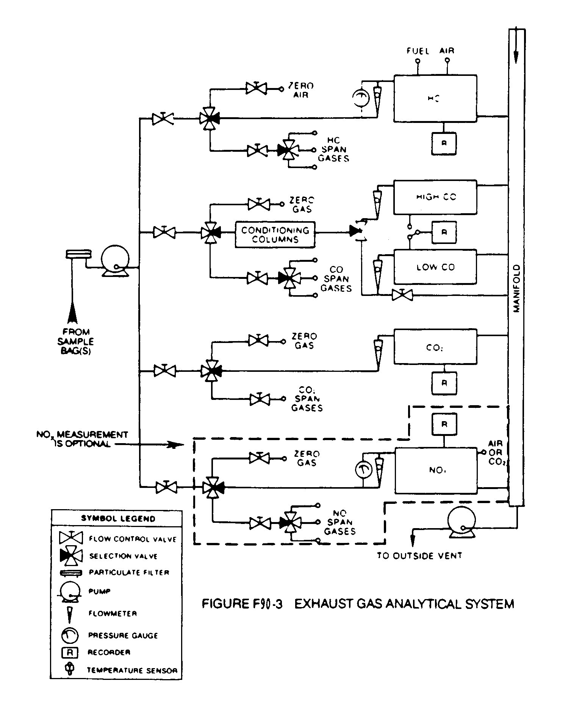

(b) Major component description. The exhaust gas analytical system for HC, CO and CO₂, Figure F90-3, consists of a flame ionization detector (FID) (heated (235 °+15 °C (113 ° +8 °C)) for methanol-fueled vehicles) for the determination of hydrocarbons, nondispersive infrared analyzers (NDIR) for the determination of carbon monoxide and carbon dioxide and, if oxides of nitrogen are measured, a chemiluminescence analyzer (CL) for the determination of oxides of nitrogen. The analytical system for methanol consists of a gas chromatograph (GC) equipped with a flame ionization detector. The analysis for formaldehyde is performed using high pressure liquid chromatography (HPLC) of 2,4-dinitrophenylhydrazine (DNPH) derivatives using ultraviolet (UV) detection. The exhaust gas analytical system shall conform to the following requirements:
(1) The CL requires that the nitrogen dioxide present in the sample be converted to nitric oxide before analysis. Other types of analyzers may be used if shown to yield equivalent results and if approved in advance by the Administrator.
(2) The carbon monoxide (CO) NDIR analyzer may require a sample conditioning column containing CaSO₄, or indicating silica gel to remove water vapor and containing ascarite to remove carbon dioxide from the CO analysis stream.
(i) If CO instruments which are essentially free of CO₂ and water vapor interference are used, the use of the conditioning column may be deleted, see §§ 86.522 and 86.544.
(ii) A CO instrument will be considered to be essentially free of CO₂ and water vapor interference if its response to a mixture of 3 percent CO₂ in N₂ which has been bubbled through water at room temperature produces an equivalent CO response, as measured on the most sensitive CO range, which is less than 1 percent of full scale CO concentration on ranges above 300 ppm full scale or less than 3 ppm on ranges below 300 ppm full scale; see § 86.522.
(c) Other analyzers and equipment. Other types of analyzers and equipment may be used if shown to yield equivalent results and if approved in advance by the Administrator.

[54 FR 14544, Apr. 11, 1989]

§ 86.513-87 Fuel and engine lubricant specifications.
(a) Gasoline having the following specifications will be used by the Administrator in exhaust emission testing. Gasoline having the following specifications or substantially equivalent specifications approved by the Administrator, shall be used by the manufacturer for emission testing except that the lead and octane specifications do not apply.
Item designation | ASTM | Leaded | Unleaded
Octane, research, min | D2699 | 100 | 93
Pb (organic), g/liter (g/U.S. gal.) | D3237 | ¹0.026 | ¹0.013
 |  | (0.100 max) | (0.050 max)
Distillation Range: | D86.
IBP, °C (°F) |  | 23.9-35 | 23.9-35
 |  | (75-95) | (75-95)
10 pct. point °C (°F) |  | 48.9-57.2 | 48.9-57.2
 |  | (120-135) | (120-135)
50 pct. point °C (°F) |  | 93.3-110 | 93.3-110
 |  | (200-230) | (200-230)
90 pct. point °C (°F) |  | 148.9-162.8 | 148.9-162.8
 |  | (300-325) | (300-325)
EP, °C (°F) |  | 212.8(415) | 212.8(415)
Sulfur, wt. Pct., max | D1266 | 0.10 | 0.10
Phosphorus, g/liter (g/U.S. gal), mas |  | 0.0026 | 0.0013
 |  | (0.01) | (0.005)
RVP, KPa (psi) | D323 | 55.2-63.4 | 55.2-63.4
 |  | (8.0-9.2) | (8.0-9.20
Hydrocarbon composition:
Olefins, pct., max | D1319 | 10 | 10
Aromatics, pct., max |  | 35 | 35
Saturates |  | (²) | (²)
¹ Maximum.
² Remainder.

(b)(1) Gasoline and engine lubricants representative of commercial fuels and engine lubricants which will be generally available through retail outlets shall be used in service accumulation.
(2) For leaded fuel the lead content shall not exceed 0.100 gram lead per gallon leaded gasoline.
(3) Where the Administrator determines that vehicles represented by a test vehicle will be operated using gasoline of different lead content than that prescribed in this paragraph, he may consent in writing to use a gasoline with a different lead content.
(4) The octane rating of the gasoline used shall be no higher than 4.0 research octane numbers above the minimum recommended by the manufacturer.
(5) The Reid Vapor Pressure of the fuel used shall be characteristic of the motor fuel during the season in which the service accumulation takes place.
(6) If the manufacturer specifies several lubricants to be used by the ultimate purchaser, the Administrator will select one to be used during service accumulation.
(c) The specification range of the fuels and engine lubricants to be used under paragraph (b) of this section shall be reported in accordance with § 86.416.
(d) The same lubricant(s) shall be used for both service accumulation and emission testing.
(e) Fuels not meeting the specifications set forth in this section may be used only with the advance approval of the Administrator.

[51 FR 24611, July 7, 1986, as amended at 52 FR 47869, Dec. 16, 1987]

§ 86.513-90 Fuel and engine lubricant specifications.
(a) Gasoline having the following specifications will be used by the Administrator in exhaust emission testing. Gasoline having the following specifications or substantially equivalent specifications approved by the Administrator, shall be used by the manufacturer for emission testing except that the octane specifications do not apply.
Item | ASTM | Value
Octane, research, minimum  Lead (organic):  g/liter (g/U.S. gal.)  Distillation range:  IBP:  °C  (°F)  10 pct. point:  °C  (°F)  50 pct. point:  °C (°F)  90 pct. point:  °C  (°F)  EP:  °C max  (°F)  Sulfur, weight percent, maximum  Phosphorus:  g/liter, max  (g/U.S. gal)  RVP, kPa (psi)  Hydrocarbon composition:  Olefins, percent, maximum Aromatics, percent, maximum Saturates | D2699  D3237  D86  D86  D86  D86  D86  D1266  D3231  D323  D1319 D1319 D1319 | 96  ¹0.013  ¹(0.050)  23.9-35  (75-95)  48.9-57.2  (120-135)  93.3-110  (200-230)  148.9-162.8  (300-325)  212.8  (415)  0.10  0.0013  (0.005)  55.2-63.4  (8.0-9.2)  10  35  Remainder
¹Maximum.

(b)(1) Unleaded gasoline and engine lubricants representative of commercial fuels and engine lubricants which will be generally available through retail outlets shall be used in service accumulation.
(2) The octane rating of the gasoline used shall be no higher than 4.0 Research octane numbers above the minimum recommended by the manufacturer.
(3) The Reid Vapor Pressure of the fuel used shall be characteristic of the motor fuel during the season in which the service accumulation takes place.
(4) If the manufacturer specifies several lubricants to be used by the ultimate purchaser, the Administrator will select one to be used during service accumulation.
(c) Methanol fuel used for exhaust and evaporative emission testing and in service accumulation of methanol-fueled motorcycle vehicles shall be representative of commercially available methanol fuel and shall consist of at least 50 percent methanol by volume.
(1) Manufacturers shall recommend the methanol fuel to be used for testing and service accumulation in accordance with paragraph (c).
(2) The Administrator shall determine the methanol fuel to be used for testing and service accumulation.
(d) Other methanol fuels may be used for testing and service accumulation provided:
(1) They are commercially available, and
(2) Information, acceptable to the Administrator, is provided to show that only the designated fuel would be used in customer service, and
(3) Use of a fuel listed under paragraph (a)(3) of this section would have a detrimental effect on emissions or durability, and
(4) Written approval from the Administrator of the fuel specifications must be provided prior to the start of testing.
(e) The specification range of the fuels and engine lubricants to be used under paragraph (b) of this section shall be reported in accordance with Sec. 86.416.
(f) The same lubricant(s) shall be used for both service accumulation and emission testing.
(g) Fuels not meeting the specifications set forth in this section may be used only with the advance approval of the Administrator.
(h) Mixtures of petroleum and methanol fuels for flexible fuel motorcycles. (1) Mixtures of petroleum and methanol fuels used for exhaust and evaporative emission testing and service accumulation for flexible fuel motorcycles shall be within the range of fuel mixtures for which the vehicle was designed.
(2) Manufacturer testing and service accumulation may be performed using only those mixtures (mixtures may be different for exhaust testing, evaporative testing, and service accumulation) expected to result in the highest emissions, provided:
(i) The fuels which constitute the mixture will be used in customer service, and
(ii) Information, acceptable to the Administrator, is provided by the manufacturer to show that the designated fuel mixtures would result in the highest emissions, and
(iii) Written approval from the Administrator of the fuel specifications must be provided prior to the start of testing.
(3) The specification range of the fuels to be used under paragraph (h)(1) of this section shall be reported in accordance with Sec. 86.090
21(b)(3).

[53 FR 476, Jan. 7, 1988, as amended at 54 FR 14546, Apr. 11, 1989]

§ 86.513-94 Fuel and engine lubricant specifications.
(a) Gasoline. (1) Gasoline having the following specifications will be used by the Administrator in exhaust emission testing of gasoline-fueled motorcycles. Gasoline having the following specifications or substantially equivalent specifications approved by the Administrator, shall be used by the manufacturer for emission testing except that the octane specifications do not apply.

Item | ASTM | Value
Octane, research, minimum  Lead (organic):  g/liter (g/U.S. gal.)  Distillation range:  IBP: °C (°F)  10 pct. point: °C (°F)  50 pct. point: °C (°F)  90 pct. point: °C (°F)  EP: °C max (°F)  Sulfur, max. wt. %  Phosphorus: max. g/liter (g/U.S. gal.)  RVP, kPa (psi)  Hydrocarbon composition:  Olefins, max.,% Aromatics, max.,% Saturates | D2699  D3237  D86  D86  D86  D86  D86  D1266  D3231  D323  D1319 D1319 D1319 | 96  ¹0.013  ¹(0.050)  23.9-35  (75-95)  48.9-57.2  (120-135)  93.3-110  (200-230)  148.9-162.8  (300-325)  212.8  (415)  0.10  0.0013  (0.005)  55.2-63.4  (8.0-9.2)  10  35  Remainder
¹Maximum.

(2) Unleaded gasoline and engine lubricants representative of commercial fuels and engine lubricants which will be generally available through retail outlets shall be used in service accumulation.
(3) The octane rating of the gasoline used shall be no higher than 4.0 Research octane numbers above the minimum recommended by the manufacturer.
(4) The Reid Vapor Pressure of the gasoline used shall be characteristic of commercial gasoline fuel during the season in which the service accumulation takes place.
(b) Methanol fuel. (1) Methanol fuel used for exhaust and evaporative emission testing and in service accumulation of methanol-fueled motorcycles shall be representative of commercially available methanol fuel and shall consist of at least 50 percent methanol by volume.
(2) Manufacturers shall recommend the methanol fuel to be used for testing and service accumulation in accordance with paragraph (b)(1) of this section.
(3) The Administrator shall determine the methanol fuel to be used for testing and service accumulation.
(4) Other methanol fuels may be used for testing and service accumulation provided:
(i) They are commercially available; and
(ii) Information, acceptable to the Administrator, is provided to show that only the designated fuel would be used in customer service; and
(iii) Use of a fuel listed under paragraphs (b)(1), (b)(2) or (b)(3) of this section would have a detrimental effect on emissions or durability; and
(iv) Written approval from the Administrator of the fuel specifications must be provided prior to the start of testing.
(c) Mixtures of petroleum and methanol fuels for flexible fuel motorcycles. (1) Mixtures of petroleum and methanol fuels used for exhaust and evaporative emission testing and service accumulation for flexible fuel motorcycles shall consist of the petroleum fuel listed in paragraph (a) of this section and the methanol fuel listed in paragraph (b), and shall be within the range of fuel mixtures for which the vehicle was designed, as reported in accordance with Sec. 86.90-21. The Administrator may use any fuel or fuel mixture within this range for testing.
(2) The fuel mixtures used by the manufacturers shall be sufficient to demonstrate compliance over the full design range, and shall include:
(i) For emission testing,
(A) The petroleum fuel specified in paragraph (a) or (b),
(B) A methanol fuel representative of the methanol fuel expected to the found in use, as specified in paragraph (b),
(ii) For service accumulation, an alternating combination of the fuels specified in paragraphs (a) and (b) will be used to demonstrate the durability of the emission control systems based on good engineering judgement. The combination shall be selected such that the cumulative volumes of both the methanol fuel and the petroleum fuel used shall be at least twenty-five percent of the total fuel volume. The fuels shall be alternated at mileage intervals not to exceed 1,000 kilometers.
(3) The specification range of the fuels to be used under paragraph (c) of this section shall be reported in accordance with Sec. 86.094-21.
(d) Natural gas-fuel. (1) Natural gas-fuel having the following specifications will be used by the Administrator for exhaust and evaporative emission testing of natural gas-fueled motorcycles. Natural gas-fuel having the following specifications or substantially similar specifications approved by the Administrator, shall be used by the manufacturer for emission testing.

Natural Gas Certification Fuel Specifications
Item |  | ASTM  test  method  No. | Value
Methane  Ethane  C₃ and higher  C₆ and higher  Oxygen  Inert gases:  Sum of CO₂ and N₂ Odorant¹ | min mole pct.  max. mole pct.  max. mole pct.  max. mole pct.  max. mole pct.  max. mole pct. | D1945  D1945  D1945  D1945  D1945  D1945 | 89.0  4.5  2.3  0.2  0.6  4.0
¹The natural gas at ambient conditions must have a distinctive odor potent enough for its presence to be detected down to a concentration in air of not over 1/5 (one-fifth) of the lower limit of flammability.

(2) Natural gas-fuel and engine lubricants representative of commercial fuels and engine lubricants which will be generally available through retail outlets shall be used in service accumulation.
(3) Other natural gas-fuels may be used for testing and service accumulation provided:
(i) They are commercially available;
(ii) Information, acceptable to the Administrator, is provided to show that only the designated fuel would be used in customer service;
(iii) Written approval from the Administrator of the fuel specifications must be provided prior to the start of testing.
(e) Liquefied petroleum gas-fuel. (1) Liquefied petroleum gas-fuel used for exhaust and evaporative emission testing and in service accumulation of liquefied petroleum gas-fueled motorcycles shall be commercially available liquefied petroleum gas-fuel.
(2) Manufacturers shall recommend the liquefied petroleum gas-fuel to be used for testing and service accumulation in accordance with paragraph (e)(1) of this section.
(3) The Administrator shall determine the liquefied petroleum gas-fuel to be used for testing and service accumulation.
(4) Other liquefied petroleum gas-fuels may be used for testing and service accumulation provided:
(i) They are commercially available;
(ii) Information, acceptable to the Administrator, is provided to show that only the designated fuel would be used in customer service; and
(iii) Written approval from the Administrator of the fuel specifications must be provided prior to the start of testing.
(f) Lubricants. (1) If the manufacturer specifies several lubricants to be used by the ultimate purchaser, the Administrator will select one to be used during service accumulation.
(2) The same lubricant(s) shall be used for both service accumulation and emission testing.
(g) The specification range of the fuels and of the engine lubricants to be used under paragraphs (a), (b), (c), (d) and (e) of this section shall be reported in accordance with §86.416.
(h) Written approval from the Administrator of the fuel and lubricant specifications must be provided prior to the start of testing.

[59 FR 48512, Sept. 21, 1994, as amended at 60 FR 34354, June 30, 1995]

§ 86.514-78 Analytical gases.
(a) Analyzer gases. (1) Gases for the CO and CO₂ analyzers shall be single blends of CO and CO₂ respectively using nitrogen as the diluent.
(2) Gases for the THC analyzer shall be:
(i) Single blends of propane using air as the diluent; and
(ii) Optionally, for response factor determination, single blends of methanol using air as the diluent.
(3) Gases for the NO_{X} analyzer shall be single blends of NO named as NO_{X} with a maximum NO₂ concentration of 5 percent of the nominal value using nitrogen as the diluent.
(4) [Reserved]
(5) The allowable zero gas (air or nitrogen) impurity concentrations shall not exceed 1 ppm equivalent carbon response, 1 ppm carbon monoxide, 0.04 percent (400 ppm) carbon dioxide, and 0.1 ppm nitric oxide.
(6)"Zero grade air" includes artificial "air" consisting of a blend of nitrogen and oxygen with oxygen concentrations between 18 and 21 mole percent.
(7) The use of proportioning and precision blending devices to obtain the required analyzer gas concentrations is allowable provided their use has been approved in advance by the Administrator.
(b) Calibration gases (not including methanol) shall be known to within 2 percent of true values.
(c) Methanol in air gases used for response factor determination shall:
(1) Be traceable to within ±2 percent of NIST (formerly NBS) gas standards, or other gas standards which have been approved by the Administrator; and
(2) Remain within ±2 percent of the labeled concentration. Demonstration of stability shall be based on a quarterly measurement procedure with a precision of ±2 percent (two standard deviations), or other method approved by the Administrator. The measurement procedure may incorporate multiple measurements. If the true concentration of the gas changes by more than two percent, but less than ten percent, the gas may be relabeled with the new concentration.

[42 FR 1137, Jan. 5, 1977, as amended at 60 FR 34354, June 30, 1995]

§ 86.515-78 EPA urban dynamometer driving schedule.
(a) The dynamometer driving schedules are listed in appendix I. The driving schedules are defined by a smooth trace drawn through the specified speed vs. time relationships. They consist of a nonrepetitive series of idle, acceleration, cruise, and deceleration modes of various time sequences and rates. Appropriate driving schedules are as follows:

Class I—Appendix I(c)
Class II—Appendix I(b)
Class III—Appendix I(b)

(b) The speed tolerance at any given time on the dynamometer driving schedule prescribed in appendix I or as printed on a driver's aid chart approved by the Administrator, when conducted to meet the requirements of Sec. 86.537 is defined by upper and lower limits. The upper limit is 3.2 km/h (2 mph) higher than the highest point on the trace within 1 second of the given time. The lower limit is 3.2 km/h (2 mph) lower than the lowest point on the trace within 1 second of the given time. Speed variations greater than the tolerances (such as may occur during gear changes) are acceptable provided they occur for less than 2 seconds on any occasion. Speeds lower than those prescribed are acceptable provided the vehicle is operated at maximum available power during such occurrences. When conducted to meet the requirements of Sec. 86.532 the speed tolerance shall be as specified above, except that the upper and lower limits shall be 6.4 km/h (4 mph).
(c) Figure F78-4 shows the range of acceptable speed tolerances for typical points. Figure F78-4(a) is typical of portions of the speed curve which are increasing or decreasing throughout the two second time interval. Figure F78-4(b) is typical of portions of the speed curve which include a maximum or minimum value.
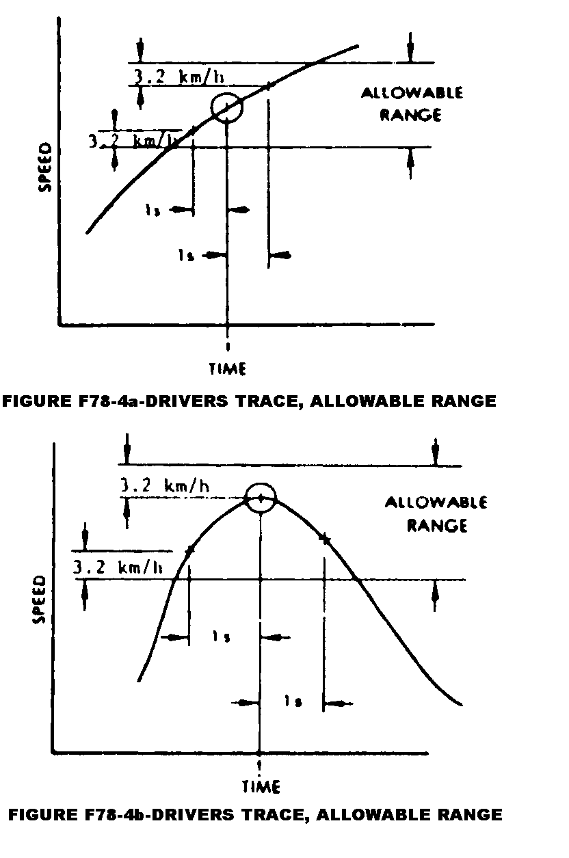
§ 86.516-90 Calibrations, frequency and overview.
(a) Calibrations shall be performed as specified in §§ 86.517 through 86.526.
(b) [Reserved]
(c) At least monthly or after any maintenance which could alter calibration, the following calibrations and checks shall be performed:
(1) Calibrate the hydrocarbon analyzer, methane analyzer, carbon dioxide analyzer, carbon monoxide analyzer, and oxides of nitrogen analyzer (certain analyzers may require more frequent calibration depending on particular equipment and uses).
(2) Calibrate the dynamometer. If the dynamometer receives a weekly performance check (and remains within calibration), the monthly calibration need not be performed.
(3) Check the oxides of nitrogen converter efficiency.
(d) At least weekly or after any maintenance which could alter calibration, the following calibrations and checks shall be performed:
(1) [Reserved]
(2) Perform a CVS system verification, and
(3) Run a performance check on the dynamometer. This check may be omitted if the dynamometer has been calibrated within the preceding month.
(e) The CVS positive displacement pump or Critical Flow Venturi shall be calibrated following initial installation, major maintenance or as necessary when indicated by the CVS system verification (described in Sec. 86.519).
(f) Sample conditioning columns, if used in the CO analyzer train, should be checked at a frequency consistent with observed column life or when the indicator of the column packing begins to show deterioration.

[54 FR 14546, Apr. 11, 1989, as amended at 58 FR 58423, Nov. 1, 1993; 60 FR 34354, June 30, 1995]

§ 86.518-78 Dynamometer calibration.
(a) The dynamometer shall be calibrated at least once each month or performance verified at least once each week and then calibrated as required. The dynamometer is driven above the test speed range. The device used to drive the dynamometer is then disengaged from the dynamometer and the roll is allowed to coast down. The kinetic energy of the system is dissipated by the dynamometer. This method neglects the variations in roll bearing friction due to the drive axle weight of the vehicle.
(b) Calibration shall consist of coasting down the dynamometer for each inertia load combination used. Coastdown times for the interval from 70 to 60 km/h shall be within the tolerances specified in Sec. 86.529. The dynamometer adjustments necessary to produce these results shall be noted for future reference.
(c) The performance check consists of conducting a dynamometer coastdown at one or more inertia-horsepower settings and comparing the coastdown time to the table in Figure F98-9 of Sec. 86.529-98. If the coastdown time is outside the tolerance, a new calibration is required.

§ 86.519-78 Constant volume sampler calibration.
The CVS (Constant Volume Sampler) is calibrated using an accurate flowmeter and restrictor valve. Measurements of various parameters are made and related to flow through the unit. Procedures used by EPA for both PDP (Positive Displacement Pump) and CFV (Critical Flow Venturi) are outlined below. Other procedures yielding equivalent results may be used if approved in advance by the Administrator. After the calibration curve has been obtained, verification of the entire system can be performed by injecting a known mass of gas into the system and comparing the mass indicated by the system to the true mass injected. An indicated error does not necessarily mean that the calibration is wrong, since other factors can influence the accuracy of the system, e.g. analyzer calibration. A verification procedure is found in paragraph (c) of this section.
(a) PDP calibration. (1) The following calibration procedure outlines the equipment, the test configuration, and the various parameters which must be measured to establish the flow rate of the constant volume sampler pump. All the parameters related to the pump are simultaneously measured with the parameters related to a flowmeter which is connected in series with the pump. The calculated flow rate (at pump inlet absolute pressure and temperature) can then be plotted versus a correlation function which is the value of a specific combination of pump parameters. The linear equation which relates the pump flow and the correlation function is then determined. In the event that a CVS has a multiple speed drive, a calibration for each range used must be performed.
(2) This calibration procedure is based on the measurement of the absolute values of the pump and flowmeter parameters that relate the flow rate at each point. Three conditions must be maintained to assure the accuracy and integrity of the calibration curve. First, the pump pressures should be measured at taps on the pump rather than at the external piping on the pump inlet and outlet. Pressure taps that are mounted at the top center and bottom center of the pump drive headplate are exposed to the actual pump cavity pressures, and therefore reflect the absolute pressure differentials. Secondly, temperature stability must be maintained during the calibration. The laminar flowmeter is sensitive to inlet temperature oscillations which cause the data points to be scattered. Gradual changes (±1 ºC (1.8 ºF)) in temperature are acceptable as long as they occur over a period of several minutes. Finally, all connections between the flowmeter and the CVS pump must be absolutely void of any leakage.
(3) During an exhaust emission test the measurement of these same pump parameters enables the user to calculate the flow rate from the calibration equation.
(4) Connect a system as shown in Figure F78-5. Although particular types of equipment are shown, other configurations that yield equivalent results may be used if approved in advance by the Administrator. For the system indicated, the following data with given accuracy are required:

CALIBRATION DATA MEASUREMENTS
Parameter | Symbol | Units | Tolerances
Barometric pressure corrected  Ambient temperature  Air Temperature into LFE  Pressure depression upstream of LFE  Pressure drop across the LFE matrix  Air temperature at CVS pump inlet  Pressure depression at CVS pump inlet  Specific gravity of manometer fluid (1.75 oil).  Pressure head at CVS pump outlet  Air temperature at CVS pump outlet (optional)  Pump revolutions during test period  Elapsed time for test period | P_{Β}  T_{Λ}  ETI  EPI  EDP  PTI  PPI  Sp. Gr.  PPO  PTO  N  t | kPa (in. Hg)  °C (°F)  °C (°F)  kPa (in. H₂0)  kPa (in. H₂0)  °C (°F)  kPa (in. Fluid)  kPa (in. Fluid)  °C (°F)  Revs  s | ±0.03 kPa (±0.01 in Hg).  ±0.3 °C (±0.54 °F).  ±0.15 °C (±0.27 °F).  ±0.01 kPa (±0.05 in. H₂0 °F).  ±0.001 kPa (±0.005 in. H₂0).  ±0.25 °C (±0.45 °F).  ±0.021 kPa (±0.046 in Fluid).  ±0.021 kPa (±0.046 in Fluid).  ±0.25 °C (±0.45 °F).  ±1 Rev.  ±0.05 s.

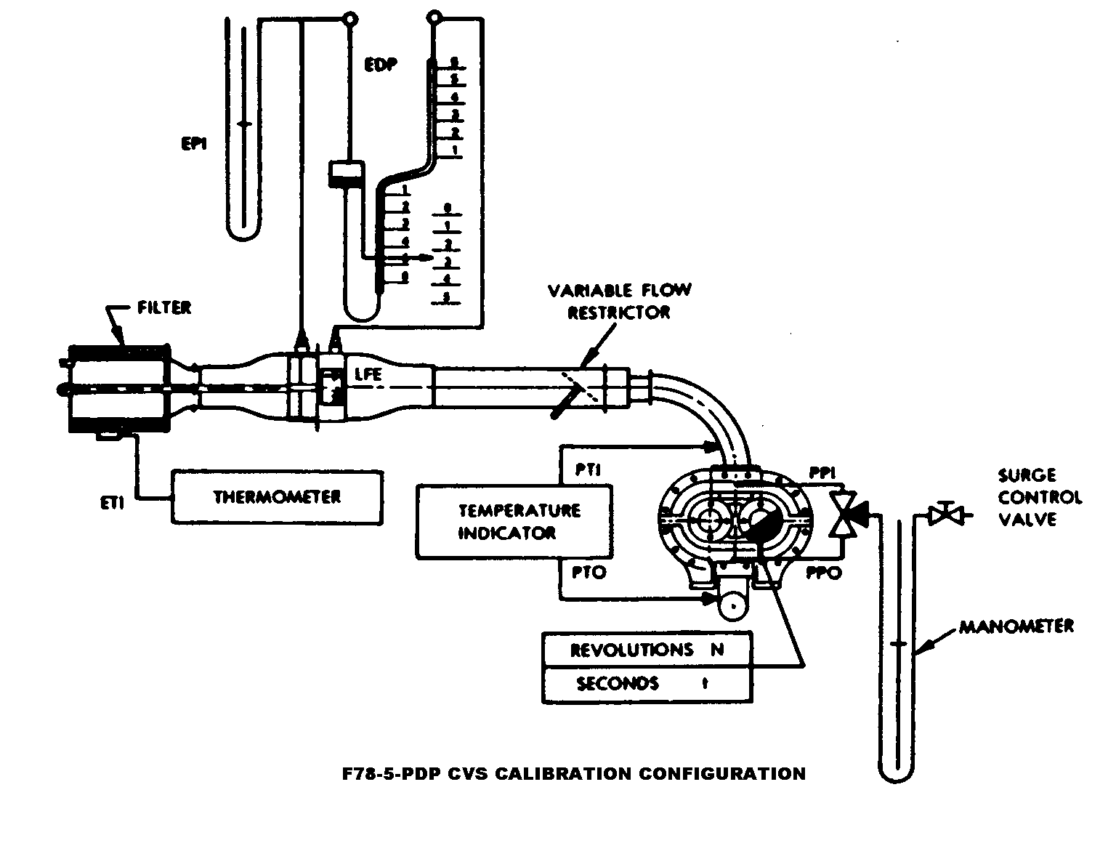

(5) After the system has been connected as shown in Figure F78-5, set the variable restrictor in the wide open position and run the CVS pump for twenty minutes. Record the calibration data.
(6) Reset the restrictor valve to a more restricted condition in an increment of pump inlet depression (about 1.0 kPa (4" H₂O)) that will yield a minimum of six data points for the total calibration. Allow the system to stabilize for 3 minutes and repeat the data acquisition.
(7) Data analysis: (i) The air flow rate, Q_{s}, at each test point is calculated from the flowmeter data using the manufacturer's prescribed method.
(ii) The air flow rate is then converted to pump flow, V_{o}, per revolution at absolute pump inlet temperature and pressure.

V_{o} = (Q_{s}/n) x (T_{p}/293.15) x (101.325/P_{p})

where:

V_{o} = Pump flow, m³/revolution (ft³/revolution) at T_{p}, P_{p}
Q_{s} = Meter air flow rate in standard cubic metres per minute, standard conditions are 20° C, 101.325 kPa (68 ºF, 29.92 in. Hg).
n = Pump speed in revolutions per minute.
T_{p} = Pump inlet temperature, K(R) = PTI + 273.15 for English units, T_{p} = PTI + 459.67
Pp = Absolute pump inlet pressure, kPa (in. Hg) = P_{B}-PPI for English units, P_{p} = P_{B}-PPI (SP. GR./13.57)
where:
P_{B} = barometric pressure, kPa (in. Hg)
PPI = Pump inlet depression, kPa (in. fluid)
SP. GR. = Specific gravity of manometer fluid relative to water.

(iii) The correlation function at each test point is then calculated from the calibration data:
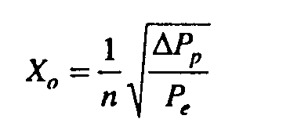
where:
X_{o} = correlation function.
P_{e} = The pressure differential from pump inlet to pump outlet, kPa (in. Hg) = P_{e}-P_{p}
P_{e}= Absolute pump outlet pressure, kPa (in. Hg) = P_{B} + PPO for English units, P_{e} = P_{B} + PPO(SP. GR./13.57)
where:
PPO = Pressure head at pump outlet, kPa (in. fluid)

(iv) A linear least squares fit is performed to generate the calibration equations which have the forms:

V_{o} = D_{o}-M(X_{o})
n = A-B(P_{p})
D_{o}, M, A, and B are the slope-intercept constants describing the lines.

(8) A CVS system that has multiple speeds shall be calibrated on each speed used. The calibration curves generated for the ranges will be approximately parallel and the intercept values, D_{Q}, will increase as the pump flow range decreases.
(9) If the calibration has been performed carefully, the calculated values from the equation will be within ±0.50 percent of the measured value of V_{O}. Values of M will vary from one pump to another, but values of D_{O} for pumps of the same make, model, and range should agree within ±3 percent of each other. Particulate influx from use will cause the pump slip to decrease as reflected by lower values for M. Calibrations should be performed at pump startup and after major maintenance to assure the stability of the pump slip rate. Analysis of mass injection data will also reflect pump slip stability.
(b) CFV calibration. (1) Calibration of the Critical Flow Venturi (CFV) is based upon the flow equation for a critical venturi. Gas flow is a function of inlet pressure and temperature:
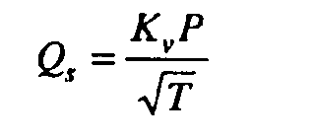
where:
Q_{s} = Flow
K_{v} = Calibration coefficient
P = Absolute pressure
T = Absolute temperature

The calibration procedure described below establishes the value of the calibration coefficient at measured values of pressure, temperature and air flow.
(2) The manufacturer's recommended procedure shall be followed for calibrating electronic portions of the CFV.
(3) Measurements necessary for flow calibration are as follows:

CALIBRATION DATA MEASUREMENTS
Parameter | Symbol | Units | Tolerances
Barometric pressure (corrected)  Air Temperature, flowmeter  Pressure depression upstream of LFE  Pressure drop across the LFE matrix  Air flow  CFV inlet depression  Temperature at venturi inlet  Specific gravity of manometer fluid (1.75 oil) | P_{Β}  ETI  EPI  EDP  Q_{s}  PPI  T_{v}  Sp. Gr. . | kPa (in. Hg)  °C (°F)  kPa (in. H₂0)  kPa (in. H₂0)  m³min. (ft³/min)  kPa (in. fluid)  °C (°F) | ±0.03 kPa (±0.01 in. Hg).  ±0.15 °C (±0.27 °F).  ±0.01 kPa (±0.05 in. H₂0).  ±0.001 kPa (±0.005 in. H₂0).  ±0.5%.  ±0.02 kPa (±0.05 in. fluid).  ±0.25 °C (±0.45 °F).

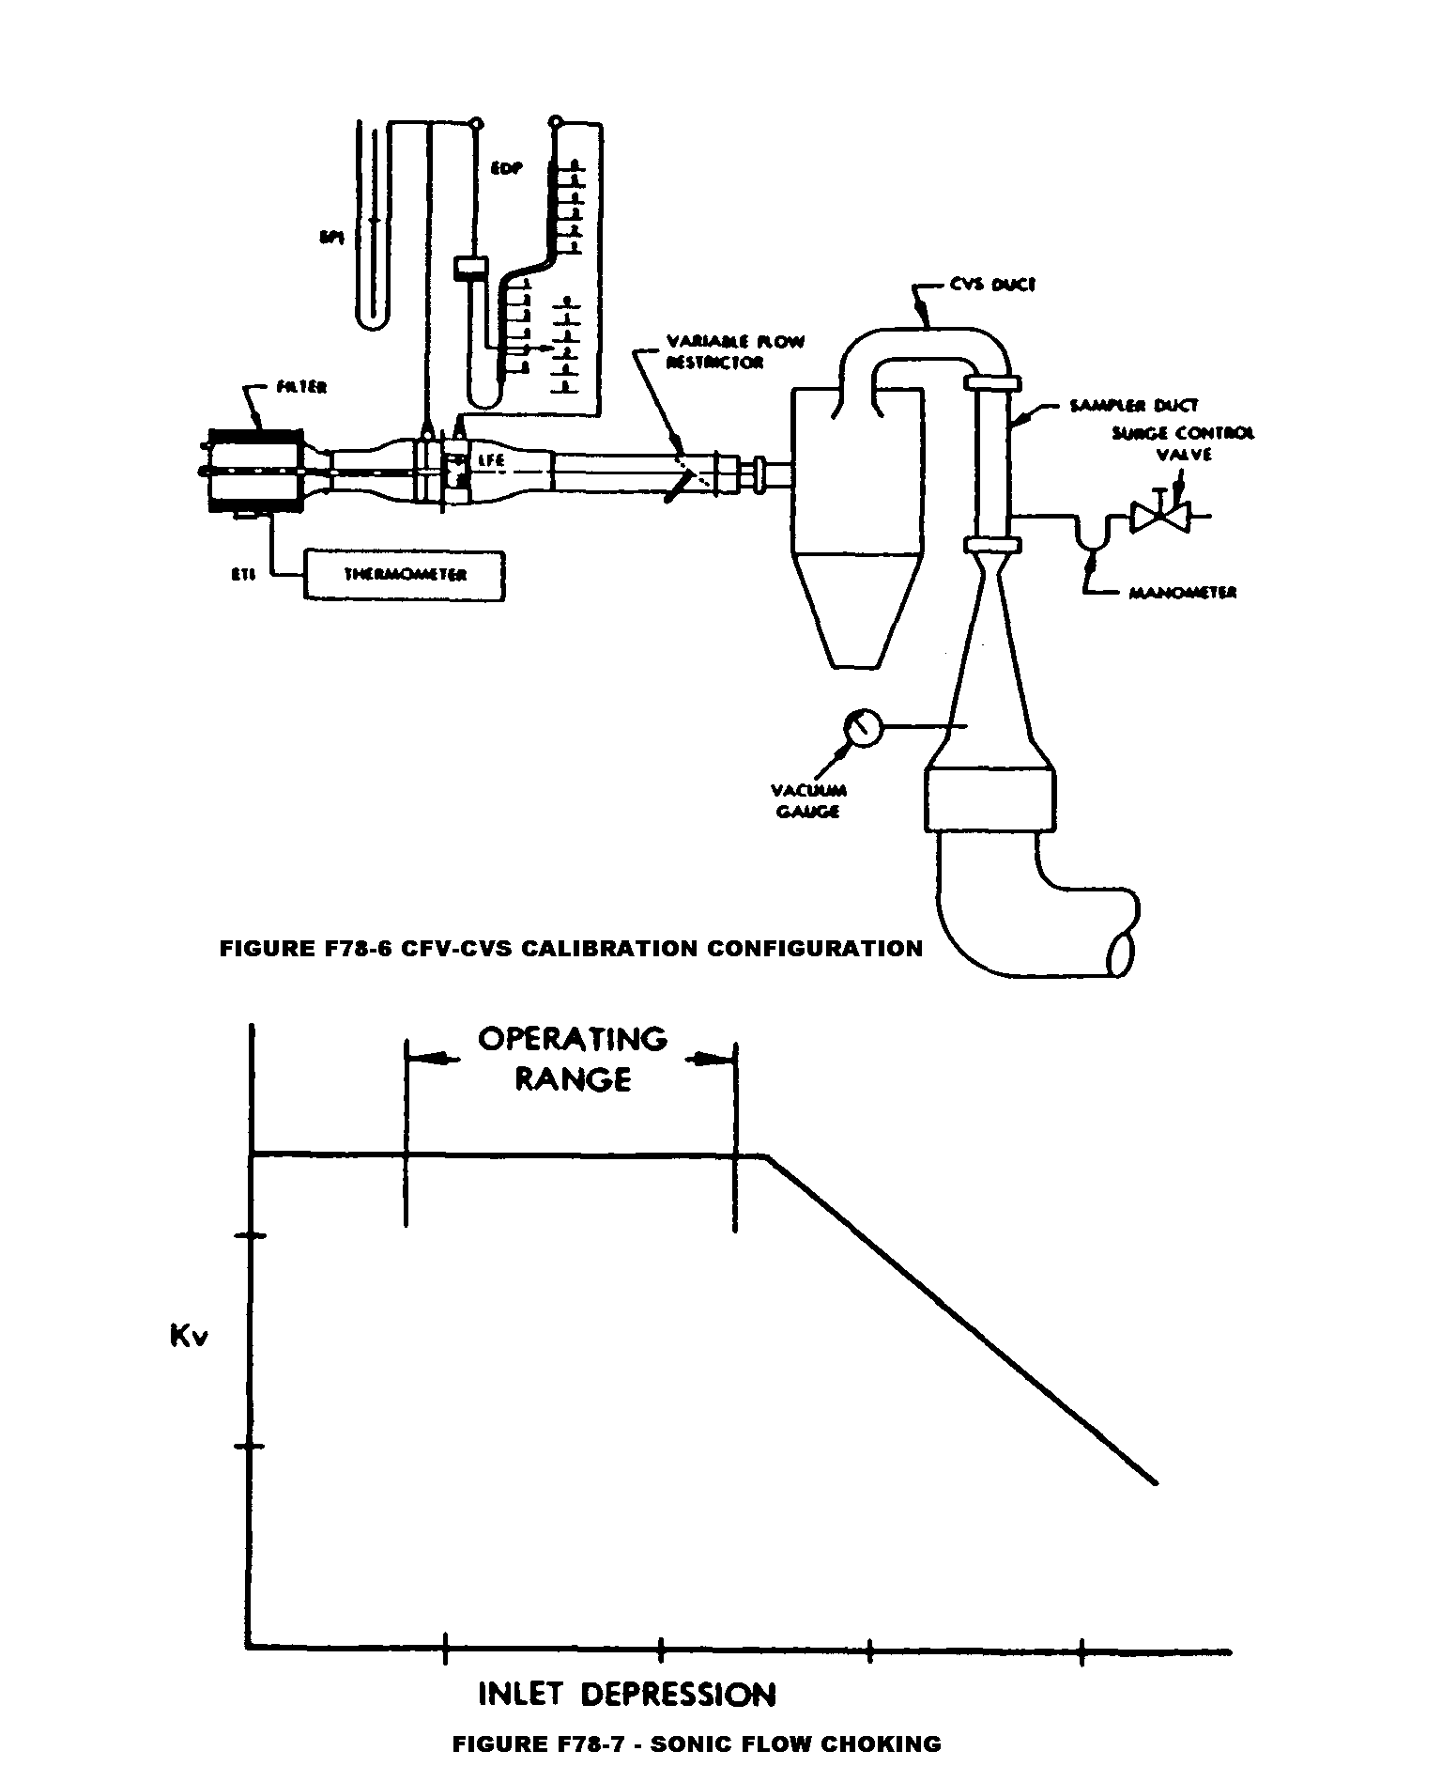

(4) Set up equipment as shown in Figure F78-6 and check for leaks. Any leaks between the flow measuring device and the critical flow venturi will seriously affect the accuracy of the calibration.
(5) Set the variable flow restrictor to the open position, start the blower and allow the system to stabilize. Record data from all instruments.
(6) Vary the flow restrictor and make at least 8 readings across the critical flow range of the venturi.
(7) Data analysis. The data recorded during the calibration are to be used in the following calculations:
(i) The air flow rate, Q_{s,} at each test point is calculated from the flow meter data using the manufacturer's prescribed method.
(ii) Calculate values of the calibration coefficient for each test point:
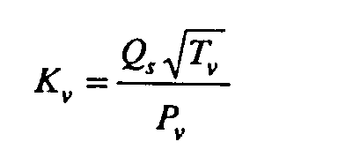
where:
Q_{s} = Flow rate, standard conditions are 20 ºC, 101.325 kPa (68 ºF, 29.92 in. Hg)
T_{v} = Temperature at venturi inlet, K(R).
P_{v} = Pressure at venturi inlet, kPa (mm Hg) = P_{B} - PPI for English units P_{v} = P_{B} - PPI (SP. GR./13.57).
where:
PPI = Venturi inlet pressure depression, kPa (in. fluid).
SP. GR. = Specific gravity of manometer fluid, relative to water.

(iii) Plot K_{v} as a function of venturi inlet depression. For sonic flow, K_{v} will have a relatively constant value. As pressure decreases (vacuum increases), the venturi becomes unchoked and K_{v} decreases (is no longer constant). See Figure F78-7.
(iv) For a minimum of 8 points in the critical region calculate an average K_{v} and the standard deviation.
(v) If the standard deviation exceeds 0.3 percent of the average K_{v} take corrective action.
(c) CVS System Verification. The following "gravimetric" technique can be used to verify that the CVS and analytical instruments can accurately measure a mass of gas that has been injected into the system. (Verification can also be accomplished by constant flow metering using critical flow orifice devices.)
(1) Obtain a small cylinder that has been charged with pure propane or carbon monoxide gas (caution—carbon monoxide is poisonous).
(2) Determine a reference cylinder weight to the nearest 0.01 grams.
(3) Operate the CVS in the normal manner and release a quantity of pure propane or carbon monoxide into the system during the sampling period (approximately 5 minutes).
(4) The calculations of § 86.544 are performed in the normal way except in the case of propane. The density of propane (0.6109 kg/m³/carbon atom (17.30 g/ft³/carbon atom)) is used in place of the density of exhaust hydrocarbons. In the case of carbon monoxide, the density of 1.164 kg/m³ (32.97 g/ft³) is used.
(5) The gravimetric mass is subtracted from the CVS measured mass and then divided by the gravimetric mass to determine the percent accuracy of the system.
(6) The cause for any discrepancy greater than ±2 percent must be found and corrected.

[42 FR 1137, Jan. 5, 1977, as amended at 42 FR 56738, Oct. 28, 1977]

§ 86.519-90 Constant volume sampler calibration.
(a) The CVS (Constant Volume Sampler) is calibrated using an accurate flowmeter and restrictor valve. Measurements of various parameters are made and related to flow through the unit. Procedures used by EPA for both PDP (Positive Displacement Pump) and CFV (Critical Flow Venturi) are outlined below. Other procedures yielding equivalent results may be used if approved in advance by the Administrator. After the calibration curve has been obtained, verification of the entire system can be performed by injecting a known mass of gas into the system and comparing the mass indicated by the system to the true mass injected. An indicated error does not necessarily mean that the calibration is wrong, since other factors can influence the accuracy of the system, e.g., analyzer calibration. A verification procedure is found in paragraph (d) of this section.
(b) PDP calibration. (1) The following calibration procedures outlines the equipment, the test configuration, and the various parameters which must be measured to establish the flow rate of the constant volume sampler pump. All the parameters related to the pump are simultaneously measured with the parameters related to a flowmeter which is connected in series with the pump. The calculated flow rate (at pump inlet absolute pressure and temperature) can then be plotted versus a correlation function which is the value of a specific combination of pump parameters. The linear equation which relates the pump flow and the correlation function is then determined. In the event that a CVS has a multiple speed drive, a calibration for each range must be performed.
(2) This calibration procedure is based on the measurement of the absolute values of the pump and flowmeter parameters that relate the flow rate at each point. Three conditions must be maintained to assure the accuracy and integrity of the calibration curve. First, the pump pressures should be measured at taps on the pump rather than at the external piping on the pump inlet and outlet. Pressure taps that are mounted at the top center and bottom center of the pump drive headplate are exposed to the actual pump cavity pressures, and therefore reflect the absolute pressure differentials. Secondly, temperature stability must be maintained during the calibration. The laminar flowmeter is sensitive to inlet temperature oscillations which cause the data points to be scattered. Gradual changes (±1 ºC (±1.8 ºF)) in temperature are acceptable as long as they occur over a period of several minutes. Finally, all connections between the flowmeter and the CVS pump must be absolutely void of any leakage.
(3) During an exhaust emission test the measurement of these same pump parameters enables the user to calculate the flow rate from the calibration equation.
(4) Connect a system as shown in Figure F78-5. Although particular types of equipment are shown, other configurations that yield equivalent results may be used if approved in advance by the Administrator. For the system indicated, the following data with given accuracy are required:

CALIBRATION DATA MEASUREMENTS
Parameter | Symbol | Units | Tolerances
Barometric pressure (corrected)  Ambient temperature  Air Temperature into LFE  Pressure depression upstream of LFE  Pressure drop across the LFE matrix  Air temperature at CVS pump inlet  Pressure depression at CVS pump inlet  Specific gravity of manometer fluid (1.75 oil).  Pressure head at CVS pump outlet  Air Temperature at CVS pump outlet (optional)  Pump revolutions during test period  Elapsed time for test period | P_{Β}  T_{A}  ETI  EPI  EDP  PTI  PPI  Sp. Gr.  PPO  PTO  N  t | kPa (in. Hg)  °C (°F)  °C (°F)  kPa (in. H₂0)  kPa (in. H₂0)  °C (°F)  kPa (in. Fluid)  kPa (in. Fluid)  °C (°F)  Revs  sec. | ±0.03 kPa (±0.01 in. Hg).  ±0.3 °C (±0.54 °F).  ±0.15 °C (±0.27 °F).  ±0.01 kPa (±0.05 in. H₂0).  ±0.001 kPa (±0.005 in. H₂0).  ±0.25 °C (±0.45 °F).  ±0.02 kPa (±0.05 in. Fluid).  ±0.21 kPa (±0.46 in. Fluid).  ±0.25 °C (±0.45 °F).  ± 1 Rev.  ±0.5% sec.

(5) After the system has been connected as shown in Figure F78-6, set the variable restrictor in the wide open position and run the CVS pump for twenty minutes. Record the calibration data.
(6) Reset the restrictor valve to a more restricted condition in an increment of pump inlet depression (about 1.0 kPa (4 in. H₂O)) that will yield a minimum of six data points for the total calibration. Allow the system to stabilize for 3 minutes and repeat the data acquisition.
(7) Data analysis:
(i) The air flow rate, Q_{s}, at each test point is calculated from the flowmeter data using the manufacturers' prescribed method.
(ii) The air flow rate is then converted to pump flow, V_{o} in m³ per revolution at absolute pump inlet temperature and pressure.
V_{o} = (Q_{s}/n) x (T_{p}/293) x (101.3/P_{p})
Where:
(A) V_{o} = Pump flow, m³/rev (ft³/rev) at T_{p}, P_{p}.
(B) Q_{s} = Meter air flow rate in standard cubic meters per minute; standard conditions are 20 ºC, 101.3 kPa (68 ºF, 29.92 in. Hg).
(C) n = Pump speed in revolutions per minute.
(D)(1) T_{p} = Pump inlet temperature, (ºK) = PTI + 273.
(2) For English units, T_{p} = PTI + 460.
(E)(1) P_{p} = Absolute pump inlet pressure, kPa (in. Hg) = P_{B} - PPI.
(2) For English units, P_{p} = P_{B} - PPI(SP.GR./13.57).
Where:
(F) P_{B} = barometric pressure, kPa (in. Hg.).
(G) PPI = Pump inlet depression, kPa (in. fluid).
(H) SP.GR. = Specific gravity of manometer fluid relative to water.
(iii) The correlation function at each test point is then calculated from the calibration data:
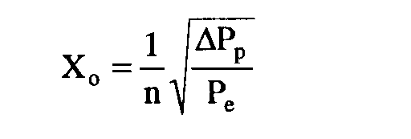
Where:
(A) X_{o} = correlation function.
(B) Δ P_{p} = The pressure differential from pump inlet to pump outlet, kPa (in. Hg) = P_{e} - P_{p.} (C)(1) P_{e} = Absolute pump outlet pressure, kPa (in. Hg) = P_{B} + PPO.
(2) For English units, P_{e} = P_{B} + PPO(SP.GR./13.57).
Where:
(D) PPO = Pressure head at pump outlet, kPa (in. fluid).
(iv) A linear least squares fit is performed to generate the calibration equations which have the forms:
V_{o} = D_{o} - M(X_{o})
n = A - B(Δ P_{p})
D_{o}' M, A, and B are the slope-intercept constants, describing the lines.
(8) A CVS system that has multiple speeds shall be calibrated on each speed used. The calibration curves generated for the ranges will be approximately parallel and the intercept values, D_{o}' will increase as the pump flow range decreases.
(9) If the calibration has been performed carefully, the calculated values from the equation will be within ±0.50 percent of the measured value of V_{o}. Values of M will vary from one pump to another, but values of D_{o} for pumps of the same make, model, and range should agree within ±3 percent of each other. Particulate influx from use will cause the pump slip to decrease as reflected by lower values for M. Calibrations should be performed at pump startup and after major maintenance to assure the stability of the pump slip rate. Analysis of mass injection data will also reflect pump slip stability.
(c) CFV calibration. (1) Calibration of the Critical Flow Venturi (CFV) is based upon the flow equation for a critical venturi. Gas flow is a function of inlet pressure and temperature:

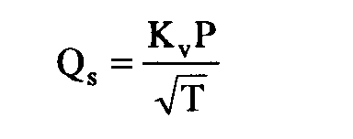

Where:
(i) Q_{s} = Flow.
(ii) K_{v} = Calibration coefficient.
(iii) P = Absolute pressure.
(iv) T = Absolute temperature.
The calibration procedure described below establishes the value of the calibration coefficient at the measured values of pressure, temperature and air flow.
(2) The manufacturer's recommended procedure shall be followed for calibrating electronic portions of the CFV.
(3) Measurements necessary for flow calibration are as follows:

CALIBRATION DATA MEASUREMENTS
Parameter | Symbol | Units | Tolerances
Barometric pressure (corrected)  Air temperature, flowmeter  Pressure depression upstream of LFE  Pressure drop across the LFE matrix  Air flow  CFV inlet depression  Temperature at venturi inlet  Specific gravity of manometer fluid (1.75 oil) | P_{Β}  ETI  EPI  EDP  Q_{s}  PPI  T_{v}.  Sp Gr | kPa (in. Hg)  °C (°F)  kPa (in. H₂0)  kPa (in. H₂0)  m³/min (ft³/min)  kPa (in. Fluid)  °C (°F)  . . . | ±0.03 kPa (±0.01 in.Hg).  ±0.15 °C (±0.27 °F).  ±0.01kPa °C (±0.05 in. H₂0).  ±0.001 kPa (±0.005 in. H₂0).  ±0.5%  ±0.02 kPa (±0.05 in. fluid).  ±0.25 °C (±0.45 °F).  . . .

(4) Set up equipment as shown in Figure F78-6 and check for leaks. Any leaks between the flow measuring device and the critical flow venturi will seriously affect the accuracy of the calibration.
(5) Set the variable flow restrictor to the open position, start the blower and allow the system to stabilize. Record data from all instruments.
(6) Vary the flow restrictor and make at least 8 readings across the critical flow range of the venturi.
(7) Data analysis. The data recorded during the calibration are to be used in the following calculations:
(i) The air flow rate, Q_{s}, at each test point is calculated from the flowmeter data using the manufacturer's prescribed method.
(ii) Calculate values of the calibration coefficient for each test point:
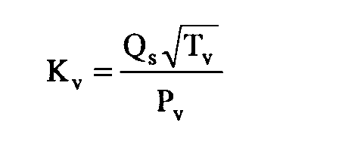

Where:

(A) Q_{s} = Flow rate in m³/minute, standard conditions are 20 °C, 101.3 kPa (68 °F, 29.92 in. Hg)
(B) T_{v} = Temperature at venturi inlet, °K(ºR).
(C)(1) P_{v} = Pressure at venturi inlet, kPa (mm Hg) = P_{B}-PPI.
(2) For English units, P_{v} = P_{B} - PPI (SP.GR./13.57).

Where:
(D) PPI = Venturi inlet pressure depression, kPa (in. fluid).
(E) SP.GR.=Specific gravity of manometer fluid, relative to water.
(iii) Plot K_{v} as a function of venturi inlet depression. For sonic flow, K_{v} will have a relatively constant value. As pressure decreases (vacuum increases), the venturi becomes unchoked and K_{v} decreases (is no longer constant). See Figure F78-7.
(iv) For a minimum of 8 points in the critical region, calculate an average K_{v} and the standard deviation.
(v) If the standard deviation exceeds 0.3 percent of the average K_{v}, take corrective action.
(d) CVS system verification. The following "gravimetric" technique can be used to verify that the CVS and analytical instruments can accurately measure a mass of gas that has been injected into the system. If the CVS and analytical system will be used only in the testing of gasoline-fueled vehicles, the system verification may be performed using either propane or carbon monoxide. If the CVS and analytical system will be used with methanol-fueled vehicles as well as gasoline-fueled vehicles, system verification performance check must include a methanol check in addition to either the propane or carbon monoxide check. (Verification can also be accomplished by constant flow metering using critical flow orifice devices.)
(1) Obtain a small cylinder that has been charged with pure propane or carbon monoxide gas (CAUTION—carbon monoxide is poisonous).
(2) Determine a reference cylinder weight to the nearest 0.01 grams.
(3) Operate the CVS in the normal manner and release a quantity of pure propane or carbon monoxide into the system during the sampling period (approximately 5 minutes).
(4) Following completion of step (3) above (if methanol injection is required), continue to operate the CVS in the normal manner and release a known quantity of pure methanol (in gaseous form) into the system during the sampling period (approximately 5 minutes). This step does not need to be performed with each verification, provided that it is performed at least twice annually.
(5) The calculations of § 86.544 are performed in the normal way except in the case of propane. The density of propane (0.6109 kg/m³/carbon atom (17.30 g/ft³/carbon atom)) is used in place of the density of exhaust hydrocarbons. In the case of carbon monoxide, the density of 1.164 kg/m³ (32.97 g/ft³) is used. In the case of methanol, the density of 1.332 kg/m³ (37.71 g/ft³) is used.
(6) The gravimetric mass is subtracted from the CVS measured mass and then divided by the gravimetric mass to determine the percent accuracy of the system.
(7) The cause for any discrepancy greater than ±2 percent must be found and corrected. The Administrator, upon request, may waive the requirement to comply with ±2 percent methanol recovery tolerance, and instead require compliance with a higher tolerance (not to exceed ±6 percent), provided that:
(i) The Administrator determines that compliance with the specified tolerance is not practically feasible; and
(ii) The manufacturer makes information available to the Administrator which indicates that the calibration tests and their results are consistent with good laboratory practice, and that the results are consistent with the results of calibration testing conducted by the Administrator.

[54 FR 14546, Apr. 11, 1989, as amended at 60 FR 34355, June 30, 1995]

§ 86.521-90 Hydrocarbon analyzer calibration.
(a) The FID hydrocarbon analyzer shall receive the following initial and periodic calibration. The HFID used with methanol-fueled vehicles shall be operated at 235 ºF±15 ºF (113 ºC±8 ºC).
(b) Initial and periodic optimization of detector response. Prior to its introduction into service and at least annually thereafter, the FID hydrocarbon analyzer shall be adjusted for optimum hydrocarbon response. Analyzers used with petroleum fuels and liquefied petroleum gas-fuel shall be optimized using propane. Analyzers used with natural gas-fuel for measurement of hydrocarbons shall be optimized using methane. If a single analyzer is used for all measurements, it shall be optimized using propane and its response factor for methane shall be determined and accounted for in measurements of total hydrocarbons from natural gas-fuel. Alternate methods yielding equivalent results may be used, if approved in advance by the Administrator.
(1) Follow the manufacturer's instructions or good engineering practice for instrument startup and basic operating adjustment using the appropriate FID fuel and zero-grade air.
(2) Optimize on the most common operating range. Introduce into the analyzer a propane (methane as appropriate) in air mixture (methanol in air mixture for methanol-fueled vehicles when optional methanol
calibrated FID procedure is used during the 1990 through 1994 model year) with a propane (or methane or methanol as appropriate) concentration equal to approximately 90 percent of the most common operating range.
(3) Select an operating FID fuel flow rate that will give near maximum response and least variation in response with minor fuel flow variations.
(4) To determine the optimum air flow, use the FID fuel flow setting determined above and vary air flow.
(5) After the optimum flow rates have been determined, record them for future reference.
(c) Initial and periodic calibration. Prior to its introduction into service and monthly thereafter the FID hydrocarbon analyzer shall be calibrated on all normally used instrument ranges, and, if applicable, the methanol response factor shall be determined (paragraph (d) of this section). Use the same flow rate as when analyzing sample.
(1) Adjust analyzer to optimize performance.
(2) Zero the hydrocarbon analyzer with zero grade air.
(3) Calibrate on each normally used operating range with propane in air (or methanol or methane in air as appropriate) calibration gases having nominal concentrations of 15, 30, 45, 60, 75 and 90 percent of that range. For each range calibrated, if the deviation from a least squares best-fit straight line is two percent or less of the value at each data point, concentration values may be calculated by use of a single calibration factor for that range. If the deviation exceeds two percent at any point, the best-fit non-linear equation which represents the data to within two percent of each test point shall be used to determine concentration.
(d) FID response factor to methanol. When the FID analyzer is to be used for the analysis of hydrocarbon samples containing methanol, the methanol response factor of the analyzer shall be established. The methanol response factor shall be determined at several concentrations in the range of concentrations in the exhaust sample, using either bag samples or gas bottles meeting the requirements of Sec. 86.514.
(1) The bag sample, if used, of methanol for analysis in the FID shall be prepared using the apparatus shown in Figure F90-4. A known volume of methanol is injected, using a microliter syringe, into the heated mixing zone (250 ºF (121 ºC)) of the apparatus. The methanol is vaporized and swept into the sample bag with a known volume of zero grade air measured by a gas flow meter meeting the performance requirements of Sec. 86.120.

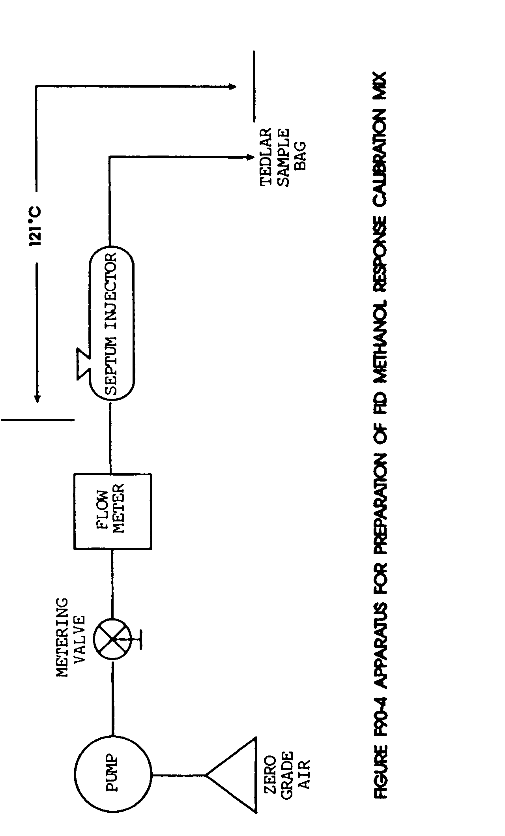

(2) The bag sample is analyzed using the FID.
(3) The FID response factor, r, is calculated as follows:
r = FID_{ppm}/SAM_{ppm}

Where:
(i) r = FID response factor.
(ii) FID_{ppm} = FID reading, ppmC.
(iii) SAMppm=methanol concentration in the sample bag, or gas bottle, in ppmC. SAMppm for sample bags:

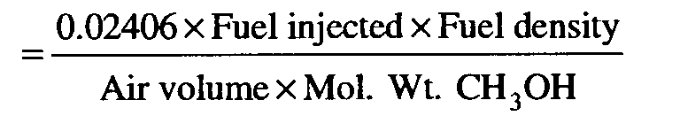
Where:
(iv) 0.02406 = Volume of one mole at 101.3 kPa (29.92 in. Hg) and 20 °C (68 °F), m³.
(v) Fuel injected = Volume of methanol injected, ml.
(vi) Fuel Density = Density of methanol, 0.7914 g/ml
(vii) Air volume = Volume of zero grade air, m³
(viii) Mol. Wt. CH₃OH = 32.04
(e) FID response factor to methane. When the FID analyzer is to be used for the analysis of natural gas-fueled motorcycle hydrocarbon samples, the methane response factor of the analyzer shall be established. To determine the total hydrocarbon FID response to methane, known methane in air concentrations traceable to National Institute of Standards and Technology (NIST) shall be analyzed by the FID. Several methane concentrations shall be analyzed by the FID in the range of concentrations in the exhaust sample. The total hydrocarbon FID response to methane is calculated as follows:

r_{CH4} = FIDppm/SAMppm

Where:
(1) r_{CH4} = FID response factor to methane.
(2) FIDppm = FID reading in ppmC.
(3) SAMppm = the known methane concentration in ppmC.

[54 FR 14546, Apr. 11, 1989, as amended at 59 FR 48514, Sept. 21, 1994; 60 FR 34355, June 30, 1995]

§ 86.522-78 Carbon monoxide analyzer calibration.
(a) Initial and periodic interference check. Prior to its introduction into service and annually thereafter the NDIR carbon monoxide analyzer shall be checked for response to water vapor and CO_{2:}
(1) Follow the manufacturer's instructions for instrument startup and operation. Adjust the analyzer to optimize performance on the most sensitive range.
(2) Zero the carbon monoxide analyzer with either zero grade air or zero grade nitrogen.
(3) Bubble a mixture of 3 percent CO₂ in N₂ through water at room temperature and record analyzer response.
(4) An analyzer response of more than 1 percent of full scale for ranges above 300 ppm full scale or of more than 3 ppm on ranges below 300 ppm full scale will require corrective action. (Use of conditioning columns is one form of corrective action which may be taken.)
(b) Initial and periodic calibration. Prior to its introduction into service and monthly thereafter the NDIR carbon monoxide analyzer shall be calibrated.
(1) Adjust the analyzer to optimize performance.
(2) Zero the carbon monoxide analyzer with either zero grade air or zero grade nitrogen.
(3) Calibrate on each normally used operating range with carbon monoxide in N₂ calibration gases having nominal concentrations of 15, 30, 45, 60, 75, and 90 percent of that range. Additional calibration points may be generated. For each range calibrated, if the deviation from a least-squares best-fit straight line is 2 percent or less of the value at each data point, concentration values may be calculated by use of a single calibration factor for that range. If the deviation exceeds 2 percent at any point, the best-fit non-linear equation which represents the data to within 2 percent of each test point shall be used to determine concentration.

§ 86.523-78 Oxides of nitrogen analyzer calibration.
(a) Prior to introduction into service and at least monthly thereafter, if oxides of nitrogen are measured, the chemiluminescent oxides of nitrogen analyzer must be checked for NO₂ to NO converter efficiency. Figure F78-8 is a reference for paragraphs (a) (1) through (11) of this section.

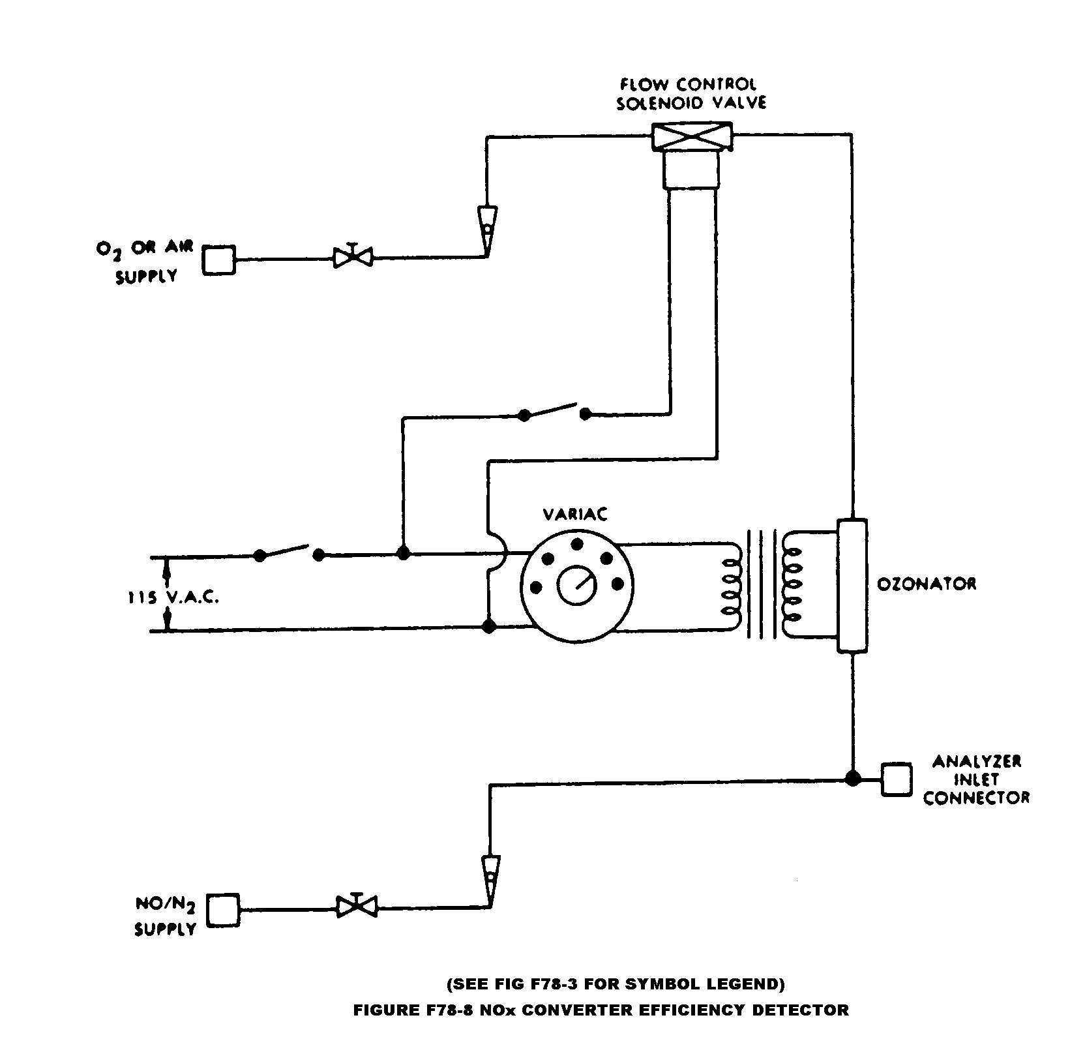

(1) Follow the manufacturer's instructions for instrument startup and operation. Adjust the analyzer to optimize performance.
(2) Zero the oxides of nitrogen analyzer with zero grade air or zero grade nitrogen.
(3) Connect the outlet of the NO_{X} generator to the sample inlet of the oxides of nitrogen analyzer which has been set to the most common operating range.
(4) Introduce into the NO_{X} generator analyzer-system a NO in nitrogen (N₂) mixture with a NO concentration equal to approximately 80 percent of the most common operating range. The NO₂ content of the gas mixture shall be less than 5 percent of the NO concentration.
(5) With the oxides of nitrogen analyzer in the NO mode, record the concentration of NO indicated by the analyzer.
(6) Turn on the NO_{X} generator O₂ (or air) supply and adjust the O₂ (or air) flow rate so that the NO indicated by the analyzer is about 10 percent less than indicated in step 5. Record the concentration of NO in this NO + O₂ mixture.
(7) Switch the NO_{X} generator to the generation mode and adjust the generation rate so that the NO measured on the analyzer is 20 percent of that measured in step 5. There must be at least 10 percent unreacted NO at this point. Record the concentration of residual NO.
(8) Switch the oxides of nitrogen analyzer to the NO_{X} mode and measure total NO_{X}. Record this value.
(9) Switch off the NO_{X} generation but maintain gas flow through the system. The oxides of nitrogen analyzer will indicate the NO_{X} in the NO + O₂ mixture. Record this value.
(10) Turn off the NO_{X} generator O₂ (or air) supply. The analyzer will now indicate the NO_{X} in the original NO in N₂ mixture. This value should be no more than 5 percent above the value indicated in step 4.
(11) Calculate the efficiency of the NO_{X} converter by substituting the concentrations obtained into the following equation:
Percent Efficiency = [1 + (a-b)/(c-d)]x100

where:
a = concentration obtained in step (8).
b = concentration obtained in step (9).
c = concentration obtained in step (6).
d = concentration obtained in step (7).

If converter efficiency is not greater than 90 percent corrective action will be required.
(b) Initial and periodic calibration. Prior to its introduction into service and monthly thereafter, if oxides of nitrogen are measured, the chemiluminescent oxides of nitrogen analyzer shall be calibrated on all
normally used instrument ranges. Use the same flow rate as when analyzing samples. Proceed as follows:
(1) Adjust analyzer to optimize performance.
(2) Zero the oxides of nitrogen analyzer with zero grade air or zero grade nitrogen.
(3) Calibrate on each normally used operating range with NO in N₂ calibration gases with nominal concentrations of 50 and 100 percent of that range. Additional calibration points may be generated.
(c) When testing methanol-fueled motorcycles, it may be necessary to clean the analyzer frequently to prevent interference with NO_{X} measurements (see EPA/600/S3-88/040).

[42 FR 1137, Jan. 5, 1977, as amended at 52 FR 47870, Dec. 16, 1987; 58 FR 58423, Nov. 1, 1993; 60 FR 34357, June 30, 1995]
§ 86.524-78 Carbon dioxide analyzer calibration.
(a) Prior to its introduction into service and monthly thereafter the NDIR carbon dioxide analyzer shall be calibrated:
(1) Follow the manufacturer's instructions for instrument startup and operation. Adjust the analyzer to optimize performance.
(2) Zero the carbon dioxide analyzer with either zero grade air or zero grade nitrogen.
(3) Calibrate on each normally used operating range with carbon dioxide in N₂ calibration gases with nominal concentrations of 15, 30, 45, 60, 75, and 90 percent of that range. Additional calibration points may be generated. For each range calibrated, if the deviation from a least-squares best-fit straight line is 2 percent or less of the value at each data point, concentration values may be calculated by use of a single calibration factor for that range. If the deviation exceeds 2 percent at any point, the best-fit non-linear equation which represents the data to within 2 percent of each test point shall be used to determine concentration.
(b) [Reserved]

§ 86.526-90 Calibration of other equipment.
Other test equipment used for testing shall be calibrated as often as required by the manufacturer or as necessary according to good practice. Specific equipment requiring calibration is the gas chromatograph and flame ionization detector used in measuring methanol and the high pressure liquid chromatograph (HPLC) and ultraviolet detector for measuring formaldehyde.

[54 FR 14551, Apr. 11, 1989]

§ 86.527-90 Test procedures, overview.
(a) The procedures described in this and subsequent sections are used to determine the conformity of motorcycles with the standards set forth in subpart E of this part.
(b) The overall test consists of prescribed sequences of fueling, parking, and operating conditions.
(c) The exhaust emission test is designed to determine hydrocarbon (gasoline-fueled, natural gas-fueled and liquefied petroleum gas-fueled motorcycles), methanol, formaldehyde, and hydrocarbon (methanol-fueled motorcycles), carbon monoxide and oxides of nitrogen mass emissions while simulating an average trip in an urban area. The test consists of engine startups and motorcycle operation on a chassis dynamometer, through a specified driving schedule. A proportional part of the diluted exhaust emissions is collected continuously for subsequent analysis, using a constant volume (variable dilution) sampler.
(d) Except in cases of component malfunction or failure, all emission control systems installed on or incorporated in a new motorcycle shall be functioning during all procedures in this subpart. Maintenance to correct component malfunction or failure shall be authorized in accordance with subpart E of this part.
(e) Background concentrations are measured for all species for which emissions measurements are made. For exhaust testing, this requires sampling and analysis of the dilution air. (When testing methanol-fueled motorcycles, manufacturers may choose not to measure background concentrations of methanol and/or formaldehyde, and then assume that the concentrations are zero during calculations.)

[54 FR 14551, Apr. 11, 1989, as amended at 59 FR 48515, Sept. 21, 1994; 60 FR 34357, June 30, 1995]

§ 86.528-78 Transmissions.
(a) Vehicles equipped with transfer cases, multiple sprockets, etc., shall be tested in the manufacturer's recommended configuration for street or highway use. If more than one configuration is recommended or if the recommendation is deemed unreasonable by the Administrator, the Administrator will specify the test configuration.
(b) All tests shall be conducted with automatic transmissions in "Drive" (highest gear). Automatic clutch-torque converter transmissions may be shifted as manual transmissions at the option of the manufacturer.
(c) Idle modes shall be run with automatic transmissions in "Drive'' and the wheels braked, manual transmission shall be in gear with the clutch disengaged; except first idle, see §§ 86.536 and 86.537.
(d) The vehicle shall be driven with minimum throttle movement to maintain the desired speed. No simultaneous use of brake and throttle shall be permitted.
(e) Acceleration modes shall be driven smoothly. Automatic transmissions shall shift automatically through the normal sequence of gears; manual transmissions shall be shifted as recommended by the manufacturer to the ultimate purchaser (unless determined to be unreasonable by the Administrator) with the operator closing the throttle during each shift and accomplishing the shift with minimum time. If the vehicle cannot accelerate at the specified rate, the vehicle shall be operated with the throttle fully opened until the vehicle speed reaches the value prescribed for that time in the driving schedule.
(f) The deceleration modes shall be run in gear using brakes or throttle as necessary to maintain the desired speed. Manual transmission vehicles shall be downshifted using the same shift points as when upshifting or as recommended by the manufacturer in the vehicle owner's manual. All downshifts shall be made smoothly, disengaging the clutch while shifting and engaging the clutch once the lower gear has been selected. For those modes which require the vehicle to decelerate to zero, manual transmission clutches shall be disengaged when the speed drops below 15 km/h (9.3 mph) for vehicles with engine displacements equal to or greater than 280 cc (17.1 cu. in.), when the speed drops below 10 km/h (6.2 mph) for vehicles with engine displacements less than 280 cc (17.1 cu. in.), when engine roughness is evident, or when engine stalling is imminent.
(g) If downshifting during deceleration is not permitted in the vehicle owner's manual, manual transmissions will be downshifted at the beginning of or during a power mode if recommended by the manufacturer or if the engine obviously is lugging. For those modes which require these vehicles to decelerate to zero, manual transmission clutches shall be disengaged when the speed drops below 25 km/h (15.5 mph) for vehicles with engine displacement equal to or greater than 280 cc (17.1 cu. in.), when the speed drops below 20 km/h (12.4 mph) for vehicles with engine displacements less than 280 cc (17.1 cu. in.), when engine roughness is evident, or when engine stalling is imminent. While the clutch is disengaged and during these deceleration modes, the vehicle shall be shifted to the appropriate gear for starting the next mode.
(h) If shift speeds are not recommended by the manufacturer, manual transmission vehicles shall be shifted as follows:
(1) For Class I and II motorcycles:
Shift | Speed
1st to 2d gear.............. | 19 km/h (11.8 mi/h).
2d to 3d gear.............. | 33 km/h (20.5 mi/h).
3d to 4th gear............. | 44 km/h (27.3 mi/h).
4th to 5th gear............ | 53 km/h (32.9 mi/h).

(2) For Class III motorcycles:
Shift | Speed
1st to 2d gear.............. | 30 km/h (18.6 mi/h).
2d to 3d gear.............. | 45 km/h (28.0 mi/h).
3d to 4th gear............. | 60 km/h (37.3 mi/h).
4th to 5th gear............ | 75 km/h (46.6 mi/h).

(3) Higher gears may be used at the manufacturer's option.

§ 86.529-78 Road load force and inertia weight determination.
(a) Road load as a function of speed is given by the following equation:

F = A + CV²

The values for coefficients A and C and the test inertia are given in Figure F78-9. Velocity (V) is in km/h and force (F) is in newtons. The forces given by this equation shall be simulated to the best ability of the equipment being used.
(b) The inertia given in Figure F78-9 shall be used. Motorcycles with loaded vehicle mass outside these limits shall be tested at an equivalent inertial mass and road load force specified by the Administrator.

FIGURE F78-9
Loaded vehicle mass (kg) | Equivalent inertial  mass (kg) | Force coefficients |  | Force at  65 km/h  (nt) | 70 to 60 kn/h coastdown calibration  times
Loaded vehicle mass (kg) | Equivalent inertial  mass (kg) | A (nt) | C (nt/(km/  h)²) | Force at  65 km/h  (nt) | Target  time (sec) |  | Allowable tolerance
 |  |  |  |  |  |  | Longest  time (sec) |  | Shortest  time (sec)
95-105 | 100 | 0.0 | 0.224 | 94.8 | 2.95 |  | 3.1 |  | 2.8
106-115 | 110 | 0.82 | .0227 | 96.8 | 3.18 |  | 3.3 |  | 3.0
116-125 | 120 | 1.70 | .0230 | 98.8 | 3.39 |  | 3.6 |  | 3.2
126-135 | 130 | 2.57 | .0233 | 100.9 | 3.60 |  | 3.8 |  | 3.4
136-145 | 140 | 3.44 | .0235 | 102.9 | 3.80 |  | 4.0 |  | 3.6
146-155 | 150 | 4.32 | 0.230 | 104.9 | 3.99 |  | 4.2 |  | 3.8
156-165 | 160 | 5.19 | .0241 | 107.0 | 4.10 |  | 4.4 |  | 4.0
166-175 | 170 | 6.06 | .0244 | 109.0 | 4.36 |  | 4.6 |  | 4.2
176-185 | 180 | 6.94 | .0246 | 111.0 | 4.53 |  | 4.7 |  | 4.3
186-195 | 190 | 7.81 | .0249 | 113.1 | 4.69 |  | 4.9 |  | 4.5
196-205 | 200 | 8.69 | .0252 | 115.1 | 4.85 |  | 5.1 |  | 4.6
206-215 | 210 | 9.56 | .0255 | 117.1 | 5.00 |  | 5.2 |  | 4.8
216-225 | 220 | 10.43 | .0257 | 119.2 | 5.15 |  | 5.4 |  | 4.9
226-235 | 230 | 11.31 | .0260 | 121.2 | 5.30 |  | 5.5 |  | 5.1
236-245 | 240 | 12.18 | .0263 | 123.2 | 5.43 |  | 5.7 |  | 5.2
246-255 | 250 | 13.06 | .0266 | 125.3 | 5.57 |  | 5.8 |  | 5.4
256-265 | 260 | 13.93 | .0268 | 127.3 | 5.70 |  | 5.9 |  | 5.5
266-275 | 270 | 14.80 | .0271 | 129.3 | 5.82 |  | 6.1 |  | 5.6
276-285 | 280 | 15.68 | .0274 | 131.4 | 5.95 |  | 6.2 |  | 5.7
286-295 | 290 | 16.55 | .0277 | 133.4 | 6.06 |  | 6.3 |  | 5.8
296-305 | 300 | 17.43 | .0279 | 135.4 | 6.18 |  | 6.4 |  | 6.0
306-315 | 310 | 18.39 | .0282 | 137.5 | 6.29 |  | 6.5 |  | 6.1
316-325 | 320 | 19.17 | .0285 | 139.5 | 6.40 |  | 6.6 |  | 6.2
326-335 | 330 | 30.05 | .0288 | 141.6 | 6.50 |  | 6.7 |  | 6.3
336-345 | 340 | 20.92 | .0290 | 143.6 | 6.60 |  | 6.8 |  | 6.4
346-355 | 350 | 21.80 | .0293 | 145.6 | 6.70 |  | 6.9 |  | 6.5
356-365 | 360 | 22.67 | .0296 | 147.7 | 6.80 |  | 7.0 |  | 6.6
366-375 | 370 | 23.54 | .0299 | 149.7 | 6.89 |  | 7.1 |  | 6.7
376-385 | 380 | 24.42 | .0301 | 151.7 | 6.98 |  | 7.2 |  | 6.8
386-395 | 390 | 25.29 | .0304 | 153.8 | 7.07 |  | 7.3 |  | 6.9
396-405 | 400 | 26.17 | .0307 | 155.8 | 7.16 |  | 7.4 |  | 6.9
406-415 | 410 | 27.04 | .0310 | 157.8 | 7.24 |  | 7.5 |  | 7.0
416-425 | 420 | 27.91 | .0312 | 159.9 | 7.33 |  | 7.6 |  | 7.1
426-435 | 430 | 28.79 | .0315 | 161.9 | 7.41 |  | 7.6 |  | 7.2
436-445 | 440 | 29.66 | .0317 | 163.7 | 7.49 |  | 7.7 |  | 7.3
446-455 | 450 | 30.54 | .0318 | 164.9 | 7.61 |  | 7.8 |  | 7.4
456-465 | 460 | 31.41 | .0319 | 166.0 | 7.73 |  | 8.0 |  | 7.5
466-475 | 470 | 32.28 | .0319 | 167.1 | 7.84 |  | 8.1 |  | 7.6
476-485 | 480 | 33.16 | .0320 | 168.3 | 7.95 |  | 8.2 |  | 7.7
486-495 | 490 | 43.03 | .0320 | 169.4 | 8.06 |  | 8.3 |  | 7.8
496-505 | 500 | 34.90 | .0321 | 170.5 | 8.17 |  | 8.4 |  | 7.9
506-515 | 510 | 35.78 | .0322 | 171.7 | 8.28 |  | 8.5 |  | 8.0
516-525 | 520 | 36.65 | .0322 | 172.8 | 8.39 |  | 8.6 |  | 8.2
526-535 | 530 | 37.53 | .0323 | 173.9 | 8.49 |  | 8.7 |  | 8.3
536-545 | 540 | 38.40 | .0323 | 175.1 | 8.60 |  | 8.8 |  | 8.4
546-555 | 550 | 39.27 | .0324 | 176.2 | 8.70 |  | 9.0 |  | 8.5
556-565 | 560 | 40.15 | .0325 | 177.3 | 8.80 |  | 9.1 |  | 8.6
566-575 | 570 | 41.02 | .0325 | 178.5 | 8.90 |  | 9.2 |  | 8.7
576-585 | 580 | 41.90 | .0326 | 179.6 | 9.00 |  | 9.3 |  | 8.8
586-595 | 590 | 42.77 | .0327 | 180.8 | 9.10 |  | 9.4 |  | 8.9
FIGURE F78-9 — Continued
Loaded vehicle mass (kg) | Equivalent inertial  mass (kg) | Force coefficients |  | Force at  65 km/h  (nt) |  | 70 to 60 kn/h coastdown calibration  times
Loaded vehicle mass (kg) | Equivalent inertial  mass (kg) | A (nt) | C (nt/(km/  h)²) |  |  | Target  time (sec) | Allowable tolerance
 |  |  |  |  |  |  | Longest time (sec) | Shortest  time (sec)
596-605 | 600 | 43.64 | .0327 | 181.9 |  | 9.19 | 9.5 | 8.9
606-615 | 610 | 44.52 | .0328 | 183.0 |  | 9.29 | 9.5 | 9.0
616-625 | 620 | 45.39 | .0328 | 184.2 |  | 9.38 | 9.6 | 9.1
626-635 | 630 | 46.27 | .0329 | 185.3 |  | 9.47 | 9.7 | 9.2
636-645 | 640 | 47.14 | .0330 | 186.4 |  | 9.56 | 9.8 | 9.3
646-655 | 650 | 48.01 | .0330 | 187.6 |  | 9.65 | 9.9 | 9.4
656-665 | 660 | 48.89 | .0331 | 188.7 |  | 9.74 | 10.0 | 9.5
666-675 | 670 | 49.76 | .0332 | 189.8 |  | 9.83 | 10.1 | 9.6
676-685 | 680 | 50.64 | .0332 | 191.0 |  | 9.92 | 10.2 | 9.7
686-695 | 690 | 51.91 | .0333 | 192.1 |  | 10.0 | 10.3 | 9.8
696-705 | 700 | 52.38 | .0333 | 193.2 |  | 10.09 | 10.4 | 9.8
706-715 | 710 | 53.26 | .0334 | 194.4 |  | 10.17 | 10.4 | 9.9
716-725 | 720 | 54.13 | .0335 | 195.5 |  | 10.26 | 10.5 | 10.0
726-735 | 730 | 55.01 | .0335 | 196.6 |  | 10.34 | 10.6 | 10.1
736-745 | 740 | 55.88 | .0336 | 197.8 |  | 10.42 | 10.7 | 10.2
746-755 | 750 | 56.75 | .0336 | 198.9 |  | 10.50 | 10.8 | 10.2
756-760 | 760 | 57.63 | .0337 | 200.1 |  | 10.58 | 10.9 | 10.3

(c) The dynamometer shall be adjusted to reproduce the specified road load as determined by the most recent calibration. Alternatively, the actual vehicle road load can be measured and duplicated:
(1) Make at least 5 replicate coastdowns in each direction from 70 to 60 km/h on a smooth, time.level, track under balanced wind conditions. The driver must have a mass of 8010kg and be in the normal driving position. Record the coastdown time.
(2) Average the coastdown times. Adjust the dynamometer load so that the coastdown time is duplicated with the vehicle and driver on the dynamometer.
(3) Alternate procedures may be used if approved in advance by the Administrator.

§ 86.529-98 Road load force and inertia weight determination.
(a)(1) Road load as a function of speed is given by the following equation:
F = A + CV²
(2) The values for coefficients A and C and the test inertia are given in Figure F98-9 of this section. Velocity V is in km/h and force (F) is in newtons. The forces given by the equation in paragraph (a)(1) of this section shall be simulated to the best ability of the equipment being used.
(b) The inertia given in Figure F98-9 shall be used. Motorcycles with loaded vehicle mass outside these limits shall be tested at an equivalent inertial mass and road load force specified by the Administrator. Figure F98-9 follows:

Figure F98-9
Loaded vehicle mass (kg) |  | Equivalent inertial mass (kg) | Force coefficients |  | Force at  65 km/h  (nt) | 70 to 60 kn/h coastdown calibration times
 |  |  |  |  |  | Target time (sec) | Allowable tolerance
 |  |  | A (nt) | C (nt/(km/ h)²) | Force at  65 km/h  (nt) | Target time (sec) | Longest  time (sec) | Shortest  time (sec)
95-105 | 100 |  | 0.0 | .0224 | 94.8 | 2.95 | 3.1 | 2.8
106-115 | 110 |  | 0.82 | .0227 | 96.8 | 3.18 | 3.3 | 3.0
116-125 | 120 |  | 1.70 | .0230 | 98.8 | 3.39 | 3.6 | 3.2
126-135 | 130 |  | 2.57 | .0233 | 100.9 | 3.60 | 3.8 | 3.4
136-145 | 140 |  | 3.44 | .0235 | 102.9 | 3.80 | 4.0 | 3.6
146-155 | 150 |  | 4.32 | .0238 | 104.9 | 3.99 | 4.2 | 3.8
156-165 | 160 |  | 5.19 | .0241 | 107.0 | 4.10 | 4.4 | 4.0
166-175 | 170 |  | 6.06 | .0244 | 109.0 | 4.36 | 4.6 | 4.2
176-185 | 180 |  | 6.94 | .0246 | 111.0 | 4.53 | 4.7 | 4.3
186-195 | 190 |  | 7.81 | .0249 | 113.1 | 4.69 | 4.9 | 4.5
196-205 | 200 |  | 8.69 | .0252 | 115.1 | 4.85 | 5.1 | 4.6
206-215 | 210 |  | 9.56 | .0255 | 117.1 | 5.00 | 5.2 | 4.8
216-225 | 220 |  | 10.43 | .0257 | 119.2 | 5.15 | 5.4 | 4.9
226-235 | 230 |  | 11.31 | .0260 | 121.2 | 5.30 | 5.5 | 5.1
236-245 | 240 |  | 12.18 | .0263 | 123.2 | 5.43 | 5.7 | 5.2
246-255 | 250 |  | 13.06 | .0266 | 125.3 | 5.57 | 5.8 | 5.4
256-265 | 260 |  | 13.93 | .0268 | 127.3 | 5.70 | 5.9 | 5.5
266-275 | 270 |  | 14.80 | .0271 | 129.3 | 5.82 | 6.1 | 5.6
276-285 | 280 |  | 15.68 | .0274 | 131.4 | 5.95 | 6.2 | 5.7
286-295 | 290 |  | 16.55 | .0277 | 133.4 | 6.06 | 6.3 | 5.8
296-305 | 300 |  | 17.43 | .0279 | 135.4 | 6.18 | 6.4 | 6.0
306-315 | 310 |  | 18.30 | .0282 | 137.5 | 6.29 | 6.5 | 6.1
316-325 | 320 |  | 19.17 | .0285 | 139.5 | 6.40 | 6.6 | 6.2
326-335 | 330 |  | 20.05 | .0288 | 141.6 | 6.50 | 6.7 | 6.3
336-345 | 340 |  | 20.92 | .0290 | 143.6 | 6.60 | 6.8 | 6.4
346-355 | 350 |  | 21.80 | .0293 | 145.6 | 6.70 | 6.9 | 6.5
356-365 | 360 |  | 22.67 | .0296 | 147.7 | 6.80 | 7.0 | 6.6
366-375 | 370 |  | 23.54 | .0299 | 149.7 | 6.89 | 7.1 | 6.7
376-385 | 380 |  | 24.42 | .0301 | 151.7 | 6.98 | 7.2 | 6.8
386-395 | 390 |  | 25.29 | .0304 | 153.8 | 7.07 | 7.3 | 6.9
396-405 | 400 |  | 26.17 | .0307 | 155.8 | 7.16 | 7.4 | 6.9
406-415 | 410 |  | 27.04 | .0310 | 157.8 | 7.24 | 7.5 | 7.0
416-425 | 420 |  | 27.91 | .0312 | 159.9 | 7.33 | 7.6 | 7.1
426-435 | 430 |  | 28.79 | .0315 | 161.9 | 7.41 | 7.6 | 7.2
436-445 | 440 |  | 29.66 | .0317 | 163.7 | 7.49 | 7.7 | 7.3
446-455 | 450 |  | 30.54 | .0318 | 164.9 | 7.61 | 7.8 | 7.4
456-465 | 460 |  | 31.41 | .0319 | 166.0 | 7.73 | 8.0 | 7.5
466-475 | 470 |  | 32.28 | .0319 | 67.1 | 7.84 | 8.1 | 7.6
476-485 | 480 |  | 33.16 | .0320 | 168.3 | 7.95 | 8.2 | 7.7
486-495 | 490 |  | 34.03 | .0320 | 169.4 | 8.06 | 8.3 | 7.8
496-505 | 500 |  | 34.90 | .0321 | 170.5 | 8.17 | 8.4 | 7.9
506-515 | 510 |  | 35.78 | .0322 | 171.7 | 8.28 | 8.5 | 8.0
516-525 | 520 |  | 36.65 | .0322 | 172.8 | 8.39 | 8.6 | 8.2
526-535 | 530 |  | 37.53 | .0323 | 173.9 | 8.49 | 8.7 | 8.3
536-545 | 540 |  | 38.40 | .0323 | 175.1 | 8.60 | 8.8 | 8.4
546-555 | 550 |  | 39.27 | .0324 | 176.2 | 8.70 | 9.0 | 8.5
556-565 | 560 |  | 40.15 | .0325 | 177.3 | 8.80 | 9.1 | 8.6
566-575 | 570 |  | 41.02 | .0325 | 178.5 | 8.90 | 9.2 | 8.7

Figure F98-9 — Continued

576-585 | 580 | 41.90 | .0326 | 179.6 | 9.00 | 9.3 | 8.8
586-595 | 590 | 42.77 | .0327 | 180.8 | 9.10 | 9.4 | 8.9
596-605 | 600 | 43.64 | .0327 | 181.9 | 9.19 | 9.5 | 8.9
606-615 | 610 | 44.52 | .0328 | 183.0 | 9.29 | 9.5 | 9.0
616-625 | 620 | 45.39 | .0328 | 184.2 | 9.38 | 9.6 | 9.1
626-635 | 630 | 46.27 | .0329 | 185.3 | 9.47 | 9.7 | 9.2
636-645 | 640 | 47.14 | .0330 | 186.4 | 9.56 | 9.8 | 9.3
646-655 | 650 | 48.01 | .0330 | 187.6 | 9.65 | 9.9 | 9.4
565-665 | 660 | 48.89 | .0331 | 188.7 | 9.74 | 10.0 | 9.5
666-675 | 670 | 49.76 | .0332 | 189.8 | 9.83 | 10.1 | 9.6
676-685 | 680 | 50.64 | .0332 | 191.0 | 9.92 | 10.2 | 9.7
686-695 | 690 | 51.51 | .0333 | 192.1 | 10.01 | 10.3 | 9.8
696-705 | 700 | 52.38 | .0333 | 193.2 | 10.09 | 10.4 | 9.8
706-715 | 710 | 53.26 | .0334 | 194.4 | 10.17 | 10.4 | 9.9
716-725 | 720 | 54.13 | .0335 | 195.5 | 10.26 | 10.5 | 10.0
726-735 | 730 | 55.01 | .0335 | 196.6 | 10.34 | 10.6 | 10.1
736-745 | 740 | 55.88 | .0336 | 197.8 | 10.42 | 10.7 | 10.2
746-755 | 750 | 56.75 | .0336 | 198.9 | 10.50 | 10.8 | 10.2
756-765 | 760 | 57.63 | .0337 | 200.1 | 10.58 | 10.9 | 10.3
766-775 | 770 | 58.50 | .0338 | 201.2 | 10.66 | 10.9 | 10.3
776-785 | 780 | 59.38 | .0338 | 203.3 | 10.74 | 11.0 | 10.4
786-795 | 790 | 60.25 | .0339 | 204.5 | 10.82 | 11.1 | 10.5
796-805 | 800 | 61.12 | .0339 | 205.6 | 10.91 | 11.2 | 10.6
806-815 | 810 | 62.00 | .0340 | 206.7 | 10.99 | 11.3 | 10.7
816-825 | 820 | 62.87 | .0341 | 207.9 | 11.07 | 11.4 | 10.8
826-835 | 830 | 63.75 | .0341 | 209.0 | 11.15 | 11.5 | 10.8
836-845 | 840 | 64.62 | .0342 | 210.1 | 11.24 | 11.5 | 10.9
846-855 | 850 | 65.49 | .0343 | 211.3 | 11.32 | 11.6 | 11.0
856-865 | 860 | 66.37 | .0343 | 212.4 | 11.40 | 11.7 | 11.1
866-873 | 870 | 67.24 | .0344 | 213.5 | 11.48 | 11.8 | 11.2

(c) The dynamometer shall be adjusted to reproduce the specified road load as determined by the most recent calibration. Alternatively, the actual vehicle road load can be measured and duplicated:

(1) Make at least 5 replicate coastdowns in each direction from 70 to 60 km/h on a smooth, level track under balanced wind conditions. The driver must have a mass of 8010 kg and be in the normal driving position. Record the coastdown time.

(2) Average the coastdown times. Adjust the dynamometer load so that the coastdown time is duplicated with the vehicle and driver on the dynamometer.

(3) Alternate procedures may be used if approved in advance by the Administrator.

[63 FR 11849, Mar. 11, 1998]

§ 86.530-78 Test sequence, general requirements.

(a) Ambient temperature levels encountered by the test vehicle throughout the test sequence shall not be less than 20 °C (68 °F) nor more than 30 °C (86 °F). The vehicle shall be approximately level during the emission test to prevent abnormal fuel distribution.

(b) [Reserved]

§ 86.531-78 Vehicle preparation.

(a) The manufacturer shall provide additional fittings and adapters, as required by the Administrator * * *, such as * * * to accommodate a fuel drain at the lowest point possible in the tank(s) as installed on the vehicle and to provide for exhaust sample collection.
(b) [Reserved]

§ 86.532-78 Vehicle preconditioning.
(a) The vehicle shall be moved to the test area and the following operations performed:
(1) The fuel tank(s) shall be drained through the provided fuel tank(s) drain(s) and charged with the specified test fuel, § 86.513, to half the tank(s) capacity.
(2) The vehicle shall be placed, either by being driven or pushed, on a dynamometer and operated through one Urban Dynamometer Driving Schedule test procedure (see § 86.515 and appendix I). The vehicle need not be cold, and may be used to set dynamometer horsepower.
(b) Within five (5) minutes of completion of preconditioning, the vehicle shall be removed from the dynamometer and may be driven or pushed to the soak area to be parked. The vehicle shall be stored for not less than the following times prior to the cold start exhaust test.

 | Hours
Class ......................................  Class II...................................  Class III.................................. | 6  8  12

In no case shall the vehicle be stored for more than 36 hours prior to the cold start exhaust test.

§ 86.535-90 Dynamometer procedure.
(a) The dynamometer run consists of two tests, a "cold'' start test and a "hot'' start test following the "cold'' start by 10 minutes. Engine startup (with all accessories turned off), operation over the driving schedule, and engine shutdown make a complete cold start test. Engine startup and operation over the first 505 seconds of the driving schedule complete the hot start test. The exhaust emissions are diluted with ambient air and a continuously proportional sample is collected for analysis during each phase. The composite samples collected in bags are analyzed for hydrocarbons, carbon monoxide, carbon dioxide, and, optionally, for oxides of nitrogen. A parallel sample of the dilution air is similarly analyzed for hydrocarbon, carbon monoxide, carbon dioxide, and, optionally, for oxides of nitrogen. Methanol and formaldehyde samples (exhaust and dilution air) are collected and analyzed for methanol-fueled vehicles (a single dilution air formaldehyde sample covering the total time of the test may be collected in place of individual test phases).
(b) [Reserved]
(c) The vehicle speed, as measured from the dynamometer roll, shall be used. A speed vs. time recording, as evidence of dynamometer test validity, shall be supplied on request of the Administrator.
(d) Practice runs over the prescribed driving schedule may be performed at test points, provided an emission sample is not taken, for the purpose of finding the minimum throttle action to maintain the proper speed-time relationship, or to permit sampling system adjustments.
(e) The drive wheel tires must be inflated to the manufacturer's recommended pressure, 15 kPa (2.2 psi). The drive wheel tire pressure shall be reported with the test results.
(f) If the dynamometer has not been operated during the two-hour period immediately preceding the test, it shall be warmed up for 15 minutes by operating at 50 km/h (31 mph) using a nontest vehicle, or as recommended by the dynamometer manufacturer.
(g) If the dynamometer horsepower must be adjusted manually, it shall be set within one hour prior to the exhaust emissions test phase. The test vehicle shall not be used to make this adjustment. Dynamometers using automatic control of preselectable power settings may be set anytime prior to the beginning of the emissions test.
(h) The driving distance, as measured by counting the number of dynamometer roll revolutions, shall be determined for the transient cold start, stabilized cold start, and transient hot start phases of the test.

[54 FR 14551, Apr. 11, 1989]

§86.536-78 Engine starting and restarting.
(a)(1) The engine shall be started according to the manufacturer's recommended starting procedures. The initial 20 second idle period shall begin when the engine starts.
(2) Choke operation. (i) Vehicles equipped with automatic chokes shall be operated according to the instructions in the manufacturer's operating instructions or owner's manual including choke setting and "kick-down'' from cold fast idle. The transmission shall be placed in gear 15 seconds after the engine is started. If necessary, braking may be employed to keep the drive wheels from turning.
(ii) Vehicles equipped with manual chokes shall be operated according to the manufacturer's operating instructions or owner's manual. Where times are provided in the instructions, the Administrator may specify the specific point for operation, within 15 seconds of the recommended time.
(3) The operator may use the choke, throttle etc. where necessary to keep the engine running.
(4) If the manufacturer's operating instructions or owner's manual do not specify a warm engine starting procedure, the engine (automatic and manual choke engines) shall be started by opening the throttle about half way and cranking the engine until it starts.
(b) [Reserved]
(c) If, during the cold start, the vehicle does not start after 10 seconds of cranking, or ten cycles of the manual starting mechanism, cranking shall cease and the reason for failure to start determined. The revolution counter on the constant volume sampler shall be turned off and the sample solenoid valves placed in the "standby'' position during this diagnostic period. In addition, either the CVS blower shall be turned off or the exhaust tube disconnected from the tailpipe during the diagnostic period.
(1) If failure to start is an operational error, the vehicle shall be rescheduled for testing from a cold start. If failure to start is caused by vehicle malfunction, corrective action (following the unscheduled maintenance provisions) of less than 30 minutes duration may be taken and the test continued. The sampling system shall be reactivated at the same time cranking is started. When the engine starts, the driving schedule timing sequence shall begin. If failure to start is caused by vehicle malfunction and the vehicle cannot be started, the test shall be voided, the vehicle removed from the dynamometer, corrective action taken (following the unscheduled maintenance provisions), and the vehicle rescheduled for test. The reason for the malfunction (if determined) and the corrective action taken shall be reported.
(2) If the vehicle does not start during the hot start after ten seconds of cranking, or ten cycles of the manual starting mechanism, cranking shall cease, the test shall be voided, the vehicle removed from the dynamometer, corrective action taken in accordance with § 86.428 or § 86.429, and the vehicle rescheduled for test. The reason for the malfunction (if determined) and the corrective action taken shall be reported.
(d) If the engine "false starts'', the operator shall repeat the recommended starting procedure (such as resetting the choke, etc.)
(e) Stalling. (1) If the engine stalls during an idle period, the engine shall be restarted immediately and the test continued. If the engine cannot be started soon enough to allow the vehicle to follow the next acceleration as prescribed, the driving schedule indicator shall be stopped. When the vehicle restarts, the driving schedule indicator shall be reactivated.
(2) If the engine stalls during some operating mode other than idle, the driving schedule indicator shall be stopped, the vehicle shall then be restarted and accelerated to the speed required at that point in the driving schedule and the test continued. During acceleration to this point, shifting shall be performed in accordance with § 86.528.
(3) If the vehicle will not restart within one minute, the test shall be voided, the vehicle removed from the dynamometer, corrective action taken, and the vehicle rescheduled for test. The reason for the malfunction (if determined) and the corrective action taken shall be reported.

§ 86.537-90 Dynamometer test runs.
(a) The vehicle shall be allowed to stand with the engine turned off (see § 86.532 for required time). The vehicle shall be stored prior to the emission test in such a manner that precipitation (e.g., rain or dew) does not occur on the vehicle. The complete dynamometer test consists of a cold start drive of 12.0 km (7.5 mi), (10.9 km (6.8 mi) for Class I motorcycles) and simulates a hot start drive of 12.0 km (7.5 mi), (10.9 km (6.8 mi) for Class I motorcycles). The vehicle is allowed to stand on the dynamometer during the 10-minute period between the cold and hot start tests. The cold start is divided into two periods. The first period, representing the cold start "transient'' phase, terminates at the end of the deceleration which is scheduled to occur at 505 seconds of the driving schedule. The second period, representing the "stabilized'' phase, consists of the remainder of the driving schedule including engine shutdown. The hot start test similarly consists of two periods. The period, representing the hot start "transient'' phase, terminates at the same point in the driving schedule at the first point of the cold start test. The second period of the hot start test, "stabilized'' phase, is assumed to be identical to the second period of the cold start test. Therefore, the hot start test terminates after the first period (505 seconds) is run.
(b) The following steps shall be taken for each test:
(1) Place drive wheel of vehicle on dynamometer without starting engine.
(2) Activate vehicle cooling fan.
(3) For all vehicles, with the sample selector valves in the "standby'' position connect evacuated sample collection bags to the dilute exhaust and dilution air sample collection systems.
(4) For methanol-fueled vehicles, with the sample selector valves in the "standby'' position, insert fresh sample collection impingers into the methanol sample collection system, fresh impingers or a fresh cartridge into the formaldehyde sample collection system and fresh impingers (or a single cartridge for formaldehyde) into the dilution air sample collection systems for methanol and formaldehyde (background measurements of methanol and formaldehyde may be omitted and concentrations assumed to be zero for calculations in § 86.544).
(5) Start the CVS (if not already on), the sample pumps and the temperature recorder. (The heat exchanger of the constant volume sampler, if used, methanol-fueled vehicle hydrocarbon analyzer and sample lines should be preheated to their respective operating temperatures before the test begins.)
(6) Adjust the sample flow rates to the desired flow rate and set the gas flow measuring devices to zero.
(i) For gaseous bag samples (except hydrocarbon samples), the minimum flow rate is 0.17 cfm (0.08 l/s).
(ii) For hydrocarbon samples, the minimum FID (or HFID in the case of methanol-fueled vehicles) flow rate is 0.066 cfm (0.031 l/s).
(iii) For methanol samples, the flow rates shall be set such that the system meets the design criteria of §86.509. For samples in which the concentration in the primary impinger exceeds 0.5 mg/l, it is recommended that the mass of methanol collected in the secondary impinger not exceed ten percent of the total mass collected. For samples in which the concentration in the primary impinger does not exceed 0.5 mg/l, secondary impingers do not need to be analyzed.
(iv) For formaldehyde samples, the flow rates shall be set such that the system meets the design criteria of §86.509. For impinger samples in which the concentration of formaldehyde in the primary impinger exceeds 0.1 mg/l, it is recommended that the mass of formaldehyde collected in the secondary impinger not exceed ten percent of the total mass collected. For samples in which the concentration in the primary impinger does not exceed 0.1 mg/l, secondary impingers do not need to be analyzed.
(7) Attach the flexible exhaust tube to the vehicle tailpipe(s).
(8) Start the gas flow measuring device, position the sample selector valves to direct the sample flow into the "transient'' exhaust sample bag, the "transient'' methanol exhaust sample, the "transient'' formaldehyde exhaust sample, the "transient'' dilution air sample bag, the "transient'' methanol dilution air sample and the "transient'' formaldehyde dilution air sample, turn the key on, and start cranking the engine.
(9) Fifteen seconds after the engine starts, place the transmission in gear.
(10) Twenty seconds after the engine starts, begin the initial vehicle acceleration of the driving schedule.
(11) Operate the vehicle according to the Urban Dynamometer Driving Schedule (§ 86.515).
(12) At the end of the deceleration which is scheduled to occur at 505 seconds, simultaneously switch the sample flows from the "transient'' bags and samples to "stabilized'' bags and samples, switch off gas flow measuring device No. 1 and, start gas flow measuring device No. 2. Before the acceleration which is scheduled to occur at 510 seconds, record the measured roll or shaft revolutions and reset the counter or switch to a second counter. As soon as possible, transfer the "stabilized'' exhaust and dilution air samples to the analytical system and process the samples according to §86.540, obtaining a stabilized reading of the exhaust bag sample on all analyzers within 20 minutes of the end of the sample collection phase of the test. Obtain methanol and formaldehyde sample analyses, if applicable, within 24 hours of the end of the sample period. (If it is not possible to perform analysis on the methanol and formaldehyde samples within 24 hours, the samples should be stored in a dark cold (4-10 °C) environment until analysis. The samples should be analyzed within fourteen days.)
(13) Turn the engine off 2 seconds after the end of the last deceleration (at 1,369 seconds).
(14) Five seconds after the engine stops running, simultaneously turn off gas flow measuring device No. 2 and position the sample selector valves to the "standby'' position (and open the valves isolating particulate filter No. 1, if applicable). Record the measured roll or shaft revolutions (both gas meter or flow measurement instrumentation readings) and re-set the counter. As soon as possible, transfer the "stabilized'' exhaust and dilution air samples to the analytical system and process the samples according to § 86.540, obtaining a stabilized reading of the exhaust bag sample on all analyzers within 20 minutes of the end of the sample collection phase of the test. Obtain methanol and formaldehyde sample analyses, if applicable, within 24 hours of the end of the sample period. (If it is not possible to perform analysis on the methanol and formaldehyde samples within 24 hours, the samples should be stored in a dark cold (4-10° C) environment until analysis. The samples should be analyzed within fourteen days.)
(15) Immediately after the end of the sample period, turn off the cooling fan.
(16) Turn off the CVS or disconnect the exhaust tube from the tailpipe(s) of the vehicle.
(17) Repeat the steps in paragraph (b) (2) through (11) of this section for the hot start test, except only two evacuated sample bags, two methanol sample impingers, and two formaldehyde sample impingers are required. The step in paragraph (b)(8) of this section shall begin between 9 and 11 minutes after the end of the sample period for the cold start test.
(18) At the end of the deceleration which is scheduled to occur at 505 seconds, simultaneously turn off gas flow measuring device No. 1 and position the sample selector valve to the "standby'' position. (Engine shutdown is not part of the hot start test sample period.) Record the measured roll or shaft revolutions.
(19) As soon as possible, transfer the hot start "transient'' exhaust and dilution air bag samples to the analytical system and process the samples according to §86.540 obtaining a stabilized reading of the bag exhaust sample on all analyzers within 20 minutes of the end of the sample collection phase of the test. Obtain methanol and formaldehyde sample analyses, if applicable, within 24 hours of the end of the sample period (if it is not possible to perform analysis on the methanol and formaldehyde samples within 24 hours, the samples should be stored in a dark, cold (~ 0 °C) environment until analysis).
(20) Disconnect the exhaust tube from the vehicle tailpipe(s) and remove the vehicle from dynamometer.
(21) The CVS or CFV may be turned off, if desired.
(22) Continuous monitoring of exhaust emissions will not normally be allowed. Specific written approval must be obtained from the Administrator for continuous monitoring of exhaust emissions.

[54 FR 14551, Apr. 11, 1989, as amended at 60 FR 34357, June 30, 1995]

§ 86.540-90 Exhaust sample analysis.
The following sequence of operations shall be performed in conjunction with each series of measurements:
(a) For CO, CO₂, gasoline-fueled, natural gas-fueled, liquefied petroleum gas-fueled and methanol-fueled motorcycle HC and, if appropriate, NO_{X}:
(1) Zero the analyzers and obtain a stable zero reading. Recheck after tests.
(2) Introduce span gases and set instrument gains. In order to avoid errors, span and calibrate at the same flow rates used to analyze the test sample. Span gases should have concentrations equal to 75 to 100 percent of full scale. If gain has shifted significantly on the analyzers, check the calibrations. Show actual concentrations on chart.
(3) Check zeros; repeat the procedure in paragraphs (a) (1) and (2) of this section if required.
(4) Check flow rates and pressures.
(5) Measure HC, CO, CO₂, and, if appropriate, NO_{X}, concentrations of samples.
(6) Check zero and span points. If difference is greater than 2 percent of full scale, repeat the procedure in paragraphs (a) (1) through (5) of this section.
(b) For CH₃OH (methanol-fueled vehicles), introduce test samples into the gas chromatograph and measure the concentration. This concentration is C_{MS} in the calculations.
(c) For HCHO (methanol-fueled vehicles), introduce test samples into the high pressure liquid chromatograph and measure the concentration of formaldehyde as a dinitropheylhydrazine derivative in acetonitrile. This concentration is C_{FS} in the calculations.

[54 FR 14552, Apr. 11, 1989, as amended at 59 FR 48515, Sept. 21, 1994; 60 FR 34357, June 30, 1995]

§ 86.542-90 Records required.
The following information shall be recorded with respect to each test:
(a) Test number.
(b) System or device tested (brief description).
(c) Date and time of day for each part of the test schedule.
(d) Instrument operator.
(e) Driver or operator.
(f) Vehicle: Make, Vehicle identification number, Model year, Transmission type, Odometer reading at initiation of preconditioning, Engine displacement, Engine family, Emission control system, Recommended idle RPM, Nominal fuel tank capacity, Inertial loading, Actual curb mass recorded at 0 kilometers, and Drive wheel tire pressure.
(g) Dynamometer serial number: As an alternative to recording the dynamometer serial number, a reference to a vehicle test cell number may be used, with the advance approval of the Administrator, provided the test cell records show the pertinent instrument information.
(h) All pertinent instrument information such as tuning-gain-serial number-detector number-range. As an alternative, a reference to a vehicle test cell number may be used, with the advance approval of the Administrator, provided test cell calibration records show the pertinent instrument information.
(i) Recorder Charts: Identify zero, span, exhaust gas, and dilution air sample traces.
(j) Test cell barometric pressure, ambient temperature and humidity.

Note: A central laboratory barometer may be used; Provided, that individual test cell barometric pressures are shown to be within ±0.1 percent of the barometric pressure at the central barometer location.

(k) [Reserved]
(l) Pressure of the mixture of exhaust and dilution air entering the CVS metering device, the pressure increase across the device, and the temperature at the inlet. The temperature may be recorded continuously or digitally to determine temperature variations.
(m) The number of revolutions of the positive displacement pump accumulated during each test phase while exhaust samples are being collected. The number of standard cubic meters metered by a critical flow venturi during each test phase would be the equivalent record for a CFV-CVS.
(n) The humidity of the dilution air.

Note: If conditioning columns are not used (see §§ 86.522 and 86.544) this measurement can be deleted. If the conditioning columns are used and the dilution air is taken from the test cell, the ambient humidity can be used for this measurement.

(o) The driving distance for each of the three phases of test, calculated from the measured roll or shaft revolutions.
(p) Additional required records for methanol-fueled vehicles:
(1) Specification of the methanol fuel, or fuel mixtures, used during testing.
(2) Volume of sample passed through the methanol sampling system and the volume of deionized water in each impinger.
(3) The methanol calibration information from the GC standards.
(4) The concentration of the GC analyses of the test samples (methanol).
(5) Volume of sample passed through the formaldehyde sampling system.
(6) The formaldehyde calibration information from the HPLC standards.
(7) The concentration of the HPLC analysis of the test sample (formaldehyde).
(q) Additional required records for natural gas-fueled vehicles. Composition, including all carbon containing compounds; e.g. CO₂, of the natural gas-fuel used during the test. C₁ and C₂ compounds shall be individually reported. C₃ and heavier hydrocarbons and C₆ and heavier compounds may be reported as a group.
(r) Additional required records for liquefied petroleum gas-fueled vehicles. Composition of the liquefied petroleum gas-fuel used during the test. Each hydrocarbon compound present, through C₄ compounds, shall be individually reported. C₅ and heavier hydrocarbons may be reported as a group.

[54 FR 14553, Apr. 11, 1989, as amended at 59 FR 48515, Sept. 21, 1994; 60 FR 34357, June 30, 1995]

§ 86.544-90 Calculations; exhaust emissions.
The final reported test results, with oxides of nitrogen being optional, shall be computed by use of the following formula: (The results of all emission tests shall be rounded, using the "Rounding-Off Method'' specified in ASTM E 29-67, to the number of places to the right of the decimal point indicated by expressing the applicable standard to three significant figures.)
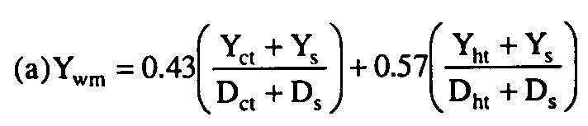
Where:
(1) Y_{wm} = Weighted mass emissions of CO₂Or of each pollutant (i.e., HC, CO, or NO_{X}) in grams per vehicle kilometer and if appropriate, the weighted carbon mass equivalent of total hydrocarbon equivalent, in grams per vehicle kilometer.
(2) Y_{ct} = Mass emissions as calculated from the "transient'' phase of the cold-start test, in grams per test phase.
(3) Y_{ht}= Mass emissions as calculated from the "transient'' phase of the hot-start test, in grams per test phase.
(4) Y_{s} = Mass emissions as calculated from the "stabilized'' phase of the cold-start test, in grams per test phase.
(5) D_{ct} = The measured driving distance from the "transient'' phase of the cold-start test, in kilometers.
(6) D_{ht} = The measured driving distance from the "transient'' phase of the hot-start test, in kilometers.
(7) D_{s} = The measured driving distance from the "stabilized'' phase of the cold-start test, in kilometers.
(b) The mass of each pollutant for each phase of both the cold-start test and the hot-start test is determined from the following:
(1) Hydrocarbon mass:

HC_{mass} = V_{mix} x Density_{HC} x (HC_{conc} 1,000,000)
(2) Oxides of nitrogen mass:

NOx_{mass} = V_{mix} x Density_{NO2} x K_{H} x (NOx _{conc}/1,000,000)
(3) Carbon monoxide mass:

CO_{mass} = V_{mix} x Density_{CO} x (CO_{conc} 1,000,000)
(4) Carbon dioxide mass:

CO_{2mass} = V_{mix} x Density_{CO2} x (CO_{2conc}/100)
(5) Methanol mass:

CH₃OH_{mass} = V_{mix} x Density_{CH3OH} x (CH₃OH_{conc}/1,000,000)
(6) Formaldehyde mass:

HCHO_{mass} = V_{mix} x Density_{HCHO} x (HCHO_{conc}/1,000,000)
(7) Total hydrocarbon equivalent:
(i) THCE = HC_{mass} + 13.8756/32.042 x (CH₃OH)_{mass} + 13.8756/30.0262 x (HCHO)_{mass}
(c) Meaning of symbols:
(1)(i) HC_{mass} = Hydrocarbon emissions, in grams per test phase.
(ii) Density_{HC} = Density of HC in exhaust gas.
(A) For gasoline-fuel; Density_{HC} = 576.8 g/m³-carbon atom (16.33 g/ft³-carbon atom), assuming an average carbon to hydrogen ratio of 1:1.85, at 20 °C (68 °F) and 101.3 kPa (760 mm Hg) pressure.
(B) For natural gas and liquefied petroleum gas-fuel; Density_{HC} = 41.57(12.011+H/C(1.008)) g/m³-carbon atom (1.1771(12.011+H/C(1.008)) g/ft³-carbon atom) where H/C is the hydrogen to carbon ratio of the hydrocarbon components of test fuel, at 20 °C 68 °F) and 101.3 kPa (760mm Hg) pressure.
(iii)(A) HC_{conc} = Hydrocarbon concentration of the dilute exhaust sample corrected for background, in ppm carbon equivalent, i.e., equivalent propane x 3.
(B) HC_{conc} = HC_{e} - HC_{d}(1 - (1/DF))

Where:
(iv)(A) HC_{e} = Hydrocarbon concentrations of the dilute exhaust sample as measured, in ppm carbon equivalent (propane ppm x 3).
(B) HC_{e} = FIDHC_{e} - (r)C_{CH3OHe}
(v) FID HC_{e} = Concentration of hydrocarbon (plus methanol if methanol-fueled motorcycle is tested) in dilute exhaust as measured by the FID ppm carbon equivalent.
(vi) r = FID response to methanol.
(vii) C_{CH30He} = Concentration of methanol in dilute exhaust as determined from the dilute exhaust methanol sample, ppm carbon.
(viii)(A) HC_{d} = Hydrocarbon concentration of the dilution air as measured, ppm carbon equivalent.
(B) HC_{d} = FID HC_{d} - (r)C_{CH30Hd}
(ix) FID HC_{d} = Concentration of hydrocarbon (plus methanol if methanol-fueled motorcycle is tested) in dilution air as measured by the FID, ppm carbon equivalent.
(x) C_{CH3OHd} = Concentration of methanol in dilution air as determined from dilution air methanol sample, ppm carbon.
(2)(i) NOx_{mass} = Oxides of nitrogen emissions, grams per test phase.
(ii) Density_{N02} = Density of oxides of nitrogen in the exhaust gas, assuming they are in the form of nitrogen dioxide, 1913 g/m³ (54.16 g/ft³), at 20 °C (68 °F) and 101.3 kPa (760 mm Hg) pressure.
(iii)(A) NOx_{conc} = Oxides of nitrogen concentration of the dilute exhaust sample corrected for background, ppm.
(B) NOx_{conc} = NOx_{e} - NOx_{d}(1 - (1/DF))

Where:
(iv) NOx_{e} = Oxides of nitrogen concentration of the dilute exhaust sample as measured, ppm.
(v) NOx_{d} = Oxides of nitrogen concentration of the dilution air as measured, ppm.
(3)(i) CO_{mass} = Carbon monoxide emissions, in grams per test phase.
(ii) Density_{CO} = Density of carbon monoxide, 1164 g/m³ (32.97 g/ft³), at 20 °C (68 °F) and 101.3 kPa (760 mm Hg) pressure.
(iii)(A) CO_{conc} = Carbon monoxide concentration of the dilute exhaust sample corrected for background, water vapor, and CO₂ extraction, ppm.
(B) CO_{conc} = CO_{e} - CO_{d}(1 - (1/DF))

Where:
(iv)(A) CO_{e} = Carbon monoxide concentration of the dilute exhaust sample volume corrected for water vapor and carbon dioxide extraction, in ppm.
(B) CO_{e} = (1 - 0.01925CO_{2e} - 0.000323R)CO_{em} for gasoline-fueled vehicles with hydrogen to carbon ratio of 1.85:1
(C) CO_{e}=[1 - (0.01+0.005HCR) CO_{2e} - 0.000323R]CO_{em} for methanol-fueled, natural gas-fueled or liquefied petroleum gas-fueled motorcycles, where HCR is hydrogen to carbon ratio as measured for the fuel used.
(v) CO_{em} = Carbon monoxide concentration of the dilute exhaust sample as measured, ppm
(vi) CO_{2e} = Carbon dioxide concentration of the dilute exhaust sample, pct.
(vii) R = Relative humidity of the dilution air, pct (see §86.542(n)).
(viii)(A) CO_{d} = Carbon monoxide concentration of the dilution air corrected for water vapor extraction, ppm.
(B) CO_{d} = (1 - 0.000323R)CO_{dm}

Where:
(ix) CO_{dm} = Carbon monoxide concentration of the dilution air sample as measured, ppm.

Note: If a CO instrument which meets the criteria specified in §. 86.511 is used and the conditioning column has been deleted, CO_{em} can be substituted directly for CO_{e} and CO_{dm} must be substituted directly for CO_{d}.

(4)(i) CO_{2mass} = Carbon dioxide emissions, grams per test phase.
(ii) Density_{C02} = Density of carbon dioxide, 1830 g/m³ (51.81 g/ft³), at 20 °C (68 °F) and 101.3 kPa (760 mm Hg) pressure.
(iii)(A) CO_{2conc} = carbon dioxide concentration of the dilute exhaust sample corrected for background, in percent.
(B) CO_{2conc} = CO_{2e} - CO_{2d}(1 - 1/DF)

Where:
(iv) CO_{2d} = Carbon dioxide concentration of the dilution air as measured, in percent.
(5)(i) CH₃OH_{mass} = Methanol emissions corrected for background, grams per test phase.
(ii) Density_{CH3OH} = Density of methanol is 1332 g/m³ (37.71 g/ft³), at 20 °C (68 °F) and 101.3 kPa (760 mm Hg) pressure.
(iii)(A) CH₃OH_{conc} = Methanol concentration of the dilute exhaust corrected for background, ppm.
(B) CH₃OH_{conc} = C_{CH3OHe} - C_{CH3OHd}(1 - (1/DF))
Where:
(iv)(A) C_{CH3OHe} = Methanol concentration in the dilute exhaust, ppm.
(B)

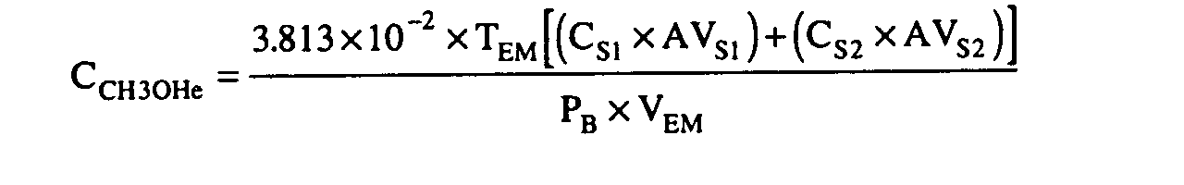
(v)(A) C_{CH3OHd}=Methanol concentra- (B)
tion in the dilution air, ppm.

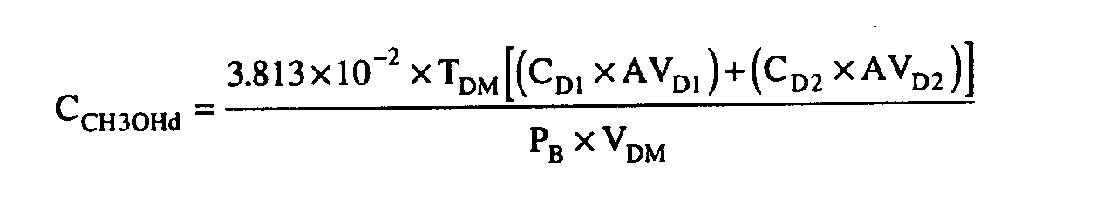

(vi) T_{EM}=Temperature of methanol sample withdrawn from dilute exhaust, °R.
(vii) T_{DM}=Temperature of methanol sample withdrawn from dilution air, °R.
(viii) P_{B}=Barometric pressure during test, mm Hg.
(ix) V_{EM}=Volume of methanol sample withdrawn from dilute exhaust, ft³.
(x) V_{DM}=Volume of methanol sample withdrawn from dilution air, ft³.
(xi) C_{s}=GC concentration of sample drawn from dilute exhaust, g/ml.
(xii) C_{D}=GC concentration of sample drawn from dilution air, g/ml.
(xiii) AV_{s}=Volume of absorbing reagent (deionized water) in impinger through which methanol sample from dilute exhaust is drawn, ml.
(xiv) AV_{D}=Volume of absorbing reagent (deionized water) in impinger through which methanol sample from dilution air is drawn, ml.
(xv) 1=first impinger.
(xvi) 2=second impinger.
(6)(i) HCHO_{mass} = Formaldehyde emissions corrected for background, grams per test phase.
(ii) Density_{HCHO} = Density of formaldehyde is 1249 g/m³ (35.36 g/ft³), at 20 °C (68 °F) and 101.3 kPa (760 mm Hg) pressure.
(iii)(A) HCHO_{conc} = Formaldehyde concentration of the dilute exhaust corrected for background, ppm.
(B) HCHO_{conc} = C_{HCHOe} - C_{HCHOd}(1 - (1/DF))
Where:
(iv)(A) C_{HCHOe} = Formaldehyde concentration in dilute exhaust, ppm.
(B)

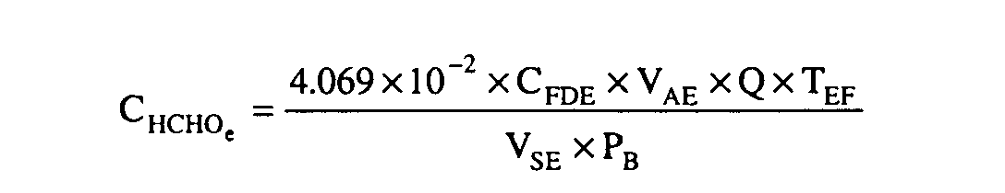

(v)(A) C_{HCHOd} = Formaldehyde concentra- (B)
tion in dilution air, ppm.

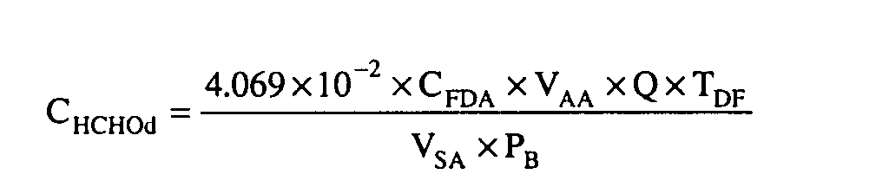

(vi) C_{FDE} = Concentration of DNPH derivative of formaldehyde from dilute exhaust sample in sampling solution, g/ml.
(vii) V_{AE} = Volume of sampling solution for dilute exhaust formaldehyde sample, ml.
(viii)(A) Q = Ratio of molecular weights of formaldehyde to its DNPH derivative.
(B) Q = 0.1429
(ix) T_{EF} = Temperature of formaldehyde sample withdrawn from dilute exhaust, °R.
(x) V_{SE} = Volume of formaldehyde sample withdrawn from dilute exhaust, ft³.
(xi) P_{B} = Barometric pressure during test, mm Hg.
(xii) C_{FDA} = Concentration of DNPH derivative of formaldehyde from dilu-
tion air sample in sampling solution, g/ml.
(xiii) V_{AA} = Volume of sampling solution for dilution air formaldehyde sample, ml.
(xiv) T_{DF} = Temperature of formaldehyde sample withdrawn from dilution air, °R.
(xv) V_{SA} = Volume of formaldehyde sample withdrawn from dilution air, ft³.
(7)(i) DF = 13.4/[CO_{2e} + (HC_{e} + CO_{e})10⁻⁴] for gasoline-fueled vehicles.
(ii) For methanol-fueled, natural gas-fueled or liquefied petroleum gas-fueled motorcycles, where fuel composition is C_{x}H_{y} O_{z} as measured, or calculated, for the fuel used (for natural gas and liquefied petroleum gas-fuel, Z=0):

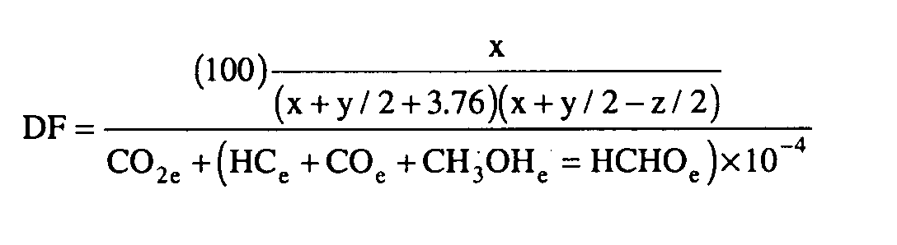

(iii)(A) V_{mix} = Total dilute exhaust volume in cubic meters per test phase corrected to standard conditions (293 °K (528 °R) and 101.3 kPa (760 mm Hg)).
(B)
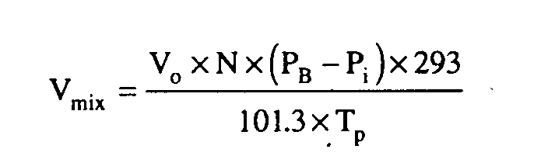

Where:
(iv) V_{o} = Volume of gas pumped by the positive displacement pump, in cubic meters per revolution. This volume is dependent on the pressure differential across the positive displacement pump. (See calibration techniques in § 86.519.)
(v) N = Number of revolutions of the positive displacement pump during the test phase while samples are being collected.
(vi) P_{B} = Barometric pressure, kPa.
(vii) P_{i} = Pressure depression below atmospheric measured at the inlet to the positive displacement pump, kPa.
(viii) T_{p} = Average temperature of dilute exhaust entering positive displacement pump during test while samples are being collected, ° K.
(ix)(A) K_{h} = Humidity correction factor.
(B) K_{h} = 1/[1 - 0.0329(H - 10.71)]

Where:
(x)(A) H = Absolute humidity in grams of water per kilogram of dry air.
(B) H = [(6.211)R_{a} x P_{d}]/[P_{B} - (P_{d} x R_{a} 100)]
(xi) R_{a} = Relative humidity of the ambient air, pct.
(xii) P_{d} = Saturated vapor pressure, in kPa at the ambient dry bulb temperature.
(xiii) P_{B} = Barometric pressure, kPa.
(d) Sample calculation of mass emission values for gasoline-fueled vehicles with engine displacements equal to or greater than 170 cc (10.4 cu. in.):
(1) For the "transient'' phase of the cold-start test, assume V_{o} = 0.0077934 m³ per rev; N = 12,115; R = 20.5 pct; R_{a} = 20.5 pct; P_{B} = 99.05 kPa; P_{d} = 3.382 kPa; P_{i} = 9.851 kPa; T_{p} = 309.8 °K; HC_{e} = 249.75 ppm carbon equivalent; NOx_{e} = 38.30 ppm; CO_{em} = 311.23 ppm; CO_{2e} = 0.415 percent; HC_{d} = 4.90 ppm; NOx_{d} = 0.30 ppm; CO_{dm} = 8.13 ppm; CO_{2d} = 0.037 pct; D_{ct} = 5.650 km.

Then:
(i) V_{mix} = [(0.0077934)(12,115)(99.05-9.851)(293.15)]/ [(101.325)(309.8)] = 78.651 m³ per test phase.
(ii) H = [(6.211)(20.5)(3.382)]/[(99.05) - (3.382)(20.5/100)] = 4.378 grams H²O per kg dry air.
(iii) K_{h} = 1/[1 - 0.0329(4.378 - 10.71)] = 0 8276
(iv) CO_{e} = [1 - 0.01925(0.415) - 0.000323 (20.5)](311.23) = 306.68 ppm.
(v) CO_{d} = [1 - 0.000323(20.5)](8.13) = 8.08 ppm.
(vi) DF =13.4/[0.415 +(249.75 +306.68)10⁻⁴] = 28.472
(vii) HC_{conc} = 249.75 - 4.90(1 - 1/28.472) = 245.02 ppm.
(viii) HC_{mass} = (78.651) (576.8) (245.02) 10⁻⁶ = 11.114 grams per test phase.
(ix) NOx_{conc} = 38.30 - 0.30(1 - 1/28.472) = 38.01 ppm.
(x) NOx_{mass} = (78.651)(1913)(38.01)(0.8276) x 10⁻⁶ = 4.733 grams per test phase.
(xi) CO^{conc} = 306.68 - 8.08 (1 - 1/28.472) = 298.88 ppm.
(xii) CO_{mass} = (78.651) (1164) (298.88) (10⁻⁶) = 27.362 grams per test phase.
(xiii) CO^{2conc} = 0.415 - 0.037 (1 - 1/28.472) = 0.3793 percent.
(xiv) CO_{2mass} = (78.651)(1843)(0.3793)/100 = 549.81 grams per test phase.
(2) For the "stabilized'' portion of the cold-start test, assume that similar calculations resulted in HC_{mass} = 7.184 grams per test phase; NOx _{mass} = 2.154 grams per test phase; CO_{mass} = 64.541 grams per test phase; and CO_{2mass} = 529.52 grams per test phase. D_{s} = 6.070 km.
(3) For the "transient'' portion of the hot-start test, assume that similar calculations resulted in HC_{mass} = 6.122 grams per test phase; NOx_{mass} = 7.056 grams per test phase;
CO_{mass} = 34.964 grams per test phase; and CO_{2mass} = 480.93 grams per test phase. D_{ht} = 5.660 km.
(4) For a 1978 motorcycle with an engine displacement equal to or greater than 170 cc (10.4 cu. in):
(i) HC_{wm} = 0.43 [(11.114 + 7.184)/(5.650 + 6.070)] + 0.57 [(6.122 + 7.184)/(5.660 + 6.070)] = 1.318 grams per vehicle kilometer.
(ii) NOx_{wm} = 0.43 [(4.733 + 2.154)/(5.650 + 6.070)] + 0.57 [(7.056 + 2.154)/(5.660 + 6.070)] = 0.700 gram per vehicle kilometer.
(iii) CO_{wm} = 0.43 [(27.362 + 64.541)/(5.650 + 6.070)] + 0.57 [(34.964 + 64.541)/(5.660 + 6.070)] = 8.207 grams per vehicle kilometer.
(iv) CO_{2wm} = 0.43 [(549.81 + 529.52)/(5.650 + 6.070)] + 0.57 [(480.93 + 529.52)/(5.660 + 6.070)] = 88.701 grams per vehicle kilometer.

[54 FR 14553, Apr. 11, 1989, as amended at 59 FR 48515, Sept. 21, 1994; 60 FR 34358, June 30, 1995]

