Submitted by the experts from The International Automotive Lighting and Light-Signalling Expert Group (GTB) | Informal document GRE-90-16  (90th GRE, 29 April to 3 May 2024, agenda item 11 (c) )

Draft proposal to amend UN Regulations Nos. 48 and 148 to introduce Signal Road Projection

I. Proposal
A. Proposal for a Supplement to the 06, 07, 08 and 09 series of amendments to UN Regulation No. 48
Insert new paragraphs 2.5.21. and 2.5.22., to read:
“2.5.21. “Direction indicator projector” means a device used to provide direction indication projection.
2.5.22. “Reversing projector” means a device used to provide reversing projection.”
Insert new paragraphs 2.7.10. to 2.7.12., to read:
“2.7.10. “Direction indicator projection” means light signal projected on the ground surface by direction indicator projectors to provide enhanced recognition of direction indication to other road users.
2.7.11. “Reversing projection” means light signal projected on the ground surface by reversing projectors to provide enhanced recognition of reversing indication to other road users.
2.7.12. “Basic element” of a direction indicator projection or reversing projection means the single shape composing the projected patterns.”
Insert a new paragraph 3.2.10., to read:
“3.2.10. Where direction indicator projections and/or reversing projections are provided, the list of patterns shall be provided by the manufacturer.”
Paragraph 5.9.1., amend to read:
“5.9.1. Direction-indicator lamps, direction indicator projections, the vehicle-hazard warning signal, amber side-marker lamps complying with paragraph 6.18.7. below, and the emergency stop signal shall be flashing lamps.”
Insert a new paragraph 5.9.4. and 5.9.5., to read:
“5.9.4. For direction indicator projections, the flash may be produced by the sequential projection of basic elements as specified in paragraph 5.12.5. of UN Regulation No. 148.
5.9.5. Reversing projection may flash and/or vary according to the steering wheel angle and/or the speed of the vehicle and/or the proximity to an obstacle.”
Paragraph 5.10.3., amend to read:
“5.10.3. No account shall be taken of lighting devices fitted for the interior lighting of the vehicle nor of reversing projections.”
Paragraph 5.15., amend to read:
“5.15. The colours of the light emitted by the lamps are the following:
Main-beam headlamp: | White
… | …
Manoeuvring lamp: | White
Direction indicator projection: | Amber
Reversing projection: | White”

Insert a new paragraph 5.36. and related sub-paragraphs, to read:
“5.36. General provision relating to direction indicator projection and reversing projection.
5.36.1. The patterns shall be explained in the owner's handbook.
5.36.2. When direction indicator projection or reversing projection are provided,
5.36.2.1. only the basic elements listed in Annex 17 shall be used;
5.36.2.2. the pattern of each projection shall be constituted by one or more basic element(s) of the same type in a line;
5.36.2.3. the number, size, ratio and the spacing between the basic elements in the pattern are not restricted, provided that the requirements of paragraph 6.27.5. or paragraph 6.28.5., whichever applies, are met.
5.36.3. When the reversing projection(s) and the rear direction indicator projection(s) are switched ON simultaneously, the projected patterns shall not overlap.
5.36.4. When the windshield wiper is switched ON and its continuous operation has occurred for a period of at least two minutes, the direction indicator projection(s) whose luminous intensity exceeds 7.00∙10³ cd shall be either switched OFF, or its luminous intensity shall be reduced at a value less than or equal to 7.00∙10³ cd. The conformity to this requirement shall be verified at the time of the direction indicator projector type approval and indicated in the related communication form.
5.36.5. The light transmitted downwards by light-signaling devices is not considered a signal projection.”
Insert a new paragraph 6.27. and related sub-paragraphs, to read:
“6.27. Reversing projection
6.27.1. Presence
Optional
6.27.2. Number
One or two reversing projection(s).
The reversing projector(s) shall be type approved according to the 01 or subsequent series of amendments to UN Regulation No. 148.
6.27.3. Arrangement
Such that the provisions of paragraphs 6.27.5., 6.27.6. and 6.27.9. are fulfilled.
6.27.4. Position
Such that the provisions of paragraphs 6.27.5., 6.27.6. and 6.27.9. are fulfilled.
6.27.5. Projection area
6.27.5.1. The lateral distance from the outer edge of the projection with respect to the longitudinal plane of the vehicle shall not be more than 1,875 mm.
The longitudinal distance from the farthest edge of the projection shall not be more than 3,000 mm from the backward extreme outer edge of the vehicle.

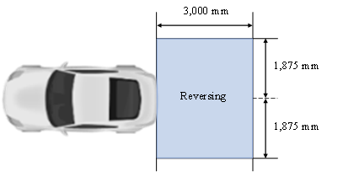

6.27.5.2. The patterns of the reversing projections shall start with their closest edge within a rectangle, symmetrical to the median longitudinal plane and adjacent to the extreme outer edge of the vehicle a width of 1,000 mm and a length of 3,750 mm.

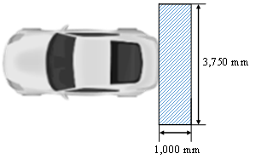
6.27.6. Orientation
Rearwards
6.27.7. Electrical connections
If provided, the reversing projections shall be switched ON only when the reversing lamp(s) is/are switched ON.
6.27.8. Tell-tale
Optional
6.27.9. Other requirements
6.27.9.1. The technical service shall, to the satisfaction of the Type Approval Authority, perform a visual test to verify that there is no direct visibility of the apparent surface of any reversing projector, if viewed by an observer moving on the boundary of a zone on a transverse plane 10 m from the front of the vehicle, a transverse plane 10 m from the rear of the vehicle , and two longitudinal planes 10 m from each side of the vehicle; these four planes to extend from 1 m to 3 m above and perpendicular to the ground as shown in Annex 14.
This requirement shall be deemed to be satisfied if the installation conditions comply with paragraph 5.13.1.2. a) of UN Regulation No. 148.
At the request of the applicant and with the consent of the Technical Service, this requirement may also be verified by a drawing or simulation.
6.27.9.2. If the requirement of paragraph 6.27.9.1. is not fulfilled, the requirement of paragraph 5.13.1.2. b) of UN Regulation No. 148 applies. The related indication shall be made in the Communication Form in Annex 1.”
Insert a new paragraph 6.28. and related sub-paragraphs, to read:
“6.28. Direction indicator projection
6.28.1. Presence
Optional
6.28.2. Number
Vehicles of categories M and N:
– One front direction indicator projection on each side of the vehicle;
– One rear direction indicator projection on each side of the vehicle;
– One side direction indicator projection on each side of the vehicle.
Vehicles of category O:
- One rear direction indicator projection on each side;
- One side direction indicator projection on each side.
The projector(s) shall be type approved according to the 01 or subsequent series of amendments to UN Regulation No. 148.
6.28.3. Arrangement
Such that the provisions of paragraphs 6.28.5., 6.28.6., 6.28.9.1. to 6.28.9.3. apply.
6.28.4. Position
Such that the provisions of paragraphs 6.28.5., 6.28.6., 6.28.9.1. to 6.28.9.3. apply.
6.28.5. Projection area
6.28.5.1. Front direction indicator projection
The lateral distance from the outer edge of the projection with respect to the longitudinal plane of the vehicle shall not be more than 2,700 mm.
The longitudinal distance from the farthest edge of the projection shall not be more than 5,000 mm from the forward extreme outer edge of the vehicle and the rearward edge of the projection shall be not more than 500 mm rearward of the forward extreme outer edge of the vehicle.
The inner boundary of the projection area is limited by a minimum distance of 300 mm from the longitudinal centre line of the vehicle (see figure below).

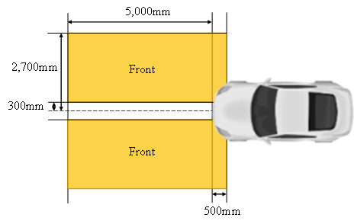
6.28.5.2. Rear direction indicator projection
The lateral distance from the outer edge of the projection with respect to the longitudinal plane of the vehicle shall not be more than 2,700 mm.
The longitudinal distance from the rearmost edge of the projection shall not be more than 2,000 mm from the rearward extreme outer edge of the vehicle and the forward edge of the projection shall be not more than 500mm forward of the rearward extreme outer edge of the vehicle.
The inner boundary of the projection area is limited by a minimum distance of 300 mm from the longitudinal centre line of the vehicle (see figure below).

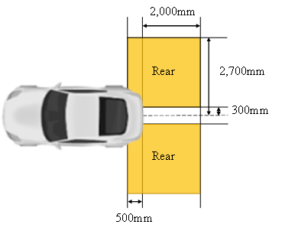
6.28.5.3. Side direction indicator projection
The lateral distance from the outer edge of the projection with respect to the longitudinal plane of the vehicle shall not be more than 2,700 mm.
In length, the projection area is limited by the vehicle length (see figure below)
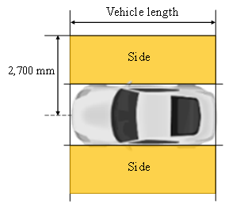
6.28.5.4. The patterns of each front direction indicator projection shall start with their closest edge within a zone limited by:
- a transverse plane 700 mm forwards of the front extreme outer edge of the vehicle,
- a transverse plane 500 mm rearwards of the front extreme outer edge of the vehicle,
- a longitudinal plane 700 mm outwards from the side extreme outer edge of the vehicle and
- a longitudinal plane 300 mm from the longitudinal median plane of the vehicle (see figure below)
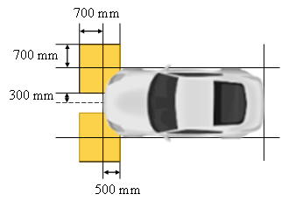
6.28.5.5. The patterns of each rear direction indicator projection shall start with their closest edge within a zone limited by:
- a transverse plane 700 mm rearwards of the rear extreme outer edge of the vehicle,
- a transverse plane 500 mm forwards of the rear extreme outer edge of the vehicle,
- a longitudinal plane 700 mm outwards from the side extreme outer edge of the vehicle and
- a longitudinal plane 300 mm from the longitudinal median plane of the vehicle (see figure below)
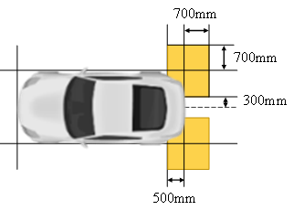
6.28.5.6. The patterns of each side direction indicator projection shall start with their closest edge within a zone limited by:
- a transverse plane at the front extreme outer edge of the vehicle,
- a transverse plane at the rear extreme outer edge of the vehicle and
- a longitudinal plane 700 mm outwards from the side extreme outer edge (see figure below)

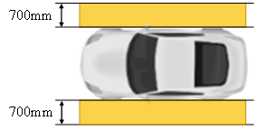
6.28.6. Orientation
Such that the requirements of paragraphs 6.28.5.1. or 6.28.5.2 or 6.28.5.3., whichever apply, are fulfilled.
6.28.7. Electrical connections
6.28.7.1. If provided, the direction indicator projection(s) shall be switched ON only when the direction indicator lamps on the same side are switched ON. When the direction indicator projection is switched ON, it shall flash in phase and at the same frequency of the direction indicator lamp.
6.28.7.2. For M₁, N₁ vehicles and trailers: at most two direction indicator projections per side may be switched ON at the same time.
For the other vehicle categories: at most three direction indicator projections per side may be switched ON at the same time.
6.28.7.3. A direction indicator projection capable of being activated in different modes (static or sequential), shall not switch between both modes once activated.
6.28.7.4. A direction indicator projection may be activated in sequential mode only if the corresponding direction indicator lamp is also activated in sequential mode.
6.28.7.5. All the direction indicator projections allowed in paragraph 6.28.7.2. may be switched ON at the same time when the hazard warning signal is switched ON. In this case, the direction indicator projections shall flash in phase and at the same frequency as the hazard warning signal.
6.28.8. Tell-tale
Optional
6.28.9. Other requirements
6.28.9.1. The technical service shall, to the satisfaction of the Type Approval Authority, perform a visual test to verify that there is no direct visibility of the apparent surface of any direction indicator projector, if viewed by an observer moving on the boundary of a zone on a transverse plane 10 m from the front of the vehicle, a transverse plane 10 m from the rear of the vehicle, and two longitudinal planes 10 m from each side of the vehicle; these four planes to extend from 1 m to 3 m above and perpendicular to the ground as shown in Annex 14.
This requirement shall be deemed to be satisfied if the installation conditions comply with paragraph 5.12.1.2. a) of UN Regulation No. 148.
At the request of the applicant and with the consent of the Technical Service, this requirement may also be verified by a drawing or simulation.
6.28.9.2. If the requirement of paragraph 6.28.9.1. is not fulfilled, the requirement of paragraph 5.12.1.2. b) of UN Regulation No. 148 applies. The related indication shall be made in the Communication Form in Annex 1.
6.28.9.3. For each of direction indicator projection, only one line of patterns is allowed.
6.28.9.4. If provided, the rear direction indicator projection(s) shall not be switched ON when the vehicle is in forward motion and the front direction indicator projection shall not be switched ON when the vehicle is in rearward motion, unless the horizontal angle of the direction of the projections to the median longitudinal plane of the vehicle exceeds 45°.”
Annex 1,
Insert new items 9.29. and 9.30. and related sub-items, to read:
“9.29. Reversing projection: yes/no²
9.29.1. According to paragraph 6.27.9., the reversing projector fulfils the requirements of paragraph 5.13.1.2. a) / paragraph 5.13.1.2. b) of UN Regulation No. 148²
9.30. Direction indicator projection:
9.30.1. Front direction indicator projection: yes/no²
9.30.1.1. According to paragraph 5.36.4., its maximum luminous intensity is:
less or equal to 7.00∙10³ cd / reduced to a value less or equal to 7.00∙10³ cd²
9.30.1.2. According to paragraph 6.28.9., the front direction indicator projector fulfils the requirements of paragraph 5.12.1.2. a) / paragraph 5.12.1.2. b) of UN Regulation No. 148²
9.30.2. Rear direction indicator projection: yes/no²
9.30.2.1. According to paragraph 5.36.4., its maximum luminous intensity is:
less or equal to 7.00∙10³ cd / reduced to a value less or equal to 7.00∙10³ cd²
9.30.2.2. According to paragraph 6.28.9., the rear direction indicator projector fulfils the requirements of paragraph 5.12.1.2. a) / paragraph 5.12.1.2. b) of UN Regulation No. 148²
9.30.3. Side direction indicator projection: yes/no²
9.30.3.1. According to paragraph 5.36.4., its maximum luminous intensity is:
less or equal to 7.00∙10³ cd / reduced to a value less or equal to 7.00∙10³ cd²
9.30.3.2. According to paragraph 6.28.9., the side direction indicator projector fulfils the requirements of paragraph 5.12.1.2. a) / paragraph 5.12.1.2. b) of UN Regulation No. 148²”
Annex 1,
Renumber the existing items 9.29. and 9.30. as 9.31. and 9.32. accordingly
Annex 14,
Title, amend to read:
“Observing area towards the apparent surface of manoeuvring lamps, exterior and courtesy lamps, direction indicator projectors and reversing projectors”
Insert a new Annex 17, to read:
“Annex 17
Basic elements to be used for direction indicator projection and reversing projection patterns
Basic elements |  | Applicable function
Rectangle |  | Reversing projection  • Colour of the Basic elements: White
Chevron |  | Front, Rear and Side Direction indicator projection  • Colour of the Basic elements: Amber
Note: Minor deviations from the shape of the basic elements when projected on the road, due to technical restrictions or environmental conditions are considered to comply with the shape of the basic elements.

B. Proposal for a Supplement to the 01 series of amendments to UN Regulation No. 148
Paragraph 1., amend to read:
“1 Scope
This Regulation applies to the following light-signalling devices (lamps):
- RER-registration plate illuminating lamps
- Direction indicator lamps
- Position lamps
- Stop lamps
- End-outline marker lamps
- Reversing lamps
- Manoeuvring lamps
- Rear fog lamps
- Parking lamps
- Daytime running lamps
- Side marker lamps
- Direction indicator projectors
- Reversing projectors”

Paragraph 2.2., amend to read:

“2.2. "Lamps of different types" means lamps, which differ in such essential respects as:
(a) The trade name or mark:
(i) Lamps bearing the same trade name or mark but produced by different manufacturers are considered as being of different types;
(ii) Lamps produced by the same manufacturer differing only by the trade name or mark are considered as being of the same type.
(b) The characteristics of the optical system (levels of intensity, light distribution angles, inclusion or elimination of components capable of altering the optical effects by reflection, refraction, absorption and/ or deformation during operation, etc.);
(c) The category or categories of light source(s) used and/or the specific identification code (s) of the light source module(s);
(d) The category of the lamp, if any;
(e) The variable intensity control, if any;
(f) The sequential activation of light sources, if any.
Nevertheless, direction indicators lamps and direction indicator projectors capable of being activated in different modes (sequential or not) without any modification of the optical characteristics of the lamp or the projectors do not constitute "Direction indicators lamps or direction indicator projectors of different types".
A change of the colour of the light source or the colour of any filter does not constitute a change of type.
The use of LED substitute light source(s) does not constitute a change of type. However, paragraph 4.8.1.6. applies.”

Insert a new paragraph 3.1.2.9., to read:
“3.1.2.9. In the case of a direction indicator projector tested together with the direction indicator lamp according to the requirements of paragraph 5.12.1.2. b) or in the case of a reversing projector tested together with the reversing lamp according to the requirements of paragraph 5.13.1.2. b), the associated measurement report, accompanied by drawings showing the relative position of the projector and of the lamp.”

Table 1, amend to read:
“
Lamp (function) | Symbol | Paragraph
Daytime running lamp | RL | 5.4.
…
Stop lamp (variable) | S2 | 5.5.
Front Direction indicator projector | DPF | 5.12.
Rear Direction indicator projector | DPR | 5.12.
Side Direction indicator projector | DPS | 5.12.
Reversing projector | RP | 5.13.
”

Table 2, amend to read:
“
Series of amendments to the Regulation | 00 | 01
Lamp (function) | Change Index for the specific Lamp (function)
Daytime running lamp | 0 | 1
…
Stop lamp (central high mounted) | 0 | 1
Front Direction indicator projector | - | 0
Rear Direction indicator projector | - | 0
Side Direction indicator projector | - | 0
Reversing projector | - | 0
”
Insert new paragraphs 5.12. and related sub-paragraphs, to read:
“5.12. Direction indicator projector (DPF, DPR, and DPS)
5.12.1. Luminous intensity and standard light distribution:
5.12.1.1. The intensity of light emitted shall not exceed 1.20∙10⁴ cd in the area as defined in paragraph 6.28.5. of UN Regulation No. 48 when installed in any mounting position specified by the applicant.
5.12.1.2. In addition, outside the area as defined in paragraph 6.28.5. of UN Regulation No. 48, one of the following conditions shall be fulfilled:
(a) The light emitted directly towards the side, the front or the rear of the vehicle shall not exceed 5∙10⁻¹ cd within the angular field as defined below:
(i) The vertical minimum angle φmin (in degrees) is:
φmin = arctan ((1-mounting height)/10); where h is mounting height in m
(ii) The vertical maximum angle φmax (in degrees) is:
φmax = φmin + 11.3
The measurement shall be limited to a horizontal angle ranging from +90° to -90° with respect to the line which cuts the reference axis and which is perpendicular to the vertical longitudinal plane of the vehicle.
(b) When the apparent surfaces of the direction indicator projector and the apparent surface of the direction indicator lamp are arranged in such a way that
(i) Either the projection of the apparent surfaces in the direction of the reference axis of them occupies not less than 60 per cent of the smallest quadrilateral circumscribing the projections of the said apparent surfaces in the direction of the reference axis; or
(ii) The minimum distance between the facing edges of the apparent surfaces in the direction of the reference axis of them does not exceed 75 mm when measured perpendicularly to the reference axis,
the direction indicator projector shall be tested together with the direction indicator lamp and the integrated luminous intensity shall not exceed the maximum luminous intensity required in Table 8 of the relevant direction indicator lamp.
5.12.1.3. To fulfil the requirement in Paragraph 5.36.4. of UN Regulation No. 48, the luminous intensity of a direction indicator projector may be reduced at a maximum luminous intensity value not exceeding 7.00∙10³ cd.
The related indication shall be made in the communication form in Annex 1.
5.12.2. Minimum luminous intensity within the angles of geometric visibility
No requirement.
5.12.3. Minimum or maximum area of apparent surface:
No requirement.
5.12.4. Measurement:
No additional requirement.
5.12.5. Additional specific requirements:
The flash may be produced by sequential projection of basic elements if the following conditions are met:
- Each projection of basic element, shall remain lit until the end of the ON cycle;
- The sequence of basic elements projection shall produce a signal which proceeds in a uniform progressive manner from the area close to the vehicle to the area farther away from the vehicle within the projection area.
- Each sequential projection cycle shall finish no more than 200 ms after the beginning of the ON cycle;
Compliance to the conditions mentioned above shall be verified in flashing mode.
5.12.6. Failure provisions:
No requirement.
5.12.7. Colour:
The colour of light emitted shall be amber.”

Insert new paragraphs 5.13. and related sub-paragraphs, to read:
“5.13. Reversing projector (RP)
5.13.1. Luminous intensity and standard light distribution:
5.13.1.1. The intensity of light emitted shall not exceed 1.20∙10⁴ cd in the area as defined in paragraph 6.27.5. of UN Regulation No. 48 when installed in any mounting position specified by the applicant.
5.13.1.2. In addition, one of the following conditions must be fulfilled outside of the area as defined in paragraph 6.27.5. of UN Regulation No. 48:
(a) The light emitted directly towards the rear of the vehicle shall not exceed 5∙10⁻¹ cd within the angular field as defined below.
(i) The vertical minimum angle φmin (in degrees) is:
φmin = arctan ((1-mounting height)/10); where h is mounting height in m
(ii) The vertical maximum angle φmax (in degrees) is:
φmax = φmin + 11.3
The measurement shall be limited to a horizontal angle ranging from +90° to -90° with respect to the line which cuts the reference axis and which is perpendicular to the vertical longitudinal plane of the vehicle.
(b) When the apparent surfaces of the reversing projector and the apparent surface of the reversing lamp are arranged in such a way that:
(i) Either the projection of the apparent surfaces in the direction of the reference axis of them occupies not less than 60 per cent of the smallest quadrilateral circumscribing the projections of the said apparent surfaces in the direction of the reference axis; or
(ii) The minimum distance between the facing edges of the apparent surfaces in the direction of the reference axis of them does not exceed 75 mm when measured perpendicularly to the reference axis,
the reversing projector shall be tested together with the reversing lamp and the integrated luminous intensity shall not exceed the maximum luminous intensity required in the Table 10.
5.13.2. Minimum luminous intensity within the angles of geometric visibility
No requirement.
5.13.3. Minimum or maximum area of apparent surface:
No requirement.
5.13.4. Measurement:
No additional requirement.
5.13.5. Additional specific requirements:
None
5.13.6. Failure provisions:
No requirement.
5.13.7. Colour:
The colour of light emitted shall be white.”

Annex 1,
Initial table, amend the list of lamps to read:
“
Lamp:² | Rear-registration plate illuminating lamp  Direction indicator lamp  Stop lamp  Position lamp  End-outline marker lamp  Reversing lamp  Manoeuvring lamp  Rear fog lamp  Parking lamp  Daytime running lamp  Side marker lamp  Direction indicator projector  Reversing projector
”

Annex 1,
Insert new item 9.1.7. and related sub-items, to read:
“9.1.7. Direction indicator projector
9.1.7.1. Front direction indicator projector:
9.1.7.1.1. Tested together with front direction indicator lamp: yes/no2
9.1.7.1.2. The luminous intensity of front direction indicator projector is intended to be reduced to not exceed 7.00∙10³ cd: yes/no²
9.1.7.2. Rear direction indicator projector:
9.1.7.2.1. Tested together with rear direction indicator lamp: yes/no2
9.1.7.3.2. The luminous intensity of rear direction indicator projector is intended to be reduced to not exceed 7.00∙10³ cd: yes/no²
9.1.7.3. Side direction indicator projector:
9.1.7.3.1. Tested together with side direction indicator lamp: yes/no2
9.1.7.3.2. The luminous intensity of side direction indicator projector is intended to be reduced to not exceed 7.00∙10³ cd: yes/no² ”

Annex 1,
Insert a new item 9.1.8., to read:
“9.1.8. Reversing projector:
Tested together with reversing lamp: yes/no2 ”

II. Justification
General
1. This proposal intends to introduce the possibility of light-signalling, in form of projection of patterns on the road, for other road users through new light-signalling functions “Direction indicator projection” and “Reversing projection”.
2. Concerning the Signal Road Projection, several studies have been done and have shown their effectiveness:
- VISION 2018: Advanced Lighting Functions with high-resolution road projection (ELS –Embedded Lighting Systems)
- ISAL 2019 Safety Enhancement Effect of Back-up Guide Lamps, (Yeungnam University, SL Corporation)
- ISAL 2019 Visibility Improvement using Guide Function of Turn Signal Lamp, (Yeungnam University, SL Corporation, Hyundai Automotive)
- SAE 2020 Investigation on Safety Improvements by Lighting for Pedestrians and Cyclists (Audi AG)
- VISION 2020 Detection rate of projected light signals by lighting condition and Activation modes (Koito)
- ESV 2023 Study on distractions and benefits of signal light projections with directional indicators (Yeungnam University)
3. For example, under the following situations the Signal Road Projections are very effective.
Front direction indicator projection
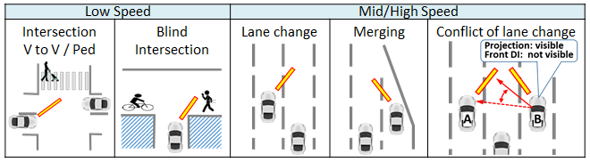

Front, Side, Rear direction indicator projection (blind spot avoidance)
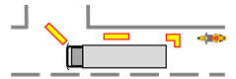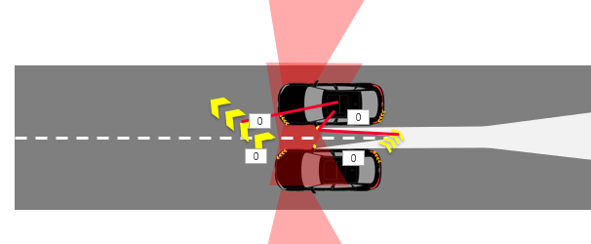

Reversing projection
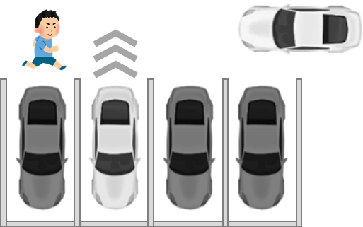

Relationship between Signal Road Projection and Signal Road Projector
4. The Signal Road Projections, both Direction indicator projection and Reversing projection, are illuminations intentionally projected to the road for providing enhanced recognition of direction indication or reversing indication respectively. Therefore, these are proposed as new light-signalling functions in UN Regulation No. 48 in order to ensure safe use in limited situations.
5. In addition, since the Signal Road Projections are light-signalling functions, Signal Road Projector, which provide the Signal Road Projection, needs provisions in component regulation. Therefore, Direction indicator projector and Reversing projector are proposed as new light-signalling devices in UN Regulation No. 148.
6. Road illuminations by downward directed light from existing light-signalling devices, that may also cause reflections from the road surface, are not regulated as Signal Road Projections. It is not intended to change any of their requirements because their performance is known and regulated. This proposal allows the introduction of Signal Road Projections as a supplement to the current regulations.
Photometric requirement and test method of Signal Road Projector
7. The maximum luminous intensity of 12,000 cd is proposed to be allowed for the Signal Road Projector to enable recognition of the pattern reflected from the road surface. Under the current UN Regulation, 12,000 cd is allowed for front fog lamp of Category F3 and the value is lower than the limit of intensity for dipped beam, so this value is safe and effective for the Signal Road Projector.
8. The Signal Road Projector may be installed in any location of the vehicle if it is invisible to other road users. To confirm this, the same requirements as for other lamps defined invisible (e.g. exterior courtesy lamp or manoeuvring lamp) shall apply. In this way, the Signal Road Projector does not confuse other road users about the number of light-signalling devices.
9. In addition, it is possible for the Signal Road Projector to be visible to other road users if the minimum distance between the facing edge of the projector and the apparent surface of a related light-signalling device does not exceed 75 mm, or the projection of the apparent surfaces of the projector and a related light-signalling device occupies not less than 60 per cent of the smallest quadrilateral circumscribing the projections of the said apparent surfaces, because the combination complies to the definition of a single lamp.
In this case, to ensure the compliance with the requirements of the corresponding lamp outside the defined projection area, the projector shall be tested in combination with the related light-signalling device as described below:
- Front direction indicator projector with Front direction indicator lamp
- Rear direction indicator projector with Rear direction indicator lamp
- Side direction indicator projector with Side direction indicator lamp
- Reversing projector with Reversing lamp
Projection area of Signal Road Projector
10. As for the projection area, in UN Regulations Nos. 48 and 148 the appropriate and effective area is specified without causing discomfort, distraction or glare.
11. The requirements in paragraphs 6.27.5.2. and 6.28.5.4. of UN Regulation No. 48 proposed in this document guarantee that observers are able to recognize the signal, to identify the correct relation between the Signal Road Projector and a projecting vehicle and that the projection does not excessively extend to other lanes.
12. To prevent the projection from exceeding one-third of the width of the adjacent lane, the width of the projection is proposed to be limited to 2,700 mm of the longitudinal plane of the vehicle, considering that the average width of the road is 3,250 mm.
3,250 mm / 3 (other lane) + 3,250 mm / 2 (own lane) = 2,700 mm
13. The result of the GTB internal research, comparing 5,000 mm and 2,000 mm pattern length, concluded that there is a visual recognition time difference, shorter by 1.08 sec at 10 km/h, in the case of the longer pattern. Therefore, the longitudinal distance from the farthest edge of the patterns on the road is proposed to be limited to 5,000 mm.

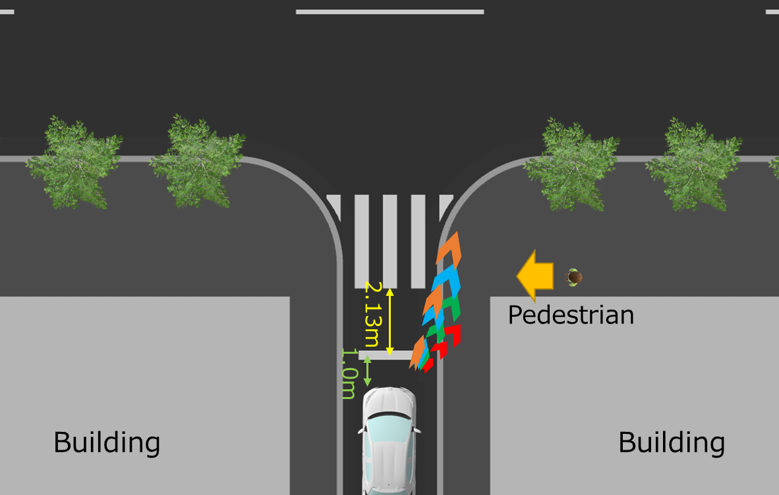. 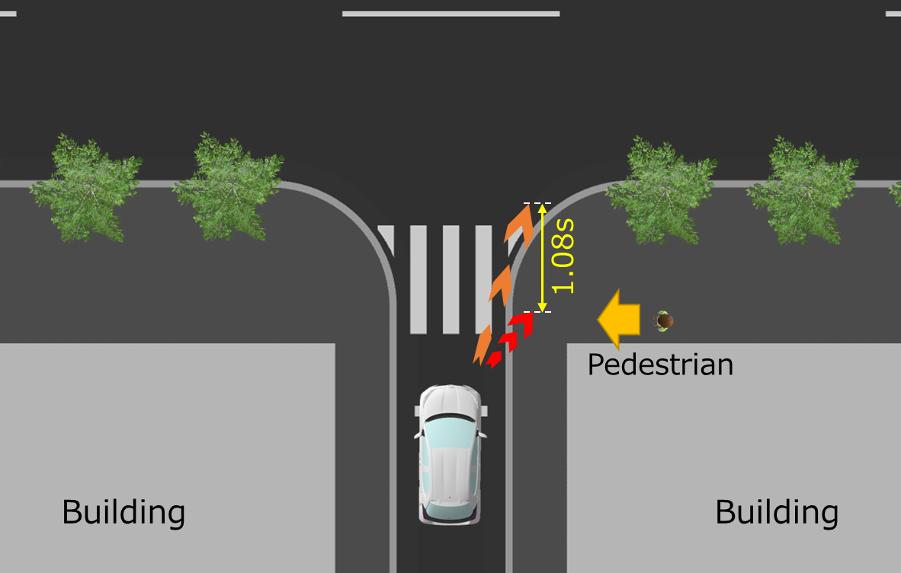

Principle of the anti-glare restriction for projectors
14. The projector might project into all areas of the projection zone with full intensity of 12,000 cd. Outside of the projection zone, the intensity is limited by the maximum intensity of the related light-signalling device when both the related light-signalling device and projector are switched ON.
Basic element of Signal Road Projection pattern
15. GTB defined basic elements of pattern that provide a clear information and cannot be confused with road signs/markings. The different basic elements for Direction Indicator Projection and Reversing Projection are selected as follows (see Annex 17):
- Direction Indicator Projection: chevron
- Reversing Projection: rectangle
16. Several Signal Road Projection studies have been conducted during the past years considering different pattern elements, with similar positive results regarding visibility of the signal, comprehension of the driver’s intention and perceived safety. Specifically, the selected shapes chevron and rectangle have been included in GTB internal and external researches (ISAL, VISION, SAE, etc). Although the researches’ objectives were not to evaluate the pattern shape, there was no negative opinion or result about the proposed pattern shapes. It means that the safety of the pattern shape has been proved by indirect way.
17. Chevron is proposed as the basic element of Direction Indicator projector because it is a proper shape for informing about the driver’s intention of changing the direction of the vehicle. Rectangle is proposed as the basic element of Reversing projection because it is generally understood as a trajectory indicator.
18. The pattern shall be constituted with one or more basic element(s) of the same type in a line. However, the number, size, ratio and spacing between the basic elements in the pattern are not restricted if it meets the related projecting area requirements (see the proposed paragraph 6.27.5. or 6.28.5 of R48 in this document).
Flashing and Variation of Reversing projection
19. The flashing and/or variation of pattern of the reversing projection(s) are proposed with the intention to raise the attention of the other road users to the patterns specially in the case where the projection is the only visible remaining source of information, for instance when the vehicle is hidden.
Although flashing is prohibited for reversing lamps, the “flashing” and/or “movement” of the reversing projection pattern on the ground is more obvious and easier to recognize, and deemed beneficial to understand the vehicle intention.
20. The flashing and/or variation of the pattern of the reversing projection are allowed according to 3 relevant parameters: Speed of the vehicle backward, Steering wheel angle, Detection of an obstacle.
The first parameter gives information on the movement of the vehicle to the road users who are located behind the car. The second one gives information on the predictive trajectory of the vehicle backwards, especially to the vulnerable road users. The third warns the driver about the presence of an obstacle behind the car: the driver can see the projection(s) thanks to the rear-view camera/rear view mirror, for instance.
Additional requirements for Direction indicator projection
21. For M₁, N₁ vehicles and trailers, maximum 2 direction indicator projections on each side are allowed to be operated simultaneously. Although the maximum installation number of direction indicator projection is totally 6 (2 Front DI projection, 2 Side DI projector, 2 Rear DI projection), it may draw too much attention of other road users if all of the direction indicator projections are switched ON together in the vehicles and trailers.
22. The front direction indicator projection is proposed to be only performed when the vehicle is in forward motion and the rear direction indicator projection is proposed to be only performed when the vehicle is in reversing motion. In the case that the pattern’s horizontal angle to the median longitudinal plane of the vehicle exceeds 45°, the front direction indicator projection and the rear direction indicator projection can be switched ON, no matter of the moving direction of the vehicle. The reason is that the pattern in which the angle exceeds 45° is perceived by the other road users like directing sideward.
Activation under adverse weather conditions
23. Since Reversing projection is used only in a very specific situation when the vehicles are reversing and moving at low speed, there is no need to limit the activation under adverse weather conditions.
24. However, since Direction indicator projection could be used quite frequently and in many different situations, its activation is restricted under adverse weather conditions. If the windshield wiper is switched ON and its continuous operation has occurred for a period of at least two minutes, it is proposed either to switch the Direction Indicator projection OFF, or to reduce its luminous intensity at a value equal to or below 7.00∙10³ cd. The chosen threshold refers to the maximum allowed luminous intensity of segment 10 and below for AFS headlamp in adverse weather condition mode, as defined in UN Regulation No. 149-01 series.

