|  |  |  |  |
| --- | --- | --- | --- |
|  | United Nations | ECE/TRANS/2023/XX | |
| _unlogo | **Economic and Social Council**  Informal document GRPE-89-40  89th GRPE, 30 May – 02 June 2023  Agenda item 2.  This Informal Document has been prepared by the Chair and secretariat to be submitted to the 86th session of ITC. | | Distr.: General  XX XX 2023  Original: English |

**Economic Commission for Europe**

Inland Transport Committee

**Eighty-sixth session**

Geneva, XX-XX February 2024  
Item XX of the provisional agenda  
**XX**

Inputs and feedback from [GRPE/WP.29] to the outline of the ITC climate change strategy and to the biennial report

Note compiled by the [GRPE/WP.29] informal task force on ITC climate change mitigation strategy.

|  |
| --- |
| *Summary* |
| Xxx |
|  |
|  |

I. Introduction

1. At its 85th session, ITC “requested the secretariat, in close cooperation with the Committee’s Bureau and relevant subsidiary bodies, to develop an ambitious strategy document for reducing Green House Gas (GHG) emissions in inland transport based on international United Nations legal instruments under the Committee’s purview with priority actions for The Inland Transport Committee (ITC) and all its relevant subsidiary bodies, supported by a strong action plan with milestones, for consideration and possible adoption by the Committee at its 86th plenary session (2024)” (Decision 44 (a))
2. ITC also “requested the secretariat to report biennially through in-depth reports to the Committee on climate change and inland transport, starting at the Committee’s 86th session in 2024” (Decision 44 (g)).
3. In a letter sent to all chairs of ITC working parties on 9 May 2023, the Chair of ITC and the Director of the Sustainable Transport Division invited “to provide your inputs and feedback to the outline of the climate change strategy as contained in the Annex to this letter as well as the biennial report for the 86th ITC session to Ms. Franziska. Hirsch (franziska.hirsch@un.org) by Friday 29 September 2023”.
4. At its 89th session, GRPE agreed to create an informal task force on ITC climate change mitigation strategy. The informal task force, open to all GRPE participants, aimed at developing the inputs at requested by ITC, and submitted to GRPE via a written procedure to deliver on time for the deadline of 29 September 2023.
5. At its 190th session, WP.29 agreed to have GRPE to consolidate the inputs to the ITC climate change mitigation strategy for WP.29 and its subsidiary bodies. All interested parties were invited to join the informal task force and/or to submit their inputs to GRPE to have them reflected in a consolidated input to be endorsed by WP.29 at its November 2023 session.

II. Inputs and feedback to the outline of the climate change strategy

1. The inputs and feedback from [GRPE/WP.29] are split into two categories for each section of the outline:
   1. What [GRPE/WP.29] (or other GRs) can do to contribute to the ITC climate mitigation strategy, labelled “[GRXX/WP.29] contribution” in the rest of this document.
   2. What [GRPE/WP.29] recommends ITC to consider for an impactful climate mitigation strategy and/or what would be needed from ITC to help [GRPE/WP.29] achieve the ambition of the strategy, labelled “[GRPE/WP.29] recommendations to ITC” in the rest of this document.

1. Section 1: Inland transport and climate

[GRPE/WP.29] recommendations to ITC

1. [GRPE/WP.29] recommends the ITC strategy to first introduce past and present data on the evolution of greenhouse gas (GHG) emissions of the inland transport sector, and its contribution to overall GHG emissions.
2. [GRPE/WP.29] recommends the ITC strategy to show latest forward-looking projections as performed by the most prominent institutions, such as the IPCC, IEA or ITF, to showing expected trends for the decades to come. [GRPE/WP.29] recommends the ITC strategy to then introduce the efforts needed to reach the target set by the Paris agreement to limit “global temperature increase to well below 2 degrees Celsius, while pursuing efforts to limit the increase to 1.5 degrees”.
3. [GRPE/WP.29] recommends the ITC strategy to be data driven, and to rely on quantified / quantifiable targets for its vision, missions, objectives, milestones and priorities.

2. Section 2: ITC vision and mission on climate action

[GRPE/WP.29] recommendations to ITC

1. [GRPE/WP.29] recommends the ITC strategy to adopt a clear vision supporting the decarbonization of global inland transport by 2050.
2. [GRPE/WP.29] recommends the ITC strategy to adopt the multi-pathway approach, encompassing every available means towards carbon neutrality to enable choosing the most adequate solution for each use case and place and take into account the specificities of each jurisdiction.
3. [GRPE/WP.29] recommends the ITC strategy to include a mission to monitor progress on the decarbonization of inland transport globally, via a data collection mechanism, that could potentially be hosted under the Working party on transport statistics (WP.6), and/or provide regular updates as part of the biennial report (para ‎42).
4. [GRPE/WP.29] recommends the ITC strategy to also consider a mission to assess the contribution of its subsidiary bodies to climate change mitigation. Such mission would potentially identify gaps and ways to improve the contribution from its subsidiary bodies and, if needed, to adapt/amend the ITC-administered instruments to maximize the mitigation potential of the activities of the subsidiary bodies.

3. Section 3: Strategic objectives

[GRPE/WP.29] contribution

1. To fully capture emerging technologies and their impact on GHG emissions, [GRPE/WP.29] agreed to move towards comprehensive carbon footprint lifecycle approaches, covering all phase of the vehicle life, from cradle to grave (from material extraction, vehicle production, use and dismantling) in the years to come (para. ‎26). [GRPE/”WP.29] noted the strategic importance of looking beyond tailpipe emissions ; to provide a more accurate and harmonized definition of zero emission vehicles, as used in many countries / regions with different meanings.
2. [GRPE/WP.29] agreed to accelerate the delivery and maintenance of tailpipe GHG measurement methodologies for all inland transport modes under its portfolio. Tailpipe GHG measurement procedures are still expected to play an important role in lifecycle GHG assessment in the decades to come and need to be kept updated to reflect real world emission performance.
3. [GRPE/WP.29] would initiate discussions to collect state of practice from the different regions and explore the feasibility of globally harmonized regulatory tools to limit / set reduction targets to tailpipe GHG emissions, as already done in many countries/regions across the globe.
4. [GRPE/WP.29] would consider the development of a GHG [impact assessment/SWOT analysis/else?] of its regulatory tools subject to vote/adoption, that could take the form of [an annex/a side document] to be inserted in [all] [GRPE/WP.29] proposals during its development. The aim of such GHG [annex/side document] would be to ensure a technology neutral approach enabling the evaluation of [all] decarbonisation pathways and that all activities performed by [GRPE/WP.29] are supporting a low carbon fuels future and/or to increase awareness and transparency about GHG impact of [GRPE/WP.29] proposals. This will ensure that environmental, economic and social needs from the jurisdictions are considered to enable choosing the right path/approach, for each use case (application and place).
5. [GRPE/WP.29] commits to include more GHG-related topics in its [list of priorities/work programme], in order to:
   1. Speed up the delivery of on-going GHG related activities from the latest list of priorities (GRPE-89-38)
   2. To make sure there are always [X] GHG-related activities in the [GRPE list of priorities / WP.29 work programme]
   3. The GRPE list of priorities will accelerate a diversity of pathways for GHG reduction. To continuously explore new topics for future considerations (GRPE-87-55) and inclusion into the [GRPE list of priorities / WP.29 work programme]

[GRE/WP.29] contribution

1. Vehicle lighting is one of the contributors to the energy efficiency. WP.29 and its Working Party on Lighting and Light-Signalling (GRE) have had preliminary discussions on reducing the power consumption of lighting devices. In the 85th session of GRE on 26-29 October 2021, GTB (The International Automotive Lighting and Light Signalling Expert Group) made a presentation GRE-85-37 titled "How to reduce power consumption in existing lighting functions without reducing safety".
2. The use of LED’s has been a very good first step, but even more efficient solutions are necessary. Amendments to the regulatory provisions will be necessary to allow new technical solutions and lamp operation conditions. For that GTB is conducting independent research studies to assess the effective energy saving measures.
3. Last time GRE reviewed its subjects under consideration in the 87th session on 25-28 October 2022. The document GRE-87-26-Rev.1 includes attention to environmental aspects and zero emission mode light-signalling as potential future priorities.

[GRPE/WP.29] recommendations to ITC

1. [GRPE/WP.29] recommends the ITC strategy to provide top->down guidance on GHG matters to its subsidiary bodies:
   1. To help [GRPE/WP.29] to act on high-priority items, a detailed action plan from contracting parties (CPs) on their inland transport decarbonization strategy would help identify the most crucial elements to consider and to prioritize. Such “CP inland transport decarbonization strategies” could further be split by action type, following the Avoid/Shift/Improve (Annex 1) approach to low carbon mobility (para. ‎28).
   2. ITC might invite some of its subsidiary bodies to pay closer consideration of non-vehicle parameters having a high impact on GHG emissions for road transport sector such as distance covered, car ownership (as already indicated in Annex III. to ECE/TRANS/2023/21)
   3. ITC might invite considering its subsidiary bodies such as WP.1 to identify and promote safe and efficient road traffic infrastructure recommendations and best practices from climate change point of view. This may include adequate integration of lighter and more efficient means of transport in urban settings such as bicycles, powered two wheelers, …), allowing filtering in traffic to reduce congestion, advanced stop lanes improving safety and efficiency and priority bus lanes. Also, best practices for Park and Ride facilities at public transport hubs enabling multi-modality between public and private forms of transport may be identified and promoted.
2. [GRPE/WP.29] recommends the ITC strategy to also work towards systematic provision of hybrid meeting possibility for its subsidiary bodies to reduce business travel and lower related GHG emissions; a monitoring mechanism of GHG emissions saved by remote participants might also be considered to quantify the related GHG emissions saved thanks to avoided travel.

4. Section 4: ITC-administered instruments to assist in mitigating climate change

[GRPE/WP.29] contribution

1. WP.29 conventions and agreements are appropriate for the existing tasks to deliver on globally harmonized methodologies to measure GHG impact of vehicles, as performed by GRPE as the main working party for all matters related to environmental impact of vehicle design, construction, use and dismantling (covering the “Improve” of the Avoid/Shift/Improve approach).
2. WP.29 is ramping up the digitalization of the administrative processes as part of the three vehicle agreements, and fully digital solutions could potentially reduce the GHG footprint of the certification process. WP.29 administrative/certification processes could be reviewed with an aim to reduce GHG emissions

[GRPE/WP.29] recommendations to ITC

1. [GRPE/WP.29] recommends the ITC strategy to consider developing a dedicated body to cover the “Shift” part of the Avoid/Shift/Improve approach, to cover both incentivization of passenger and freight modal shift as well as intermodality, e,g., connecting public transport through Park and Ride facilities with light and efficient powered two wheelers (PTWs) To achieve this, [GRPE/WP.29] recommends ITC to:
   1. Provide continuous support to WP.24 to further contribute to freight inter modal transport
   2. Create a dedicated body/instrument/working party for passenger modal shifting, as part of WP.5, SC.2 and/or as a standalone body.

Establish a link with urban city leaders such as through the UNECE forum of Mayors and relevant external networks

1. [GRPE/WP.29] recommends the ITC strategy to investigate to possibility to have a dedicated body looking at transport demand management to cover the “Avoid” part of the Avoid/Shift/Improve approach. Such body would look at relevant policies and regulatory options to incentivize optimized transport demand and accelerate deployment of Mobility as a Service (MAAS).
2. To ease the wider deployment of hybrid meeting options (para. ‎19), [GRPE/WP.29] recommends the ITC strategy to also review ITC-administered tools to allow for the possibility for remote participants to have the same rights and obligations as in-person participants. For example, all ITC-administered instruments should be fit for remote adoption/vote procedure.

5. Section 5: ITC Climate Action Plan with milestones – ITC to help deliver on climate goals

[GRPE/WP.29] contribution

1. By 2025, [GRPE/WP.29] would deliver on a methodology to determine carbon footprint of cars over its lifetime, from cradle to grave (as part of the A-LCA activities). By [2030], similar methodology would be developed for vans and heavy-duty vehicle categories, and by [2035] for all other vehicle categories.
2. By [2030], [GRPE/WP.29] would deliver on globally harmonized tailpipe GHG measurement methodologies for all vehicle categories, including heavy-duty vehicles.

[GRPE/WP.29] recommendations to ITC

1. By 2028, ITC to set-up data collection mechanism to track inland transport GHG emissions evolution over the years. Regular progress monitoring would also be covered (e.g. as part of ITC climate change mitigation biennial report).
2. By 2030, ITC to provide guidance to its subsidiary bodies on CPs inland transport decarbonization strategies (para. ‎‎21.a.). Such country plans to decarbonize inland transport adopt similar approach to UNFCCC Nationally Determined Contributions (NDCs), also using similar timeline as UNFCCC’s NDC submission cycle.

6. Section 6: List of priorities

[GRPE/WP.29] contribution

1. [GRPE/WP.29] commits to actively contribute to the following regulatory priorities as listed in ECE/TRANS/2023/21:
   1. Para. 14. (a): Decreasing carbon intensity over the vehicles’ life; defining harmonized methodologies to determine the climate impact of vehicles during their lifetime that can then inform the corresponding regulatory framework; developing Carbon life cycle assessment (LCA) of vehicles a critical stepping stone
   2. Para. 14. (b): Developing of the harmonized international regulatory framework for facilitating the transition to alternative fuels and greening addressing a diversity of pathways for GHG reduction answering to the needs of all regions and the diversity of mobility applications
   3. Para: 14 (c): support the acceleration of electrification. Enhancing vehicle fuel efficiency and increasing the adoption of EVs can play an essential role in combating climate emissions whilst improving air quality.
   4. Para 14. (h): Accelerated regulatory framework for digitalization of the sector, and integration of innovations and new technologies.

7. Section 7: Resource mobilization for the delivery of the strategy

[GRPE/WP.29] contribution

1. In order to deliver on the strategic objectives, action plan with milestones and list of priorities, [GRPE/WP.29] would benefit from greater implication and higher resources from all CPs signatories to the WP.29 agreements, together with a strong mandate from their responsible authority to develop those activities as part of ITC and their subsidiary bodies. More resources for type approval authorities and accredited technical services would help deliver more quickly on the ambitious ITC climate change mitigation strategy.

[GRPE/WP.29] recommendations to ITC

1. [GRPE/WP.29] recommends the ITC strategy to include the creation of a dedicated ITC secretariat staff to work on the implementation of the ITC strategy on climate change mitigation. This dedicated staff would be responsible for the implementation of the ITC climate change mitigation strategy and would coordinate actions:
   1. in between all ITC subsidiary bodies
   2. with other UNECE divisions, such as Energy, Environment, Statistics,…
   3. with other international activities and initiatives working on inland transport climate change mitigation, such as UNFCCC, ITF, SLoCaT,…
2. [GRPE/WP.29] recommends the ITC strategy to mobilize resources to ramp up data collection capabilities on GHG emissions from inland transport (in-house, at WP.6, or in cooperation with other bodies). this would make the deployment of the data driven strategy (para. ‎9) possible.

8. Section 8: Strategic partnerships for the delivery of this Strategy

[GRPE/WP.29] contribution

1. To help deliver on the strategy on climate change mitigation, [GRPE/WP.29] commits to regularly invite key global / international initiatives working on vehicle decarbonization to update [GRPE/WP.29] on their latest activities. Initiatives like the Breakthrough Agenda, the ZEV Transition Council, the WEF Circular Car Initiative, the G20 Transport Task Group, … are examples of some of the most relevant activities related to some activities of [GRPE/WP.29].

[GRPE/WP.29] recommendations to ITC

1. [GRPE/WP.29] recommends the ITC strategy to consider the inclusion of a closer working relationship with the UNFCCC secretariat on inland transport, on the following activities, among others:
   1. Inland transport emission inventories: for example, electrification of the inland transport sector might require new approaches to attribute the use of electricity to end-use sectors, such as inland transport.
   2. Decarbonization plans and objectives: knowing CPs plan to decarbonize their inland transport sector would be key to a successful strategy; given the similarities with the UNFCCC NDCs, some bridges would be beneficial to ease the burden of CPs to submit their contribution.

III. feedback to the biennial report on climate change and inland transport

[GRPE/WP.29] contribution

1. As done as part for the 85th session of ITC (Annex III. to ECE/TRANS/2023/21), [GRPE/WP.29] commit to update its contribution on the latest progress made on the activities performed under the framework of WP.29 for the biennial report. The WP.29 work programme / List of priorities of the GRs would also be used to update on the GHG-related activities.
2. For other vehicle-specific GHG-related activities not developed under the framework of WP.29, some key information would also be shared to be included in the biennial report, using different ways to collect the information:
   1. Information included in publication from external sources, such as the Global EV Outlook published annually by the International Energy Agency, and the accompanying EV policy tracker,…
   2. Sending a survey to [GRPE/WP.29] participants to enquire about latest GHG-related policy development in their jurisdiction for CPs, for their product/field of interests for NGOs

[GRPE/WP.29] recommendations to ITC

1. [GRPE/WP.29] recommends ITC to prepare the biennial report to include a GHG emissions data progress part from its 2028 edition (para. ‎27), in order to show the evolution of GHG emissions from the global inland transport sector.

IV. Conclusions

1. Given the challenge ahead to limit the impact of climate change, [GRPE/WP.29] congratulates ITC to take this initiative to develop the ITC climate change mitigation strategy and encourages an ambitious strategy, as requested to the secretariat. Through this contribution, [GRPE/WP.29] tackles both bottom-up (what can [GRPE/WP.29] do to contribute to the strategy) but also top-down (what [GRPE/WP.29] would recommend ITC to consider for a successful strategy).
2. [GRPE/WP.29] wishes every success to ITC for the adoption of this strategy and ITC can count on [GRPE/WP.29] to continuously contribute to this important task.

**Different presentations should be inserted in the Annexes.**

**Annex I**

Explanatory figures of the Avoid/Shift/Improve approach

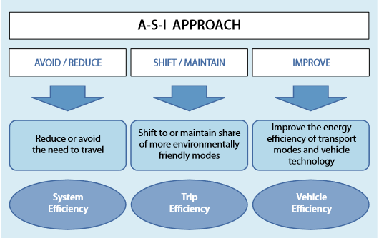

Source : GIZ

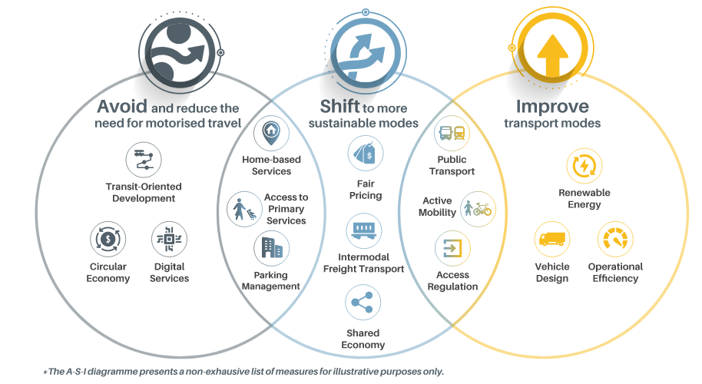

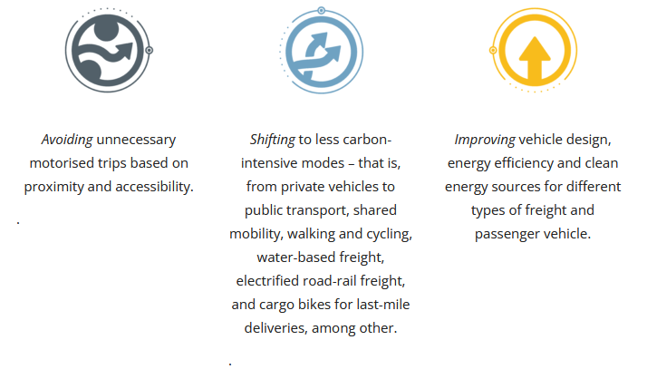

Source: Slocat

**Annex II**

**IRU Green Compact project – to be included.**