|  |  |  |  |
| --- | --- | --- | --- |
|  | United Nations | ECE/TRANS/WP.29/GRBP/2023/17 | |
| _unlogo | **Economic and Social Council** | | Distr.: General  15 June 2023  Original: English |

**Economic Commission for Europe**

Inland Transport Committee

**World Forum for Harmonization of Vehicle Regulations**

**Working Party on Noise and Tyres**

**Seventy-eighth session**

Geneva, 30 August – 1 September 2023

Item 5 of the provisional agenda

**UN Regulation No. 92 (Replacement exhaust silencing systems for motorcycles)**

**Proposal for a document for reference**

**Submitted by the expert from the International Motorcycle Manufacturers Association**[[1]](#footnote-2)\*

The text reproduced below was prepared by the expert from the International Motorcycle Manufacturers Association (IMMA). This document aims at providing industry guidelines on the antitampering provisions for Non-Original Replacement Exhaust Silencing Systems (NORESS) in UN Regulation No. 9 based on informal GRBP-77-20. This guidance document is intended for use by both type approval authorities and industry to evaluate compliance with paragraph 6.3.1. in UN Regulation No. 92.

**Industry guidelines on the anti-tampering provisions for Non-Original Replacement Exhaust Silencing Systems (NORESS) in UN Regulation No. 92**

1. Introduction

The following content aims at supporting manufacturers, national type approval authorities and enforcement authorities in their understanding of the requirements under paragraph 6.3.1. of UN Regulation No. 92.

The wording expressed in italics in section 3 below gives guidance on the interpretation of this paragraph with a view to providing NORESS manufacturers with regulatory certainty to ensure the implementation of a high level of antitampering measures, and to provide national authorities with a set of harmonized best practices for these requirements.

2. Definitions

In order to ensure clarity, the following definitions are provided (see the figure below):

* **Exit-cone:** last part of the exhaust silencer assembly through which exhaust gases exit.
* **Exhaust casing:** shell of the exhaust silencer, main assembly.
* **Baffle:** component or sub-assembly that contributes to the noise attenuation performance of a silencer, e.g. ‘dB killer’.
* **Fastener:** a device used to mechanically join two components.
* **Tamper-proof:** an exhaust is considered tamper-proof when grinding, cutting or drilling is required to remove an exit cone, a fastener or a baffle from a silencer.

**Figure**

Parts of a silencer

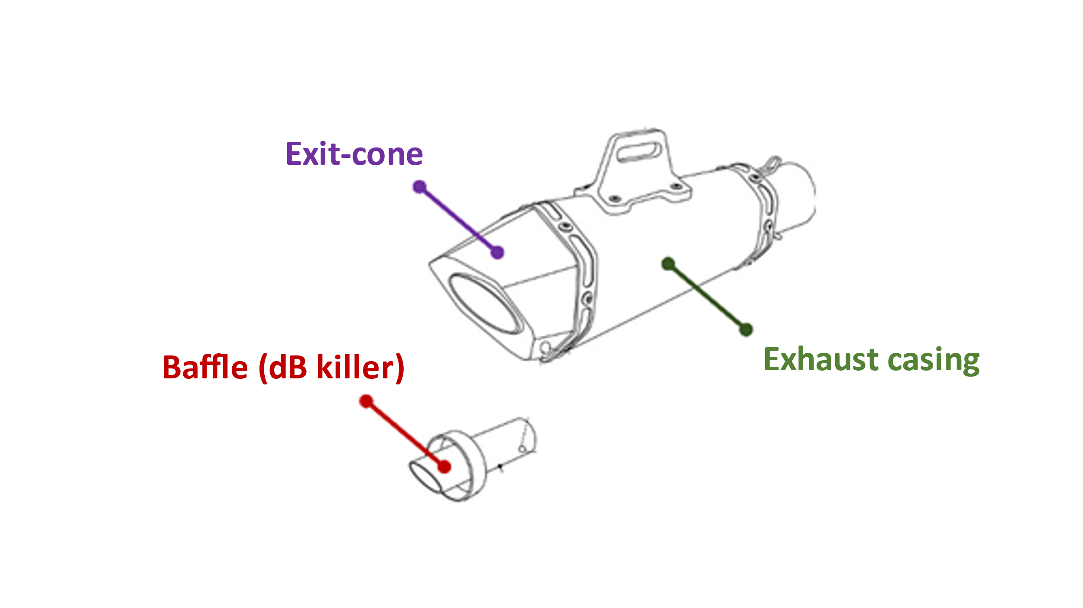

3. Best practices and interpretation[[2]](#footnote-3)

6.3.1.    Tampering protection provisions

The NORESS or its components shall be constructed in a way that does not permit removal of baffles, exit-cones and other parts whose primary function is as part of the silencing/expansion chambers. Where incorporation of such a part is unavoidable, its method of attachment shall be such that removal is not facilitated(e.g. with conventional threaded fixings) and shall also be attached such that removal causes permanent/irrecoverable damage to the assembly.

To facilitate the understanding of paragraph 6.3.1., it is split in three parts A, B and C.

A. Ensuring tamper-proof characteristics of the product

The NORESS or its components shall be constructed in a way that does not permit removal of baffles, exit-cones and other parts whose primary function is as part of the silencing/expansion chambers. (…)

1. *Primarily, as per definition, NORESS should be* ***tamper-proof****.*
2. *Baffles and exit-cones* ***should not be removable by construction/design****. Exhausts manufacturers therefore take the necessary means so that the NORESS integrity would not be easily compromised by users/owners.*
3. ***Exit-cones*** *should be tamper-proof. In detail, this means that:*
   * ***Conventional threaded fixing*** *or similar methods used to fasten* ***exit-cones*** *to the rest of the assembly are not considered as tamper-proof*
     + *Should manufacturers use* ***conventional threaded fixing*** *or similar,* ***exit cones*** *should be also fastened to the* ***exhaust casing*** *by another method such as gluing or welding.*
   * *However,* ***rivets*** *or* ***break-head bolts*** *may be used to secure* ***exit-cones*** *to the exhaust casing. In such event:*
     + *Concerning rivets, stainless steel (not aluminum) should be used as a primary option*
     + *Should manufacturers use non-stainless steel rivets,* ***exit cones*** *should be also fastened to the* ***exhaust casing*** *by another method such as gluing or welding. Alternatively, exist cones fasteners should be filled with epoxy or similar substance;*

*AND*

* + *The* ***baffles*** *should be fixed* ***to the exhaust casing*** *or* ***to the exit-cone*** *so as to ensure that removal of the* ***exit-cones*** *should not facilitate the removal of the baffle. The baffle should be tamper-proof: its fixing methods include e.g. sufficient welding or use of threaded fixings covered by epoxy or similar substances.*
  + *Cosmetic end caps (exit cones) may be attached with conventional fasteners if:* 
    - *removal of the end cap does not facilitate removal of baffles or attenuation devices, and*
    - *is not a part whose function is as part of the silencing/expansion chambers.*

B. Methods of attachment

(…) Where incorporation of such a part is unavoidable, its method of attachment shall be such that removal is not facilitated(e.g. with conventional threaded fixings) (…)

1. *'such a part’ means the above mentioned ‘baffles, exit-cones and other parts whose primary function is as part of the silencing/expansion chambers’;*
2. ***Baffles and other parts*** *should* ***be welded to the exhaust*** *(exit cone or exhaust casing) as a primary method of attachment. It is the manufacturer's choice and responsibility to make sure that such welding covers a sufficient perimeter of the outer rim of the baffle to avoid easy removals.*
3. *Screws and other threaded fixings can be used as a secondary way to secure the* ***baffle*** *to the exhaust, (or as an alternative to welding if welding is not technically possible due to different materials being used for the exit cone and the exhaust casing, for example). In such cases,* ***these fixings should be secured by welding, or filled with epoxy or similar substances.***
4. ***Baffles*** *should never be attached to the rest of the assembly by use of* ***circlips*** *or similar method of assembly, as this would not be considered a tamper-proof method of attachment.*

C. Permanent and irrecoverable damages

(…) and shall also be attached such that removal causes permanent/irrecoverable damage to the assembly.

1. *“removal causing permanent/irrecoverable damage to the assembly” is understood as a being the result (removal) of using other mechanical means than traditional, low cost, easily available tools such as hammer, screwdrivers, or pliers.*
2. *“Irrecoverable damage” includes damages to the aesthetics of the product or damages which would prevent the reintroduction of the removed part(s).*

\_\_\_\_\_\_\_\_\_\_\_\_\_\_\_\_\_

1. \* In accordance with the programme of work of the Inland Transport Committee for 2023 as outlined in proposed programme budget for 2023 (A/77/6 (Sect.20), table 20.6), the World Forum will develop, harmonize and update UN Regulations in order to enhance the performance of vehicles. The present document is submitted in conformity with that mandate. [↑](#footnote-ref-2)
2. Note: the legal text of paragraph 6.3.1. of UN Regulation No. 92 is shown in text boxes. The interpretation is put in italics. [↑](#footnote-ref-3)