INF.6
Economic Commission for Europe  Inland Transport Committee  Working Party on the Transport of Perishable Foodstuffs  Seventy-ninth session  Geneva, 25-28 October 2022  Item 3 (c) of the provisional agenda  Activities of other international organizations dealing  with issues of interest to the Working Party:  standardization organizations | 20 October 2022  English

Liaison with ISO TC 315
Transmitted by Tranfrigoroute International on behalf of the ISO liaison representatives
Summary
Executive summary: Report of liaison with ISO TC315
Action to be taken: Information only.
Related documents: NA.
Introduction
1. Back in 2021, a new ISO Technical Committee (TC) has been established with the intent to deal with Cold chain logistics.
2. It has been discussed that a liaison between Working Party on the Transport of Perishable Foodstuffs (WP 11) and this new TC 315 would be beneficial for both.
3. In April 2022, a liaison between UNECE and ISO/TC 315 has been officially approved
4. Accordingly, Yan Zhang (UNECE); Alibech Mireles Diaz (UNECE) and Lionel Pourcheresse (AFNOR expert) have been registered as a liaison representative from UNECE to TC 315 in the ISO database (ISO Global Directory).
Latest update from ISO/TC 315
- Next TC 315 Plenary and WG meetings will be in Nov 29 - Dec 2, 2022 (hybrid mode, Japan + online)
- 04-2022 - Call for definitions of the term "delivery"
- Decision 07/2022 - Approval of ISO/TC 315 Strategic Business Plan
- Decision 08/2022 – Establishment of ISO/TC 315/WG 4 "Terminology"
ISO/TC 315/WG 4 will replace ISO/TC 315/AHG 2 Terminology
Mr. Toshinori Nakamura is convenor of ISO/TC 315/WG 4.
Call for experts for newly established ISO/TC 315/WG 4 "Terminology"
WG 4 convenor is planning to hold the first WG meeting on December 1, 2022.
- 09/2022 - New work item proposal from Korea
Temperature validation methods of temperature-controlled storages and road vehicles
Scope
This document specifies the general terminology, requirements, procedures, and documentation for temperature validation that shall be used for temperature-controlled storages and road vehicles.
This document does not intend to evaluate the safety and technology of storage and transportation equipment or facilities.

Latest structure of ISO/TC 315
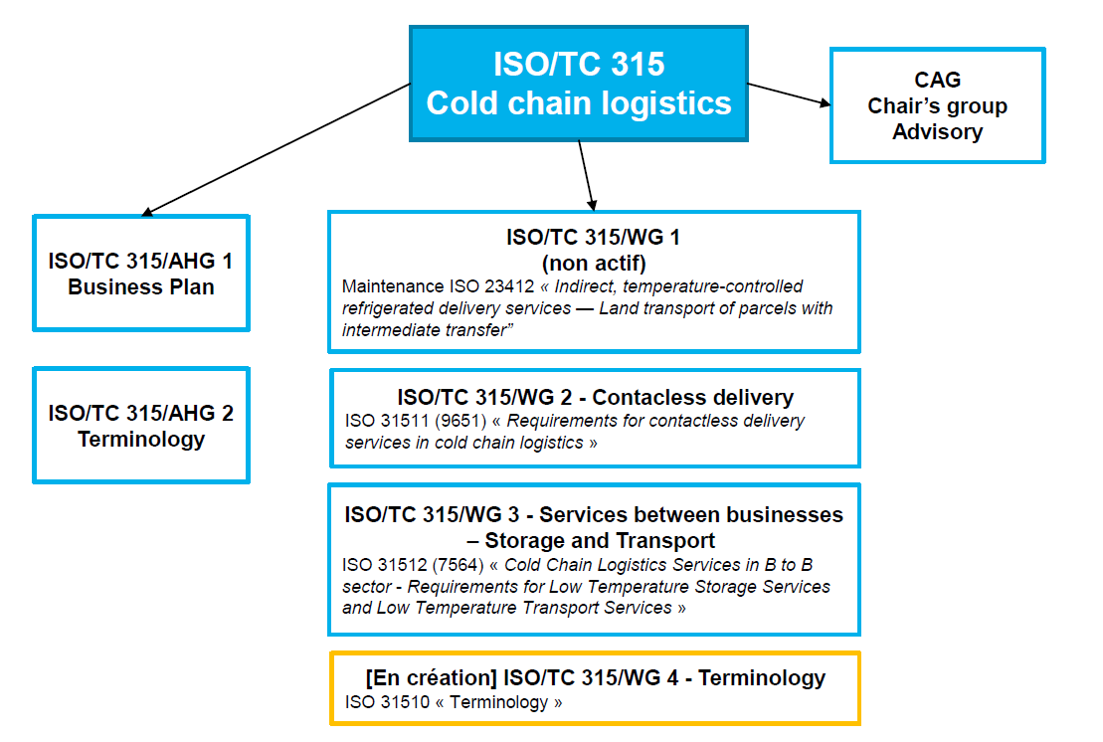

More information: https://www.iso.org/committee/6880159.html

