

UNITED NATIONS
ECONOMIC COMMISSION FOR EUROPE

New Threats to Security in the Economic Social and Environmental Dimensions
A UNECE Report

Eleventh OSCE Economic Forum, Prague, May 23-25 2003

Prague, Czech Republic

2003

Table of Contents

Introduction 4

Chapter I
The Economic and Environmental Dimension to Security 5

1. Introduction 5
2. Systemic and Structural Reforms: Strengthening the Economic and 6
Environmental Dimensions of Security 6
3. The Role of Institutions for Systemic Stability 7
4. Social Cohesion as a Precondition for Systemic Stability 8
5. The Role of International Co-operation in Reducing Tensions and Promoting 9
Security 9
6. Recent Economic Developments in Eastern Europe and the CIS 10

Chapter II
Reviewing OSCE Participating States Commitments in Good Governance 18

1. Introduction 18
2. Trends in the Performance of States in Implementing Commitments in Governance 19
2.1. Overall trends 20
2.2. Voice and accountability 21
2.3. Political Stability/No Violence 21
2.4. Improved regulatory regimes 22
2.5. Government effectiveness 23
2.6. Rule of Law 24
2.7. Control of corruption 25
2.8. Participation and Access to Justice of Civil Society: the Case of Aahrus Convention 26
3. Overall findings and implications for policy 27

Chapter III
A New Framework to Respond to the New Security Threats and Challenges in Europe 41

1. Reviewing and Re-launching the Policy Strategy 41
2. Key Elements 42
3. New Threats and Old Threats Revisited 43
4. An integrated and strategic approach to the New Commitments 45
5. Implementation through an Early Warning System 47
6. Implementation through Partnership 48
7. A Cross-Sectoral Approach 48

Geoffrey Hamilton, Robert Nowak with the technical assistance of Mitja Jarh, prepared the Report. Dieter Hesse coordinated Chapter 1 with the contribution of Joseph Smolik and Rumen Dobrinsky. The recently established UNECE Intersectoral Task Force on Security – Ms. Francesca Bernardini, Mr. Tom Butterly, Mr. Jean-Etienne Chapron, Mr. Poul Hansen, Mr. Bo Libert, Mr. Sead Vilogorac, and Ms. Ewa Ruminska-Zimny, - prepared inputs. The Task Force is coordinated by Mr. Paolo Garonna, the UNECE Deputy Executive Secretary.

Introduction

Following a pattern of cooperation that has become well established since the mid-1990’s, and based on a specific request by the current OSCE Chairman in Office (Netherlands), the UNECE intends to contribute to the eleventh OSCE Economic Forum. This Report aims at providing an input to the Prague Forum, the intergovernmental discussion, and its follow-up.

In the past the ECE has reviewed the commitments of member states in relation to the economic and environmental dimensions of security, as reflected in the Bonn Declaration of 1990. The OSCE decided at the Ministerial meeting in Porto in December 2002 to elaborate a New Strategy Document, recognising that many of the issues and threats in the Bonn Declaration have been overtaken by events. The UNECE has been called upon to provide inputs and support to the formulation of the “New Strategy”, based on its experience and expertise in many aspects of economic cooperation in Europe that have substantial implications for security. In this context, the OSCE Chairman in Office (CIO) conveyed to UNECE its opinion on the specific contributions that the UNECE Report should provide to the Prague meeting. In particular, the CIO highlighted the following desired content of the UNECE Report:

- To identify the issues which are essential elements of the economic and environmental threats currently undermining security and stability in the region
- To consider the Istanbul Charter of 1999, paying particular attention to the section of the Charter (paragraphs 31-33) dealing with good governance, the rule of law and corruption, with a view to providing information on the implementation of commitments and the further examination of areas where more progress needs to be made,
- To provide inputs that may assist in both the preparation of the New Strategy Document as well as the discussion on the role of the OSCE, and other organisations, in the economic and environmental dimensions of security.
- To propose new policy perspectives and approaches that can assist member states in addressing the new threats to stability.

The report is organized as follows:

  - Chapter I reviews the broader aspects of the economic and environmental dimensions to security, particularly those linked to the transition to the market economy;

  - Chapter II evaluates the implementation of the commitments made by OSCE participating states in the area of good governance.

  - Chapter III presents some ideas for responding to the new security threats and challenges in Europe.

Chapter I

The Economic and Environmental Dimension to Security

1. Introduction

The past decade or so has witnessed a significant change in the definition of the concept of “security”. It is now commonly accepted that security is a complex, multifaceted concept that encompasses not only the traditional military dimension but also the broader notion of human security, which, in turn, is closely linked with the issue of human rights. Main components of this wider concept of security are economic - including social - issues (e.g. stability and economic rights), environmental matters (e.g. transboundary pollution and water), health (e.g. HIV/Aids) and so on.

Since 1990, the economic, social and environmental risks to security in Europe have to a large extent been associated with the uncertainty about the outcome of the process of transition towards market economy systems and multi-party political democracies in the countries of central and eastern Europe and the CIS. A successful outcome of the transition process has been seen to be necessary for achieving a stable economic and political environment in the wider Europe.

The document adopted at the CSCE Conference on Economic Co-operation in Europe held in Bonn in 1990 provided a reference framework for the kind of economic and political reforms to be undertaken and for economic co-operation among the member states of the CSCE/OSCE to support this reform process.

The Bonn document lists a number of basic principles for the political and economic reforms launched in eastern Europe, including multiparty democracy, rule of law, competition, economic stability, free trade and capital flows, social justice etc. This is complemented by a broad framework for cooperation between countries, comprising (i) the development and diversification of economic relations; (ii) industrial co-operation and (iii) cooperation in specific areas including technologies for more efficient use of raw materials and energy designed to foster sustainable development; and (iv) monetary and fiscal aspects of economic reforms. The objective of the Bonn document was to set the stage for closer economic relations between countries and thereby contribute to greater economic stability in Europe.

It is noteworthy that the Bonn document neither mentions the term “transition” nor “security”. What is also absent is any perspective on the “process” of transition, i.e. the expected timeframe for completion of economic and political reforms, the possible adverse economic and social consequences, and the associated security risks, due to the legacy of forty or seventy years of central planning, and the issues of intertemporal dependency (possible vicious circles, sequencing, spillover etc.).

In fact, progress in transition has been quite uneven over time and across countries. The most rapid progress was achieved in central and eastern European countries that will join the European Union in 2004, and where the accession process acted as an engine of structural and institutional reforms. In contrast, in south-eastern Europe and the CIS systemic reforms have been more sluggish, reflecting to a large extent unfavourable initial conditions and weak public governance.

The forthcoming enlargement of the EU is tantamount to extending stability and security beyond the borders of the current “western Europe” to the acceding central and eastern European countries. It can therefore be assumed that a greater attention will be given to security risk at the border regions of the enlarged EU and beyond. These security risks are mainly associated with the existing economic backwardness, lingering social and political crises in many of these countries, a lack of adequate institutional structures for intra-CIS and CIS –ECE economic relations, and ethnic and religious antagonisms.

More generally, economic and social crises in combination with weak public governance are also a fertile ground for other security risks such as organised crime, terrorism, clandestine immigration, smuggling and drug trafficking, corruption, money laundering and proliferation of weapons.

Against this background the remainder of this chapter briefly reviews the economic and environmental security dimensions of systemic and structural reforms, including the role of institution building, social cohesion and international cooperation.

2. Systemic and Structural Reforms: Strengthening the Economic and

Environmental Dimensions of Security

Major tremors in the existing economic and political systems of one or several countries, which stem from the restructuring of production processes and from the redistribution of income and wealth, entail risks to both domestic and international security. In this context, the process of economic and political transformation in the former centrally planned economies of eastern Europe and the former Soviet Union, which started in 1989, was a significant challenge to European security. From the onset of reforms the economies in transition were faced with serious economic problems that affected negatively the welfare of large groups of their population. Due to the accumulated monetary overhang and the inherited distorted prices, price liberalization resulted in very high inflation which was not only an important obstacle to their recovery but also eroded – almost completely in some cases – previous savings and other monetary assets. The resultant forced redistribution of wealth sent strong shock waves through all social strata, endangering the stability of these societies. Thus macroeconomic stabilization was a policy issue of high priority in the early phases of transition. Notably, by the end of the 1990s most economies in transition had made considerable progress in macroeconomic stabilization and in general price stability at present is no longer among the main policy concerns in these countries.

Since the start of economic and political transformation, the transition economies have been engaged in comprehensive systemic and structural reforms which, on the one hand, were aimed at establishing a functioning market economy and, in the longer run, will also contribute to the strengthening of the economic and environmental dimensions of security, both domestically and internationally. The successful completion of the accession negotiations with the EU by eight former centrally planned economies is an important confirmation of their considerable progress in implementing market-oriented economic reforms. It is now generally accepted that in the case of the most advanced reformers the period of their transition from plan to market is coming to an end. Accession to the European Union will formally confirm its successful completion.

But progress in systemic and structural reforms has been uneven among the former centrally planned economies. There is a broad consensus that in general the countries of central Europe and the Baltic region have made more progress in market reforms than most of the members of the Commonwealth of Independent States and some of the countries in southeast Europe. In the latter two regions, the pace of systemic reforms has been fairly uneven and in some countries has even been reversed, mostly due to political upheavals, armed conflict, economic crises and/or vested interests. Some of these economies are still faced with major challenges on their long road towards establishing functioning market economies. The upshot is that these regions may potentially be sources of security risks.

Many economies in transition inherited considerable environmental damage, which also poses security risks and hazards. The need for environmental rehabilitation – and in the case of the acceding countries, compliance with EU environmental standards – generates very high claims on public funds, which many of these countries are not in a position to meet. In addition, disputes over the use of river water, as well as the preservation of its quality (the control of transboundary pollution) have increased after the emergence of numerous new states. International assistance and joint efforts with the richer west European countries would be instrumental in reducing the security risks arising from the environmentally unsustainable policies followed in the past.

3. The Role of Institutions for Systemic Stability

At the onset of transition the reform agenda was dominated by the conventional economic view, which advocated a rapid liberalization of prices and foreign trade, privatisation and macroeconomic stabilization. This approach to transition was commonly known as the “Washington consensus”, or -in a narrower version of it- “shock therapy” and downplayed the role of institution building in the economic and political transformation process. In contrast, the key role of institution building has from the very start of transition been stressed by the UNECE.
Institutions are the formal (laws, regulations etc.) and informal (norms of behaviour, customs, shared values, etc.) rules governing economic, political and social interactions (“the rules of the game”) that together with enforcement mechanisms define the incentive structure of societies and economies and shape economic performance.

While the formal rules can be changed quickly, the informal norms tend to change only gradually over time. This means that the simple adoption of the formal political and economic rules of successful western market economies by transition economies is not a sufficient condition for good economic performance. Developing norms of behaviour that support and legitimize new rules is a slow process that requires behavioural adaptation, and a sustained process of capacity building and international dialogue.

It has become accepted that the overall effectiveness of institutions depends on a host of factors: the quality of governance, which in turn reflects such things as the efficiency of the public sector, the regulatory burden, the degree of corruption and the political rights enjoyed by the population; legal protection accorded to private property and the commitment to the enforcement of laws; and, in more general terms, the quality of political leadership and the transparency of the policy process. A commitment to transparent policies is particularly important when issues involving the distribution of power, income and wealth in a society are at stake.

At the time the old command system collapsed in 1989, the coordinating mechanism of the market economy was not yet in place, thus creating an “institutional hiatus” in the transition economies. It can be argued that this played an important role in the output collapse in the early years of reforms. A major lesson from the experience of the transition is that the success of liberalization, macroeconomic stabilization and privatisation policies is contingent on the existence of adequate institutions. It is now generally accepted that institutional factors have to be considered as part and parcel of any economic reform programme. Moreover, economic development will not be possible without the rule of law and democratic modernization.

4. Social Cohesion as a Precondition for Systemic Stability

Social tensions may be caused by various factors such as poverty, inequitable distribution of income and wealth, persistent high unemployment, dysfunctional and inefficient systems of social protection, discriminatory policies towards minority groups, etc. Increasing and maintaining social cohesion is thus a basic pre-requisite for a conflict-free development of the society and a smooth functioning of the economy.

One of the side effects of the transition from plan to market was the rapid and painful social stratification of these previously rather homogenous societies. This major societal transformation was often accompanied by the widespread change of social status (often to a lower level) and the loss of previously existing privileges such as job security. Often the social costs of transition were rather unevenly distributed which, in turn, was an important source of tensions and unrest.

In particular, there is growing evidence of the emergence of excessive income inequalities within some transition economies, especially in the lower income countries. Due to the disproportionate sharing of the costs of economic adjustment by various subgroups of the population, poverty increased sharply from near negligible to endemic proportions in some of the low-income countries. In countries such as Armenia, Kyrgyzstan, the Republic of Moldova and Tajikistan more than 80 per cent of the population live below the international poverty line of $ 4.30 per person per day and more than 40 per cent – below the international absolute poverty line of $2.15 per person per day. Another important risk factor is the excessively high unemployment in some transition economies: in 2002 the average unemployment rate in eastern Europe was above 15 per cent and in some countries of south-east Europe these rates were 30 per cent or even higher. The existing social safety nets are often inadequate and provide little protection for the lower levels of these societies.

The output collapse and the institutional hiatus during the initial phase of transition was accompanied by, among other things, a general degradation of the existing health care systems while health care reforms were not assigned adequate priority. As a result many countries witnessed a general deterioration of the health of the population and, in some cases, a decline in life expectancy. Another side effect of the transition was a persistent wave of emigration, which involved both highly skilled workers (thus contributing to a brain drain) and persons with limited skills who were among the losers of reforms. The latter often engage in illegal or semi-legal activities thus adding to the security risks both in the source and in the host countries.

These examples emphasize the high importance that has to be assigned to addressing the acute social problems accompanying the process of economic transformation in the former centrally planned economies and thus there is a growing need for targeted policies addressing these problems. Policies enhancing social cohesion will at the same time help to reduce security risks in the region as a whole. Providing assistance to the transition economies in designing and implementing policies of social cohesion has appeared therefore increasingly in the common security interest of all countries in the region.

But currently there are also large gaps in real per capita income across countries in the ECE region. In 2001 the average per capita GDP level measured at purchasing power parities (PPPs) in the transition economies relative to the EU average ranged from 45 per cent on average for the central European economies to some 12 to 15 per cent, respectively, in the Caucasian and central Asian countries. Large income gaps across countries may also become a threat for sustainable development in the region. Conversely, accelerating the process of catching up by the lower income countries will increase social cohesion and pan-ECE solidarity. This points to the need for creating a conducive macroeconomic and institutional environment for achieving high and sustained rates of economic growth by the catching up economies. In addition, this highlights the importance of achieving sustained robust economic growth in the EU’s major economies, so that these larger economies resume their leading role as engines of growth for the smaller and weaker east European economies.

5. The Role of International Co-operation in Reducing Tensions and Promoting

Security

Although international economic institutions are not security organisations, their activities help to widen and deepen pan-European and pan-ECE economic co-operation and thus strengthen the foundations of a security system in the region. The institutions active in Eastern Europe and the CIS (e.g. the Bretton Woods organisations, ADB, EBRD, ECE, OECD) have contributed in their own, often complementary, ways to the long-run stability of the ECE region. They have contributed to macroeconomic stabilisation and to the economic transition with their policy advice, technical assistance and, in many cases, financial support. This assistance has improved these countries’ prospects for achieving sustained growth and narrowing income gaps, and thus for enhancing economic stability in the region.

In the ECE member governments have tackled a large number of precisely defined problems, including ones with security implications, which have resulted in the adoption and implementation of a host of norms, standards and conventions. This bottom up approach in a variety of sectors has inter alia helped to protect the environment and facilitated economic integration, thus providing real benefits to the population. The larger significance of this technical work is that it has helped to create a framework in which the habits of co-operation to overcome differences of interest and seeking common ground have become deeply entrenched over the course of nearly 50 years.

The integration processes that underlie the creation of the EU inherently also remove the potential for various conflicts between member states. Among other things, these processes involve the freeing of trade in goods and services, the adoption of common or mutually recognised norms and standards, accordance of national treatment to the individuals and businesses of other member states, and the implementation of harmonized legislation (acquis communautaire) and regulatory frameworks. The functioning of the system is underpinned by political and legal institutions that facilitate the resolution of internal and trans-boundary disputes. EU regional policies, supported by various sources of funds, are intended to reduce income disparities between countries and regions while social cohesion programmes target the less fortunate in the Union. Hence the periodic enlargement of the EU has had not only economic and political implications but has also extended the EU sphere of internal security. These processes are being repeated with the accession of 10 new member states, most of which because of their recent histories have been viewed as particularly vulnerable to instability. Moreover, the fact that their accession will likely prompt their (non-acceding) trade partners, including the members of the CIS, to adopt various EU norms, standards etc. as a pre-condition for facilitating business relations implies that the use of many stability-enhancing economic instruments will be extended beyond the borders of an enlarged EU.

6. Recent Economic Developments in Eastern Europe and the CIS

Recent developments show on the one hand promising impacts of greater economic stability and growth, but on the other they point out longer-term structural imbalances and vulnerabilities that are significantly related to security risks. Despite some slowing down of activity in Eastern Europe and the CIS in 2002, rates of economic growth in these regions remained generally higher than those in western Europe. The slowdown was more pronounced in some of the CIS countries, particularly in the two largest economies, Russia and Ukraine, which pulled down the rate of growth of GDP for the region as a whole. Nevertheless, aggregate GDP in the CIS grew by 4.9 per cent in 2002 due to the still significant momentum from the previous year of rapid growth and a continuing boom in some of the Caucasian and central Asian countries (Table 1 and Chart 1). In eastern Europe, real GDP rose on average by 3 per cent in 2002, basically the same growth rate as in the previous year. Growth patterns varied in different parts of the region: central Europe continued to be the slowest growing subregion (weighed down by the sluggish Polish economy), while south-eastern Europe and, especially, the Baltic states performed considerably better than the average. Thus despite the unfavourable external environment, the area as a whole was still among the fastest growing regions in the world. Among other things, this reflected an important change that had emerged already in 2001 but which became dominant in 2002, namely, a shift from external to domestic sources of growth. The enduring strength of domestic demand was in fact the main factor that prevented a further weakening of output growth in this part of the ECE region.

Such a pattern of growth, however, is a mixed blessing for the east European and CIS economies. On the one hand, the resilience of domestic demand is a sign of confidence in the future prospects of these economies on the part of both consumers and investors. This also reflects the considerable progress that some of these countries have made in their market reforms as evidenced by the invitation to eight east European countries to join the European Union in 2004. But also in some of the CIS economies, which are generally lagging behind eastern Europe in systemic reforms, several years of strong growth have contributed to rising incomes and levels of welfare of the population, which, in turn, have reinforced domestic support for economic activity. On the other hand, reliance on domestic demand as the main engine of growth is unlikely to be sustainable since most of the region consists of small, open economies. With few exceptions, most east European and CIS economies are characterized by chronic and large current account deficits, accompanied in some cases by fiscal imbalances (tables 1 and 2); an excessive shift towards domestically-driven growth is clearly not an appropriate strategy for keeping these deficits in check.

Although net exports did not generally make a positive contribution to GDP growth in 2002, one of the surprising developments during the year was the strength of east European exports in the face of the persistent weakness of economic activity in western Europe: on average they grew faster than both western import demand and total world exports. Moreover, this was the second consecutive year of such relative strength, a consequence of which was a large increase in the east European share of west European markets despite the weakness of import demand (Table 2). Several factors are likely to have contributed to this outcome. First, since the start of economic transformation more than a decade ago, a number of east European economies have had massive inflows of FDI, a large part of which have been undertaken by large, export-oriented multinational companies. These new capacities exploit the comparative advantages of these economies in low-cost labour (particularly, low-cost skilled labour) as well as their proximity to the major markets of western Europe. This strong competitive edge appears to have been one of the factors that allowed east European exporters to continue to gain export market share in 2002 despite the weakness of western demand and, in some cases, some deterioration in their relative cost competitiveness.

In a period of global economic slowdown – as was the case in 2001 and 2002 – the importance of eastern Europe’s comparative advantage may have been amplified by the general squeeze on profit margins, which has made multinational companies even more sensitive to their production costs. Faced with the need to trim their global costs in response to the slump in global demand, multinationals tend to accelerate the relocation of part of their global production volumes to lower cost countries. As the east European economies are still very competitive in this regard vis-à-vis their western counterparts, they may have benefited from such intra-company relocation of production in this period. At the same time eastern Europe itself is under pressure from countries offering even more competitive conditions for cost-saving or located nearer to other major markets, as suggested by the recent relocation of some production lines from eastern Europe to destinations in south-east Asia.

Overall, the rising market shares of east European exporters are a medium-term development reflecting transition-related changes in the international division of labour. Due to the nature of their underlying comparative advantage and the existing differences in labour costs, the east European economies are likely to gain further market shares in west European and global markets in the short to medium run. In the longer run, however, comparative advantage is not static and as development and income levels in eastern Europe start to catch up with those in the industrialized countries new sources of international competitiveness will have to be developed via the accumulation of physical and human capital.

The macroeconomic environment in 2002 was generally supportive of disinflation, and most east Europe and CIS economies made further progress towards price stability or lower rates of inflation (table 1). Nowadays inflation in the majority of these countries, while generally higher than that in the more developed market economies, mostly reflects transition-specific developments and cannot be attributed to loose macroeconomic policy. Thus in 2002, the main sources of inflationary pressures in the region were the rising prices of services which can be regarded as a normal feature of the development process in these economies as well as increases in some administered prices. During most of the year the prices of tradable goods, however, tended to offset these domestic inflationary pressures: imported inflation was almost non-existent due to weak world market prices for basic commodities and manufactures and, in some east European economies, appreciating exchange rates. Good harvests in many countries eased, moreover, the domestic price of food.

Labour markets in most of eastern Europe and the CIS continue to suffer from chronic structural imbalances. While there were some positive developments in 2002 they were confined to just a few countries: unemployment, as measured by labour force surveys, declined in the largest CIS economies (Kazakhstan, Russia and Ukraine) as well as in all the Baltic states. At the same time, unemployment remains worryingly high in south-east Europe and has continued to increase in other countries, in some cases (such as Poland) to record levels.

Against the overall trends in domestic and external demand in 2002, as well as changes in the terms of trade, the aggregate current account balances of eastern Europe and the CIS deteriorated although there were considerable differences among countries (table 2). While in several east European countries (Croatia, the Czech Republic, Estonia, Hungary and Yugoslavia, among others) there was a substantial widening of their current account deficits, in others there were improvements (Bulgaria, Romania and Slovenia). Within the CIS, Russia’s current account surplus shrank but was still much larger than had been expected at the beginning of the year. The situation with financing also varied: in general, east European countries had few problems in financing their current account deficits (even when they increased); but some CIS countries continued to face balance of payments constraints due to their limited access to external finance.

Despite the generally unfavourable external environment, net capital flows into eastern Europe generally rose in 2002, largely due to changes in international investors’ perception of relative risk in emerging markets. The upturn reflects changes in two main flows: larger volumes of FDI, and a surge in short-term capital flows, which, in net terms, changed direction from 2001. However, privatization, which has been a major attraction for FDI in eastern Europe in recent years and an important source of financing of current account deficits, is nearing its end in most of these countries. The elimination of this convenient source of financing implies the need for alternatives or for an adjustment in the external balances of some countries.

The official outlook for most countries in eastern Europe and the CIS remains fairly optimistic about growth prospects in 2003. These forecasts imply aggregate real GDP growth in eastern Europe of some 3½ per cent in 2003 and in the CIS by more than 5 per cent. It should be borne in mind, however, that growth in both these regions will be shaped to a considerable degree by the strength of output in the two largest regional economies – Poland and Russia, respectively. GDP growth is expected to remain moderate in 2003 (between 3 and 4 per cent) in the central European countries (the Czech Republic, Hungary, Slovakia, Poland and Slovenia). By contrast, relatively strong growth (with GDP growing by some 5-5½ per cent) is expected to continue in the three Baltic states, the fastest growing region of eastern Europe for the last three years. According to official forecasts, growth will remain fairly strong also in the south-east European economies, with GDP increasing in most cases by some 4 to 5 per cent. Russia’s budget for 2003 was based on a set of macroeconomic projections whereby, under different assumptions about the external environment (in the first place, the price of crude oil) the rate of GDP growth was expected to be in a range of between 3.5 and 4.4 per cent. The most recent forecasts by private analysts are even more optimistic, suggesting GDP growth of between 4 and 5 per cent. Official forecasts for the other large CIS economies are also optimistic. In Ukraine, the rate GDP growth should accelerate, reaching some 5½ per cent. Strong growth is expected to continue in Kazakhstan where, according to official forecasts, GDP should grow by more than 8 per cent. Moderate to high rates of GDP growth are forecast elsewhere in the CIS, with official forecasts for 2003 ranging between 4 and 7 per cent (Table 1).

In conclusion, recent developments and the prospects for the future tend to confirm the mixed signals and the lessons learned in the last decade of transition. On the one hand, the considerable progress made in macroeconomic stabilisation has brought about a healthy rate of economic growth; on the other major economic reforms remain to be carried out and new structural imbalances have emerged. The ‘old’ and the ‘new’ in the economic dimension of security overlap and interact presenting a growingly complex challenge to national and international security strategies.

TABLE 1
Basic economic indicators for the east European and CIS economies, 2000-2003
(Rates of change and shares, per cent)

 | GDP |  |  |  | Consumer price inflation |  |  | Registered unemployment rate |  |  | Consolidated general government deficit
 | (growth rates) |  |  |  | (per cent change, Dec./Dec.) |  |  | (end of period,  per cent) |  |  | (per cent of GDP)
 | 2000 | 2001 | 2002 | 2003 forecast | 2000 | 2001 | 2002 | 2000 | 2001 | 2002 | 2000 | 2001 | 2002
Eastern Europe | 3.9 | 3.0 | 3.0 | 3.6 |  |  |  | 14.8 | 15.3 | 15.3
Albania | 7.8 | 6.5 | 4.5 | 6 | 4.2 | 3.5 | 2.0 | 16.9 | 14.5 | 16.2 | -9.8 | -9.1 | -8.0
Bosnia and Herzegovina | 4.5 | 2.3 | 4 | 4 | 3.4 | 1.5 | .. | 39.4 | 39.9 | 42.7 | .. | .. | -0.3
Bulgaria | 5.4 | 4.0 | 4.2 | 4.8 | 11.2 | 4.8 | 3.8 | 17.9 | 17.9 | 16.3 | -1.0 | -0.9 | -0.7
Croatia | 2.9 | 3.8 | 4.6 | 4.2 | 7.5 | 2.5 | 1.8 | 22.6 | 23.1 | 21.5 | -5.7 | -5.2 | -6.2
Czech Republic | 3.3 | 3.3 | 2.5 | 3.3 | 4.1 | 4.2 | 0.6 | 8.8 | 8.9 | 9.8 | -4.7 | -6.0 | -9.0
Estonia | 7.1 | 5.0 | 5.7 | 4.8 | 5.0 | 4.3 | 2.3 | 7.7 | 7.7 | 6.8 | -1.3 | -0.5 | 2.2
Hungary | 5.2 | 3.8 | 3.2 | 3.8 | 10.1 | 6.9 | 5.0 | 8.9 | 8.0 | 8.0 | -4.5 | -4.0 | -9.5
Latvia | 6.8 | 7.7 | 5.7 | 5.6 | 1.9 | 3.0 | 1.5 | 7.8 | 7.7 | 7.6 | -5.2 | -4.3 | -2.5
Lithuania | 3.8 | 5.9 | 5.9 | 4.9 | 1.5 | 2.1 | -0.9 | 12.6 | 12.9 | 10.9 | -3.1 | -1.9 | -1.5
Poland | 4.0 | 1.0 | 1.3 | 3 | 8.6 | 3.6 | 0.7 | 15.1 | 17.5 | 18.1 | -4.3 | -5.5 | -5.8
Romania | 1.8 | 5.3 | 4.7 | 5.2 | 40.7 | 30.2 | 17.9 | 10.5 | 8.8 | 8.1 | -4.2 | -3.5 | -2.9
Slovakia | 2.2 | 3.3 | 4 | 3.5 | 8.3 | 6.2 | 3.3 | 17.9 | 18.6 | 17.4 | -8.5 | -4.0 | -7.7
Slovenia | 4.6 | 3.0 | 3.2 | 3.5 | 9.0 | 7.1 | 7.4 | 12.0 | 11.8 | 11.3 | -1.6 | -1.3 | -2.8
The former Yugoslav Republic of Macedonia | 4.5 | -4.5 | 0.3 | 3.4 | 6.1 | 3.5 | 1.3 | 45* | 42* | 45* | -1.3 | -5.9 | -4.5
Serbia and Montenegro | 6.4 | 5.1 | 4 | 3 | 115.1 | 40.5 | 11.7 | 26.6 | 27.9 | 32* | -0.2 | -1.7 | -5.9
CIS | 8.2 | 6.0 | 4.9 | 5.1 |  |  |  | 2.4 | 2.4 | 2.3
Armenia | 5.9 | 9.6 | 12.9 | 6.0 | 0.4 | 2.8 | 1.9 | 9.5 | 9.3 | 9.2 | -7.8 | -3.8 | -3.4
Azerbaijan | 11.1 | 9.9 | 10.6 | 7.5 | 2.1 | 1.5 | 3.2 | 1.3 | 1.3 | 1.3 | -2.2 | 1.5 | -0.1
Belarus | 5.8 | 4.7 | 4.7 | 6.3 | 108.0 | 46.3 | 34.9 | 2.6 | 2.9 | 3.0 | -0.1 | -1.4 | -1.5
Georgia | 1.9 | 4.7 | 5.4 | 4.5 | 4.6 | 3.4 | 5.6 | .. | .. | .. | -4.1 | -1.2 | -1.1
Kazakhstan | 9.8 | 13.5 | 9.5 | 8.3 | 10.0 | 6.6 | 6.7 | 3.6 | 2.9 | 2.7 | 0.8 | 2.7 | 1.0
Kyrgyzstan | 5.4 | 5.3 | -0.5 | 6.0 | 9.5 | 3.8 | 2.4 | 3.3 | 3.2 | 3.1 | -9.3 | -5.0 | -5.4
Republic of Moldova | 2.1 | 6.1 | 7.2 | 5.0 | 18.5 | 6.4 | 4.4 | 1.9 | 1.8 | 1.6 | -1.9 | -0.5 | -3.0
Russian Federation | 9.0 | 5.0 | 4.3 | 4.5 | 20.1 | 18.8 | 15.1 | 1.7 | 1.7 | 1.7 | 1.9 | 2.9 | 2.5
Tajikistan | 8.3 | 10.2 | 9.1 | 7.4 | 60.6 | 12.5 | 14.4 | 2.7 | 2.7 | 2.7 | -0.6 | -0.1 | -0.3
Turkmenistan | 17.6 | 20.5 | 21.2 | 8.0 | .. | .. | .. | .. | .. | .. | .. | -1.2 | -0.8
Ukraine | 5.9 | 9.1 | 4.6 | 5.5 | 25.8 | 6.1 | -0.6 | 3.7 | 3.6 | 3.6 | -1.3 | -1.7 | -2.0
Uzbekistan | 4.0 | 4.5 | 4.2 | 5.3 | 28.2 | .. | .. | .. | .. | .. | .. | -1.3 | -3.6
Total above | 6.5 | 4.8 | 4.1 | 4.5

Source: UNECE Economic Survey of Europe, 2003, No. 1.

TABLE 2
Trade performance and external balances of east European and CIS economies, 2000-2002
(Rates of change and shares, per cent)
 | Merchandise exports  (growth rates) |  |  | Merchandise imports  (growth rates) |  |  | Trade balance  (per cent of GDP) |  |  | Current account balance  (per cent of GDP)
 | 2000 | 2001 | 2002 a | 2000 | 2001 | 2002 a | 2000 | 2001 | 2002 a | 2000 | 2001 | 2002 a
Eastern Europe | 12.9 | 10.7 | 9.6 | 11.0 | 8.6 | 8.7 | -10.5 | -10.0 | -9.2 | -5.0 | -4.5 | -4.5
Albania | -10.0 | 17.6 | -2.5 | 14.0 | 24.3 | 15.0 | -20.6 | -24.6 | -24.2 | -4.4 | -5.3 | -9.2
Bosnia and Herzegovina | 30.2 | 18.5 | -13.9 | -5.8 | 2.2 | 10.6 | -38.3 | -33.4 | -50.7 | -21.6 | -24.4 | -26.9
Bulgaria | 20.0 | 6.0 | 5.2 | 17.6 | 11.6 | 1.9 | -14.0 | -15.8 | -12.5 | -5.9 | -6.2 | -0.5
Croatia | 3.0 | 5.1 | 3.6 | 1.6 | 14.7 | 13.6 | -18.3 | -22.4 | -25.2 | -2.1 | -3.2 | -3.2
Czech Republic b | 10.4 | 14.9 | 13.7 | 14.9 | 13.4 | 9.7 | -6.4 | -5.5 | -2.6 | -4.5 | -4.6 | -5.1
Estonia | 33.2 | 4.1 | -3.1 | 23.7 | 0.8 | 6.0 | -21.9 | -17.8 | -21.0 | -6.3 | -6.2 | -11.5
Hungary | 12.3 | 8.6 | 10.0 | 14.5 | 5.0 | 7.8 | -8.7 | -6.1 | -4.6 | -3.3 | -2.1 | -5.0
Latvia | 8.1 | 7.3 | 10.7 | 8.1 | 10.0 | 13.3 | -18.5 | -19.9 | -20.1 | -6.9 | -9.7 | -6.7
Lithuania | 28.1 | 20.3 | 10.5 | 13.0 | 16.4 | 19.9 | -14.3 | -14.8 | -16.5 | -6.0 | -4.8 | -3.7
Poland | 15.5 | 14.0 | 7.9 | 6.6 | 2.7 | 5.8 | -11.0 | -8.0 | -7.7 | -6.3 | -3.9 | -3.6
Romania | 21.9 | 9.8 | 15.1 | 25.6 | 19.1 | 12.0 | -7.3 | -10.5 | -8.9 | -3.7 | -5.6 | -3.2
Slovakia | 15.8 | 6.6 | 8.7 | 12.5 | 16.0 | 7.4 | -4.0 | -9.7 | -7.0 | -3.7 | -8.6 | -7.1
Slovenia | 2.2 | 6.0 | 8.9 | 0.3 | 0.3 | 4.2 | -7.6 | -4.8 | -2.0 | -3.4 | 0.2 | 2.4
The former Yugoslav  Republic of Macedonia | 11.3 | -12.4 | -7.0 | 16.3 | -19.0 | 16.0 | -20.7 | -15.2 | -21.0 | -3.2 | -6.9 | -7.7
Serbia and Montenegro | 15.1 | 10.0 | 15.0 | 12.6 | 30.0 | 21.0 | -24.6 | -28.4 | -26.9 | -4.2 | -6.0 | -14.0
CIS | 38.0 | -0.2 | 0.8 | 14.0 | 15.6 | 6.7 | 21.3 | 14.9 | 13.3 | 13.9 | 8.2 | 7.3
Armenia | 29.7 | 12.6 | 46.0 | 9.0 | -1.8 | 8.1 | -30.5 | -25.0 | -20.7 | -14.5 | -9.3 | -6.5
Azerbaijan | 87.8 | 32.6 | -2.1 | 13.1 | 22.1 | 22.7 | 10.9 | 15.6 | 9.1 | -3.2 | -0.9 | -8.4
Belarus | 24.9 | 1.3 | 4.0 | 27.0 | -6.1 | 7.0 | -10.6 | -5.1 | -4.1 | -2.1 | -2.2 | -0.4
Georgia | 38.5 | -3.0 | -5.9 | 20.7 | 5.1 | 0.1 | -13.2 | -11.4 | -11.8 | -8.7 | -6.6 | -6.7
Kazakhstan | 63.4 | -5.2 | 3.7 | 37.0 | 26.0 | 1.4 | 22.3 | 10.3 | 11.2 | 4.1 | -5.6 | -1.4
Kyrgyzstan | 11.2 | -5.6 | -0.8 | -7.6 | -15.7 | 30.1 | -3.8 | 0.6 | -6.0 | -5.9 | -1.3 | -0.9
Republic of Moldova | 1.6 | 21.0 | 13.6 | 32.5 | 15.5 | 15.4 | -23.8 | -22.1 | -23.4 | -9.4 | -6.2 | -4.6
Russian Federation | 39.5 | -2.1 | -0.5 | 8.9 | 22.1 | 10.6 | 27.5 | 19.2 | 16.9 | 18.4 | 11.2 | 9.5
Tajikistan | 13.9 | -16.9 | 9.3 | 1.8 | 1.9 | 0.8 | 11.1 | -3.4 | -0.8 | -6.3 | -7.0 | 0.4
Turkmenistan | 110.1 | 8.0 | 0.7 | 18.7 | 26.4 | -26.0 | 16.3 | 7.5 | 6.7 | 2.3 | .. | ..
Ukraine | 25.8 | 11.6 | 6.3 | 17.8 | 13.0 | 6.0 | 1.9 | 1.3 | 2.4 | 4.7 | 3.7 | 7.0
Uzbekistan | 0.9 | -3.7 | -10.6 | -5.0 | 6.0 | -13.9 | 2.8 | 0.8 | 1.3 | 1.4 | 0.4 | ..
Total above | 24.7 | 5.3 | 5.5 | 12.0 | 10.6 | 8.1 | 3.9 | 2.0 | 1.7 | 3.6 | 1.6 | 1.2

Source: UNECE Economic Survey of Europe, 2003, No. 1.

a January-September over same period of 2001.

CHART 1
Quarterly changes in real GDP in Eastern Europe and the CIS, 2000QI-2002QIII
(Percentage change over the same period of previous year)

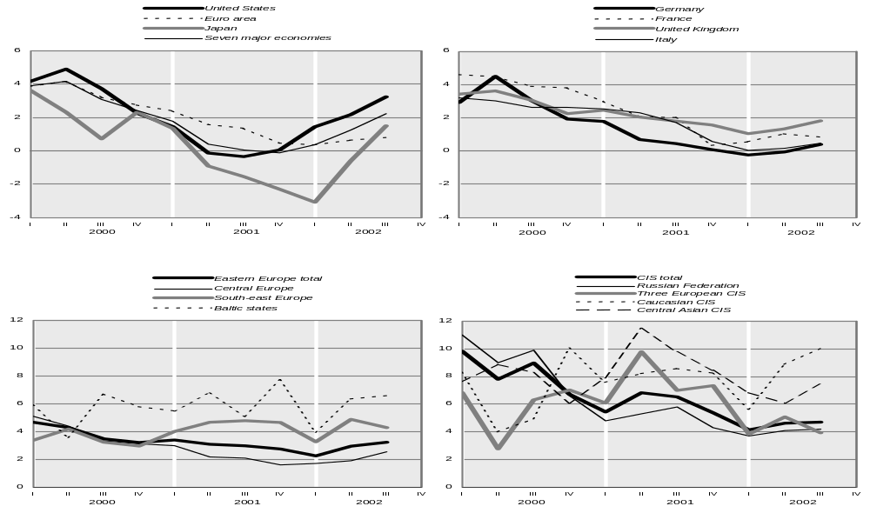

Source: UNECE Economic Survey of Europe, 2003, No. 1.

Chapter II

Reviewing OSCE Participating States Commitments in Good Governance

1. Introduction

Governance can be broadly defined as the exercise of political, economic and administrative authority to manage a nation’s affairs. Governance is thus about the importance of institutions, the interactions between different levels of government within a country, the interaction between the public, including nongovernmental organizations and business, and government. On an international plane it entails the interaction between different governments. International organizations also play an important part.

As discussed in the previous chapter, good governance is a key condition for sustainable economic stability and security. Evidence also suggests that good governance is an essential component of sustained economic performance, particularly in transition economies. In contrast, poor governance and slow economic development appear to be mutually reinforcing. International institutions have increasingly observed the links between good governance and security. In particular, OSCE members made specific governance related commitments at the Istanbul Summit in November 1999.

- First, members reaffirmed their “commitment to the rule of law”

- Second, they “pledged to strengthen their efforts to combat corruption and the conditions that foster it “;

- Third they committed to promote a “positive framework for good government practices and public integrity”.

- Fourth, they pledged to work with “NGOs that are committed to a strong public and business consensus against corrupt practices”.

- Finally, they committed “to ensure access to information, public participation in decision-making and access to justice in environmental matters” in the spirit of the UNECE Aarhus Convention of 1998 on “Access to Information, Public Participation in Decision-Making and Access to Justice in Environmental Matters”.

This chapter reviews the performance of OSCE participating states in meeting their commitments in the area of good governance over the years 1997-2001. It uses for this purpose aggregate governance indicators, which have been compiled and estimated by the World Bank.

It is important to note that with respect to measuring “intangible” concepts such as the “rule of law” or “institutional stability”, the degree of their precision or meaningfulness may be questioned. Nevertheless, the intent here is to demonstrate how a few indices can provide constructive inputs to policy discussions and monitoring, thereby highlighting both their merits and limitations.

It is also important to record that change after 2001 has not been considered in the data: the question of timeliness and data quality will have to be addressed as a priority in building a monitoring system in the future.

2. Trends in the Performance of States in Implementing Commitments in

Governance

With the heightened interest in governance and economic performance, there has been an explosion of cross-country indices measuring various aspects of governance. The individual governance indicators come from a variety of organizations, including commercial risk agencies, international organizations, think tanks and NGOs. They are based on surveys of experts, firms and individuals. Researchers at the World Bank have aggregated these available governance indices containing more than 300 indicators for 175 countries. The researchers defined governance as “ the exercise of authority through formal and informal traditions and institutions for the common good”. This process comprises of a. selecting, monitoring and replacing governments; b. capacity to formulate and implement sound policies; c. respect for the institutions.

This definition of governance – for the purpose of measurement and analysis – was further unbundled into six more detailed governance concepts (two for each element).
They are:

- Voice and accountability (which includes political rights, civil liberties and independence of the media)

- Political stability (such as probability that the government will be overthrown)

- Government effectiveness (e.g., quality of public service provision and the competence of civil servants)

- Regulatory quality (e.g., incidence of market unfriendly or excessive regulation and inadequate banking supervision)

- Rule of law (e.g., crime, effectiveness of the judiciary and the enforceability of contracts)

- Control of corruption (e.g., the exercise of public power for private gain).

These have been quantified and are available for 1998 and 2001 illustrating cross sectional differences as well as progress, if any, between 1998 and 2001.

2.1. Overall trends

Overall the charts demonstrate the following:

- All states need to improve in the area of good governance;

- Corruption can be identified as a major challenge everywhere;

- Many governance issues remain to be addressed in CIS countries despite the fact that the vast majority of post-communist countries are currently considerably more democratic and considerably more open than they were under communism. In addition, more work remains to be done despite their economies – in general - being progressively more market oriented.

As can be seen from the charts below there are considerable differences between the regions. The countries grouped in the “OECD Region” category have consistently the highest scores of aggregate governance indicators – across all six basic components of governance – followed by the “Eastern Europe” category. The “Former Soviet Union” category countries have the lowest. In terms of changes between 1997 and 2001, the “OECD Region” countries registered improvements in three out of six components while “Eastern Europe” countries scored higher on five out of six. “The Former Soviet Union” countries’ scores worsened in four out of six. With regard to individual country performance (see Annex I), caution should be exercised because of the existence of large margins of error. Nevertheless, the charts in the Annex demonstrate considerable differences in countries’ performance.

2.2. Voice and accountability

Chart 1

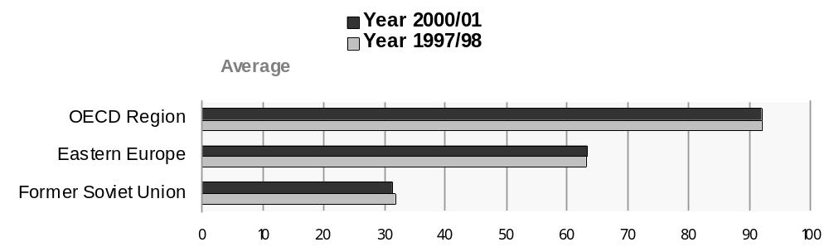
Source: For a detailed explanation of sources, methods and access to governance indicators databank see www.worldbank.org/wbi/governance.
Note: The margins of error (not shown) in all governance data suggest caution in interpreting these results. In particular, precise country rankings should not be inferred.

These indicators attempt to measure the extent to which citizens of a country are able to participate in the selection of governments. Indicators measuring the independence of the media are included as they serve an important role in monitoring those in authority and holding them accountable. The overall performance of the three regions remained stable over the given time period. Chart I (Annex I) shows that Croatia, and Bosnia and Slovakia are amongst those Eastern European countries, which have exhibited significant improvement in this category during this period. By contrast, some CIS countries such as Belarus, Ukraine, Russian Federation, Kyrgyzstan and Kazakhstan exhibited more problems in this governance dimension.

2.3. Political Stability/No Violence

Chart 2
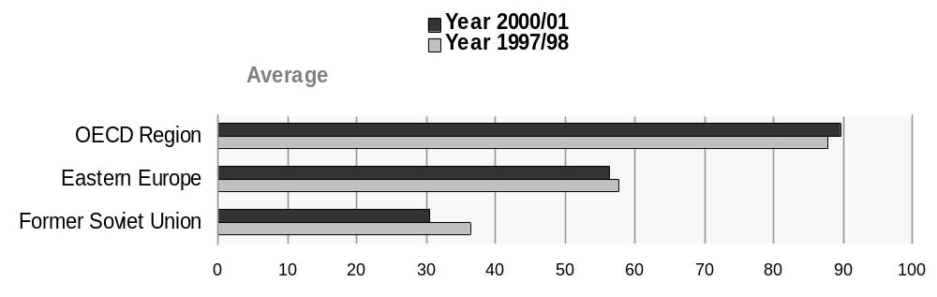

Source: For a detailed explanation of sources, methods and access to governance indicators databank see www.worldbank.org/wbi/governance.
Note: The margins of error (not shown) in all governance data suggest caution in interpreting these results. In particular, precise country rankings should not be inferred.

This aggregate measure combines several indicators which measure the likelihood that the government in power will be destabilized or overthrown by unconstitutional and/or violent means. The measure includes domestic violence and terrorism. This captures the idea that the quality of governance in a country is compromised by the likelihood of wrenching changes in government. The probability of drastic change has a direct effect on the continuity of policies and it undermines the ability of all citizens to peacefully select and replace those in power.

The perception of the overall situation on political stability improved slightly in the OECD countries in the period from1997/98 to 2000/01. In the same time period, the countries of Eastern Europe have seen a small decrease whereas the countries of the Former Soviet Union experienced some deterioration.

Chart II (Annex I) shows that in the OECD region the most significant risk of deterioration in the indicators on political stability were registered in Italy, Malta, New Zealand and Ireland while Canada and Luxembourg saw an increase in stability. In the Eastern Europe category the FYR of Macedonia, Croatia, Hungary and Poland exhibited some deterioration in this category of risks. The only three countries, which saw their political stability improve, were Albania, Yugoslavia and Bosnia and Herzegovina. In the CIS region, Georgia, Armenia, Kyrgyzstan and Republic of Moldova recorded the greatest concerns while Azerbaijan, Ukraine, Turkmenistan and Belarus by contrast experienced some improvement in political stability over the period.

2.4. Improved regulatory regimes

Chart 3

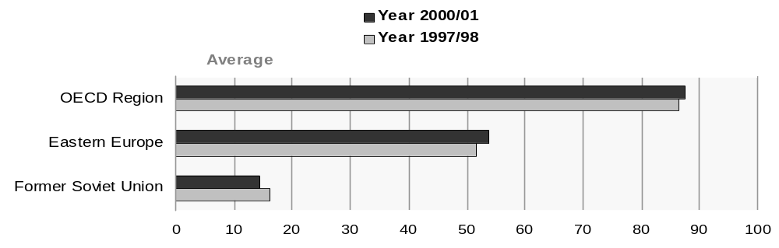 Source: For a detailed explanation of sources, methods and access to governance indicators databank see www.worldbank.org/wbi/governance.
Note: The margins of error (not shown) in all governance data suggest caution in interpreting these results. In particular, precise country rankings should not be inferred.

This measure includes the incidence of market-unfriendly policies such as price controls or inadequate bank supervision as well as perceptions of the burdens imposed by excessive regulation in areas such as foreign trade and business development.

As seen in Chart 3 the overall performance of OECD and Eastern European countries improved while CIS countries experienced a decrease in the area. In Chart III (Annex I), it is possible to see that improvements in regulatory regimes in Albania, Estonia and Yugoslavia and Azerbaijan. By contrast, Russian Federation, Republic of Moldova, and Belarus exhibit growing concern in this area.

States where there are excessive regulation often have very large ‘informal economies’ as entrepreneurs move “underground” to escape high taxes. This response to higher costs as well as to the unpredictability of government measures can be debilitating for a transition economy. As the size of the unofficial economy increases, more taxes go unpaid further impairing the government’s ability to provide public goods such as law and order. The state’s inability to perform its basic functions, in turn, encourages more corruption.

Of course subsequent changes in performance will not be captured in this chart and it should be recognised that some countries have made reforms in this area. In 2001, Ukraine for one simplified its business taxation and registration, making it possible for anyone to register as a “private entrepreneur” and pay basically a small poll tax. Private entrepreneurs no longer need to obtain special licenses. Accordingly, many small businesses in Ukraine have now been put on an official footing and hold formal records and receipts, which can be used for taxation and also credit giving purposes. It is unclear as yet what the impact of these changes has been – the survey indicates for the period 1997/8-2000/01 a slight improvement in the case of Ukraine - but it is likely to improve even more significantly this country’s performance in this area.

2.5. Government effectiveness

Chart 4

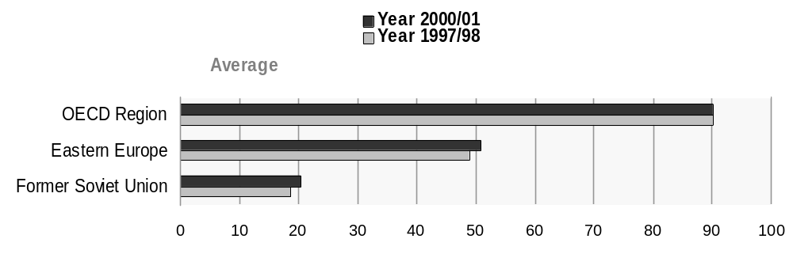Source: For a detailed explanation of sources, methods and access to governance indicators databank see www.worldbank.org/wbi/governance.
Note: The margins of error (not shown) in all governance data suggest caution in interpreting these results. In particular, precise country rankings should not be inferred.

This aggregate measure combines a single grouping responses on the quality of public service provision, the quality of the bureaucracy, the competence of civil servants, the independence of the civil service from political pressures and the credibility of the government’s commitment to policies. The main focus of this indicator is on “inputs” required for the government to produce and implement good policies and deliver public goods.

As seen from Chart 4, the overall situation improved in all three regions, most notably in the CIS countries. In Chart IV (Annex I), the individual OECD countries, which saw some improvement in this area were Iceland, Switzerland and Greece. Some worrying signals were registered in Italy, New Zealand, Norway and Denmark.

Eastern European countries such as Estonia, Bulgaria, Bosnia and Herzegovina showed strong improvements in their government effectiveness. By contrast Latvia, Croatia and Poland registered some deterioration in this area. In the CIS countries, those with biggest improvement were Azerbaijan, Kyrgyzstan, Kazakhstan and Russian Federation. By contrast Armenia, Belarus and Republic of Moldova seemed to have registered more problems.

2.6. Rule of Law

Chart 5

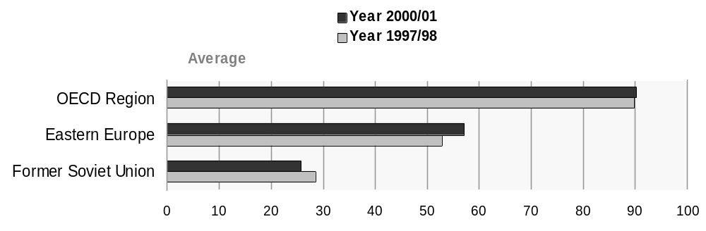

Source: For a detailed explanation of sources, methods and access to governance indicators databank see www.worldbank.org/wbi/governance.
Note: The margins of error (not shown) in all governance data suggest caution in interpreting these results. In particular, precise country rankings should not be inferred.

The rule of law aggregate indicator includes several measures indicating the extent to which individuals have confidence in and abide by the rules of society. These include perceptions of the incidence of crime, the effectiveness and predictability of the judiciary, and the enforceability of contracts. Together, these indicators measure the success of a society in developing an environment in which fair and predictable rules form the basis for economic and social interactions, and importantly, the extent to which property rights are protected.

The overall performance in this area appears to have improved in OECD and Eastern European countries while CIS countries experienced a small decrease. As seen in Chart V (Annex I), OECD countries France, United States and Austria registered some improvement while Malta, Italy, Portugal and United Kingdom experienced deterioration over the time period. Eastern European countries like Bosnia and Herzegovina, Estonia, Latvia and Slovakia exhibit improvement in this area. By contrast Yugoslavia and Poland show signals of possible deterioration. Considerable improvement in this area appears to be required especially in the CIS. The three countries from the region, which exhibited improvement in this field, were Ukraine, Georgia and Kazakhstan.

Improving the “rule of law” is difficult because it depends on a number of factors in order to spring things into operation. On the “supply” side, governments may simply be unable to collect enough taxes to finance a market–supporting legal system or to guarantee effective judicial enforcement. Sustaining demand for the rule of law over time may also be problematic in the countries where the private sector is weak and thus makes few demands on legal systems and institutions for protection. In addition short-term losses from reform may turn part of the electorate against reform in general, and the institution of law in particular. Short-term winners may be tempted to block further institutional reform in order to safeguard newly acquired rents. Strong pressure from interest groups might emerge from the reform process itself. As the modalities of privatisation demonstrate, in the CIS there were cases of asset stripping rather than productive investment and enterprise restructuring by the new owners. This probably holds even more strongly in the economies that are dominated by non-renewable natural resources rather than by manufacturing industry.

2.7. Control of corruption

Chart 6

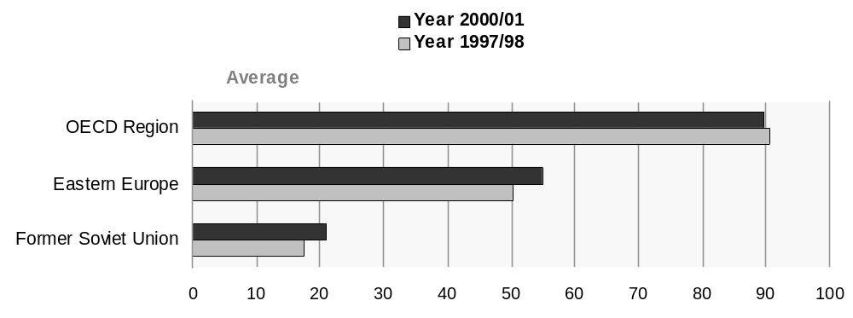
Source: For a detailed explanation of sources, methods and access to governance indicators databank see www.worldbank.org/wbi/governance.
Note: The margins of error (not shown) in all governance data suggest caution in interpreting these results. In particular, precise country rankings should not be inferred.

This aggregate measure indicates perceptions of corruption (i.e. the exercise of public power for private gain). Corruption was a main emphasis of the Istanbul Security Charter. Corruption is a symptom of institutional collapse, missing institutions or institutional hiatus and usually linked to excessive regulation as seen above. It has been prevalent in transition economies as these countries have inherited state institutions that are inexperienced with regulating markets and, more importantly had been shaped by decades of discretionary power and arbitrary justice. As a result, unaccountable public institutions and a badly functioning legal system – one that does not provide security of persons and property, does not enforce private contracts and does not allow the people to hold their government accountable - are still characteristics of many transition economies.

Despite this straightforward focus, the particular aspect of corruption measured by various sources differs somewhat, ranging from the frequency of “additional payments to get things done,” to the effects of corruption on the business environment, to measuring “grand corruption” in the political arena or in the tendency of elite forms to engage in “state capture”. The presence of corruption is often a manifestation of a lack of respect of both the corrupter (typically a private citizen or firm) and the corrupted (typically a public official or politician) for the rules, which govern their interactions, and hence represents a failure of governance according to the definition.

As seen in Chart 6, control of corruption improved in Eastern Europe and CIS while in OECD countries it decreased. In Chart VI (Annex I), the OECD countries with greatest improvements were Finland, United States, Japan and Austria. More problems were seen in Malta, Italy, Cyprus and Greece. In Eastern Europe significant improvements were registered in Croatia, Latvia and Bulgaria. By contrast, a possible deterioration was signalled in Romania, Bosnia and Herzegovina and Czech Republic. In the CIS region, the countries, which have experienced more problems in the control of corruption during this period, were Russian Federation, Kyrgyzstan and Republic of Moldova.

2.8. Participation and Access to Justice of Civil Society: the Case of Aahrus Convention

The ECE Aarhus Convention establishes rights and obligations in these fields and is thereby a legally binding instrument on government accountability, transparency and responsiveness as well as a multilateral environmental agreement. Overall OSCE participating states are making progress in implementing their commitments to public access to information, public participation in decision-making and access to justice in environmental matters in the past years although at a varying pace.

All Eastern Europe and CIS countries, except for Russia and Uzbekistan are Parties to the Convention. In these countries, the Convention is primarily considered as a tool to foster further the democratisation process in the countries. Experience expressed by governmental as well as non-governmental stakeholders at various workshops and meetings give the over-all picture of relatively good declaratory legislation but a lack of procedural regulations and fairly poor implementation in practice at least with respect to access to information and public participation. The implementation of access to justice proves far more difficult. Major challenges ahead are also to ensure the implementation at local level and to reach the public living outside capitals and other big agglomerations as well as to ensure that the members of the public can and actually do exercise their rights under the Convention.

In Central and Eastern European countries, the progress towards the harmonization of national legislation with the provisions of the Convention is noticeable. This is probably because this development is coinciding with efforts by EU accession countries in particular to harmonize their national legislation with EU law. There are more and better examples of the Convention being implemented in practice in this region and the more favourable economic, cultural, structural and social conditions seem to contribute to this trend.

Of the Western European States, only five have ratified the Convention so far. However, most States seem to be currently updating their legislation in order for it to be in compliance with the provisions of the Convention before they proceed with the actual ratification. Most likely, a fully correct application of the principles of access to information, public participation and access to justice, as expressed in the Convention, will require less changes in current standards and practices in these countries, although significant changes will nevertheless be required.

3. Overall findings and implications for policy

Returning now to the five commitments that OSCE participating states had made at the Istanbul Summit, this survey suggests the following conclusions:

- With regard to the commitment of the OSCE participating states to promote the ‘rule of law’, the performance in this improved markedly in Eastern Europe while in CIS countries it deteriorated and in the OECD it remained stable.

- Concerning the pledge to combat corruption, the performance improved both in countries of Eastern Europe and CIS while in the OECD it deteriorated.

- The commitment in 3 above to create a positive framework for good government, can be assessed by using the indicators on political stability, voice and accountability etc.. These seem to have deteriorated in the CIS and Eastern European countries over the given time period. In contrast, Government effectiveness has improved in both CIS countries and Eastern Europe countries.

- With respect to regulatory frameworks, the CIS countries performance has lagged behind. The OECD and Eastern European countries showed a positive trend over the given period of time. Overall progress is being made in the implementation of this commitment. However, there is a need to improve the access of civil society to the courts to defend their rights in environmental matters.

- With regard to the commitment to implement the practices contained in the UNECE Aahrus Convention, progress has been achieved. However, the challenge is to improve the legal process whereby citizens can access the judicial systems to ensure the protection of their rights contained in the Convention.

In general, reform in post-communist countries has been more protracted and complex than originally anticipated. Initial conditions and complexity of problems were greatly underestimated. Also, powerful opposition by entrenched interests as well as general resistance from sceptical societies have delayed a process of moving from a centrally planned economy to a market one. Despite considerable achievements in many areas, cosy relationships between the state and quasi-private firms exist, the dearth of institutions to protect property rights and contracts prevents market based transactions and the abundance of other largely unforeseen institutional shortcomings is in evidence throughout Europe and the former USSR.

In summary, there has been some progress in the implementation of commitments. However, increased attention should be paid to increasing performance gaps between some states. It appears that most effective polices to improve governance point towards encouraging external agents to pressure governments for more accountability and transparency rather than programs which promote internal reform. Finally, the link between governance and security needs to be made if new commitments in good governance are to contribute directly to security enhancement.

In terms of policy prescriptions in individual aspects of governance there is a great deal to be learned from this experience. With respect to corruption, an often neglected weapon against corruption, it would appear, is simply to reduce the economic opportunities for it. In the transition context, the fight against corruption must be linked to the reform of the state. In some countries, especially those where the state and politicians maintain their grip on the economy, transparent leadership by example and basic economic reforms, including privatisation, would sharply curtail economic opportunities for dishonesty. In these cases, economic distortions and administrative controls, which should be given priority, include those that involve high discretion such as issuance of licences, permits, quotas, customs, border crossing documentation and tax exemptions. At the same time, it is counter-productive to allow regulations to proliferate, even those that are specifically aimed at fighting corruption.

More broadly with regard to current thinking on the best approach to improve governance there is now a trend amongst the international organisations and a growing recognition, that policy help and assistance should focus less on promoting public administrative changes (codes of conducts/ethics for civil servants, stronger disciplinary measures etc..) and more on community focused schemes with the intention of improving the external pressure that the community can exert on political elites to improve its transparency and accountability etc. This approach corresponds well with the approach of the UNECE Aarhus Convention, which commits to improving participation of groups and access.

Concerning the improved performance of Eastern Europe as compared to the rest of the states in Europe, it does seem that one of the main factors in accounting for this development is the EU enlargement process in recent years, which has forced the pace of reform and encouraged most of the EU acceding states to improve governance quite markedly. At the same time this does not necessarily account for why the performance of CIS countries has deteriorated. The risk however is that the countries that are less under pressure to improve their governance will continue to fall further behind unless there is some counterbalancing programme to specifically help countries to improve governance. Seminars and conferences on governance, improving the development of community groups and external pressure points on governments, the involvement of civil society and the business community, the use of pan-European training organised jointly between western and eastern Europe countries would seem to be particularly appropriate in this respect.

Annex I

Chart I Voices and accountability

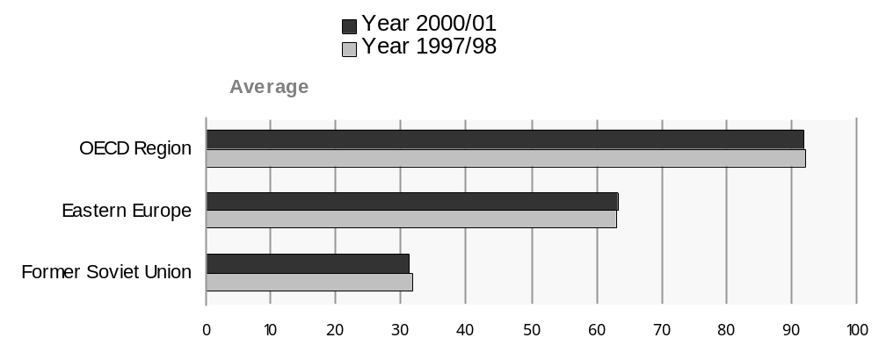

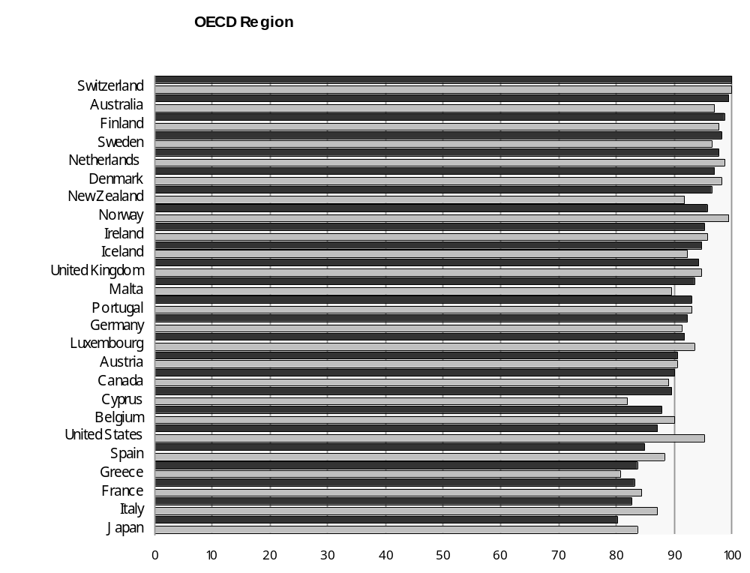

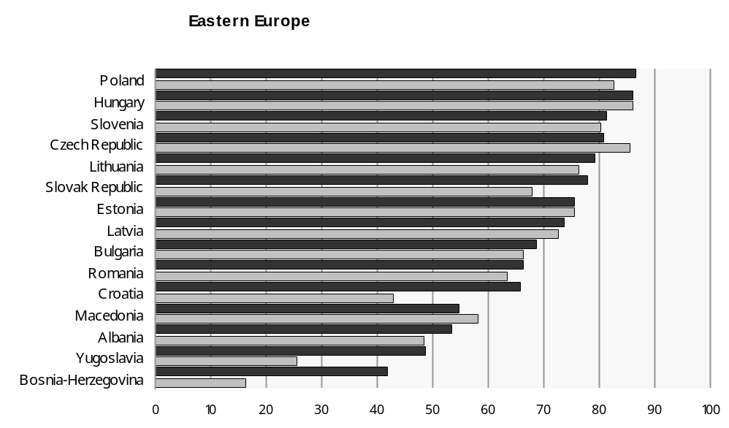

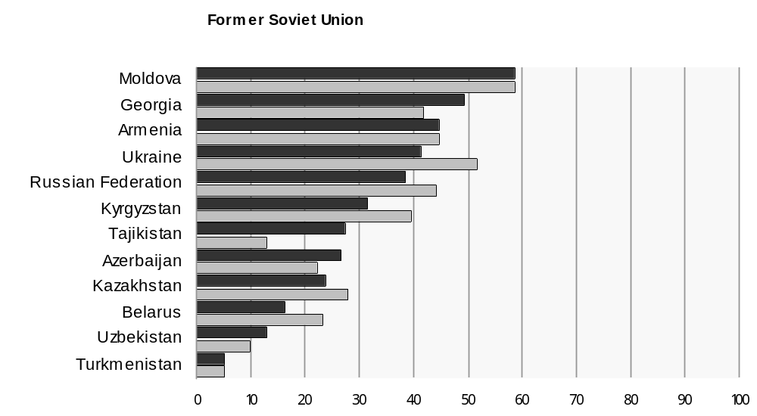

Chart II Political Stability/No Violence

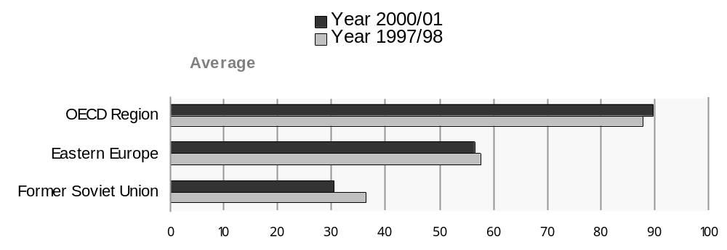

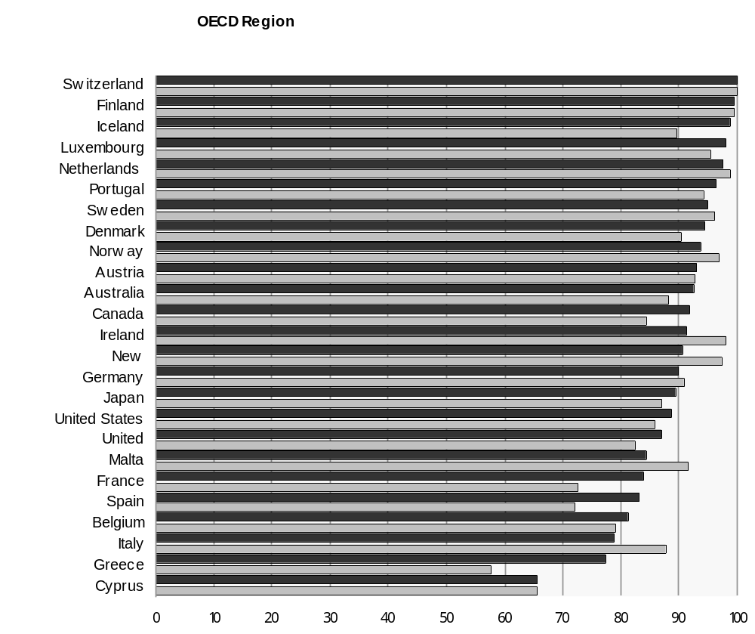

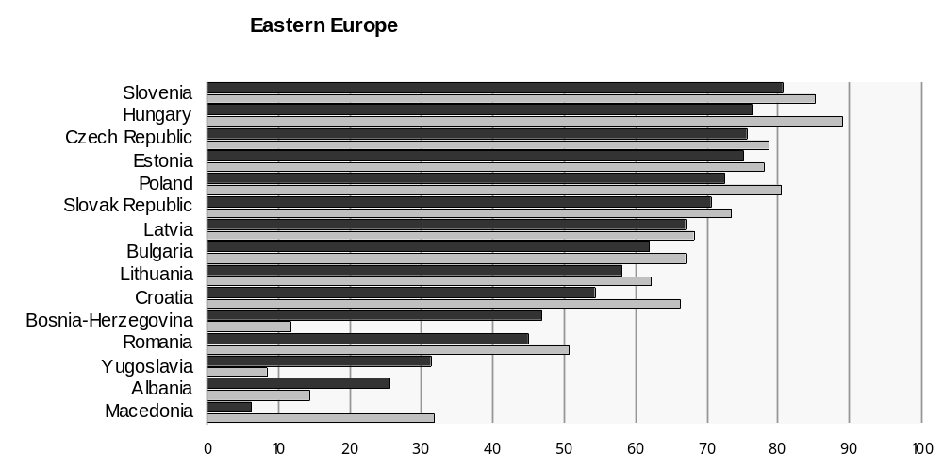

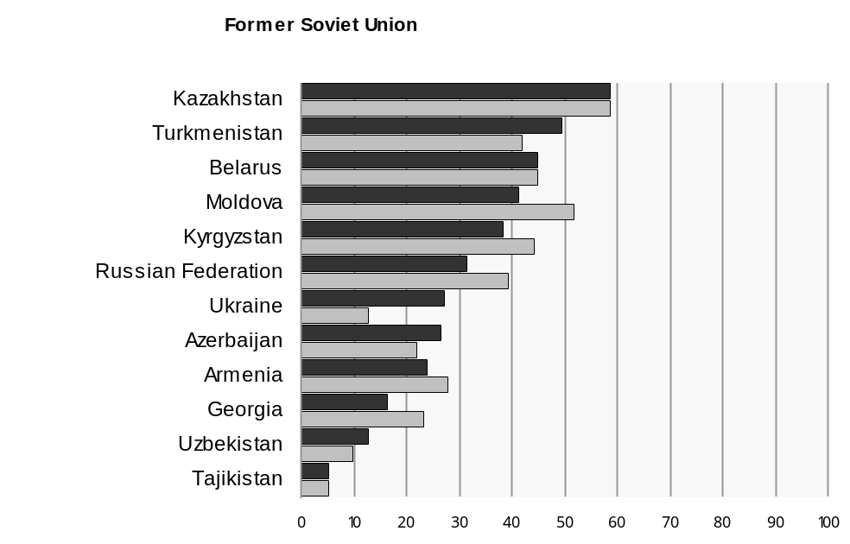

Chart III Regulatory Quality

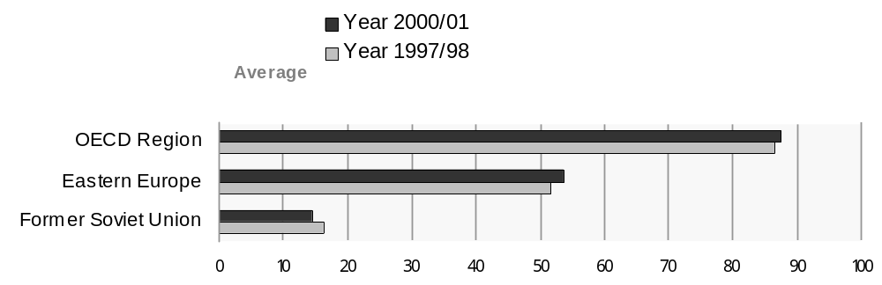

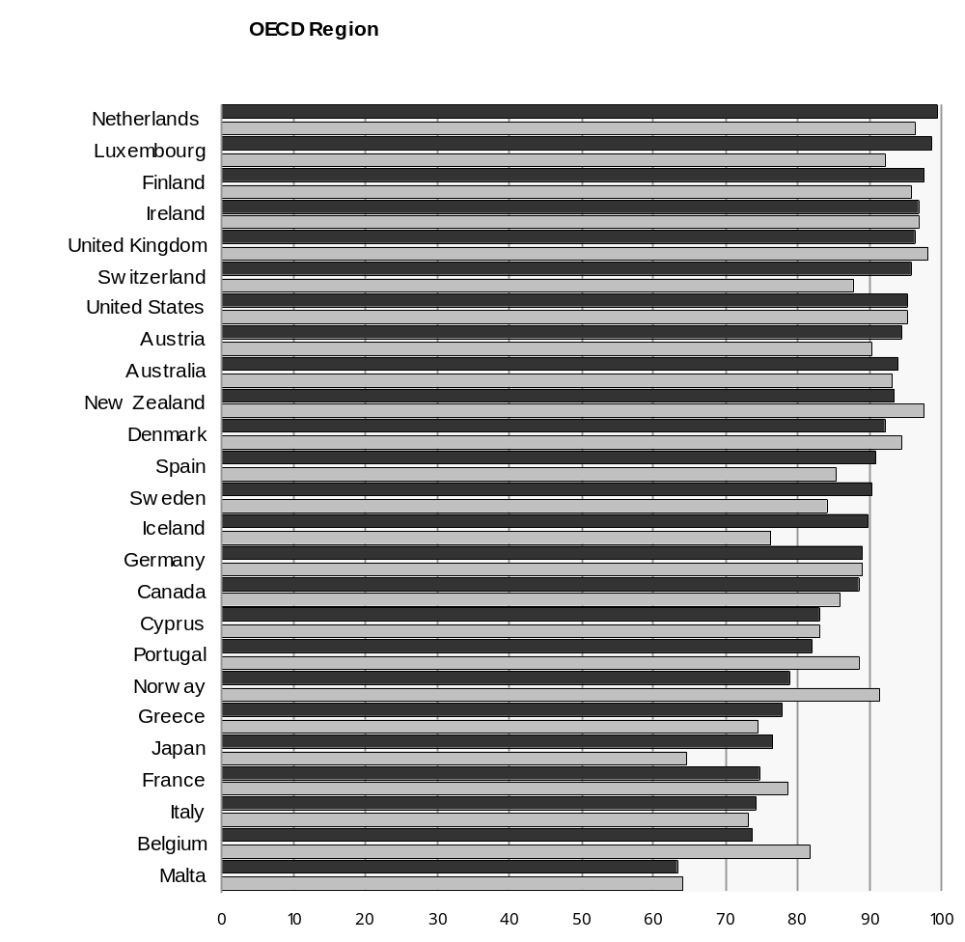

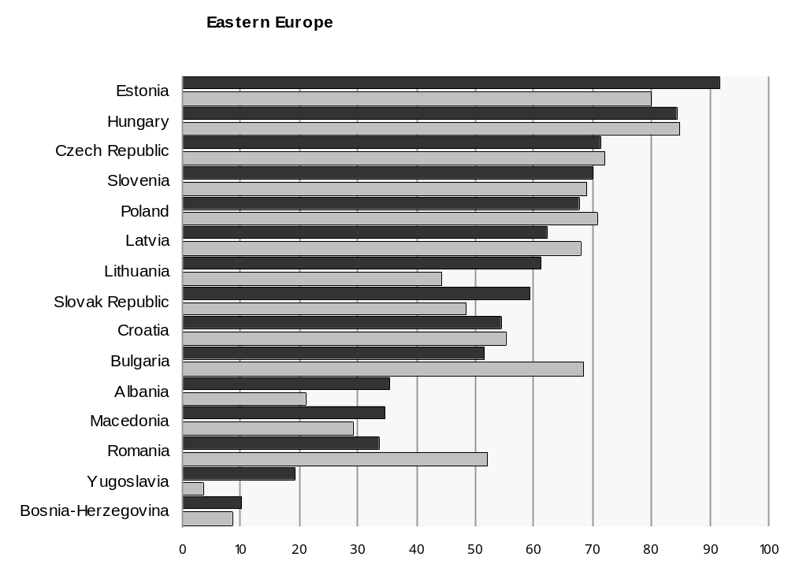

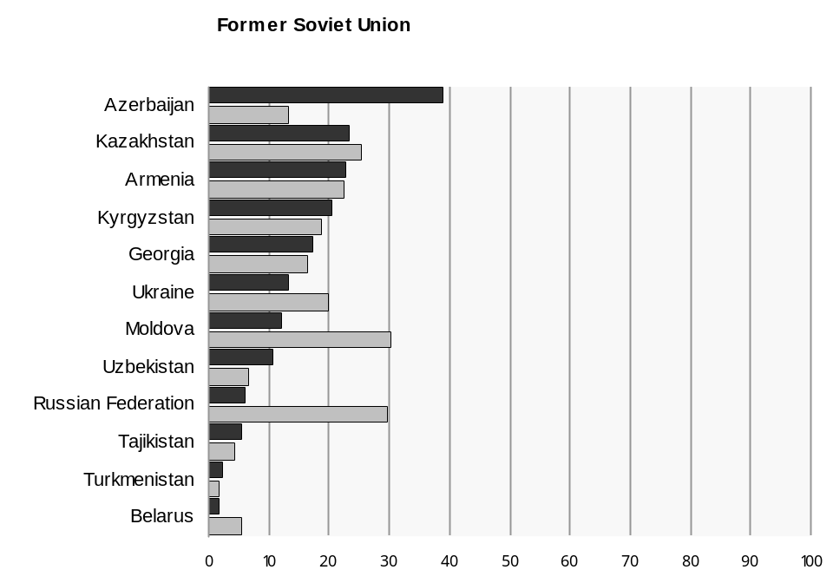

Chart IV Government Effectiveness

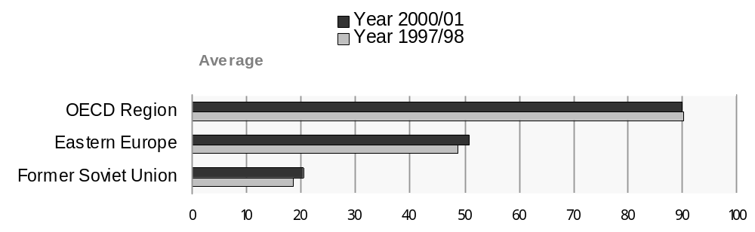

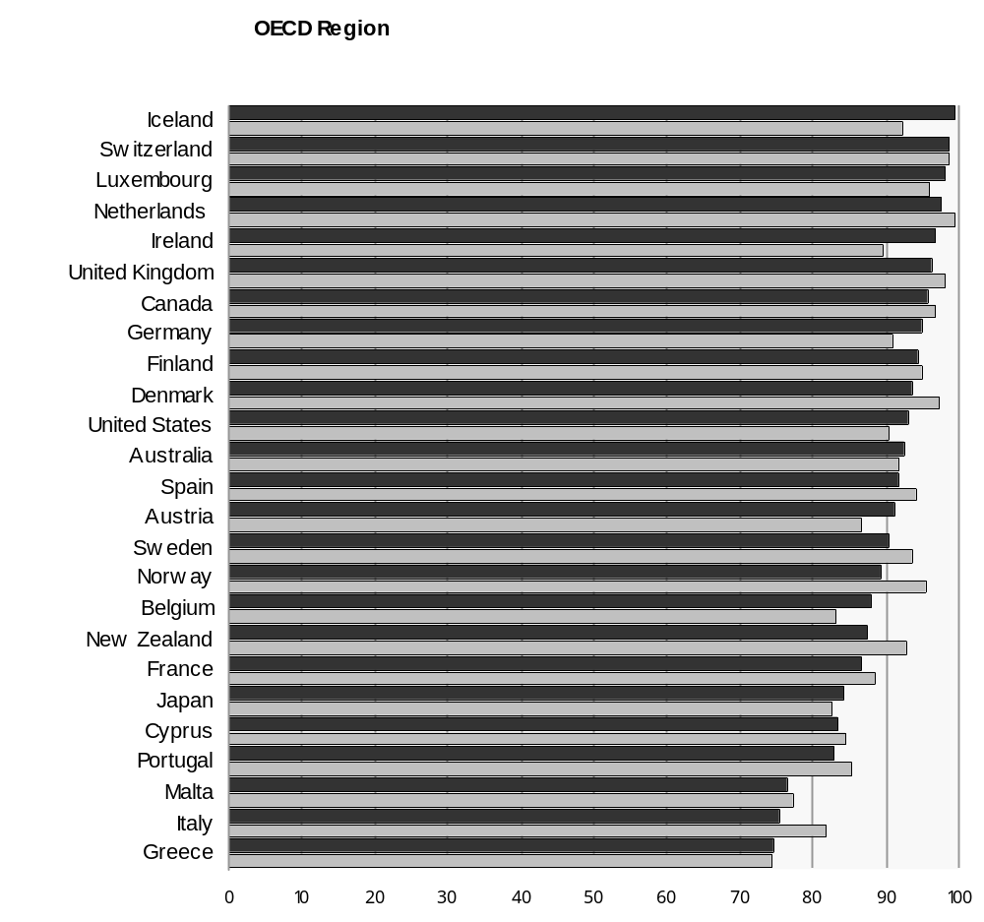

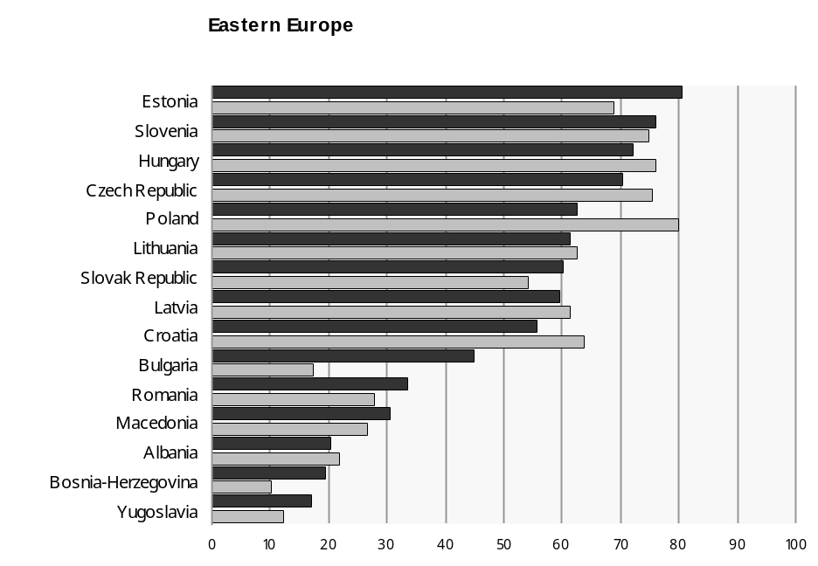

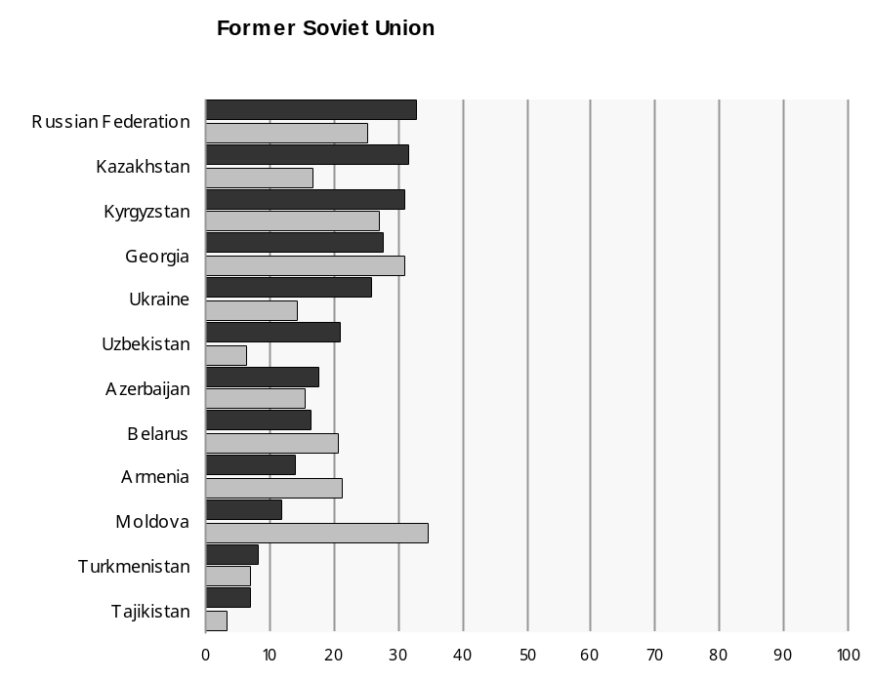

Chart V Rule of Law

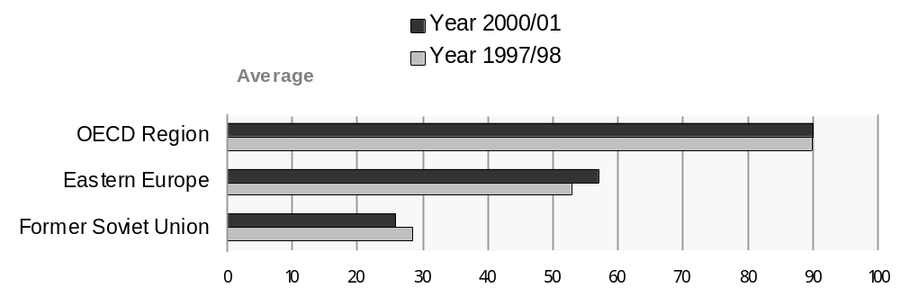

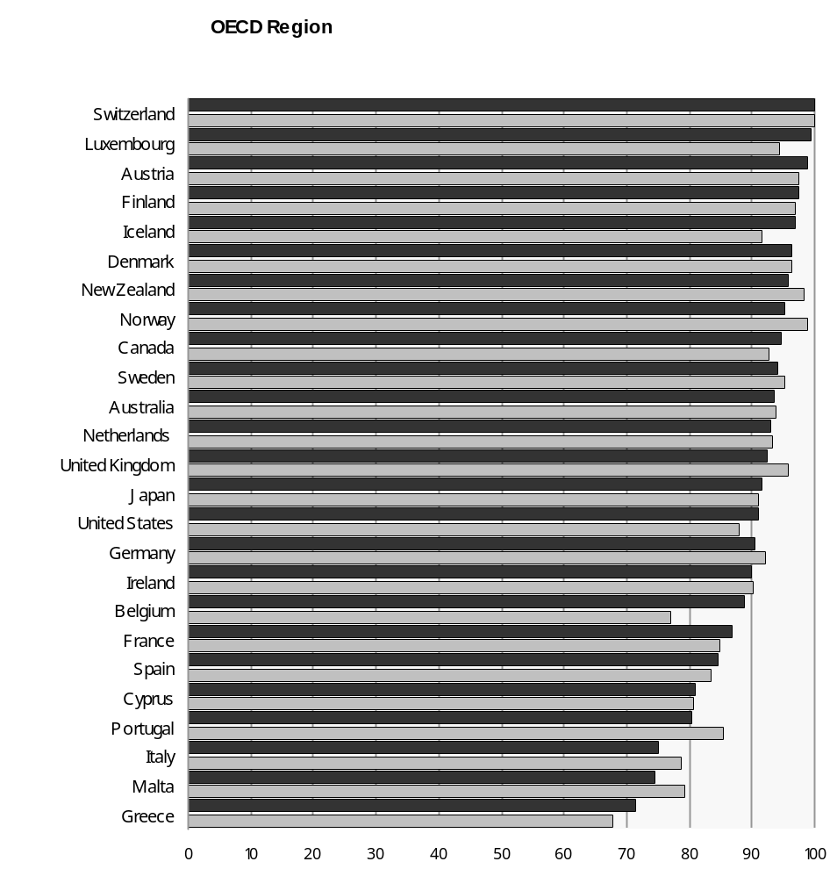

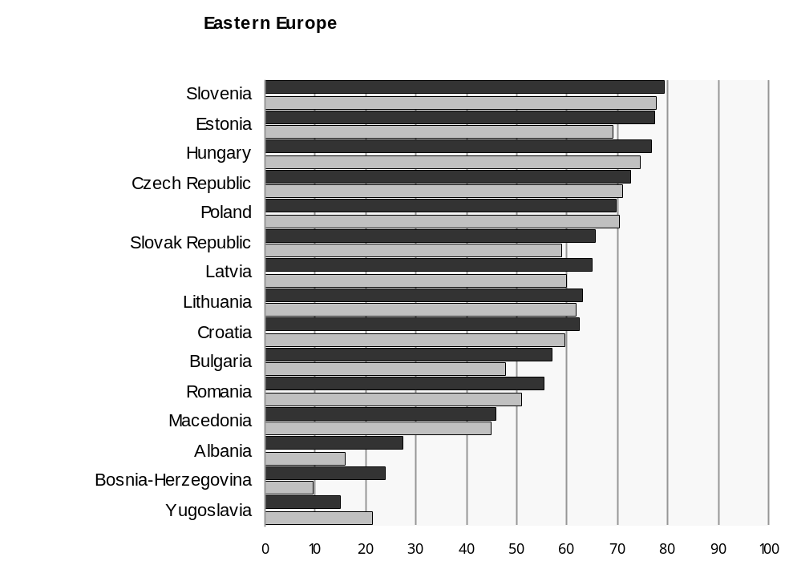

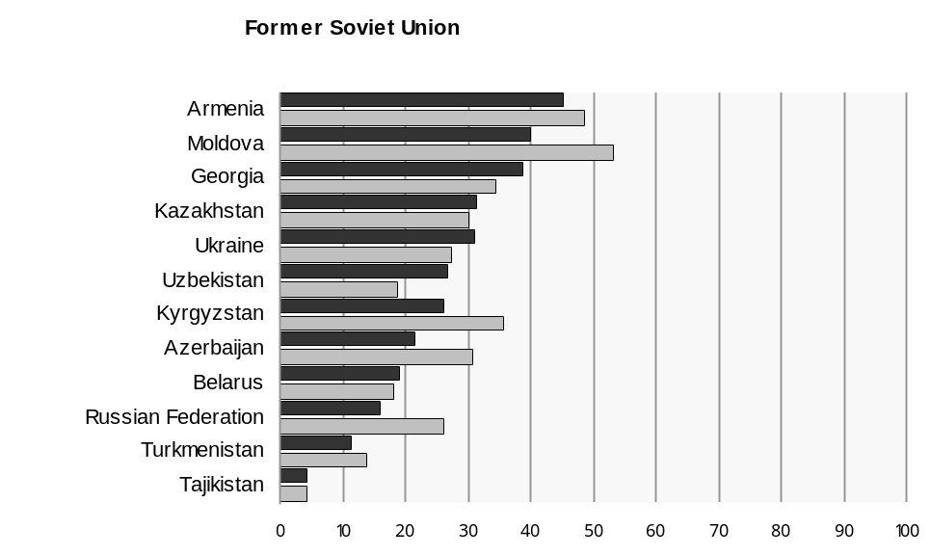

Chart VI Control of Corruption

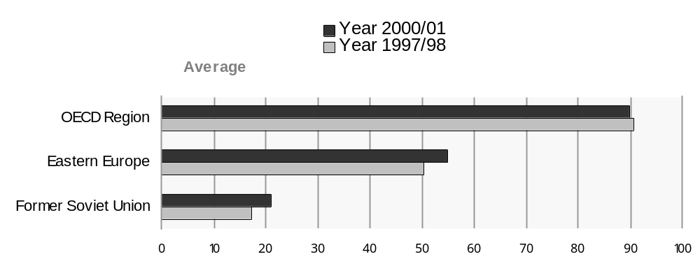

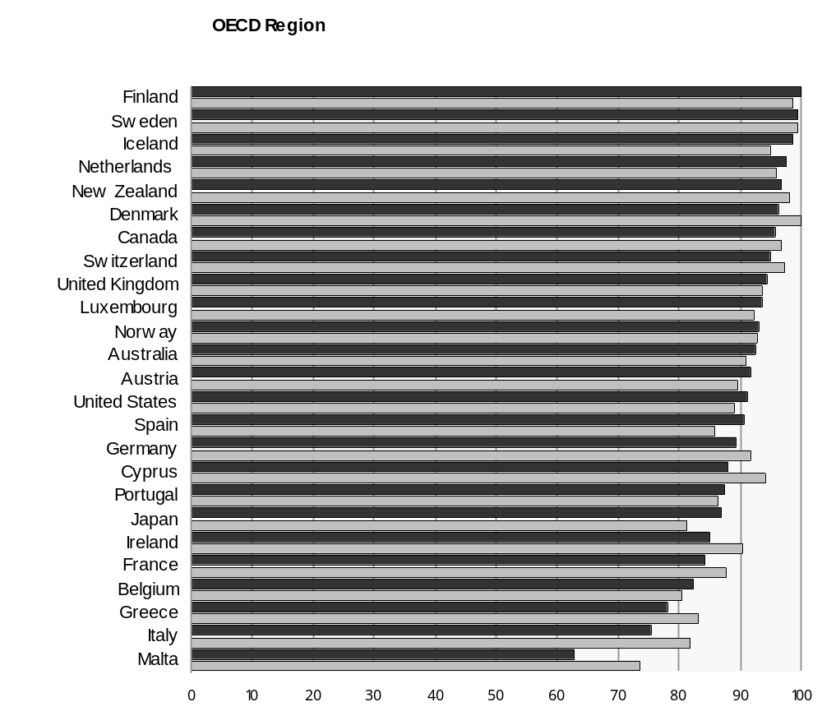

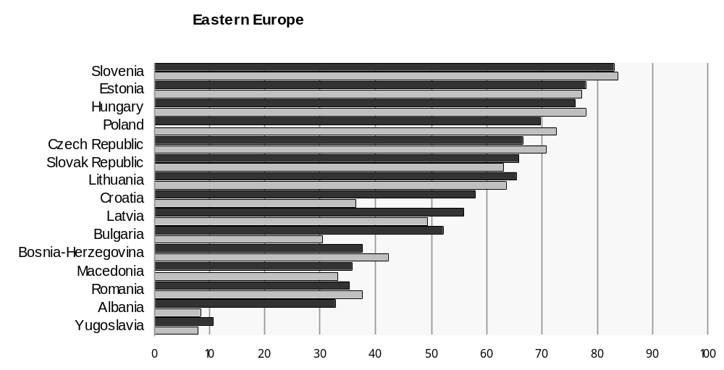

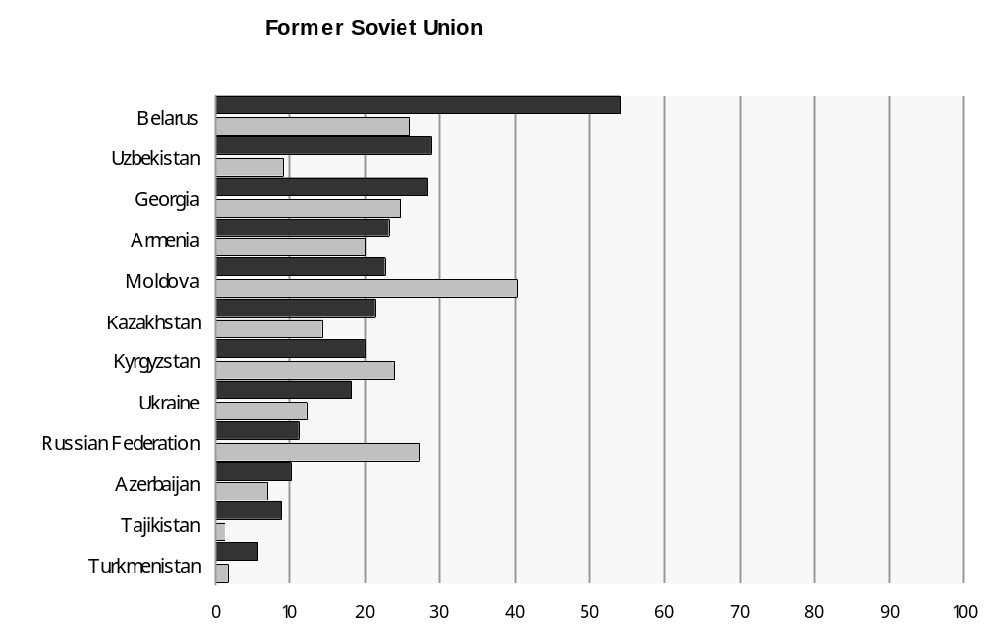

Source: For a detailed explanation of sources, methods and access to governance indicators databank see www.worldbank.org/wbi/governance.
Note: The margins of error (not shown) in all governance data suggest caution in interpreting these results. In particular, precise country rankings should not be inferred.

Chapter III

A New Framework to Respond to the New Security Threats and Challenges in Europe

1. Reviewing and Re-launching the Policy Strategy
A decade ago, conflict prevention was essentially seen as an activity to stop wars between states in the military and political dimensions. Today the approach to conflict prevention has changed. There is now a shared vision in Europe, within the United Nations, OSCE, EU, member states and others, to address the security challenges more effectively and to give more prominence to the economic and environmental dimension. This means a new desire to: focus on prevention and tackling the root causes of conflict including those in the socio-economic area; adopt integrated approaches involving the economic with other dimensions such as human rights, and democracy; involve all actors, not just states, in the promotion of wider notions of human security; and to adopt strategic approaches which can be sustained through time and across different organizations.
The Bonn Document reflected the timing of 1990; it was first and foremost a political achievement. It outlined the first steps that countries, which would become the ‘transition economies’, agreed to take in the process of becoming market economies. But it did not address the question of security in its full sense, that is, in terms of the cohesion of the social fabric, human security, even the prevention of conflict. Conflict is multidimensional and needs integrated responses. The transition from former planned economies brought much higher social and economic costs than anticipated and these costs were a strong factor in explaining the intensity of some of the conflicts in the 1990s in the region. But despite this, the economic and environmental pillar within OSCE was given less attention than the others.
The dynamic of threats to security is changing. September 11th has introduced a new dimension to insecurity. Europe is entering a new era, which faces new challenges and threats. At the same time when compared to 1990, Europe at the regional level is immeasurably more secure. The most important contribution and the process, which has contributed the most in stability terms in the ECE region, has been the European Union. During the 1990s and to the present, EU integration has been an anchor for reform and stability in the region. The prospect of membership or privileged relationships has given and will give a formidable stimulus to reform, stability and secure relations. Moreover, while EU enlargement may result in new problems for the future, there have also been created in the region a whole new network of bilateral and multilateral mechanisms for dialogue and negotiation which can be used to solve problems between states without the resort to old methods and confrontational politics.
Generating more confidence, at the level of specific individual states and regions is the next main challenge. It is the case of often relatively small states, rather vulnerable to the effects of globalization and European integration, often located far from Europe’s centers of commerce, and susceptible to the tensions arising from nation- building, persistent ethnic and minority group tensions, weak institutions and with populations that are sadly under severe social and economic distress. The lessons of the internal conflicts of the 1990s have been learned. The challenge is to implement this new thinking on how to address these conflicts into a coherent and results-orientated programme of conflict prevention in the economic and environmental dimension. The OSCE Porto Ministerial Declaration encapsulated this new thinking in its objective to adopt a New Strategy for Security in the Economic and Environmental Dimensions. This chapter provides an input to the ongoing discussion, by presenting possible key elements of the new approach; by reviewing the new threats and some of the old threats; and by discussing how a strategy for consolidating the economic dimensions of security in Europe can be further enhanced.

2. Key Elements
The central paradigm of the new thinking on security is that the best approach to enhancing security is through the adoption of integrated approaches. Security is not just one element but consists of several interacting with each other. The stability and security of states are best assured by: (i) governments which are legitimized by democratic processes, (ii) an order within society, secured by the rule of law, and by institutions which make economic policies effective; and (iii) by an effective production and a fair distribution of economic resources amongst the population. Stability and security in any socio-politico system can be achieved when all of these three components – legitimacy, order, and economic welfare - are evident. In other words, conflicts and insecurity within societies will least occur where governments are legitimate and accountable to their citizens, where the rule of law and property rights are protected, and where there is a distribution of resources that is considered as fair and a market system that works.
From this central approach there flow a number of important objectives and principles:
(i) To protect the economic, social and environmental rights of citizens and in particular the vulnerable groups, minorities and ethnic groups;
(ii) To address the root causes of conflicts - economic and social grievances and deprivation – and to promote measures that would reduce poverty, stimulate economic growth and achieve general social and economic stability;
(iii) To promote ‘good governance’ in a holistic way i.e. by respect for human rights, democracy, promotion of social equity and bridging institutional capacity gaps;
(iv) To develop systems of interventions in the economic and environmental dimension to stop conflicts degenerating into bloody violence and to identify indicators which can point to early warning signs of violent conflict.
This involves:
- Strengthening international and national capacities to prevent conflict in the environmental and economic dimensions
- Elaboration of new tools and instruments by which interventions can be made to stop conflicts
- Mobilisation of new resources for this task and the involvement of new players and civil society
- Improvement in coordination and cooperation in conflict prevention at the UN, OSCE, Council of Europe and the EU, and promotion of initiatives and a more operational and effective division of labour.

3. New Threats and Old Threats Revisited
The new era of insecurity post September 11, has reinforced the threats, adding new threats as well. There are four main categories of security risks that can be currently identified:
- Socio-economic failure: gaps in development
Prospects for significant a few ECE states are still clouded in uncertainty and reform is not being implemented. Poverty is growing and spreading within several rural and urban areas. There are increases in unemployment and these feed the sources of extremism, exclusion and disenchantment among many in society and particularly the youth where social problems, drug taking and HIV /Aids is on the increase.
The gap between the countries in the region is growing and the resulting concerns about migration continue to grow as well. In South East Europe and the Balkans, GDP per head is on average at best a quarter of the EU average (and in Albania much less). Indeed, the difference between them and central Europe is as large, if not larger, than that between the latter and western Europe. Uncontrolled economic migration can destabilize both wealthy and low-income countries, by fuelling resentment amongst local populations and this can ignite inter-group tensions. At the same time, without promoting more ‘open labour mobility’ and more ‘open societies’, the skill shortage and the need to increase interaction and the sharing of economic opportunities will not be addressed in the ECE region.

b) National security strategies: gaps in governance
Economic failure decreases the states capacity to create the order and security in society on which the economy depends. One of the main causes of the wars in the 1990s was the institutional hiatus, which occurred in many countries in south east Europe as the state eroded and collapsed. Rather than new institutions emerging as was expected there was a regress into kinship patterns, ‘clans’, and old networks in which groups had survived in the past. Such a regression disintegrated society and constituted a profound threat to security when coupled with the weak state of the economies. Coercion, corruption and personality politics can be also understood as a reaction to economic mismanagement. Many states now in institutional uncertainty face security pressure from organised crime. Economic governance weaknesses and capacity gaps for economic policy have emerged to be a major source of insecurity, contributing to institutional weaknesses, the difficulty in separating states functions from economic interests, and endemic corruption. The tendency to respond to such threats by resorting to authoritarian measures can also be put in relation to economic conditions, especially where states are not able to provide economic benefits to its citizens.
The States’ capacity to deal with security threats has been limited by the weak economic performance and uncertainty. This weakness in capacities means that it is also vulnerable to terrorist threats. The main threats from international terrorism is to large –scale installations, nuclear power plants, ports, tunnels, bridges, drinking water etc. As the infrastructure chain is by its nature interconnected internationally and as the effects of terrorist attack on infrastructure can cross borders easily as in the case of nuclear power stations, all states are vulnerable to security risks.
- Conflict over the environment and natural resources: gaps in partnership
Conflicts between groups over access to resources remain another persistent threat. Increasing tensions have emerged over the management of water resources in central Asia between upstream and downstream states. The same conflicts and tensions are obvious over land as well as over non-renewable resources and the revenues from the transit trade of oil and gas. The management of environmental and natural resources pose complex issues of economic governance and require effective partnership mechanisms: public- private, national – international, etc.

d) Conflicts between states: gaps in economic integration
Overall the risks highlighted above are internal, but there are too tensions between states. In recent years as noted previously the most visible signs of tensions and open disputes in the ECE region appear to have been mainly among members of the CIS and in the Balkans, in the areas of international trade, energy, transport, and water management. These problems have emerged since the dissolution of the former Yugoslavia and of the Soviet Union in which all the relations of the former constituent republics were internal and managed by the centre. This system has been replaced by a set of intra-CIS economic arrangements and economic integration problems that for the time being appear inadequate to achieve the objectives of economic stability and security. Given this situation, there is a need for the countries of the region to establish the principle of bound commitments and rule-based behaviour in their international economic relations. Adoption of a transparent system of rules and dispute settlement mechanisms and generally accepted norms and standards applying to goods and services would help to improve their economic welfare, reduce tensions and enhance security. Such measures, particularly if compatible with the principles underlying the enlargement of the EU (see above) would also constitute a key step in the creation of a “wider Europe”, and contribute to the global Doha, development process.

4. An integrated and strategic approach to the New Commitments
A central challenge is to address these security threats effectively, moving away from ad hoc solutions and ephemeral changes in perceptions that do not transform on a permanent basis behavior and policy capacity; in other terms we aim at establishing a new “security culture” in Europe, and promoting “ownership” of such a culture among governments and all stakeholders. The implementation of the new strategy is also challenged by the conventional thinking, which tends to see security in the economic and environmental dimension as something entirely separate from political, human rights and governance aspects. The need is for a strategy, which integrates the key elements of the new approach, while at the same time promoting division of labor and partnership. Moreover, such an ambitious strategy cannot be achieved as a ‘big bang’, but should be introduced incrementally, targeting first the most urgent objectives, and then laying the groundwork for the achievement of the next stages. Finally the strategy should be the outcome of a wide and inclusive process where all parties and groups, governments and stakeholders, national regional and global organizations, and all those committed to prevention of conflict and peace building, can be involved and play a role. The discussion of the new strategy should pro-actively aim at raising awareness of the new concepts, and mobilizing new actors and resources into peace building activities.
The first, and most urgent, stage in this process is the elaboration of the New Commitments, which is currently underway. These commitments need to have a focus on conflict, especially those arising from competition over natural resources and from social and economic distress and growing inequalities. This focus requires the identification of: - the specific economic factors at play; - and the ‘good policies’ and the governance aspects required for meeting these threats. In this context indicators, both quantitative and qualitative ones, can play a very useful role, as they can be appropriately translated in score cards, benchmarks and check lists that can be of great assistance in the policy dialogue, particularly at the stage of monitoring and implementation.
Indicators that provide information and signs of security threats have already attracted a great deal of attention in the economic literature and debate. They are also subject to intense academic discussions, having relevant implications for policy formulation. However, the approach here is pragmatic, that is, to identify, in relation to the concrete situations of potential conflict in the region, a basic classification of the key variables that are generally considered to be contributory factors to conflict, namely for instance: weak governance, economic failure and inter ethnic group tensions. The indicators that correspond to these main types of economic factors can then be identified. Examples of such variables are the following: ’State capture’; the strength of civil society - e.g. private sector development and small and medium enterprises, especially the spread of private sector within the territory and its distribution according to specific groups; labour migration; poverty, income changes between different ethnic groups and income distribution; degree of participation of states in international activities, the adoption of international norms and standards in relevant security enhancing activities, e.g. ECE conventions on water.
A preliminary grouping of such factors can be formulated as follows:
- Increasing the protection of those groups at risk, and their right to access to land and labour as well as to the services provided by the state without discrimination and with the right of redress against any wrongs, which public bodies, or others, may commit against such group;
- Alleviating poverty, through mobilizing more resources for social policy objectives, ensuring social service delivery targeted at those particularly in need, and reconfirming the commitments made under the Millennium Declaration;
- Improving participatory, democratic and inclusive economic policies and institutions, through decentralization (e.g. “fiscal federalism”), giving local communities and groups access to the management of local resources (local autonomy), providing checks and balances and inclusive structures that allow all groups a voice in their economic and environmental dimensions (e.g. industrial policies, labour regulation, taxation, public budgets, etc.); fighting against the threat of illegal migration and promoting the integration of migrants, e.g. assisting immigrants in settling in. Development support should be provided to the migrants’ countries of origin to alleviate the poor economic conditions that propel emigration. Common civic programmes to integrate all groups economically are important too.
- Good quality government, accountability, openness, freedom of information, including access to good quality public statistics, information on policy performance, transparency of government expenditures and civil service pay, the economic participation of specific groups in society, equal opportunities, etc.
- International cooperation; governments need to commit to improving their participation in international organizations, which are involved in economic, and security matters. They need to adopt the international norms and standards that enhance security, or are related to factors having an impact on security; where they cannot do this for reasons of resources, ways should be found to facilitate their participation. Governments need to implement and regularly review the commitments they make in the environmental and economic dimensions.

5. Implementation through an Early Warning System
Commitments must be implemented seriously. This can be done more efficiently by making reference to indicators, including policy performance indicators. The results of monitoring these indicators would then be subject to peer dialogue and review in appropriate forums. Securing structures that can promote and support the implementation and monitoring of commitments must be considered as well. To date the OSCE has found considerable difficulties in acting as a catalyst and giving impulses to other organizations or stakeholders. Thus the New Commitments must focus in the implementation side, and identify what role organizations should play in monitoring and reviewing these commitments. UNECE has done this for almost ten years on an ad hoc basis. It is time to clarify and strengthen such institutional arrangements and relationships.
The successful monitoring and implementation of commitments require the design of an early warning system of conflict prevention in the economic and environmental dimensions.
Indices of good governance, policy performance and trends in conflicts/tensions can be built and provided at national and international levels, and regularly updated over time. However, these can only provide a reliable indication of impending conflicts if they are linked to specific regional, sub-regional or country situation, and if they are openly debated with the relevant players in a process of “open coordination” and peer dialogue. In other terms, systematic monitoring should provide an input to policy discussions and to an open dialogue involving all relevant players, including business and civil society, both at national and international level. Appropriate forums should be established for this discussion, possibly on the basis of collaboration among the main agencies involved, i.e. the OSCE, the UNECE, the EU, the Council of Europe and others.
Since the primary responsibility for security in the economic dimension lies at the national level, with national Governments and with all the other stakeholders, capacity building should be strengthened at the national level. It is at this level that it would be useful to develop a framework of indicators, tailor-made for the specific conditions and geo-political tensions. It is at the national level that a strategy for a timely identification of risks and threats to security must be defined. National strategies can be compared and discussed at the regional level or at the level of OSCE. For instance Risk Review Assessments could be undertaken aiming at implementation of commitments and early warning. Such reviews could be carried out by a team of independent experts in cooperation with the host country, following the patterns established, and the experience gained in the performance reviews carried out by UNECE in the field of the environment and in other fields. The peer dialogue would enable donors to target more sharply ODA resources to support the implementation of the recommendations for enhancing security. The experience of the UNECE, and its subsidiary bodies, should be put at the disposal of the OSCE sub-Committee and other players interested and involved in the process.

6. Implementation through Partnership
This last comment highlights a fundamental dimension of implementation. It is necessary in fact to promote partnerships in a multi-stakeholders perspective to implement these commitments. There are many players that have to contribute to an integrated security policy approach. This includes the local and regional levels of government. It includes also the private sector, both business and civil society. Here enhancing the role of women can secure tangible results and achieve real progress. The role of the business sector should be enhanced in all possible ways in peace keeping. By investing and stimulating economic activities in the social and economic fabric of conflict prone regions, we can defuse tensions and create economic opportunities. This is why business should along with civil society be given a role in the implementation of the new commitments. A possible initiative to this end would be to encourage the creation of a “Regional Economic Security Compact for Good Governance” or something similar. The idea here is to give the private sector a visible role in partnership with governments in security, under arrangements where the private sector might invest in social and economic projects while the governments might give in return ‘governance guarantees‘. The involvement of civil society will require more than sending generic invitations to join this process. It will require the elaboration of a fully-fledged common strategy on how civil society can be more effectively involved in peace building work within the context of the current framework of activities and collaboration with international organizations.

7. A Cross-Sectoral Approach
It is also relevant to discuss more fully the new security threats in all the relevant economic sectors in which threats are developing, and policies can be appropriately formulated and adjusted. These are areas such as environment, trade, transport, energy, industrial restructuring, and others, in which the UNECE has been quite active in promoting economic cooperation, international standards and policy guidelines. Some of these areas have been severely affected by the threats coming from international terrorism, and others have enhanced their work on the tensions arising from possible conflicts over supply and access to natural resources. Peace building solutions can be also usefully pursued through from such sectoral analysis and policy initiatives. In the context of UNECE activities, there has been a renewed interest, and a series of specific policy development in the field of the sectorial threats to security in Europe.
The environment is an important area where it has been shown, also on the basis of specific UNECE experience, that cooperation in post conflict situations can represent an effective confidence building measure amongst former belligerents. The UNECE has prepared a report on the sectoral dimensions of security, which will be provided as a contribution to the on-going discussion and the New Strategy Document.

Conclusions

The new approach needs to be discussed and integrated gradually within the context of the OSCE New Strategy initiative and within the on-going activities inside the UNECE and its various principal subsidiary bodies, as well as the activities of the Council of Europe, the European Union, and all other relevant partners.

At the same time, there is urgency for action, especially in view of the required follow-up to the Declaration of the OSCE Porto Ministerial Conference in December 2002.

The four elements above – the integrated approach, early warning, partnership and the cross-sectoral dimension- have been provided as an input to the on-going discussion and an illustration of the fact that the UNECE is ready and willing to take full part in the design and implementation of the New Strategy.

UNECE, Economic Survey of Europe 2003 No.1, chapter 5: Progress in Systemic Reforms in the CIS, pp. 159-183
Wim van Moeurs (ed.), Beyond EU Enlargement. Vol. 2, the Agenda of Stabilisation for Southeastern Europe, Bertelsmann Foundation Publishers. 2001.
UNECE, Economic Survey of Europe in 1989-1990, pp. 13-17.
Douglass C. North, Institutions, Institutional Change, and Economic Performance, New York, Cambridge University Press, 1990; ----, Economic performance through time. Lecture to the memory of Alfred Nobel, December 9, 1993 [www.nobel.se/economics]
The increased perception of security in the acceding countries has been reflected in the declining risk premium on their traded securities and relatively large inflows of foreign investment.
The United Nations Economic Commission for Europe in its annual Economic Survey of Europe has consistently paid considerable attention to institutional reform and good governance in transition economies. See for example The Economic Survey of Europe, 2003, vol. 1, Chapter 5.
The typical symptoms of poor governance are the failure to make a clear separation between what is public and what is private; arbitrariness in the application of rules and laws; excessive rules and regulations which impede the functioning of markets and encourage rent-seeking; and narrowly-based or non-transparent decision-making.
For detailed description of techniques and data see www.worldbank.org/wbi/governance.
For one list see D. Kaufmann, a. Kraay and P. Zoido-Lobaton, Aggregating Governance Indicators, Policy Research Working Paper 2195, World Bank, October 1999.
D. Kaufmann, A. Kraay and P. Zoido-Lobaton, Governance Matters, Policy Research Working Paper 2196, World Bank, October 1999 and D. Kaufmann, A. Kraay and P. Zoido-Lobaton, Governance Matters II, Policy Research Working Paper 2772, World Bank, February 2002.
Countries and regional average estimates are subject to margins of error (not shown) suggesting caution in interpretation of the estimates. In particular no precise country rating is warranted.
Charts depict the percentile rank on each governance indicator. Percentile rank indicates the percentage of countries worldwide that rate below the selected country (subject to margin of error).
It is worth noting that there is some ambiguity regarding the normative direction of a few of the subcomponents this indicator. For example, countries such as Cuba and North Korea rank highly in terms of political stability reflecting the longevity of the governments in power in these countries.
The ECE Convention on Access to Information, Public Participation in Decision-making and Access to Justice in Environmental Matters (Aarhus, 1998)
See e.g. the report of the second Central Asia Workshop, available at: (http://www.unece.org/env/pp/oa.htm)
Belgium, Denmark, France, Italy, Malta
This concept is not new. In 1947, General George C. Marshall, outlining the Marshall Plan in an address at Harvard University on June 5 1947, surveying the wrecked economies of Europe, noted the possibilities of disturbances arising as a result of the desperation of the people concerned. He argued that there could “be no political stability and no assured peace “without economic security, and that US policy, should be “directed not against any country or doctrine but against hunger, poverty, desperation, and chaos”.
The weakness of security systems to fight organised crime is too a major weakness of governance and a threat to the security of ordinary citizens and hence it is also necessary to provide a safe environment for people, access to legal redress through independent courts, without discrimination, and a more accountable, transparent and effective security service.
It is not clear however to what extent this migration is taking place and what is the economic impact of these movements on the employment and income security of residents in the ECE region. More systematic analysis to achieve strong reliable data is required, not least because nationalist politicians are always waiting to whip up racist tensions over the uncertainty as to the extent of such migrations.
The effect of oil in restricting the development of democracy in poorer countries is not confined to the Middle East. The suggested links between oil and authoritarianism include: a rentier effect whereby the governments uses low tax rates and high spending to deflate popular pressure for democracy, repression etc.. A key challenge is whether these societies are willing and able to begin a strategy towards the ‘Norwegian model’ or to default to a rentier society. A related challenge is to dismantle the networks of international crime and drug trafficking.
For example, see ECE, Economic Aspects of Security in Europe, op.cit.pp.11-12 and Economic Survey of Europe 2003, No.1, section 6.2 (iv), “Evolution of institutions for economic integration within the CIS”.
In many countries women have developed leadership roles and within communities have played a stabilizing role. Enhancing security must involve social and economic actors and their role needs to be encouraged.
The nearest to such a concept is the Investment Compact for the Stability Pact which has improved conditions for FDI in the region
Conflict Prevention: the untapped potential of the business sector, Andreas Wenger &Daniel Mockli, Boulder , London 2003

