ECE/TRANS/180/Add.6/Amend.3/Appendix 1
9 October 2020

Global Registry
Created on 18 November 2004, pursuant to Article 6 of the Agreement concerning the establishing of global technical regulations for wheeled vehicles, equipment and parts which can be fitted and/or be used on wheeled vehicles (ECE/TRANS/132 and Corr.1) done at Geneva on 25 June 1998
Addendum 6: United Nations Global Technical Regulation No. 6
United Nations Global Technical Regulation on Safety glazing materials for motor vehicles and motor vehicle equipment
Amendment 3 – Appendix 1
(Established in the Global Registry on 24 June 2020)
Proposal and report pursuant to Article 6, paragraph 6.3.7., of the Agreement
- Authorization to develop an amendment to UN GTR No. 6 (Safety glazing) (ECE/TRANS/WP.29/AC.3/55).
- Technical report on the development of Amendment 3 to UN GTR No. 6 (Safety glazing) (ECE/TRANS/WP.29/2020/46).

UNITED NATIONS
Request for authorization to develop an amendment to UN Global Technical Regulation No. 6 (Safety Glazing)
I. Objective
1. The objective of this proposal is to develop, in the framework of the 1998 Agreement, an amendment to UN Global Technical Regulation (UN GTR) No. 6 on Safety Glazing to exempt in Zone I the possible opaque obscuration in the test area on the windscreen of Category 1-2 and 2 vehicles which is used for installation of those devices such as rain-drop sensor, inside mirror or autonomous vehicle sensors, etc.
II. Background
2. In the 116th session of the Working Party on General Safety Provisions (GRSG)
(1-5 April 2019), the expert from Republic of Korea introduced GRSG-116-30 and
GRSG-116-31 on the need to exempt in Zone I the possible opaque obscuration which is defined in paragraph 7.1.3.2.4. of the annexes 7.1. The expert from Germany principly agreed the proposed amendments, adding that the opaque obscuration had to be clearly defined. The expert from Finland affirmed the necessity for similar amendments in UN Regulation No. 43.
III. Subject of amendment
3. The amendment to UN GTR No. 6 shall include:
(a) Amendment of Part A - Statement of technical rationale and justification;
(b) Amendment of Part B - Text of the global technical regulation, in particular:
(i) Amendment of text in clauses 7.1.3.3.2. to exempt in Zone I the possible opaque obscuration in the test area on the windscreen of Category 1-2 and 2 vehicles which is defined in paragraph 7.1.3.2.4. of Annex 7.1.
(ii) Annex 7.1. “Procedures for determining test areas on windscreens of Category 1-1 vehicles in relation to the "V" Points and Category 1-2 and 2 vehicles in relation to the "O" point.”
(iii) Para. 7.1.3.2. Determination of two test areas for Category 1-1 vehicles using the "V" points
(iv) Para. 7.1.3.3. Determination of the Test Areas for Category 1-2 and 2 Vehicles using the "O" Point
(v) Para. 7.1.3.3.2. Zone I is the zone determined by the intersection of the windscreen with the four planes defined below:
In addition, opaque obscuration can be exempted in Zone I. It is the limited areas where it is intended that a sensing device, e.g. a rain-drop detector, rear view mirror or autonomous vehicle sensors, will be bonded to the inner side of the windscreen. The opaque obscuration where such devices may be applied is defined in paragraph 7.1.3.2.4.(Figure 2(a) or Figure 2(b)) of this annex.
P1 a vertical plane passing through 0 and forming an angle of 15° to the left of the median longitudinal plane of the vehicle;
P2 a vertical plane symmetrical to P1 about the median longitudinal plane of the vehicle.
If this is not possible (in the absence of a symmetrical median longitudinal plane, for instance) P2 shall be the plane symmetrical to P1 about the longitudinal plane of the vehicle passing through point O.
P3 a plane passing through a transverse horizontal line containing O and forming an angle of 10° above the horizontal plane;
P4 a plane passing through a transverse horizontal line containing O and forming an angle of 8° below the horizontal plane;
Figure 4
Determination of Zone 1
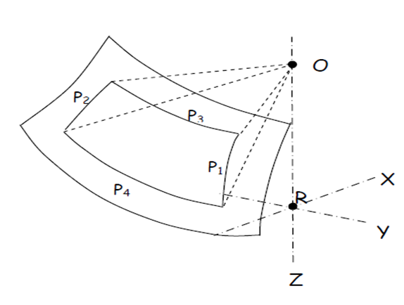
(c) Any further refinements or corrections as deemed appropriate.
IV. Organization of process and timeline
4. The proposal will be drafted by the experts from Republic of Korea. The amendments to the proposal will be developed in cooperation with all interested GRSG experts. The meetings of interested experts are not planned, but will be organized, if necessary.
5. The proposed action plan:
(a) October 2019: Consideration of the proposal (working document) at the 117th GRSG session;
(b) April 2020: Consideration of the final proposal and its possible adoption at the 118th GRSG session;
(c) November 2020: Adoption of the proposal by AC.3, if no remaining issues had existed.
6. The progress of works will be reported to AC.3 at its November 2019 March, and June 2020 sessions.

Technical report on the development of the amendment to UN Global Technical Regulation No. 6 (Safety Glazing)
I. Introduction
1. The expert from Republic of Korea proposed to amend UN GTR No. 6 on safety glazing to exempt in Zone I the possible opaque obscuration in the test area on the windscreen of Category 1-2 and 2 vehicles which is used for installation of those devices such as rain-drop sensor, inside mirror or autonomous vehicle sensors, etc.
II. Objective
2. As the technical advanced, there is the inside room mirror having a sensor, such as weather rain sensors, lane detection sensors, and highway electronic toll sensors. These functions were integrated into the room mirror. It affected to Zone I of Category 1-2 and 2 vehicles.
3. However, Category 1-2 and 2 vehicles have no opaque obscuration. On the other hand, Passenger cars have the opaque obscuration. This proposal is to allow additional opaque obscuration in relation to the optical distortion test and secondary image separation test in GTR 6.
III. Meeting held by GRSG
4. In the 116th session of GRSG (1-5 April 2019), the expert from Republic of Korea introduced GRSG-116-30 and GRSG-116-31 on the need to exempt in Zone I the possible opaque obscuration which is defined in paragraph 7.1.3.2.4. of the annexes 7.1. The expert from Germany principally agreed the proposed amendments, adding that the opaque obscuration had to be clearly defined. The expert from Finland affirmed the necessity for similar amendments in UN Regulation No. 43.
5. In the 117th session of GRSG (8-11 October 2019), The expert from the Republic of Korea presented ECE/TRANS/WP.29/GRSG/2019/33 as amended by GRSG-117-43 and GRSG-117-49 on the need to exempt in Zone I the possible opaque obscuration which is defined in paragraph 7.1.3.2.4. of the annexes on installing laminated-glass panes. The expert from Germany clarified that there was no real difference between UN GTR No. 6 and UN Regulation No.43 as the UNGTR would provide for two options while the UN Regulation would use only one of the options which was in accordance with the agreements.
6. GRSG adopted ECE/TRANS/WP.29/GRSG/2019/33 as amended by GRSG-117-49 and requested the secretariat to submit it to AC.3 as draft amendment to UN GTR No. 6 for consideration at its March 2020 sessions.
IV. Main resolutions agreed by GRSG
7. Various safety and convenience options (Lane Departure Warning Systems (LDWS), Autonomous sensors, etc.) for trucks are being installed or under development. If these options are fitted on the underside dashboard-top of the windshield glass, it may limit the driver’s direct front of vision.
8. For the optimization of installation, the above options may be integrated with the interior mirror. However, it is difficult for some models to install the interior mirror, since Zone I may be intruded. Therefore, the opaque obscuration which can be used for installation of the above safety and convenience options must be permitted additionally. For this reason, some new planes such as P5, P6, and P7 shall be added. On the other hand, the new opaque obscuration for Category 1-2 and 2 Vehicles has to be equal level with the one for Category 1-1 vehicles using the “V” points in order not to violate safety.
V. Development of the UN GTR
9. The objective of the proposal is to develop, in the framework of the 1998 Agreement, an amendment to UN GTR No. 6 on Safety Glazing to adapt the provisions to technical progress to enable the approval of windscreens with extended areas of opaque obscuration providing for the installation of safety and convenience elements (e.g. LDWS).
10. The development of the draft language for updating the GTR involved consideration of the differences between the respective 1998 Agreement and 1958 Agreement. Specific solutions for the different technical items were developed whereby GRSG experts were requested to support and contribute in the process.
The Amendment 2 to UN GTR No. 6 incorporates:
Determination of the opaque obscuration by defining planes P5, P6, and P7
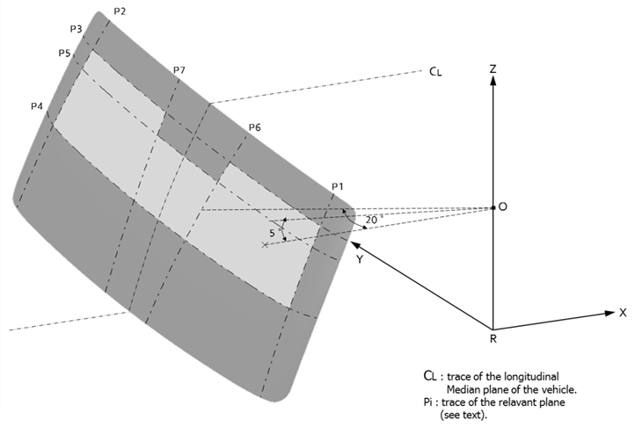
VI. Conclusion
11. Following the adoption of the draft Amendment 3 to UN GTR No. 6 at its 117th session, GRSG requests AC.3 voting for establishing this Amendment 3 (as proposed in ECE/TRANS/GRSG/2019/33) in the Global Registry.

