E/ECE/324/Rev.2/Add.128/Rev.3/Amend.4−E/ECE/TRANS/505/Rev.2/Add.128/Rev.3/Amend.4
29 January 2020
Agreement
Concerning the Adoption of Harmonized Technical United Nations Regulations for Wheeled Vehicles, Equipment and Parts which can be Fitted and/or be Used on Wheeled Vehicles and the Conditions for Reciprocal Recognition of Approvals Granted on the Basis of these United Nations Regulations*
(Revision 3, including the amendments which entered into force on 14 September 2017)
_________
Addendum 128 – UN Regulation No. 129
Revision 3 - Amendment 4
Supplement 5 to the 02 series of amendments – Date of entry into force: 11 January 2020
Uniform provisions concerning the approval of Enhanced Child Restraint Systems used on board of motor vehicles
This document is meant purely as documentation tool. The authentic and legal binding text is: ECE/TRANS/WP.29/2019/39.
_________
UNITED NATIONS

Paragraph 4.5., amend to read:
"4.5. Integral Enhanced Child Restraint Systems that can be used forward and rearward facing, shall have the following label permanently attached on the part hosting the child and visible to the person installing an Enhanced Child Restraint System in the vehicle:
The manufacturer shall be permitted to include the word "months" to explain the symbol "M" in the label. The word "months" should be in a language commonly spoken in the country or countries where the product is sold. More than one language is allowed.
Minimum label size 40 x 40 mm

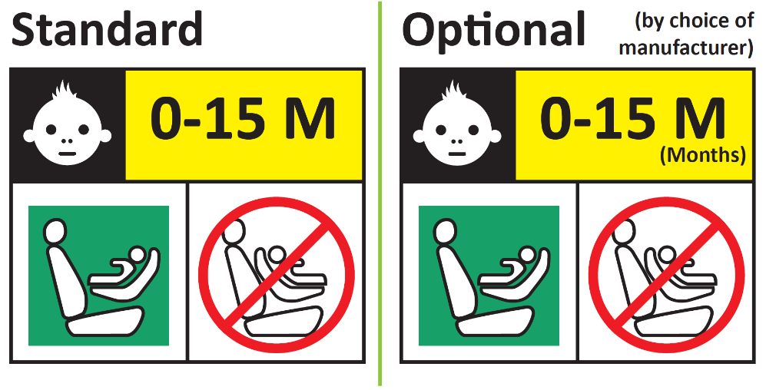
Forbidden sign – red
Label outline, vertical and horizontal lines black
Square – green
Background white
Top symbol white on black background
All text black on yellow or amber background
Background white

Integral Enhanced Child Restraint Systems that can be used forward facing only shall have the following label permanently attached on the part hosting the child and visible to the person installing an Enhanced Child Restraint System in the vehicle:
The manufacturer shall be permitted to include the word "months" to explain the symbol "M" in the label. The word "months" should be in a language commonly spoken in the country or countries where the product is sold. More than one language is allowed.
Minimum label size 40 x 40 mm
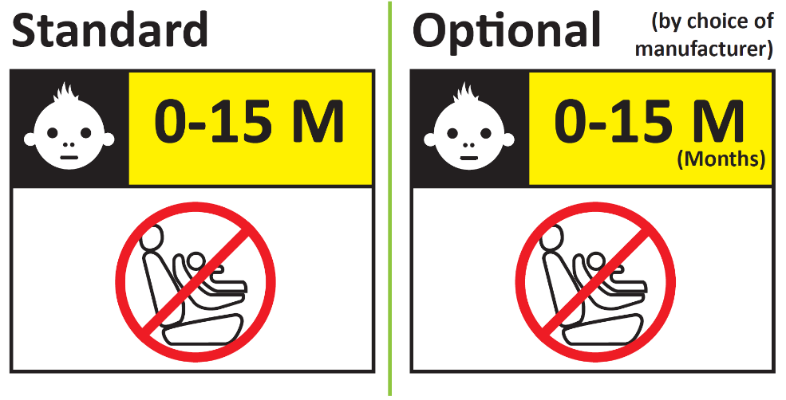"
Paragraphs 6.6.4.4.1.1. and 6.6.4.4.1.1.1., amend to read:
"6.6.4.4.1.1. Forward facing Enhanced Child Restraint Systems
Head excursion: No part of the head of the dummy shall pass beyond the planes BA, DA and DE as defined in Figure 1 below. However, the head of the dummy may pass beyond the DE plane, if there is part of the child restraint structure, i.e. head pad or backrest, behind the head of the dummy, at the point the head passes the DE plane.
This shall be judged up to 300 ms or the moment that the dummy has come to a definitive standstill whatever occurs first.
Except for booster seats when testing using Q10 dummy where:
(a) The value in relation to the DA plane is 840 mm; and
(b) The value in relation to the BA plane is 550 mm; and
(c) The rebound phase is not considered for the assessment of the plane DA and DE.
6.6.4.4.1.1.1. Where a test is conducted in accordance with paragraph 6.6.4.1.6.2. or paragraph 6.6.4.1.8.2. above, a tolerance of +10 per cent shall be applicable to the head excursion value distance between Cr point and plane AB.
Figure 1
Arrangement for testing a forward-facing device
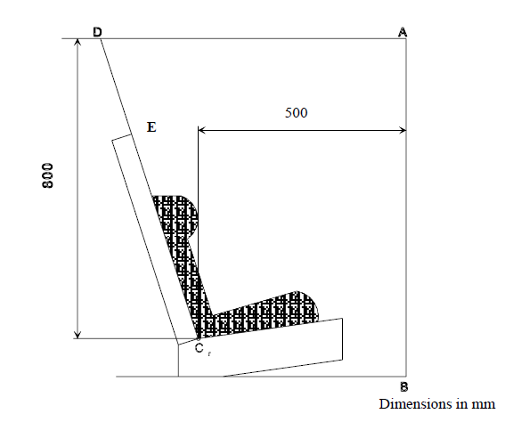"
Paragraph 10.2., amend to read:
"10.2. The minimum requirements for conformity of production control procedures set forth in Annex 12 to this Regulation shall be complied with.
The conformity of production procedures and all assessments shall follow the regulatory provisions applied at the time of the approval or, if applicable, extensions thereof."
Paragraph 14.3.3., amend to read:
"14.3.3. For integral forward facing Enhanced Child Restraint Systems, the following information shall be clearly visible on the exterior of the packing:
"IMPORTANT – DO NOT USE BEFORE THE CHILD’S AGE EXCEEDS 15 MONTHS (Refer to instruction)".
For integral Enhanced Child Restraint Systems that can be used forward and rearward facing, the following information shall be clearly visible on the exterior of the packing:
"IMPORTANT – DO NOT USE FORWARD FACING BEFORE THE CHILD’S AGE EXCEEDS 15 MONTHS (Refer to instruction)".
"

Annex 2., amend to read:
"Annex 2
Arrangements of the approval mark
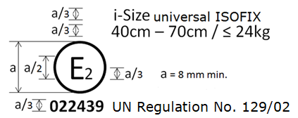
…
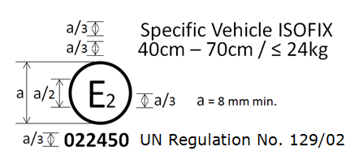
…
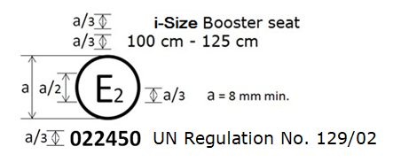
…
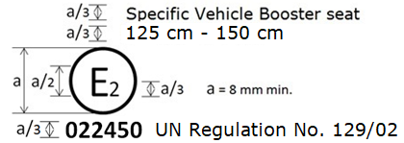
The Enhanced Child Restraint System bearing the above approval mark…125 cm–150 cm size range…
…
In case of combinations, for example an Enhanced Child Restraint System, that is approved as an i-Size Booster seat from 100 cm – 125 cm and from 125 cm – 150 cm as a Specific Vehicle Booster seat, the approval marked is to be combined as given below.
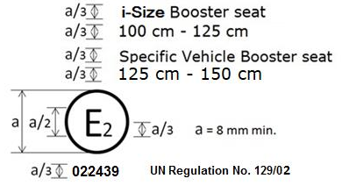
Combinations can only be made for those allowed by paragraph 3.2.2.
Arrangements of the module mark in combination with an approval mark
Current examples given to be deleted and replaced by the following:
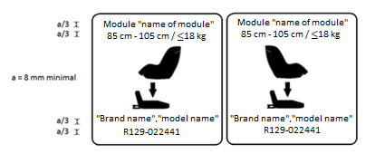
The Enhanced Child Restraint System module bearing the above module marks is capable of being used in a rearward facing mode with the base "brand name and model name", for the 85 cm–105 cm size range and with a mass limit of 18 kg; approved according to UN Regulation No. 129-02 under the number 022441.
The Enhanced Child Restraint System module bearing the above marks is also capable of being used in a forward facing mode with the base "brand name and model name", for the
85 cm–105 cm size range and with a mass limit of 18 kg; approved according to UN Regulation No. 129-02 under the same number 022441.
The approval number indicates that the approval was granted in accordance with the requirements of the UN Regulation concerning the approval of Enhanced Child Restraint Systems used on-board motor vehicles as amended by the 02 series of amendments.
Examples of the symbols to be used on the module mark are given in the figures below. As chosen by the Enhanced Child Restraint Systems manufacturer, one of the symbols or an equivalent shall be used on the module mark.
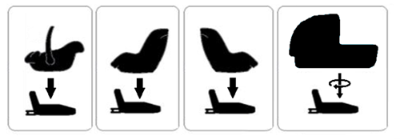"

* Former titles of the Agreement: Agreement concerning the Adoption of Uniform Conditions of Approval and Reciprocal Recognition of Approval for Motor Vehicle Equipment and Parts, done at Geneva on 20 March 1958 (original version); Agreement concerning the Adoption of Uniform Technical Prescriptions for Wheeled Vehicles, Equipment and Parts which can be Fitted and/or be Used on Wheeled Vehicles and the Conditions for Reciprocal Recognition of Approvals Granted on the Basis of these Prescriptions, done at Geneva on 5 October 1995 (Revision 2).

