E/ECE/324/Rev.2/Add.106/Rev.8/Amend.3−E/ECE/TRANS/505/Rev.2/Add.106/Rev.8/Amend.3
2 November 2020
Agreement
Concerning the Adoption of Harmonized Technical United Nations Regulations for Wheeled Vehicles, Equipment and Parts which can be Fitted and/or be Used on Wheeled Vehicles and the Conditions for Reciprocal Recognition of Approvals Granted on the Basis of these United Nations Regulations*
(Revision 3, including the amendments which entered into force on 14 September 2017)
_________
Addendum 106 – UN Regulation No. 107
Revision 8 - Amendment 3
Supplement 3 to 08 series of amendments – Date of entry into force: 25 September 2020
Uniform provisions concerning the approval of category M₂ and M₃ vehicles with regard to their general construction
This document is meant purely as documentation tool. The authentic and legal binding text is: ECE/TRANS/WP.29/2020/14.
_________
UNITED NATIONS

Annex 3
Paragraph 7.6.2.8., amend to read:
"7.6.2.8. For vehicles of classes I, II and III, required escape hatches shall be positioned as follows:
(a) If there is only one hatch, it shall be situated in the middle third of the passenger compartment; or
(b) If there are two hatches, they shall be separated by a distance of at least 2 m measured between the nearest edges of the apertures in a line parallel to the longitudinal axis of the vehicle."
Insert a new paragraph 7.6.2.9. to read:
"7.6.2.9. For vehicles of classes A and B, required escape hatches shall be positioned as follows:
(a) If there is only one hatch, it shall be situated in the middle third of the passenger compartment. As an alternative, on vehicles with a very short passenger compartment length, the hatch may be located in the mid-section of this compartment, and this mid-section shall be equally spaced longitudinally each side of the transverse centre line of the passenger compartment, with a length of no greater than 1.6m as shown in Annex 4, Figure 31;
(b) If there are two hatches, they shall be separated by a distance of at least 2 m measured between the nearest edges of the apertures in a line parallel to the longitudinal axis of the vehicle."
Annex 4
After Figure 30 insert a new Figure 31 to read:
"Figure 31
Alternative placement of escape hatch for very short passenger compartment length having a middle third smaller than 1600 mm
(See Annex 3, paragraph 7.6.2.9.)
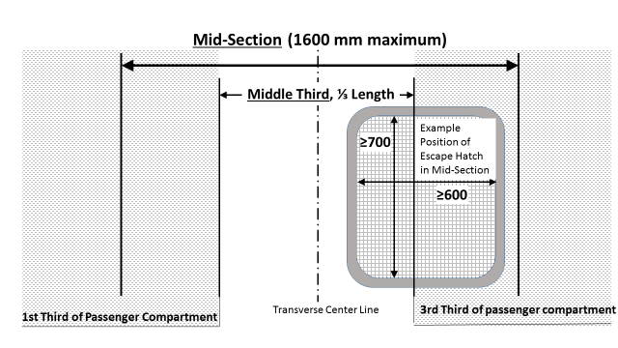
(All dimensions in mm)"

* Former titles of the Agreement: Agreement concerning the Adoption of Uniform Conditions of Approval and Reciprocal Recognition of Approval for Motor Vehicle Equipment and Parts, done at Geneva on 20 March 1958 (original version); Agreement concerning the Adoption of Uniform Technical Prescriptions for Wheeled Vehicles, Equipment and Parts which can be Fitted and/or be Used on Wheeled Vehicles and the Conditions for Reciprocal Recognition of Approvals Granted on the Basis of these Prescriptions, done at Geneva on 5 October 1995 (Revision 2).

