|  |  |  |
| --- | --- | --- |
| E/ECE/324/Add.3/Rev.4−E/ECE/TRANS/505/Add.3/Rev.4 | | |
|  |  | 9 June 2020 |

Agreement

Concerning the Adoption of Harmonized Technical United Nations Regulations for Wheeled Vehicles, Equipment and Parts which can be Fitted and/or be Used on Wheeled Vehicles and the Conditions for Reciprocal Recognition of Approvals Granted on the Basis of these United Nations Regulations [1]*

(Revision 3, including the amendments which entered into force on 14 September 2017)

_________

Addendum 3: UN Regulation No. 4

Revision 4

Incorporating all valid text up to:

Supplement 17 to the original version of the Regulation – Date of entry into force: 15 June 2015

Corrigendum 1 to Revision 3 of the Regulation (*Erratum by the secretariat*)

Supplement 18 to the original version of the Regulation – Date of entry into force: 10 October 2017

Supplement 19 to the original version of the Regulation – Date of entry into force: 10 February 2018

01 series of amendments – Date of entry into force: 15 October 2019

Uniform provisions concerning the approval of devices for the illumination of rear registration plates of power-driven vehicles and their trailers

**_________**



**UNITED NATIONS**

This document is meant purely as documentation tool. The authentic and legal binding texts are:

- ECE/TRANS/WP.29/2014/54 as amended by para. 59 of the report (ECE/TRANS/WP.29/1112)

- E/ECE/324/Add.3/Rev.3/Corr.1-E/ECE/TRANS/505/Add.3/Rev.3/Corr.1

- ECE/TRANS/WP.29/2017/20

- ECE/TRANS/WP.29/2017/72 as amended by para. 74 of the report (ECE/TRANS/WP.29/1131)

- ECE/TRANS/WP.29/2018/92/Rev.1

UN Regulation No. 4

Uniform provisions concerning the approval of devices for the illumination of rear registration plates of power-driven vehicles and their trailers

Contents

*Page*

Regulation

Scope 4

1. Definitions 4

2. Application for approval 5

3. Markings 5

4. Approval 6

5. General specifications 8

6. Colour of light 9

7. Incidence of the light 9

8. Measuring procedure 10

9. Photometric characteristics 10

10. Conformity of production 10

11. Penalties for non-conformity of production 11

12. Production definitively discontinued 11

13. Transitional provisions 11

[14. Names and addresses of Technical Services conducting approval tests, and of   
Type Approval Authorities 12](#_Toc347156889)

Annexes

1 Arrangement of approval marks 13

2 Communication 16

3 Measurement points for test purposes 18

4 Minimum field of visibility of the surface to be illuminated 21

5 Photometric measurement of lamps equipped with several light sources 22

6 Minimum requirements for conformity of production control procedures 23

7 Minimum requirements for sampling by an inspector 25

Scope

This Regulation applies to rear registration plate lamps for vehicles of categories M, N, O, and T.[2]

1. Definitions

For the purpose of this Regulation:

1.1. "*Rear registration plate lamp*" means the device for the illumination of rear registration plates, hereinafter called "illuminating device", which illuminates the rear registration plate by reflection. For the approval of this device, the illumination of the space to be occupied by the plate is determined. The illuminated areas are grouped into the following categories:

1.1.1. Category 1a: illuminated area for use on a vehicle mounted a registration plate, the size of which is 340 x 240 mm or less (tall plate).

1.1.2. Category 1b: illuminated area for use on a vehicle mounted a registration plate, the size of which is 520 x 120 mm or less (wide plate).

1.1.3. Category 1c: illuminated area for use on a vehicle mounted a registration plate, the size of which is 255 x 165 mm or less (plate for agricultural or forestry tractors).

1.1.4. Category 2a: illuminated area for use on a vehicle mounted a registration plate, the size of which is 330 x 165 mm or less.

1.1.5. Category 2b: illuminated area for use on a vehicle mounted a registration plate, the size of which is 440 x 220 mm or less.

1.2. The definitions given in UN Regulation No. 48 and its series of amendments in force at the time of application for type approval shall apply to this Regulation.

1.3. "*Rear registration plate lamps of different types*" means lamps which differ in such essential respects as:

(a) The trade name or mark:

(i) Lamps bearing the same trade name or mark but produced by different manufacturers shall be considered as being of different types;

(ii) Lamps produced by the same manufacturer differing only by the trade name or mark shall be considered as being of the same type.

(b) The characteristics of the optical system (levels of intensity, light distribution angles, category of light source, light source module, etc.).

1.4. References made in this Regulation to standard (étalon) filament lamp(s) and to UN Regulation No. 37 shall refer to UN Regulation No. 37 and its series of amendments in force at the time of application for type approval.

References made in this Regulation to standard (étalon) LED light source(s) and to UN Regulation No. 128 shall refer to UN Regulation No. 128 and its series of amendments in force at the time of application for type approval.

2. Application for approval

The application for approval shall be submitted by the holder of the trade name or mark or by his duly accredited representative. It shall specify whether the device is intended to illuminate the area, category 1a, 1b, 1c, 2a, 2b, or any combination of those areas according to paragraphs 1.1.1. to 1.1.5. At the choice of the applicant, it will also specify that the device may be fitted in more than one or a field of positions in relation to the space to be occupied by this registration plate; these different positions shall be indicated by the applicant in the communication form. It shall be accompanied by the following, in respect of each type:

(a) Drawings (three copies) in sufficient detail to permit identification of the type and showing geometrically the position in which the illuminating device is to be fitted in relation to the space to be occupied by the registration plate, and the outlines of the area adequately illuminated. The drawings must show the position intended for the approval number in relation to the circle of the approval mark;

(b) A brief technical description stating in particular, with the exception of lamps with non-replaceable light sources:

(i) The category or categories of filament lamp prescribed; this filament lamp category shall be one of those contained in UN Regulation No. 37 and its series of amendments in force at the time of application for type approval; and/or

(ii) The category or categories of LED light source(s) prescribed; this LED light source category shall be one of those contained in UN Regulation No. 128 and its series of amendments in force at the time of application for type approval.; and/or

(iii) The light source module specific identification code[3];

(c) Two samples, equipped with the light source(s);

(d) In the case of a non-replaceable filament lamp(s) or light source module(s) equipped with non-replaceable filament lamp(s): the documents according to paragraph 5.7. of this Regulation;

(e) In the case of a type of lamp differing only by the trade name or mark from a type that has already been approved it shall be sufficient to submit:

(i) A declaration by the lamp manufacturer that the type submitted is identical (except in the trade name or mark) with and has been produced by the same manufacturer as the type already approved, the latter being identified by its approval code;

(ii) Two samples bearing the new trade name or mark or equivalent documentation.

3. Markings

Illuminating devices submitted for approval must bear:

3.1. The trade name or mark of the maker or manufacturer of the illuminating device;

3.2. A space of sufficient size for the approval mark; this space shall be shown in the drawings mentioned in paragraph 2. (a) above.

3.3. In the case of lamps with non-replaceable light sources or light source module(s), the marking of the rated voltage or range of voltage.

3.4. With the exception of lamps with non-replaceable light sources it must bear a clearly legible and indelible marking indicating:

(a) The category or categories of light source(s) prescribed; and/or

(b) The light source module specific identification code.

3.5. In the case of lamps with light source module(s), the light source module(s) shall bear:

3.5.1. The trade name or mark of the applicant; this marking must be clearly legible and indelible;

3.5.2. The specific identification code of the module; this marking must be clearly legible and indelible. This specific identification code shall comprise the starting letters "MD" for "MODULE" followed by the approval marking without the circle as prescribed in paragraph 4.4.1. below and, in the case of several non-identical light source modules are used, followed by additional symbols or characters; this specific identification code shall be shown in the drawings mentioned in paragraph 2. (a) above.

The approval marking does not have to be the same as the one on the lamp in which the module is used, but both markings shall be from the same applicant.

3.5.3. The marking of the rated voltage or range of voltage.

4. Approval

4.1. If the two samples of a type of illuminating device submitted in accordance with paragraph 2. above satisfy the provisions of this Regulation, approval shall be granted.

4.2. An approval number shall be assigned to each type approved. Its first two digits (at present 00 for the Regulation in its original form)[4] shall indicate the series of amendments incorporating the most recent major technical amendments made to the Regulation at the time of issue of the approval. The same Contracting Party may not assign this number to another type of device covered by this Regulation, except in the case of an extension of the approval to a device differing only in the colour of the light emitted.

4.3. Notice of approval or of extension or refusal of approval of a type of illuminating device pursuant to this Regulation shall be communicated to the Parties to the 1958 Agreement applying this Regulation, by means of a form conforming to the model in Annex 2 to this Regulation.

4.4. Every illuminating device conforming to a type approved under this Regulation shall, in addition to the markings referred to in paragraphs 3. (a) and (c) above, bear an international approval mark in conformity with Annex 1, consisting of:

4.4.1. A circle surrounding the letter "E" followed by a number identifying the country which has granted approval;[5]

4.4.2. An approval number, in the vicinity of the circle;

4.4.3. The following additional symbol: the letter "L";

4.4.4. The first two digits of the approval number which indicate the most recent series of amendments to this Regulation may be placed in the vicinity of the additional symbol L.

4.5. The mark and symbols referred to in paragraphs 4.4.1., 4.4.2. and 4.4.3. shall be indelible and shall be clearly legible even when the illuminating device is mounted on the vehicle.

4.6. When two or more lamps are part of the same unit of grouped, combined or reciprocally incorporated lamps, approval is granted only if each of these lamps satisfies the requirements of this Regulation or of another UN Regulation. Lamps not satisfying any one of those Regulations shall not be part of such a unit of grouped, combined or reciprocally incorporated lamps.

4.6.1. Where grouped, combined or reciprocally incorporated lamps comply with the requirements of several UN Regulations, a single international approval mark may be applied, consisting of a circle surrounding the letter "E" followed by the distinguishing number of the country which has granted the approval, an approval number and, if necessary, the required arrow. This approval mark may be placed anywhere on the grouped, combined or reciprocally incorporated lamps provided that:

4.6.1.1. It is visible after their installation;

4.6.1.2. No part of the grouped, combined or reciprocally incorporated lamps that transmits light can be removed without at the same time removing the approval mark.

4.6.2. The identification symbol for each lamp appropriate to each UN Regulation under which approval has been granted, together with the corresponding series of amendments incorporating the most recent major technical amendments to the Regulation at the time of issue of the approval, shall be marked:

4.6.2.1. Either on the appropriate light-emitting surface;

4.6.2.2. Or in a group, in such a way that each lamp of the grouped, combined or reciprocally incorporated lamps may be clearly identified (see three possible examples in Annex 1).

4.6.3. The size of the components of a single approval mark shall not be less than the minimum size required for the smallest of the individual marks by a Regulation under which approval has been granted.

4.6.4. An approval number shall be assigned to each type approved. The same Contracting Party may not assign the same number to another type of grouped, combined or reciprocally incorporated lamps covered by this Regulation.

4.6.5. The approval marking shall be clearly legible and indelible. It may be placed on an inner or outer part (transparent or not) of the device which cannot be separated from the transparent part of the device emitting the light. In any case the marking shall be visible when the device is fitted on the vehicle or when a movable part such as the hood or boot lid or a door is opened.

4.7. Annex 1 gives examples of arrangements of approval marks for a single lamp (Figure 1) and for grouped, combined or reciprocally incorporated lamps (Figure 2) with all the additional symbols referred to above.

5. General specifications

The requirements contained in sections 5. "General specifications" and 6. "Individual specifications" and in the Annexes referenced in the said sections of UN Regulations Nos. 48, 53, 74 or 86, and their series of amendments in force at the time of application for the device type approval shall apply to this Regulation.

The requirements pertinent to each device and to the category/ies of vehicle on which the device is intended to be installed shall be applied, where its verification at the moment of device type approval is feasible.

Each device shall satisfy the provisions of paragraph 9[6].

5.1. The devices for the illumination of rear registration plates shall be so constructed that the whole surface of the plate will be visible within the angles given in Annex 4.

5.2. All measurements shall be made with the standard uncoloured or coloured light source of the category prescribed by the manufacturer, supplied with the voltage:

(a) In the case of filament lamp(s), that is necessary to produce the reference luminous flux required for that category of filament lamp;

(b) In the case of LED light source(s) of 6.75 V, 13.5 V or 28.0 V, the luminous flux value produced shall be corrected. The correction factor is the ratio between the objective luminous flux and the value of the luminous flux found at the voltage applied.

All measurements on the devices with non-replaceable light sources shall be made at 6.75 V, 13.5 V or 28.0 V respectively.

5.3 In the case of light sources supplied by a special power supply, the above test voltages shall be applied to the input terminals of that power supply. The test laboratory may require from manufacturer the special power supply needed to supply the light sources.

5.4. For any rear registration plate illuminating device, except those equipped with filament lamp(s), the luminance values measured after one minute and after 30 minutes of operation shall comply with the minimum requirements.

The luminance distribution after one minute of operation can be calculated by applying at each test point the ratio of luminance values measured in one point after one minute and after 30 minutes of operation.

5.5. In the case of light source modules, it shall be checked that:

5.5.1. The design of the light source module(s) shall be such as:

(a) That each light source module can only be fitted in no other position than the designated and correct one and can only be removed with the use of tool(s);

(b) If there are more than one light source module used in the housing for a device, light source modules having different characteristics cannot be interchanged within the same lamp housing.

5.5.2. The light source module(s) shall be tamperproof.

5.5.3. A light source module shall be so designed that regardless of the use of tool(s), it shall not be mechanically interchangeable with any replaceable approved light source.

5.6. In the case of replaceable light source(s):

5.6.1. The illuminating device shall only be equipped with light source(s) approved according to UN Regulation No. 37 and/or UN Regulation No. 128, provided that no restriction on the use is made in UN Regulation No. 37 and its series of amendments in force at the time of application for type approval or in UN Regulation No. 128 and its series of amendments in force at the time of application for type approval.

5.6.2. The design of the device shall be such that the light source cannot be fixed in any other position but the correct one.

5.6.3. The light source holder shall conform to the characteristics given in IEC Publication 60061. The holder data sheet relevant to the category of light source used, applies.

5.7. In the case of non-replaceable filament lamp(s) or light source module(s) equipped with non-replaceable filament lamp(s), the applicant shall annex to the type approval documentation a report (by the light source manufacturer indicated in the type approval documentation), acceptable to the Authority responsible for type approval, that demonstrates compliance of these non-replaceable filament lamp(s) with the requirements as specified in paragraph 4.11. of IEC 60809, Edition 3.

6. Colour of light

The light of the lamp used in the illuminating device must be sufficiently colourless not to cause any appreciable change in the colour of the registration plate.

7. Incidence of the light

The manufacturer of the illuminating device shall specify one or more or a field of positions in which the device is to be fitted in relation to the space for the registration plate; when the lamp is placed in the position (s) specified by the manufacturer the angle of incidence of the light on the surface of the plate shall not exceed 82º at any point of the surface to be illuminated, this angle being measured from the extremity of the device's illuminating area which is furthest from the surface of the plate. If there is more than one illuminating device, the foregoing requirement shall apply only to that part of the plate intended to be illuminated by the device concerned.

When the device has one outer edge of the illuminating surface that is parallel to the surface of the registration plate, the extremity of the illuminating surface of the device which is furthest from the surface of the plate is the middle point of the edge of the illuminating surface, which is parallel to the plate and is furthest from the surface of the plate.

The device must be so designed that no light is emitted directly towards the rear, with the exception of red light if the device is combined or grouped with a rear lamp.

8. Measuring procedure

Luminance measurements shall be made on a diffuse colourless surface with known diffuse reflection factor[7]. The diffuse colourless surface shall have the dimensions of the registration plate or the dimension exceeding one measuring point. Its centre shall be placed in the centre of the positions of the measuring points.

This diffuse colourless surface(s)shall be placed in the position normally occupied by the registration plate and 2 mm in front of its holder.

Luminance measurements shall be made perpendicularly to the surface of the diffuse colourless surface with the tolerance of 5° in each direction at the points shown in Annex 3 to this Regulation, each point representing a circular area of 25 mm in diameter. The measured luminance shall be corrected for the diffuse reflection factor 1.0.

9. Photometric characteristics

At each of the points of measurement shown in Annex 3, the luminance B shall be at least equal to 2.5 cd/m2.

The gradient of the luminance between the values B1 and B2, measured at any two points 1 and 2 selected from among those mentioned above, shall not exceed 2 x Bo/cm, Bo being the minimum luminance measured at the various points, that is to say:



10. Conformity of production

The conformity of production procedures shall comply with those set out in the Agreement, Schedule 1 (E/ECE/TRANS/505/Rev.3), with the following requirements:

10.1. Devices for the illumination of rear registration plates (henceforth called devices) shall be so manufactured as to conform to the type approved under this Regulation. If there is more than one device necessary for meeting the requirements of this Regulation, then in the following text a device means a set of devices.

The compliance with the requirements set forth in paragraphs 5., 6. and 9. above shall be verified as follows:

10.1.1. The minimum requirements for conformity of production control procedures set forth in Annex 6 to this Regulation shall be complied with.

10.1.2. The minimum requirements for sampling by an inspector set forth in Annex 7 to this Regulation shall be complied with.

10.2. The Authority which has granted type approval may at any time verify the conformity control methods applied in each production facility. The normal frequency of these verifications shall be once every two years.

10.3. In the case of non-replaceable filament lamp(s) or light source module(s) equipped with non-replaceable filament lamps, a report (by the light source manufacturer indicated in the type approval documentation) shall demonstrate compliance of these non-replaceable filament lamp(s) with lifetime requirements and, in the case of colour coated filament lamps, also with colour endurance requirements, as specified in paragraph 4.11. of IEC 60809, Edition 3*.*

11. Penalties for non-conformity of production

11.1. The approval granted in respect of an illuminating device pursuant to this Regulation may be withdrawn if the requirements laid down above are not complied with.

11.2. If a Contracting Party to the Agreement which applies this Regulation withdraws an approval it has previously granted, it shall forthwith notify the other Contracting Parties applying this Regulation thereof by means of a communication form conforming to the model in Annex 2 to this Regulation.

12. Production definitively discontinued

If the holder of the approval completely ceases to manufacture an illuminating device under this Regulation, he shall inform thereof the Authority which granted the approval. Upon receiving the relevant communication that Authority shall inform the other Parties to the Agreement which apply this Regulation thereof by means of a communication form conforming to the model in Annex 2 to this Regulation.

13. Transitional provisions[8]

13.1. As from 24 months after the official date of entry into force of UN Regulation No. 148, Contracting Parties applying this Regulation shall cease to grant approvals to this Regulation.

13.2. Contracting Parties applying this Regulation shall not refuse to grant extensions of approval to this and any previous series of amendments of this Regulation.

13.3. Contracting Parties applying this Regulation shall continue to grant approvals for devices on basis of this and any previous series of amendments to this Regulation, provided that the devices are intended as replacements for fitting to vehicles in use.

13.4. Contracting Parties applying this Regulation shall continue to allow fitting or use on a vehicle in use of device approved to this Regulation as amended by any previous series of amendments, provided that the device is intended for replacement.

14. Names and addresses of Technical Services conducting approval tests, and of Type Approval Authorities

The Contracting Parties to the Agreement which apply this Regulation shall communicate to the Secretariat of the United Nations the names and addresses of the Technical Services conducting approval tests and of the Type Approval Authorities which grant approval and to which forms certifying approval or refusal or withdrawal or approval, issued in other countries, are to be sent.

Annex 1

Arrangement of approval marks

# Figure 1

**(Marking for single lamps)**

# Model A

**00**

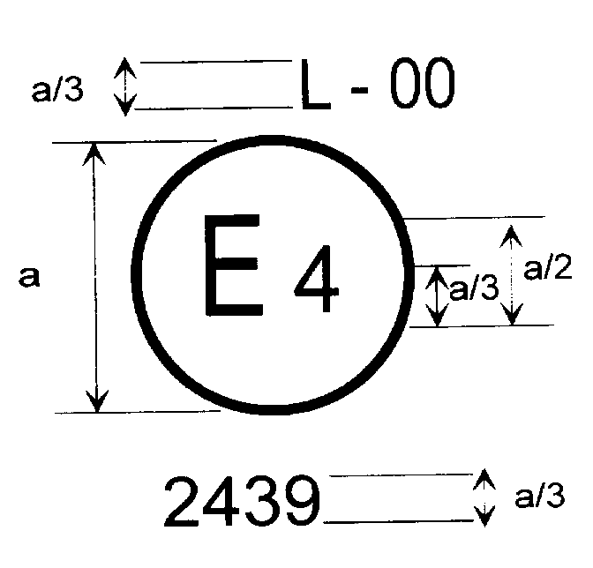

a = 5 mm min

The device bearing the approval mark shown above is a device for the illumination of a vehicle's rear registration plate (L) approved in the Netherlands (E 4) pursuant to UN Regulation No. 4 under approval number 2439. The approval number indicates that the approval was granted in accordance with the requirements of UN Regulation No. 4 in its original form or as amended by the respective supplements to the Regulation in its original form, as the case may be.[9]

# Figure 2

**Simplified marking for grouped, combined or reciprocally incorporated lamps**

(The vertical and horizontal lines schematize the shape of the light-signalling device.   
These are not part of the approval mark).

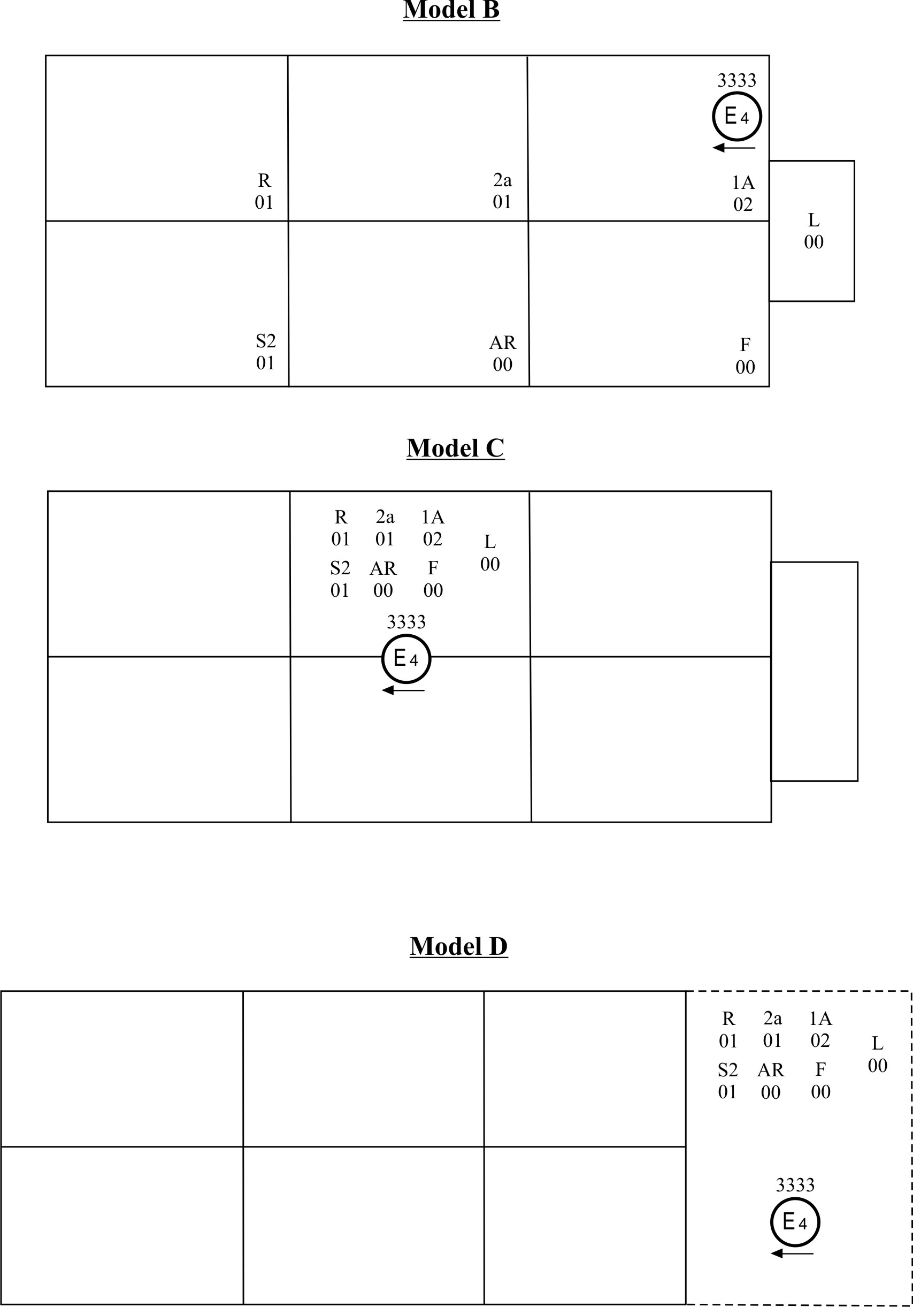

*Note:* The three examples of approval marks, models B, C and D represent three possible variants of the marking of a lighting device when two or more lamps are part of the same unit of grouped, combined or reciprocally incorporated lamps. This approval mark shows that the device was approved in the Netherlands (E4) under approval number 3333 and comprising:

Model D

A retro reflector of class IA approved in accordance with the 02 series of amendments to UN Regulation No. 3;

A rear direction indicator of category 2a approved in accordance with the 01 series of amendments to UN Regulation No. 6;

A red rear position lamp (R) approved in accordance with the 01 series of amendments to UN Regulation 7;

A rear fog lamp (F) approved in accordance with UN Regulation No. 38 in its original form;

A reversing lamp (AR) approved in accordance with UN Regulation No. 23 in its original form;

A stop lamp with two levels of illumination (S2) approved in accordance with the 01 series of amendments to UN Regulation No. 7;

A rear registration plate illuminating device (L) approved in accordance with UN Regulation No. 4 in its original form.

# Figure 3

# **Light source modules**

# Model E

MD E3 17325

The light source module bearing the identification code shown above has been approved together with a lamp approved in Italy (E3) under approval number 17325.

Annex 2

Communication

(Maximum format: A4 (210 x 297 mm))

issued by: Name of administration:

......................................

......................................

......................................

**1**

**1**



[10]

concerning:[11] Approval granted

**1**

Approval extended

Approval refused

Approval withdrawn

Production definitively discontinued

of a type of device for the illumination of rear registration plates of motor vehicles (except motor cycles) and their trailers pursuant to UN Regulation No. 4

Approval No....................................... Extension No.............................................

1. Trade name or mark of the device:

2. Manufacturer's name for the type of device:

3. Manufacturer's name and address:

4. If applicable, name and address of manufacturer's representative

5. Submitted for approval on:

6. Technical Service responsible for conducting approval tests:

7. Date of report issued by that Service:

8. Number of report issued by that Service:

9. Concise description:[12]

Device for illuminating:

Category 1a, 1b, 1c, 2a, 2b 2

Number and category (ies) of light source(s):

Light source module: Yes/No2

Light source module specific identification code:

Geometrical conditions of installation (position(s) and inclination(s) of the device in relation to the space to be occupied by the registration plate and/or different inclinations of this space):

10. Position of the approval mark:

11. Reason(s) for extension (if applicable):

12. Approval granted/extended/refused/withdrawn:2

13. Place:

14. Date:

15. Signature:

16. The list of documents deposited with the Type Approval Authority which has granted approval is annexed to this communication and may be obtained on request.

Annex 3

**Measurement points for test purposes**

(a) Category 1a (340 x 240 mm)

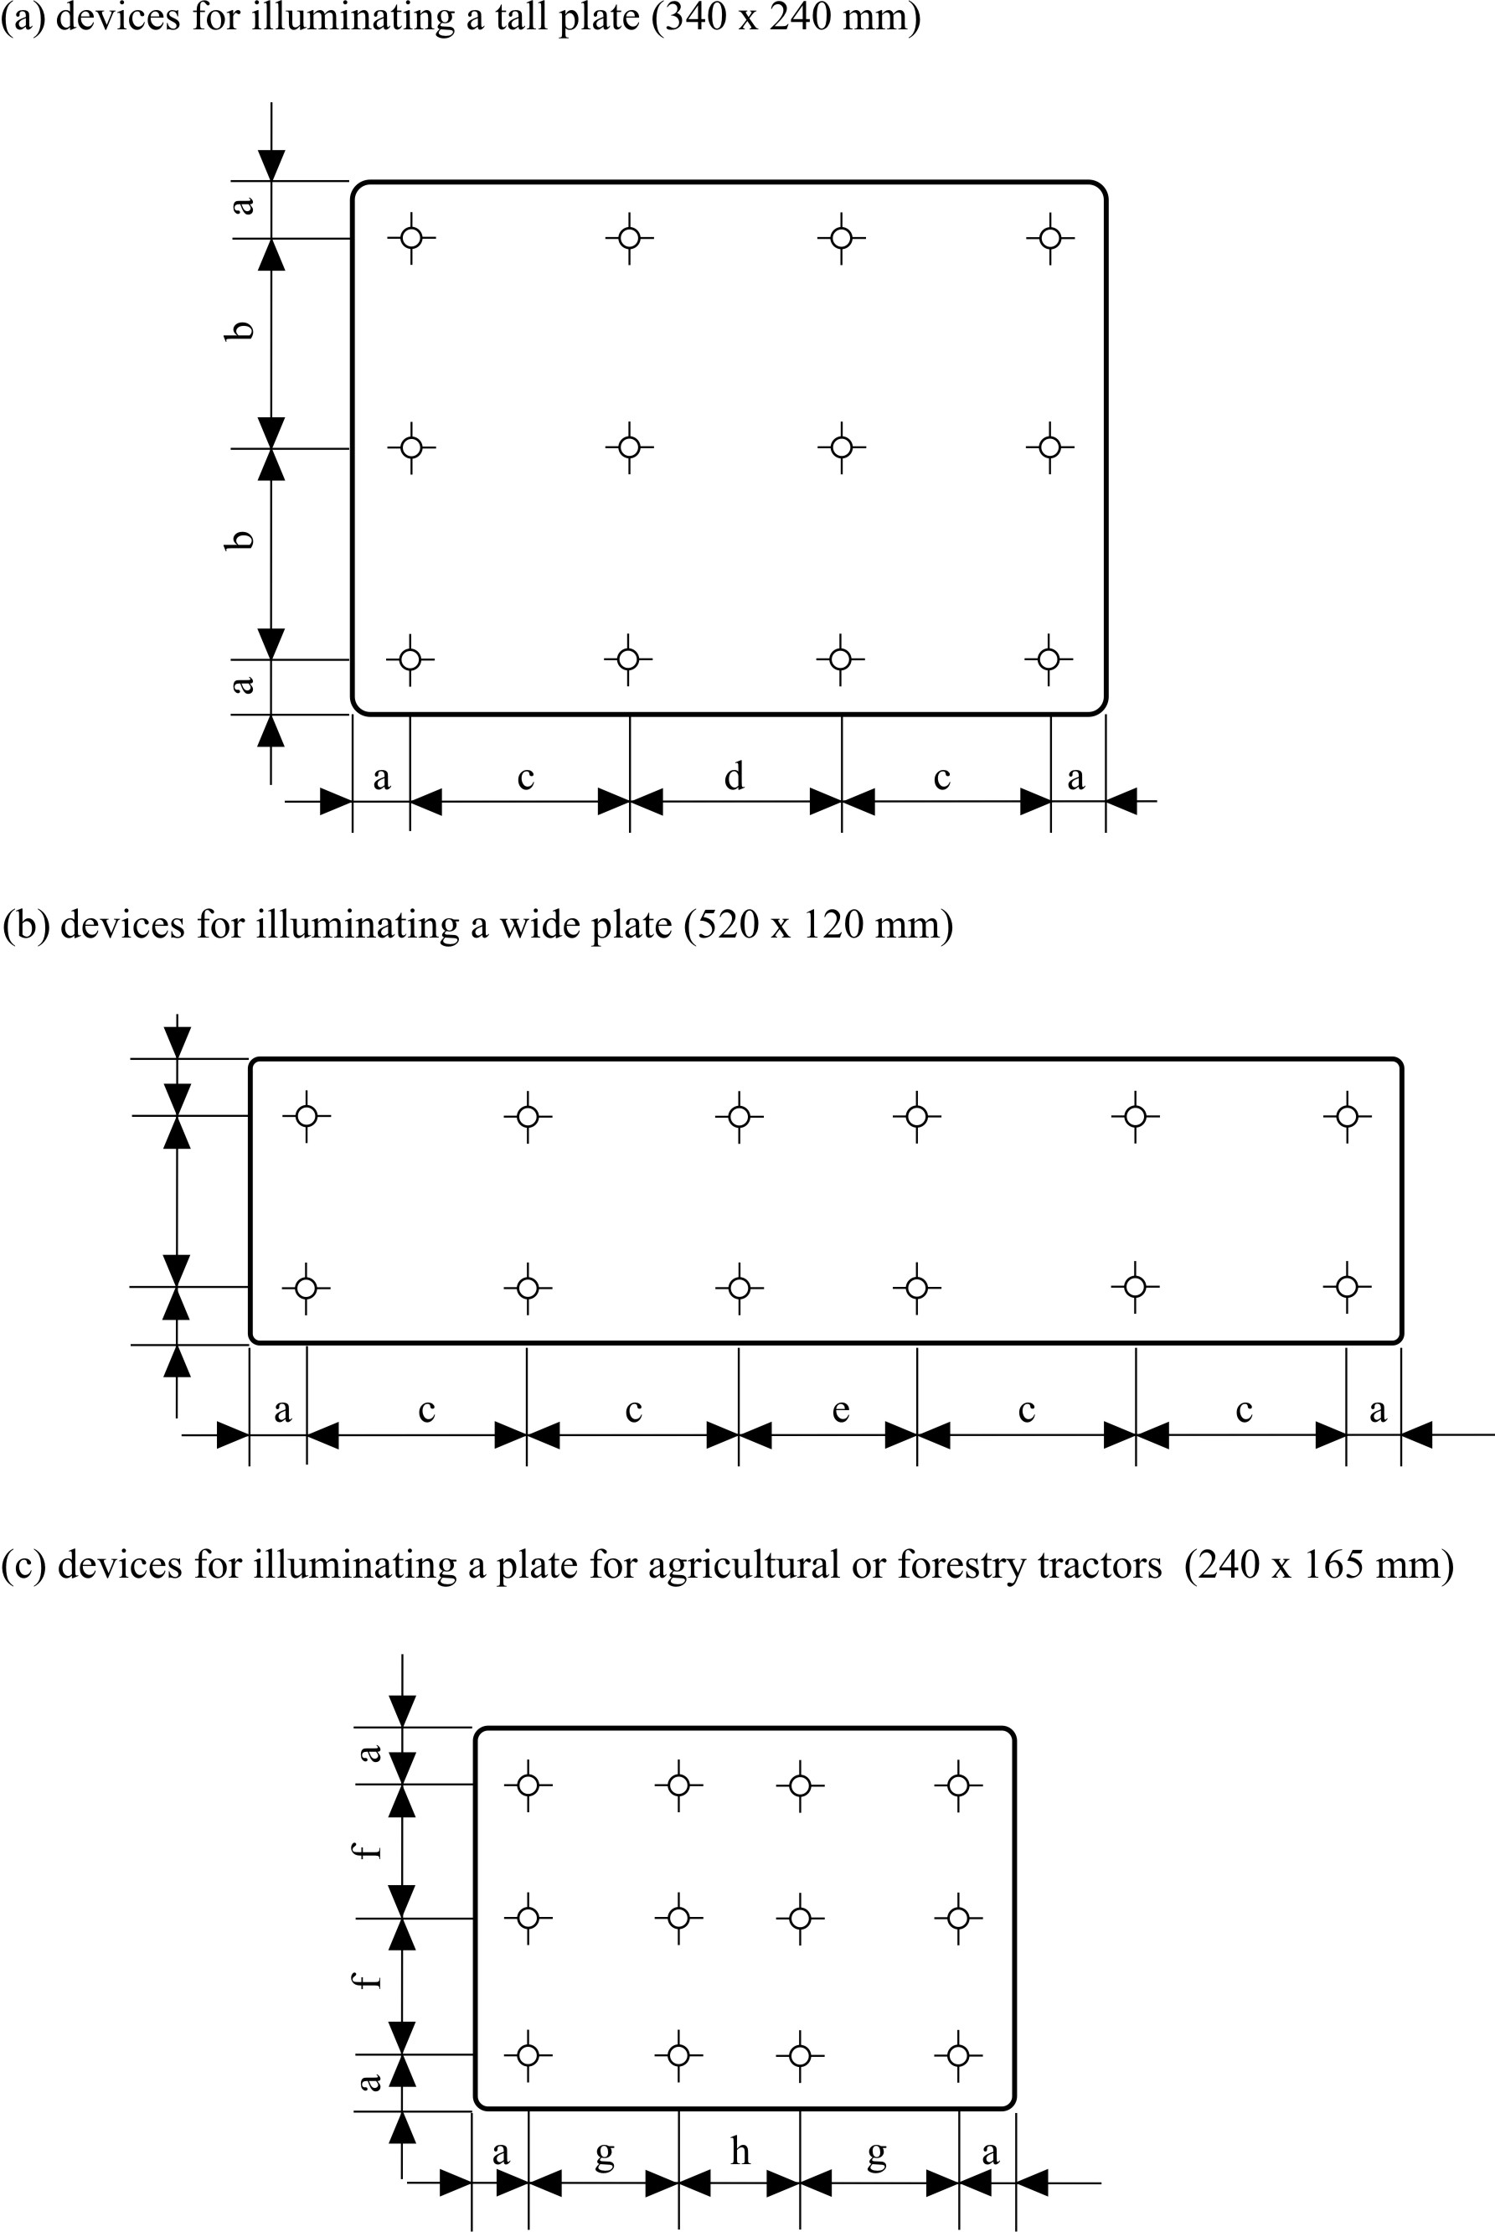

(b) Category 1b (520 x 120 mm)



(c) Category 1c (255 x 165 mm)



1

a = 25 mm b = 95 mm c = 100 mm d = 90 mm

e = 70 mm f = 57.5 mm g = 70 mm h = 65 mm

1

Category 2a (330 x 165 mm)

m

l

k

l

m

i

j

i



i = 32.5 mm

j = 100 mm

k = 50 mm

l = 100 mm

m = 40 mm

Category 2b (440 x 220 mm)

r

q

p

q

r

n

o

n



n = 50 mm

o = 120 mm

p = 50 mm

q = 145 mm

r = 50 mm

*Note*: In the case of devices for illuminating two or all of the plates, the measurement points used are obtained by combining the corresponding drawings above in accordance with the outline indicated by the make or manufacturer; however, if two measurement points are less than 30 mm apart, only one shall be used.

Annex 4

Minimum field of visibility of the surface to be illuminated

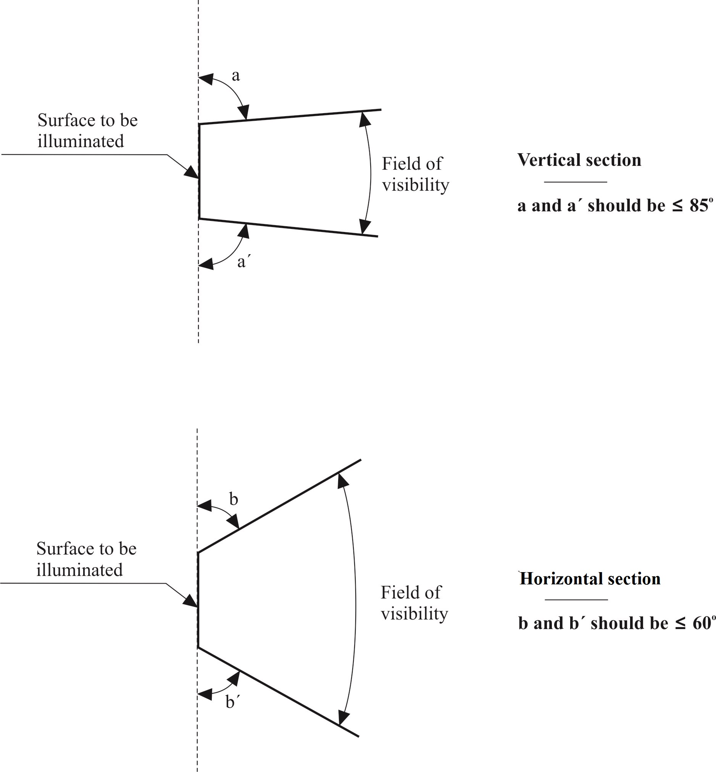

1. The field-of-visibility angles shown above relate only to the relative positions of the illuminating device and the space for the registration plate.

2. The field of visibility of the registration plate when mounted on the vehicle remains subject to the relevant national regulations.

3. The angles shown take account of the partial occultation caused by the illuminating device. They must be adhered to in the directions in which there is most occultation. The illuminating devices must be such as to reduce the areas partly occulted to the minimum strictly necessary.

Annex 5

Photometric measurement of lamps equipped with several light sources

1. The photometric performance shall be checked:

1.1. For non-replaceable light sources (filament lamps and other):

With the light sources present in the lamp, in accordance with paragraph 5.2.1. of this Regulation.

1.2. For replaceable light sources:

When equipped with light sources at 6.75 V, 13.5 V or 28.0 V, the luminance values produced shall be corrected. For filament lamps the correction factor is the ratio between the reference luminous flux and the mean value of the luminous flux found at the voltage applied (6.75 V, 13.5 V or 28.0 V).

For LED light sources the correction factor is the ratio between the objective luminous flux and the mean value of the luminous flux found at the voltage applied (6.75 V, 13.5 V or 28.0 V).

The actual luminous fluxes of each light source used shall not deviate more than ±5 per cent from the mean value. Alternatively and in case of filament lamps only a standard filament lamp may be used in turn, in each of the individual positions, operated at its reference flux, the individual measurements in each position being added together.

Annex 6

Minimum requirements for conformity of production control procedures

1. General

1.1. The conformity requirements shall be considered satisfied from a mechanical and geometric standpoint, if the differences do not exceed inevitable manufacturing deviations within the requirements of this Regulation.

1.2. With respect to photometric performances, the conformity of mass-produced devices shall not be contested if, when testing according to paragraph 8 of this Regulation, the photometric performances as set forth in paragraph 9 of this Regulation of any device chosen at random and equipped with a standard light source, or when the devices are equipped with non-replaceable light sources (filament lamps or other), and when all measurements are made at 6.75 V, 13.5 V or 28.0 V respectively:

1.2.1. No measured value deviates unfavourably by more than 20 per cent from the values prescribed in this Regulation.

1.2.2. With respect to the gradient of luminance the unfavourable deviation may be:

2.5 x Bo/cm comparable to 20 per cent

3.0 x Bo/cm comparable to 30 per cent

1.2.3. If, in the case of a device equipped with a replaceable light source and if results of the test described above do not meet the requirements, tests on devices shall be repeated using another standard light source.

1.2.4. In the case of non-replaceable filament lamp(s) or light source module(s) equipped with non-replaceable filament lamps, at any conformity of production check:

1.2.4.1. The holder of the approval mark shall demonstrate the use in normal production and show the identification of the non-replaceable filament lamp(s) as indicated in the type approval documentation;

1.2.4.2. In the case where doubt exists in respect to compliance of the non-replaceable filament lamp(s) with lifetime requirements and/or, in the case of colour coated filament lamps, with colour endurance requirements, as specified in paragraph 4.11. of IEC 60809, Edition 3, conformity shall be checked (by the light source manufacturer indicated in the type approval documentation) as specified in paragraph 4.11. of IEC 60809, Edition 3.

2. Minimum requirements for verification of conformity by the manufacturer

For each type of device the holder of the approval mark shall carry out at least the following tests, at appropriate intervals. The tests shall be carried out in accordance with the provisions of this Regulation.

If any sampling shows non-conformity with regard to the type of test concerned, further samples shall be taken and tested. The manufacturer shall take steps to ensure the conformity of the production concerned.

2.1. Nature of tests

Tests of conformity in this Regulation shall cover the photometric characteristics.

2.2. Methods used in tests

2.2.1. Tests shall generally be carried out in accordance with the methods set out in this Regulation.

2.2.2. In any test of conformity carried out by the manufacturer, equivalent methods may be used with the consent of the Type Approval Authority responsible for approval tests. The manufacturer is responsible for proving that the applied methods are equivalent to those laid down in this Regulation.

2.2.3. The application of paragraphs 2.2.1. and 2.2.2. requires regular calibration of test apparatus and its correlation with measurements made by a Type Approval Authority.

2.2.4. In all cases, the reference methods shall be those of this Regulation, particularly for the purpose of administrative verification and sampling.

2.3. Nature of sampling

Samples of devices shall be selected at random from the production of a uniform batch. A uniform batch means a set of devices of the same type, defined according to the production methods of the manufacturer.

The assessment shall in general cover series production from individual factories. However, a manufacturer may group together records concerning the same type from several factories, provided these operate under the same quality system and quality management.

2.4. Measured and recorded photometric characteristics

The sampled device shall be subjected to photometric measurements provided for in the Regulation.

2.5. Criteria governing acceptability

The manufacturer is responsible for carrying out a statistical study of the test results and for defining, in agreement with the Type Approval Authority, criteria governing the acceptability of his products in order to meet the specifications laid down for verification of conformity of products in paragraph 10.1. of this Regulation.

The criteria governing the acceptability shall be such that, with a confidence level of 95 per cent, the minimum probability of passing a spot check in accordance with Annex 7 (first sampling) would be 0.95.

Annex 7

Minimum requirements for sampling by an inspector

1. General

1.1. The conformity requirements shall be considered satisfied from a mechanical and a geometric standpoint, in accordance with the requirements of this Regulation, if any, if the differences do not exceed inevitable manufacturing deviations.

1.2. With respect to photometric performances, the conformity of mass-produced devices shall not be contested if, when testing according to paragraph 8. of this Regulation, the photometric performances as set forth in paragraph 9. to this Regulation of any device chosen at random and equipped with a standard light source, or when the devices are equipped with non-replaceable light sources (filament lamps or other), and when all measurements are made at 6.75 V, 13.5 V or 28.0 V respectively:

1.2.1. According to the requirements in paragraph 1.2.1. of Annex 6 to this Regulation are met.

1.2.2. In the case of a device equipped with a replaceable light source, if results of the test described above do not meet the requirements, tests on devices shall be repeated using another standard light source.

1.2.3. Devices with apparent defects are disregarded.

2. First sampling

In the first sampling four devices are selected at random. The first sample of two is marked A, the second sample of two is marked B.

2.1. The conformity of mass-produced devices shall not be contested if the deviation of any specimen of samples A and B (all four devices) is not more than 20 per cent.

In the case, that the deviation of both devices of sample A is not more than 0 per cent, the measurement can be closed.

2.2. The conformity of mass-produced devices shall be contested if the deviation of at least one specimen of sample A or B is more than 20 per cent.

The manufacturer shall be requested to bring his production in line with the requirements (alignment) and a repeated sampling according to paragraph 3. below shall be carried out within two months' time after the notification. The samples A and B shall be retained by the Technical Service until the entire CoP process is finished.

3. First repeated sample

A sample of four devices is selected at random from stock manufactured after alignment.

The first sample of two is marked C, the second sample of two is marked D.

3.1. The conformity of mass-produced devices shall not be contested if the deviation of any specimen of samples C and D (all four devices) is not more than 20 per cent.

In the case, that the deviation of both devices of sample C is not more than 0 per cent, the measurement can be closed.

3.2. The conformity of mass-produced devices shall be contested if the deviation of at least.

3.2.1. One specimen of sample C and D is more than 20 per cent but the deviation of all specimen of these samples is not more than 30 per cent.

The manufacturer shall be requested again to bring his production in line with the requirements (alignment).

A second repeated sampling according to paragraph 4. below shall be carried out within two months' time after the notification. The samples C and D shall be retained by the Technical Service until the entire CoP process is finished.

3.2.2. One specimen of sample C or D is more than 30 per cent.

In this case the approval shall be withdrawn and paragraph 5. below shall be applied.

4. Second repeated sample

A sample of four devices is selected at random from stock manufactured after alignment.

The first sample of two is marked E, the second sample of two is marked F.

4.1. The conformity of mass-produced devices shall not be contested if the deviation of any specimen of samples E and F (all four devices) is not more than 20 per cent.

In the case, that the deviation of both devices of sample E is not more than 0 per cent, the measurement can be closed.

4.2. The conformity of mass-produced devices shall be contested if the deviation of at least one specimen of sample E or F is more than 20 per cent.

In this case the approval shall be withdrawn and paragraph 5. below shall be applied.

5. Approval withdrawn

Approval shall be withdrawn according to paragraph 11. of this Regulation.

1. **\*** Former titles of the Agreement:

   Agreement Concerning the Adoption of Uniform Conditions of Approval and Reciprocal Recognition of Approval for Motor Vehicle Equipment and Parts, done at Geneva on 20 March 1958;

   (original version);

   Agreement concerning the Adoption of Uniform Technical Prescriptions for Wheeled Vehicles, Equipment and Parts which can be Fitted and/or be Used on Wheeled Vehicles and the Conditions for Reciprocal Recognition of Approvals Granted on the Basis of these Prescriptions, done at Geneva on 5 October 1995 (Revision 2).
2. As defined in the Consolidated Resolution on the Construction of Vehicles (R.E.3.) (ECE/TRANS/WP.29/78/Rev.6, para. 2.) [www.unece.org/trans/main/wp29/wp29wgs/wp29gen/wp29resolutions.html](http://www.unece.org/trans/main/wp29/wp29wgs/wp29gen/wp29resolutions.html)
3. A light source is defined in ISO 7227:1987 "Road vehicles - Lighting and light-signalling devices - Vocabulary" as an emitter of visible and radiant energy.
4. The 01 series of amendments does not require changes in the approval number (TRANS/WP.29/815, para. 82).
5. The distinguishing numbers of the Contracting Parties to the 1958 Agreement are reproduced in Annex 3 to the Consolidated Resolution on the Construction of Vehicles (R.E.3) (ECE/TRANS/WP.29/78/Rev.6) [www.unece.org/trans/main/wp29/wp29wgs/wp29gen/wp29resolutions.html](http://www.unece.org/trans/main/wp29/wp29wgs/wp29gen/wp29resolutions.html)
6. These specifications are such as to ensure good visibility if the inclination of the registration plate does not exceed 30º on either side of the vertical.
7. CIE Publication No.17 –1970, paragraph 45-20-040
8. The 01 series of amendments does not require changes in the approval number (TRANS/WP.29/815, para. 82).
9. The 01 series of amendments does not require changes in the approval number (TRANS/WP.29/815, para. 82).
10. Distinguishing number of the country which has granted/refused/withdrawn approval (see approval provisions in the Regulation).
11. Strike out which does not apply.
12. For lamps with non-replaceable light sources indicate the number and the total wattage of the light sources.