E/ECE/324/Rev.2/Add.128/Rev.3/Amend.1−E/ECE/TRANS/505/Rev.2/Add.128/Rev.3/Amend.1
16 January 2019
Agreement
Concerning the Adoption of Harmonized Technical United Nations Regulations for Wheeled Vehicles, Equipment and Parts which can be Fitted and/or be Used on Wheeled Vehicles and the Conditions for Reciprocal Recognition of Approvals Granted on the Basis of these United Nations Regulations*
(Revision 3, including the amendments which entered into force on 14 September 2017)
_________
Addendum 128– UN Regulation No. 129
Revision 3 – Amendment 1
Supplement 3 to the 02 series of amendments – Date of entry into force: 29 December 2018
Uniform provisions concerning the approval of Enhanced Child Restraint Systems used on board of motor vehicles (ECRS)
This document is meant purely as documentation tool. The authentic and legal binding texts is: ECE/TRANS/WP.29/2018/42.
_________
UNITED NATIONS
Paragraph 6.2.1.6., amend to read:
"6.2.1.6. For i-Size or specific vehicle booster seats, the lap portion of the adult safety-belt shall be positively guided to ensure that the loads transmitted by the adult lap belt are transmitted through the pelvis. The shoulder portion of the adult safety belt shall be positively guided to ensure that the child torso and neck do not escape.
During the dynamic tests, the standard safety-belt used to install a non-integral Enhanced Child Restraint System, shall not become disengaged from any guide or locking device utilized for the test conducted; however, for the shoulder portion of the standard safety-belt this shall be judged up to the moment that the maximum horizontal head excursion of the dummy is reached."
Paragraph 6.3.1.1., amend to read:
"6.3.1.1. The Enhanced Child Restraint System manufacturer shall declare in writing that the toxicity of materials used in the manufacture of restraint systems and accessible to the restrained child is in conformity with the relevant parts of EN 71-3:2013+A1:2014 (paragraph 4.2., Table 2, Category III for specific requirements and paragraph 7.3.3. for test methodology). Tests confirming the validity of the declaration may be carried out at the discretion of the Technical Service. This paragraph does not apply to Non-integral ECRS with a stature range starting at 100 cm or above."
Paragraph 7.2.8., amend to read:
"7.2.8. The complete seat, or the component fitted with ISOFIX attachments (e.g. ISOFIX base) if it has a release button, is attached rigidly to a test rig in such a way that ISOFIX connectors are aligned as shown in Figure 3. A 6 mm diameter bar, 350 mm long, shall be attached to the ISOFIX connectors. A force of 50 ± 1 N shall be applied to the extremities of the bar."

Figure 3, amend to read:
"Figure 3
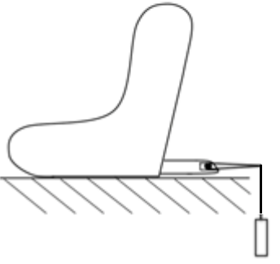
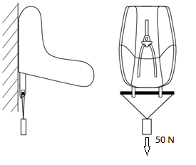
"

* Former titles of the Agreement: Agreement concerning the Adoption of Uniform Conditions of Approval and Reciprocal Recognition of Approval for Motor Vehicle Equipment and Parts, done at Geneva on 20 March 1958 (original version); Agreement concerning the Adoption of Uniform Technical Prescriptions for Wheeled Vehicles, Equipment and Parts which can be Fitted and/or be Used on Wheeled Vehicles and the Conditions for Reciprocal Recognition of Approvals Granted on the Basis of these Prescriptions, done at Geneva on 5 October 1995 (Revision 2).

