E/ECE/324/Rev.2/Add.128/Rev.1/Amend.5−E/ECE/TRANS/505/Rev.2/Add.128/Rev.1/Amend.5
16 January 2019
Agreement
Concerning the Adoption of Harmonized Technical United Nations Regulations for Wheeled Vehicles, Equipment and Parts which can be Fitted and/or be Used on Wheeled Vehicles and the Conditions for Reciprocal Recognition of Approvals Granted on the Basis of these United Nations Regulations*
(Revision 3, including the amendments which entered into force on 14 September 2017)
_________
Addendum 128– UN Regulation No. 129
Revision 1 – Amendment 5
Supplement 4 to the 01 series of amendments – Date of entry into force: 29 December 2018
Uniform provisions concerning the approval of Enhanced Child Restraint Systems used on board of motor vehicles (ECRS)
This document is meant purely as documentation tool. The authentic and legal binding texts is: - ECE/TRANS/WP.29/2018/41.
_________
UNITED NATIONS
Paragraph 7.2.8., amend to read:
"7.2.8. The complete seat, or the component fitted with ISOFIX attachments (e.g. ISOFIX base) if it has a release button, is attached rigidly to a test rig in such a way that ISOFIX connectors are aligned as shown in Figure 3. A 6 mm diameter bar, 350 mm long, shall be attached to the ISOFIX connectors. A force of 50 ± 1 N shall be applied to the extremities of the bar."
Figure 3, amend to read:
"Figure 3
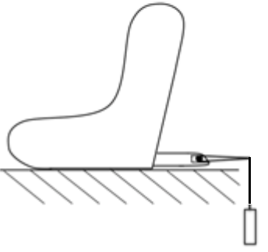
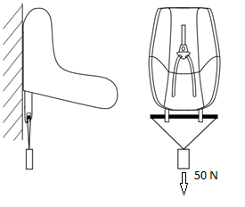
"

* Former titles of the Agreement: Agreement concerning the Adoption of Uniform Conditions of Approval and Reciprocal Recognition of Approval for Motor Vehicle Equipment and Parts, done at Geneva on 20 March 1958 (original version); Agreement concerning the Adoption of Uniform Technical Prescriptions for Wheeled Vehicles, Equipment and Parts which can be Fitted and/or be Used on Wheeled Vehicles and the Conditions for Reciprocal Recognition of Approvals Granted on the Basis of these Prescriptions, done at Geneva on 5 October 1995 (Revision 2).

