E/ECE/324/Rev.2/Add.109/Rev.4/Amend.1−E/ECE/TRANS/505/Rev.2/Add.109/Rev.4/Amend.1
10 August 2018
Agreement
Concerning the Adoption of Harmonized Technical United Nations Regulations for Wheeled Vehicles, Equipment and Parts which can be Fitted and/or be Used on Wheeled Vehicles and the Conditions for Reciprocal Recognition of Approvals Granted on the Basis of these United Nations Regulations*
(Revision 3, including the amendments which entered into force on 14 September 2017)
_________
Addendum 109 – UN Regulation No. 110
Revision 4 –– Amendment 1
Supplement 1 to the 02 series of amendments – Date of entry into force: 19 July 2018
Uniform provisions concerning the approval of:
I. Specific components of motor vehicles using compressed natural gas (CNG) and/or liquefied natural gas (LNG) in their propulsion system
II. Vehicles with regard to the installation of specific components of an approved type for the use of compressed natural gas (CNG) and/or liquefied natural gas (LNG) in their propulsion system
This document is meant purely as documentation tool. The authentic and legal binding texts is: ECE/TRANS/WP.29/2017/115.
_________
UNITED NATIONS
Paragraph 4.16.1., amend to read:
"4.16.1. "Manual valve": as defined in paragraph 4.22. that is rigidly fixed to the cylinder or tank."
Paragraph 4.16.3., amend to read:
"4.16.3. "Excess flow valve": as defined in paragraph 4.21."
Paragraph 4.22., amend to read:
"4.22. "Manual valve" means a valve which is operated manually."
Paragraph 7.1., correct "paragraphs 8.12. to 8.21." to read "paragraphs 8.12. to 8.22.".
Paragraphs 18.1.7.1. and 18.1.7.2., amend to read:
"18.1.7.1. Notwithstanding the provisions of paragraph 18.1.7., vehicles may be fitted with a heating system to heat the passenger compartment and/or the load area or a refrigeration system to cool the cargo compartment which is connected to the CNG and/or LNG system.
18.1.7.2. The heating or refrigeration system referred to in paragraph 18.1.7.1. shall be permitted if, in the view of the Technical Services responsible for conducting type approval, the heating or refrigeration system is adequately protected and the required operation of the normal CNG and/or LNG system is not affected."
Paragraph 18.5.1.3., amend to read:
"18.5.1.3. Notwithstanding the provisions of paragraph 18.5.1.2.:
(a) The automatic cylinder valve may stay in an open position during commanded stop phases; and
(b) In the case where a fire alarm system is installed in the autonomous CNG and/or LNG heater compartment, the automatic valve(s) may be opened by an CNG/LNG electronic control unit to permit the warming of the engine. Any defect or failure of the system shall cause the automatic valve of the cylinder supplying the heating system to close; and
(c) In the case where a fire alarm system is installed in the refrigeration system compartment of the cargo compartment, the automatic valve(s) may be opened by an CNG/LNG electronic control unit to permit the cooling of the cargo compartment. Any defect or failure of the system shall cause the automatic valve of the cylinder supplying the refrigeration system to close."
Annex 1A
Items 1.2.4.5.15. to 1.2.4.5.15.3., amend to read (footnote¹ remains unchanged):
"1.2.4.5.15. Connection to CNG/LNG system for heating system: yes/no¹
or connection to CNG/LNG system for refrigeration system: yes/no¹
1.2.4.5.15.1. Make(s) of the heating system:
1.2.4.5.15.2. Type(s) of the heating system:
1.2.4.5.15.3. Description and drawings of installation of the heating system:"
Insert new items 1.2.4.5.15.4 to 1.2.4.5.15.6, to read:
"1.2.4.5.15.4. Make(s) of the refrigeration system:
1.2.4.5.15.5. Type(s) of the refrigeration system:
1.2.4.5.15.6. Description and drawings of the installation of the refrigeration system:"
Annex 1B
Items 1.2.4.5.15. to 1.2.4.5.15.3., amend to read (footnote ² remains unchanged):
"1.2.4.5.15. Connection to CNG/LNG system for heating system: yes/no²
or connection to CNG/LNG system for refrigeration system: yes/no²
1.2.4.5.15.1. Make(s) of the heating system:
1.2.4.5.15.2. Type(s) of the heating system:
1.2.4.5.15.3. Description and drawings of installation of the heating system:"
Insert new items 1.2.4.5.15.4. to 1.2.4.5.15.6., to read:
"1.2.4.5.15.4. Make(s) of the refrigeration system:
1.2.4.5.15.5. Type(s) of the refrigeration system:
1.2.4.5.15.6. Description and drawings of the installation of the refrigeration system:"
Annex 4A
Paragraph 4.2.4., correct "of Class 1 and Class 2" to read "of Class 2".
Annex 4B
Paragraph 1.6.2.2., amend to read:
"1.6.2.2. The interface type for the hose coupling shall be:
(a) Sealing cone of swivel-nut type of the type with a half vertical angle of 45°; or
(b) Other couplings complying with the tests described in paragraph 1.7., as well as the tests mentioned in Annexes 5A and 5B.
In the case of an interface type using a soft seal body (e.g. O-ring), the type of material chosen shall be tested in accordance with Annexes 5D, 5F and 5G.
Couplings shall have complementary counterparts."
Annex 4H
Paragraph 2.2., correct "than 5 seconds" to read "than 2 seconds".
Annex 4J
Paragraph 2.2., shall be deleted.
Paragraph 3.1.6., correct "shall be not be" to read "shall not be".
Insert new paragraphs 4. and 4.1., to read:
"4. LNG filling receptacle dimensions
4.1. Figure 1 shows the dimensions of the LNG filling receptacle.
Figure 1
Dimensions of the receptacle
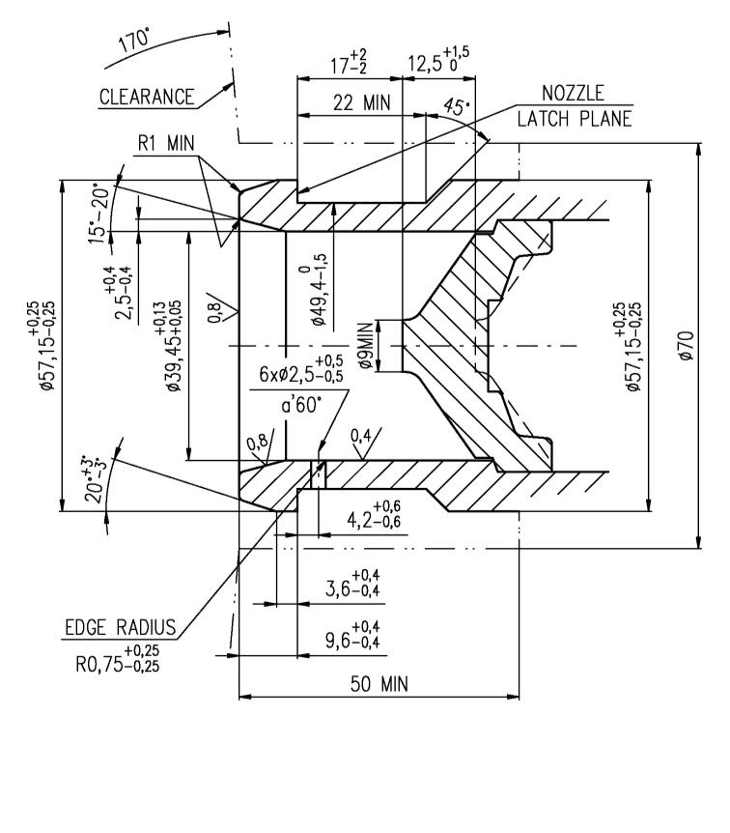"
all dimensions in millimetres
The 50 mm dimension is the minimum distance to the mounting flange

* Former titles of the Agreement: Agreement concerning the Adoption of Uniform Conditions of Approval and Reciprocal Recognition of Approval for Motor Vehicle Equipment and Parts, done at Geneva on 20 March 1958 (original version); Agreement concerning the Adoption of Uniform Technical Prescriptions for Wheeled Vehicles, Equipment and Parts which can be Fitted and/or be Used on Wheeled Vehicles and the Conditions for Reciprocal Recognition of Approvals Granted on the Basis of these Prescriptions, done at Geneva on 5 October 1995 (Revision 2).

