E/ECE/324/Rev.1/Add.21/Rev.4/Amend.2−E/ECE/TRANS/505/Rev.1/Add.21/Rev.4/Amend.2
16 January 2019

Agreement
Concerning the Adoption of Harmonized Technical United Nations Regulations for Wheeled Vehicles, Equipment and Parts which can be Fitted and/or be Used on Wheeled Vehicles and the Conditions for Reciprocal Recognition of Approvals Granted on the Basis of these United Nations Regulations*
(Revision 3, including the amendments which entered into force on 14 September 2017)

Addendum 21 – UN Regulation No. 22
Revision 4 – Amendment 2
Supplement 3 to the 05 series of amendments - Date of entry into force: 29 December 2018
Uniform provisions concerning the approval of protective helmets and their visors for drivers and passengers of motor cycles and mopeds
This document is meant purely as documentation tool. The authentic and legal binding text is: ECE/TRANS/WP.29/2018/38

UNITED NATIONS
Insert a new paragraph 5.1.8., to read:
"5.1.8. The approval marks prescribed in paragraphs 5.1.4., 5.1.5. and 5.2.4. above may not be replaced by a Unique Identifier (UI) as referred to in Schedule 5 of the 1958 Agreement."
Paragraphs 5.1.8. to 5.1.13., renumber as paragraphs 5.1.9. to 5.1.14.
Annex 12, amend to read:
"Annex 12
Type approval scheme (Flow chart)

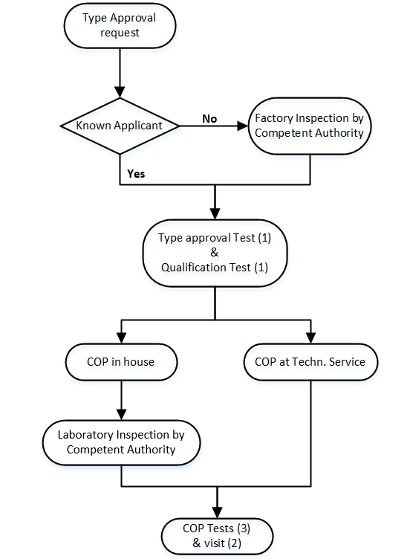

(1) To be carried out at the same technical service or the same accredited independent laboratory.
(2) Visit of the manufacturer for inspection and random sampling by the authority or technical service:
(a) If there is no ISO 9002* or an equivalent standard: 1 times a year
(b) If there is an ISO 9002* or an equivalent standard: 1 time every 1 to 2 years, depending on the results of the inspection.
(3) Tests in accordance to paragraph 10.5 and/or 10.6 on samples taken out of the production:
(a) If there is no ISO 9002*: of the authority or technical service during the visit of footnote 2 a) of the manufacturer between the visits of footnote 2 a)
(b) If there is an ISO 9002*: taken by the manufacturer, procedure checked during visit of footnote 2 b)"

* Former titles of the Agreement: Agreement concerning the Adoption of Uniform Conditions of Approval and Reciprocal Recognition of Approval for Motor Vehicle Equipment and Parts, done at Geneva on 20 March 1958 (original version); Agreement concerning the Adoption of Uniform Technical Prescriptions for Wheeled Vehicles, Equipment and Parts which can be Fitted and/or be Used on Wheeled Vehicles and the Conditions for Reciprocal Recognition of Approvals Granted on the Basis of these Prescriptions, done at Geneva on 5 October 1995 (Revision 2).
* Or an equivalent standard, i.e. one that delivers the same or better levels of quality.

