|  |  |  |
| --- | --- | --- |
|  | E/ECE/324/Rev.1/Add.15/Rev.9/Amend.5−E/ECE/TRANS/505/Rev.1/Add.15/Rev.9/Amend.5 | |
|  |  | 24 June 2019 |

Agreement

Concerning the Adoption of Harmonized Technical United Nations Regulations for Wheeled Vehicles, Equipment and Parts which can be Fitted and/or be Used on Wheeled Vehicles and the Conditions for Reciprocal Recognition of Approvals Granted on the Basis of these United Nations Regulations[1]*

(Revision 3, including the amendments which entered into force on 14 September 2017)

_________

Addendum 15 – UN Regulation No. 16

Revision 9 - Amendment 5

08 series of amendments – Date of entry into force: 28 May 2019

Uniform provisions concerning the approval of:

I. Safety-belts, restraint systems, child restraint systems and ISOFIX child restraint systems for occupants of power-driven vehicles

II. Vehicles equipped with safety-belts, safety-belt reminder, restraint systems, child restraint systems, ISOFIX child restraint systems and i-Size child restraint systems

This document is meant purely as documentation tool. The authentic and legal binding text is: ECE/TRANS/WP.29/2018/141

**_________**

**UNITED NATIONS**

*Insert a new paragraph 8.1.7.4.*, to read:

"8.1.7.4. Paragraphs 8.1.7.1. to 8.1.7.3. shall not apply to a driver’s seat."

*Insert new paragraphs 8.1.8. and 8.1.8.1.,* to read:

"8.1.8. The vehicle shall carry information to the effect that it is equipped with frontal protection airbags for seats.

8.1.8.1. For a vehicle fitted with an airbag assembly intended to protect the driver, this information shall consist of the inscription "AIRBAG" located in the interior of the circumference of the steering wheel; this inscription shall be durably affixed and easily visible"

*Paragraph 8.1.8.*, renumber as 8.1.8.2. and amend to read:

"8.1.8.2. Every passenger seating position which is fitted with a frontal protection airbag shall be provided with a warning against the use of a rearward-facing child restraint in that seating position. This information shall consist of a label containing clear warning pictograms as indicated below:

Figure 1

**Warning label**

…

The overall dimensions of the label shall be at least 120 x 60 mm or the equivalent area.

The label may be adapted in such a way that the layout differs from the example shown here; however, the content shall meet the precise prescriptions. Furthermore, no other type of information shall be included on the label unless it is placed outside a clearly marked rectangle with at least the overall dimensions as required above. In derogation to the aforementioned, a part number, bar code or similar identification mark not exceeding 8 mm x 35 mm or the equivalent area may be placed on the label.

It shall also be ensured that no deviations in the shape and orientation of the provided pictograms are permitted, notably that any customised appearance of the prescribed pictogram images shall be prohibited, with the exception of the hand with pointing index finger and the open face booklet with letter 'i' on its right page provided that they are clearly recognisable as such.

Small irregularities concerning line thickness, label imprinting and other relevant production tolerances shall be accepted.

Figure 2

**Pictogram according to ISO 2575:2004 - Z.01 that shall be used and that shall have an outer diameter of at least 38 mm**



Figure 3

**Pictogram depicting airbag deployment danger that shall be used and that shall measure 40 mm in width and 28 mm in height or proportionally larger**



"

*Paragraph 8.1.9.*, renumber as 8.1.8.3. and amend to read:

"8.1.8.3. In the case of a frontal protection airbag placed before the front passenger seats, the warning shall be durably affixed … interior of the vehicle.

If the vehicle … at all times.

In the case of a frontal protection airbag for other passenger seats in the vehicle … child restraint on that seat.

This paragraph and paragraph 8.1.8.2. do not apply to those passenger seating positions equipped with a device ..."

*Paragraph 8.1.10.*, renumber as 8.1.8.4. and amend to read:

"8.1.8.4. Detailed information, … as a minimum, this information shall include at least the following text:

"NEVER use a rearward facing child restraint on a seat protected by an ACTIVE AIRBAG in front of it, DEATH or SERIOUS INJURY to the CHILD can occur" [2]9

The text shall …"

*Paragraph 8.1.11.*, renumber as paragraph 8.1.9.

*Paragraph 8.4.1.1., the reference to footnote 9 and footnote 9,* renumber asfootnote 10

*Paragraphs 15.5. to 15.10.*, renumber as paragraphs 15.4.1. to 15.4.6.

*Insert new paragraphs 15.5. to 15.5.6.*, to read:

"15.5. As from the official date of entry into force of the 08 series of amendments, no Contracting Party applying this Regulation shall refuse to grant or refuse to accept type approvals under this Regulation as amended by the 08 series of amendments.

15.5.1. As from 1 September 2020, Contracting Parties applying this Regulation shall not be obliged to accept type approvals to the preceding series of amendments that were first issued on or after 1 September 2020.

15.5.2. Until 1 September 2022, Contracting Parties applying this Regulation shall accept type approvals to the preceding series of amendments that were first issued before 1 September 2020.

15.5.3. As from 1 September 2022, Contracting Parties applying this Regulation shall not be obliged to accept type approvals issued to the preceding series of amendments to this Regulation.

15.5.4. Notwithstanding paragraph 15.5.3., Contracting Parties applying this Regulation shall continue to accept type approvals of safety-belts and restraint systems to the preceding series of amendments to the UN Regulation.

15.5.5. Notwithstanding paragraph 15.5.3., Contracting Parties applying this Regulation shall continue to accept type approvals to the preceding series of amendments to this Regulation, for vehicles which are not affected by the changes introduced by the 08 series of amendments.

15.5.6. Contracting Parties applying this Regulation shall not refuse to grant type approvals according to any preceding series of amendments to this Regulation or extensions thereof."

*Annex 2*, amend to read:

"Annex 2

…

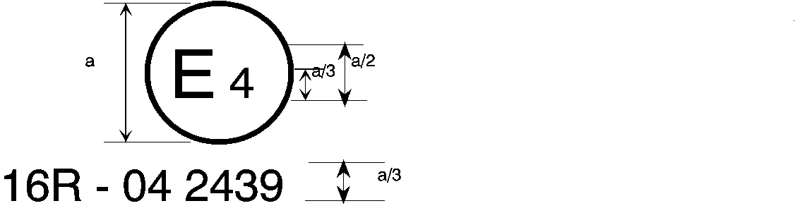

08 2439

The above … amended by the 08 series of amendments.

…

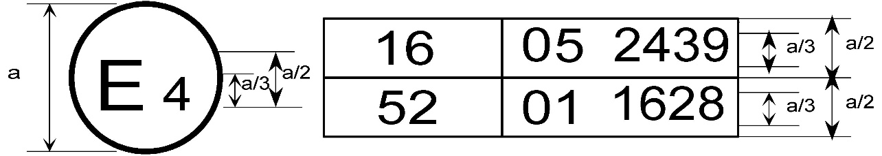

08 2439

The above … included the 08 series of amendments and Regulation No. 52 the 01 series of amendments.

…

2. Arrangements of the safety-belt approval marks (see paragraph 5.3.5. of this Regulation)



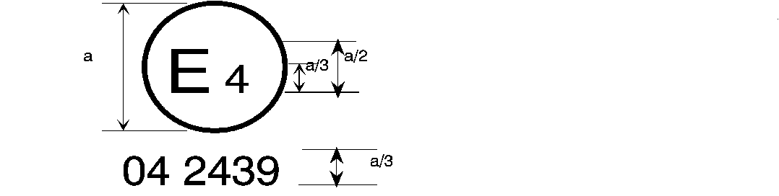

08 2439

a = 8 mm min.

The belt … the 06, 07 or 08 series of amendments at the time of approval.

###### B → 4 m



08 2489

The belt … 06, 07 or 08 series of amendments at the time of approval.

…

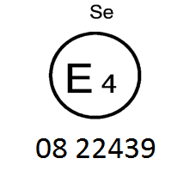

The belt bearing … the 06, 07 or 08 series of amendments at the time of approval.

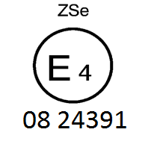

The belt … the 06, 07 or 08 series of amendments at the time of approval.



08 2439

a ≥ 8 mm

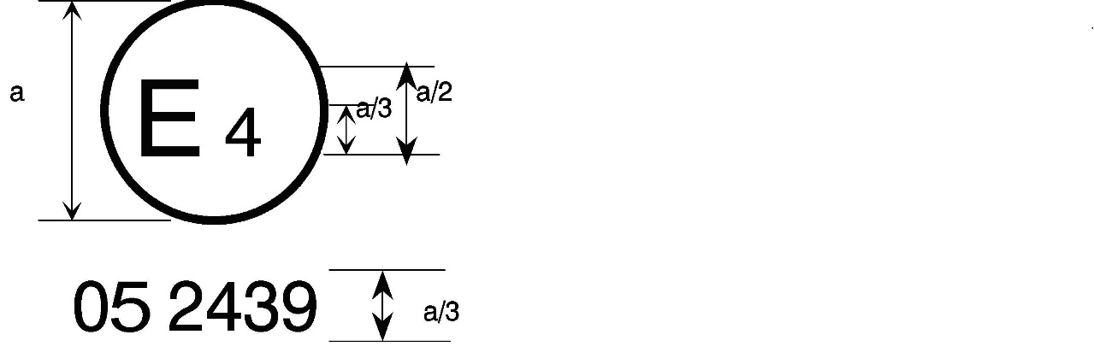

a = 8 mm min.



The belt … the 06, 07 or 08 series of amendments at the time of approval. This belt shall not be fitted to vehicles of category M1.

**Aer4m**

**E4**

**AIRBAG**

**082439**

The … 06, 07 or 08 series of amendments at the time of the approval. This safety-belt has to be fitted to a vehicle equipped with an airbag in the given seating position."

1. * Former titles of the Agreement:

   Agreement concerning the Adoption of Uniform Conditions of Approval and Reciprocal Recognition of Approval for Motor Vehicle Equipment and Parts, done at Geneva on 20 March 1958 (original version);

   Agreement concerning the Adoption of Uniform Technical Prescriptions for Wheeled Vehicles, Equipment and Parts which can be Fitted and/or be Used on Wheeled Vehicles and the Conditions for Reciprocal Recognition of Approvals Granted on the Basis of these Prescriptions, done at Geneva on 5 October 1995 (Revision 2).
2. 9 Unrelated to type approval, Contracting Parties may specify in which languages the text shall be provided with each vehicle placed on the market at the point of sale within their territory.