E/ECE/324/Rev.1/Add.12/Rev.8/Amend.5−E/ECE/TRANS/505/Rev.1/Add.12/Rev.8/Amend.5
2 November 2018
Agreement
Concerning the Adoption of Harmonized Technical United Nations Regulations for Wheeled Vehicles, Equipment and Parts which can be Fitted and/or be Used on Wheeled Vehicles and the Conditions for Reciprocal Recognition of Approvals Granted on the Basis of these United Nations Regulations*
(Revision 3, including the amendments which entered into force on 14 September 2017)
_________
Addendum 12 – UN Regulation No. 13
Revision 8 - Amendment 5
Supplement 15 to the 11 series of amendments – Date of entry into force: 16 October 2018
Uniform provisions concerning the approval of vehicles of categories M, N and O with regard to braking
This document is meant purely as documentation tool. The authentic and legal binding text is: ECE/TRANS/WP.29/2018/9 (as amended by paragraph 90 of the report ECE/TRANS/WP.29/1137).
_________
UNITED NATIONS
Footnote 12, amend to read:
"
¹² Off-road vehicles, special purpose vehicles (e.g. mobile plant using nonstandard vehicle chassis, mobile cranes, hydro-static driven vehicles in which the hydraulic drive system is also used for braking and auxiliary functions, vehicles having a non-standard chassis where the installation of sensor(s) for values of lateral acceleration and/or yaw rate, necessary for the function of the stability control, cannot be installed within the specified area close to the center of gravity of the vehicle without compromising its special purpose), N₂ vehicles which have all of the following features: a gross vehicle mass between 3.5 and 7.5 tonnes, a non-standard low-frame chassis, more than two axles and hydraulic transmission, Class I and Class A buses of categories M₂ and M₃, articulated buses and coaches, N₂ tractors for semi-trailer with a gross vehicle mass (GVM) between 3.5 and 7.5 tonnes shall be excluded from this requirement."
Annex 5,
Paragraphs 2.2. and 2.2.1., shall be deleted
Paragraphs. 2.3. to 2.4.1. (former), shall be renumber as paragraphs 2.2. to 2.3.1.
Annex 12,
Paragraphs 2.3.10. and 2.3.11., shall be deleted.
Paragraph 2.3.12. (former), amend to read and renumber:
"2.3.10. s_{cd} Maximum differential travel that the compensator is capable to accommodate, due to its geometric and constructive properties, when only one brake operates in the forward direction and the other in reverse direction, while allowing equal tension in both cables/rods.
(See Figure 5A of appendix 1)"
Footnote 1, shall be deleted.
Paragraph 8.1.2., amend to read:
"8.1.2. Drawing details are to be provided to demonstrate that the compensator articulation is sufficient to ensure equal cable tension is applied to each of the rear cables. The compensator needs to have sufficient distance across the width to facilitate the differential travels left to right. The jaws of the yokes also need to be deep enough relative to their width to make sure that they do not prevent articulation when the compensator is at an angle.
Differential travel at compensator (s_{cd}) shall be derived from:
S_{cd} ≥ 1.2 • S_{r}"
Annex 12, Appendix 1, Figure 5A, amend to read:
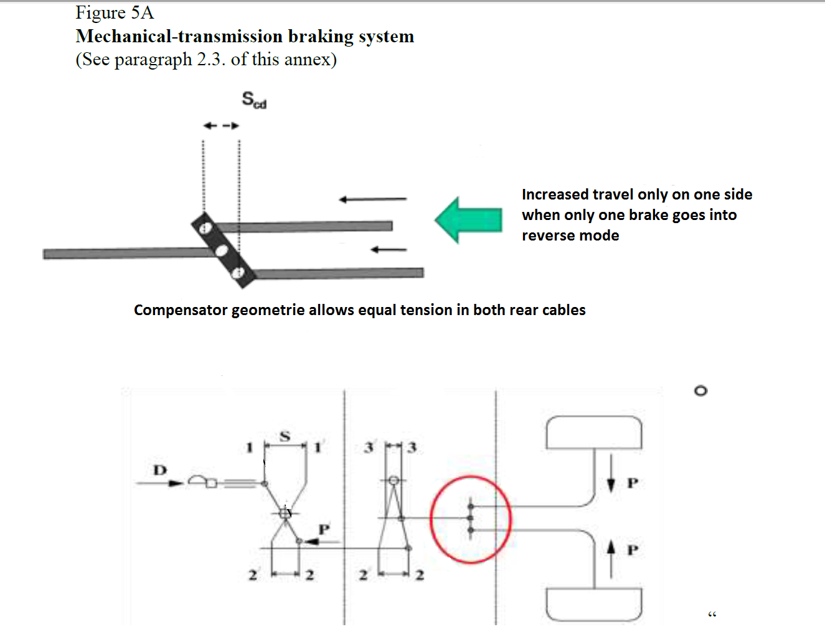
Annex 12, Appendix 4,
Paragraphs 6.1.1. to 6.1.3., shall be deleted
Insert new paragraphs 6.1.1. and 6.1.2., to read:
"6.1.1. Maximum possible differential compensator travel capacity
s_{cd}= mm
6.1.2. Ratio 1.2 * sR = ___________ mm
(shall not be greater than scd)"
Annex 21
Paragraph 2.1.4., second subparagraph, amend to read:
"Additionally, interventions by systems related to the vehicle stability function (including traction control, trailer stability assist, corner brake control, other similar functions that use throttle individual torque control to operate and share common components with vehicle stability function, and ESC or VSF intervention on the steering angle of one or more wheels for the purpose of vehicle stability) may also be indicated to the driver by this flashing optical warning signal."

* Former titles of the Agreement: Agreement concerning the Adoption of Uniform Conditions of Approval and Reciprocal Recognition of Approval for Motor Vehicle Equipment and Parts, done at Geneva on 20 March 1958 (original version); Agreement concerning the Adoption of Uniform Technical Prescriptions for Wheeled Vehicles, Equipment and Parts which can be Fitted and/or be Used on Wheeled Vehicles and the Conditions for Reciprocal Recognition of Approvals Granted on the Basis of these Prescriptions, done at Geneva on 5 October 1995 (Revision 2).

