E/ECE/324/Rev.2/Add.117/Rev.1/Amend.4−E/ECE/TRANS/505/Rev.2/Add.117/Rev.1/Amend.4
11 December 2017
Agreement
Concerning the Adoption of Harmonized Technical United Nations Regulations for Wheeled Vehicles, Equipment and Parts which can be Fitted and/or be Used on Wheeled Vehicles and the Conditions for Reciprocal Recognition of Approvals Granted on the Basis of these United Nations Regulations*
(Revision 3, including the amendments which entered into force on 14 September 2017)
_________
Addendum 117 – UN Regulation No. 118
Revision 1 – Amendment 4
03 series of amendments – Date of entry into force: 10 October 2017
Uniform technical prescriptions concerning the burning behaviour and/or the capability to repel fuel or lubricant of materials used in the construction of certain categories of motor vehicles
This document is meant purely as documentation tool. The authentic and legal binding texts is: - ECE/TRANS/WP.29/2017/18 (1622654).
_________
UNITED NATIONS

List of contents
Item 5., amend to read:
"5. Part I: Approval of a vehicle type with regard to the burning behaviour of the components used in the interior compartment, the engine compartment and any separate heating compartment and with regard to the burning behaviour of electric cables and cable sleeves or cable conduits used in the vehicle and/or the capability to repel fuel or lubricant of insulation materials used in the engine compartment and any separate heating compartment."
Annexes, insert a new reference to Annex 10 to read:
"10. Test to determine the resistance to flame propagation of electrical cables"
Paragraph 1.2. (Scope), amend to read:
"1.2. Part I - Approval of a vehicle type with regard to the burning behaviour and/or the capability to repel fuel or lubricant of the components used in the interior compartment, the engine compartment and any separate heating compartment and with regard to the burning behaviour of electric cables and cable sleeves or cable conduits used for protecting electric cables in the vehicle."
Insert new paragraphs 2.10. to 2.12., to read:
"2.10. "Electrical cable" means a single-core or multi-core cable, when applicable sheathed, screened and unscreened, two or more cores running side by side and bonded, twisted, or braided together, including cores to form a single assembly enabling the transfer of electrical signals from one device to the other.
2.11. "Cable sleeve" means any component that enfolds single cables to a multi-core cable or electrical harness.
2.12. "Cable conduit" means any component that covers electrical cables to guide or route the cables (e.g. tubes, channels, ducts) or fasten electrical cables to the vehicle."
Paragraph 4.2., replace the figure "02" by "03" (2 times).
Paragraphs 5.2.1. and 5.2.2., amend to read:
"5.2.1. The materials inside and no more than 13 mm beyond the interior compartment, materials of the engine compartment, materials of any separate heating compartment and electric cables, cable sleeves or cable conduits used in the vehicle to be type approved shall meet the requirements of Part II of this Regulation.
5.2.2. The materials and/or equipment used in the interior compartment, the engine compartment and any separate heating compartment and/or in devices approved as components, electric cables and cable sleeves or cable conduits used in the vehicle shall be so installed as to minimize the risk of flame development and flame propagation."
Paragraph 6.2.6., amend to read:
"6.2.6. Any electrical cable exceeding a length of 100 mm used in the vehicle shall undergo the resistance to flame propagation test described in Annex 10 to this Regulation. As an alternative to these requirements, the test procedure described in ISO Standard 6722-1:2011, paragraph 5.22. may be applied. Test reports and approvals of components obtained according to ISO 6722:2006, paragraph 12. shall remain valid.
The exposure to the test flame shall be finished:
(1) For single-core cables:
(a) When the conductor becomes visible; or
(b) After 15 s for cables with conductor sizes less or equal than 2.5 mm2; and
(c) After 30 s for cables with conductor sizes greater than 2.5 mm²;
Or
(2) For sheathed, screened and unscreened single- or multi-core cables with a sum of conductor sizes smaller than or equal to 15 mm²:
(a) Until a conductor becomes visible or for 30 s, for all cables, whichever comes first;
Or
(3) For sheathed, screened and unscreened single- or multi-core cables with a sum of conductor sizes greater than 15 mm²:
(a) According to (1) or (2), whichever is applicable.
Electrical cables according to (2) may be tested either completely or separately.
Electrical cables according to (3) shall be tested separately.
The result of the test shall be considered satisfactory if, taking into account the worst test result, any combustion flame of insulating material shall extinguish within 70 seconds and a minimum of 50 mm insulation at the top of the test sample shall remain unburned."
Insert a new paragraph 6.2.7., to read:
"6.2.7. Any cable sleeve or cable conduit exceeding a length of 100 mm shall undergo the test to determine the burning rate of materials as specified in Annex 8. The result of the test shall be considered satisfactory if, taking the worst test results into account, the vertical burning rate is not more than 100 mm/minute or if the flame extinguishes before the destruction of one of the first marker threads occurred."
Paragraphs 6.2.7. to 6.2.7.4. (former), renumber as paragraphs 6.2.8. to 6.2.8.4.
Add new paragraphs 12.11. to 12.14. (Transitional provisions), to read:
"12.11. As from the official date of entry into force of the 03 series of amendments, no Contracting Parties applying this Regulation shall refuse to grant approval under this Regulation as amended by the 03 series of amendment.
12.12. As from 1 September 2019, Contracting Parties applying this Regulation shall grant approvals only if the vehicle type or component type to be approved meet the requirements of this Regulation as amended by the 03 series of amendments.
12.13. As from 1 September 2021, Contracting Parties applying this Regulation may refuse first national registration (first entry into service) of a vehicle which does not meet the requirements of this Regulation as amended by the 03 series of amendments.
12.14. Even after the date of entry into force of the 03 series of amendments, approvals of the components to the preceding series of amendments to the regulation shall remain valid and Contracting Parties applying the Regulation shall continue to accept them."
Annex 5 (Arrangements of approval marks), replace in the figures "02" by "03" (8 times).
Annex 6
Insert a new paragraph 3.1.3., to read:
"3.1.3. The size of the sample shall be mentioned in the test report."
Annex 7
Insert a new paragraph 3.1., to read:
"3.1. The size and the mass of the sample shall be mentioned in the test report."
Annex 8
Paragraph 2.1., amend to read:
"2.1. The specimen holder shall consist of a rectangular frame of 560 mm high and shall have two rigidly connected parallel rods spaced 150 mm apart on which pins shall be fitted for mounting the test specimen which is located in a plane at least 20 mm from the frame. The mounting pins shall be not greater than 2 mm in diameter and at least 40 mm long. The pins shall be located on the parallel rods at locations shown in Figure 1. The frame shall be fitted onto a suitable support to maintain the rods in a vertical orientation during testing (for the purpose of locating the specimen on the pins in a plane away from the frame, spacer stubs 2 mm in diameter may be provided adjacent to the pins).
The specimen holder shown in Figure 1 may be modified in width to allow the fixation of the sample.
To fix the sample in a vertical position, a support may be provided consisting of 0.25 mm diameter heat resistant wires that horizontally span the sample at 25 mm intervals along the complete height of the specimen holder. Alternatively, the sample may be fixed by additional clamps to the specimen holder."
Paragraph 2.3., amend to read:
"2.3. The test apparatus may be placed in a fume cupboard assembly. The size and shape of the fume cupboard shall be such that the test results are not affected. Before the test, the vertical velocity of the air through the fume cupboard shall be measured 100 mm in front of and behind the final position where the test apparatus will be located. It shall be between 0.10 and 0.30 m/s in order to avoid possible discomfort, by combustion products, to the operator. It is possible to use a fume cupboard with natural ventilation and an appropriate air velocity."
Paragraphs 3.1. and 3.2., amend to read:
"3.1. Materials according to paragraph 6.2.3. of this Regulation: The samples dimensions are 560 mm x 170 mm.
If the dimensions of a material do not permit taking a sample of the given dimensions the test shall be carried out taking a sample having the dimensions of at least 380 mm in height and at least 3 mm in width.
Cable sleeves and cable conduits: The samples dimensions are:
length: 560 mm, but at least 380 mm if the dimensions of a material do not permit taking a sample of the given dimensions; width: actual component dimension.
3.2. Materials according to paragraph 6.2.3. of this Regulation: When the thickness of the sample is more than 13 mm, it shall be reduced to 13 mm by a mechanical process applied to the side which does not face the respective compartment (interior, engine or separate heating compartment). If it is impossible, the test shall be carried out in accordance with the Technical Service the initial thickness of the material, which shall be mentioned in the test report. Composite materials (see paragraph 6.1.3.) shall be tested as if they were of uniform construction. In the case of materials made of superimposed layers of different composition which are not composite materials, all the layers of material included within a depth of 13 mm from the surface facing towards the respective compartment shall be tested individually."
Insert a new paragraph 3.3., to read:
"3.3. The size of the sample shall be mentioned in the test report."
Paragraph 3.3. (former), renumber as paragraph 3.4.
Figure 1, amend to read (removing "Burner" at the bottom and replacing "220" by "240"):
"Figure 1
Specimen holder (Dimensions in millimetres)
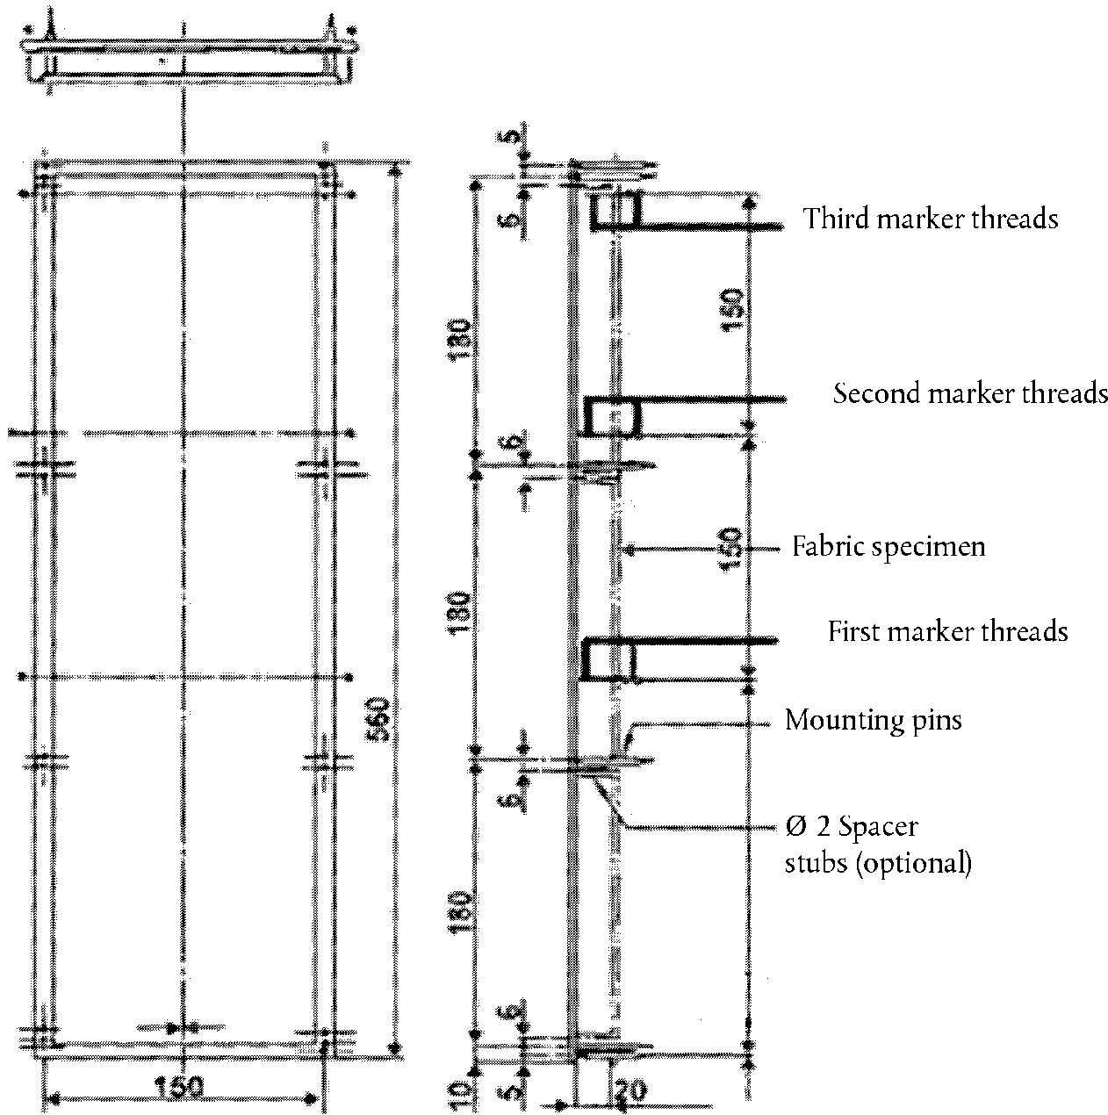
240
"

Insert a new Annex 10, to read:
"Annex 10
Test to determine the resistance to flame propagation of electrical cables
1. Scope
This annex defines prescriptions to test the resistance to flame propagation of electrical cables used in the vehicle.
2. Sampling and principle
2.1. Five samples shall undergo the test
3. Samples
3.1. Test samples shall have a length of at least 600 mm of insulation.
4. Procedure
Determine the resistance to flame propagation using a Bunsen burner with an appropriate gas, having a combustion tube of 9 mm internal diameter, where the flame temperature at the tip of the inner blue cone shall be (950 +/- 50) °C.
Suspend the test sample in a draught-free chamber and expose the test sample to the tip of the inner cone of the flame, as shown in Figure 1. The upper end of the cable shall point away from the closest wall of the chamber. The sample shall be subject to a stress, e.g. by means of a weight over a pulley, in order to keep it straight at all times. The angle of the cable shall be 45° ± 1° relative to the vertical line. In any case, the shortest distance of any part of the sample shall be 100 mm minimum from any wall of the chamber. Apply the flame with the tip of the inner blue cone touching the insulation (500 ± 5) mm from the upper end of the insulation.

Figure 1
Apparatus for resistance to flame propagation (Dimensions in millimetres)
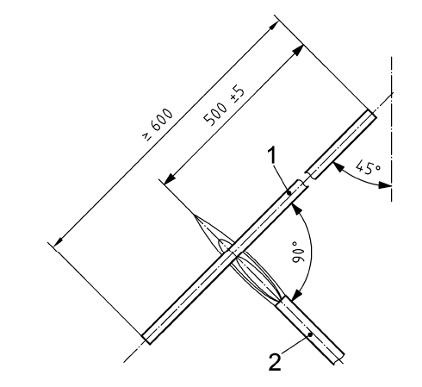

Key
1 test sample
2 Bunsen burner

"

* Former titles of the Agreement: Agreement concerning the Adoption of Uniform Conditions of Approval and Reciprocal Recognition of Approval for Motor Vehicle Equipment and Parts, done at Geneva on 20 March 1958 (original version); Agreement concerning the Adoption of Uniform Technical Prescriptions for Wheeled Vehicles, Equipment and Parts which can be Fitted and/or be Used on Wheeled Vehicles and the Conditions for Reciprocal Recognition of Approvals Granted on the Basis of these Prescriptions, done at Geneva on 5 October 1995 (Revision 2).

