E/ECE/324/Rev.2/Add.111/Rev.3/Amend.4−E/ECE/TRANS/505/Rev.2/Add.111/Rev.3/Amend.4
7 December 2017
Agreement
Concerning the Adoption of Harmonized Technical United Nations Regulations for Wheeled Vehicles, Equipment and Parts which can be Fitted and/or be Used on Wheeled Vehicles and the Conditions for Reciprocal Recognition of Approvals Granted on the Basis of these United Nations Regulations*
(Revision 3, including the amendments which entered into force on 14 September 2017)
_________
Addendum 111 – UN Regulation No. 112
Revision 3 –– Amendment 4
Supplement 7 to the 01 series of amendments – Date of entry into force: 10 October 2017
Uniform provisions concerning the approval of motor vehicle headlamps emitting an asymmetrical passing-beam or a driving-beam or both and equipped with filament lamps and/or light-emitting diode (LED) modules
This document is meant purely as documentation tool. The authentic and legal binding texts is: - ECE/TRANS/WP.29/2017/38 (1622502).
_________

UNITED NATIONS
Paragraph 1.3.1., amend to read:
"1.3.1. The trade name or mark:
(a) Lamps bearing the same trade name or mark but produced by different manufacturers shall be considered as being of different types;
(b) Lamps produced by the same manufacturer differing only by the trade name or mark shall be considered as being of the same type."
Insert a new paragraph 2.4., to read:
"2.4. In the case of a type of lamp differing only by the trade name or mark from a type that has already been approved it shall be sufficient to submit:
2.4.1. A declaration by the lamp manufacturer that the type submitted is identical (except in the trade name or mark) with and has been produced by the same manufacturer as, the type already approved, the latter being identified by its approval code;
2.4.2. Two samples bearing the new trade name or mark or equivalent documentation."
Paragraph 5., amend to read:
"5. General specifications
The requirements contained in sections 5. "General specifications" and 6. "Individual specifications" and in the Annexes referenced in the said sections of UN Regulations Nos. 48, 53, 74 or 86, and their series of amendments in force at the time of application for the lamp type approval shall apply to this Regulation.
The requirements pertinent to each lamp and to the category/ies of vehicle on which the lamp is intended to be installed shall be applied, where its verification at the moment of lamp type approval is feasible.
5.1. …"
Paragraph 6.4.3., amend to read:
"6.4.3. Additional tests are made after the reflector has been moved vertically ± 2° or at least into the maximum position, if less than 2°, from its initial position by means of the headlamps adjusting device. Having re-aimed the headlamp as a whole (by means of the goniometer for example) in the corresponding opposite direction the light output in the following directions shall be controlled and lie within the required limits:
Passing-beam: points B50L and 75 R (B50R and 75 L, respectively);
Driving-beam: I_{M} and point HV (percentage of I_{M})."
Paragraphs 10.1. to 10.5., amend to read:
"10.1. Headlamps shall be so manufactured as to conform to the type approved under this Regulation.
The compliance with the requirements set forth in paragraphs 6. and 7. above shall be verified as follows:
The minimum requirements for Conformity of Production (CoP) control procedures set forth in Annex 5 to this Regulation shall be complied with.
The minimum requirements for sampling by an inspector set forth in Annex 7 to this Regulation shall be complied with.
10.2. The authority which has granted type approval may at any time verify the conformity control methods applied in each production facility. The normal frequency of these verifications shall be once every two years.
10.3. Headlamps with apparent defects are disregarded.
10.4. The reference mark is disregarded.
10.5. The measuring test points 1 to 8 of paragraph 6.2.4. of this Regulation are disregarded."
Paragraph 10.6., shall be deleted.
Annex 2, figures 5 to 10, amend to read:
" ...
Figure 5 Figure 6

The headlamp bearing the above approval mark is a headlamp incorporating a lens of plastic material meeting the requirements of this Regulation in respect of the passing-beam only and is designed:
Figure 5: Class A for left-hand traffic only.
Figure 6: Class B for both traffic systems.
Figure 7 Figure 8
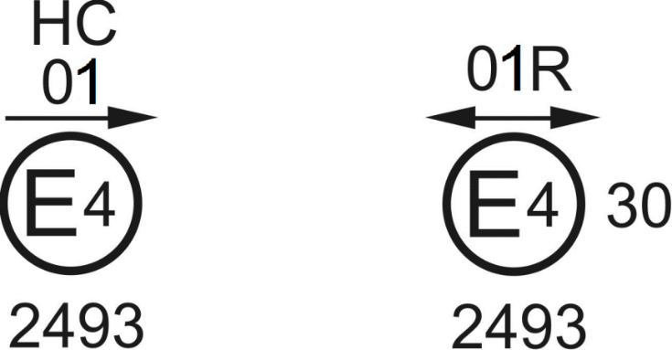
The headlamp bearing the above approval mark is a headlamp meeting the requirements of this Regulation:
Figure 7: Class B in respect of the passing-beam only and is designed for left-hand traffic only.
Figure 8: Class A in respect of the driving-beam only.
Figure 9 Figure 10
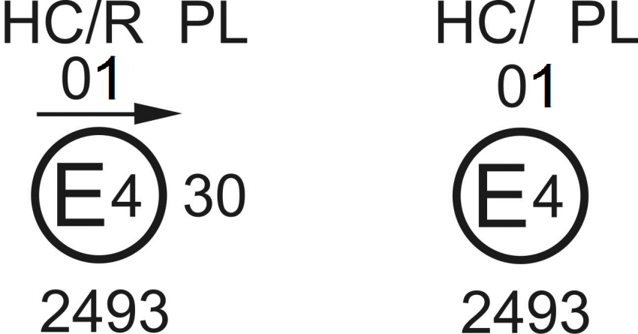
Identification of a headlamp incorporating a lens of plastic material meeting the requirements of this Regulation:
Figure 9: Class B in respect to both the passing-beam and driving-beam and designed for left-hand traffic only.
Figure 10: Class B in respect to the passing-beam only and designed for right-hand traffic only.
The passing-beam shall not be operated simultaneously with the driving-beam and/or another reciprocally incorporated headlamp…"
Annex 3
Figure B, amend to read:

"Figure B

Passing-beam for right-hand traffic
h-h = horizontal plane , v-v = vertical plane passing through the optical axis of the headlamp
The test point locations for left-hand traffic are mirrored about the VV line."
Annex 4
Introductory part, amend to read:
"Tests on complete headlamps
Once the photometric values have been measured according to the prescriptions of this Regulation, in the point for I_{max} for driving-beam and in points 25L, 50 R, B 50 L for passing-beam (or 25R, 50 L, B 50 R for headlamps designed for left-hand traffic) a complete headlamp sample shall be tested for stability of photometric performance in operation. "Complete headlamp" shall be understood to mean the complete lamp itself including those surrounding body parts and lamps which could influence its thermal dissipation.
…"
Paragraph 1.2.1.1.2., amend to read:
"1.2.1.1.2. For headlamp with the outside lens in plastic material:
The mixture of water and polluting agent to be applied to the headlamp shall be composed of:
(a) 9 parts by weight of silica sand with a particle size of 0-100 μm;
(b) 1 part by weight of vegetal carbon dust produced from beech wood with a particle size of 0-100 μm;
(c) 0.2 part by weight of NaCMC³;
(d) 5 parts by weight of sodium chloride (pure at 99 per cent);
(e) 13 parts by weight of distilled water with a conductivity of ≤ 1 mS/m;
(f) 2 ± 1 drops of surfactant.⁴
The mixture shall not be more than 14 days old."
Paragraphs 2.2.1. and 2.2.2, amend to read:
"2.2.1. The result expressed in milliradians (mrad) shall be considered as acceptable for a passing beam headlamp when the absolute value Δ r₁ = ⏐ r₃ – r₆₀ ⏐ recorded on the headlamp is not more than 1.0 mrad (Δ r₁ ≤ 1.0 mrad) upward and not more than 2.0 mrad (Δ r₁ ≤ 2.0 mrad) downwards.
2.2.2. However, if this value is:
Movement
Upward | more than 1.0 mrad but not more than 1.5 mrad  (1.0 mrad < Δr_{I} < 1.5 mrad)
Downward | more than 2.0 mrad but not more than 3.0 mrad  (2.0 mrad < Δr_{I} < 3.0 mrad)
A further sample of a headlamp mounted on a test fixture representative of the correct installation on the vehicle shall be tested as described in paragraph 2.1. above after being subjected three consecutive times to the cycle as described below, in order to stabilize the position of mechanical parts of the headlamp:
(a) Operation of the passing beam for one hour (the voltage shall be adjusted as specified in paragraph 1.1.1.2.);
(b) One hour period with the lamp switched off.
After these three cycles, the headlamp type shall be considered as acceptable if the absolute values Δr measured according to paragraph 2.1. above on this further sample meet the requirements in paragraph 2.2.1. above."
Annex 5
Paragraph 1.2.2.1., amend to read:
"1.2.2.1. For the passing-beam, the values prescribed in this Regulation are met at one point within a circle of 0.35 degrees around points B 50 L (or R) (with a tolerance of 85 cd), 75 R (or L), 50 V, 25 R, 25 L, and in the entire area of zone IV which is not more than 0.52 degrees above line 25 R and 25 L;"
Paragraph 2.4., amend to read:
"2.4. Measured and recorded photometric characteristics
The sampled headlamps shall be subjected to photometric measurements at the points provided for in the Regulation, the reading being limited at the points I_{max}, HV¹, HL, HR² in the case of a driving-beam, and to points B 50 L (or R), 50L (or R), 50 V, 75 R (or L) and 25 L (or R) in the case of the passing-beam (see figure in Annex 3)."
Annex 6
Paragraph 2.6.1.2., amend to read:
"2.6.1.2. Results
After the test, the results of photometric measurements carried out on the headlamp in accordance with this Regulation shall not exceed:
(a) By more than 30 per cent the maximum values prescribed at points B 50 L and by more than 10 per cent below the minimum values prescribed at point 75 R (in the case of headlamps intended for left-hand traffic, the points to be considered are B 50 R and 75 L);
Or
(b) By more than 10 per cent below the minimum values prescribed for HV in the case of a headlamp producing driving-beam only."
Annex 7
Paragraph 1.2.2.1., amend to read:
"1.2.2.1. For the passing-beam, the values prescribed in this Regulation are met at one point of each area delimited on the measuring screen (at 25 m) by a circle 15 cm in radius around points B 50 L (or R)¹ (with a tolerance of 85 cd), 75 R (or L), 50 V, 25 R, 25 L, and in the entire area of zone IV which is not more than 22.5 cm above line 25 R and 25 L;"
Paragraphs 2. to 4., replace and amend to read:
"2. First sampling
In the first sampling four headlamps are selected at random. The first sample of two is marked A, the second sample of two is marked B.
2.1. The conformity of mass-produced headlamps shall not be contested if the deviation of any specimen of samples A and B (all four lamps) is not more than 20 per cent.
In the case, that the deviation of both lamps of sample A is not more than 0 per cent, the measurement can be closed.
2.2. The conformity of mass-produced headlamps shall be contested if the deviation of at least one specimen of samples A or B is more than 20 per cent.
The manufacturer shall be requested to bring his production in line with the requirements (alignment) and a repeated sampling according to paragraph 3. below shall be carried out within two months' time after the notification. The samples A and B shall be retained by the Technical Service until the entire CoP process is finished.
3. First repeated sampling
A sample of four lamps is selected at random from stock manufactured after alignment.
The first sample of two is marked C, the second sample of two is marked D.
3.1. The conformity of mass-produced headlamps shall not be contested if the deviation of any specimen of samples C and D (all four lamps) is not more than 20 per cent.
In the case, that the deviation of both lamps of sample C is not more than 0 per cent, the measurement can be closed.
3.2. The conformity of mass-produced headlamps shall be contested if the deviation of at least:
3.2.1. One specimen of samples C or D is more than 20 per cent but the deviation of all specimen of these samples is not more than 30 per cent.
The manufacturer shall be requested again to bring his production in line with the requirements (alignment).
A second repeated sampling according to paragraph 4. below shall be carried out within two months' time after the notification. The samples C and D shall be retained by the Technical Service until the entire CoP process is finished.
3.2.2. One specimen of samples C and D is more than 30 per cent.
In this case the approval shall be withdrawn and paragraph 5. below shall be applied.
4. Second repeated sampling
A sample of four lamps is selected at random from stock manufactured after alignment.
The first sample of two is marked E, the second sample of two is marked F.
4.1. The conformity of mass-produced headlamps shall not be contested if the deviation of any specimen of samples E and F (all four lamps) is not more than 20 per cent.
In the case, that the deviation of both lamps of sample E is not more than 0 per cent, the measurement can be closed.
4.2. The conformity of mass-produced headlamps shall be contested if the deviation of at least one specimen of samples E or F is more than 20 per cent.
In this case the approval shall be withdrawn and paragraph 5. below shall be applied.
5. Approval withdrawn
Approval shall be withdrawn according to paragraph 11. of this Regulation.
6. Change of the vertical position of the cut-off line
With respect to the verification of the change in vertical positions of the
cut-off line under the influence of heat, the following procedure shall be applied:
One of the headlamps of sample A shall be tested according to the procedure described in paragraph 2.1. of Annex 4 after being subjected three consecutive times to the cycle described in paragraph 2.2.2. of Annex 4.
The headlamp shall be considered as acceptable if Δr does not exceed 1.5 mrad upwards and does not exceed 2.5 mrad downwards.
If this value exceeds 1.5 mrad but is not more than 2.0 mrad upwards or exceeds 2.5 mrad but is not more than 3.0 mrad downwards, the second headlamp of sample A shall be subjected to the test after which the mean of the absolute values recorded in both samples shall not exceed 1.5 mrad upwards and shall not exceed 2.5 mrad downwards.
However, if this value of 1.5 mrad upwards and 2.5 mrad downwards on sample A is not complied with, the two headlamps of sample B shall be subjected to the same procedure and the value of Δr for each of them shall not exceed 1.5 mrad upwards and shall not exceed 2.5 mrad downwards."
Figure 1, shall be deleted.

* Former titles of the Agreement: Agreement concerning the Adoption of Uniform Conditions of Approval and Reciprocal Recognition of Approval for Motor Vehicle Equipment and Parts, done at Geneva on 20 March 1958 (original version); Agreement concerning the Adoption of Uniform Technical Prescriptions for Wheeled Vehicles, Equipment and Parts which can be Fitted and/or be Used on Wheeled Vehicles and the Conditions for Reciprocal Recognition of Approvals Granted on the Basis of these Prescriptions, done at Geneva on 5 October 1995 (Revision 2).

