E/ECE/324/Rev.2/Add.106/Rev.4/Amend.2−E/ECE/TRANS/505/Rev.2/Add.106/Rev.4/Amend.2
26 July 2017
Agreement
Concerning the Adoption of Uniform Technical Prescriptions for Wheeled Vehicles, Equipment and Parts which can be Fitted and/or be Used on Wheeled Vehicles and the Conditions for Reciprocal Recognition of Approvals Granted on the Basis of these Prescriptions*
(Revision 2, including the amendments which entered into force on 16 October 1995)
_________
Addendum 106 – Regulation No. 107
Revision 4 – Amendment 2
Supplement 5 to the 04 series of amendments – Date of entry into force: 22 June 2017
Uniform provisions concerning the approval of category M₂ or M₃ vehicles with regard to their general construction
This document is meant purely as documentation tool. The authentic and legal binding texts is: ECE/TRANS/WP.29/2016/91.
_________

UNITED NATIONS

Annex 3
Paragraph 7.7.5.1., amend to read:
"7.7.5.1. …
In vehicles of Classes II, III and B, the gauging device according to Annex 4, Figure 6 may come into contact with any monitor or display device mounted from the ceiling above the gangway. The maximum force necessary to move any such monitor or display device out of the way, in both directions, shall not exceed 35 Newton. This maximum force shall be applied normal to the middle of the lower edge of the monitor or display device in both directions in turn until the monitor or display device has reached a position which allows clear passage of the gauging device. After being moved out of the way, the monitor or display device shall maintain its position and not automatically redeploy.
If a vehicle of Class I, II or A is …"
Paragraphs 7.7.8.4. to 7.7.8.4.2., amend to read:
"7.7.8.4. Seat spacing (see Annex 4, Figures 12A and 12B)
7.7.8.4.1. In the case of seats facing in the same direction, the distance between the front of a seat squab and the back of the squab of the seat preceding it (dimension H), shall, when measured horizontally, parallel to the longitudinal plane of the vehicle and at all heights above the floor between the level of the top surface of the seat cushion and a point 620 mm above the floor, not be less than:
H
Classes I, A and B | 650 mm
Classes II and III | 680 mm
        - All measurements shall be taken, with the seat cushion and squab uncompressed using the testing gauge shown in Annex 4, Figure 12B."
Annex 4, Figure 12, amend to read:
"Figure 12A
Seat spacing …
…
Figure 12B
Testing gauge for H dimension (see Annex 3, paragraph 7.7.8.4.2.)
Thickness of the gauge: 5 mm maximum
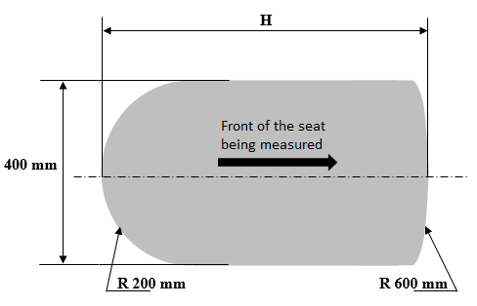"

* Former title of the Agreement: Agreement Concerning the Adoption of Uniform Conditions of Approval and Reciprocal Recognition of Approval for Motor Vehicle Equipment and Parts, done at Geneva on 20 March 1958.

