E/ECE/324/Rev.1/Add.15/Rev.8/Amend.3−E/ECE/TRANS/505/Rev.1/Add.15/Rev.8/Amend.3
18 July 2017
Agreement
Concerning the Adoption of Uniform Technical Prescriptions for Wheeled Vehicles, Equipment and Parts which can be Fitted and/or be Used on Wheeled Vehicles and the Conditions for Reciprocal Recognition of Approvals Granted on the Basis of these Prescriptions*
(Revision 2, including the amendments which entered into force on 16 October 1995)
_________
Addendum 15 — Regulation No. 16
Revision 8 — Amendment 3
Supplement 8 to the 06 series of amendments — Date of entry into force: 22 June 2017
Uniform provisions concerning the approval of:
I. Safety-belts, restraint systems, child restraint systems and ISOFIX child restraint systems for occupants of power-driven vehicles
II. Vehicles equipped with safety-belts, safety-belt reminder, restraint systems, child restraint systems, ISOFIX child restraint systems and i-Size child restraint systems
This document is meant purely as documentation tool. The authentic and legal binding text is: ECE/TRANS/WP.29/2016/98 (as amended by paragraph 75 of the report ECE/TRANS/WP.29/1126).
_________

UNITED NATIONS
Table of content, amend to read:
"Contents
…
Annexes
…
17 Requirements for the installation of safety-belts and restraint systems for adult
occupants of power-driven vehicles on forward facing seats, for the installation of
ISOFIX child restraint systems and i-size child restraint systems
…

Appendix 3:
Example of detailed information e.g. for child restraint system
manufacturers
Appendix 4: Installation of 10-year manikin positions
…"
Text of the Regulation,
Paragraph 2.8, amend to read:
"2.8. "Airbag assembly" means a device … of the passenger compartment. Any such described deployed structure shall not be considered as a rigid part."
Paragraph 5.3.4.2.2.6., amend to read:
"5.3.4.2.2.6. If the safety-belt is approved following the provisions of paragraphs 6.4.1.3.3. and 6.4.1.3.4. of this Regulation, it shall be marked with the word "AIRBAG" in a rectangle."
Insert new paragraph 6.4.1.3.4., to read:
"6.4.1.3.4. In case of a seating position, other than the outboard front seating positions, which is protected with an airbag in front of it, the displacement of the chest reference point may exceed that specified in paragraph 6.4.1.3.2. above if its speed at this value does not exceed 24 km/h in tests performed with the airbag in a vehicle related environment, reflecting the vehicle coordinates of the airbag mounting and attachment points."
Paragraph 6.4.1.4.1., amend to read:
"6.4.1.4.1. The movement of the chest reference point may exceed that specified in Paragraph 6.4.1.3.2. above if it can be shown either by calculation or a further test that no part of the torso or the head of the manikin used in the dynamic test would have come into contact with any forward rigid part of the vehicle other than:"
Insert new paragraphs 6.4.1.4.1.1. and 6.4.1.4.1.2., to read:
"6.4.1.4.1.1. In the case of the driver, contact of the chest with the steering assembly would be allowed, if the latter meets the requirements of Regulation No. 12 and provided contact does not occur at a speed higher than 24 km/h. For this assessment the seat shall be considered to be in the positions specified in paragraph 7.7.1.5. below.
6.4.1.4.1.2. In the case of any other occupant, a contact of the head or of the chest with any rigid part of the vehicle in front of the manikin would not be allowed. Additionally contact of the manikins head with its knees is not allowed.
For this assessment the seat of the tested manikin and, if applicable, the seat in front of the manikin shall be considered to be in the positions specified in paragraph 7.7.1.6. below."
Paragraph 7.7.1.5., amend to read:
"7.7.1.5. For the assessment of the requirements in paragraphs 6.4.1.4.1. and 6.4.1.4.1.1. the seat shall be positioned in its most forward driving position appropriate to the dimensions of the manikin."
Insert new paragraphs 7.7.1.6. to 7.7.1.7., to read:
"7.7.1.6. For the assessment of the requirements in paragraphs 6.4.1.4.1. and 6.4.1.4.1.2. the seat adjustment shall be:
7.7.1.6.1. For front passenger seats: the occupant in the front shall be in its most forward travelling position according to the dimensions of the manikin. The positions of the seats shall be stated in the report.
7.7.1.6.2. For rear seats: For any testing position of rear seated occupants, the position of the tested seating position, shall be considered as positioned to the seats R-Point. If the seat back is adjustable, the seat back angle should be adjusted using the 3-D H Point machine with its torso angle as close as possible to 10°.
The seating position in front of the tested seating position shall be adjusted to the middle position of travel and height or in the nearest locking position thereto. If the seat back of this seat is adjustable, the seat back angle should be adjusted using the 3-D H Point machine with its torso angle as close as possible to 10°.
This may be proven by a contour on CAD or drawing of the in-vehicle situation.
7.7.1.7. Alternatively to paragraphs 7.7.1.5. and 7.7.1.6., in the case where those devices cannot be tested on the test trolley, the manufacturer may demonstrate by a conventional frontal impact test at 50 km/h in conformity with the procedure ISO 3560:2013 that the device complies with the requirements of the Regulation."
Paragraphs 7.7.1.6. and 7.7.1.7. (former), renumber as paragraphs 7.7.1.8. and 7.7.1.9.
Paragraph 7.10.1., amend to read:
"7.10.1. The test report shall record the results of all the tests in paragraph 7. above and in particular:
(a) …
…
(i) For any restrain system other than the driver’s the contour of the contact should be evaluated versus the movement of the manikin in the sled by the technical service in this report.
If by virtue …"
Paragraph 8.3.4., amend to read:
"8.3.4. Safety-belts or restraint systems incorporating retractors shall be so installed that the retractors are able to operate correctly and stow the strap efficiently. In case of both a belt adjusting device for height as well as a flexible shoulder adjustment device for height, in at least its highest and its lowest position, checks shall be made that the retractor automatically adjusts the strap to the shoulder of the concerned wearer after buckling, as well as that the tongue-plate rolls up in case of an unbuckling."
Annex 1B, item 12, footnote 4, amend to read:
_____________
"⁴ "If a safety-belt is approved following the provisions of paragraph 6.4.1.3.3. of this Regulation, this safety-belt shall only be installed in an outboard front seating position protected by an airbag in front of it, under the condition that the vehicle concerned is approved to Regulation No. 94, 01 series of amendments or its later version in force.
If a safety-belt is approved following the provisions of paragraph 6.4.1.3.4. of this Regulation, this safety-belt shall only be installed in a seating position protected by an airbag in front of it."
Annex 1B, insert new item 12.1., to read:
"12.1. In case a restraint system has been granted/extended/,² those can be used for particular types of vehicles compatible with the following dimensional conditions: no interior part in a quoted A-zone as shown below (Figure 2):
Figure 2
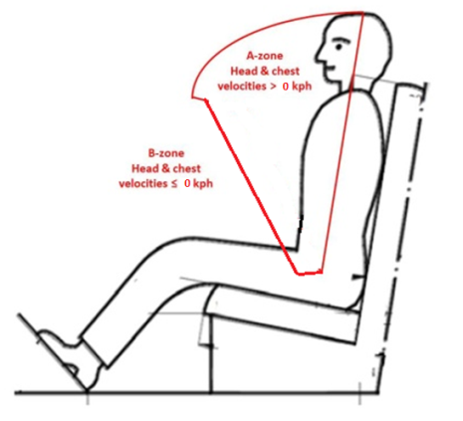
_____________
² Strike out what does not apply.
"
Annex 2, last example, amend to read:
" The safety-belt bearing this type approval mark is a three-point belt ("A") fitted with an energy absorber ("e"), approved as meeting the specific requirements of paragraph 6.4.1.3.3. or 6.4.1.3.4. of this Regulation, and with a multiple-sensitivity ("m") type 4 ("r4") retractor, in respect of which type approval was granted in the Netherlands ("E 4") under the approval number 062439. The first two digits indicate that the Regulation already incorporated the 06 series of amendments at the time of the approval. This safety-belt has to be fitted to a vehicle equipped with an airbag in the given seating position."
Annex 14,
Paragraph 2.2.3., amend to read:
"2.2.3. Results
Test results shall meet the requirements set out in paragraph 6.4.1.3.1. of this Regulation.
The forward displacement of the manikin may be controlled with regard to paragraph 6.4.1.3.2. of this Regulation (or 6.4.1.4. where applicable) during a test performed by means of a simplified adapted method.
A simplified, adapted method could be, e.g., the use of a reference chest speed measured at 300 mm forward displacement carried out in a physical test without an airbag or additional restraint system components, to be considered in the conformity control plan."
Paragraph 2.2.3.1., amend to read:
"2.2.3.1. In the case of approval following paragraph 6.4.1.3.3. or 6.4.1.3.4. of this Regulation and paragraph 1.6.1. of this annex, it is only specified that no part of the belt shall be destructed or disengaged, and that a speed of 24 km/h of the chest reference point at 300 mm displacement shall not be exceeded."
Annex 16, amend to read:

" Annex 16
Safety-belt installation showing the belt types and retractor types
Minimum requirements for safety-belts and Retractors
Vehicle category | Forward facing seating positions |  |  |  |  |  | Rearward-facing  seating positions | Side-facing seating position
 | Outboard seating positions |  |  | Centre seating position
 | Front |  | Other than front | Front |  | Other than front
M₁ | Ar4m |  | Ar4m | Ar4m |  | Ar4m | B, Br3, Br4m | -
M₂ < 3.5 t | Ar4m, Ar4Nm |  | Ar4m, Ar4Nm | Ar4m, Ar4Nm |  | Ar4m, Ar4Nm | Br3, Br4m, Br4Nm | -
M₂ > 3.5 t | Br3, Br4m, Br4Nm, or Ar4m or Ar4Nm ● |  | Br3, Br4m, Br4Nm, or Ar4m or Ar4Nm ● | Br3, Br4m, Br4Nm or Ar4m or Ar4Nm ● |  | Br3, Br4m, Br4Nm or Ar4m or Ar4Nm ● | Br3, Br4m, Br4Nm | -
M₃ | Br3, Br4m, Br4Nm, or Ar4m or Ar4Nm ●  See para. 8.1.7. for conditions when a lap belt is permitted |  | Br3, Br4m, Br4Nm, or Ar4m or Ar4Nm ●  See para. 8.1.7. for conditions when a lap belt is permitted | Br3, Br4m, Br4Nm or Ar4m or Ar4Nm ●  See para. 8.1.7. for conditions when a lap belt is permitted |  | Br3, Br4m, Br4Nm or Ar4m or Ar4Nm ●  See para. 8.1.7. for conditions when a lap belt is permitted | - | B, Br3, Br4m, Br4Nm
N₁ | Ar4m, Ar4Nm |  | Ar4m, Ar4Nm, Br4m, Br4Nm Ø | B, Br3, Br4m, Br4Nm or A, Ar4m, Ar4Nm* ¹ |  | B, Br3, Br4m, Br4Nm | B, Br3, Br4m, Br4Nm | -
 |  |  | Para. 8.1.2.1. lap belt permitted if seat is inboard of a passageway | Para. 8.1.6. lap belt permitted if the windscreen is not in the reference zone
N₂ | Br3, Br4m, Br4Nm orAr4m, Ar4Nm*  Para. 8.1.6. lap belt permitted if the windscreen is outside the reference zone and for the driver's seat |  | B, Br3, Br4m, Br4Nm | B, Br3, Br4m, Br4Nm, or A, Ar4m, Ar4Nm*  Para. 8.1.6. lap belt permitted if the windscreen is not in the reference zone |  | B, Br3, Br4m, Br4Nm | B, Br3, Br4m, Br4Nm | -
N₃ | Br3, Br4m, Br4Nm orAr4m, Ar4Nm*  Para. 8.1.6. lap belt permitted if the windscreen is outside the reference zone and for the driver's seat |  | B, Br3, Br4m, Br4Nm | B, Br3, Br4m, Br4Nm, or A, Ar4m, Ar4Nm*  Para. 8.1.6. lap belt permitted if the windscreen is not in the reference zone |  | B, Br3, Br4m, Br4Nm | B, Br3, Br4m, Br4Nm | -
A: three-point (lap and diagonal) belt  3: automatically locking retractor |  | B: 2-point (lap) belt  4: emergency locking retractor |  |  | r: retractor  N: higher response threshold |  | m: emergency locking retractor with multiple sensitivity
*: Refers to para. 8.1.6. of this Regulation ² |  | Ø: Refers to para. 8.1.2.1. of this Regulation |  |  | ●: refers to para. 8.1.7. of this Regulation² |  | (see Regulation No. 16, paras. 2.14.3. and 2.14.5.)
¹ Erratum to Supplement 12 to the 04 series of amendments, applicable "ab initio."
² Erratum to Revision 4, applicable "ab initio."
Note: In all cases all S-type belts may be fitted in place of all possible A or B type belts, provided their anchorages comply with Regulation No. 14.
Where a harness belt has been approved as a S-type belt according to this Regulation, using the lap belt strap, the shoulder belt straps and possibly one or more retractors, one or two additional crotch straps including their attachments for their anchorages may be provided by the manufacturer/applicant. These additional anchorages need not meet the requirements of Regulation No. 14 (Erratum to Supplement 14 to the 04 series of amendments, applicable "ab initio.")."
"
ECE/TRANS/WP.29/GRSP/2016/12

Annex 17, Appendix 1,
Paragraph 2.7., amend to read:
"2.7. Ensure that the fixture is located with its vertical plane of symmetry within ±25 mm of the vertical plane of symmetry of the seating position."
Paragraph 3.2., amend to read:
"3.2. The lap portion of the belt shall touch the fixture on both sides at the rear of the lap belt path (see Figure 3). The seat belt webbing shall always cover the points BP on the left and right ends of the curved edge; the exact position of point BP on the curved edge is indicated in detail W of Figure 1."
Figures 1 to 3, amend to read:

"Figure 1

Specifications of the fixture (all dimensions in mm)

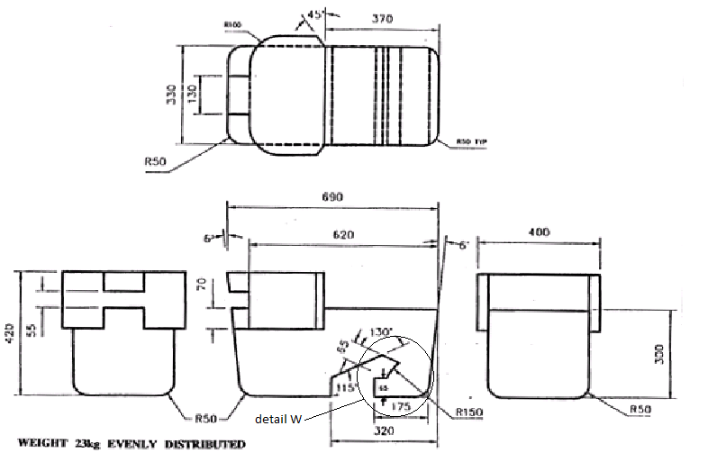

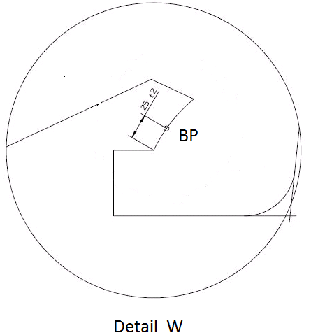
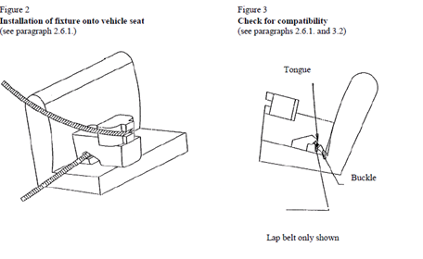"
Annex 17, amend to read:
"Annex 17
Requirements for the installation of safety-belts and restraint systems for adult occupants of power-driven vehicles on forward facing seats, for the installation of ISOFIX child restraint systems and i-size child restraint systems
1. Compatibility with child restraint systems
1.1. The vehicle manufacturer shall include in the vehicle handbook simple advice to the vehicle user on the suitability of each passenger seating position for the fitting of child restraint systems. This information shall be given by pictograms, or in the national language, or at least one of the national languages, of the country in which the vehicle is offered for sale.
For each forward-facing passenger seating position, and for each specified ISOFIX position, the vehicle manufacturer shall indicate:
(a) If the seating position is suitable for child restraints of the "universal" category (see paragraph 1.2. below); and/or
(b) If the seating position is suitable for i-size child restraint systems (see paragraph 1.4. below); and/or
(c) If the seating position is suitable for child restraint systems other than those specified above (e.g. see paragraph 1.3. below).
If a seating position is only suitable for use with forward-facing child restraint systems, this shall also be indicated in the vehicle handbook.
In addition to the above defined information for the vehicle user, the vehicle manufacturers shall make available the information as defined by Appendix 3 of this Annex. For example, this information can be included in separate Annexes of the vehicle handbook, or in technical descriptions of the vehicle or on a dedicated webpage.
1.2. A child restraint system of the universal category means a child restraint approved to the "universal" category of Regulation No. 44, Supplement 5 to 03 series of amendments. Seating positions, which are indicated by the vehicle manufacturer as being suitable for the installation of child restraints systems shall comply with the provisions of Appendix 1 to this annex.
1.3. An ISOFIX child restraint shall be approved to Regulation No. 44, Supplement 5 to 03 series of amendments or to Regulation No. 129. ISOFIX positions, which are indicated by the vehicle manufacturer as being suitable for the installation of ISOFIX child restraints systems shall comply with the provisions of Appendix 2 to this annex.
1.4. An i-Size child restraint means a child restraint approved to the i-Size category of Regulation No. 129. Seating positions, which are indicated by the vehicle manufacturer as being suitable for the installation of i-Size child restraints systems shall comply with the provisions of Appendix 2 to this annex."
Annex 17, Appendix 2, paragraph 2., amend to read:
"2. Test procedure
ISOFIX positions in the vehicle, defined by the vehicle manufacturer shall be checked to ensure that the CRF listed in paragraph 4 of this Appendix can be accommodated. Where the vehicle manufacturer has indicated that the ISOFIX position(s) will accommodate a particular CRF, then it shall be assumed that smaller CRFs of the same orientation may be accommodated.
i-Size seating positions, defined by the vehicle manufacturer, shall be checked to ensure that it is possible to accommodate both the ISO/R2 and the ISO/F2X child restraint fixtures (see paragraph 4 of this Annex) including the i-Size support leg installation assessment volume.
For both, ISOFIX and i-size position(s), the following procedure shall apply:"
Annex 17, Appendix 3,
Tables 1 to 3, shall be deleted
Insert new Table 1, to read:
"Annex 17 – Appendix 3
Example of detailed information e.g. for child restraint system manufacturers

Table 1
This table gives technical information specifically intended e.g. for child restraint system manufacturer and as such translation into national languages is not required.
 | Seating position
Seat position number | 1 | 2 | 3 | 4 | 5 | 6 | 7 | 8 | 9
Seating position suitable for universal belted (yes/ no)
i-Size seating position (yes/no]
Seating position suitable for lateral fixture (L1/ L2)
Largest suitable rearward facing fixture (R1/ R2/ R3)
Largest suitable forward facing fixture (F1/F2/F2X/F3)
1. Add information for each non i-size seating position compatible with a support leg, as described in this regulation.
2. Add information for each seating position equipped with lower ISOFIX anchorages but without Top Tether, according to this regulation.
3. Add information if the adult safety belt buckles are located laterally in between both ISOFIX lower anchorages.
Note:
1. Orientation is normal driving direction; columns for seating positions not available in a vehicle can be deleted.
2. The numbering of seating positions shall be made on basis of following definition:
Seat Number | Position in the vehicle
1 | Front left
2 | Front centre
3 | Front right
4 | 2nd row left
5 | 2nd row centre
6 | 2nd row right
7 | 3rd row left
8 | 3rd row centre
9 | 3rd row right
The information about the seat position number can be given by means of a table or by sketches or pictograms."

* Former title of the Agreement: Agreement Concerning the Adoption of Uniform Conditions of Approval and Reciprocal Recognition of Approval for Motor Vehicle Equipment and Parts, done at Geneva on 20 March 1958.

