|  |  |  |
| --- | --- | --- |
|  | E/ECE/324/Rev.1/Add.98/Rev.3/Amend.2−E/ECE/TRANS/505/Rev.1/Add.98/Rev.3/Amend.2 | |
|  |  | 11 July 2016 |

Agreement

Concerning the Adoption of Uniform Technical Prescriptions for Wheeled Vehicles, Equipment and Parts which can be Fitted and/or be Used on Wheeled Vehicles and the Conditions for Reciprocal Recognition of Approvals Granted on the Basis of these Prescriptions[1]*

(Revision 2, including the amendments which entered into force on 16 October 1995)

_________

Addendum 98 – Regulation No. 99

Revision 3 - Amendment 2

Supplement 11 to the original version of the Regulation – Date of entry into force: 18 June 2016

Uniform provisions concerning the approval of gas-discharge light sources for use in approved gas-discharge lamp units of power-driven vehicles

This document is meant purely as documentation tool. The authentic and legal binding text is: ECE/TRANS/WP.29/2015/81.

**_________**

**UNITED NATIONS**

*Annex 1,*

*List of categories of gas-discharge light sources and their sheet numbers,* amend to read:

"

| *Light source category* |  | *Sheet numbers* |
| --- | --- | --- |
| D1R |  | DxR/1 to 7 |
| D1S |  | DxS/1 to 6 |
| D2R |  | DxR/1 to 7 |
| D2S |  | DxS/1 to 6 |
| D3R |  | DxR/1 to 7 |
| D3S |  | DxS/1 to 6 |
| D4R |  | DxR/1 to 7 |
| D4S |  | DxS/1 to 6 |
| D5S |  | D5S/1 to 5 |
| D6S |  | D6S/1 to 5 |
| D8R |  | D8R/1 to 6 |
| D8S |  | D8S/1 to 5 |
| D9S |  | D9S/1 to 5 |

"

*List of sheets for gas-discharge light sources and their sequence in this annex*, amend to read:

"

|  |  |
| --- | --- |
| *Sheet numbers* |  |
| DxR/1 to 7 | (Sheet DxR/6: two pages) |
| DxS/1 to 6 |  |
| D5S/1 to 5 |  |
| D6S/1 to 5 |  |
| D8R/1 to 6 |  |
| D8S/1 to 5 |  |
| D9S/1 to 5 |  |

"

*Insert new sheets D9S/1 to 5, after D8S/5,* to read (see following pages; one page per sheet):

**Category D9S Sheet D9S/1**

The drawings are intended only to illustrate the essential dimensions (in mm)

Figure 1

**Category D9S - Cap PK32d-9**

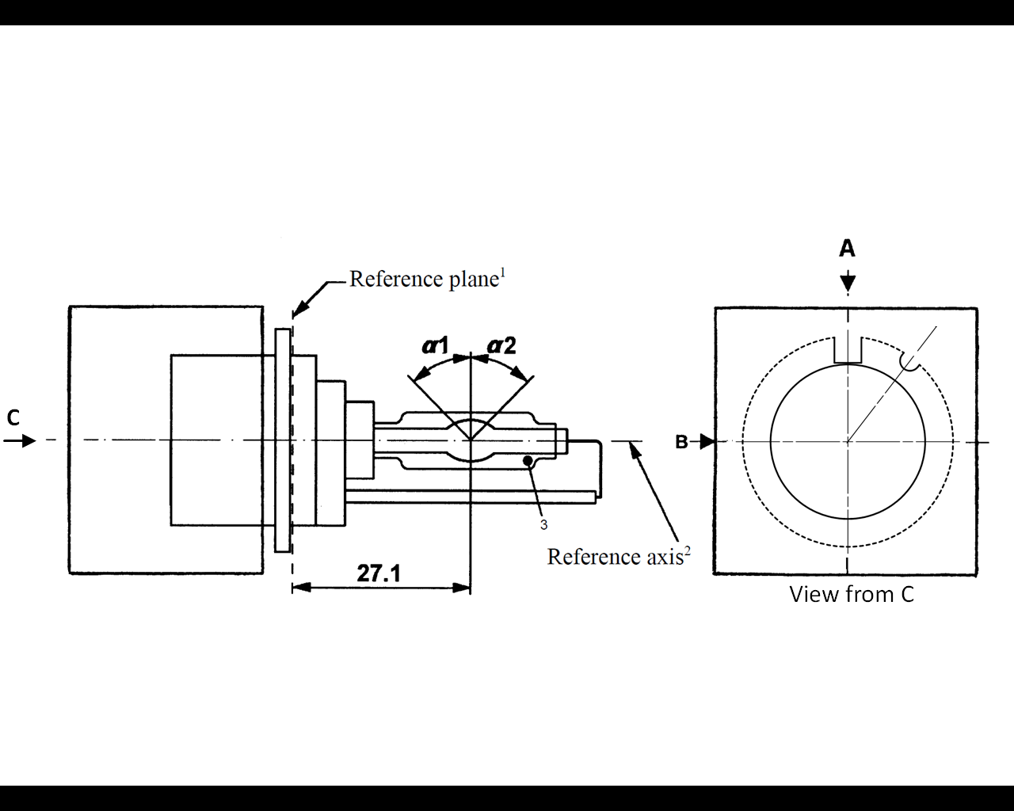

1 The reference plane is defined by the positions on the surface of the holder on which the three supporting bosses of the cap ring will rest.

2 See sheet D9S/2.

3 When measured at a distance of27.1 mm from the reference plane and with respect to the mid-point of the inner bulb, the outer bulb shall have an eccentricity of 1 mm max.

**Category D9S Sheet D9S/2**

Figure 2

**Definition of reference axis1**

The cap shall be pushed in this direction



Reference axis

Figure 3

**Maximum lamp outline2**



52

**Reference axis**

1 The reference axis is perpendicular to the reference plane and crosses the intersection of the two parallel lines as indicated in Figure 2.

2 Glass bulb and supports shall not exceed the envelope, as indicated in Figure 3. The envelope is concentric with the reference axis.

**Category D9S Sheet D9S/3**

|  |  |  |  |  |  |  |  |
| --- | --- | --- | --- | --- | --- | --- | --- |
| *Dimensions* | | | | *Production*  *light sources* | | *Standard*  *light sources* | |
| Position of the electrodes | | | | Sheet D9S/4 | | | |
| Position and form of the arc | | | | Sheet D9S/5 | | | |
| α1, α2 1 | | | | 55° min. | | 55° min. | |
| D9S: Cap PK32d-9 | | in accordance with IEC Publication 60061 (sheet 7004-111-5) | | | | | |
| Electrical and photometric characteristics | | | | | | | |
| Rated voltage of the ballast | | | V | 12 2 | | 12 | |
| Rated wattage | | | W | 27 | 35 | 27 | 35 |
| Test voltage | | | V | 13.5 | | 13.5 | |
| Objective lamp voltage | | | V | 34 ± 6 | 38 ± 8 | 34 ± 4 | 38 ± 4 |
| Objective lamp wattage | | | W | 27 ± 3 | 35 ± 3 | 27 ± 0.5 | 35 ± 0.5 |
| Objective Luminous flux | | | lm | 2000 ± 300 | 3000 ± 450 | 2000 ± 100 | 3000 ± 150 |
| Chromaticity coordinates | Objective | |  | x = 0.375 | | y = 0.375 | |
| Tolerance area 3 | | Boundaries | x = 0.345  x = 0.405 | | y = 0.150 + 0.640 x  y = 0.050 + 0.750 x | |
| Intersection  points | x = 0.345 | | y = 0.371 | |
| x = 0.405 | | y = 0.409 | |
| x = 0.405 | | y = 0.354 | |
| x = 0.345 | | y = 0.309 | |
| Hot-restrike switch-off time | | | s | 10 | | 10 | |

1 The part of the bulb within the angles α1 and α2 shall be the light emitting part. This part shall be as homogeneous in form as possible and shall be optically distortion free. This applies to the whole bulb circumference within the angles α1 and α2.

2 Application voltages of ballasts may differ from 12 V.

3 See Annex 4.

**Category D9S Sheet D9S/4**

Position of the electrodes

This test is used to determine whether the electrodes are correctly positioned relative to the reference axis and the reference plane.

Side and top view (schematic):

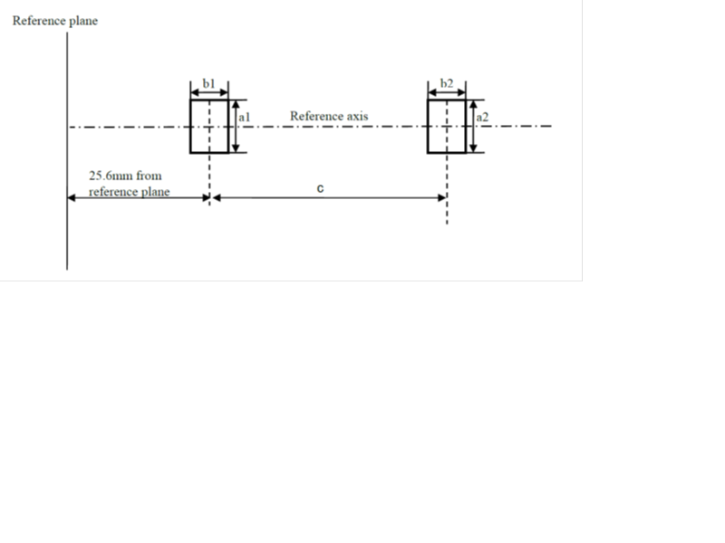

Reference plane

Reference axis

25.6 mm from  
reference plane

b1

b2

a1

a2

c

Measuring direction: light source side and top view

|  |  |  |  |
| --- | --- | --- | --- |
| *Dimension*  *in* *mm* | *Production*  *light* *sources* | *Standard*  *light* *sources* | The arc attachment point to the electrode nearest to the reference plane shall be positioned in the area defined by a1 and b1. The arc attachment point to the electrode furthest from the reference plane shall be positioned in the area defined by a2 and b2. The geometrical data is valid for 27W and 35W operation. |
| a1 | 0.30 | 0.20 |
| a2 | 0.50 | 0.25 |
| b1 | 0.30 | 0.15 |
| b2 | 0.60 | 0.30 |
| c | 3.00 | 3.00 |

**Category D9S Sheet D9S/5**

Position and form of the arc

This test is used to determine the form of the arc and its position relative to the reference axis and the reference plane by measuring its bending and diffusion in the cross section at a distance 27.1 mm from the reference plane.

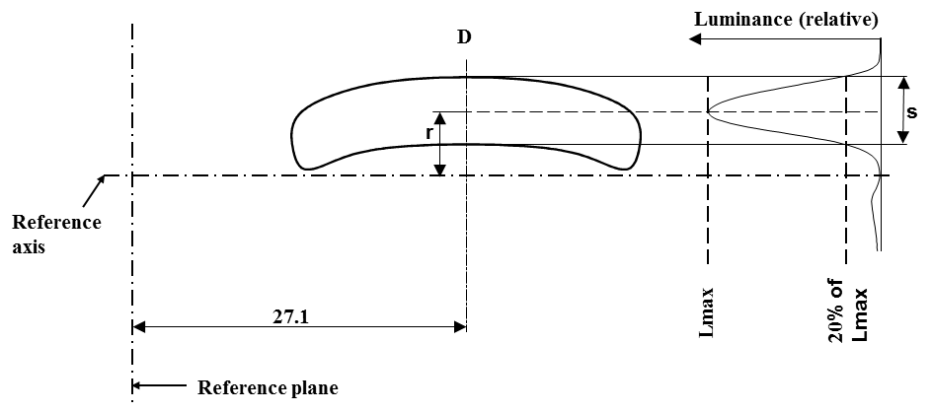

|  |  |  |
| --- | --- | --- |
|  |  |  |
| Relative luminance distribution in the central cross section D. | The form of the arc is for illustration purpose only. | Measuring direction:  light source side view |

When measuring the relative luminance distribution in the central cross section as indicated in the drawing above, the maximum value shall be located within the distance r from the reference axis. The point of 20 per cent of the maximum value shall be within s. The geometrical data is valid for 27W and 35W operation.

|  |  |  |
| --- | --- | --- |
| *Dimension* *in* *mm* | *Production* *light* *sources* | *Standard* *light* *sources* |
| r (arc bending) | 0.35 +/- 0.25 | 0.35 +/- 0.15 |
| s (arc diffusion) | 0.80 +/- 0.25 | 0.80 +/- 0.15 |

"

1. * Former title of the Agreement: Agreement Concerning the Adoption of Uniform Conditions of Approval and Reciprocal Recognition of Approval for Motor Vehicle Equipment and Parts, done at Geneva on 20 March 1958.