E/ECE/324/Rev.2/Add.127/Amend.4−E/ECE/TRANS/505/Rev.2/Add.127/Amend.4
9 November 2015
Agreement
Concerning the Adoption of Uniform Technical Prescriptions for Wheeled Vehicles, Equipment and Parts which can be Fitted and/or be Used on Wheeled Vehicles and the Conditions for Reciprocal Recognition of Approvals Granted on the Basis of these Prescriptions*
(Revision 2, including the amendments which entered into force on 16 October 1995)
_________
Addendum 127 – Regulation No. 128
Amendment 4
Supplement 4 to the original version of the Regulation – Date of entry into force:
8 October 2015
Uniform provisions concerning the approval of light emitting diode (LED) light sources for use in approved lamp units on power-driven vehicles and their trailers
This document is meant purely as documentation tool. The authentic and legal binding texts are: - ECE/TRANS/WP.29/2015/33
- ECE/TRANS/WP.29/2015/33/Corr.1.
_________

UNITED NATIONS

Paragraph 3.8., the table, amend to read:
"
λ | S(λ) |  | λ | S(λ) |  | λ | S(λ)
250 | 0.430 |  | 305 | 0.060 |  | 355 | 0.000 16
255 | 0.520 |  | 310 | 0.015 |  | 360 | 0.000 13
260 | 0.650 |  | 315 | 0.003 |  | 365 | 0.000 11
265 | 0.810 |  | 320 | 0.001 |  | 370 | 0.000 09
270 | 1.000 |  | 325 | 0.000 50 |  | 375 | 0.000 077
275 | 0.960 |  | 330 | 0.000 41 |  | 380 | 0.000 064
280 | 0.880 |  | 335 | 0.000 34 |  | 385 | 0.000 053
285 | 0.770 |  | 340 | 0.000 28 |  | 390 | 0.000 044
290 | 0.640 |  | 345 | 0.000 24 |  | 395 | 0.000 036
295 | 0.540 |  | 350 | 0.000 20 |  | 400 | 0.000 030
300 | 0.300
"
Annex 1,
The list of categories of LED light sources and their sheet numbers, amend to read:
"
 | Category |  | Sheet number(s)
 | LR1 |  | LR1/1 to 5
 | LW2 |  | LW2/1 to 5
 | LR3A |  | LR3/1 to 5
 | LR3B |  | LR3/1 to 5
 | LR4A |  | LR4/1 to 5
 | LR4B |  | LR4/1 to 5
"
The list of sheets for LED light sources and their sequence in this annex, amend to read:
"
Sheet number(s)
LR1/1 to 5
LW2/1 to 5
LR3/1 to 5
LR4/1 to 5
"
After sheet LW2/5, insert new sheets LR3/1 to 5 and LR4/1 to 5, to read (see following pages; one page per sheet):
Categories LR3A and LR3B Sheet LR3/1
The drawings are intended only to illustrate the essential dimensions of the LED light source
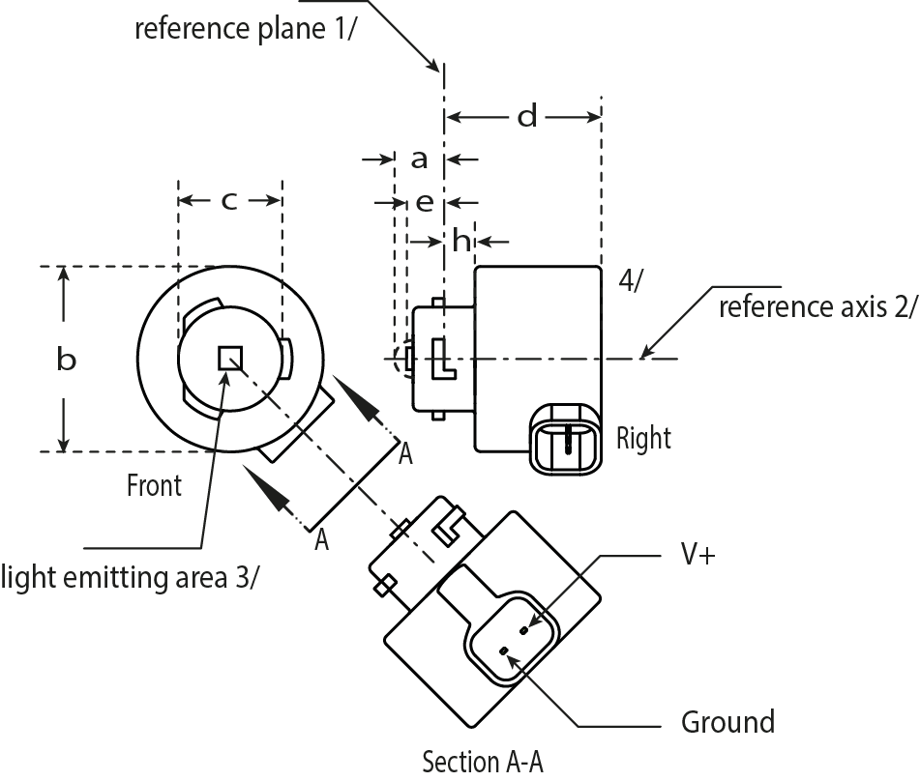
Reference axis ²
Reference plane ¹
Reference axis ²
Right
Right
Right
Front
Light emitting area ³
Ground
Section A-A
⁴

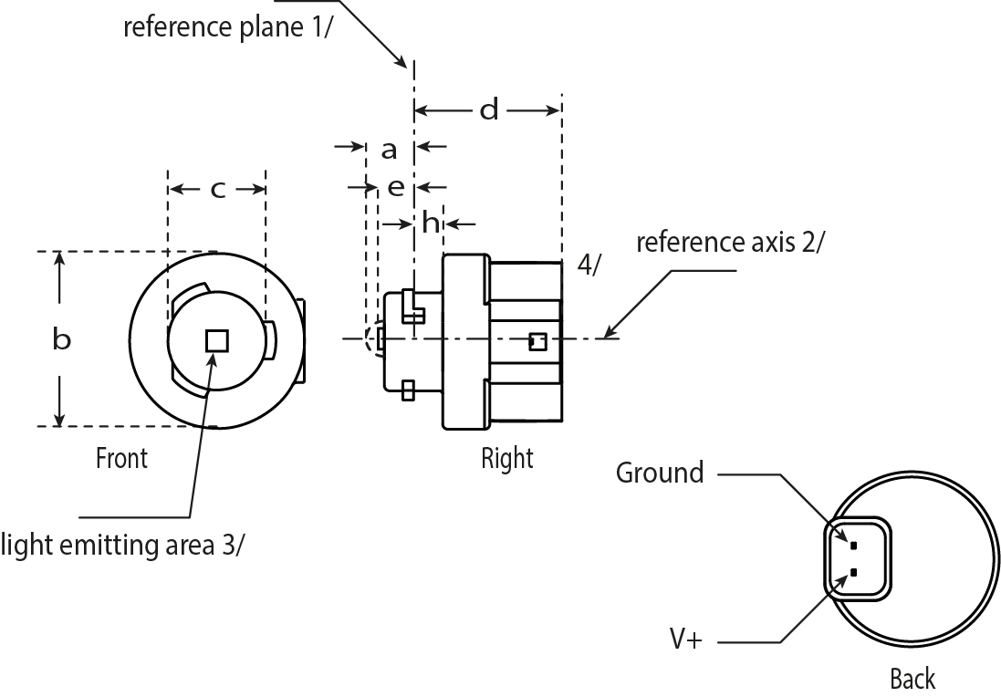
V+
Reference plane ¹
Reference axis ²
Right
Front
Light emitting area ³
Ground
Back
⁴
Figure 1*
Main Drawing, LR3A (top) and LR3B (bottom)
For the notes see sheet LR3/2.
* Projection method:

Categories LR3A and LR3B Sheet LR3/2

Table 1
Essential electrical and photometric characteristics of the LED light source

Dimensions |  |  | Production LED light sources | Standard LED light sources
a |  | mm | 6.0 max.
b |  | mm | c + 10.0 min.  38.0 max.
c |  | mm | 18.5 ± 0.1
d |  | mm | 28.0 max.
e |  | mm | 3.0 ± 0.30 | 3.0 ± 0.15
h |  | mm | 5.5 + 0.0/ – 0.1
Cap PGJ18.5d-1 in accordance with IEC Publication 60061 (sheet 7004-185-1)
Electrical and photometric characteristics ⁵
Rated values | Volts |  | 12
 | Watts |  | 3
Objective Values ⁶ | Watts  (at 13.5 V DC) |  | 3.5 max. | 3.5 max.
 | Luminous flux  (in lm at 13.5 V DC) |  | 80 ± 20% ⁷ | 80 ± 10% ⁸
 | Luminous flux  (in lm at 9 V DC) |  | 19 min.
¹ The reference plane is the plane defined by the contact points of the cap-holder fit.
² The reference axis is perpendicular to the reference plane and passing through the centre of the bayonet core.
³ Light emitting area: to be checked by means of the box system in Figure 2
⁴ A minimum free air space of 5mm around the light source shall be respected for convection.
⁵ The emitted light shall be red.
⁶ After continuous operation for 30 minutes at 23 ± 2.5° C.
⁷ The measured value shall be in between 100 per cent and 70 per cent of the value measured after 1 minute.
⁸ The measured value shall be in between 85 per cent and 75 per cent of the value measured after 1 minute.

Electrical characteristics

In case of LED light source failure (no light emitted) the max. electrical current draw, when operated between 12 V and 14 V, shall be less than 20 mA (open circuit condition).

Categories LR3A and LR3B Sheet LR3/3

Screen projection requirements

The following test is intended to define the requirements for the apparent light emitting area of the LED light source and to determine whether the light emitting area is correctly positioned relative to the reference axis and reference plane in order to check compliance with the requirements.

The position of the light emitting area is checked by the box system defined in Figure 2, which is aligned to the planes C90 and C180 and shows the projection when viewing along direction γ=0º (C, γ as defined in Figure 3).

The proportion of the total luminous flux emitted into the viewing direction shall be as described in table 3.

f/3
Reference axis
perpendicular in the
centre of the light-
emitting area
f/3
f/3
f/3
f/3
f/3
AA
BB
BB
BB
BB
CC
CC
CC
CC
f/2
f/2

Figure 2

Box definition of the light emitting area with dimensions as specified in table 2

Table 2

Dimensions of the box system in Figure 2

Dimensions in mm | f
LED light sources of normal production | 3.0
Standard LED light sources | 3.0

Table 3

Proportion of the total luminous flux emitted into the viewing direction from the areas specified in figure 2

Area(s) | LED light sources of normal production | Standard LED light sources
A | ≤ 25% | ≤ 10%
Each B individually | ≥ 15% | ≥ 20%
Each C individually | - | ≤ 10%
A, all B and all C together | ≥ 90% | ≥ 90%
Categories LR3A and LR3B Sheet LR3/4

Normalized luminous intensity distribution

The following test is intended to determine the normalized luminous intensity distribution of the light source in an arbitrary plane containing the reference axis. The intersection of the reference axis and the parallel plane to the reference plane in distance e is used as the coordinate system origin.

The light source is mounted on a flat plate with the corresponding mounting lug features. The plate is mounted to the goniometer table by a bracket, so that the reference axis of the light source lines up with one of the rotating axis of the goniometer. The corresponding measurement set-up is described in Figure 3.

Luminous intensity data is recorded with a standard photo-goniometer. The measurement distance should be chosen appropriately, to make sure that the detector is located in the far field of the light distribution.
The measurements shall be performed in C-planes C0/180 and C90/270, which contain the reference axis of the light source. The test points for each plane for multiple polar angles γ are specified in Table 4.

After measurement the data shall be normalized to 1,000 lm according to Paragraph 3.1.11 using the luminous flux of the individual light source under test. The data shall comply with the tolerance band as defined in Table 4.

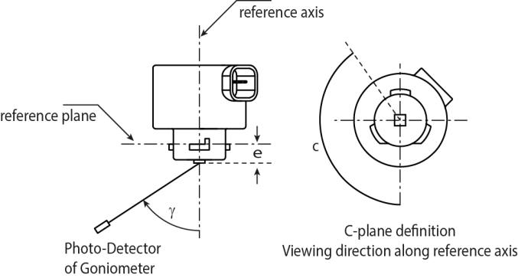The drawings are intended only to illustrate the essential set-up for measurement of the LED light source.
Reference axis
Reference plane
Photo-Detector of Goniometer
C-plane definition
Viewing direction along reference axis
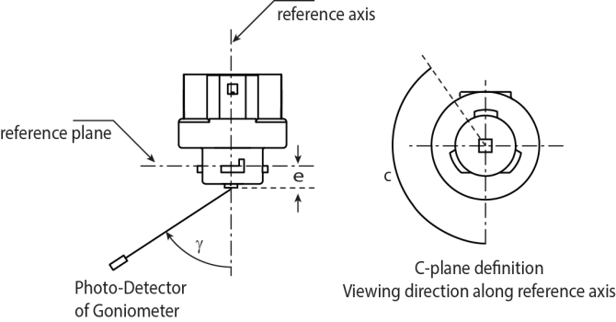
Reference axis
Reference plane
Photo-Detector of Goniometer
C-plane definition
Viewing direction along reference axis

Figure 3

Set-up to measure the luminous intensity distribution, LR3A (top) and LR3B (bottom)
Categories LR3A and LR3B Sheet LR3/5

The light pattern as described in Table 4 shall be substantially uniform, i.e. in between two adjacent grid points the relative luminous intensity requirement is calculated by linear interpolation using the two adjacent grid points. In case of doubt this may be checked in addition to verification of the grid points given in table 4.

Table 4
Test point values of normalized intensities of normal production and standard lamps, respectively.

 | LED lamps of normal production |  | Standard LED lamps
Angle γ | Minimum Intensity  in cd /1000 lm | Maximum Intensity  in cd/1000 lm | Minimum Intensity  in cd /1000 lm | Maximum Intensity in cd /1000 lm
-90° | 0 | 38 | 0 | 25
-75° | 0 | 160 | 0 | 140
-60° | 98 | 246 | 127 | 220
-45° | 142 | 305 | 181 | 275
-30° | 169 | 352 | 213 | 315
-15° | 192 | 389 | 239 | 340
0° | 200 | 401 | 248 | 352
15° | 192 | 389 | 239 | 340
30° | 169 | 352 | 213 | 315
45° | 142 | 305 | 181 | 275
60° | 98 | 246 | 127 | 220
75° | 0 | 160 | 0 | 140
90° | 0 | 38 | 0 | 25

Categories LR4A and LR4B Sheet LR4/1

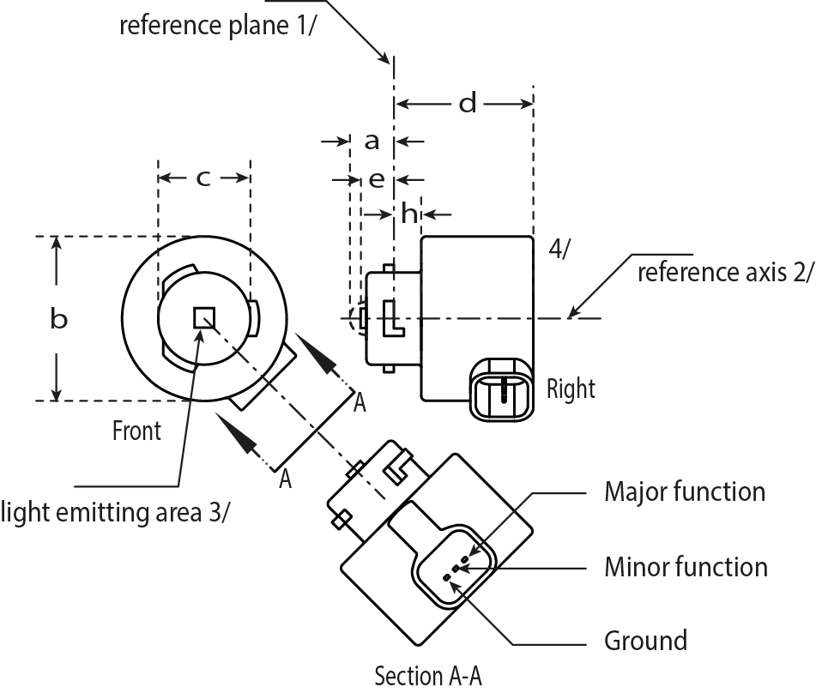The drawings are intended only to illustrate the essential dimensions of the LED light source
Reference plane ¹
Reference axis ²
Right
Light emitting area ³
Front
Ground
Section A-A
Major function
Minor function
⁴
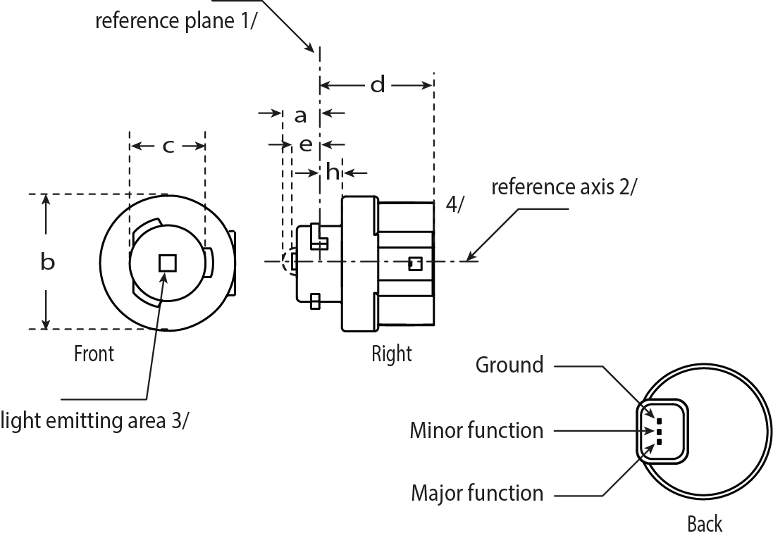
Reference plane ¹
Reference axis ²
Right
Major function
Minor function
Ground
Light emitting area ³
Back
Front
⁴
Figure 1*
Main Drawing, LR4A (top) and LR4B (bottom)
For the notes see sheet LR4/2.
* Projection method:
Categories LR4A and LR4B Sheet LR4/2

Table 1
Essential electrical and photometric characteristics of the LED light source

Dimensions |  |  | Production LED light sources |  | Standard LED light sources
a |  | mm | 6.0 max.
b |  | mm | c + 10.0 min.  38.0 max.
c |  | mm | 18.5 ± 0.1
d |  | mm | 28.0 max.
e |  | mm | 3.0 ± 0.30 |  | 3.0 ± 0.15
h |  | mm | 5.5 + 0.0/ – 0.1
Cap PGJ18.5t-5 in accordance with IEC Publication 60061 (sheet 7004-185-1)
Electrical and photometric characteristics ⁵
Rated values |  |  | Minor function | Major function | Minor function | Major function
 | Volts |  | 12 |  | 12
 | Watts |  | 0.75 | 3 | 0.75 | 3
Objective  Values ⁶ | Watts  (at 13.5 V DC) |  | 1.0 max. | 3.5 max. | 1.0 max. | 3.5 max.
 | Luminous flux  (in lm at 13.5 V DC) |  | 6 ± 20% | 80 ± 20% ⁷ | 6 ± 10% | 80 ± 10% ⁸
 | Luminous flux  (in lm at 9 V DC) |  | 1.5 min. | 19 min.

¹ The reference plane is the plane defined by the contact points of the cap-holder fit.
² The reference axis is perpendicular to the reference plane and passing through the centre of the Bayonet core.
³ Light emitting area: to be checked by means of the box system in Figure 2
⁴ A minimum free air space of 5mm around the light source shall be respected for convection.
⁵ The emitted light shall be red.
⁶ After continuous operation for 30 minutes at 23 ± 2.5° C.
⁷ The measured value shall be in between 100 per cent and 70 per cent of the value measured after 1 minute.
⁸ The measured value shall be in between 85 per cent and 75 per cent of the value measured after 1 minute.

Electrical characteristics

In case of LED light source failure (no light emitted) the max. electrical current draw, when operated between 12 V and 14 V, shall be less than 20 mA (open circuit condition).
The major and the minor function shall be operated by separate electrical circuits.

Categories LR4A and LR4B Sheet LR4/3

Screen projection requirements

The following test is intended to define the requirements for the apparent light emitting area of the LED light source and to determine whether the light emitting area is correctly positioned relative to the reference axis and reference plane in order to check compliance with the requirements.

The position of the light emitting area is checked by the box system defined in Figure 2, which is aligned to the planes C90 and C180 and shows the projection when viewing along direction γ=0º (C, γ as defined in Figure 3).

The proportion of the total luminous flux emitted into the viewing direction shall be as described in table 3.

f/3
Reference axis
perpendicular in the
centre of the light-
emitting area
f/3
f/3
f/3
f/3
f/3
AA
BB
BB
BB
BB
CC
CC
CC
CC
f/2
f/2

Figure 2

Box definition of the light emitting area with dimensions as specified in table 2

Table 2

Dimensions of the box system in Figure 2

Dimensions in mm | f
LED light sources of normal production | 4.5
Standard LED light sources | 4.5

Table 3

Proportion of the total luminous flux emitted into the viewing direction from the areas specified in figure 2

Function | Area(s) | LED light sources of normal production | Standard LED light sources
Minor | A | ≥ 75% | ≥ 80%
Major | A | ≤ 25% | ≤ 10%
 | Each B individually | ≥ 15% | ≥ 20%
 | Each C individually | - | ≤ 10%
 | A, all B and all C together | ≥ 90% | ≥ 90%
Categories LR4A and LR4B Sheet LR4/4

Normalized luminous intensity distribution

The following test is intended to determine the normalized luminous intensity distribution of the light source in an arbitrary plane containing the reference axis. The intersection of the reference axis and the parallel plane to the reference plane in distance e is used as the coordinate system origin.

The light source is mounted on a flat plate with the corresponding mounting lug features. The plate is mounted to the goniometer table by a bracket, so that the reference axis of the light source lines up with one of the rotating axis of the goniometer. The corresponding measurement set-up is described in Figure 3.

Luminous intensity data is recorded with a standard photo-goniometer. The measurement distance should be chosen appropriately, to make sure that the detector is located in the far field of the light distribution.
The measurements shall be performed in C-planes C0/180 and C90/270, which contain the reference axis of the light source. The test points for each plane for multiple polar angles γ are specified in Table 4.

After measurement the data shall be normalized to 1000 lm according to Paragraph 3.1.11 using the luminous flux of the individual light source under test. The data shall comply with the tolerance band as defined in Table 4.

The drawings are intended only to illustrate the essential set-up for measurement of the LED light source
Reference axis
Reference plane
Photo-Detector of Goniometer
C-plane definition
Viewing direction along reference axis
Reference axis
Reference plane
Photo-Detector of Goniometer
C-plane definition
Viewing direction along reference axis

Figure 3

Set-up to measure the luminous intensity distribution, LR4A (top) and LR4B (bottom)
Categories LR4A and LR4B Sheet LR4/5

The light pattern as described in Table 4 shall be substantially uniform, i.e. in between two adjacent grid points the relative luminous intensity requirement is calculated by linear interpolation using the two adjacent grid points. In case of doubt this may be checked in addition to verification of the grid points given in Table 4.

Table 4
Test point values of normalized intensities of normal production and standard lamps, respectively.
Requirements apply to both, major and minor function.

 | LED lamps of normal production |  | Standard LED lamps
Angle γ | Minimum Intensity  in cd /1000lm | Maximum Intensity  in cd/1000lm | Minimum Intensity  in cd /1000lm | Maximum Intensity in cd/1000lm
-90° | 0 | 38 | 0 | 25
-75° | 0 | 160 | 0 | 140
-60° | 98 | 246 | 127 | 220
-45° | 142 | 305 | 181 | 275
-30° | 169 | 352 | 213 | 315
-15° | 192 | 389 | 239 | 340
0° | 200 | 401 | 248 | 352
15° | 192 | 389 | 239 | 340
30° | 169 | 352 | 213 | 315
45° | 142 | 305 | 181 | 275
60° | 98 | 246 | 127 | 220
75° | 0 | 160 | 0 | 140
90° | 0 | 38 | 0 | 25

Annex 4,
Paragraph 1.2., amend to read:
"1.2. The luminous flux values, as measured after
(a) 30 minutes, or
(b) Stabilisation of temperature T_{b}
shall comply with the minimum and maximum requirements.
In case of (a), unless otherwise specified on the data sheet, this value shall be in between 100 per cent and 80 per cent of the value measured after 1 minute."

* Former title of the Agreement: Agreement Concerning the Adoption of Uniform Conditions of Approval and Reciprocal Recognition of Approval for Motor Vehicle Equipment and Parts, done at Geneva on 20 March 1958.

