E/ECE/324/Rev.2/Add.120/Rev.1/Amend.5−E/ECE/TRANS/505/Rev.2/Add.120/Rev.1/Amend.5
22 June 2015
Agreement
Concerning the Adoption of Uniform Technical Prescriptions for Wheeled Vehicles, Equipment and Parts which can be Fitted and/or be Used on Wheeled Vehicles and the Conditions for Reciprocal Recognition of Approvals Granted on the Basis of these Prescriptions*
(Revision 2, including the amendments which entered into force on 16 October 1995)
_________
Addendum 120 – Regulation No. 121
Revision 1 - Amendment 5
01 series of amendments – Date of entry into force: 15 June 2015
Uniform provisions concerning the approval of vehicles with regard to the location and identification of hand controls, tell-tales and indicators
This document is meant purely as documentation tool. The authentic and legal binding texts are: - ECE/TRANS/WP.29/2012/30
- ECE/TRANS/WP.29/2012/30/Corr.1.
_________
UNITED NATIONS

Paragraph 4.2., amend the words "at present 00 for the Regulation in its original form" to read "at present 01 corresponding to the 01 series of amendments to the Regulation".
Add new paragraphs 12. to 12.3., to read:
"12. Transitional provisions
12.1. As from the official date of entry into force of the 01 series of amendment to this Regulation, no Contracting Party applying this Regulation shall refuse national or regional type approval of a vehicle type approved to the 01 series of amendment to this Regulation.
12.2. Contracting Parties applying this Regulation shall not refuse to grant extensions of approval according to the preceding series of amendments to this Regulation.
12.3. As from 24 months after the date of entry into force of the 01 series of amendments, Contracting Parties applying this Regulation shall grant type approvals only if the vehicle type to be approved meets the requirements of this Regulation as amended by the 01 series of amendments.
"
Table 1, amend to read (including the insertion of new footnote 21/):
No. | Column 1 | Column 2 | Column 3 | Column 4 | Column 5
 | ITEM | SYMBOL 2/ | FUNCTION | ILLUMINATION | COLOUR
… | … | … | … | … | …
43. | Electronic stability control | or ESC  17/ | Tell-tale | Yes | Yellow
44. | Electronic stability control system "OFF" | or ESC OFF  17/ 21/ | Control | Yes
 |  |  | Tell-tale | Yes | Yellow
_________________
21/ The supplementary letters "OFF" may be positioned on or adjacent to the outline of the symbol of item No. 43. The font of the letters "OFF" or "ESC OFF" is not intended to be restrictive (Note: the letters "OFF" and "ESC OFF" shall be kept in English and shall not be translated)."

Annex 2, approval mark models A and B, amend to read (existing footnote ¹ remains unchanged):
"Model A
(See paragraph 4.4. of this Regulation)
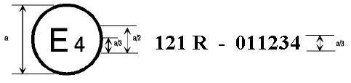
a = 8 mm min.
The above approval mark affixed to a vehicle shows that the vehicle type concerned has, with regard to the location and identification of hand controls, tell-tales and indicators, been approved in the Netherlands (E4) pursuant to Regulation No. 121 under the approval No. 011234. The first two digits (01) of the approval number indicated that the approval was granted in accordance with the requirements of Regulation No. 121 as amended by the 01 series of amendments.
Model B
(See paragraph 4.5. of this Regulation)
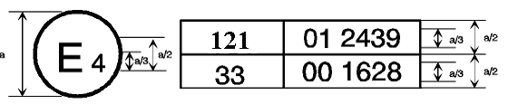
a = 8 mm min.
The above approval mark affixed to a vehicle shows that the vehicle type concerned has been approved in the Netherlands (E4) pursuant to Regulation No. 121 and Regulation No. 33¹. The approval number indicates that, at the dates when the respective approvals were granted in accordance with Regulation No. 121 as amended by the 01 series of amendments and with Regulation No. 33 which was still in its original form."

* Former title of the Agreement: Agreement Concerning the Adoption of Uniform Conditions of Approval and Reciprocal Recognition of Approval for Motor Vehicle Equipment and Parts, done at Geneva on 20 March 1958.

