|  |  |  |
| --- | --- | --- |
|  | E/ECE/324/Add.3/Rev.3/Amend.1−E/ECE/TRANS/505/Add.3/Rev.3/Amend.1 | |
|  |  | 22 June 2015 |

Agreement

Concerning the Adoption of Uniform Technical Prescriptions for Wheeled Vehicles, Equipment and Parts which can be Fitted and/or be Used on Wheeled Vehicles and the Conditions for Reciprocal Recognition of Approvals Granted on the Basis of these Prescriptions[1]*

(Revision 2, including the amendments which entered into force on 16 October 1995)

_________

Addendum 3 – Regulation No. 4

Revision 3 - Amendment 1

Supplement 17 to the original version of the Regulation – Date of entry into force: 15 June 2015

Uniform provisions concerning the approval of devices for the illumination of rear registration plates of power-driven vehicles and their trailers

This document is meant purely as documentation tool. The authentic and legal binding text is: ECE/TRANS/WP.29/2014/54 (as amended by paragraph 59 of the report ECE/TRANS/WP.29/1112).

**_________**



**UNITED NATIONS**

*Paragraph 1.1.*, amend to read:

"1.1. "*Rear registration plate lamp*" means the device for the illumination of rear registration plates, hereinafter called "illuminating device", which illuminates the rear registration plate by reflection. For the approval of this device, the illumination of the space to be occupied by the plate is determined. The illuminated areas are grouped into the following categories:"

*Insert new paragraphs 1.1.1. to 1.1.5.,* to read:

"1.1.1. Category 1a: illuminated area for use on a vehicle mounted a registration plate, the size of which is 340 x 240 mm or less (tall plate).

1.1.2. Category 1b: illuminated area for use on a vehicle mounted a registration plate, the size of which is 520 x 120 mm or less (wide plate).

1.1.3. Category 1c: illuminated area for use on a vehicle mounted a registration plate, the size of which is 255 x 165 mm or less (plate for agricultural or forestry tractors).

1.1.4. Category 2a: illuminated area for use on a vehicle mounted a registration plate, the size of which is 330 x 165 mm or less.

1.1.5. Category 2b: illuminated area for use on a vehicle mounted a registration plate, the size of which is 440 x 220 mm or less."

*Paragraph 2.,* amend to read:

"2. Application for approval

The application for approval shall be submitted by the holder of the trade name or mark or by his duly accredited representative. It shall specify whether the device is intended to illuminate the area, category 1a, 1b, 1c, 2a, 2b, or any combination of those areas according to paragraphs 1.1.1. to 1.1.5. At the choice of the applicant, …"

*Annex 2,*

*Item 9*, amend to read:

"9. Concise description: 3

Device for illuminating:

Category 1a, 1b, 1c, 2a, 2b 2

…"

*Annex 3*, amend to read:

"Annex 3

Measurement points for test purposes

Category 1a (340 x 240 mm)

…

Category 1b (520 x 120 mm)

…

Category 1c (255 x 165 mm)

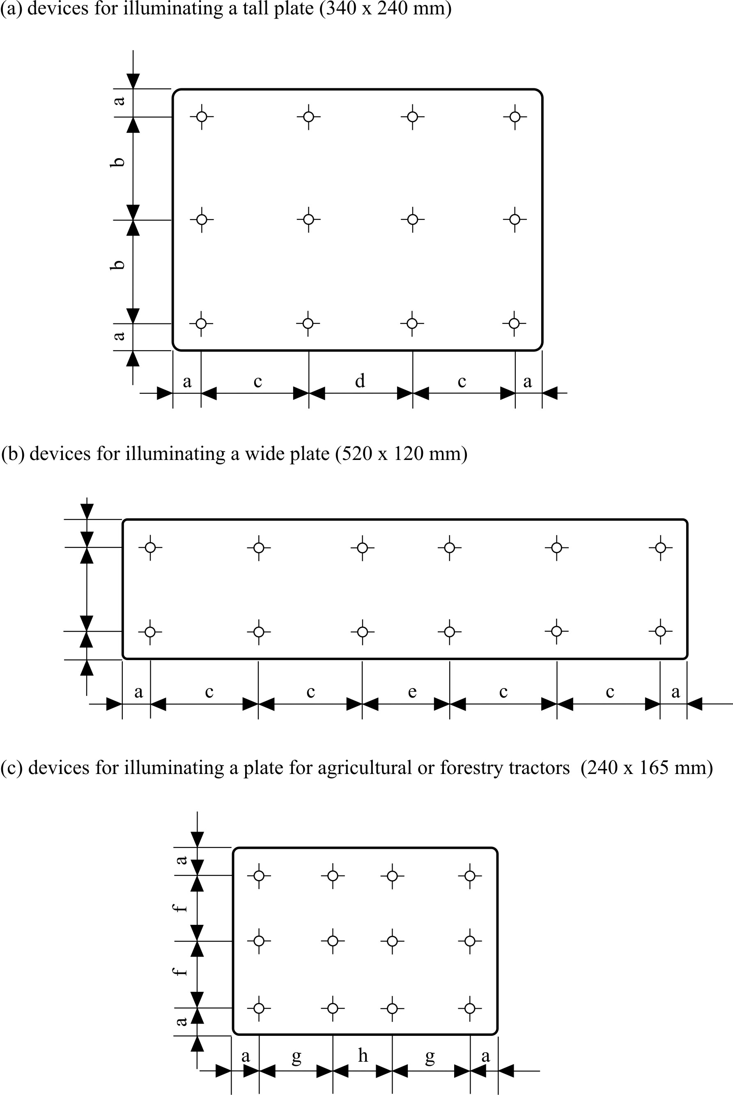

1

a = 25 mm b = 95 mm c = 100 mm d = 90 mm

e = 70 mm f = 57.5 mm g = 70 mm h = 65 mm

Category 2a (330 x 165 mm)

m

l

k

l

m

i

j

i



i = 32.5 mm

j = 100 mm

k = 50 mm

l = 100 mm

m = 40 mm

Category 2b (440 x 220 mm)

r

q

p

q

r

n

o

n



n = 50 mm

o = 120 mm

p = 50 mm

q = 145 mm

r = 50 mm

*Note:* In the case of devices …"

1. * Former title of the Agreement: Agreement Concerning the Adoption of Uniform Conditions of Approval and Reciprocal Recognition of Approval for Motor Vehicle Equipment and Parts, done at Geneva on 20 March 1958.