ECE/TRANS/180/Add.15
12 May 2014

Global Registry
Created on 18 November 2004, pursuant to Article 6 of the Agreement concerning the establishing of global technical regulations for wheeled vehicles, equipment and parts which can be fitted and/or be used on wheeled vehicles (ECE/TRANS/132 and Corr.1) done at Geneva on 25 June 1998
Addendum 15: Global technical regulation No. 15
Worldwide harmonized Light vehicles Test Procedure
Established in the Global Registry on 12 March 2014


UNITED NATIONS

Global technical regulation on Worldwide harmonized Light vehicles Test Procedure
Contents
Page
I. Statement of technical rationale and justification 5
A. Introduction 5
B. Procedural background and future development of the WLTP 6
C. Background on driving cycles and test procedures 7
D. Technical feasibility, anticipated costs and benefits 8
II. Text of the global technical regulation 10
1. Purpose 10
2. Scope and application 10
3. Definitions 10
4. Abbreviations 16
5. General requirements 18
6. Performance requirements 20
Annexes
1 Worldwide light-duty test cycles (WLTC) 22
2 Gear selection and shift point determination for vehicles equipped with manual transmissions 72
3 Reference fuels 76
4 Road load and dynamometer setting 91
Appendix 1 - Calculation of road load for the dynamometer test 117
Appendix 2 - Adjustment of chassis dynamometer load setting 119
5 Test equipment and calibrations 121
6 Type 1 test procedure and test conditions 165
Appendix 1 - Emissions test procedure for all vehicles equipped with periodically
regenerating systems 180
Appendix 2 - Test procedure for electric power supply system monitoring 185
7 Calculations 190
8 Pure and hybrid electric vehicles 205
Appendix 1a - RCB profile OVC-HEV, charge-depleting and charge-sustaining tests 223
Appendix 1b - RCB profile, OVC-HEV and NOVC-HEV charge-sustaining test 224
Appendix 1c - RCB profile, PEV, electric range and electric energy consumption test 225
Appendix 2 - REESS charge balance (RCB) correction 226
Appendix 3 - Measuring the electricity balance of NOVC-HEV and OVC-HEV batteries 229
Appendix 4 - Preconditioning of PEVs and OVC-HEVs 230
Appendix 5 - Utility factor (UF) for OVC-HEVs 232
[Appendix 6 - RESERVED: Determining the range of PEVs on a per-phase basis] 233
[9 RESERVED: Determination of system equivalence] 234

I. Statement of technical rationale and justification
A. Introduction
1. The compliance with emission standards is a central issue of vehicle certification worldwide. Emissions comprise criteria pollutants having a direct (mainly local) negative impact on health and environment, as well as pollutants having a negative environmental impact on a global scale. Regulatory emission standards typically are complex documents, describing measurement procedures under a variety of well-defined conditions, setting limit values for emissions, but also defining other elements such as the durability and on-board monitoring of emission control devices.
2. Most manufacturers produce vehicles for a global clientele or at least for several regions. Albeit vehicles are not identical worldwide since vehicle types and models tend to cater to local tastes and living conditions, the compliance with different emission standards in each region creates high burdens from an administrative and vehicle design point of view. Vehicle manufacturers, therefore, have a strong interest in harmonizing vehicle emission test procedures and performance requirements as much as possible on a global scale. Regulators also have an interest in global harmonization since it offers more efficient development and adaptation to technical progress, potential collaboration at market surveillance and facilitates the exchange of information between authorities.
3. As a consequence stakeholders launched the work for this global technical regulation (gtr) on Worldwide harmonized Light vehicle Test Procedures (WLTP) that aims at harmonizing emission related test procedures for light duty vehicles to the extent this is possible. Vehicle test procedures need to represent real driving conditions as much as possible to make the performance of vehicles at certification and in real life comparable. Unfortunately, this aspect puts some limitations on the level of harmonization to be achieved, since for instance, ambient temperatures vary widely on a global scale. In addition, due to the different levels of development, different population densities and the costs associated with emission control technology, the regulatory stringency of legislation is expected to be different from region to region for the foreseeable future. The setting of emission limit values, therefore, is not part of this gtr for the time being.
4. The purpose of a gtr is its implementation into regional legislation by as many Contracting Parties as possible. However, the scope of regional legislations in terms of vehicle categories concerned depends on regional conditions and cannot be predicted for the time being. On the other hand, according to the rules of the 1998 UNECE agreement, Contracting Parties implementing a gtr must include all equipment falling into the formal gtr scope. Care must be taken, so that an unduly large formal scope of the gtr does not prevent its regional implementation. Therefore the formal scope of this gtr is kept to the core of light duty vehicles. However, this limitation of the formal gtr scope does not indicate that it could not be applied to a larger group of vehicle categories by regional legislation. In fact, Contracting Parties are encouraged to extend the scope of regional implementations of this gtr if this is technically, economically and administratively appropriate.
5. This first version of the WLTP gtr, in particular, does not contain any specific test requirements for dual fuel vehicles and hybrid vehicles not based on a combination of an internal combustion engine and an electric machine. For example, specific requirements for hybrids using fuel cells or compressed gases as energy storage are not covered. Thus these vehicles are not included in the scope of the WLTP gtr. Contracting Parties may however apply the WLTP gtr provisions to such vehicles to the extent possible and complement them by additional provisions, e.g. emission testing with different fuel grades and types, in regional legislation.
B. Procedural background and future development of the WLTP
6. In its November 2007 session, WP.29 decided to set up an informal WLTP group under GRPE to prepare a road map for the development of the WLTP. After various meetings and intense discussions, WLTP presented in June 2009 a first road map consisting of 3 phases, which was subsequently revised a number of times and contains the following main tasks:
(a) Phase 1 (2009–2014): Development of the worldwide harmonized light duty driving cycle and associated test procedure for the common measurement of criteria compounds, CO_{2,} fuel and energy consumption.
(b) Phase 2 (2014–2018): Low temperature/high altitude test procedure, durability, in-service conformity, technical requirements for on-board diagnostics (OBD), mobile air-conditioning (MAC) system energy efficiency, off-cycle/real driving emissions.
(c) Phase 3 (2018-…): Emission limit values and OBD threshold limits, definition of reference fuels, comparison with regional requirements.
7. It should be noted that since the beginning of the WLTP process, the European Union had a strong political objective set by its own legislation (Regulations (EC) 443/2009 and 510/2011) to implement a new and more realistic test cycle by 2014, which was a major political driving factor for setting the time frame of phase 1.
8. For the work of phase 1 the following working groups and subgroups were established:
(a) Development of Harmonised Cycle (DHC): construction of a new Worldwide Light-duty Test Cycle (WLTC), i.e. the driving curve of the WLTP, based on the statistical analysis of real driving data.
The DHC group started working in September 2009, launched the collection of driving data in 2010 and proposed a first version of the driving cycle by mid-2011, which was revised a number of times to take into consideration technical issues such as driveability and better representativeness of driving conditions after a first validation.
(b) Development of Test Procedures (DTP): development of test procedures with the following specific expert groups:
(i) PM-PN: Particle mass (PM) and particle number (PN) measurements.
(ii) AP: Additional Pollutant measurements, i.e. measurement procedures for exhaust substances which are not yet regulated yet as compounds but may be regulated in the near future, such as NO₂, ethanol, aldehydes and ammonia.
(iii) LabProcICE: test conditions and measurement procedures of existing regulated compounds for vehicles equipped with internal combustion engines (other than PM and PN).
(iv) EV-HEV: specific test conditions and measurement procedures for electric and hybrid-electric vehicles.
(v) Reference fuels: definition of reference fuels.
The DTP group started working in April 2010.
9. This first version of the gtr will only contain results of phase 1. During the work of the DTP group it became clear that a number of issues, in particular but not only in relation to electric and hybrid-electric vehicles, could not be resolved in time for an adoption of the first version of the WLTP gtr by WP.29 in March 2014. Therefore it was agreed that these elements would be further developed by the existing expert groups and should be adopted as a "phase 1b" amendment to the WLTP gtr within an appropriate time frame. Without claiming completeness "phase 1b" should address the following work items:
(a) LabProcICE:
(i) Normalization methods, speed trace index;
(ii) Energy economy rating and absolute speed change rating for speed trace violations;
(iii) Wind tunnel as alternative method for road load determination;
(iv) Supplemental test with representative regional temperature and soak period.
(b) EV-HEV:
(i) Calculation method of each phase range for Pure Electric Vehicles (PEVs);
(ii) Shortened test procedure for PEV range test;
(iii) Combined CO₂ (fuel consumption) of each phase for Off-Vehicle Charging Hybrid Electric Vehicles (OVC-HEVs);
(iv) Hybrid Electric Vehicle (HEV)/PEV power and maximum speed;
(v) Combined test approach for OVC-HEVs and PEVs;
(vi) Fuel cell vehicles;
(vii) Utility factors;
(viii) Preconditioning;
(ix) Predominant mode.
(c) APM:
Measurement method for ammonia, ethanol and aldehydes.
(d) DHC:
(i) Speed violation criteria;
(ii) Further downscaling in Wide Open Throttle (WOT) operation;
(iii) Sailing and gear shifting.
C. Background on driving cycles and test procedures
10. The development of the worldwide harmonized light duty vehicle driving cycle was based on experience gained from work on the World-wide Heavy-Duty Certification procedure (WHDC), World-wide Motorcycle Test Cycle (WMTC) and other national cycles.
11. The WLTC is a transient cycle by design. For constructing the WLTC, driving data from all participating Contracting Parties were collected and weighted according to the relative contribution of regions to the globally driven mileage and data collected for WLTP purpose.
12. The resulting driving data were subsequently cut into idling periods and "short trips" (i.e. driving events between two idling periods). By randomised combinations of these segments, a large number of "draft cycles" were generated. From the latter "draft cycle" family, the cycle best fitting certain dynamic properties of the original WLTP database was selected as a first "raw WLTC". In the subsequent work the "raw WLTC" was further processed, in particular with respect to its driveability and better representativeness, to obtain the final WLTC.
13. The driveability of the WLTC was assessed extensively during the development process and is supported by three distinct validation phases. Specific cycle versions for certain vehicles with limited driving capabilities due to a low power/mass ratio or limited maximum vehicle speed have been introduced. In addition, the speed trace to be followed by a test vehicle will be downscaled according to a mathematically prescribed method if the vehicle would have to encounter an unduly high proportion of "full throttle" driving in order to follow the original speed trace. Gear shift points are determined according to a mathematical procedure that is based on the characteristics of individual vehicles, which also enhances the driveability of the WLTC.
14. For the development of the test procedures, the DTP subgroup took into account existing emissions and energy consumption legislation, in particular those of the 1958 and 1998 Agreements, those of Japan and the United States Environmental Protection Agency (US EPA) Standard Part 1066. These test procedures were critically reviewed, compared to each other, updated to technical progress and complemented by new elements where necessary.
D. Technical feasibility, anticipated costs and benefits
15. In designing and validating the WLTP, strong emphasis has been put on its practicability, which is ensured by a number of measures explained above.
16. While in general the WLTP has been defined on the basis of the best technology available at the moment of its drafting, the practical facilitation of the WLTP procedures on a global scale has been kept in mind as well. The latter had some impact e.g. on the definition of set values and tolerances for several test parameters, such as the test temperature or deviations from the speed trace. Also, facilities without the most recent technical equipment should be able to perform WLTP certifications, leading to higher tolerances than those which would have been required just by best performing facilities.
17. The replacement of a regional test cycle by the WLTP initially will bear some costs for vehicle manufacturers, technical services and authorities, at least considered on a local scale, since some test equipment and procedures have to be upgraded. However, these costs should be limited since such upgrades are done regularly as adaptations to the technical progress. Related costs would have to be quantified on a regional level since they largely depend on the local conditions.
18. As pointed out in the technical rationale and justification, the principle of a globally harmonized light duty vehicle test procedure offers potential cost reductions for vehicle manufacturers. The design of vehicles can be better unified on a global scale and administrative procedures may be simplified. The monetary quantification of these benefits depends largely on the extent and timing of implementations of the WLTP in regional legislation.
19. The WLTP provides a higher representation of real driving conditions when compared to the previous regional driving cycles. Therefore, benefits are expected from the resulting consumer information about fuel and energy consumption. In addition the more representative WLTP will set proper incentives for implementing those CO₂ saving vehicle technologies that are also the most effective in real driving. The effectiveness of technology cost relative to the real driving CO₂ saving will, therefore, be improved with respect to existing less representative driving cycles.
II. Text of the global technical regulation
1. Purpose
This global technical regulation (gtr) aims at providing a worldwide harmonized method to determine the levels of gaseous, particulate matter, particle number, CO₂ emissions, fuel consumption, electric energy consumption and electric range from light-duty vehicles in a repeatable and reproducible manner designed to be representative of real world vehicle operation. The results will provide the basis for the regulation of these vehicles within regional type approval and certification procedures.
2. Scope and application
This gtr applies to vehicles of categories 1-2 and 2, both having a technically permissible maximum laden mass not exceeding 3,500 kg, and to all vehicles of category 1-1.
3. Definitions
3.1. Test equipment
3.1.1. "Accuracy" means the difference between a measured value and a reference value, traceable to a national standard and describes the correctness of a result. See Figure 1.
3.1.2. "Calibration" means the process of setting a measurement system's response so that its output agrees with a range of reference signals. Contrast with "verification".
3.1.3. "Calibration gas" means a gas mixture used to calibrate gas analysers.
3.1.4. "Double dilution method" means the process of separating a part of the diluted exhaust flow and mixing it with an appropriate amount of dilution air prior to the particulate sampling filter.
3.1.5. "Full-flow exhaust dilution system" means the continuous dilution of the total vehicle exhaust with ambient air in a controlled manner using a constant volume sampler (CVS).
3.1.6. "Linearization" means the application of a range of concentrations or materials to establish a mathematical relationship between concentration and system response.
3.1.7. "Major maintenance" means the adjustment, repair or replacement of a component or module that could affect the accuracy of a measurement, after which calibration/validation should be performed on the parameters that could be affected.
3.1.8. "Non-methane hydrocarbons" (NMHC) are the total hydrocarbons (THC) minus the methane (CH₄) contribution.
3.1.9. "Precision" means the degree to which repeated measurements under unchanged conditions show the same results (Figure 1). In this gtr, precision requirements always refer to one standard deviation.
3.1.10. "Reference value" means a value traceable to a national standard. See Figure 1.
3.1.11. "Set point" means the target value a control system aims to reach.
3.1.12. "Span" means to adjust an instrument so that it gives a proper response to a calibration standard that represents between 75 per cent and 100 per cent of the maximum value in the instrument range or expected range of use.
3.1.13. "Total hydrocarbons" (THC) means all volatile compounds measurable by a flame ionization detector (FID).
3.1.14. "Verification" means to evaluate whether or not a measurement system's outputs agrees with applied reference signals within one or more predetermined thresholds for acceptance.
3.1.15. "Zero gas" means a gas containing no analyte, which is used to set a zero response on an analyser.

Figure 1
Definition of accuracy, precision and reference value

value
precision
accuracy
reference value
probability
density
3.2. Road and dynamometer load
3.2.1. "Aerodynamic drag" means the force that opposes a vehicle’s forward motion through air.
3.2.2. "Aerodynamic stagnation point" means the point on the surface of a vehicle where wind velocity is equal to zero.
3.2.3. "Anemometry blockage" means the effect on the anemometer measurement due to the presence of the vehicle where the apparent air speed is different than the vehicle speed combined with wind speed relative to the ground. By using an appropriate anemometer calibration procedure, this effect can be minimized.
3.2.4. "Constrained analysis" means the vehicle’s frontal area and aerodynamic drag coefficient have been independently determined and those values shall be used in the equation of motion.
3.2.5. "Mass in running order" means the mass of the vehicle, with its fuel tank(s) filled to at least 90 per cent of its or their capacity/capacities, including the mass of the driver and liquids, fitted with the standard equipment in accordance with the manufacturer’s specifications and, when they are fitted, the mass of the bodywork, the cabin, the coupling and the spare wheel(s) as well as the tools when they are fitted.
3.2.6. "Mass of the driver" means a mass rated at 75 kg located at the driver’s seating reference point.
3.2.7. "Maximum vehicle load" means in this gtr the difference between the technically permissible maximum laden mass and the sum of the mass in running order, 25 kg and the mass of the optional equipment of vehicle H.
3.2.8. "Optional equipment" means all the features not included in the standard equipment which are fitted to a vehicle under the responsibility of the manufacturer, and that can be ordered by the customer.
3.2.9. "Reference atmospheric conditions (regarding road load measurements)" means the atmospheric conditions to which these measurement results are corrected:
(a) Atmospheric pressure: p₀= 100 kPa, unless otherwise specified by regulations;
(b) Atmospheric temperature: T₀= 293 K, unless otherwise specified by regulations;
(c) Dry air density: ρ₀= 1,189 kg/m³, unless otherwise specified by regulations;
(d) Wind speed: 0 m/s.
3.2.10. "Reference speed" means the vehicle speed at which road load is determined or chassis dynamometer load is verified. Reference speeds may be continuous speed points covering the complete test cycle speed range.
3.2.11. "Road load" means the opposition to the movement of a vehicle. It is the total resistance if using the coastdown method or the running resistance if using the torque meter method.
3.2.12. "Rolling resistance" means the forces of the tyres opposing the motion of a vehicle.
3.2.13. "Running resistance" means the torque resisting the forward motion of a vehicle, measured by torque meters installed at the driven wheels of a vehicle.
3.2.14. "Simulated road load" means the road load calculated from measured coastdown data.
3.2.15. "Speed range" means the range of speed considered for road load determination which is between the maximum speed of the Worldwide Light-duty Test Cycle (WLTC) for the class of test vehicle and minimum speed selected by the manufacturer which shall not be greater than 20 km/h.
3.2.16. "Stationary anemometry" means measurement of wind speed and direction with an anemometer at a location and height above road level alongside the test road where the most representative wind conditions will be experienced.
3.2.17. "Standard equipment" means the basic configuration of a vehicle equipped with all the features required under the regulatory acts of the Contracting Party including all features fitted without giving rise to any further specifications on configuration or equipment level.
3.2.18. "Target road load" means the road load to be reproduced on the chassis dynamometer.
3.2.19. "Total resistance" means the total force resisting movement of a vehicle, including the frictional forces in the drivetrain.
3.2.20. "Vehicle coastdown mode" means a mode of operation enabling an accurate and repeatable determination of total resistance and an accurate dynamometer setting.
3.2.21. "Vehicle H" means the vehicle within the CO₂ vehicle family with the combination of road load relevant characteristics (e.g. mass, aerodynamic drag and tyre rolling resistance) producing the highest cycle energy demand.
3.2.22. "Vehicle L" means the vehicle within the CO₂ vehicle family with the combination of road load relevant characteristics (e.g. mass, aerodynamic drag and tyre rolling resistance) producing the lowest cycle energy demand.
3.2.23. "Wind correction" means correction of the effect of wind on road load based on input of the stationary or on-board anemometry.
3.3. Pure electric vehicles and hybrid electric vehicles
3.3.1. "All-electric range" (AER) in the case of an off-vehicle charging hybrid electric vehicle (OVC-HEV) means the total distance travelled from the beginning of the charge-depleting test over a number of complete WLTCs to the point in time during the test when the combustion engine starts to consume fuel.
3.3.2. "All-electric range" (AER) in the case of a pure electric vehicle (PEV) means the total distance travelled from the beginning of the charge-depleting test over a number of WLTCs until the break-off criteria is reached.
3.3.3. "Charge-depleting actual range" (R_{CDA}) means the distance travelled in a series of WLTCs in charge-depleting operation condition until the rechargeable electric energy storage system (REESS) is depleted.
3.3.4. "Charge-depleting cycle range" (R_{CDC}) means the distance from the beginning of the charge-depleting test to the end of the last cycle prior to the cycle or cycles satisfying the break-off criteria, including the transition cycle where the vehicle may have operated in both depleting and sustaining modes.
3.3.5. "Charge-depleting operation condition" means an operating condition in which the energy stored in the REESS may fluctuate but, on average, decreases while the vehicle is driven until transition to charge-sustaining operation.
3.3.6. "Charge-depleting break-off criteria" is determined based on absolute net energy change.
3.3.7. "Charge-sustaining operation condition" means an operating condition in which the energy stored in the REESS may fluctuate but, on average, is maintained at a neutral charging balance level while the vehicle is driven.
3.3.8. "Electric machine" (EM) means an energy converter transforming electric energy into mechanical energy or vice versa.
3.3.9. "Electrified vehicle" (EV) means a vehicle using at least one electric machine for the purpose of vehicle propulsion.
3.3.10. "Energy converter" means the part of the powertrain converting one form of energy into a different one.
3.3.11. "Energy storage system" means the part of the powertrain on board a vehicle that can store chemical, electrical or mechanical energy and which can be refilled or recharged externally and/or internally.
3.3.12. "Equivalent all-electric range" (EAER) means that portion of the total charge-depleting actual range (R_{CDA}) attributable to the use of electricity from the REESS over the charge-depleting range test.
3.3.13. "Highest fuel consuming mode" means the mode with the highest fuel consumption of all driver-selectable modes.
3.3.14. "Hybrid electric vehicle" (HEV) means a vehicle using at least one fuel consuming machine and one electric machine for the purpose of vehicle propulsion.
3.3.15. "Hybrid vehicle" (HV) means a vehicle with a powertrain containing at least two different types of energy converters and two different types of energy storage systems.
3.3.16. "Net energy change" means the ratio of the REESS energy change divided by the cycle energy demand of the test vehicle.
3.3.17. "Not off-vehicle charging" (NOVC) means that the REESS cannot be charged externally. This is also known as not externally chargeable.
3.3.18. "Not off-vehicle chargeable hybrid electric vehicle" (NOVC-HEV)means a hybrid electric vehicle that cannot be charged externally.
3.3.19. "Off-vehicle charging" (OVC)" means that the REESS can be charged externally. This REESS is also known as externally-chargeable.
3.3.20. "Off-vehicle charging hybrid electric vehicle" (OVC-HEV) identifies a hybrid electric vehicle that can be charged externally.
3.3.21. "Pure electric mode" means operation by an electric machine only using electric energy from a REESS without fuel being consumed under any condition.
3.3.22. "Pure electric vehicle" (PEV) means a vehicle where all energy converters used for propulsion are electric machines and no other energy converter contributes to the generation of energy to be used for vehicle propulsion.
3.3.23. "Recharged energy"(E_{AC}) means the AC electric energy which is recharged from the grid at the mains socket.
3.3.24. "REESS charge balance" (RCB) means the charge balance of the REESS measured in Ah.
3.3.25. "REESS correction criteria" means the RCB value (Ah) which determines if and when correction of the CO₂ emissions and/or fuel consumption value in charge-sustaining (CS) operation condition is necessary.
3.4. Powertrain
3.4.1. "Manual transmission" means a transmission where gears are shifted by hand in conjunction with a manual disengagement of a clutch.
3.5. General
3.5.1. "Auxiliaries" means additional equipment and/or devices not required for vehicle operation.
3.5.2. "Category 1 vehicle" means a power driven vehicle with four or more wheels designed and constructed primarily for the carriage of one or more persons.
3.5.3. "Category 1-1 vehicle" means a category 1 vehicle comprising not more than eight seating positions in addition to the driver’s seating position. A category 1-1 vehicle may have standing passengers.
3.5.4. "Category 1-2 vehicle" means a category 1 vehicle designed for the carriage of more than eight passengers, whether seated or standing, in addition to the driver.
3.5.5. "Category 2 vehicle" means a power driven vehicle with four or more wheels designed and constructed primarily for the carriage of goods. This category shall also include:
(a) Tractive units;
(b) Chassis designed specifically to be equipped with special equipment.
3.5.6. "Cycle energy demand" means the calculated positive energy required by the vehicle to drive the prescribed cycle.
3.5.7. "Defeat device" means any element of design which senses temperature, vehicle speed, engine rotational speed, drive gear, manifold vacuum or any other parameter for the purpose of activating, modulating, delaying or deactivating the operation of any part of the emission control system that reduces the effectiveness of the emission control system under conditions which may reasonably be expected to be encountered in normal vehicle operation and use. Such an element of design may not be considered a defeat device if:
(a) The need for the device is justified in terms of protecting the engine against damage or accident and for safe operation of the vehicle; or
(b) The device does not function beyond the requirements of engine starting; or
(c) Conditions are substantially included in the Type 1 test procedures.
3.5.8. "Mode" means a distinct driver-selectable condition which could affect emissions, and fuel and energy consumption.
3.5.9. "Multi-mode" means that more than one operating mode can be selected by the driver or automatically set.
3.5.10. "Predominant mode" for the purposes of this gtr means a single mode that is always selected when the vehicle is switched on regardless of the operating mode selected when the vehicle was previously shut down. The predominant mode must not be able to be redefined. The switch of the predominant mode to another available mode after the vehicle being switched on shall only be possible by an intentional action of the driver.
3.5.11. "Reference conditions (with regards to calculating mass emissions)" means the conditions upon which gas densities are based, namely 101.325 kPa and 273.15 K.
3.5.12. "Exhaust emissions" means the emission of gaseous compounds, particulate matter and particle number at the tailpipe of a vehicle.
3.5.13. "Type 1 test" means a test used to measure a vehicle's cold start gaseous, particulate matter, particle number, CO₂ emissions, fuel consumption, electric energy consumption and electric range at ambient conditions.
3.6. PM/PN
3.6.1. "Particle number" (PN) means the total number of solid particles emitted from the vehicle exhaust and as specified in this gtr.
3.6.2. "Particulate matter" (PM) means any material collected on the filter media from diluted vehicle exhaust as specified in this gtr.
3.7. WLTC
3.7.1. "Rated engine power" () means maximum engine power in kW as per the certification procedure based on current regional regulation. In the absence of a definition, the rated engine power shall be declared by the manufacturer according to Regulation No. 85.
3.7.2. "Maximum speed" (v_{max}) means the maximum speed of a vehicle as defined by the Contracting Party. In the absence of a definition, the maximum speed shall be declared by the manufacturer according to Regulation No. 68.
3.7.3. "Rated engine speed" means the range of rotational speed at which an engine develops maximum power.
3.7.4. "WLTC city cycle" means a low phase followed by a medium phase.
3.8. Procedure
3.8.1. "Periodically regenerating system" means an exhaust emissions control device (e.g. catalytic converter, particulate trap) that requires a periodical regeneration process in less than 4,000 km of normal vehicle operation. During cycles where regeneration occurs, emission standards can be exceeded. If a regeneration of an anti-pollution device occurs at least once during vehicle preparation cycle, it will be considered as a continuously regenerating system which does not require a special test procedure.
4. Abbreviations
4.1. General abbreviations
CFV | Critical flow venturi
CFO | Critical flow orifice
CLD | Chemiluminescent detector
CLA | Chemiluminescent analyser
CVS | Constant volume sampler
deNO_{x} | NO_{x} after-treatment system
ECD | Electron capture detector
ET | Evaporation tube
Extra High₂ | WLTC extra high speed phase for Class 2 vehicles
Extra High₃ | WLTC extra high speed phase for Class 3 vehicles
FID | Flame ionization detector
FTIR | Fourier transform infrared analyser
GC | Gas chromatograph
HEPA | High efficiency particulate air (filter)
HFID | Heated flame ionization detector
High₂ | WLTC high speed phase for Class 2 vehicles
High₃₋₁ | WLTC high speed phase for Class 3 vehicles with km/h
High₃₋₂ | WLTC high speed phase for Class 3 vehicles with km/h
LoD | Limit of detection
LoQ | Limit of quantification
Low₁ | WLTC low speed phase for Class 1 vehicles
Low₂ | WLTC low speed phase for Class 2 vehicles
Low₃ | WLTC low speed phase for Class 3 vehicles
Medium₁ | WLTC medium speed phase for Class 1 vehicles
Medium₂ | WLTC medium speed phase for Class 2 vehicles
Medium₃₋₁ | WLTC medium speed phase for Class 3 vehicles with km/h
Medium₃₋₂ | WLTC medium speed phase for Class 3 vehicles with km/h
LPG | Liquefied petroleum gas
NDIR | Non-dispersive infrared (analyser)
NMC | Non-methane cutter
NOVC-HEV | Not off-vehicle chargeable hybrid electric vehicle
PAO | Poly-alpha-olefin
PCF | Particle pre-classifier
PCRF | Particle concentration reduction factor
PDP | Positive displacement pump
Per cent FS | Per cent of full scale
PM | Particulate matter
PN | Particle number
PNC | Particle number counter
PND₁ | First particle number dilution device
PND₂ | Second particle number dilution device
PTS | Particle transfer system
PTT | Particle transfer tube
QCL-IR | Infrared quantum cascade laser
 | Charge-depleting actual range
REESS | Rechargeable electric energy storage system
SSV | Subsonic venturi
USFM | Ultrasonic flow meter
VPR | Volatile particle remover
WLTC | Worldwide light-duty test cycle
4.2. Chemical symbols and abbreviations
C₁ | Carbon 1 equivalent hydrocarbon
CH₄ | Methane
C₂H₆ | Ethane
C₂H₅OH | Ethanol
C₃H₈ | Propane
CO | Carbon monoxide
CO₂ | Carbon dioxide
DOP | Di-octylphthalate
THC | Total hydrocarbons (all compounds measurable by an FID)
H₂O | Water
NMHC | Non-methane hydrocarbons
NO_{x} | Oxides of nitrogen
NO | Nitric oxide
NO₂ | Nitrogen dioxide
N₂O | Nitrous oxide
5. General requirements
5.1. The vehicle and its components liable to affect the emissions of gaseous compounds, particulate matter and particle number shall be so designed, constructed and assembled as to enable the vehicle in normal use and under normal conditions of use such as humidity, rain, snow, heat, cold, sand, dirt, vibrations, wear, etc. to comply with the provisions of this gtr during its useful life.
5.1.1. This shall include the security of all hoses, joints and connections used within the emission control systems.
5.2. The test vehicle shall be representative in terms of its emissions-related components and functionality of the intended production series to be covered by the approval. The manufacturer and the responsible authority shall agree which vehicle test model is representative.
5.3. Vehicle testing condition
5.3.1. The types and amounts of lubricants and coolant for emissions testing shall be as specified for normal vehicle operation by the manufacturer.
5.3.2. The type of fuel for emissions testing shall be as specified of Annex 3 to this gtr.
5.3.3. All emissions controlling systems shall be in working order.
5.3.4. The use of any defeat device is prohibited.
5.3.5. The engine shall be designed to avoid crankcase emissions.
5.3.6. The tyres used for emissions testing shall be as defined in paragraph 1.2.4.5. of Annex 6 to this gtr.
5.4. Petrol tank inlet orifices
5.4.1. Subject to paragraph 5.4.2. below, the inlet orifice of the petrol or ethanol tank shall be so designed as to prevent the tank from being filled from a fuel pump delivery nozzle which has an external diameter of 23.6 mm or greater.
5.4.2. Paragraph 5.4.1. shall not apply to a vehicle in respect of which both of the following conditions are satisfied:
(a) The vehicle is so designed and constructed that no device designed to control the emission of gaseous and particulate compounds shall be adversely affected by leaded petrol; and
(b) The vehicle is conspicuously, legibly and indelibly marked with the symbol for unleaded petrol, specified in ISO 2575:2010 "Road vehicles -- Symbols for controls, indicators and tell-tales", in a position immediately visible to a person filling the petrol tank. Additional markings are permitted.
5.5. Provisions for electronic system security
5.5.1. Any vehicle with an emission control computer shall include features to deter modification, except as authorised by the manufacturer. The manufacturer shall authorise modifications if these modifications are necessary for the diagnosis, servicing, inspection, retrofitting or repair of the vehicle. Any reprogrammable computer codes or operating parameters shall be resistant to tampering and afford a level of protection at least as good as the provisions in ISO 15031-7 (March 15, 2001). Any removable calibration memory chips shall be potted encased in a sealed container or protected by electronic algorithms and shall not be changeable without the use of specialized tools and procedures.
5.5.2. Computer-coded engine operating parameters shall not be changeable without the use of specialized tools and procedures (e.g. soldered or potted computer components or sealed (or soldered) enclosures).
5.5.3. Manufacturers may seek approval from the responsible authority for an exemption to one of these requirements for those vehicles which are unlikely to require protection. The criteria that the responsible authority will evaluate in considering an exemption will include, but are not limited to, the current availability of performance chips, the high-performance capability of the vehicle and the projected sales volume of the vehicle.
5.5.4. Manufacturers using programmable computer code systems shall deter unauthorised reprogramming. Manufacturers shall include enhanced tamper protection strategies and write-protect features requiring electronic access to an off-site computer maintained by the manufacturer. Methods giving an adequate level of tamper protection will be approved by the responsible authority.
5.6. CO₂ vehicle family
5.6.1. Unless vehicles are identical with respect to the following vehicle/powertrain/transmission characteristics, they shall not be considered to be part of the same CO₂ vehicle family:
(a) Type of internal combustion engine: fuel type, combustion type, engine displacement, full-load characteristics, engine technology, and charging system shall be identical, but also other engine subsystems or characteristics that have a non-negligible influence on CO₂ under WLTP conditions;
(b) Operation strategy of all CO₂-influencing components within the powertrain;
(c) Transmission type (e.g. manual, automatic, CVT);
(d) n/v ratios (engine rotational speed divided by vehicle speed). This requirement shall be considered fulfilled if, for all transmission ratios concerned, the difference with respect to the transmission ratios of the most commonly installed transmission type is within 8 per cent;
(e) Number of powered axles;
(f) [RESERVED: family criteria for EVs].
6. Performance requirements
6.1. Limit values
When implementing the test procedure contained in this gtr as part of their national legislation, Contracting Parties to the 1998 Agreement are encouraged to use limit values which represent at least the same level of severity as their existing regulations; pending the development of harmonized limit values, by the Executive Committee (AC.3) of the 1998 Agreement, for inclusion in the gtr at a later date.
6.2. Testing
Testing shall be performed according to:
(a) The WLTCs as described in Annex 1;
(b) The gear selection and shift point determination as described in Annex 2;
(c) The appropriate fuel as described in Annex 3;
(d) The road and dynamometer load as described in Annex 4;
(e) The test equipment as described in Annex 5;
(f) The test procedures as described in Annexes 6 and 8;
(g) The methods of calculation as described in Annexes 7 and 8.

Annex 1
Worldwide light-duty test cycles (WLTC)
1. General requirements
1.1. The cycle to be driven shall be dependent on the test vehicle’s rated power to unladen mass ratio, W/kg, and its maximum velocity, v_{max}.
1.2. v_{max} is the maximum speed of a vehicle as defined in paragraph 3.7.2. of this global technical regulation and not that which may be artificially restricted.
2. Vehicle classifications
2.1. Class 1 vehicles have a power to unladen mass ratio () W/kg.
2.2. Class 2 vehicles have a power to unladen mass ratio > 22 but ≤ 34 W/kg.
2.3. Class 3 vehicles have a power to unladen mass ratio > 34 W/kg.
2.3.1. All vehicles tested according to Annex 8 shall be considered to be Class 3 vehicles.
3. Test cycles
3.1. Class 1 vehicles
3.1.1. A complete cycle for Class 1 vehicles shall consist of a low phase (Low₁), a medium phase (Medium₁) and an additional low phase (Low₁).
3.1.2. The Low₁ phase is described in Figure A1/1 and Table A1/1.
3.1.3. The Medium₁ phase is described in Figure A1/2 and Table A1/2.
3.2. Class 2 vehicles
3.2.1. A complete cycle for Class 2 vehicles shall consist of a low phase (Low₂), a medium phase (Medium₂), a high phase (High₂) and an extra high phase (Extra High₂).
3.2.2. The Low₂ phase is described in Figure A1/3 and Table A1/3.
3.2.3. The Medium₂ phase is described in Figure A1/4 and Table A1/4.
3.2.4. The High₂ phase is described in Figure A1/5 and Table A1/5.
3.2.5. The Extra High₂ phase is described in Figure A1/6 and Table A1/6.
3.2.6. At the option of the Contracting Party, the Extra High₂ phase may be excluded.
3.3. Class 3 vehicles
Class 3 vehicles are divided into 2 subclasses according to their maximum speed, v_{max}.
3.3.1. Class 3a vehicles with v_{max} < 120 km/h
3.3.1.1. A complete cycle shall consist of a low phase (Low₃) , a medium phase (Medium₃₋₁), a high phase (High₃₋₁) and an extra high phase (Extra High₃).
3.3.1.2. The Low₃ phase is described in Figure A1/7 and Table A1/7.
3.3.1.3. The Medium₃₋₁ phase is described in Figure A1/8 and Table A1/8.
3.3.1.4. The High₃₋₁ phase is described in Figure A1/10 and Table A1/10.
3.3.1.5. The Extra High₃ phase is described in Figure A1/12 and Table A1/12.
3.3.1.6. At the option of the Contracting Party, the Extra High₃ phase may be excluded.
3.3.2. Class 3b vehicles with v_{max} ≥ 120 km/h
3.3.2.1. A complete cycle shall consist of a low phase (Low₃) phase, a medium phase (Medium₃₋₂), a high phase (High₃₋₂) and an extra high phase (Extra High₃).
3.3.2.2. The Low₃ phase is described in Figure A1/7 and Table A1/7.
3.3.2.3. The Medium₃₋₂ phase is described in Figure A1/9 and Table A1/9.
3.3.2.4. The High₃₋₂ phase is described in Figure A1/11 and Table A1/11.
3.3.2.5. The Extra High₃ phase is described in Figure A1/12 and Table A1/12.
3.3.2.6. At the option of the Contracting Party, the Extra High₃ phase may be excluded.
3.4. Duration of all phases
3.4.1. All low speed phases last 589 seconds (s).
3.4.2. All medium speed phases last 433 seconds (s).
3.4.3. All high speed phases last 455 seconds (s).
3.4.4. All extra high speed phases last 323 seconds (s).
3.5 WLTC city cycles
OVC-HEVs and PEVs shall be tested using the WLTC and WLTC city cycles (see Annex 8) for Class 3a and Class 3b vehicles.
The WLTC city cycle consists of the low and medium speed phases only.
4. WLTC Class 1 vehicles

Figure A1/1

WLTC, Class 1 vehicles, phase Low₁
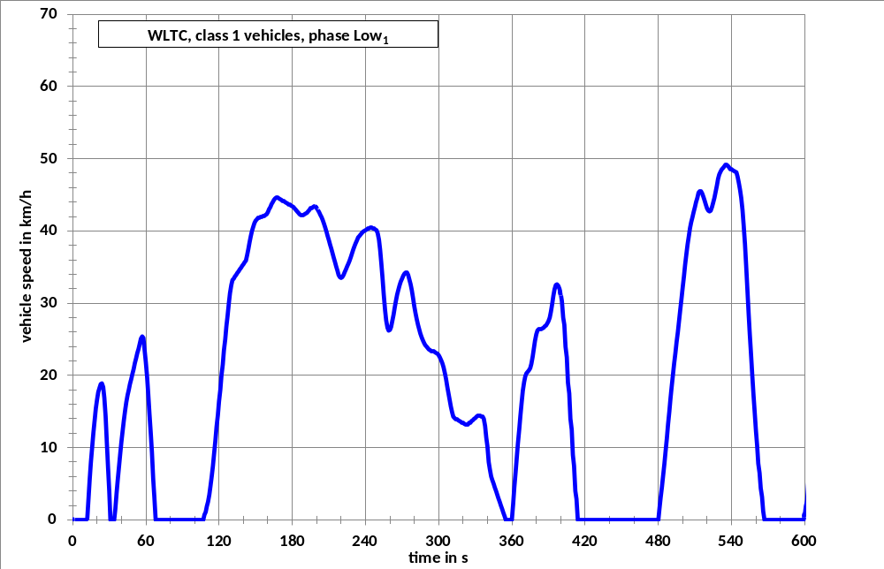

Figure A1/2

WLTC, Class 1 vehicles, phase Medium₁
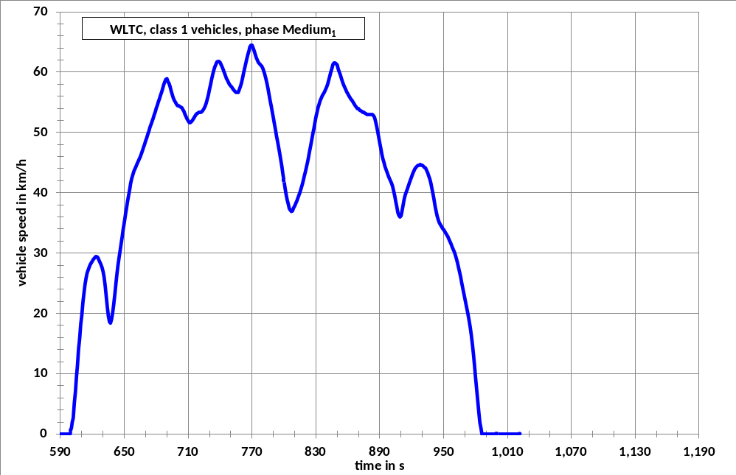

Table A1/1

WLTC, Class 1 vehicles, phase Low1
Time in s | speed in km/h | Time in s | speed in km/h | Time in s | speed in km/h | Time in s | speed in km/h
0 | 0.0 | 47 | 18.8 | 94 | 0.0 | 141 | 35.7
1 | 0.0 | 48 | 19.5 | 95 | 0.0 | 142 | 35.9
2 | 0.0 | 49 | 20.2 | 96 | 0.0 | 143 | 36.6
3 | 0.0 | 50 | 20.9 | 97 | 0.0 | 144 | 37.5
4 | 0.0 | 51 | 21.7 | 98 | 0.0 | 145 | 38.4
5 | 0.0 | 52 | 22.4 | 99 | 0.0 | 146 | 39.3
6 | 0.0 | 53 | 23.1 | 100 | 0.0 | 147 | 40.0
7 | 0.0 | 54 | 23.7 | 101 | 0.0 | 148 | 40.6
8 | 0.0 | 55 | 24.4 | 102 | 0.0 | 149 | 41.1
9 | 0.0 | 56 | 25.1 | 103 | 0.0 | 150 | 41.4
10 | 0.0 | 57 | 25.4 | 104 | 0.0 | 151 | 41.6
11 | 0.0 | 58 | 25.2 | 105 | 0.0 | 152 | 41.8
12 | 0.2 | 59 | 23.4 | 106 | 0.0 | 153 | 41.8
13 | 3.1 | 60 | 21.8 | 107 | 0.0 | 154 | 41.9
14 | 5.7 | 61 | 19.7 | 108 | 0.7 | 155 | 41.9
15 | 8.0 | 62 | 17.3 | 109 | 1.1 | 156 | 42.0
16 | 10.1 | 63 | 14.7 | 110 | 1.9 | 157 | 42.0
17 | 12.0 | 64 | 12.0 | 111 | 2.5 | 158 | 42.2
18 | 13.8 | 65 | 9.4 | 112 | 3.5 | 159 | 42.3
19 | 15.4 | 66 | 5.6 | 113 | 4.7 | 160 | 42.6
20 | 16.7 | 67 | 3.1 | 114 | 6.1 | 161 | 43.0
21 | 17.7 | 68 | 0.0 | 115 | 7.5 | 162 | 43.3
22 | 18.3 | 69 | 0.0 | 116 | 9.4 | 163 | 43.7
23 | 18.8 | 70 | 0.0 | 117 | 11.0 | 164 | 44.0
24 | 18.9 | 71 | 0.0 | 118 | 12.9 | 165 | 44.3
25 | 18.4 | 72 | 0.0 | 119 | 14.5 | 166 | 44.5
26 | 16.9 | 73 | 0.0 | 120 | 16.4 | 167 | 44.6
27 | 14.3 | 74 | 0.0 | 121 | 18.0 | 168 | 44.6
28 | 10.8 | 75 | 0.0 | 122 | 20.0 | 169 | 44.5
29 | 7.1 | 76 | 0.0 | 123 | 21.5 | 170 | 44.4
30 | 4.0 | 77 | 0.0 | 124 | 23.5 | 171 | 44.3
31 | 0.0 | 78 | 0.0 | 125 | 25.0 | 172 | 44.2
32 | 0.0 | 79 | 0.0 | 126 | 26.8 | 173 | 44.1
33 | 0.0 | 80 | 0.0 | 127 | 28.2 | 174 | 44.0
34 | 0.0 | 81 | 0.0 | 128 | 30.0 | 175 | 43.9
35 | 1.5 | 82 | 0.0 | 129 | 31.4 | 176 | 43.8
36 | 3.8 | 83 | 0.0 | 130 | 32.5 | 177 | 43.7
37 | 5.6 | 84 | 0.0 | 131 | 33.2 | 178 | 43.6
38 | 7.5 | 85 | 0.0 | 132 | 33.4 | 179 | 43.5
39 | 9.2 | 86 | 0.0 | 133 | 33.7 | 180 | 43.4
40 | 10.8 | 87 | 0.0 | 134 | 33.9 | 181 | 43.3
41 | 12.4 | 88 | 0.0 | 135 | 34.2 | 182 | 43.1
42 | 13.8 | 89 | 0.0 | 136 | 34.4 | 183 | 42.9
43 | 15.2 | 90 | 0.0 | 137 | 34.7 | 184 | 42.7
44 | 16.3 | 91 | 0.0 | 138 | 34.9 | 185 | 42.5
45 | 17.3 | 92 | 0.0 | 139 | 35.2 | 186 | 42.3
46 | 18.0 | 93 | 0.0 | 140 | 35.4 | 187 | 42.2
188 | 42.2 | 237 | 39.7 | 286 | 25.3 | 335 | 14.3
189 | 42.2 | 238 | 39.9 | 287 | 24.9 | 336 | 14.3
190 | 42.3 | 239 | 40.0 | 288 | 24.5 | 337 | 14.0
191 | 42.4 | 240 | 40.1 | 289 | 24.2 | 338 | 13.0
192 | 42.5 | 241 | 40.2 | 290 | 24.0 | 339 | 11.4
193 | 42.7 | 242 | 40.3 | 291 | 23.8 | 340 | 10.2
194 | 42.9 | 243 | 40.4 | 292 | 23.6 | 341 | 8.0
195 | 43.1 | 244 | 40.5 | 293 | 23.5 | 342 | 7.0
196 | 43.2 | 245 | 40.5 | 294 | 23.4 | 343 | 6.0
197 | 43.3 | 246 | 40.4 | 295 | 23.3 | 344 | 5.5
198 | 43.4 | 247 | 40.3 | 296 | 23.3 | 345 | 5.0
199 | 43.4 | 248 | 40.2 | 297 | 23.2 | 346 | 4.5
200 | 43.2 | 249 | 40.1 | 298 | 23.1 | 347 | 4.0
201 | 42.9 | 250 | 39.7 | 299 | 23.0 | 348 | 3.5
202 | 42.6 | 251 | 38.8 | 300 | 22.8 | 349 | 3.0
203 | 42.2 | 252 | 37.4 | 301 | 22.5 | 350 | 2.5
204 | 41.9 | 253 | 35.6 | 302 | 22.1 | 351 | 2.0
205 | 41.5 | 254 | 33.4 | 303 | 21.7 | 352 | 1.5
206 | 41.0 | 255 | 31.2 | 304 | 21.1 | 353 | 1.0
207 | 40.5 | 256 | 29.1 | 305 | 20.4 | 354 | 0.5
208 | 39.9 | 257 | 27.6 | 306 | 19.5 | 355 | 0.0
209 | 39.3 | 258 | 26.6 | 307 | 18.5 | 356 | 0.0
210 | 38.7 | 259 | 26.2 | 308 | 17.6 | 357 | 0.0
211 | 38.1 | 260 | 26.3 | 309 | 16.6 | 358 | 0.0
212 | 37.5 | 261 | 26.7 | 310 | 15.7 | 359 | 0.0
213 | 36.9 | 262 | 27.5 | 311 | 14.9 | 360 | 0.0
214 | 36.3 | 263 | 28.4 | 312 | 14.3 | 361 | 2.2
215 | 35.7 | 264 | 29.4 | 313 | 14.1 | 362 | 4.5
216 | 35.1 | 265 | 30.4 | 314 | 14.0 | 363 | 6.6
217 | 34.5 | 266 | 31.2 | 315 | 13.9 | 364 | 8.6
218 | 33.9 | 267 | 31.9 | 316 | 13.8 | 365 | 10.6
219 | 33.6 | 268 | 32.5 | 317 | 13.7 | 366 | 12.5
220 | 33.5 | 269 | 33.0 | 318 | 13.6 | 367 | 14.4
221 | 33.6 | 270 | 33.4 | 319 | 13.5 | 368 | 16.3
222 | 33.9 | 271 | 33.8 | 320 | 13.4 | 369 | 17.9
223 | 34.3 | 272 | 34.1 | 321 | 13.3 | 370 | 19.1
224 | 34.7 | 273 | 34.3 | 322 | 13.2 | 371 | 19.9
225 | 35.1 | 274 | 34.3 | 323 | 13.2 | 372 | 20.3
226 | 35.5 | 275 | 33.9 | 324 | 13.2 | 373 | 20.5
227 | 35.9 | 276 | 33.3 | 325 | 13.4 | 374 | 20.7
228 | 36.4 | 277 | 32.6 | 326 | 13.5 | 375 | 21.0
229 | 36.9 | 278 | 31.8 | 327 | 13.7 | 376 | 21.6
230 | 37.4 | 279 | 30.7 | 328 | 13.8 | 377 | 22.6
231 | 37.9 | 280 | 29.6 | 329 | 14.0 | 378 | 23.7
232 | 38.3 | 281 | 28.6 | 330 | 14.1 | 379 | 24.8
233 | 38.7 | 282 | 27.8 | 331 | 14.3 | 380 | 25.7
234 | 39.1 | 283 | 27.0 | 332 | 14.4 | 381 | 26.2
235 | 39.3 | 284 | 26.4 | 333 | 14.4 | 382 | 26.4
236 | 39.5 | 285 | 25.8 | 334 | 14.4 | 383 | 26.4
384 | 26.4 | 433 | 0.0 | 482 | 3.1 | 531 | 48.2
385 | 26.5 | 434 | 0.0 | 483 | 4.6 | 532 | 48.5
386 | 26.6 | 435 | 0.0 | 484 | 6.1 | 533 | 48.7
387 | 26.8 | 436 | 0.0 | 485 | 7.8 | 534 | 48.9
388 | 26.9 | 437 | 0.0 | 486 | 9.5 | 535 | 49.1
389 | 27.2 | 438 | 0.0 | 487 | 11.3 | 536 | 49.1
390 | 27.5 | 439 | 0.0 | 488 | 13.2 | 537 | 49.0
391 | 28.0 | 440 | 0.0 | 489 | 15.0 | 538 | 48.8
392 | 28.8 | 441 | 0.0 | 490 | 16.8 | 539 | 48.6
393 | 29.9 | 442 | 0.0 | 491 | 18.4 | 540 | 48.5
394 | 31.0 | 443 | 0.0 | 492 | 20.1 | 541 | 48.4
395 | 31.9 | 444 | 0.0 | 493 | 21.6 | 542 | 48.3
396 | 32.5 | 445 | 0.0 | 494 | 23.1 | 543 | 48.2
397 | 32.6 | 446 | 0.0 | 495 | 24.6 | 544 | 48.1
398 | 32.4 | 447 | 0.0 | 496 | 26.0 | 545 | 47.5
399 | 32.0 | 448 | 0.0 | 497 | 27.5 | 546 | 46.7
400 | 31.3 | 449 | 0.0 | 498 | 29.0 | 547 | 45.7
401 | 30.3 | 450 | 0.0 | 499 | 30.6 | 548 | 44.6
402 | 28.0 | 451 | 0.0 | 500 | 32.1 | 549 | 42.9
403 | 27.0 | 452 | 0.0 | 501 | 33.7 | 550 | 40.8
404 | 24.0 | 453 | 0.0 | 502 | 35.3 | 551 | 38.2
405 | 22.5 | 454 | 0.0 | 503 | 36.8 | 552 | 35.3
406 | 19.0 | 455 | 0.0 | 504 | 38.1 | 553 | 31.8
407 | 17.5 | 456 | 0.0 | 505 | 39.3 | 554 | 28.7
408 | 14.0 | 457 | 0.0 | 506 | 40.4 | 555 | 25.8
409 | 12.5 | 458 | 0.0 | 507 | 41.2 | 556 | 22.9
410 | 9.0 | 459 | 0.0 | 508 | 41.9 | 557 | 20.2
411 | 7.5 | 460 | 0.0 | 509 | 42.6 | 558 | 17.3
412 | 4.0 | 461 | 0.0 | 510 | 43.3 | 559 | 15.0
413 | 2.9 | 462 | 0.0 | 511 | 44.0 | 560 | 12.3
414 | 0.0 | 463 | 0.0 | 512 | 44.6 | 561 | 10.3
415 | 0.0 | 464 | 0.0 | 513 | 45.3 | 562 | 7.8
416 | 0.0 | 465 | 0.0 | 514 | 45.5 | 563 | 6.5
417 | 0.0 | 466 | 0.0 | 515 | 45.5 | 564 | 4.4
418 | 0.0 | 467 | 0.0 | 516 | 45.2 | 565 | 3.2
419 | 0.0 | 468 | 0.0 | 517 | 44.7 | 566 | 1.2
420 | 0.0 | 469 | 0.0 | 518 | 44.2 | 567 | 0.0
421 | 0.0 | 470 | 0.0 | 519 | 43.6 | 568 | 0.0
422 | 0.0 | 471 | 0.0 | 520 | 43.1 | 569 | 0.0
423 | 0.0 | 472 | 0.0 | 521 | 42.8 | 570 | 0.0
424 | 0.0 | 473 | 0.0 | 522 | 42.7 | 571 | 0.0
425 | 0.0 | 474 | 0.0 | 523 | 42.8 | 572 | 0.0
426 | 0.0 | 475 | 0.0 | 524 | 43.3 | 573 | 0.0
427 | 0.0 | 476 | 0.0 | 525 | 43.9 | 574 | 0.0
428 | 0.0 | 477 | 0.0 | 526 | 44.6 | 575 | 0.0
429 | 0.0 | 478 | 0.0 | 527 | 45.4 | 576 | 0.0
430 | 0.0 | 479 | 0.0 | 528 | 46.3 | 577 | 0.0
431 | 0.0 | 480 | 0.0 | 529 | 47.2 | 578 | 0.0
432 | 0.0 | 481 | 1.6 | 530 | 47.8 | 579 | 0.0
580 | 0.0
581 | 0.0
582 | 0.0
583 | 0.0
584 | 0.0
585 | 0.0
586 | 0.0
587 | 0.0
588 | 0.0
589 | 0.0

Table A1/2

WLTC, Class 1 vehicles, phase Medium1
Time in s | speed in km/h | Time in s | speed in km/h | Time in s | speed in km/h | Time in s | speed in km/h
590 | 0.0 | 637 | 18.4 | 684 | 56.2 | 731 | 57.9
591 | 0.0 | 638 | 19.0 | 685 | 56.7 | 732 | 58.8
592 | 0.0 | 639 | 20.1 | 686 | 57.3 | 733 | 59.6
593 | 0.0 | 640 | 21.5 | 687 | 57.9 | 734 | 60.3
594 | 0.0 | 641 | 23.1 | 688 | 58.4 | 735 | 60.9
595 | 0.0 | 642 | 24.9 | 689 | 58.8 | 736 | 61.3
596 | 0.0 | 643 | 26.4 | 690 | 58.9 | 737 | 61.7
597 | 0.0 | 644 | 27.9 | 691 | 58.4 | 738 | 61.8
598 | 0.0 | 645 | 29.2 | 692 | 58.1 | 739 | 61.8
599 | 0.0 | 646 | 30.4 | 693 | 57.6 | 740 | 61.6
600 | 0.6 | 647 | 31.6 | 694 | 56.9 | 741 | 61.2
601 | 1.9 | 648 | 32.8 | 695 | 56.3 | 742 | 60.8
602 | 2.7 | 649 | 34.0 | 696 | 55.7 | 743 | 60.4
603 | 5.2 | 650 | 35.1 | 697 | 55.3 | 744 | 59.9
604 | 7.0 | 651 | 36.3 | 698 | 55.0 | 745 | 59.4
605 | 9.6 | 652 | 37.4 | 699 | 54.7 | 746 | 58.9
606 | 11.4 | 653 | 38.6 | 700 | 54.5 | 747 | 58.6
607 | 14.1 | 654 | 39.6 | 701 | 54.4 | 748 | 58.2
608 | 15.8 | 655 | 40.6 | 702 | 54.3 | 749 | 57.9
609 | 18.2 | 656 | 41.6 | 703 | 54.2 | 750 | 57.7
610 | 19.7 | 657 | 42.4 | 704 | 54.1 | 751 | 57.5
611 | 21.8 | 658 | 43.0 | 705 | 53.8 | 752 | 57.2
612 | 23.2 | 659 | 43.6 | 706 | 53.5 | 753 | 57.0
613 | 24.7 | 660 | 44.0 | 707 | 53.0 | 754 | 56.8
614 | 25.8 | 661 | 44.4 | 708 | 52.6 | 755 | 56.6
615 | 26.7 | 662 | 44.8 | 709 | 52.2 | 756 | 56.6
616 | 27.2 | 663 | 45.2 | 710 | 51.9 | 757 | 56.7
617 | 27.7 | 664 | 45.6 | 711 | 51.7 | 758 | 57.1
618 | 28.1 | 665 | 46.0 | 712 | 51.7 | 759 | 57.6
619 | 28.4 | 666 | 46.5 | 713 | 51.8 | 760 | 58.2
620 | 28.7 | 667 | 47.0 | 714 | 52.0 | 761 | 59.0
621 | 29.0 | 668 | 47.5 | 715 | 52.3 | 762 | 59.8
622 | 29.2 | 669 | 48.0 | 716 | 52.6 | 763 | 60.6
623 | 29.4 | 670 | 48.6 | 717 | 52.9 | 764 | 61.4
624 | 29.4 | 671 | 49.1 | 718 | 53.1 | 765 | 62.2
625 | 29.3 | 672 | 49.7 | 719 | 53.2 | 766 | 62.9
626 | 28.9 | 673 | 50.2 | 720 | 53.3 | 767 | 63.5
627 | 28.5 | 674 | 50.8 | 721 | 53.3 | 768 | 64.2
628 | 28.1 | 675 | 51.3 | 722 | 53.4 | 769 | 64.4
629 | 27.6 | 676 | 51.8 | 723 | 53.5 | 770 | 64.4
630 | 26.9 | 677 | 52.3 | 724 | 53.7 | 771 | 64.0
631 | 26.0 | 678 | 52.9 | 725 | 54.0 | 772 | 63.5
632 | 24.6 | 679 | 53.4 | 726 | 54.4 | 773 | 62.9
633 | 22.8 | 680 | 54.0 | 727 | 54.9 | 774 | 62.4
634 | 21.0 | 681 | 54.5 | 728 | 55.6 | 775 | 62.0
635 | 19.5 | 682 | 55.1 | 729 | 56.3 | 776 | 61.6
636 | 18.6 | 683 | 55.6 | 730 | 57.1 | 777 | 61.4
778 | 61.2 | 827 | 49.7 | 876 | 53.2 | 925 | 44.4
779 | 61.0 | 828 | 50.6 | 877 | 53.1 | 926 | 44.5
780 | 60.7 | 829 | 51.6 | 878 | 53.0 | 927 | 44.6
781 | 60.2 | 830 | 52.5 | 879 | 53.0 | 928 | 44.7
782 | 59.6 | 831 | 53.3 | 880 | 53.0 | 929 | 44.6
783 | 58.9 | 832 | 54.1 | 881 | 53.0 | 930 | 44.5
784 | 58.1 | 833 | 54.7 | 882 | 53.0 | 931 | 44.4
785 | 57.2 | 834 | 55.3 | 883 | 53.0 | 932 | 44.2
786 | 56.3 | 835 | 55.7 | 884 | 52.8 | 933 | 44.1
787 | 55.3 | 836 | 56.1 | 885 | 52.5 | 934 | 43.7
788 | 54.4 | 837 | 56.4 | 886 | 51.9 | 935 | 43.3
789 | 53.4 | 838 | 56.7 | 887 | 51.1 | 936 | 42.8
790 | 52.4 | 839 | 57.1 | 888 | 50.2 | 937 | 42.3
791 | 51.4 | 840 | 57.5 | 889 | 49.2 | 938 | 41.6
792 | 50.4 | 841 | 58.0 | 890 | 48.2 | 939 | 40.7
793 | 49.4 | 842 | 58.7 | 891 | 47.3 | 940 | 39.8
794 | 48.5 | 843 | 59.3 | 892 | 46.4 | 941 | 38.8
795 | 47.5 | 844 | 60.0 | 893 | 45.6 | 942 | 37.8
796 | 46.5 | 845 | 60.6 | 894 | 45.0 | 943 | 36.9
797 | 45.4 | 846 | 61.3 | 895 | 44.3 | 944 | 36.1
798 | 44.3 | 847 | 61.5 | 896 | 43.8 | 945 | 35.5
799 | 43.1 | 848 | 61.5 | 897 | 43.3 | 946 | 35.0
800 | 42.0 | 849 | 61.4 | 898 | 42.8 | 947 | 34.7
801 | 40.8 | 850 | 61.2 | 899 | 42.4 | 948 | 34.4
802 | 39.7 | 851 | 60.5 | 900 | 42.0 | 949 | 34.1
803 | 38.8 | 852 | 60.0 | 901 | 41.6 | 950 | 33.9
804 | 38.1 | 853 | 59.5 | 902 | 41.1 | 951 | 33.6
805 | 37.4 | 854 | 58.9 | 903 | 40.3 | 952 | 33.3
806 | 37.1 | 855 | 58.4 | 904 | 39.5 | 953 | 33.0
807 | 36.9 | 856 | 57.9 | 905 | 38.6 | 954 | 32.7
808 | 37.0 | 857 | 57.5 | 906 | 37.7 | 955 | 32.3
809 | 37.5 | 858 | 57.1 | 907 | 36.7 | 956 | 31.9
810 | 37.8 | 859 | 56.7 | 908 | 36.2 | 957 | 31.5
811 | 38.2 | 860 | 56.4 | 909 | 36.0 | 958 | 31.0
812 | 38.6 | 861 | 56.1 | 910 | 36.2 | 959 | 30.6
813 | 39.1 | 862 | 55.8 | 911 | 37.0 | 960 | 30.2
814 | 39.6 | 863 | 55.5 | 912 | 38.0 | 961 | 29.7
815 | 40.1 | 864 | 55.3 | 913 | 39.0 | 962 | 29.1
816 | 40.7 | 865 | 55.0 | 914 | 39.7 | 963 | 28.4
817 | 41.3 | 866 | 54.7 | 915 | 40.2 | 964 | 27.6
818 | 41.9 | 867 | 54.4 | 916 | 40.7 | 965 | 26.8
819 | 42.7 | 868 | 54.2 | 917 | 41.2 | 966 | 26.0
820 | 43.4 | 869 | 54.0 | 918 | 41.7 | 967 | 25.1
821 | 44.2 | 870 | 53.9 | 919 | 42.2 | 968 | 24.2
822 | 45.0 | 871 | 53.7 | 920 | 42.7 | 969 | 23.3
823 | 45.9 | 872 | 53.6 | 921 | 43.2 | 970 | 22.4
824 | 46.8 | 873 | 53.5 | 922 | 43.6 | 971 | 21.5
825 | 47.7 | 874 | 53.4 | 923 | 44.0 | 972 | 20.6
826 | 48.7 | 875 | 53.3 | 924 | 44.2 | 973 | 19.7
974 | 18.8
975 | 17.7
976 | 16.4
977 | 14.9
978 | 13.2
979 | 11.3
980 | 9.4
981 | 7.5
982 | 5.6
983 | 3.7
984 | 1.9
985 | 1.0
986 | 0.0
987 | 0.0
988 | 0.0
989 | 0.0
990 | 0.0
991 | 0.0
992 | 0.0
993 | 0.0
994 | 0.0
995 | 0.0
996 | 0.0
997 | 0.0
998 | 0.0
999 | 0.0
1000 | 0.0
1001 | 0.0
1002 | 0.0
1003 | 0.0
1004 | 0.0
1005 | 0.0
1006 | 0.0
1007 | 0.0
1008 | 0.0
1009 | 0.0
1010 | 0.0
1011 | 0.0
1012 | 0.0
1013 | 0.0
1014 | 0.0
1015 | 0.0
1016 | 0.0
1017 | 0.0
1018 | 0.0
1019 | 0.0
1020 | 0.0
1021 | 0.0
1022 | 0.0
5. WLTC for Class 2 vehicles

Figure A1/3

WLTC, Class 2 vehicles, phase Low₂
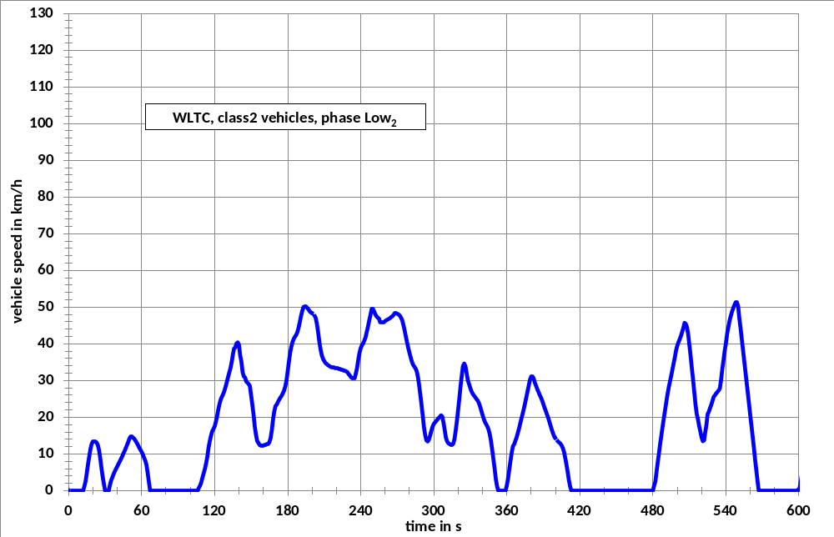

Figure A1/4

WLTC, Class 2 vehicles, phase Medium₂
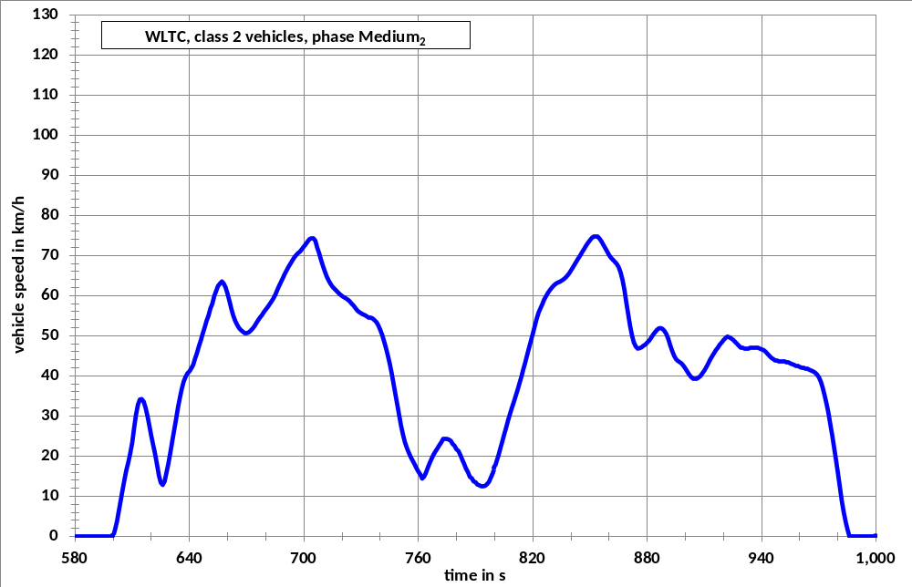

Figure A1/5

WLTC, Class 2 vehicles, phase High₂
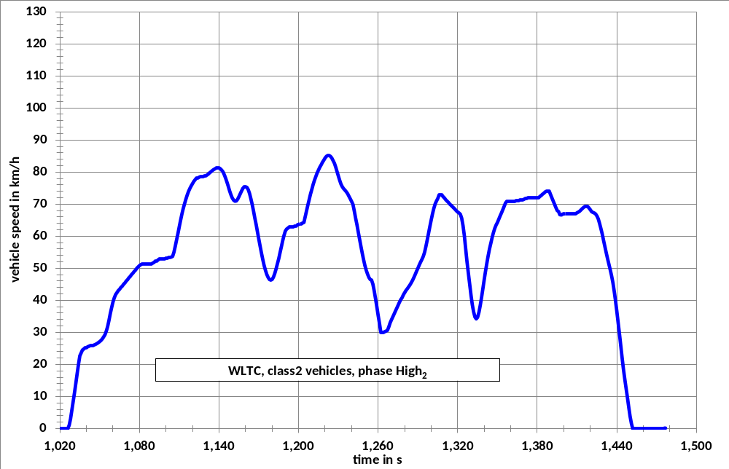

Figure A1/6

WLTC, Class 2 vehicles, phase Extra High₂
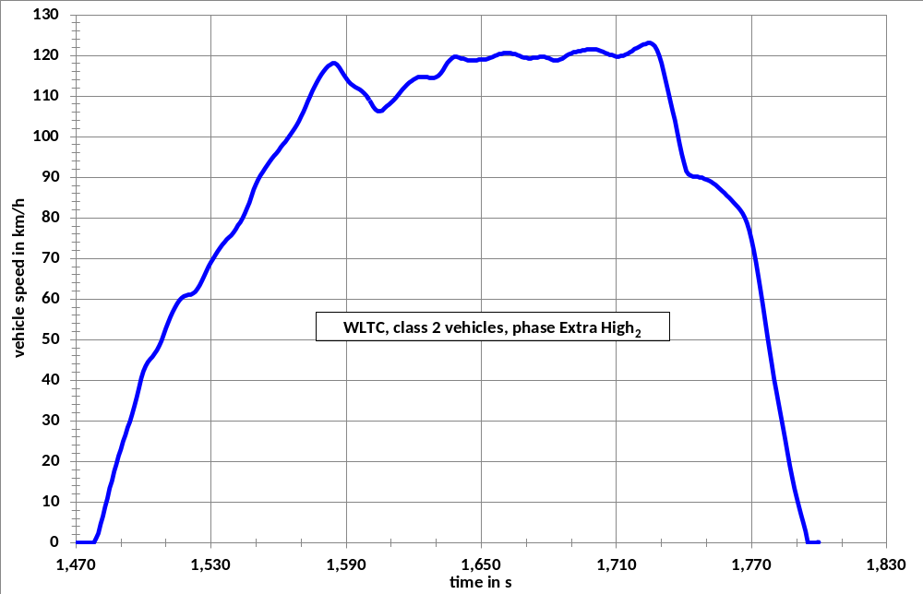

Table A1/3

WLTC, Class 2 vehicles, phase Low2
Time in s | speed in km/h | Time in s | speed in km/h | Time in s | speed in km/h | Time in s | speed in km/h
0 | 0.0 | 47 | 11.6 | 94 | 0.0 | 141 | 36.8
1 | 0.0 | 48 | 12.4 | 95 | 0.0 | 142 | 35.1
2 | 0.0 | 49 | 13.2 | 96 | 0.0 | 143 | 32.2
3 | 0.0 | 50 | 14.2 | 97 | 0.0 | 144 | 31.1
4 | 0.0 | 51 | 14.8 | 98 | 0.0 | 145 | 30.8
5 | 0.0 | 52 | 14.7 | 99 | 0.0 | 146 | 29.7
6 | 0.0 | 53 | 14.4 | 100 | 0.0 | 147 | 29.4
7 | 0.0 | 54 | 14.1 | 101 | 0.0 | 148 | 29.0
8 | 0.0 | 55 | 13.6 | 102 | 0.0 | 149 | 28.5
9 | 0.0 | 56 | 13.0 | 103 | 0.0 | 150 | 26.0
10 | 0.0 | 57 | 12.4 | 104 | 0.0 | 151 | 23.4
11 | 0.0 | 58 | 11.8 | 105 | 0.0 | 152 | 20.7
12 | 0.0 | 59 | 11.2 | 106 | 0.0 | 153 | 17.4
13 | 1.2 | 60 | 10.6 | 107 | 0.8 | 154 | 15.2
14 | 2.6 | 61 | 9.9 | 108 | 1.4 | 155 | 13.5
15 | 4.9 | 62 | 9.0 | 109 | 2.3 | 156 | 13.0
16 | 7.3 | 63 | 8.2 | 110 | 3.5 | 157 | 12.4
17 | 9.4 | 64 | 7.0 | 111 | 4.7 | 158 | 12.3
18 | 11.4 | 65 | 4.8 | 112 | 5.9 | 159 | 12.2
19 | 12.7 | 66 | 2.3 | 113 | 7.4 | 160 | 12.3
20 | 13.3 | 67 | 0.0 | 114 | 9.2 | 161 | 12.4
21 | 13.4 | 68 | 0.0 | 115 | 11.7 | 162 | 12.5
22 | 13.3 | 69 | 0.0 | 116 | 13.5 | 163 | 12.7
23 | 13.1 | 70 | 0.0 | 117 | 15.0 | 164 | 12.8
24 | 12.5 | 71 | 0.0 | 118 | 16.2 | 165 | 13.2
25 | 11.1 | 72 | 0.0 | 119 | 16.8 | 166 | 14.3
26 | 8.9 | 73 | 0.0 | 120 | 17.5 | 167 | 16.5
27 | 6.2 | 74 | 0.0 | 121 | 18.8 | 168 | 19.4
28 | 3.8 | 75 | 0.0 | 122 | 20.3 | 169 | 21.7
29 | 1.8 | 76 | 0.0 | 123 | 22.0 | 170 | 23.1
30 | 0.0 | 77 | 0.0 | 124 | 23.6 | 171 | 23.5
31 | 0.0 | 78 | 0.0 | 125 | 24.8 | 172 | 24.2
32 | 0.0 | 79 | 0.0 | 126 | 25.6 | 173 | 24.8
33 | 0.0 | 80 | 0.0 | 127 | 26.3 | 174 | 25.4
34 | 1.5 | 81 | 0.0 | 128 | 27.2 | 175 | 25.8
35 | 2.8 | 82 | 0.0 | 129 | 28.3 | 176 | 26.5
36 | 3.6 | 83 | 0.0 | 130 | 29.6 | 177 | 27.2
37 | 4.5 | 84 | 0.0 | 131 | 30.9 | 178 | 28.3
38 | 5.3 | 85 | 0.0 | 132 | 32.2 | 179 | 29.9
39 | 6.0 | 86 | 0.0 | 133 | 33.4 | 180 | 32.4
40 | 6.6 | 87 | 0.0 | 134 | 35.1 | 181 | 35.1
41 | 7.3 | 88 | 0.0 | 135 | 37.2 | 182 | 37.5
42 | 7.9 | 89 | 0.0 | 136 | 38.7 | 183 | 39.2
43 | 8.6 | 90 | 0.0 | 137 | 39.0 | 184 | 40.5
44 | 9.3 | 91 | 0.0 | 138 | 40.1 | 185 | 41.4
45 | 10 | 92 | 0.0 | 139 | 40.4 | 186 | 42.0
46 | 10.8 | 93 | 0.0 | 140 | 39.7 | 187 | 42.5
188 | 43.2 | 237 | 33.5 | 286 | 32.5 | 335 | 25.0
189 | 44.4 | 238 | 35.8 | 287 | 30.9 | 336 | 24.6
190 | 45.9 | 239 | 37.6 | 288 | 28.6 | 337 | 23.9
191 | 47.6 | 240 | 38.8 | 289 | 25.9 | 338 | 23.0
192 | 49.0 | 241 | 39.6 | 290 | 23.1 | 339 | 21.8
193 | 50.0 | 242 | 40.1 | 291 | 20.1 | 340 | 20.7
194 | 50.2 | 243 | 40.9 | 292 | 17.3 | 341 | 19.6
195 | 50.1 | 244 | 41.8 | 293 | 15.1 | 342 | 18.7
196 | 49.8 | 245 | 43.3 | 294 | 13.7 | 343 | 18.1
197 | 49.4 | 246 | 44.7 | 295 | 13.4 | 344 | 17.5
198 | 48.9 | 247 | 46.4 | 296 | 13.9 | 345 | 16.7
199 | 48.5 | 248 | 47.9 | 297 | 15.0 | 346 | 15.4
200 | 48.3 | 249 | 49.6 | 298 | 16.3 | 347 | 13.6
201 | 48.2 | 250 | 49.6 | 299 | 17.4 | 348 | 11.2
202 | 47.9 | 251 | 48.8 | 300 | 18.2 | 349 | 8.6
203 | 47.1 | 252 | 48.0 | 301 | 18.6 | 350 | 6.0
204 | 45.5 | 253 | 47.5 | 302 | 19.0 | 351 | 3.1
205 | 43.2 | 254 | 47.1 | 303 | 19.4 | 352 | 1.2
206 | 40.6 | 255 | 46.9 | 304 | 19.8 | 353 | 0.0
207 | 38.5 | 256 | 45.8 | 305 | 20.1 | 354 | 0.0
208 | 36.9 | 257 | 45.8 | 306 | 20.5 | 355 | 0.0
209 | 35.9 | 258 | 45.8 | 307 | 20.2 | 356 | 0.0
210 | 35.3 | 259 | 45.9 | 308 | 18.6 | 357 | 0.0
211 | 34.8 | 260 | 46.2 | 309 | 16.5 | 358 | 0.0
212 | 34.5 | 261 | 46.4 | 310 | 14.4 | 359 | 0.0
213 | 34.2 | 262 | 46.6 | 311 | 13.4 | 360 | 1.4
214 | 34.0 | 263 | 46.8 | 312 | 12.9 | 361 | 3.2
215 | 33.8 | 264 | 47.0 | 313 | 12.7 | 362 | 5.6
216 | 33.6 | 265 | 47.3 | 314 | 12.4 | 363 | 8.1
217 | 33.5 | 266 | 47.5 | 315 | 12.4 | 364 | 10.3
218 | 33.5 | 267 | 47.9 | 316 | 12.8 | 365 | 12.1
219 | 33.4 | 268 | 48.3 | 317 | 14.1 | 366 | 12.6
220 | 33.3 | 269 | 48.3 | 318 | 16.2 | 367 | 13.6
221 | 33.3 | 270 | 48.2 | 319 | 18.8 | 368 | 14.5
222 | 33.2 | 271 | 48.0 | 320 | 21.9 | 369 | 15.6
223 | 33.1 | 272 | 47.7 | 321 | 25.0 | 370 | 16.8
224 | 33.0 | 273 | 47.2 | 322 | 28.4 | 371 | 18.2
225 | 32.9 | 274 | 46.5 | 323 | 31.3 | 372 | 19.6
226 | 32.8 | 275 | 45.2 | 324 | 34.0 | 373 | 20.9
227 | 32.7 | 276 | 43.7 | 325 | 34.6 | 374 | 22.3
228 | 32.5 | 277 | 42.0 | 326 | 33.9 | 375 | 23.8
229 | 32.3 | 278 | 40.4 | 327 | 31.9 | 376 | 25.4
230 | 31.8 | 279 | 39.0 | 328 | 30.0 | 377 | 27.0
231 | 31.4 | 280 | 37.7 | 329 | 29.0 | 378 | 28.6
232 | 30.9 | 281 | 36.4 | 330 | 27.9 | 379 | 30.2
233 | 30.6 | 282 | 35.2 | 331 | 27.1 | 380 | 31.2
234 | 30.6 | 283 | 34.3 | 332 | 26.4 | 381 | 31.2
235 | 30.7 | 284 | 33.8 | 333 | 25.9 | 382 | 30.7
236 | 32.0 | 285 | 33.3 | 334 | 25.5 | 383 | 29.5
384 | 28.6 | 433 | 0.0 | 482 | 2.5 | 531 | 26.0
385 | 27.7 | 434 | 0.0 | 483 | 5.2 | 532 | 26.5
386 | 26.9 | 435 | 0.0 | 484 | 7.9 | 533 | 26.9
387 | 26.1 | 436 | 0.0 | 485 | 10.3 | 534 | 27.3
388 | 25.4 | 437 | 0.0 | 486 | 12.7 | 535 | 27.9
389 | 24.6 | 438 | 0.0 | 487 | 15.0 | 536 | 30.3
390 | 23.6 | 439 | 0.0 | 488 | 17.4 | 537 | 33.2
391 | 22.6 | 440 | 0.0 | 489 | 19.7 | 538 | 35.4
392 | 21.7 | 441 | 0.0 | 490 | 21.9 | 539 | 38.0
393 | 20.7 | 442 | 0.0 | 491 | 24.1 | 540 | 40.1
394 | 19.8 | 443 | 0.0 | 492 | 26.2 | 541 | 42.7
395 | 18.8 | 444 | 0.0 | 493 | 28.1 | 542 | 44.5
396 | 17.7 | 445 | 0.0 | 494 | 29.7 | 543 | 46.3
397 | 16.6 | 446 | 0.0 | 495 | 31.3 | 544 | 47.6
398 | 15.6 | 447 | 0.0 | 496 | 33.0 | 545 | 48.8
399 | 14.8 | 448 | 0.0 | 497 | 34.7 | 546 | 49.7
400 | 14.3 | 449 | 0.0 | 498 | 36.3 | 547 | 50.6
401 | 13.8 | 450 | 0.0 | 499 | 38.1 | 548 | 51.4
402 | 13.4 | 451 | 0.0 | 500 | 39.4 | 549 | 51.4
403 | 13.1 | 452 | 0.0 | 501 | 40.4 | 550 | 50.2
404 | 12.8 | 453 | 0.0 | 502 | 41.2 | 551 | 47.1
405 | 12.3 | 454 | 0.0 | 503 | 42.1 | 552 | 44.5
406 | 11.6 | 455 | 0.0 | 504 | 43.2 | 553 | 41.5
407 | 10.5 | 456 | 0.0 | 505 | 44.3 | 554 | 38.5
408 | 9.0 | 457 | 0.0 | 506 | 45.7 | 555 | 35.5
409 | 7.2 | 458 | 0.0 | 507 | 45.4 | 556 | 32.5
410 | 5.2 | 459 | 0.0 | 508 | 44.5 | 557 | 29.5
411 | 2.9 | 460 | 0.0 | 509 | 42.5 | 558 | 26.5
412 | 1.2 | 461 | 0.0 | 510 | 39.5 | 559 | 23.5
413 | 0.0 | 462 | 0.0 | 511 | 36.5 | 560 | 20.4
414 | 0.0 | 463 | 0.0 | 512 | 33.5 | 561 | 17.5
415 | 0.0 | 464 | 0.0 | 513 | 30.4 | 562 | 14.5
416 | 0.0 | 465 | 0.0 | 514 | 27.0 | 563 | 11.5
417 | 0.0 | 466 | 0.0 | 515 | 23.6 | 564 | 8.5
418 | 0.0 | 467 | 0.0 | 516 | 21.0 | 565 | 5.6
419 | 0.0 | 468 | 0.0 | 517 | 19.5 | 566 | 2.6
420 | 0.0 | 469 | 0.0 | 518 | 17.6 | 567 | 0.0
421 | 0.0 | 470 | 0.0 | 519 | 16.1 | 568 | 0.0
422 | 0.0 | 471 | 0.0 | 520 | 14.5 | 569 | 0.0
423 | 0.0 | 472 | 0.0 | 521 | 13.5 | 570 | 0.0
424 | 0.0 | 473 | 0.0 | 522 | 13.7 | 571 | 0.0
425 | 0.0 | 474 | 0.0 | 523 | 16.0 | 572 | 0.0
426 | 0.0 | 475 | 0.0 | 524 | 18.1 | 573 | 0.0
427 | 0.0 | 476 | 0.0 | 525 | 20.8 | 574 | 0.0
428 | 0.0 | 477 | 0.0 | 526 | 21.5 | 575 | 0.0
429 | 0.0 | 478 | 0.0 | 527 | 22.5 | 576 | 0.0
430 | 0.0 | 479 | 0.0 | 528 | 23.4 | 577 | 0.0
431 | 0.0 | 480 | 0.0 | 529 | 24.5 | 578 | 0.0
432 | 0.0 | 481 | 1.4 | 530 | 25.6 | 579 | 0.0
580 | 0.0
581 | 0.0
582 | 0.0
583 | 0.0
584 | 0.0
585 | 0.0
586 | 0.0
587 | 0.0
588 | 0.0
589 | 0.0

Table A1/4

WLTC, Class 2 vehicles, phase Medium2
Time in s | speed in km/h | Time in s | speed in km/h | Time in s | speed in km/h | Time in s | speed in km/h
590 | 0.0 | 637 | 38.6 | 684 | 59.3 | 731 | 55.3
591 | 0.0 | 638 | 39.8 | 685 | 60.2 | 732 | 55.1
592 | 0.0 | 639 | 40.6 | 686 | 61.3 | 733 | 54.8
593 | 0.0 | 640 | 41.1 | 687 | 62.4 | 734 | 54.6
594 | 0.0 | 641 | 41.9 | 688 | 63.4 | 735 | 54.5
595 | 0.0 | 642 | 42.8 | 689 | 64.4 | 736 | 54.3
596 | 0.0 | 643 | 44.3 | 690 | 65.4 | 737 | 53.9
597 | 0.0 | 644 | 45.7 | 691 | 66.3 | 738 | 53.4
598 | 0.0 | 645 | 47.4 | 692 | 67.2 | 739 | 52.6
599 | 0.0 | 646 | 48.9 | 693 | 68.0 | 740 | 51.5
600 | 0.0 | 647 | 50.6 | 694 | 68.8 | 741 | 50.2
601 | 1.6 | 648 | 52.0 | 695 | 69.5 | 742 | 48.7
602 | 3.6 | 649 | 53.7 | 696 | 70.1 | 743 | 47.0
603 | 6.3 | 650 | 55.0 | 697 | 70.6 | 744 | 45.1
604 | 9.0 | 651 | 56.8 | 698 | 71.0 | 745 | 43.0
605 | 11.8 | 652 | 58.0 | 699 | 71.6 | 746 | 40.6
606 | 14.2 | 653 | 59.8 | 700 | 72.2 | 747 | 38.1
607 | 16.6 | 654 | 61.1 | 701 | 72.8 | 748 | 35.4
608 | 18.5 | 655 | 62.4 | 702 | 73.5 | 749 | 32.7
609 | 20.8 | 656 | 63.0 | 703 | 74.1 | 750 | 30.0
610 | 23.4 | 657 | 63.5 | 704 | 74.3 | 751 | 27.5
611 | 26.9 | 658 | 63.0 | 705 | 74.3 | 752 | 25.3
612 | 30.3 | 659 | 62.0 | 706 | 73.7 | 753 | 23.4
613 | 32.8 | 660 | 60.4 | 707 | 71.9 | 754 | 22.0
614 | 34.1 | 661 | 58.6 | 708 | 70.5 | 755 | 20.8
615 | 34.2 | 662 | 56.7 | 709 | 68.9 | 756 | 19.8
616 | 33.6 | 663 | 55.0 | 710 | 67.4 | 757 | 18.9
617 | 32.1 | 664 | 53.7 | 711 | 66.0 | 758 | 18.0
618 | 30.0 | 665 | 52.7 | 712 | 64.7 | 759 | 17.0
619 | 27.5 | 666 | 51.9 | 713 | 63.7 | 760 | 16.1
620 | 25.1 | 667 | 51.4 | 714 | 62.9 | 761 | 15.5
621 | 22.8 | 668 | 51.0 | 715 | 62.2 | 762 | 14.4
622 | 20.5 | 669 | 50.7 | 716 | 61.7 | 763 | 14.9
623 | 17.9 | 670 | 50.6 | 717 | 61.2 | 764 | 15.9
624 | 15.1 | 671 | 50.8 | 718 | 60.7 | 765 | 17.1
625 | 13.4 | 672 | 51.2 | 719 | 60.3 | 766 | 18.3
626 | 12.8 | 673 | 51.7 | 720 | 59.9 | 767 | 19.4
627 | 13.7 | 674 | 52.3 | 721 | 59.6 | 768 | 20.4
628 | 16.0 | 675 | 53.1 | 722 | 59.3 | 769 | 21.2
629 | 18.1 | 676 | 53.8 | 723 | 59.0 | 770 | 21.9
630 | 20.8 | 677 | 54.5 | 724 | 58.6 | 771 | 22.7
631 | 23.7 | 678 | 55.1 | 725 | 58.0 | 772 | 23.4
632 | 26.5 | 679 | 55.9 | 726 | 57.5 | 773 | 24.2
633 | 29.3 | 680 | 56.5 | 727 | 56.9 | 774 | 24.3
634 | 32.0 | 681 | 57.1 | 728 | 56.3 | 775 | 24.2
635 | 34.5 | 682 | 57.8 | 729 | 55.9 | 776 | 24.1
636 | 36.8 | 683 | 58.5 | 730 | 55.6 | 777 | 23.8
778 | 23.0 | 827 | 59.9 | 876 | 46.9 | 925 | 49.0
779 | 22.6 | 828 | 60.7 | 877 | 47.1 | 926 | 48.5
780 | 21.7 | 829 | 61.4 | 878 | 47.5 | 927 | 48.0
781 | 21.3 | 830 | 62.0 | 879 | 47.8 | 928 | 47.5
782 | 20.3 | 831 | 62.5 | 880 | 48.3 | 929 | 47.0
783 | 19.1 | 832 | 62.9 | 881 | 48.8 | 930 | 46.9
784 | 18.1 | 833 | 63.2 | 882 | 49.5 | 931 | 46.8
785 | 16.9 | 834 | 63.4 | 883 | 50.2 | 932 | 46.8
786 | 16.0 | 835 | 63.7 | 884 | 50.8 | 933 | 46.8
787 | 14.8 | 836 | 64.0 | 885 | 51.4 | 934 | 46.9
788 | 14.5 | 837 | 64.4 | 886 | 51.8 | 935 | 46.9
789 | 13.7 | 838 | 64.9 | 887 | 51.9 | 936 | 46.9
790 | 13.5 | 839 | 65.5 | 888 | 51.7 | 937 | 46.9
791 | 12.9 | 840 | 66.2 | 889 | 51.2 | 938 | 46.9
792 | 12.7 | 841 | 67.0 | 890 | 50.4 | 939 | 46.8
793 | 12.5 | 842 | 67.8 | 891 | 49.2 | 940 | 46.6
794 | 12.5 | 843 | 68.6 | 892 | 47.7 | 941 | 46.4
795 | 12.6 | 844 | 69.4 | 893 | 46.3 | 942 | 46.0
796 | 13.0 | 845 | 70.1 | 894 | 45.1 | 943 | 45.5
797 | 13.6 | 846 | 70.9 | 895 | 44.2 | 944 | 45.0
798 | 14.6 | 847 | 71.7 | 896 | 43.7 | 945 | 44.5
799 | 15.7 | 848 | 72.5 | 897 | 43.4 | 946 | 44.2
800 | 17.1 | 849 | 73.2 | 898 | 43.1 | 947 | 43.9
801 | 18.7 | 850 | 73.8 | 899 | 42.5 | 948 | 43.7
802 | 20.2 | 851 | 74.4 | 900 | 41.8 | 949 | 43.6
803 | 21.9 | 852 | 74.7 | 901 | 41.1 | 950 | 43.6
804 | 23.6 | 853 | 74.7 | 902 | 40.3 | 951 | 43.5
805 | 25.4 | 854 | 74.6 | 903 | 39.7 | 952 | 43.5
806 | 27.1 | 855 | 74.2 | 904 | 39.3 | 953 | 43.4
807 | 28.9 | 856 | 73.5 | 905 | 39.2 | 954 | 43.3
808 | 30.4 | 857 | 72.6 | 906 | 39.3 | 955 | 43.1
809 | 32.0 | 858 | 71.8 | 907 | 39.6 | 956 | 42.9
810 | 33.4 | 859 | 71.0 | 908 | 40.0 | 957 | 42.7
811 | 35.0 | 860 | 70.1 | 909 | 40.7 | 958 | 42.5
812 | 36.4 | 861 | 69.4 | 910 | 41.4 | 959 | 42.4
813 | 38.1 | 862 | 68.9 | 911 | 42.2 | 960 | 42.2
814 | 39.7 | 863 | 68.4 | 912 | 43.1 | 961 | 42.1
815 | 41.6 | 864 | 67.9 | 913 | 44.1 | 962 | 42.0
816 | 43.3 | 865 | 67.1 | 914 | 44.9 | 963 | 41.8
817 | 45.1 | 866 | 65.8 | 915 | 45.6 | 964 | 41.7
818 | 46.9 | 867 | 63.9 | 916 | 46.4 | 965 | 41.5
819 | 48.7 | 868 | 61.4 | 917 | 47.0 | 966 | 41.3
820 | 50.5 | 869 | 58.4 | 918 | 47.8 | 967 | 41.1
821 | 52.4 | 870 | 55.4 | 919 | 48.3 | 968 | 40.8
822 | 54.1 | 871 | 52.4 | 920 | 48.9 | 969 | 40.3
823 | 55.7 | 872 | 50.0 | 921 | 49.4 | 970 | 39.6
824 | 56.8 | 873 | 48.3 | 922 | 49.8 | 971 | 38.5
825 | 57.9 | 874 | 47.3 | 923 | 49.6 | 972 | 37.0
826 | 59.0 | 875 | 46.8 | 924 | 49.3 | 973 | 35.1
974 | 33.0
975 | 30.6
976 | 27.9
977 | 25.1
978 | 22.0
979 | 18.8
980 | 15.5
981 | 12.3
982 | 8.8
983 | 6.0
984 | 3.6
985 | 1.6
986 | 0.0
987 | 0.0
988 | 0.0
989 | 0.0
990 | 0.0
991 | 0.0
992 | 0.0
993 | 0.0
994 | 0.0
995 | 0.0
996 | 0.0
997 | 0.0
998 | 0.0
999 | 0.0
1000 | 0.0
1001 | 0.0
1002 | 0.0
1003 | 0.0
1004 | 0.0
1005 | 0.0
1006 | 0.0
1007 | 0.0
1008 | 0.0
1009 | 0.0
1010 | 0.0
1011 | 0.0
1012 | 0.0
1013 | 0.0
1014 | 0.0
1015 | 0.0
1016 | 0.0
1017 | 0.0
1018 | 0.0
1019 | 0.0
1020 | 0.0
1021 | 0.0
1022 | 0.0

Table A1/5

WLTC, Class 2 vehicles, phase High2
Time in s | speed in km/h | Time in s | speed in km/h | Time in s | speed in km/h | Time in s | speed in km/h
1023 | 0.0 | 1070 | 46.0 | 1117 | 73.9 | 1164 | 71.7
1024 | 0.0 | 1071 | 46.4 | 1118 | 74.9 | 1165 | 69.9
1025 | 0.0 | 1072 | 47.0 | 1119 | 75.7 | 1166 | 67.9
1026 | 0.0 | 1073 | 47.4 | 1120 | 76.4 | 1167 | 65.7
1027 | 1.1 | 1074 | 48.0 | 1121 | 77.1 | 1168 | 63.5
1028 | 3.0 | 1075 | 48.4 | 1122 | 77.6 | 1169 | 61.2
1029 | 5.7 | 1076 | 49.0 | 1123 | 78.0 | 1170 | 59.0
1030 | 8.4 | 1077 | 49.4 | 1124 | 78.2 | 1171 | 56.8
1031 | 11.1 | 1078 | 50.0 | 1125 | 78.4 | 1172 | 54.7
1032 | 14.0 | 1079 | 50.4 | 1126 | 78.5 | 1173 | 52.7
1033 | 17.0 | 1080 | 50.8 | 1127 | 78.5 | 1174 | 50.9
1034 | 20.1 | 1081 | 51.1 | 1128 | 78.6 | 1175 | 49.4
1035 | 22.7 | 1082 | 51.3 | 1129 | 78.7 | 1176 | 48.1
1036 | 23.6 | 1083 | 51.3 | 1130 | 78.9 | 1177 | 47.1
1037 | 24.5 | 1084 | 51.3 | 1131 | 79.1 | 1178 | 46.5
1038 | 24.8 | 1085 | 51.3 | 1132 | 79.4 | 1179 | 46.3
1039 | 25.1 | 1086 | 51.3 | 1133 | 79.8 | 1180 | 46.5
1040 | 25.3 | 1087 | 51.3 | 1134 | 80.1 | 1181 | 47.2
1041 | 25.5 | 1088 | 51.3 | 1135 | 80.5 | 1182 | 48.3
1042 | 25.7 | 1089 | 51.4 | 1136 | 80.8 | 1183 | 49.7
1043 | 25.8 | 1090 | 51.6 | 1137 | 81.0 | 1184 | 51.3
1044 | 25.9 | 1091 | 51.8 | 1138 | 81.2 | 1185 | 53.0
1045 | 26.0 | 1092 | 52.1 | 1139 | 81.3 | 1186 | 54.9
1046 | 26.1 | 1093 | 52.3 | 1140 | 81.2 | 1187 | 56.7
1047 | 26.3 | 1094 | 52.6 | 1141 | 81.0 | 1188 | 58.6
1048 | 26.5 | 1095 | 52.8 | 1142 | 80.6 | 1189 | 60.2
1049 | 26.8 | 1096 | 52.9 | 1143 | 80.0 | 1190 | 61.6
1050 | 27.1 | 1097 | 53.0 | 1144 | 79.1 | 1191 | 62.2
1051 | 27.5 | 1098 | 53.0 | 1145 | 78.0 | 1192 | 62.5
1052 | 28.0 | 1099 | 53.0 | 1146 | 76.8 | 1193 | 62.8
1053 | 28.6 | 1100 | 53.1 | 1147 | 75.5 | 1194 | 62.9
1054 | 29.3 | 1101 | 53.2 | 1148 | 74.1 | 1195 | 63.0
1055 | 30.4 | 1102 | 53.3 | 1149 | 72.9 | 1196 | 63.0
1056 | 31.8 | 1103 | 53.4 | 1150 | 71.9 | 1197 | 63.1
1057 | 33.7 | 1104 | 53.5 | 1151 | 71.2 | 1198 | 63.2
1058 | 35.8 | 1105 | 53.7 | 1152 | 70.9 | 1199 | 63.3
1059 | 37.8 | 1106 | 55.0 | 1153 | 71.0 | 1200 | 63.5
1060 | 39.5 | 1107 | 56.8 | 1154 | 71.5 | 1201 | 63.7
1061 | 40.8 | 1108 | 58.8 | 1155 | 72.3 | 1202 | 63.9
1062 | 41.8 | 1109 | 60.9 | 1156 | 73.2 | 1203 | 64.1
1063 | 42.4 | 1110 | 63.0 | 1157 | 74.1 | 1204 | 64.3
1064 | 43.0 | 1111 | 65.0 | 1158 | 74.9 | 1205 | 66.1
1065 | 43.4 | 1112 | 66.9 | 1159 | 75.4 | 1206 | 67.9
1066 | 44.0 | 1113 | 68.6 | 1160 | 75.5 | 1207 | 69.7
1067 | 44.4 | 1114 | 70.1 | 1161 | 75.2 | 1208 | 71.4
1068 | 45.0 | 1115 | 71.5 | 1162 | 74.5 | 1209 | 73.1
1069 | 45.4 | 1116 | 72.8 | 1163 | 73.3 | 1210 | 74.7
1211 | 76.2 | 1260 | 35.4 | 1309 | 72.3 | 1358 | 70.8
1212 | 77.5 | 1261 | 32.7 | 1310 | 71.9 | 1359 | 70.8
1213 | 78.6 | 1262 | 30.0 | 1311 | 71.3 | 1360 | 70.9
1214 | 79.7 | 1263 | 29.9 | 1312 | 70.9 | 1361 | 70.9
1215 | 80.6 | 1264 | 30.0 | 1313 | 70.5 | 1362 | 70.9
1216 | 81.5 | 1265 | 30.2 | 1314 | 70.0 | 1363 | 70.9
1217 | 82.2 | 1266 | 30.4 | 1315 | 69.6 | 1364 | 71.0
1218 | 83.0 | 1267 | 30.6 | 1316 | 69.2 | 1365 | 71.0
1219 | 83.7 | 1268 | 31.6 | 1317 | 68.8 | 1366 | 71.1
1220 | 84.4 | 1269 | 33.0 | 1318 | 68.4 | 1367 | 71.2
1221 | 84.9 | 1270 | 33.9 | 1319 | 67.9 | 1368 | 71.3
1222 | 85.1 | 1271 | 34.8 | 1320 | 67.5 | 1369 | 71.4
1223 | 85.2 | 1272 | 35.7 | 1321 | 67.2 | 1370 | 71.5
1224 | 84.9 | 1273 | 36.6 | 1322 | 66.8 | 1371 | 71.7
1225 | 84.4 | 1274 | 37.5 | 1323 | 65.6 | 1372 | 71.8
1226 | 83.6 | 1275 | 38.4 | 1324 | 63.3 | 1373 | 71.9
1227 | 82.7 | 1276 | 39.3 | 1325 | 60.2 | 1374 | 71.9
1228 | 81.5 | 1277 | 40.2 | 1326 | 56.2 | 1375 | 71.9
1229 | 80.1 | 1278 | 40.8 | 1327 | 52.2 | 1376 | 71.9
1230 | 78.7 | 1279 | 41.7 | 1328 | 48.4 | 1377 | 71.9
1231 | 77.4 | 1280 | 42.4 | 1329 | 45.0 | 1378 | 71.9
1232 | 76.2 | 1281 | 43.1 | 1330 | 41.6 | 1379 | 71.9
1233 | 75.4 | 1282 | 43.6 | 1331 | 38.6 | 1380 | 72.0
1234 | 74.8 | 1283 | 44.2 | 1332 | 36.4 | 1381 | 72.1
1235 | 74.3 | 1284 | 44.8 | 1333 | 34.8 | 1382 | 72.4
1236 | 73.8 | 1285 | 45.5 | 1334 | 34.2 | 1383 | 72.7
1237 | 73.2 | 1286 | 46.3 | 1335 | 34.7 | 1384 | 73.1
1238 | 72.4 | 1287 | 47.2 | 1336 | 36.3 | 1385 | 73.4
1239 | 71.6 | 1288 | 48.1 | 1337 | 38.5 | 1386 | 73.8
1240 | 70.8 | 1289 | 49.1 | 1338 | 41.0 | 1387 | 74.0
1241 | 69.9 | 1290 | 50.0 | 1339 | 43.7 | 1388 | 74.1
1242 | 67.9 | 1291 | 51.0 | 1340 | 46.5 | 1389 | 74.0
1243 | 65.7 | 1292 | 51.9 | 1341 | 49.1 | 1390 | 73.0
1244 | 63.5 | 1293 | 52.7 | 1342 | 51.6 | 1391 | 72.0
1245 | 61.2 | 1294 | 53.7 | 1343 | 53.9 | 1392 | 71.0
1246 | 59.0 | 1295 | 55.0 | 1344 | 56.0 | 1393 | 70.0
1247 | 56.8 | 1296 | 56.8 | 1345 | 57.9 | 1394 | 69.0
1248 | 54.7 | 1297 | 58.8 | 1346 | 59.7 | 1395 | 68.0
1249 | 52.7 | 1298 | 60.9 | 1347 | 61.2 | 1396 | 67.7
1250 | 50.9 | 1299 | 63.0 | 1348 | 62.5 | 1397 | 66.7
1251 | 49.4 | 1300 | 65.0 | 1349 | 63.5 | 1398 | 66.6
1252 | 48.1 | 1301 | 66.9 | 1350 | 64.3 | 1399 | 66.7
1253 | 47.1 | 1302 | 68.6 | 1351 | 65.3 | 1400 | 66.8
1254 | 46.5 | 1303 | 70.1 | 1352 | 66.3 | 1401 | 66.9
1255 | 46.3 | 1304 | 71.0 | 1353 | 67.3 | 1402 | 66.9
1256 | 45.1 | 1305 | 71.8 | 1354 | 68.3 | 1403 | 66.9
1257 | 43.0 | 1306 | 72.8 | 1355 | 69.3 | 1404 | 66.9
1258 | 40.6 | 1307 | 72.9 | 1356 | 70.3 | 1405 | 66.9
1259 | 38.1 | 1308 | 73.0 | 1357 | 70.8 | 1406 | 66.9
1407 | 66.9 | 1456 | 0.0
1408 | 67.0 | 1457 | 0.0
1409 | 67.1 | 1458 | 0.0
1410 | 67.3 | 1459 | 0.0
1411 | 67.5 | 1460 | 0.0
1412 | 67.8 | 1461 | 0.0
1413 | 68.2 | 1462 | 0.0
1414 | 68.6 | 1463 | 0.0
1415 | 69.0 | 1464 | 0.0
1416 | 69.3 | 1465 | 0.0
1417 | 69.3 | 1466 | 0.0
1418 | 69.2 | 1467 | 0.0
1419 | 68.8 | 1468 | 0.0
1420 | 68.2 | 1469 | 0.0
1421 | 67.6 | 1470 | 0.0
1422 | 67.4 | 1471 | 0.0
1423 | 67.2 | 1472 | 0.0
1424 | 66.9 | 1473 | 0.0
1425 | 66.3 | 1474 | 0.0
1426 | 65.4 | 1475 | 0.0
1427 | 64.0 | 1476 | 0.0
1428 | 62.4 | 1477 | 0.0
1429 | 60.6
1430 | 58.6
1431 | 56.7
1432 | 54.8
1433 | 53.0
1434 | 51.3
1435 | 49.6
1436 | 47.8
1437 | 45.5
1438 | 42.8
1439 | 39.8
1440 | 36.5
1441 | 33.0
1442 | 29.5
1443 | 25.8
1444 | 22.1
1445 | 18.6
1446 | 15.3
1447 | 12.4
1448 | 9.6
1449 | 6.6
1450 | 3.8
1451 | 1.6
1452 | 0.0
1453 | 0.0
1454 | 0.0
1455 | 0.0

Table A1/6

WLTC, Class 2 vehicles, phase Extra High2
Time in s | speed in km/h | Time in s | speed in km/h | Time in s | speed in km/h | Time in s | speed in km/h
1478 | 0.0 | 1525 | 63.4 | 1572 | 107.4 | 1619 | 113.7
1479 | 1.1 | 1526 | 64.5 | 1573 | 108.7 | 1620 | 114.1
1480 | 2.3 | 1527 | 65.7 | 1574 | 109.9 | 1621 | 114.4
1481 | 4.6 | 1528 | 66.9 | 1575 | 111.2 | 1622 | 114.6
1482 | 6.5 | 1529 | 68.1 | 1576 | 112.3 | 1623 | 114.7
1483 | 8.9 | 1530 | 69.1 | 1577 | 113.4 | 1624 | 114.7
1484 | 10.9 | 1531 | 70.0 | 1578 | 114.4 | 1625 | 114.7
1485 | 13.5 | 1532 | 70.9 | 1579 | 115.3 | 1626 | 114.6
1486 | 15.2 | 1533 | 71.8 | 1580 | 116.1 | 1627 | 114.5
1487 | 17.6 | 1534 | 72.6 | 1581 | 116.8 | 1628 | 114.5
1488 | 19.3 | 1535 | 73.4 | 1582 | 117.4 | 1629 | 114.5
1489 | 21.4 | 1536 | 74.0 | 1583 | 117.7 | 1630 | 114.7
1490 | 23.0 | 1537 | 74.7 | 1584 | 118.2 | 1631 | 115.0
1491 | 25.0 | 1538 | 75.2 | 1585 | 118.1 | 1632 | 115.6
1492 | 26.5 | 1539 | 75.7 | 1586 | 117.7 | 1633 | 116.4
1493 | 28.4 | 1540 | 76.4 | 1587 | 117.0 | 1634 | 117.3
1494 | 29.8 | 1541 | 77.2 | 1588 | 116.1 | 1635 | 118.2
1495 | 31.7 | 1542 | 78.2 | 1589 | 115.2 | 1636 | 118.8
1496 | 33.7 | 1543 | 78.9 | 1590 | 114.4 | 1637 | 119.3
1497 | 35.8 | 1544 | 79.9 | 1591 | 113.6 | 1638 | 119.6
1498 | 38.1 | 1545 | 81.1 | 1592 | 113.0 | 1639 | 119.7
1499 | 40.5 | 1546 | 82.4 | 1593 | 112.6 | 1640 | 119.5
1500 | 42.2 | 1547 | 83.7 | 1594 | 112.2 | 1641 | 119.3
1501 | 43.5 | 1548 | 85.4 | 1595 | 111.9 | 1642 | 119.2
1502 | 44.5 | 1549 | 87.0 | 1596 | 111.6 | 1643 | 119.0
1503 | 45.2 | 1550 | 88.3 | 1597 | 111.2 | 1644 | 118.8
1504 | 45.8 | 1551 | 89.5 | 1598 | 110.7 | 1645 | 118.8
1505 | 46.6 | 1552 | 90.5 | 1599 | 110.1 | 1646 | 118.8
1506 | 47.4 | 1553 | 91.3 | 1600 | 109.3 | 1647 | 118.8
1507 | 48.5 | 1554 | 92.2 | 1601 | 108.4 | 1648 | 118.8
1508 | 49.7 | 1555 | 93.0 | 1602 | 107.4 | 1649 | 118.9
1509 | 51.3 | 1556 | 93.8 | 1603 | 106.7 | 1650 | 119.0
1510 | 52.9 | 1557 | 94.6 | 1604 | 106.3 | 1651 | 119.0
1511 | 54.3 | 1558 | 95.3 | 1605 | 106.2 | 1652 | 119.1
1512 | 55.6 | 1559 | 95.9 | 1606 | 106.4 | 1653 | 119.2
1513 | 56.8 | 1560 | 96.6 | 1607 | 107.0 | 1654 | 119.4
1514 | 57.9 | 1561 | 97.4 | 1608 | 107.5 | 1655 | 119.6
1515 | 58.9 | 1562 | 98.1 | 1609 | 107.9 | 1656 | 119.9
1516 | 59.7 | 1563 | 98.7 | 1610 | 108.4 | 1657 | 120.1
1517 | 60.3 | 1564 | 99.5 | 1611 | 108.9 | 1658 | 120.3
1518 | 60.7 | 1565 | 100.3 | 1612 | 109.5 | 1659 | 120.4
1519 | 60.9 | 1566 | 101.1 | 1613 | 110.2 | 1660 | 120.5
1520 | 61.0 | 1567 | 101.9 | 1614 | 110.9 | 1661 | 120.5
1521 | 61.1 | 1568 | 102.8 | 1615 | 111.6 | 1662 | 120.5
1522 | 61.4 | 1569 | 103.8 | 1616 | 112.2 | 1663 | 120.5
1523 | 61.8 | 1570 | 105.0 | 1617 | 112.8 | 1664 | 120.4
1524 | 62.5 | 1571 | 106.1 | 1618 | 113.3 | 1665 | 120.3
1666 | 120.1 | 1715 | 120.4 | 1764 | 82.6
1667 | 119.9 | 1716 | 120.8 | 1765 | 81.9
1668 | 119.6 | 1717 | 121.1 | 1766 | 81.1
1669 | 119.5 | 1718 | 121.6 | 1767 | 80.0
1670 | 119.4 | 1719 | 121.8 | 1768 | 78.7
1671 | 119.3 | 1720 | 122.1 | 1769 | 76.9
1672 | 119.3 | 1721 | 122.4 | 1770 | 74.6
1673 | 119.4 | 1722 | 122.7 | 1771 | 72.0
1674 | 119.5 | 1723 | 122.8 | 1772 | 69.0
1675 | 119.5 | 1724 | 123.1 | 1773 | 65.6
1676 | 119.6 | 1725 | 123.1 | 1774 | 62.1
1677 | 119.6 | 1726 | 122.8 | 1775 | 58.5
1678 | 119.6 | 1727 | 122.3 | 1776 | 54.7
1679 | 119.4 | 1728 | 121.3 | 1777 | 50.9
1680 | 119.3 | 1729 | 119.9 | 1778 | 47.3
1681 | 119.0 | 1730 | 118.1 | 1779 | 43.8
1682 | 118.8 | 1731 | 115.9 | 1780 | 40.4
1683 | 118.7 | 1732 | 113.5 | 1781 | 37.4
1684 | 118.8 | 1733 | 111.1 | 1782 | 34.3
1685 | 119.0 | 1734 | 108.6 | 1783 | 31.3
1686 | 119.2 | 1735 | 106.2 | 1784 | 28.3
1687 | 119.6 | 1736 | 104.0 | 1785 | 25.2
1688 | 120.0 | 1737 | 101.1 | 1786 | 22.0
1689 | 120.3 | 1738 | 98.3 | 1787 | 18.9
1690 | 120.5 | 1739 | 95.7 | 1788 | 16.1
1691 | 120.7 | 1740 | 93.5 | 1789 | 13.4
1692 | 120.9 | 1741 | 91.5 | 1790 | 11.1
1693 | 121.0 | 1742 | 90.7 | 1791 | 8.9
1694 | 121.1 | 1743 | 90.4 | 1792 | 6.9
1695 | 121.2 | 1744 | 90.2 | 1793 | 4.9
1696 | 121.3 | 1745 | 90.2 | 1794 | 2.8
1697 | 121.4 | 1746 | 90.1 | 1795 | 0.0
1698 | 121.5 | 1747 | 90.0 | 1796 | 0.0
1699 | 121.5 | 1748 | 89.8 | 1797 | 0.0
1700 | 121.5 | 1749 | 89.6 | 1798 | 0.0
1701 | 121.4 | 1750 | 89.4 | 1799 | 0.0
1702 | 121.3 | 1751 | 89.2 | 1800 | 0.0
1703 | 121.1 | 1752 | 88.9
1704 | 120.9 | 1753 | 88.5
1705 | 120.6 | 1754 | 88.1
1706 | 120.4 | 1755 | 87.6
1707 | 120.2 | 1756 | 87.1
1708 | 120.1 | 1757 | 86.6
1709 | 119.9 | 1758 | 86.1
1710 | 119.8 | 1759 | 85.5
1711 | 119.8 | 1760 | 85.0
1712 | 119.9 | 1761 | 84.4
1713 | 120.0 | 1762 | 83.8
1714 | 120.2 | 1763 | 83.2

6. WLTC for Class 3 vehicles

Figure A1/7

WLTC, Class 3 vehicles, phase Low₃
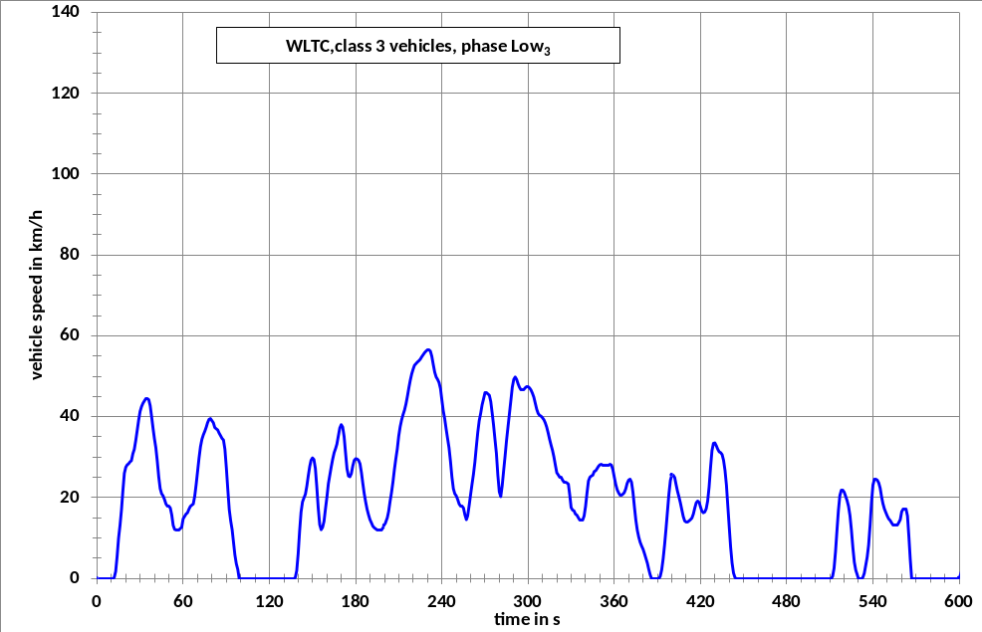

Figure A1/8

WLTC, Class 3 vehicles, phase Medium₃₋₁
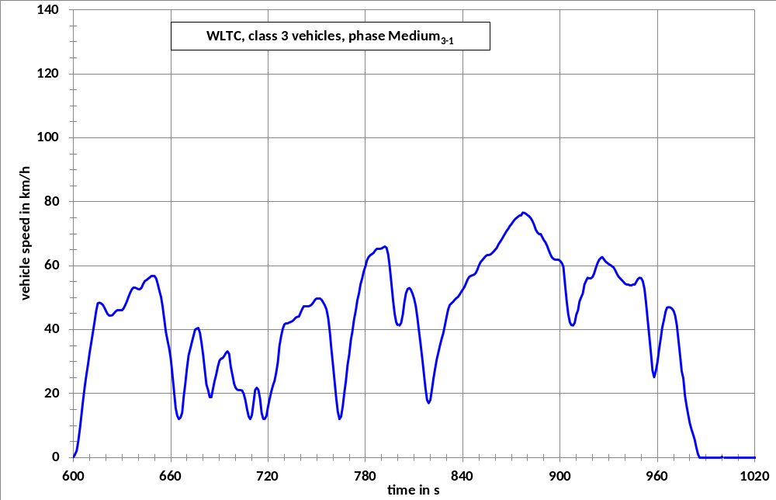

Figure A1/9

WLTC, Class 3 vehicles, phase Medium₃₋₂

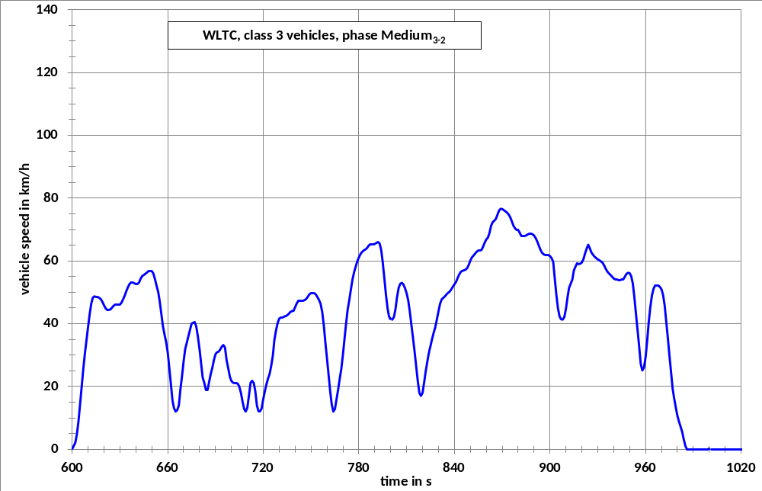

Figure A1/10

WLTC, Class 3 vehicles, phase High₃₋₁

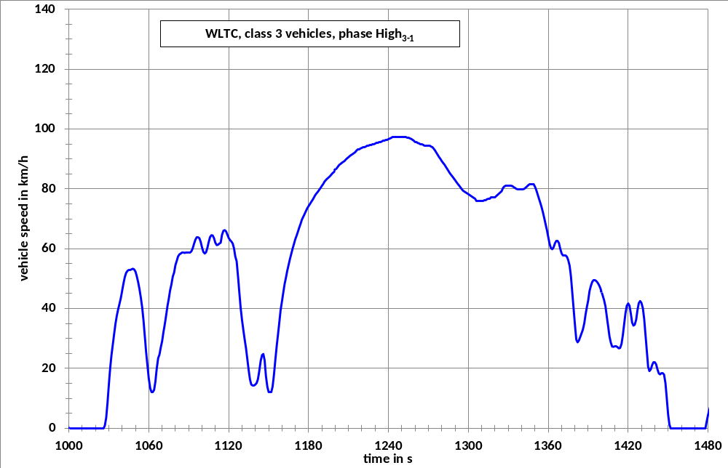

Figure A1/11

WLTC, Class 3 vehicles, phase High₃₋₂
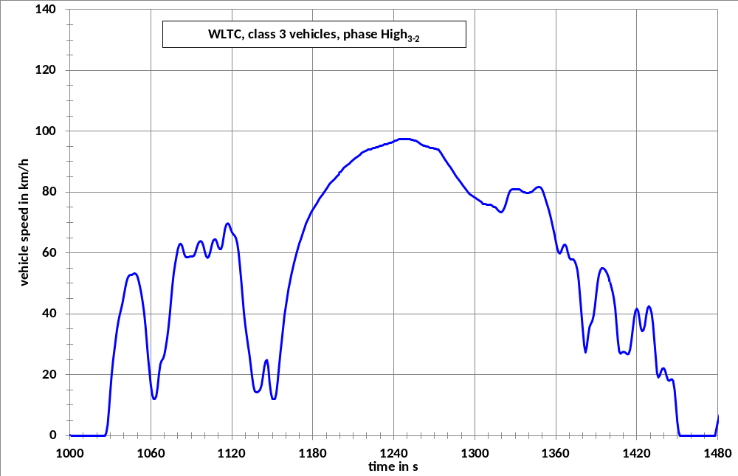

Figure A1/12

WLTC, Class 3 vehicles, phase Extra High₃
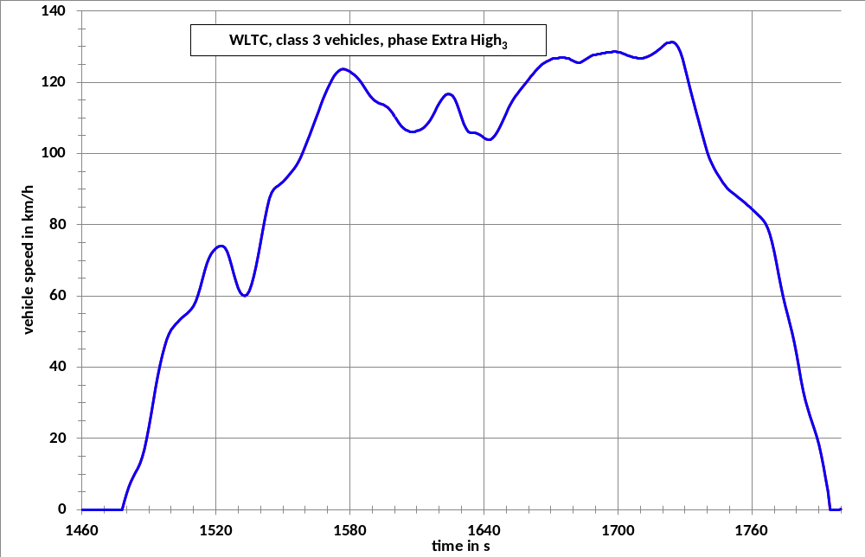

Table A1/7

WLTC, Class 3 vehicles, phase Low3
Time in s | speed in km/h | Time in s | speed in km/h | Time in s | speed in km/h | Time in s | speed in km/h
0 | 0.0 | 47 | 19.5 | 94 | 12.0 | 141 | 11.7
1 | 0.0 | 48 | 18.4 | 95 | 9.1 | 142 | 16.4
2 | 0.0 | 49 | 17.8 | 96 | 5.8 | 143 | 18.9
3 | 0.0 | 50 | 17.8 | 97 | 3.6 | 144 | 19.9
4 | 0.0 | 51 | 17.4 | 98 | 2.2 | 145 | 20.8
5 | 0.0 | 52 | 15.7 | 99 | 0.0 | 146 | 22.8
6 | 0.0 | 53 | 13.1 | 100 | 0.0 | 147 | 25.4
7 | 0.0 | 54 | 12.1 | 101 | 0.0 | 148 | 27.7
8 | 0.0 | 55 | 12.0 | 102 | 0.0 | 149 | 29.2
9 | 0.0 | 56 | 12.0 | 103 | 0.0 | 150 | 29.8
10 | 0.0 | 57 | 12.0 | 104 | 0.0 | 151 | 29.4
11 | 0.0 | 58 | 12.3 | 105 | 0.0 | 152 | 27.2
12 | 0.2 | 59 | 12.6 | 106 | 0.0 | 153 | 22.6
13 | 1.7 | 60 | 14.7 | 107 | 0.0 | 154 | 17.3
14 | 5.4 | 61 | 15.3 | 108 | 0.0 | 155 | 13.3
15 | 9.9 | 62 | 15.9 | 109 | 0.0 | 156 | 12.0
16 | 13.1 | 63 | 16.2 | 110 | 0.0 | 157 | 12.6
17 | 16.9 | 64 | 17.1 | 111 | 0.0 | 158 | 14.1
18 | 21.7 | 65 | 17.8 | 112 | 0.0 | 159 | 17.2
19 | 26.0 | 66 | 18.1 | 113 | 0.0 | 160 | 20.1
20 | 27.5 | 67 | 18.4 | 114 | 0.0 | 161 | 23.4
21 | 28.1 | 68 | 20.3 | 115 | 0.0 | 162 | 25.5
22 | 28.3 | 69 | 23.2 | 116 | 0.0 | 163 | 27.6
23 | 28.8 | 70 | 26.5 | 117 | 0.0 | 164 | 29.5
24 | 29.1 | 71 | 29.8 | 118 | 0.0 | 165 | 31.1
25 | 30.8 | 72 | 32.6 | 119 | 0.0 | 166 | 32.1
26 | 31.9 | 73 | 34.4 | 120 | 0.0 | 167 | 33.2
27 | 34.1 | 74 | 35.5 | 121 | 0.0 | 168 | 35.2
28 | 36.6 | 75 | 36.4 | 122 | 0.0 | 169 | 37.2
29 | 39.1 | 76 | 37.4 | 123 | 0.0 | 170 | 38.0
30 | 41.3 | 77 | 38.5 | 124 | 0.0 | 171 | 37.4
31 | 42.5 | 78 | 39.3 | 125 | 0.0 | 172 | 35.1
32 | 43.3 | 79 | 39.5 | 126 | 0.0 | 173 | 31.0
33 | 43.9 | 80 | 39.0 | 127 | 0.0 | 174 | 27.1
34 | 44.4 | 81 | 38.5 | 128 | 0.0 | 175 | 25.3
35 | 44.5 | 82 | 37.3 | 129 | 0.0 | 176 | 25.1
36 | 44.2 | 83 | 37.0 | 130 | 0.0 | 177 | 25.9
37 | 42.7 | 84 | 36.7 | 131 | 0.0 | 178 | 27.8
38 | 39.9 | 85 | 35.9 | 132 | 0.0 | 179 | 29.2
39 | 37.0 | 86 | 35.3 | 133 | 0.0 | 180 | 29.6
40 | 34.6 | 87 | 34.6 | 134 | 0.0 | 181 | 29.5
41 | 32.3 | 88 | 34.2 | 135 | 0.0 | 182 | 29.2
42 | 29.0 | 89 | 31.9 | 136 | 0.0 | 183 | 28.3
43 | 25.1 | 90 | 27.3 | 137 | 0.0 | 184 | 26.1
44 | 22.2 | 91 | 22.0 | 138 | 0.2 | 185 | 23.6
45 | 20.9 | 92 | 17.0 | 139 | 1.9 | 186 | 21.0
46 | 20.4 | 93 | 14.2 | 140 | 6.1 | 187 | 18.9
188 | 17.1 | 237 | 49.2 | 286 | 37.4 | 335 | 15.0
189 | 15.7 | 238 | 48.4 | 287 | 40.7 | 336 | 14.5
190 | 14.5 | 239 | 46.9 | 288 | 44.0 | 337 | 14.3
191 | 13.7 | 240 | 44.3 | 289 | 47.3 | 338 | 14.5
192 | 12.9 | 241 | 41.5 | 290 | 49.2 | 339 | 15.4
193 | 12.5 | 242 | 39.5 | 291 | 49.8 | 340 | 17.8
194 | 12.2 | 243 | 37.0 | 292 | 49.2 | 341 | 21.1
195 | 12.0 | 244 | 34.6 | 293 | 48.1 | 342 | 24.1
196 | 12.0 | 245 | 32.3 | 294 | 47.3 | 343 | 25.0
197 | 12.0 | 246 | 29.0 | 295 | 46.8 | 344 | 25.3
198 | 12.0 | 247 | 25.1 | 296 | 46.7 | 345 | 25.5
199 | 12.5 | 248 | 22.2 | 297 | 46.8 | 346 | 26.4
200 | 13.0 | 249 | 20.9 | 298 | 47.1 | 347 | 26.6
201 | 14.0 | 250 | 20.4 | 299 | 47.3 | 348 | 27.1
202 | 15.0 | 251 | 19.5 | 300 | 47.3 | 349 | 27.7
203 | 16.5 | 252 | 18.4 | 301 | 47.1 | 350 | 28.1
204 | 19.0 | 253 | 17.8 | 302 | 46.6 | 351 | 28.2
205 | 21.2 | 254 | 17.8 | 303 | 45.8 | 352 | 28.1
206 | 23.8 | 255 | 17.4 | 304 | 44.8 | 353 | 28.0
207 | 26.9 | 256 | 15.7 | 305 | 43.3 | 354 | 27.9
208 | 29.6 | 257 | 14.5 | 306 | 41.8 | 355 | 27.9
209 | 32.0 | 258 | 15.4 | 307 | 40.8 | 356 | 28.1
210 | 35.2 | 259 | 17.9 | 308 | 40.3 | 357 | 28.2
211 | 37.5 | 260 | 20.6 | 309 | 40.1 | 358 | 28.0
212 | 39.2 | 261 | 23.2 | 310 | 39.7 | 359 | 26.9
213 | 40.5 | 262 | 25.7 | 311 | 39.2 | 360 | 25.0
214 | 41.6 | 263 | 28.7 | 312 | 38.5 | 361 | 23.2
215 | 43.1 | 264 | 32.5 | 313 | 37.4 | 362 | 21.9
216 | 45.0 | 265 | 36.1 | 314 | 36.0 | 363 | 21.1
217 | 47.1 | 266 | 39.0 | 315 | 34.4 | 364 | 20.7
218 | 49.0 | 267 | 40.8 | 316 | 33.0 | 365 | 20.7
219 | 50.6 | 268 | 42.9 | 317 | 31.7 | 366 | 20.8
220 | 51.8 | 269 | 44.4 | 318 | 30.0 | 367 | 21.2
221 | 52.7 | 270 | 45.9 | 319 | 28.0 | 368 | 22.1
222 | 53.1 | 271 | 46.0 | 320 | 26.1 | 369 | 23.5
223 | 53.5 | 272 | 45.6 | 321 | 25.6 | 370 | 24.3
224 | 53.8 | 273 | 45.3 | 322 | 24.9 | 371 | 24.5
225 | 54.2 | 274 | 43.7 | 323 | 24.9 | 372 | 23.8
226 | 54.8 | 275 | 40.8 | 324 | 24.3 | 373 | 21.3
227 | 55.3 | 276 | 38.0 | 325 | 23.9 | 374 | 17.7
228 | 55.8 | 277 | 34.4 | 326 | 23.9 | 375 | 14.4
229 | 56.2 | 278 | 30.9 | 327 | 23.6 | 376 | 11.9
230 | 56.5 | 279 | 25.5 | 328 | 23.3 | 377 | 10.2
231 | 56.5 | 280 | 21.4 | 329 | 20.5 | 378 | 8.9
232 | 56.2 | 281 | 20.2 | 330 | 17.5 | 379 | 8.0
233 | 54.9 | 282 | 22.9 | 331 | 16.9 | 380 | 7.2
234 | 52.9 | 283 | 26.6 | 332 | 16.7 | 381 | 6.1
235 | 51.0 | 284 | 30.2 | 333 | 15.9 | 382 | 4.9
236 | 49.8 | 285 | 34.1 | 334 | 15.6 | 383 | 3.7
384 | 2.3 | 433 | 31.3 | 482 | 0.0 | 531 | 0.0
385 | 0.9 | 434 | 31.1 | 483 | 0.0 | 532 | 0.0
386 | 0.0 | 435 | 30.6 | 484 | 0.0 | 533 | 0.2
387 | 0.0 | 436 | 29.2 | 485 | 0.0 | 534 | 1.2
388 | 0.0 | 437 | 26.7 | 486 | 0.0 | 535 | 3.2
389 | 0.0 | 438 | 23.0 | 487 | 0.0 | 536 | 5.2
390 | 0.0 | 439 | 18.2 | 488 | 0.0 | 537 | 8.2
391 | 0.0 | 440 | 12.9 | 489 | 0.0 | 538 | 13
392 | 0.5 | 441 | 7.7 | 490 | 0.0 | 539 | 18.8
393 | 2.1 | 442 | 3.8 | 491 | 0.0 | 540 | 23.1
394 | 4.8 | 443 | 1.3 | 492 | 0.0 | 541 | 24.5
395 | 8.3 | 444 | 0.2 | 493 | 0.0 | 542 | 24.5
396 | 12.3 | 445 | 0.0 | 494 | 0.0 | 543 | 24.3
397 | 16.6 | 446 | 0.0 | 495 | 0.0 | 544 | 23.6
398 | 20.9 | 447 | 0.0 | 496 | 0.0 | 545 | 22.3
399 | 24.2 | 448 | 0.0 | 497 | 0.0 | 546 | 20.1
400 | 25.6 | 449 | 0.0 | 498 | 0.0 | 547 | 18.5
401 | 25.6 | 450 | 0.0 | 499 | 0.0 | 548 | 17.2
402 | 24.9 | 451 | 0.0 | 500 | 0.0 | 549 | 16.3
403 | 23.3 | 452 | 0.0 | 501 | 0.0 | 550 | 15.4
404 | 21.6 | 453 | 0.0 | 502 | 0.0 | 551 | 14.7
405 | 20.2 | 454 | 0.0 | 503 | 0.0 | 552 | 14.3
406 | 18.7 | 455 | 0.0 | 504 | 0.0 | 553 | 13.7
407 | 17.0 | 456 | 0.0 | 505 | 0.0 | 554 | 13.3
408 | 15.3 | 457 | 0.0 | 506 | 0.0 | 555 | 13.1
409 | 14.2 | 458 | 0.0 | 507 | 0.0 | 556 | 13.1
410 | 13.9 | 459 | 0.0 | 508 | 0.0 | 557 | 13.3
411 | 14.0 | 460 | 0.0 | 509 | 0.0 | 558 | 13.8
412 | 14.2 | 461 | 0.0 | 510 | 0.0 | 559 | 14.5
413 | 14.5 | 462 | 0.0 | 511 | 0.0 | 560 | 16.5
414 | 14.9 | 463 | 0.0 | 512 | 0.5 | 561 | 17.0
415 | 15.9 | 464 | 0.0 | 513 | 2.5 | 562 | 17.0
416 | 17.4 | 465 | 0.0 | 514 | 6.6 | 563 | 17.0
417 | 18.7 | 466 | 0.0 | 515 | 11.8 | 564 | 15.4
418 | 19.1 | 467 | 0.0 | 516 | 16.8 | 565 | 10.1
419 | 18.8 | 468 | 0.0 | 517 | 20.5 | 566 | 4.8
420 | 17.6 | 469 | 0.0 | 518 | 21.9 | 567 | 0.0
421 | 16.6 | 470 | 0.0 | 519 | 21.9 | 568 | 0.0
422 | 16.2 | 471 | 0.0 | 520 | 21.3 | 569 | 0.0
423 | 16.4 | 472 | 0.0 | 521 | 20.3 | 570 | 0.0
424 | 17.2 | 473 | 0.0 | 522 | 19.2 | 571 | 0.0
425 | 19.1 | 474 | 0.0 | 523 | 17.8 | 572 | 0.0
426 | 22.6 | 475 | 0.0 | 524 | 15.5 | 573 | 0.0
427 | 27.4 | 476 | 0.0 | 525 | 11.9 | 574 | 0.0
428 | 31.6 | 477 | 0.0 | 526 | 7.6 | 575 | 0.0
429 | 33.4 | 478 | 0.0 | 527 | 4.0 | 576 | 0.0
430 | 33.5 | 479 | 0.0 | 528 | 2.0 | 577 | 0.0
431 | 32.8 | 480 | 0.0 | 529 | 1.0 | 578 | 0.0
432 | 31.9 | 481 | 0.0 | 530 | 0.0 | 579 | 0.0
580 | 0.0
581 | 0.0
582 | 0.0
583 | 0.0
584 | 0.0
585 | 0.0
586 | 0.0
587 | 0.0
588 | 0.0
589 | 0.0

Table A1/8

WLTC, Class 3 vehicles, phase Medium3-1
Time in s | speed in km/h | Time in s | speed in km/h | Time in s | speed in km/h | Time in s | speed in km/h
590 | 0.0 | 637 | 53.0 | 684 | 18.9 | 731 | 41.9
591 | 0.0 | 638 | 53.0 | 685 | 18.9 | 732 | 42.0
592 | 0.0 | 639 | 52.9 | 686 | 21.3 | 733 | 42.2
593 | 0.0 | 640 | 52.7 | 687 | 23.9 | 734 | 42.4
594 | 0.0 | 641 | 52.6 | 688 | 25.9 | 735 | 42.7
595 | 0.0 | 642 | 53.1 | 689 | 28.4 | 736 | 43.1
596 | 0.0 | 643 | 54.3 | 690 | 30.3 | 737 | 43.7
597 | 0.0 | 644 | 55.2 | 691 | 30.9 | 738 | 44.0
598 | 0.0 | 645 | 55.5 | 692 | 31.1 | 739 | 44.1
599 | 0.0 | 646 | 55.9 | 693 | 31.8 | 740 | 45.3
600 | 0.0 | 647 | 56.3 | 694 | 32.7 | 741 | 46.4
601 | 1.0 | 648 | 56.7 | 695 | 33.2 | 742 | 47.2
602 | 2.1 | 649 | 56.9 | 696 | 32.4 | 743 | 47.3
603 | 5.2 | 650 | 56.8 | 697 | 28.3 | 744 | 47.4
604 | 9.2 | 651 | 56.0 | 698 | 25.8 | 745 | 47.4
605 | 13.5 | 652 | 54.2 | 699 | 23.1 | 746 | 47.5
606 | 18.1 | 653 | 52.1 | 700 | 21.8 | 747 | 47.9
607 | 22.3 | 654 | 50.1 | 701 | 21.2 | 748 | 48.6
608 | 26.0 | 655 | 47.2 | 702 | 21.0 | 749 | 49.4
609 | 29.3 | 656 | 43.2 | 703 | 21.0 | 750 | 49.8
610 | 32.8 | 657 | 39.2 | 704 | 20.9 | 751 | 49.8
611 | 36.0 | 658 | 36.5 | 705 | 19.9 | 752 | 49.7
612 | 39.2 | 659 | 34.3 | 706 | 17.9 | 753 | 49.3
613 | 42.5 | 660 | 31.0 | 707 | 15.1 | 754 | 48.5
614 | 45.7 | 661 | 26.0 | 708 | 12.8 | 755 | 47.6
615 | 48.2 | 662 | 20.7 | 709 | 12.0 | 756 | 46.3
616 | 48.4 | 663 | 15.4 | 710 | 13.2 | 757 | 43.7
617 | 48.2 | 664 | 13.1 | 711 | 17.1 | 758 | 39.3
618 | 47.8 | 665 | 12.0 | 712 | 21.1 | 759 | 34.1
619 | 47.0 | 666 | 12.5 | 713 | 21.8 | 760 | 29.0
620 | 45.9 | 667 | 14.0 | 714 | 21.2 | 761 | 23.7
621 | 44.9 | 668 | 19.0 | 715 | 18.5 | 762 | 18.4
622 | 44.4 | 669 | 23.2 | 716 | 13.9 | 763 | 14.3
623 | 44.3 | 670 | 28.0 | 717 | 12.0 | 764 | 12.0
624 | 44.5 | 671 | 32.0 | 718 | 12.0 | 765 | 12.8
625 | 45.1 | 672 | 34.0 | 719 | 13.0 | 766 | 16.0
626 | 45.7 | 673 | 36.0 | 720 | 16.3 | 767 | 20.4
627 | 46.0 | 674 | 38.0 | 721 | 20.5 | 768 | 24.0
628 | 46.0 | 675 | 40.0 | 722 | 23.9 | 769 | 29.0
629 | 46.0 | 676 | 40.3 | 723 | 26.0 | 770 | 32.2
630 | 46.1 | 677 | 40.5 | 724 | 28.0 | 771 | 36.8
631 | 46.7 | 678 | 39.0 | 725 | 31.5 | 772 | 39.4
632 | 47.7 | 679 | 35.7 | 726 | 33.4 | 773 | 43.2
633 | 48.9 | 680 | 31.8 | 727 | 36.0 | 774 | 45.8
634 | 50.3 | 681 | 27.1 | 728 | 37.8 | 775 | 49.2
635 | 51.6 | 682 | 22.8 | 729 | 40.2 | 776 | 51.4
636 | 52.6 | 683 | 21.1 | 730 | 41.6 | 777 | 54.2
778 | 56.0 | 827 | 37.1 | 876 | 75.8 | 925 | 62.3
779 | 58.3 | 828 | 38.9 | 877 | 76.6 | 926 | 62.7
780 | 59.8 | 829 | 41.4 | 878 | 76.5 | 927 | 62.0
781 | 61.7 | 830 | 44.0 | 879 | 76.2 | 928 | 61.3
782 | 62.7 | 831 | 46.3 | 880 | 75.8 | 929 | 60.9
783 | 63.3 | 832 | 47.7 | 881 | 75.4 | 930 | 60.5
784 | 63.6 | 833 | 48.2 | 882 | 74.8 | 931 | 60.2
785 | 64.0 | 834 | 48.7 | 883 | 73.9 | 932 | 59.8
786 | 64.7 | 835 | 49.3 | 884 | 72.7 | 933 | 59.4
787 | 65.2 | 836 | 49.8 | 885 | 71.3 | 934 | 58.6
788 | 65.3 | 837 | 50.2 | 886 | 70.4 | 935 | 57.5
789 | 65.3 | 838 | 50.9 | 887 | 70.0 | 936 | 56.6
790 | 65.4 | 839 | 51.8 | 888 | 70.0 | 937 | 56.0
791 | 65.7 | 840 | 52.5 | 889 | 69.0 | 938 | 55.5
792 | 66.0 | 841 | 53.3 | 890 | 68.0 | 939 | 55.0
793 | 65.6 | 842 | 54.5 | 891 | 67.3 | 940 | 54.4
794 | 63.5 | 843 | 55.7 | 892 | 66.2 | 941 | 54.1
795 | 59.7 | 844 | 56.5 | 893 | 64.8 | 942 | 54.0
796 | 54.6 | 845 | 56.8 | 894 | 63.6 | 943 | 53.9
797 | 49.3 | 846 | 57.0 | 895 | 62.6 | 944 | 53.9
798 | 44.9 | 847 | 57.2 | 896 | 62.1 | 945 | 54.0
799 | 42.3 | 848 | 57.7 | 897 | 61.9 | 946 | 54.2
800 | 41.4 | 849 | 58.7 | 898 | 61.9 | 947 | 55.0
801 | 41.3 | 850 | 60.1 | 899 | 61.8 | 948 | 55.8
802 | 43.0 | 851 | 61.1 | 900 | 61.5 | 949 | 56.2
803 | 45.0 | 852 | 61.7 | 901 | 60.9 | 950 | 56.1
804 | 46.5 | 853 | 62.3 | 902 | 59.7 | 951 | 55.1
805 | 48.3 | 854 | 62.9 | 903 | 54.6 | 952 | 52.7
806 | 49.5 | 855 | 63.3 | 904 | 49.3 | 953 | 48.4
807 | 51.2 | 856 | 63.4 | 905 | 44.9 | 954 | 43.1
808 | 52.2 | 857 | 63.5 | 906 | 42.3 | 955 | 37.8
809 | 51.6 | 858 | 63.9 | 907 | 41.4 | 956 | 32.5
810 | 49.7 | 859 | 64.4 | 908 | 41.3 | 957 | 27.2
811 | 47.4 | 860 | 65.0 | 909 | 42.1 | 958 | 25.1
812 | 43.7 | 861 | 65.6 | 910 | 44.7 | 959 | 27.0
813 | 39.7 | 862 | 66.6 | 911 | 46.0 | 960 | 29.8
814 | 35.5 | 863 | 67.4 | 912 | 48.8 | 961 | 33.8
815 | 31.1 | 864 | 68.2 | 913 | 50.1 | 962 | 37.0
816 | 26.3 | 865 | 69.1 | 914 | 51.3 | 963 | 40.7
817 | 21.9 | 866 | 70.0 | 915 | 54.1 | 964 | 43.0
818 | 18.0 | 867 | 70.8 | 916 | 55.2 | 965 | 45.6
819 | 17.0 | 868 | 71.5 | 917 | 56.2 | 966 | 46.9
820 | 18.0 | 869 | 72.4 | 918 | 56.1 | 967 | 47.0
821 | 21.4 | 870 | 73.0 | 919 | 56.1 | 968 | 46.9
822 | 24.8 | 871 | 73.7 | 920 | 56.5 | 969 | 46.5
823 | 27.9 | 872 | 74.4 | 921 | 57.5 | 970 | 45.8
824 | 30.8 | 873 | 74.9 | 922 | 59.2 | 971 | 44.3
825 | 33.0 | 874 | 75.3 | 923 | 60.7 | 972 | 41.3
826 | 35.1 | 875 | 75.6 | 924 | 61.8 | 973 | 36.5
974 | 31.7
975 | 27.0
976 | 24.7
977 | 19.3
978 | 16.0
979 | 13.2
980 | 10.7
981 | 8.8
982 | 7.2
983 | 5.5
984 | 3.2
985 | 1.1
986 | 0.0
987 | 0.0
988 | 0.0
989 | 0.0
990 | 0.0
991 | 0.0
992 | 0.0
993 | 0.0
994 | 0.0
995 | 0.0
996 | 0.0
997 | 0.0
998 | 0.0
999 | 0.0
1000 | 0.0
1001 | 0.0
1002 | 0.0
1003 | 0.0
1004 | 0.0
1005 | 0.0
1006 | 0.0
1007 | 0.0
1008 | 0.0
1009 | 0.0
1010 | 0.0
1011 | 0.0
1012 | 0.0
1013 | 0.0
1014 | 0.0
1015 | 0.0
1016 | 0.0
1017 | 0.0
1018 | 0.0
1019 | 0.0
1020 | 0.0
1021 | 0.0
1022 | 0.0

Table A1/9

WLTC, Class 3 vehicles, phase Medium3-2
Time in s | speed in km/h | Time in s | speed in km/h | Time in s | speed in km/h | Time in s | speed in km/h
590 | 0.0 | 637 | 53.0 | 684 | 18.9 | 731 | 41.9
591 | 0.0 | 638 | 53.0 | 685 | 18.9 | 732 | 42.0
592 | 0.0 | 639 | 52.9 | 686 | 21.3 | 733 | 42.2
593 | 0.0 | 640 | 52.7 | 687 | 23.9 | 734 | 42.4
594 | 0.0 | 641 | 52.6 | 688 | 25.9 | 735 | 42.7
595 | 0.0 | 642 | 53.1 | 689 | 28.4 | 736 | 43.1
596 | 0.0 | 643 | 54.3 | 690 | 30.3 | 737 | 43.7
597 | 0.0 | 644 | 55.2 | 691 | 30.9 | 738 | 44.0
598 | 0.0 | 645 | 55.5 | 692 | 31.1 | 739 | 44.1
599 | 0.0 | 646 | 55.9 | 693 | 31.8 | 740 | 45.3
600 | 0.0 | 647 | 56.3 | 694 | 32.7 | 741 | 46.4
601 | 1.0 | 648 | 56.7 | 695 | 33.2 | 742 | 47.2
602 | 2.1 | 649 | 56.9 | 696 | 32.4 | 743 | 47.3
603 | 4.8 | 650 | 56.8 | 697 | 28.3 | 744 | 47.4
604 | 9.1 | 651 | 56.0 | 698 | 25.8 | 745 | 47.4
605 | 14.2 | 652 | 54.2 | 699 | 23.1 | 746 | 47.5
606 | 19.8 | 653 | 52.1 | 700 | 21.8 | 747 | 47.9
607 | 25.5 | 654 | 50.1 | 701 | 21.2 | 748 | 48.6
608 | 30.5 | 655 | 47.2 | 702 | 21.0 | 749 | 49.4
609 | 34.8 | 656 | 43.2 | 703 | 21.0 | 750 | 49.8
610 | 38.8 | 657 | 39.2 | 704 | 20.9 | 751 | 49.8
611 | 42.9 | 658 | 36.5 | 705 | 19.9 | 752 | 49.7
612 | 46.4 | 659 | 34.3 | 706 | 17.9 | 753 | 49.3
613 | 48.3 | 660 | 31.0 | 707 | 15.1 | 754 | 48.5
614 | 48.7 | 661 | 26.0 | 708 | 12.8 | 755 | 47.6
615 | 48.5 | 662 | 20.7 | 709 | 12.0 | 756 | 46.3
616 | 48.4 | 663 | 15.4 | 710 | 13.2 | 757 | 43.7
617 | 48.2 | 664 | 13.1 | 711 | 17.1 | 758 | 39.3
618 | 47.8 | 665 | 12.0 | 712 | 21.1 | 759 | 34.1
619 | 47.0 | 666 | 12.5 | 713 | 21.8 | 760 | 29.0
620 | 45.9 | 667 | 14.0 | 714 | 21.2 | 761 | 23.7
621 | 44.9 | 668 | 19.0 | 715 | 18.5 | 762 | 18.4
622 | 44.4 | 669 | 23.2 | 716 | 13.9 | 763 | 14.3
623 | 44.3 | 670 | 28.0 | 717 | 12.0 | 764 | 12.0
624 | 44.5 | 671 | 32.0 | 718 | 12.0 | 765 | 12.8
625 | 45.1 | 672 | 34.0 | 719 | 13.0 | 766 | 16.0
626 | 45.7 | 673 | 36.0 | 720 | 16.0 | 767 | 19.1
627 | 46.0 | 674 | 38.0 | 721 | 18.5 | 768 | 22.4
628 | 46.0 | 675 | 40.0 | 722 | 20.6 | 769 | 25.6
629 | 46.0 | 676 | 40.3 | 723 | 22.5 | 770 | 30.1
630 | 46.1 | 677 | 40.5 | 724 | 24.0 | 771 | 35.3
631 | 46.7 | 678 | 39.0 | 725 | 26.6 | 772 | 39.9
632 | 47.7 | 679 | 35.7 | 726 | 29.9 | 773 | 44.5
633 | 48.9 | 680 | 31.8 | 727 | 34.8 | 774 | 47.5
634 | 50.3 | 681 | 27.1 | 728 | 37.8 | 775 | 50.9
635 | 51.6 | 682 | 22.8 | 729 | 40.2 | 776 | 54.1
636 | 52.6 | 683 | 21.1 | 730 | 41.6 | 777 | 56.3
778 | 58.1 | 827 | 37.1 | 876 | 72.7 | 925 | 64.1
779 | 59.8 | 828 | 38.9 | 877 | 71.3 | 926 | 62.7
780 | 61.1 | 829 | 41.4 | 878 | 70.4 | 927 | 62.0
781 | 62.1 | 830 | 44.0 | 879 | 70.0 | 928 | 61.3
782 | 62.8 | 831 | 46.3 | 880 | 70.0 | 929 | 60.9
783 | 63.3 | 832 | 47.7 | 881 | 69.0 | 930 | 60.5
784 | 63.6 | 833 | 48.2 | 882 | 68.0 | 931 | 60.2
785 | 64.0 | 834 | 48.7 | 883 | 68.0 | 932 | 59.8
786 | 64.7 | 835 | 49.3 | 884 | 68.0 | 933 | 59.4
787 | 65.2 | 836 | 49.8 | 885 | 68.1 | 934 | 58.6
788 | 65.3 | 837 | 50.2 | 886 | 68.4 | 935 | 57.5
789 | 65.3 | 838 | 50.9 | 887 | 68.6 | 936 | 56.6
790 | 65.4 | 839 | 51.8 | 888 | 68.7 | 937 | 56.0
791 | 65.7 | 840 | 52.5 | 889 | 68.5 | 938 | 55.5
792 | 66.0 | 841 | 53.3 | 890 | 68.1 | 939 | 55.0
793 | 65.6 | 842 | 54.5 | 891 | 67.3 | 940 | 54.4
794 | 63.5 | 843 | 55.7 | 892 | 66.2 | 941 | 54.1
795 | 59.7 | 844 | 56.5 | 893 | 64.8 | 942 | 54.0
796 | 54.6 | 845 | 56.8 | 894 | 63.6 | 943 | 53.9
797 | 49.3 | 846 | 57.0 | 895 | 62.6 | 944 | 53.9
798 | 44.9 | 847 | 57.2 | 896 | 62.1 | 945 | 54.0
799 | 42.3 | 848 | 57.7 | 897 | 61.9 | 946 | 54.2
800 | 41.4 | 849 | 58.7 | 898 | 61.9 | 947 | 55.0
801 | 41.3 | 850 | 60.1 | 899 | 61.8 | 948 | 55.8
802 | 42.1 | 851 | 61.1 | 900 | 61.5 | 949 | 56.2
803 | 44.7 | 852 | 61.7 | 901 | 60.9 | 950 | 56.1
804 | 48.4 | 853 | 62.3 | 902 | 59.7 | 951 | 55.1
805 | 51.4 | 854 | 62.9 | 903 | 54.6 | 952 | 52.7
806 | 52.7 | 855 | 63.3 | 904 | 49.3 | 953 | 48.4
807 | 53.0 | 856 | 63.4 | 905 | 44.9 | 954 | 43.1
808 | 52.5 | 857 | 63.5 | 906 | 42.3 | 955 | 37.8
809 | 51.3 | 858 | 64.5 | 907 | 41.4 | 956 | 32.5
810 | 49.7 | 859 | 65.8 | 908 | 41.3 | 957 | 27.2
811 | 47.4 | 860 | 66.8 | 909 | 42.1 | 958 | 25.1
812 | 43.7 | 861 | 67.4 | 910 | 44.7 | 959 | 26.0
813 | 39.7 | 862 | 68.8 | 911 | 48.4 | 960 | 29.3
814 | 35.5 | 863 | 71.1 | 912 | 51.4 | 961 | 34.6
815 | 31.1 | 864 | 72.3 | 913 | 52.7 | 962 | 40.4
816 | 26.3 | 865 | 72.8 | 914 | 54.0 | 963 | 45.3
817 | 21.9 | 866 | 73.4 | 915 | 57.0 | 964 | 49.0
818 | 18.0 | 867 | 74.6 | 916 | 58.1 | 965 | 51.1
819 | 17.0 | 868 | 76.0 | 917 | 59.2 | 966 | 52.1
820 | 18.0 | 869 | 76.6 | 918 | 59.0 | 967 | 52.2
821 | 21.4 | 870 | 76.5 | 919 | 59.1 | 968 | 52.1
822 | 24.8 | 871 | 76.2 | 920 | 59.5 | 969 | 51.7
823 | 27.9 | 872 | 75.8 | 921 | 60.5 | 970 | 50.9
824 | 30.8 | 873 | 75.4 | 922 | 62.3 | 971 | 49.2
825 | 33.0 | 874 | 74.8 | 923 | 63.9 | 972 | 45.9
826 | 35.1 | 875 | 73.9 | 924 | 65.1 | 973 | 40.6
974 | 35.3
975 | 30.0
976 | 24.7
977 | 19.3
978 | 16.0
979 | 13.2
980 | 10.7
981 | 8.8
982 | 7.2
983 | 5.5
984 | 3.2
985 | 1.1
986 | 0.0
987 | 0.0
988 | 0.0
989 | 0.0
990 | 0.0
991 | 0.0
992 | 0.0
993 | 0.0
994 | 0.0
995 | 0.0
996 | 0.0
997 | 0.0
998 | 0.0
999 | 0.0
1000 | 0.0
1001 | 0.0
1002 | 0.0
1003 | 0.0
1004 | 0.0
1005 | 0.0
1006 | 0.0
1007 | 0.0
1008 | 0.0
1009 | 0.0
1010 | 0.0
1011 | 0.0
1012 | 0.0
1013 | 0.0
1014 | 0.0
1015 | 0.0
1016 | 0.0
1017 | 0.0
1018 | 0.0
1019 | 0.0
1020 | 0.0
1021 | 0.0
1022 | 0.0

Table A1/10

WLTC, Class 3 vehicles, phase High3-1
Time in s | speed in km/h | Time in s | speed in km/h | Time in s | speed in km/h | Time in s | speed in km/h
1023 | 0.0 | 1070 | 29.0 | 1117 | 66.2 | 1164 | 52.6
1024 | 0.0 | 1071 | 32.0 | 1118 | 65.8 | 1165 | 54.5
1025 | 0.0 | 1072 | 34.8 | 1119 | 64.7 | 1166 | 56.6
1026 | 0.0 | 1073 | 37.7 | 1120 | 63.6 | 1167 | 58.3
1027 | 0.8 | 1074 | 40.8 | 1121 | 62.9 | 1168 | 60.0
1028 | 3.6 | 1075 | 43.2 | 1122 | 62.4 | 1169 | 61.5
1029 | 8.6 | 1076 | 46.0 | 1123 | 61.7 | 1170 | 63.1
1030 | 14.6 | 1077 | 48.0 | 1124 | 60.1 | 1171 | 64.3
1031 | 20.0 | 1078 | 50.7 | 1125 | 57.3 | 1172 | 65.7
1032 | 24.4 | 1079 | 52.0 | 1126 | 55.8 | 1173 | 67.1
1033 | 28.2 | 1080 | 54.5 | 1127 | 50.5 | 1174 | 68.3
1034 | 31.7 | 1081 | 55.9 | 1128 | 45.2 | 1175 | 69.7
1035 | 35.0 | 1082 | 57.4 | 1129 | 40.1 | 1176 | 70.6
1036 | 37.6 | 1083 | 58.1 | 1130 | 36.2 | 1177 | 71.6
1037 | 39.7 | 1084 | 58.4 | 1131 | 32.9 | 1178 | 72.6
1038 | 41.5 | 1085 | 58.8 | 1132 | 29.8 | 1179 | 73.5
1039 | 43.6 | 1086 | 58.8 | 1133 | 26.6 | 1180 | 74.2
1040 | 46.0 | 1087 | 58.6 | 1134 | 23.0 | 1181 | 74.9
1041 | 48.4 | 1088 | 58.7 | 1135 | 19.4 | 1182 | 75.6
1042 | 50.5 | 1089 | 58.8 | 1136 | 16.3 | 1183 | 76.3
1043 | 51.9 | 1090 | 58.8 | 1137 | 14.6 | 1184 | 77.1
1044 | 52.6 | 1091 | 58.8 | 1138 | 14.2 | 1185 | 77.9
1045 | 52.8 | 1092 | 59.1 | 1139 | 14.3 | 1186 | 78.5
1046 | 52.9 | 1093 | 60.1 | 1140 | 14.6 | 1187 | 79.0
1047 | 53.1 | 1094 | 61.7 | 1141 | 15.1 | 1188 | 79.7
1048 | 53.3 | 1095 | 63.0 | 1142 | 16.4 | 1189 | 80.3
1049 | 53.1 | 1096 | 63.7 | 1143 | 19.1 | 1190 | 81.0
1050 | 52.3 | 1097 | 63.9 | 1144 | 22.5 | 1191 | 81.6
1051 | 50.7 | 1098 | 63.5 | 1145 | 24.4 | 1192 | 82.4
1052 | 48.8 | 1099 | 62.3 | 1146 | 24.8 | 1193 | 82.9
1053 | 46.5 | 1100 | 60.3 | 1147 | 22.7 | 1194 | 83.4
1054 | 43.8 | 1101 | 58.9 | 1148 | 17.4 | 1195 | 83.8
1055 | 40.3 | 1102 | 58.4 | 1149 | 13.8 | 1196 | 84.2
1056 | 36.0 | 1103 | 58.8 | 1150 | 12.0 | 1197 | 84.7
1057 | 30.7 | 1104 | 60.2 | 1151 | 12.0 | 1198 | 85.2
1058 | 25.4 | 1105 | 62.3 | 1152 | 12.0 | 1199 | 85.6
1059 | 21.0 | 1106 | 63.9 | 1153 | 13.9 | 1200 | 86.3
1060 | 16.7 | 1107 | 64.5 | 1154 | 17.7 | 1201 | 86.8
1061 | 13.4 | 1108 | 64.4 | 1155 | 22.8 | 1202 | 87.4
1062 | 12.0 | 1109 | 63.5 | 1156 | 27.3 | 1203 | 88.0
1063 | 12.1 | 1110 | 62.0 | 1157 | 31.2 | 1204 | 88.3
1064 | 12.8 | 1111 | 61.2 | 1158 | 35.2 | 1205 | 88.7
1065 | 15.6 | 1112 | 61.3 | 1159 | 39.4 | 1206 | 89.0
1066 | 19.9 | 1113 | 61.7 | 1160 | 42.5 | 1207 | 89.3
1067 | 23.4 | 1114 | 62.0 | 1161 | 45.4 | 1208 | 89.8
1068 | 24.6 | 1115 | 64.6 | 1162 | 48.2 | 1209 | 90.2
1069 | 27.0 | 1116 | 66.0 | 1163 | 50.3 | 1210 | 90.6
1211 | 91.0 | 1260 | 95.7 | 1309 | 75.9 | 1358 | 68.2
1212 | 91.3 | 1261 | 95.5 | 1310 | 76.0 | 1359 | 66.1
1213 | 91.6 | 1262 | 95.3 | 1311 | 76.0 | 1360 | 63.8
1214 | 91.9 | 1263 | 95.2 | 1312 | 76.1 | 1361 | 61.6
1215 | 92.2 | 1264 | 95.0 | 1313 | 76.3 | 1362 | 60.2
1216 | 92.8 | 1265 | 94.9 | 1314 | 76.5 | 1363 | 59.8
1217 | 93.1 | 1266 | 94.7 | 1315 | 76.6 | 1364 | 60.4
1218 | 93.3 | 1267 | 94.5 | 1316 | 76.8 | 1365 | 61.8
1219 | 93.5 | 1268 | 94.4 | 1317 | 77.1 | 1366 | 62.6
1220 | 93.7 | 1269 | 94.4 | 1318 | 77.1 | 1367 | 62.7
1221 | 93.9 | 1270 | 94.3 | 1319 | 77.2 | 1368 | 61.9
1222 | 94.0 | 1271 | 94.3 | 1320 | 77.2 | 1369 | 60.0
1223 | 94.1 | 1272 | 94.1 | 1321 | 77.6 | 1370 | 58.4
1224 | 94.3 | 1273 | 93.9 | 1322 | 78.0 | 1371 | 57.8
1225 | 94.4 | 1274 | 93.4 | 1323 | 78.4 | 1372 | 57.8
1226 | 94.6 | 1275 | 92.8 | 1324 | 78.8 | 1373 | 57.8
1227 | 94.7 | 1276 | 92.0 | 1325 | 79.2 | 1374 | 57.3
1228 | 94.8 | 1277 | 91.3 | 1326 | 80.3 | 1375 | 56.2
1229 | 95.0 | 1278 | 90.6 | 1327 | 80.8 | 1376 | 54.3
1230 | 95.1 | 1279 | 90.0 | 1328 | 81.0 | 1377 | 50.8
1231 | 95.3 | 1280 | 89.3 | 1329 | 81.0 | 1378 | 45.5
1232 | 95.4 | 1281 | 88.7 | 1330 | 81.0 | 1379 | 40.2
1233 | 95.6 | 1282 | 88.1 | 1331 | 81.0 | 1380 | 34.9
1234 | 95.7 | 1283 | 87.4 | 1332 | 81.0 | 1381 | 29.6
1235 | 95.8 | 1284 | 86.7 | 1333 | 80.9 | 1382 | 28.7
1236 | 96.0 | 1285 | 86.0 | 1334 | 80.6 | 1383 | 29.3
1237 | 96.1 | 1286 | 85.3 | 1335 | 80.3 | 1384 | 30.5
1238 | 96.3 | 1287 | 84.7 | 1336 | 80.0 | 1385 | 31.7
1239 | 96.4 | 1288 | 84.1 | 1337 | 79.9 | 1386 | 32.9
1240 | 96.6 | 1289 | 83.5 | 1338 | 79.8 | 1387 | 35.0
1241 | 96.8 | 1290 | 82.9 | 1339 | 79.8 | 1388 | 38.0
1242 | 97.0 | 1291 | 82.3 | 1340 | 79.8 | 1389 | 40.5
1243 | 97.2 | 1292 | 81.7 | 1341 | 79.9 | 1390 | 42.7
1244 | 97.3 | 1293 | 81.1 | 1342 | 80.0 | 1391 | 45.8
1245 | 97.4 | 1294 | 80.5 | 1343 | 80.4 | 1392 | 47.5
1246 | 97.4 | 1295 | 79.9 | 1344 | 80.8 | 1393 | 48.9
1247 | 97.4 | 1296 | 79.4 | 1345 | 81.2 | 1394 | 49.4
1248 | 97.4 | 1297 | 79.1 | 1346 | 81.5 | 1395 | 49.4
1249 | 97.3 | 1298 | 78.8 | 1347 | 81.6 | 1396 | 49.2
1250 | 97.3 | 1299 | 78.5 | 1348 | 81.6 | 1397 | 48.7
1251 | 97.3 | 1300 | 78.2 | 1349 | 81.4 | 1398 | 47.9
1252 | 97.3 | 1301 | 77.9 | 1350 | 80.7 | 1399 | 46.9
1253 | 97.2 | 1302 | 77.6 | 1351 | 79.6 | 1400 | 45.6
1254 | 97.1 | 1303 | 77.3 | 1352 | 78.2 | 1401 | 44.2
1255 | 97.0 | 1304 | 77.0 | 1353 | 76.8 | 1402 | 42.7
1256 | 96.9 | 1305 | 76.7 | 1354 | 75.3 | 1403 | 40.7
1257 | 96.7 | 1306 | 76.0 | 1355 | 73.8 | 1404 | 37.1
1258 | 96.4 | 1307 | 76.0 | 1356 | 72.1 | 1405 | 33.9
1259 | 96.1 | 1308 | 76.0 | 1357 | 70.2 | 1406 | 30.6
1407 | 28.6 | 1456 | 0.0
1408 | 27.3 | 1457 | 0.0
1409 | 27.2 | 1458 | 0.0
1410 | 27.5 | 1459 | 0.0
1411 | 27.4 | 1460 | 0.0
1412 | 27.1 | 1461 | 0.0
1413 | 26.7 | 1462 | 0.0
1414 | 26.8 | 1463 | 0.0
1415 | 28.2 | 1464 | 0.0
1416 | 31.1 | 1465 | 0.0
1417 | 34.8 | 1466 | 0.0
1418 | 38.4 | 1467 | 0.0
1419 | 40.9 | 1468 | 0.0
1420 | 41.7 | 1469 | 0.0
1421 | 40.9 | 1470 | 0.0
1422 | 38.3 | 1471 | 0.0
1423 | 35.3 | 1472 | 0.0
1424 | 34.3 | 1473 | 0.0
1425 | 34.6 | 1474 | 0.0
1426 | 36.3 | 1475 | 0.0
1427 | 39.5 | 1476 | 0.0
1428 | 41.8 | 1477 | 0.0
1429 | 42.5
1430 | 41.9
1431 | 40.1
1432 | 36.6
1433 | 31.3
1434 | 26.0
1435 | 20.6
1436 | 19.1
1437 | 19.7
1438 | 21.1
1439 | 22.0
1440 | 22.1
1441 | 21.4
1442 | 19.6
1443 | 18.3
1444 | 18.0
1445 | 18.3
1446 | 18.5
1447 | 17.9
1448 | 15.0
1449 | 9.9
1450 | 4.6
1451 | 1.2
1452 | 0.0
1453 | 0.0
1454 | 0.0
1455 | 0.0

Table A1/11

WLTC, Class 3 vehicles, phase High3-2
Time in s | speed in km/h | Time in s | speed in km/h | Time in s | speed in km/h | Time in s | speed in km/h
1023 | 0.0 | 1070 | 26.4 | 1117 | 69.7 | 1164 | 52.6
1024 | 0.0 | 1071 | 28.8 | 1118 | 69.3 | 1165 | 54.5
1025 | 0.0 | 1072 | 31.8 | 1119 | 68.1 | 1166 | 56.6
1026 | 0.0 | 1073 | 35.3 | 1120 | 66.9 | 1167 | 58.3
1027 | 0.8 | 1074 | 39.5 | 1121 | 66.2 | 1168 | 60.0
1028 | 3.6 | 1075 | 44.5 | 1122 | 65.7 | 1169 | 61.5
1029 | 8.6 | 1076 | 49.3 | 1123 | 64.9 | 1170 | 63.1
1030 | 14.6 | 1077 | 53.3 | 1124 | 63.2 | 1171 | 64.3
1031 | 20.0 | 1078 | 56.4 | 1125 | 60.3 | 1172 | 65.7
1032 | 24.4 | 1079 | 58.9 | 1126 | 55.8 | 1173 | 67.1
1033 | 28.2 | 1080 | 61.2 | 1127 | 50.5 | 1174 | 68.3
1034 | 31.7 | 1081 | 62.6 | 1128 | 45.2 | 1175 | 69.7
1035 | 35.0 | 1082 | 63.0 | 1129 | 40.1 | 1176 | 70.6
1036 | 37.6 | 1083 | 62.5 | 1130 | 36.2 | 1177 | 71.6
1037 | 39.7 | 1084 | 60.9 | 1131 | 32.9 | 1178 | 72.6
1038 | 41.5 | 1085 | 59.3 | 1132 | 29.8 | 1179 | 73.5
1039 | 43.6 | 1086 | 58.6 | 1133 | 26.6 | 1180 | 74.2
1040 | 46.0 | 1087 | 58.6 | 1134 | 23.0 | 1181 | 74.9
1041 | 48.4 | 1088 | 58.7 | 1135 | 19.4 | 1182 | 75.6
1042 | 50.5 | 1089 | 58.8 | 1136 | 16.3 | 1183 | 76.3
1043 | 51.9 | 1090 | 58.8 | 1137 | 14.6 | 1184 | 77.1
1044 | 52.6 | 1091 | 58.8 | 1138 | 14.2 | 1185 | 77.9
1045 | 52.8 | 1092 | 59.1 | 1139 | 14.3 | 1186 | 78.5
1046 | 52.9 | 1093 | 60.1 | 1140 | 14.6 | 1187 | 79.0
1047 | 53.1 | 1094 | 61.7 | 1141 | 15.1 | 1188 | 79.7
1048 | 53.3 | 1095 | 63.0 | 1142 | 16.4 | 1189 | 80.3
1049 | 53.1 | 1096 | 63.7 | 1143 | 19.1 | 1190 | 81.0
1050 | 52.3 | 1097 | 63.9 | 1144 | 22.5 | 1191 | 81.6
1051 | 50.7 | 1098 | 63.5 | 1145 | 24.4 | 1192 | 82.4
1052 | 48.8 | 1099 | 62.3 | 1146 | 24.8 | 1193 | 82.9
1053 | 46.5 | 1100 | 60.3 | 1147 | 22.7 | 1194 | 83.4
1054 | 43.8 | 1101 | 58.9 | 1148 | 17.4 | 1195 | 83.8
1055 | 40.3 | 1102 | 58.4 | 1149 | 13.8 | 1196 | 84.2
1056 | 36.0 | 1103 | 58.8 | 1150 | 12.0 | 1197 | 84.7
1057 | 30.7 | 1104 | 60.2 | 1151 | 12.0 | 1198 | 85.2
1058 | 25.4 | 1105 | 62.3 | 1152 | 12.0 | 1199 | 85.6
1059 | 21.0 | 1106 | 63.9 | 1153 | 13.9 | 1200 | 86.3
1060 | 16.7 | 1107 | 64.5 | 1154 | 17.7 | 1201 | 86.8
1061 | 13.4 | 1108 | 64.4 | 1155 | 22.8 | 1202 | 87.4
1062 | 12.0 | 1109 | 63.5 | 1156 | 27.3 | 1203 | 88.0
1063 | 12.1 | 1110 | 62.0 | 1157 | 31.2 | 1204 | 88.3
1064 | 12.8 | 1111 | 61.2 | 1158 | 35.2 | 1205 | 88.7
1065 | 15.6 | 1112 | 61.3 | 1159 | 39.4 | 1206 | 89.0
1066 | 19.9 | 1113 | 62.6 | 1160 | 42.5 | 1207 | 89.3
1067 | 23.4 | 1114 | 65.3 | 1161 | 45.4 | 1208 | 89.8
1068 | 24.6 | 1115 | 68.0 | 1162 | 48.2 | 1209 | 90.2
1069 | 25.2 | 1116 | 69.4 | 1163 | 50.3 | 1210 | 90.6
1211 | 91.0 | 1260 | 95.7 | 1309 | 75.9 | 1358 | 68.2
1212 | 91.3 | 1261 | 95.5 | 1310 | 75.9 | 1359 | 66.1
1213 | 91.6 | 1262 | 95.3 | 1311 | 75.8 | 1360 | 63.8
1214 | 91.9 | 1263 | 95.2 | 1312 | 75.7 | 1361 | 61.6
1215 | 92.2 | 1264 | 95.0 | 1313 | 75.5 | 1362 | 60.2
1216 | 92.8 | 1265 | 94.9 | 1314 | 75.2 | 1363 | 59.8
1217 | 93.1 | 1266 | 94.7 | 1315 | 75.0 | 1364 | 60.4
1218 | 93.3 | 1267 | 94.5 | 1316 | 74.7 | 1365 | 61.8
1219 | 93.5 | 1268 | 94.4 | 1317 | 74.1 | 1366 | 62.6
1220 | 93.7 | 1269 | 94.4 | 1318 | 73.7 | 1367 | 62.7
1221 | 93.9 | 1270 | 94.3 | 1319 | 73.3 | 1368 | 61.9
1222 | 94.0 | 1271 | 94.3 | 1320 | 73.5 | 1369 | 60.0
1223 | 94.1 | 1272 | 94.1 | 1321 | 74.0 | 1370 | 58.4
1224 | 94.3 | 1273 | 93.9 | 1322 | 74.9 | 1371 | 57.8
1225 | 94.4 | 1274 | 93.4 | 1323 | 76.1 | 1372 | 57.8
1226 | 94.6 | 1275 | 92.8 | 1324 | 77.7 | 1373 | 57.8
1227 | 94.7 | 1276 | 92.0 | 1325 | 79.2 | 1374 | 57.3
1228 | 94.8 | 1277 | 91.3 | 1326 | 80.3 | 1375 | 56.2
1229 | 95.0 | 1278 | 90.6 | 1327 | 80.8 | 1376 | 54.3
1230 | 95.1 | 1279 | 90.0 | 1328 | 81.0 | 1377 | 50.8
1231 | 95.3 | 1280 | 89.3 | 1329 | 81.0 | 1378 | 45.5
1232 | 95.4 | 1281 | 88.7 | 1330 | 81.0 | 1379 | 40.2
1233 | 95.6 | 1282 | 88.1 | 1331 | 81.0 | 1380 | 34.9
1234 | 95.7 | 1283 | 87.4 | 1332 | 81.0 | 1381 | 29.6
1235 | 95.8 | 1284 | 86.7 | 1333 | 80.9 | 1382 | 27.3
1236 | 96.0 | 1285 | 86.0 | 1334 | 80.6 | 1383 | 29.3
1237 | 96.1 | 1286 | 85.3 | 1335 | 80.3 | 1384 | 32.9
1238 | 96.3 | 1287 | 84.7 | 1336 | 80.0 | 1385 | 35.6
1239 | 96.4 | 1288 | 84.1 | 1337 | 79.9 | 1386 | 36.7
1240 | 96.6 | 1289 | 83.5 | 1338 | 79.8 | 1387 | 37.6
1241 | 96.8 | 1290 | 82.9 | 1339 | 79.8 | 1388 | 39.4
1242 | 97.0 | 1291 | 82.3 | 1340 | 79.8 | 1389 | 42.5
1243 | 97.2 | 1292 | 81.7 | 1341 | 79.9 | 1390 | 46.5
1244 | 97.3 | 1293 | 81.1 | 1342 | 80.0 | 1391 | 50.2
1245 | 97.4 | 1294 | 80.5 | 1343 | 80.4 | 1392 | 52.8
1246 | 97.4 | 1295 | 79.9 | 1344 | 80.8 | 1393 | 54.3
1247 | 97.4 | 1296 | 79.4 | 1345 | 81.2 | 1394 | 54.9
1248 | 97.4 | 1297 | 79.1 | 1346 | 81.5 | 1395 | 54.9
1249 | 97.3 | 1298 | 78.8 | 1347 | 81.6 | 1396 | 54.7
1250 | 97.3 | 1299 | 78.5 | 1348 | 81.6 | 1397 | 54.1
1251 | 97.3 | 1300 | 78.2 | 1349 | 81.4 | 1398 | 53.2
1252 | 97.3 | 1301 | 77.9 | 1350 | 80.7 | 1399 | 52.1
1253 | 97.2 | 1302 | 77.6 | 1351 | 79.6 | 1400 | 50.7
1254 | 97.1 | 1303 | 77.3 | 1352 | 78.2 | 1401 | 49.1
1255 | 97.0 | 1304 | 77.0 | 1353 | 76.8 | 1402 | 47.4
1256 | 96.9 | 1305 | 76.7 | 1354 | 75.3 | 1403 | 45.2
1257 | 96.7 | 1306 | 76.0 | 1355 | 73.8 | 1404 | 41.8
1258 | 96.4 | 1307 | 76.0 | 1356 | 72.1 | 1405 | 36.5
1259 | 96.1 | 1308 | 76.0 | 1357 | 70.2 | 1406 | 31.2
1407 | 27.6 | 1456 | 0.0
1408 | 26.9 | 1457 | 0.0
1409 | 27.3 | 1458 | 0.0
1410 | 27.5 | 1459 | 0.0
1411 | 27.4 | 1460 | 0.0
1412 | 27.1 | 1461 | 0.0
1413 | 26.7 | 1462 | 0.0
1414 | 26.8 | 1463 | 0.0
1415 | 28.2 | 1464 | 0.0
1416 | 31.1 | 1465 | 0.0
1417 | 34.8 | 1466 | 0.0
1418 | 38.4 | 1467 | 0.0
1419 | 40.9 | 1468 | 0.0
1420 | 41.7 | 1469 | 0.0
1421 | 40.9 | 1470 | 0.0
1422 | 38.3 | 1471 | 0.0
1423 | 35.3 | 1472 | 0.0
1424 | 34.3 | 1473 | 0.0
1425 | 34.6 | 1474 | 0.0
1426 | 36.3 | 1475 | 0.0
1427 | 39.5 | 1476 | 0.0
1428 | 41.8 | 1477 | 0.0
1429 | 42.5
1430 | 41.9
1431 | 40.1
1432 | 36.6
1433 | 31.3
1434 | 26.0
1435 | 20.6
1436 | 19.1
1437 | 19.7
1438 | 21.1
1439 | 22.0
1440 | 22.1
1441 | 21.4
1442 | 19.6
1443 | 18.3
1444 | 18.0
1445 | 18.3
1446 | 18.5
1447 | 17.9
1448 | 15.0
1449 | 9.9
1450 | 4.6
1451 | 1.2
1452 | 0.0
1453 | 0.0
1454 | 0.0
1455 | 0.0

Table A1/12

WLTC, Class 3 vehicles, phase Extra High3
Time in s | speed in km/h | Time in s | speed in km/h | Time in s | speed in km/h | Time in s | speed in km/h
1478 | 0.0 | 1525 | 72.5 | 1572 | 120.7 | 1619 | 113.0
1479 | 2.2 | 1526 | 70.8 | 1573 | 121.8 | 1620 | 114.1
1480 | 4.4 | 1527 | 68.6 | 1574 | 122.6 | 1621 | 115.1
1481 | 6.3 | 1528 | 66.2 | 1575 | 123.2 | 1622 | 115.9
1482 | 7.9 | 1529 | 64.0 | 1576 | 123.6 | 1623 | 116.5
1483 | 9.2 | 1530 | 62.2 | 1577 | 123.7 | 1624 | 116.7
1484 | 10.4 | 1531 | 60.9 | 1578 | 123.6 | 1625 | 116.6
1485 | 11.5 | 1532 | 60.2 | 1579 | 123.3 | 1626 | 116.2
1486 | 12.9 | 1533 | 60.0 | 1580 | 123.0 | 1627 | 115.2
1487 | 14.7 | 1534 | 60.4 | 1581 | 122.5 | 1628 | 113.8
1488 | 17.0 | 1535 | 61.4 | 1582 | 122.1 | 1629 | 112.0
1489 | 19.8 | 1536 | 63.2 | 1583 | 121.5 | 1630 | 110.1
1490 | 23.1 | 1537 | 65.6 | 1584 | 120.8 | 1631 | 108.3
1491 | 26.7 | 1538 | 68.4 | 1585 | 120.0 | 1632 | 107.0
1492 | 30.5 | 1539 | 71.6 | 1586 | 119.1 | 1633 | 106.1
1493 | 34.1 | 1540 | 74.9 | 1587 | 118.1 | 1634 | 105.8
1494 | 37.5 | 1541 | 78.4 | 1588 | 117.1 | 1635 | 105.7
1495 | 40.6 | 1542 | 81.8 | 1589 | 116.2 | 1636 | 105.7
1496 | 43.3 | 1543 | 84.9 | 1590 | 115.5 | 1637 | 105.6
1497 | 45.7 | 1544 | 87.4 | 1591 | 114.9 | 1638 | 105.3
1498 | 47.7 | 1545 | 89.0 | 1592 | 114.5 | 1639 | 104.9
1499 | 49.3 | 1546 | 90.0 | 1593 | 114.1 | 1640 | 104.4
1500 | 50.5 | 1547 | 90.6 | 1594 | 113.9 | 1641 | 104.0
1501 | 51.3 | 1548 | 91.0 | 1595 | 113.7 | 1642 | 103.8
1502 | 52.1 | 1549 | 91.5 | 1596 | 113.3 | 1643 | 103.9
1503 | 52.7 | 1550 | 92.0 | 1597 | 112.9 | 1644 | 104.4
1504 | 53.4 | 1551 | 92.7 | 1598 | 112.2 | 1645 | 105.1
1505 | 54.0 | 1552 | 93.4 | 1599 | 111.4 | 1646 | 106.1
1506 | 54.5 | 1553 | 94.2 | 1600 | 110.5 | 1647 | 107.2
1507 | 55.0 | 1554 | 94.9 | 1601 | 109.5 | 1648 | 108.5
1508 | 55.6 | 1555 | 95.7 | 1602 | 108.5 | 1649 | 109.9
1509 | 56.3 | 1556 | 96.6 | 1603 | 107.7 | 1650 | 111.3
1510 | 57.2 | 1557 | 97.7 | 1604 | 107.1 | 1651 | 112.7
1511 | 58.5 | 1558 | 98.9 | 1605 | 106.6 | 1652 | 113.9
1512 | 60.2 | 1559 | 100.4 | 1606 | 106.4 | 1653 | 115.0
1513 | 62.3 | 1560 | 102.0 | 1607 | 106.2 | 1654 | 116.0
1514 | 64.7 | 1561 | 103.6 | 1608 | 106.2 | 1655 | 116.8
1515 | 67.1 | 1562 | 105.2 | 1609 | 106.2 | 1656 | 117.6
1516 | 69.2 | 1563 | 106.8 | 1610 | 106.4 | 1657 | 118.4
1517 | 70.7 | 1564 | 108.5 | 1611 | 106.5 | 1658 | 119.2
1518 | 71.9 | 1565 | 110.2 | 1612 | 106.8 | 1659 | 120.0
1519 | 72.7 | 1566 | 111.9 | 1613 | 107.2 | 1660 | 120.8
1520 | 73.4 | 1567 | 113.7 | 1614 | 107.8 | 1661 | 121.6
1521 | 73.8 | 1568 | 115.3 | 1615 | 108.5 | 1662 | 122.3
1522 | 74.1 | 1569 | 116.8 | 1616 | 109.4 | 1663 | 123.1
1523 | 74.0 | 1570 | 118.2 | 1617 | 110.5 | 1664 | 123.8
1524 | 73.6 | 1571 | 119.5 | 1618 | 111.7 | 1665 | 124.4
1666 | 125.0 | 1715 | 127.7 | 1764 | 82.0
1667 | 125.4 | 1716 | 128.1 | 1765 | 81.3
1668 | 125.8 | 1717 | 128.5 | 1766 | 80.4
1669 | 126.1 | 1718 | 129.0 | 1767 | 79.1
1670 | 126.4 | 1719 | 129.5 | 1768 | 77.4
1671 | 126.6 | 1720 | 130.1 | 1769 | 75.1
1672 | 126.7 | 1721 | 130.6 | 1770 | 72.3
1673 | 126.8 | 1722 | 131.0 | 1771 | 69.1
1674 | 126.9 | 1723 | 131.2 | 1772 | 65.9
1675 | 126.9 | 1724 | 131.3 | 1773 | 62.7
1676 | 126.9 | 1725 | 131.2 | 1774 | 59.7
1677 | 126.8 | 1726 | 130.7 | 1775 | 57.0
1678 | 126.6 | 1727 | 129.8 | 1776 | 54.6
1679 | 126.3 | 1728 | 128.4 | 1777 | 52.2
1680 | 126.0 | 1729 | 126.5 | 1778 | 49.7
1681 | 125.7 | 1730 | 124.1 | 1779 | 46.8
1682 | 125.6 | 1731 | 121.6 | 1780 | 43.5
1683 | 125.6 | 1732 | 119.0 | 1781 | 39.9
1684 | 125.8 | 1733 | 116.5 | 1782 | 36.4
1685 | 126.2 | 1734 | 114.1 | 1783 | 33.2
1686 | 126.6 | 1735 | 111.8 | 1784 | 30.5
1687 | 127.0 | 1736 | 109.5 | 1785 | 28.3
1688 | 127.4 | 1737 | 107.1 | 1786 | 26.3
1689 | 127.6 | 1738 | 104.8 | 1787 | 24.4
1690 | 127.8 | 1739 | 102.5 | 1788 | 22.5
1691 | 127.9 | 1740 | 100.4 | 1789 | 20.5
1692 | 128.0 | 1741 | 98.6 | 1790 | 18.2
1693 | 128.1 | 1742 | 97.2 | 1791 | 15.5
1694 | 128.2 | 1743 | 95.9 | 1792 | 12.3
1695 | 128.3 | 1744 | 94.8 | 1793 | 8.7
1696 | 128.4 | 1745 | 93.8 | 1794 | 5.2
1697 | 128.5 | 1746 | 92.8 | 1795 | 0.0
1698 | 128.6 | 1747 | 91.8 | 1796 | 0.0
1699 | 128.6 | 1748 | 91.0 | 1797 | 0.0
1700 | 128.5 | 1749 | 90.2 | 1798 | 0.0
1701 | 128.3 | 1750 | 89.6 | 1799 | 0.0
1702 | 128.1 | 1751 | 89.1 | 1800 | 0.0
1703 | 127.9 | 1752 | 88.6
1704 | 127.6 | 1753 | 88.1
1705 | 127.4 | 1754 | 87.6
1706 | 127.2 | 1755 | 87.1
1707 | 127.0 | 1756 | 86.6
1708 | 126.9 | 1757 | 86.1
1709 | 126.8 | 1758 | 85.5
1710 | 126.7 | 1759 | 85.0
1711 | 126.8 | 1760 | 84.4
1712 | 126.9 | 1761 | 83.8
1713 | 127.1 | 1762 | 83.2
1714 | 127.4 | 1763 | 82.6
7. Cycle modification
7.1. General remarks
The cycle to be driven shall depend on the test vehicle’s rated power to unladen mass ratio, W/kg, and its maximum velocity, v_{max}.
Driveability problems may occur for vehicles with power to mass ratios close to the borderlines between Class 2 and Class 3 vehicles or very low powered vehicles in Class 1.
Since these problems are related mainly to cycle phases with a combination of high vehicle speed and high accelerations rather than to the maximum speed of the cycle, the downscaling procedure shall be applied to improve driveability.
This paragraph shall not apply to vehicles tested according to Annex 8.
7.2. This paragraph describes the method to modify the cycle profile using the downscaling procedure.
7.2.1. Downscaling procedure for Class 1 vehicles

Figure A1/13

Downscaled medium speed phase of the Class 1 WLTC
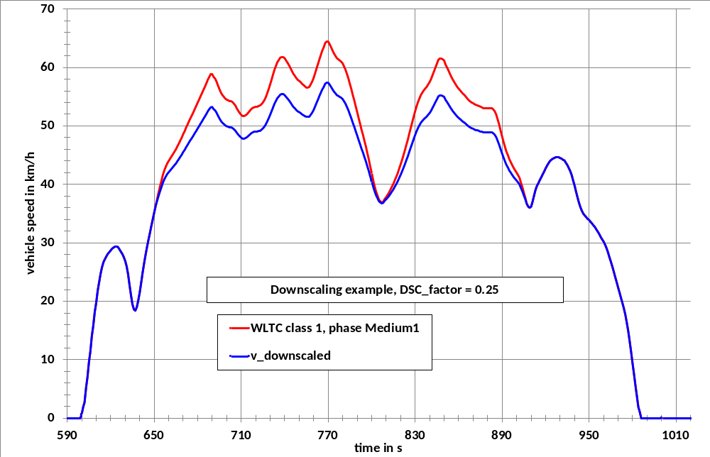
For the Class 1 cycle, the downscaling period is the time period between second 651 and second 906. Within this time period, the acceleration for the original cycle shall be calculated using the following equation:
(1)
where:
is the vehicle speed, km/h;
i is the time between 651 and 906 s.
The downscaling shall be first applied in the time period between second 651 and 848. The downscaled speed trace shall then be calculated using the following equation:
(2)
with.
For , .
In order to meet the original vehicle speed at second 907, a correction factor for the deceleration shall be calculated using the following equation:
(3)
where 36.7 km/h is the original vehicle speed at second 907.
The downscaled vehicle speed between second 849 and 906 shall then be calculated using the following equation:
(4)
With .
7.2.2. Downscaling procedure for Class 2 vehicles
Since the driveability problems are exclusively related to the extra high speed phases of the Class 2 and Class 3 cycles, the downscaling is related to those paragraphs of the extra high speed phases where the driveability problems occur (see Figure A1/14).

Figure A1/14

Downscaled extra high speed phase of the Class 2 WLTC
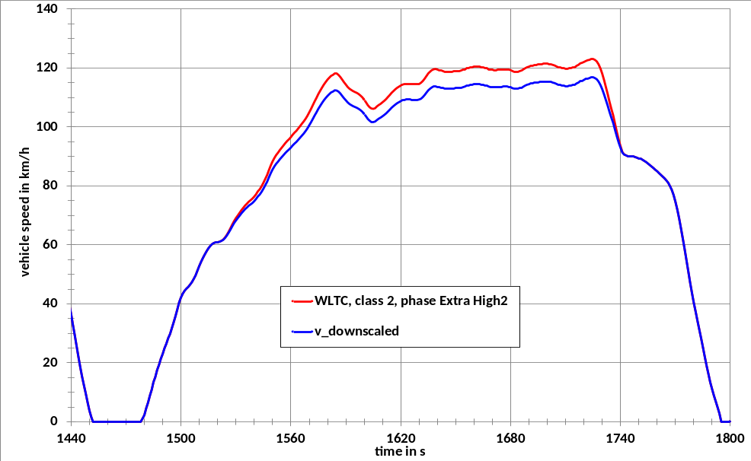
For the Class 2 cycle, the downscaling period is the time period between second 1520 and second 1742. Within this time period, the acceleration for the original cycle shall be calculated using the following equation:
(5)
where:
v_{i} is the vehicle speed, km/h;
i is the time between second 1520 and 1742.
The downscaling shall be applied first in the time period between second 1520 and 1725. Second 1725 is the time where the maximum speed of the extra high speed phase is reached. The downscaled speed trace shall then be calculated using the following equation:
(6)
with .
For , .
In order to meet the original vehicle speed at second 1743, a correction factor for the deceleration shall be calculated using the following equation:
(7)
90.4 km/h is the original vehicle speed at second 1743.
The downscaled vehicle speed between 1726 and 1742 s shall be calculated using the following equation:
(8)
with .
7.2.3. Downscaling procedure for Class 3 vehicles
Figure A1/15 shows an example for a downscaled extra high speed phase of the Class 3 WLTC.

Figure A1/15

Downscaled extra high speed phase of the Class 3 WLTC
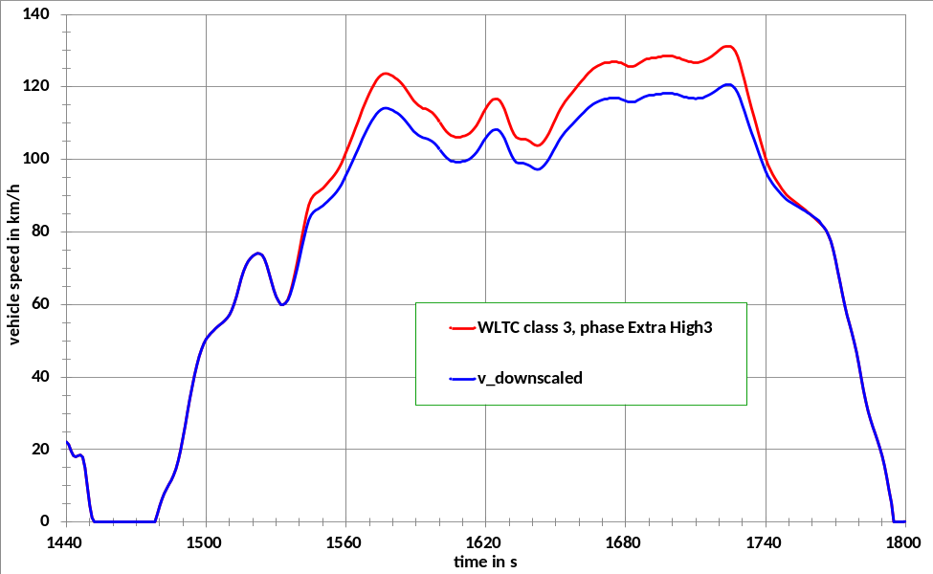
For the Class 3 cycle, this is the period between second 1533 and second 1762. Within this time period, the acceleration for the original cycle shall be calculated using the following equation:
(9)
where:
v_{i} is the vehicle speed, km/h;
i is the time between 1533 and 1762 s.
The downscaling shall be applied first in the time period between second 1533 and 1724. Second 1724 is the time where the maximum speed of the extra high speed phase is reached. The downscaled speed trace shall then be calculated using the following equation:
(10)
with .
For , .
In order to meet the original vehicle speed at second 1763, a correction factor for the deceleration is calculated using the following equation:
(11)
82.6 km/h is the original vehicle speed at second 1763.
The downscaled vehicle speed between 1725 and 1762 s shall then be calculated using the following equation:
(12)
with .
7.3. Determination of the downscaling factor
The downscaling factor f_{dsc} is a function of the ratio, r_{max}
,between the maximum required power of the cycle phases where the downscaling is to be applied and the rated power of the vehicle ().
The maximum required power, in kW, is related to a specific time i in the cycle trace and is calculated from the road load coefficients f₀, f₁, f₂ and the test mass TM as follows:
(13)
with in N, in N/(km/h) and in N/(km/h)², in kg.
The cycle time i, at which maximum power or power values close to maximum power is required, is: 764 s for Class 1, 1574 s for Class 2 and 1566 s for Class 3 vehicles.
The corresponding vehicle speed values and acceleration values are as follows:
km/h, m/s² for Class 1,
km/h, m/s² for Class 2,
km/h, m/s² for Class 3.
The driving resistance coefficients , and shall be determined by coastdown measurements or an equivalent method.
is calculated using the following equation:
(14)
The downscaling factor is calculated using the following equations:
if , then
if , then (15)
The calculation parameter/coefficients , and are as follows:
Class 1 , ,
Class 2 for vehicles with km/h, , , . No downscaling shall be applied for vehicles with km/h
Class 3 for vehicles with km/h, , , ; for vehicles with km/h,, , .
The resulting f_{dsc} is mathematically rounded to one digit after the comma and is only applied if it exceeds one per cent.
7.4. Additional requirements
If a vehicle is tested under different configurations in terms of test mass and driving resistance coefficients, vehicle L as defined in paragraph 4.2.1. of Annex 4 shall be used for the determination of the downscaling factor and the resulting downscaled cycle shall be used for all measurements.
If the maximum speed of the vehicle is lower than the maximum speed of the downscaled cycle, the vehicle shall be driven with its maximum speed in those cycle periods where the cycle speed is higher than the maximum speed of the vehicle.
If the vehicle cannot follow the speed trace of the downscaled cycle within the tolerance for specific periods, it shall be driven with the accelerator control fully activated during these periods. During such periods of operation, driving trace violations shall be permitted.
Annex 2
Gear selection and shift point determination for vehicles equipped with manual transmissions
1. General approach
1.1. The shifting procedures described in this annex shall apply to vehicles equipped with manual and automatic shift transmissions.
1.2. The prescribed gears and shifting points are based on the balance between the power required to overcome driving resistance and acceleration, and the power provided by the engine in all possible gears at a specific cycle phase.
1.3. The calculation to determine the gears to use shall be based on normalised engine speeds (normalised to the span between idling speed and rated engine speed) and normalised full load power curves (normalised to rated power) versus normalised engine speed.
1.4. This annex shall not apply to vehicles tested according to Annex 8.
2. Required data
The following data is required to calculate the gears to be used when driving the cycle on a chassis dynamometer:
(a) , the maximum rated engine power as declared by the manufacturer;
(b) , the rated engine speed at which an engine develops its maximum power. If the maximum power is developed over an engine speed range, s is determined by the mean of this range;
(c) , idling speed
(d) , the number of forward gears;
(e) , minimum engine speed for gears when the vehicle is in motion. The minimum value is determined by the following equation:
(1)
Higher values may be used if requested by the manufacturer;
(f) , the ratio obtained by dividing n in min⁻¹ by v in km/h for each gear , to ;
(g) , test mass of the vehicle in kg;
(h) , , , driving resistance coefficients as defined of Annex 4 in N, N/(km/h), and N/(km/h)² respectively;
(i) is the full load power curve, normalised to rated power and (rated engine speed – idling speed), where .
3. Calculations of required power, engine speeds, available power, and possible gear to be used
3.1. Calculation of required power
For every second of the cycle trace, the power required to overcome driving resistance and to accelerate shall be calculated using the following equation:
(2)
where:
is the road load coefficient, N;
is the road load parameter dependent on velocity, N/(km/h);
is the road load parameter based on the square of velocity, N/(km/h)²;
is the required power at second j, kW;
is the vehicle speed at second j, km/h;
is the vehicle acceleration at second j, m/s², ;
is the vehicle test mass, kg;
is a factor taking the inertial resistances of the drivetrain during acceleration into account and is set to 1.1.
3.2. Determination of engine speeds
For each km/h, the engine speed shall be set to and the gear lever shall be placed in neutral with the clutch engaged.
For each km/h of the cycle trace and each gear i, to , the engine speed shall be calculated using the following equation:
(3)
All gears i for which are possible gears to be used for driving the cycle trace at .
If ,
;
if and ,
;
if , the clutch shall be disengaged.
if ,
3.3. Calculation of available power
The available power for each possible gear i and each vehicle speed value of the cycle trace shall be calculated using the following equation:
(4)
where:
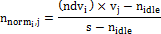
and:
is the rated power, kW;
is the percentage of rated power available at at full load condition from the normalised full load power curve;
is a safety margin accounting for the difference between stationary full load condition power curve and the power available during transition conditions. SM is set to 0.9;
is the idling speed, min⁻¹;
is the rated engine speed.
3.4. Determination of possible gears to be used
The possible gears to be used shall be determined by the following conditions:
(a) ;
(b)
The initial gear to be used for each second of the cycle trace is the highest final possible gear . When starting from standstill, only the first gear shall be used.
4. Additional requirements for corrections and/or modifications of gear use
The initial gear selection shall be checked and modified in order to avoid too frequent gearshifts and to ensure driveability and practicality.
Corrections and/or modifications shall be made according to the following requirements:
(a) First gear shall be selected one second before beginning an acceleration phase from standstill with the clutch disengaged. Vehicle speeds below 1 km/h imply that the vehicle is standing still;
(b) Gears shall not be skipped during acceleration phases. Gears used during accelerations and decelerations must be used for a period of at least three seconds (e.g. a gear sequence 1, 1, 2, 2, 3, 3, 3, 3, 3 shall be replaced by 1, 1, 1, 2, 2, 2, 3, 3, 3);
(c) Gears may be skipped during deceleration phases. For the last phase of a deceleration to a stop, the clutch may be either disengaged or the gear lever placed in neutral and the clutch left engaged;
(d) There shall be no gearshift during transition from an acceleration phase to a deceleration phase. E.g., if and the gear for the time sequence and is i, gear i is also kept for the time , even if the initial gear for would be ;
(e) If a gear is used for a time sequence of 1 to 5 s and the gear before this sequence is the same as the gear after this sequence, e.g. , the gear use for this sequence shall be corrected to .
Example:
(i) a gear sequence , , is replaced by , , ;
(ii) a gear sequence , , , is replaced by , , , ;
(iii) a gear sequence , , ,, is replaced by , ,, , ;
(iv) a gear sequence , ,, , , is replaced by , , , , , ;
(v) a gear sequence , ,,, , , is replaced by , , , , , , .
For all cases (i) to (v), must be fulfilled;
(f) A gear sequence ,,, shall be replaced by ,,, if the following conditions are fulfilled:
(i) Engine speed does not drop below n_{min}; and
(ii) The sequence does not occur more often than four times each for the low, medium and high speed cycle phases and not more than three times for the extra high speed phase.
Requirement (ii) is necessary as the available power will drop below the required power when the gear , is replaced by ;
(g) If, during an acceleration phase, a lower gear is required at a higher vehicle speed for at least 2 seconds, the higher gears before shall be corrected to the lower gear.
Example: . The originally calculated gear use is 2, 3, 3, 3, 2, 2, 3. In this case the gear use will be corrected to 2, 2, 2, 2, 2, 2, 2, 3.
Since the above modifications may create new gear use sequences which are in conflict with these requirements, the gear sequences shall be checked twice.
Annex 3
Reference fuels
1. As there are regional differences in the market specifications of fuels, regionally different reference fuels need to be recognised. Example reference fuels are however required in this gtr for the calculation of hydrocarbon emissions and fuel consumption. Reference fuels are therefore given as examples for such illustrative purposes.
2. It is recommended that Contracting Parties select their reference fuels from this annex and bring any regionally agreed amendments or alternatives into this gtr by amendment. This does not however limit the right of Contracting Parties to define individual reference fuels to reflect local market fuel specifications.
3. Liquid fuels for positive ignition engines
3.1. Gasoline/Petrol (nominal 90 RON, E0)

Table A3/1

Gasoline/Petrol (nominal 90 RON, E0)
Fuel Property or Substance Name | Unit | Standard |  | Test method
Fuel Property or Substance Name | Unit | Minimum | Maximum | Test method
Research octane number, RON |  | 90 | 92 | JIS K2280
Motor octane number, MON |  | 80 | 82 | JIS K2280
Density | g/cm³ | 0.720 | 0.734 | JIS K2249
Vapour pressure | kPa | 56 | 60 | JIS K2258
Distillation:
— 10 % distillation temperature | K (°C) | 318 (45) | 328 (55) | JIS K2254
— 50 % distillation temperature | K (°C) | 363 (90) | 373 (100) | JIS K2254
— 90 % distillation temperature | K (°C) | 413 (140) | 443 (170) | JIS K2254
— final boiling point | K (°C) |  | 488 (215) | JIS K2254
— olefins | vol % | 15 | 25 | JIS K2536-1  JIS K2536-2
— aromatics | vol % | 20 | 45 | JIS K2536-1  JIS K2536-2  JIS K2536-3
— benzene | vol % |  | 1.0 | JIS K2536-2  JIS K2536-3  JIS K2536-4
Oxygen content |  | not to be detected |  | JIS K2536-2  JIS K2536-4  JIS K2536-6
Existent gum | mg/100ml |  | 5 | JIS K2261
Sulphur content | Wt ppm |  | 10 | JIS K2541-1  JIS K2541-2  JIS K2541-6  JIS K2541-7
Lead content |  | not to be detected |  | JIS K2255
Ethanol |  | not to be detected |  | JIS K2536-2  JIS K2536-4  JIS K2536-6
Methanol |  | not to be detected |  | JIS K2536-2  JIS K2536-4  JIS K2536-5  JIS K2536-6
MTBE |  | not to be detected |  | JIS K2536-2  JIS K2536-4  JIS K2536-5  JIS K2536-6
Kerosene |  | not to be detected |  | JIS K2536-2  JIS K2536-4
3.2. Gasoline/petrol (nominal 91 RON, E0)

Table A3/2

Gasoline/petrol (nominal 91 RON, E0)
Fuel Property or Substance Name | Unit |  | Standard |  | Test method
Fuel Property or Substance Name |  |  | Minimum | Maximum | Test method
Research octane number, RON |  |  | 91 | 94 | KS M 2039
Vapour pressure | kPa | Summer | 44 | 60 | KS M ISO 3007
Vapour pressure | kPa | Winter | 44 | 96 | KS M ISO 3007
Distillation:
— 10 % distillation temperature | °C |  | - | 70 | ASTM D86
— 50 % distillation temperature | °C |  | - | 125 | ASTM D86
— 90 % distillation temperature | °C |  | - | 170 | ASTM D86
— final boiling point | °C |  | - | 225 | ASTM D86
Residue | % v/v |  | - | 2.0 | ASTM D86
Water content | vol % |  | - | 0.01 | KS M 2115
— olefins⁽¹⁾ | vol % |  | - | 16(19) | KS M 2085, ASTM D6296, D6293, D6839
— aromatics⁽¹⁾ | vol % |  | - | 24 (21) | KS M 2407, ASTM D3606, D5580,D6293,D6839,PIONA
— benzene | vol % |  | - | 0.7 | KS M 2407, ASTM D3606, D5580, D6293, D6839, PIONA
Oxygen content | wt % |  | - | 2.3 | KS M 2408, ASTM D4815, D6839
Unwashed gum | mg/100ml |  | - | 5 | KS M 2041
Sulphur content | wt ppm |  | - | 10 | KS M 2027, ASTM D5453
Lead content | mg/L |  | - | 13 | KS M 2402, ASTM D3237
Phosphorus content | mg/L |  | - | 1.3 | KS M 2403, ASTM D3231
Methanol | wt % |  | - | 0.01 | KS M 2408
Oxidation stability | min |  | 480 | - | KS M 2043
Copper corrosion | 50℃, 3h |  | - | 1 | KS M 2018
Colour | Yellow |  | - | - | Sensory test
⁽¹⁾ The standard in brackets may apply for olefins. In this case, the value in brackets for aromatics shall apply.
3.3. Gasoline/petrol (nominal 100 RON, E0)

Table A3/3

Gasoline/petrol (nominal 100 RON, E0)
Fuel Property or Substance Name | Unit | Standard |  | Test method
Fuel Property or Substance Name | Unit | Minimum | Maximum | Test method
Research octane number, RON |  | 99 | 101 | JIS K2280
Motor octane number, MON |  | 86 | 88 | JIS K2280
Density | g/cm³ | 0.740 | 0.754 | JIS K2249
Vapour pressure | kPa | 56 | 60 | JIS K2258
Distillation:
— 10 % distillation temperature | K (°C) | 318 (45) | 328 (55) | JIS K2254
— 50 % distillation temperature | K (°C) | 363 (90) | 373 (100) | JIS K2254
— 90 % distillation temperature | K (°C) | 413 (140) | 443 (170) | JIS K2254
— final boiling point | K (°C) |  | 488 (215) | JIS K2254
— olefins | vol % | 15 | 25 | JIS K2536-1  JIS K2536-2
— aromatics | vol % | 20 | 45 | JIS K2536-1  JIS K2536-2  JIS K2536-3
— benzene | vol % |  | 1.0 | JIS K2536-2  JIS K2536-3  JIS K2536-4
Oxygen content |  | not to be detected |  | JIS K2536-2  JIS K2536-4  JIS K2536-6
Existent gum | mg/100ml |  | 5 | JIS K2261
Sulphur content | Wt ppm |  | 10 | JIS K2541-1  JIS K2541-2  JIS K2541-6  JIS K2541-7
Lead content |  | not to be detected |  | JIS K2255
Ethanol |  | not to be detected |  | JIS K2536-2  JIS K2536-4  JIS K2536-6
Methanol |  | not to be detected |  | JIS K2536-2  JIS K2536-4  JIS K2536-5  JIS K2536-6
MTBE |  | not to be detected |  | JIS K2536-2  JIS K2536-4  JIS K2536-5  JIS K2536-6
Kerosene |  | not to be detected |  | JIS K2536-2  JIS K2536-4
3.4. Gasoline/petrol (nominal 94 RON, E0)

Table A3/4

Gasoline/petrol (nominal 94 RON, E0)
Fuel Property or Substance Name | Unit |  | Standard |  | Test method
Fuel Property or Substance Name |  |  | Minimum | Maximum | Test method
Research octane number, RON |  |  | 94 | - | KS M 2039
Vapour pressure | kPa | Summer | 44 | 60 | KS M ISO 3007
Vapour pressure | kPa | Winter | 44 | 96 | KS M ISO 3007
Distillation:
— 10 % distillation temperature | °C |  | - | 70 | ASTM D86
— 50 % distillation temperature | °C |  | - | 125 | ASTM D86
— 90 % distillation temperature | °C |  | - | 170 | ASTM D86
— final boiling point | °C |  | - | 225 | ASTM D86
Residue | % v/v |  |  | 2.0 | ASTM D86
Water content | vol % |  |  | 0.01 | KS M 2115
— olefins⁽¹⁾ | vol % |  |  | 16 (19) | KS M 2085, ASTM D6296, D6293, D6839
— aromatics⁽¹⁾ | vol % |  |  | 24 (21) | KS M 2407, ASTM D3606, D5580, D6293, D6839, PIONA
— benzene | vol % |  |  | 0.7 | KS M 2407, ASTM D3606, D5580, D6293, D6839, PIONA
Oxygen content | wt % |  |  | 2.3 | KS M 2408, ASTM D4815, D6839
Unwashed gum | mg/100ml |  |  | 5 | KS M 2041
Sulphur content | wt ppm |  |  | 10 | KS M 2027, ASTM D5453
Lead content | mg/L |  |  | 13 | KS M 2402, ASTM D3237
Phosphorus content | mg/L |  |  | 1.3 | KS M 2403, ASTM D3231
Methanol | wt % |  |  | 0.01 | KS M 2408
Oxidation stability | min |  | 480 | - | KS M 2043
Copper corrosion | 50℃, 3h |  |  | 1 | KS M 2018
Colour | Green |  | - | - | Sensory Test
⁽¹⁾ The standard in brackets may apply for olefins. In this case, the value in brackets for aromatics shall apply.
3.5. Gasoline/petrol (nominal 95 RON, E5)

Table A3/5

Gasoline/petrol (nominal 95 RON, E5)
Parameter | Unit | Limits ⁽¹⁾ |  | Test method
Parameter | Unit | Minimum | Maximum | Test method
Research octane number, RON |  | 95.0 |  | EN 25164  EN ISO 5164
Motor octane number, MON |  | 85.0 |  | EN 25163  EN ISO 5163
Density at 15 °C | kg/m³ | 743 | 756 | EN ISO 3675  EN ISO 12185
Vapour pressure | kPa | 56.0 | 60.0 | EN ISO 13016-1 (DVPE)
Water content | % v/v |  | 0.015 | ASTM E 1064
Distillation:
— evaporated at 70 °C | % v/v | 24.0 | 44.0 | EN-ISO 3405
— evaporated at 100 °C | % v/v | 48.0 | 60.0 | EN-ISO 3405
— evaporated at 150 °C | % v/v | 82.0 | 90.0 | EN-ISO 3405
— final boiling point | °C | 190 | 210 | EN-ISO 3405
Residue | % v/v |  | 2.0 | EN-ISO 3405
Hydrocarbon analysis:
— olefins | % v/v | 3.0 | 13.0 | ASTM D 1319
— aromatics | % v/v | 29.0 | 35.0 | ASTM D 1319
— benzene | % v/v |  | 1.0 | EN 12177
— saturates | % v/v | To be recorded |  | ASTM 1319
Carbon/hydrogen ratio |  | To be recorded
Carbon/oxygen ratio |  | To be recorded
Induction period ⁽²⁾ | minutes | 480 |  | EN-ISO 7536
Oxygen content ⁽³⁾ | % m/m | To be recorded |  | EN 1601
Existent gum | mg/ml |  | 0.04 | EN-ISO 6246
Sulphur content ⁽⁴⁾ | mg/kg |  | 10 | EN ISO 20846  EN ISO 20884
Copper corrosion |  |  | Class 1 | EN-ISO 2160
Lead content | mg/l |  | 5 | EN 237
Phosphorus content ⁽⁵⁾ | mg/l |  | 1.3 | ASTM D 3231
Ethanol ⁽³⁾ | % v/v | 4.7 | 5.3 | EN 1601  EN 13132
⁽¹⁾ The values quoted in the specifications are "true values". In establishing of their limit values the terms of ISO 4259 "Petroleum products — Determination and application of precision data in relation to methods of test" have been applied and in fixing a minimum value, a minimum difference of 2R above zero has been taken into account; in fixing a maximum and minimum value, the minimum difference is 4R (R = reproducibility). Notwithstanding this measure, which is necessary for technical reasons, the manufacturer of fuels shall nevertheless aim at a zero value where the stipulated maximum value is 2R and at the mean value in the case of quotations of maximum and minimum limits. Should it be necessary to clarify whether a fuel meets the requirements of the specifications, the terms of ISO 4259 shall be applied.
⁽²⁾ The fuel may contain oxidation inhibitors and metal deactivators normally used to stabilise refinery gasoline streams, but detergent/dispersive additives and solvent oils shall not be added.
⁽³⁾ Ethanol meeting the specification of EN 15376 is the only oxygenate that shall be intentionally added to the reference fuel.
⁽⁴⁾ The actual sulphur content of the fuel used for the Type 1 test shall be recorded.
⁽⁵⁾ There shall be no intentional addition of compounds containing phosphorus, iron, manganese, or lead to this reference fuel.
3.6. Gasoline/petrol (nominal 95 RON, E10)

Table A3/6

Gasoline/petrol (nominal 95 RON, E10)
Parameter | Unit | Limits ⁽¹⁾ |  | Test method ⁽²⁾
Parameter | Unit | Minimum | Maximum | Test method ⁽²⁾
Research octane number, RON ⁽³⁾ |  | 95.0 | 98.0 | EN ISO 5164
Motor octane number, MON ⁽³⁾ |  | 85.0 | 89.0 | EN ISO 5163
Density at 15 °C | kg/m³ | 743.0 | 756.0 | EN ISO 12185
Vapour pressure | kPa | 56.0 | 60.0 | EN 13016-1
Water content | % v/v | max 0.05  Appearance at -7 °C: clear and bright |  | EN 12937
Distillation:
— evaporated at 70 °C | % v/v | 34.0 | 46.0 | EN-ISO 3405
— evaporated at 100 °C | % v/v | 54.0 | 62.0 | EN-ISO 3405
— evaporated at 150 °C | % v/v | 86.0 | 94.0 | EN-ISO 3405
— final boiling point | °C | 170 | 195 | EN-ISO 3405
Residue | % v/v |  | 2.0 | EN-ISO 3405
Hydrocarbon analysis:
— olefins | % v/v | 6.0 | 13.0 | EN 22854
— aromatics | % v/v | 25.0 | 32.0 | EN 22854
— benzene | % v/v |  | 1.00 | EN 22854  EN 238
— saturates | % v/v | To be recorded |  | EN 22854
Carbon/hydrogen ratio |  | To be recorded
Carbon/oxygen ratio |  | To be recorded
Induction period ⁽⁴⁾ | minutes | 480 |  | EN-ISO 7536
Oxygen content ⁽⁵⁾ | % m/m | 3.3 | 3.7 | EN 22854
Solvent washed gum  (Existent gum content) | mg/100ml |  | 4 | EN-ISO 6246
Sulphur content ⁽⁶⁾ | mg/kg |  | 10 | EN ISO 20846  EN ISO 20884
Copper corrosion |  |  | Class 1 | EN-ISO 2160
Lead content | mg/l |  | 5 | EN 237
Phosphorus content ⁽⁷⁾ | mg/l |  | 1.3 | ASTM D 3231
Ethanol ⁽⁵⁾ | % v/v | 9.0 | 10.0 | EN 22854
⁽¹⁾ The values quoted in the specifications are "true values". In establishing of their limit values the terms of ISO 4259 "Petroleum products - Determination and application of precision data in relation to methods of test" have been applied and in fixing a minimum value, a minimum difference of 2R above zero has been taken into account; in fixing a maximum and minimum value, the minimum difference is 4R (R = reproducibility).
Notwithstanding this measure, which is necessary for technical reasons, the manufacturer of fuels shall nevertheless aim at a zero value where the stipulated maximum value is 2R and at the mean value in the case of quotations of maximum and minimum limits. Should it be necessary to clarify whether a fuel meets the requirements of the specifications, the terms of ISO 4259 shall be applied.
⁽²⁾ Equivalent EN/ISO methods will be adopted when issued for properties listed above.
⁽³⁾ A correction factor of 0.2 for MON and RON shall be subtracted for the calculation of the final result in accordance with EN 228:2008.
⁽⁴⁾ The fuel may contain oxidation inhibitors and metal deactivators normally used to stabilise refinery gasoline streams, but detergent/dispersive additives and solvent oils shall not be added.
⁽⁵⁾ Ethanol is the only oxygenate that shall be intentionally added to the reference fuel. The Ethanol used shall conform to EN 15376.
⁽⁶⁾ The actual sulphur content of the fuel used for the Type 1 test shall be recorded.
⁽⁷⁾ There shall be no intentional addition of compounds containing phosphorus, iron, manganese, or lead to this reference fuel.
3.7. Ethanol (nominal 95 RON, E85)

Table A3/7

Ethanol (nominal 95 RON, E85)
Parameter | Unit | Limits ⁽¹⁾ |  | Test method⁽²⁾
Parameter | Unit | Minimum | Maximum | Test method⁽²⁾
Research octane number, RON |  | 95 |  | EN ISO 5164
Motor octane number, MON |  | 85 |  | EN ISO 5163
Density at 15 °C | kg/m³ | To be recorded |  | ISO 3675
Vapour pressure | kPa | 40 | 60 | EN ISO 13016-1 (DVPE)
Sulphur content ⁽³⁾⁽⁴⁾ | mg/kg |  | 10 | EN ISO 20846 EN ISO  20884
Oxidation stability | minutes | 360 |  | EN ISO 7536
Existent gum content (solvent washed) | mg/100ml |  | 5 | EN-ISO 6246
Appearance: This shall be determined at ambient temperature or 15 °C whichever is higher. |  | Clear and bright, visibly free of suspended or precipitated contaminants |  | Visual inspection
Ethanol and higher alcohols ⁽⁷⁾ | % (V/V) | 83 | 85 | EN 1601  EN 13132  EN 14517
Higher alcohols (C3-C8) | % (V/V) |  | 2
Methanol | % (V/V) |  | 0.5
Petrol ⁽⁵⁾ | % (V/V) | Balance |  | EN 228
Phosphorus | mg/l | 0.3 ⁽⁶⁾ |  | ASTM D 3231
Water content | % (V/V) |  | 0.3 | ASTM E 1064
Inorganic chloride content | mg/l |  | 1 | ISO 6227
pHe |  | 6.5 | 9 | ASTM D 6423
Copper strip corrosion (3h at 50 °C) | Rating | Class 1 |  | EN ISO 2160
Acidity, (as acetic acid CH3COOH) | % (m/m)  (mg/l) |  | 0.005-40 | ASTM D 1613
Carbon/hydrogen ratio |  | Record
Carbon/oxygen ratio |  | Record
⁽¹⁾ The values quoted in the specifications are "true values". In establishing of their limit values the terms of ISO 4259 "Petroleum products — Determination and application of precision data in relation to methods of test" have been applied and in fixing a minimum value, a minimum difference of 2R above zero has been taken into account; in fixing a maximum and minimum value, the minimum difference is 4R (R = reproducibility). Notwithstanding this measure, which is necessary for technical reasons, the manufacturer of fuels shall nevertheless aim at a zero value where the stipulated maximum value is 2R and at the mean value in the case of quotations of maximum and minimum limits. Should it be necessary to clarify whether a fuel meets the requirements of the specifications, the terms of ISO 4259 shall be applied.
⁽²⁾ In cases of dispute, the procedures for resolving the dispute and interpretation of the results based on test method precision, described in EN ISO 4259 shall be used.
⁽³⁾ In cases of national dispute concerning sulphur content, either EN ISO 20846 or EN ISO 20884 shall be called up (similar to the reference in the national Annex of EN 228).
⁽⁴⁾ The actual sulphur content of the fuel used for the Type 1 test shall be recorded.
⁽⁵⁾ The unleaded petrol content can be determined as 100 minus the sum of the percentage content of water and alcohols.
⁽⁶⁾ There shall be no intentional addition of compounds containing phosphorus, iron, manganese, or lead to this reference fuel.
⁽⁷⁾ Ethanol to meet specification of EN 15376 is the only oxygenate that shall be intentionally added to this reference fuel.
4. Gaseous fuels for positive ignition engines
4.1. LPG (A and B)

Table A3/8

LPG (A and B)
Parameter | Unit | Fuel E1 | Fuel E2 | Fuel J | Fuel K | Test method
Composition: |  |  |  |  |  | ISO 7941
C3-content | % vol | 30 ± 2 | 85 ± 2 |  | Winter:  min 15,  max 35  Summer:  max 10 | KS M ISO 7941
Propane and propylene content | % mole |  |  | Min 20,  max 30 |  | JIS K2240
C4-content | % vol | Balance |  |  | Winter:  min 60,  Summer:  min 85 | KS M ISO 7941
Butane and butylene content |  |  |  | Min 70,  max 80 |  | JIS K2240
Butadiene |  |  |  |  | max 0.5 | KS M ISO 7941
< C3, > C4 | % vol | Max 2 | Max 2
Olefins | % vol | Max 12 | Max 15
Evaporation residue | mg/kg | Max 50 | Max 50 |  |  | EN 15470
Evaporation residue (100ml) | ml | - |  |  | 0.05 | ASTM D2158
Water at 0 °C |  | Free |  |  |  | EN 15469
Total sulphur content | mg/kg | Max 10 | Max 10 |  |  | ASTM 6667
Total sulphur content |  |  |  |  | Max 40 | KS M 2150, ASTM D4486,  ASTM D5504
Hydrogen sulphide |  | None | None |  |  | ISO 8819
Copper strip corrosion | rating | Class 1 | Class 1 |  |  | ISO 6251 ⁽¹⁾
Copper corrosion | 40℃, 1h | - |  |  | 1 | KS M ISO 6251
Odour |  | Characteristic
Motor octane number |  | Min 89 | Min 89 |  |  | EN 589  Annex B
Vapour pressure(40 ℃) | MPa | - | 1.27 |  |  | KS M ISO 4256  KS M ISO 8973
Density(15 ℃) | kg/m³ | 500 |  |  | 620 | KS M 2150,  KS M ISO 3993  KS M ISO 8973
⁽¹⁾ This method may not accurately determine the presence of corrosive materials if the sample contains corrosion inhibitors or other chemicals which diminish the corrosivity of the sample to the copper strip. Therefore, the addition of such compounds for the sole purpose of biasing the test method is prohibited.
4.2. NG/biomethane
4.2.1. "G20""High Gas" (nominal 100 % Methane)

Table A3/9

"G20" "High Gas" (nominal 100 per cent Methane)
Characteristics | Units | Basis | Limits |  | Test method
Characteristics | Units | Basis | Minimum | Maximum | Test method
Composition:
Methane | % mole | 100 | 99 | 100 | ISO 6974
Balance ⁽¹⁾ | % mole | — | — | 1 | ISO 6974
N₂ | % mole |  |  |  | ISO 6974
Sulphur content | mg/m³⁽²⁾ | — | — | 10 | ISO 6326-5
Wobbe Index (net) | MJ/m³⁽³⁾ | 48.2 | 47.2 | 49.2
⁽¹⁾ Inerts (different from N₂) + C2 + C2+.
⁽²⁾ Value to be determined at 293.15 K (20°C) and 101.325 kPa.
⁽³⁾ Value to be determined at 273.15 K (0°C) and 101.325 kPa.
4.2.2. "K-Gas" (nominal 88 % Methane)

Table A3/10

"K-Gas" (nominal 88 per cent Methane)
Characteristics | Units | Limits |  | Test method
Characteristics | Units | Minimum | Maximum | Test method
Methane | vol% | 88.0 | - | KS M ISO 6974, ASTM D1946, ASTM D1945-81,  JIS K 0114
Ethane | vol% | - | 7.0 | KS M ISO 6974, ASTM D1946, ASTM D1945-81,  JIS K 0114
C₃ + hydrocarbon | vol% | - | 5.0 | KS M ISO 6974, ASTM D1946, ASTM D1945-81,  JIS K 0114
C₆ + hydrocarbon | vol% | - | 0.2 | KS M ISO 6974, ASTM D1946, ASTM D1945-81,  JIS K 0114
Sulphur content | ppm | - | 40 | KS M ISO 6326-1,  KS M ISO 19739,  ASTM D5504,  JIS K 0127
Inert gas(CO₂, N₂ ,etc.) | vol% | - | 4.5 | KS M ISO 6974, ASTM D1946, ASTM D1945-81,  JIS K 0114
4.2.3. "G25""Low Gas" (nominal 86 % Methane)

Table A3/11

"G25" "Low Gas" (nominal 86 per cent Methane)
Characteristics | Units | Basis | Limits |  | Test method
Characteristics | Units | Basis | Minimum | Maximum | Test method
Composition:
Methane | % mole | 86 | 84 | 88 | ISO 6974
Balance ⁽¹⁾ | % mole | — | — | 1 | ISO 6974
N₂ | % mole | 14 | 12 | 16 | ISO 6974
Sulphur content | mg/m³⁽²⁾ | — | — | 10 | ISO 6326-5
Wobbe Index (net) | MJ/m³⁽³⁾ | 39.4 | 38.2 | 40.6
⁽¹⁾ Inerts (different from N₂) + C2 + C2+.
⁽²⁾ Value to be determined at 293.2 K (20°C) and 101.3 kPa.
⁽³⁾ Value to be determined at 273.2 K (0°C) and 101.3 kPa.
4.2.4. "J-Gas" (nominal 85 % Methane)

Table A3/12

"J-Gas" (nominal 85 per cent Methane)
Characteristics | Units | Limits
Characteristics | Units | Minimum | Maximum
Methane | % mole | 85
Ethane | % mole |  | 10
Propane | % mole |  | 6
Butane | % mole |  | 4
HC of C₃+C₄ | % mole |  | 8
HC of C₅ or more | % mole |  | 0.1
Other gases (H₂+O₂+N₂+CO+CO₂) | % mole |  | 1.0
Sulphur content | mg/Nm³ |  | 10
Wobbe Index | WI | 13.260 | 13.730
Gross Calorific value | kcal/Nm³ | 10.410 | 11.050
Maximum combustion speed | MCP | 36.8 | 37.5
5. Liquid fuels for compression ignition engines
5.1. J-Diesel (nominal 53 Cetane, B0)

Table A3/13

J-Diesel (nominal 53 Cetane, B0)
Fuel property or substance name | Units | Specification |  | Test method
Fuel property or substance name | Units | Minimum | Maximum | Test method
Cetane number |  | 53 | 57 | JIS K2280
Density | g/cm³ | 0.824 | 0.840 | JIS K2249
Distillation:
— 50 % distillation temperature | K (°C) | 528 (255) | 568 (295) | JIS K2254
— 90 % distillation temperature | K (°C) | 573 (300) | 618 (345) | JIS K2254
— final boiling point | K (°C) |  | 643 (370) | JIS K2254
Flash point | K (°C) | 331(58) |  | JIS K2265–3
Kinematic Viscosity at 30 °C | mm²/s | 3.0 | 4.5 | JIS K2283
All aromatic series | vol % |  | 25 | JIS Method HPLC
Polycyclic aromatic hydrocarbons | vol % |  | 5.0 | JIS Method HPLC
Sulphur content | Wt ppm |  | 10 | JIS K2541-1  JIS K2541-2  JIS K2541-6  JIS K2541-7
FAME | % |  | 0.1 | Method prescribed in the Japanese concentration measurement procedure announcement
Triglyceride | % |  | 0.01 | Method prescribed in the Japanese concentration measurement procedure announcement
5.2. E-Diesel (nominal 52 Cetane, B5)

Table A3/14

E-Diesel (nominal 52 Cetane, B5)
Parameter | Unit | Limits ⁽¹⁾ |  | Test method
Parameter | Unit | Minimum | Maximum | Test method
Cetane number ⁽²⁾ |  | 52.0 | 54.0 | EN-ISO 5165
Density at 15 °C | kg/m³ | 833 | 837 | EN-ISO 3675
Distillation:
— 50 % point | °C | 245 | — | EN-ISO 3405
— 95 % point | °C | 345 | 350 | EN-ISO 3405
— final boiling point | °C | — | 370 | EN-ISO 3405
Flash point | °C | 55 | — | EN 22719
CFPP | °C | — | –5 | EN 116
Viscosity at 40 °C | mm²/s | 2.3 | 3.3 | EN-ISO 3104
Polycyclic aromatic hydrocarbons | % m/m | 2.0 | 6.0 | EN 12916
Sulphur content ⁽³⁾ | mg/kg | — | 10 | EN ISO 20846/  EN ISO 20884
Copper corrosion |  | — | Class 1 | EN-ISO 2160
Conradson carbon residue (10 % DR) | % m/m | — | 0.2 | EN-ISO10370
Ash content | % m/m | — | 0.01 | EN-ISO 6245
Water content | % m/m | — | 0.02 | EN-ISO12937
Neutralization (strong acid) number | mg KOH/g | — | 0.02 | ASTM D 974
Oxidation stability ⁽⁴⁾ | mg/ml | — | 0.025 | EN-ISO12205
Lubricity (HFRR wear scan diameter at 60 °C) | μm | — | 400 | EN ISO 12156
Oxidation stability at 110 °C ⁽⁴⁾⁽⁶⁾ | h | 20.0 |  | EN 14112
FAME ⁽⁵⁾ | % v/v | 4.5 | 5.5 | EN 14078
⁽¹⁾ The values quoted in the specifications are "true values". In establishing of their limit values the terms of ISO 4259 Petroleum products — Determination and application of precision data in relation to methods of test have been applied and in fixing a minimum value, a minimum difference of 2R above zero has been taken into account; in fixing a maximum and minimum value, the minimum difference is 4R (R = reproducibility). Notwithstanding this measure, which is necessary for technical reasons, the manufacturer of fuels shall nevertheless aim at a zero value where the stipulated maximum value is 2R and at the mean value in the case of quotations of maximum and minimum limits. Should it be necessary to clarify whether a fuel meets the requirements of the specifications, the terms of ISO 4259 shall be applied.
⁽²⁾ The range for cetane number is not in accordance with the requirements of a minimum range of 4R. However, in the case of a dispute between fuel supplier and fuel user, the terms of ISO 4259 may be used to resolve such disputes provided replicate measurements, of sufficient number to archive the necessary precision, are made in preference to single determinations.
⁽³⁾ The actual sulphur content of the fuel used for the Type 1 test shall be recorded.
⁽⁴⁾ Even though oxidation stability is controlled, it is likely that shelf life will be limited. Advice shall be sought from the supplier as to storage conditions and life.
⁽⁵⁾ FAME content to meet the specification of EN 14214.
⁽⁶⁾ Oxidation stability can be demonstrated by EN-ISO12205 or by EN 14112. This requirement shall be reviewed based on CEN/TC19 evaluations of oxidative stability performance and test limits.
5.3. K-Diesel (nominal 52 Cetane, B5)

Table A3/15

K-Diesel (nominal 52 Cetane, B5)
Fuel property or substance name | Units | Specification |  | Test method
Fuel property or substance name | Units | Minimum | Maximum | Test method
Pour point | ℃ | - | 0.0  (winter:  -17.5 ℃) | ASTM D6749
Flash point | ℃ | 40 | - | KS M ISO 2719
Kinematic Viscosity at 40 ℃ | mm²/s | 1.9 | 5.5 | KS M 2014
90% distillation temperature | ℃ | - | 360 | ASTM D86
10% carbon residue | wt% | - | 0.15 | KS M 2017, ISO 4262,  IP 14, ASTM D524
Water content | vol% | - | 0.02 | KS M 2115
Sulphur content | mg/kg | - | 10 | KS M 2027, ASTM D5453
Ash | wt% | - | 0.02 | KS M ISO 6245
Cetane number |  | 52 | - | KS M 2610,
Copper corrosion | 100℃, 3h | - | 1 | KS M 2018
Lubricity(60 ℃, micron)(HFRR) |  | - | 400 | CFC F-06-A, ASTM D6079
Density(15 ℃) | kg/cm³ | 815 | 835 | KS M 2002, ASTM D4052
Polycyclic aromatic hydrocarbons | wt% | - | 5 | KS M 2456
All aromatic series | wt% | - | 30 | IP 391, ASTM D5186
Fatty acid methyl esters content | vol% | - | 5 | EN 14078
5.4. E-Diesel (nominal 52 Cetane, B7)

Table A3/16

E-Diesel (nominal 52 Cetane, B7)
Parameter | Unit | Limits ⁽¹⁾ |  | Test method
Parameter | Unit | Minimum | Maximum | Test method
Cetane Index |  | 46.0 |  | EN-ISO 4264
Cetane number ⁽²⁾ |  | 52.0 | 56.0 | EN-ISO 5165
Density at 15 °C | kg/m³ | 833.0 | 837.0 | EN-ISO 12185
Distillation:
— 50 % point | °C | 245.0 | — | EN-ISO 3405
— 95 % point | °C | 345.0 | 360.0 | EN-ISO 3405
— final boiling point | °C | — | 370.0 | EN-ISO 3405
Flash point | °C | 55 | — | EN ISO 2719
Cloud point | °C | — | -10 | EN 116
Viscosity at 40 °C | mm²/s | 2.30 | 3.30 | EN-ISO 3104
Polycyclic aromatic hydrocarbons | % m/m | 2.0 | 4.0 | EN 12916
Sulphur content | mg/kg | — | 10.0 | EN ISO 20846/  EN ISO 20884
Copper corrosion (3 hours, 50 °C) |  | — | Class 1 | EN-ISO 2160
Conradson carbon residue (10 % DR) | % m/m | — | 0.20 | EN-ISO10370
Ash content | % m/m | — | 0.010 | EN-ISO 6245
Total contamination | mg/kg |  | 24 | EN 12662
Water content | mg/kg | — | 200 | EN-ISO12937
Acid number | mg KOH/g | — | 0.10 | EN ISO 6618
Lubricity (HFRR wear scan diameter at 60 °C) | μm | — | 400 | EN ISO 12156
Oxidation stability at 110 °C ⁽³⁾ | h | 20.0 |  | EN 15751
FAME ⁽⁴⁾ | % v/v | 6.0 | 7.0 | EN 14078
⁽¹⁾ The values quoted in the specifications are "true values". In establishing of their limit values the terms of ISO 4259 Petroleum products – Determination and application of precision data in relation to methods of test have been applied and in fixing a minimum value, a minimum difference of 2R above zero has been taken into account; in fixing a maximum and minimum value, the minimum difference is 4R (R = reproducibility).
Notwithstanding this measure, which is necessary for technical reasons, the manufacturer of fuels shall nevertheless aim at a zero value where the stipulated maximum value is 2R and at the mean value in the case of quotations of maximum and minimum limits. Should it be necessary to clarify whether a fuel meets the requirements of the specifications, the terms of ISO 4259 shall be applied.
⁽²⁾ The range for cetane number is not in accordance with the requirements of a minimum range of 4R. However, in the case of a dispute between fuel supplier and fuel user, the terms of ISO 4259 may be used to resolve such disputes provided replicate measurements, of sufficient number to archive the necessary precision, are made in preference to single determinations.
⁽³⁾ Even though oxidation stability is controlled, it is likely that shelf life will be limited. Advice shall be sought from the supplier as to storage conditions and life.
⁽⁴⁾ FAME content to meet the specification of EN 14214.

Annex 4
Road load and dynamometer setting
1. Scope
This annex describes the determination of the road load of a test vehicle and the transfer of that road load to a chassis dynamometer.
2. Terms and definitions
For the purpose of this document, the terms and definitions given in ISO 3833 and in paragraph 3. of this global technical regulation apply.
3. Measurement criteria
3.1. Required overall measurement accuracy
The required overall measurement accuracy shall be as follows:
(a) Vehicle speed: ±0.5 km/h or ±1 per cent, whichever is greater;
(b) Time accuracy: min. ±10 ms; time resolution: min. ±0.01 s;
(c) Wheel torque (per torque meter): ±3 Nm or ±0.5 per cent of the maximum measured torque, whichever is greater;
(d) Wind speed: ±0.3 m/s;
(e) Wind direction: ±3°;
(f) Atmospheric temperature: ±1 K;
(g) Atmospheric pressure: ±0.3 kPa;
(h) Vehicle mass: ±10 kg; (±20 kg for vehicles > 4,000 kg)
(i) Tyre pressure: ±5 kPa;
(j) Product of aerodynamic drag coefficient and frontal projected area (): ±2 per cent;
(k) Chassis dynamometer roller speed: ±0.5 km/h or ±1 per cent, whichever is greater;
(l) Chassis dynamometer force: ±10 N or ±0.1 per cent of full scale, whichever is greater.
3.2. Wind tunnel criteria
The wind tunnel used for the determination of the product of aerodynamic drag coefficient and frontal area within the road load vehicle family shall meet the criteria in this paragraph.
These criteria are only valid for determining values in order to use the CO₂ interpolation method.
3.2.1. Wind velocity
The wind velocity during a measurement shall remain within ±2 km/h at the center of the test section. The possible wind velocity shall be at least 140 km/h.
3.2.2. Air temperature
The air temperature during a measurement shall remain within ±3 K at the center of the test section. The air temperature distribution at the nozzle outlet shall remain within ±3K.
3.2.3. Turbulence
For an equally spaced 3 by 3 grid over the entire nozzle outlet,, the turbulence intensity, , shall not exceed one per cent. See Figure A4/1 below.
Figure A4/1
Turbulence intensity
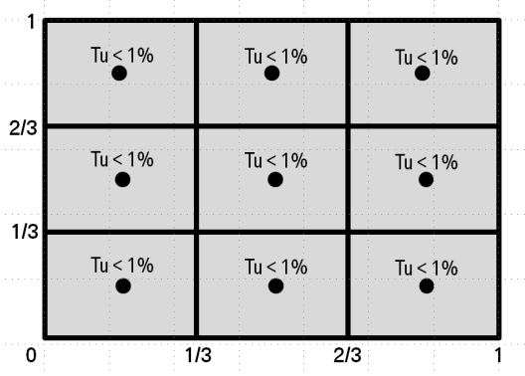
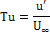
where:
is turbulence intensity;
is turbulent velocity fluctuation, m/s;
is free flow velocity, m/s.
3.2.4. Solid blockage
The vehicle blockage fraction, , expressed as the quotient of the vehicle frontal area and the area of the nozzle outlet as shown in the following equation, shall not exceed 35 per cent.
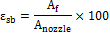
where:
is vehicle blockage in per cent;
is frontal area of vehicle, m²;
is the area of nozzle outlet, m².
3.2.5. Rotating wheels
To determine the aerodynamic influence of the wheels properly, the wheels of the test vehicle shall rotate at such a speed that the resulting vehicle velocity is within a ± 3 km/h tolerance of the wind velocity.
3.2.6. Moving belt
To simulate the fluid flow at the underbody of the test vehicle, the wind tunnel shall have a moving belt extending from the front to the rear of the vehicle. The speed of the moving belt shall be within ± 3 km/h of the wind velocity.
3.2.7. Fluid flow angle
At 9 equally distributed points over the nozzle area, the root mean square deviation of both angles (Y-, Z-plane) α and β at the nozzle outlet shall not exceed 1°.
3.2.8. Air pressure
At 9 equally distributed points over the nozzle area, the root mean square deviation of the total pressure at the nozzle outlet shall not exceed two per cent.
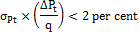
where:
is the standard deviation of the total pressure;
is the variation of total pressure between the measurement points;
is the dynamic pressure, N/ m².
The pressure coefficient, , over a distance 2 m ahead and 2 m behind the vehicle shall not deviate more than ±1 per cent.
where:
is the pressure coefficient, N/m².
3.2.9. Boundary layer thickness
At (balance center point), the wind velocity shall have at least 99 per cent of the inflow velocity 30 mm above the wind tunnel floor.
mm
where:
is the distance perpendicular to the road, where 99 per cent of free stream velocity is reached (boundary layer thickness).
3.2.10. Restraint system
The restraint system mounting shall not be in front of the vehicle. The relative blockage fraction for the restraint system, , shall not exceed 10 per cent of the vehicle frontal area.
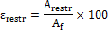
where:
is the relative blockage of the restraint system;
is the frontal area of the restraint system projected on the nozzle face, m²;
is the frontal area of the vehicle in m².
3.2.11. Measurement accuracy of the balance in x-direction
The inaccuracy of the resulting force in the x-direction shall not exceed ±5 N. The resolution of the measured force shall be within ±3 N.
3.2.12. Measurement repeatability
The repeatability of the measured force shall be within ±3 N.
4. Road load measurement on road
4.1. Requirements for road test
4.1.1. Atmospheric conditions for road test
4.1.1.1. Permissible wind conditions
The maximum permissible wind conditions for road load determination are described in paragraphs 4.1.1.1.1. and 4.1.1.1.2. below.
In order to determine the applicability of the anemometry type to be used, the average wind speed shall be determined by continuous wind speed measurement, using a recognized meteorological instrument, at a location and height above the road level alongside the test road where the most representative wind conditions will be experienced.
If tests in opposite directions cannot be performed at the same part of the test track (e.g. on an oval test track with an obligatory driving direction), wind speed and direction at each part of the test track shall be measured. In this case the higher measured value determines the type of anemometry to be used and the lower value the criteria for the allowance of waiving of wind correction.
4.1.1.1.1. Permissible wind conditions when using stationary anemometry
Stationary anemometry shall be used only when wind speeds average less than 5 m/s and peak wind speeds are less than 8 m/s. In addition, the vector component of the wind speed across the test road shall be less than 2 m/s. The wind correction shall be conducted as given in paragraph 4.5.3. below. Wind correction may be waived when the lowest average wind speed is 3 m/s or less.
4.1.1.1.2. Wind conditions using on-board anemometry
For testing with an on-board anemometer, a device shall be used as described in paragraph 4.3.2. of this annex. The overall average wind speed during the test activity over the test road shall be less than 7 m/s with peak wind speeds of less than 10 m/s. In addition, the vector component of the wind speed across the road shall be less than 4 m/s.
Contracting Parties may choose to permit more relaxed wind speed limits for coastdown test data using on-board anemometry from test facilities that are generally free from wind obstructions and thus providing stable wind conditions. In this case, the limits shall correspond to an overall average wind speed during the test activity over the test road that is less than 10 m/s with peak wind speeds of less than 14 m/s. In addition, the vector component of the wind speed across the road shall be less than 5 m/s.
4.1.1.2. Atmospheric temperature
The atmospheric temperature should be within the range of 278 up to and including 313 K.
Contracting Parties may deviate from the upper range by ±5 K on regional level.
At its option, a manufacturer may choose to perform coastdowns between 274 and 278 K.
4.1.2. Test road
The road surface shall be flat, clean, dry and free of obstacles or wind barriers that might impede the measurement of the road load, and its texture and composition shall be representative of current urban and highway road surfaces. The test road longitudinal slope shall not exceed ±1 per cent. The local slope between any points 3 m apart shall not deviate more than ±0.5 per cent from this longitudinal slope. If tests in opposite directions cannot be performed at the same part of the test track (e.g. on an oval test track with an obligatory driving direction), the sum of the longitudinal slopes of the parallel test track segments shall be between 0 and an upward slope of 0.1 per cent. The maximum camber of the test road shall be 1.5 per cent.
4.2. Preparation
4.2.1. Test vehicle
A test vehicle (vehicle H) shall be selected from the CO₂ vehicle family (see paragraph 5.6. of this gtr) with the combination of road load relevant characteristics (e.g. mass, aerodynamic drag and tyre rolling resistance) producing the highest cycle energy demand.
At the request of the manufacturer, the CO₂ interpolation method may be applied for individual vehicles in the CO₂ vehicle family (see paragraph 1.2.3.1. of Annex 6 and paragraph 3.2.3.2. of Annex 7). In that case, the road load shall also be determined on a test vehicle (vehicle L) having a combination of road load relevant characteristics producing the lowest cycle energy demand.
Each test vehicle shall conform in all its components with the production series, or, if the vehicle is different from the production vehicle, a full description shall be recorded. If the manufacturer requests to use the CO₂ interpolation method, the increase or decrease in the product of the aerodynamic drag coefficient () and frontal area (), m², expressed as for all of the optional equipment in the CO₂ vehicle family having an influence on the aerodynamic drag of the vehicle shall be recorded.
4.2.1.1. Movable aerodynamic body parts
Movable aerodynamic body parts on test vehicles shall operate during road load determination as intended under WLTP Type 1 test conditions (test temperature, speed and acceleration range, engine load, etc.).
Appropriate requirements shall be added if future vehicles are equipped with movable aerodynamic options whose influence on aerodynamic drag justify the need for further requirements.
4.2.1.2 Wheels
If the manufacturer is not able to measure the aerodynamic drag of individual rotating wheels, the wheel with the highest expected aerodynamic drag shall be selected for test vehicles H and L.
As a guideline, the highest aerodynamic drag may be expected for a wheel with (a) the largest width, (b) the largest diameter, and (c) the most open structure design (in that order of importance).
4.2.1.3. Weighing
Before and after the road load determination procedure, the selected vehicle shall be weighed, including the test driver and equipment, to determine the average mass . The mass of the vehicle shall be equal to or higher than the target test mass () or , calculated according to paragraph 4.2.1.3.1. below at the start of the road load determination procedure.
For the test mass correction factor determination in paragraph 4.5.4. of this annex, the actual test masses and will be used, i.e. the average mass for the respective test masses.
4.2.1.3.1. Vehicle test mass
The maximum and minimum values of test mass for vehicle and vehicle of the CO₂ vehicle family shall be calculated as follows:
shall be the sum of the mass in running order, the mass of the optional equipment of vehicle H, 25 kg, and the mass representative of the vehicle load.
shall be the sum of the mass in running order, 25 kg, and the mass representative of the vehicle load
The mass representative of the vehicle load shall be 15 per cent for category 1 vehicles or 28 per cent for category 2 vehicle (depending on their anticipated usage to be decided at regional level) from the vehicle load. The vehicle load is the difference between the technically permissible maximum laden mass (LM) and the sum of the mass in running order, 25 kg, and the mass of the optional equipment of vehicle H.
4.2.1.4. Test vehicle configuration
The test vehicle configuration shall be recorded and shall be used for any subsequent testing.
4.2.1.5. Test vehicle condition
4.2.1.5.1. Run-in
The test vehicle shall be suitably run-in for the purpose of the subsequent test for at least 10,000 but no more than 80,000 km.
4.2.1.5.1.1. At the request of the manufacturer, a vehicle with a minimum of 3,000 km may be used.
4.2.1.5.2. Manufacturer's specifications
The vehicle shall conform to the manufacturer’s intended production vehicle specifications regarding tyre pressures (paragraph 4.2.2.3. below), wheel alignment, ground clearance, vehicle height, drivetrain and wheel bearing lubricants, and brake adjustment to avoid unrepresentative parasitic drag.
4.2.1.5.3. Alignment
If an alignment parameter is adjustable (track, camber, caster), it shall be set to the nominal value of the manufacturer’s intended production vehicle. In absence of a nominal value, it shall be set to the mean of the values recommended by the manufacturer.
Such adjustable parameter(s) and set value shall be recorded.
4.2.1.5.4. Closed panels
During the road test, the engine bonnet, manually-operated moveable panels and all windows shall be closed.
4.2.1.5.5. Coastdown mode
If the determination of dynamometer settings cannot meet the criteria described in paragraphs 8.1.3. or 8.2.3. of this annex due to non-reproducible forces, the vehicle shall be equipped with a vehicle coastdown mode. The coastdown mode shall be approved and recorded by the responsible authority.
4.2.1.5.5.1. If a vehicle is equipped with a vehicle coastdown mode, it shall be engaged both during road load determination and on the chassis dynamometer.
4.2.2. Tyres
4.2.2.1. Tyre selection
The selection of tyres shall be based on paragraph 4.2.1. with their rolling resistances measured according to Regulation No. 117-02, or an internationally accepted equivalent. The rolling resistance coefficients shall be aligned according to the respective regional procedures (e.g. EU 1235/2011), and categorised according to the rolling resistance classes in Table A4/1.
Table A4/1
Classes of rolling resistance coefficients (RRC) for tyre categories C1, C2 and C3, kg/tonne
Class | C1 range | C2 range | C3 range
1 | RRC ≤ 6.5 | RRC ≤ 5.5 | RRC ≤ 4.0
2 | 6.5 < RRC ≤ 7.7 | 5.5 < RRC ≤ 6.7 | 4.0 < RRC ≤ 5.0
3 | 7.7 < RRC ≤ 9.0 | 6.7 < RRC ≤ 8.0 | 5.0 < RRC ≤ 6.0
4 | 9.0 < RRC ≤ 10.5 | 8.0 < RRC ≤ 9.2 | 6.0 < RRC ≤ 7.0
5 | 10.5 < RRC ≤ 12.0 | 9.2 < RRC ≤ 10.5 | 7.0 < RRC ≤ 8.0
6 | RRC > 12.0 | RRC > 10.5 | RRC > 8.0
Class | C1 class value | C2 class value | C3 class value
1 | RRC = 5.9 | RRC = 4.9 | RRC = 3.5
2 | RRC = 7.1 | RRC = 6.1 | RRC = 4.5
3 | RRC = 8.4 | RRC = 7.4 | RRC = 5.5
4 | RRC = 9.8 | RRC = 8.6 | RRC = 6.5
5 | RRC = 11.3 | RRC = 9.9 | RRC = 7.5
6 | RRC = 12.9 | RRC = 11.2 | RRC = 8.5
The actual rolling resistances values for the tyres fitted to the test vehicles shall be used as input for the calculation procedure of the CO₂ interpolation method in paragraph 3.2.3.2 of Annex 7. For individual vehicles in the CO₂ vehicle family, the CO₂ interpolation method shall be based on the RRC class value for the tyres fitted to the individual vehicle.
4.2.2.2. Tyre condition
Tyres used for the test shall:
(a) Not be older than 2 years after production date;
(b) Not be specially conditioned or treated (e.g. heated or artificially aged), with the exception of grinding in the original shape of the tread;
(c) Be run-in on a road for at least 200 km before road load determination;
(d) Have a constant tread depth before the test between 100 and 80 per cent of the original tread depth over the full tread width of the tyre.
4.2.2.2.1. After measurement of tread depth, driving distance shall be limited to 500 km. If 500 km are exceeded, tread depth shall be measured again.
4.2.2.2.2. Tread depth shall be measured before performing another road load determination with the same tyres but on another vehicle.
4.2.2.3. Tyre pressure
The front and rear tyres shall be inflated to the lower limit of the tyre pressure range for the selected tyre at the coastdown test mass, as specified by the vehicle manufacturer.
4.2.2.3.1. Tyre-pressure adjustment
If the difference between ambient and soak temperature is more than 5 K, the tyre pressure shall be adjusted as follows:
(a) The tyres shall be soaked for more than 1 hour at 10 per cent above the target pressure;
(b) Prior to testing, the tyre pressure shall be reduced to the inflation pressure as specified in paragraph 4.2.2.3. above, adjusted for difference between the soaking environment temperature and the ambient test temperature at a rate of 0.8 kPa per 1 K using the following equation:
where:
is the tyre pressure adjustment added to the tyre pressure defined in paragraph 4.2.2.3. of this annex, kPa;
0.8 is the pressure adjustment factor, kPa/K;
is the tyre soaking temperature, Kelvin (K);
is the test ambient temperature, Kelvin (K);
(c) Between the pressure adjustment and the vehicle warm-up, the tyres shall be shielded from external heat sources including sun radiation.
4.2.3. Instrumentation
Any instruments, especially those installed outside the vehicle, shall be installed in such a manner as to minimise effects on the aerodynamic characteristics of the vehicle.
4.2.4. Vehicle warm-up
4.2.4.1. On the road
Warming up shall be performed by driving the vehicle only.
4.2.4.1.1. Before warm-up, the vehicle shall be decelerated with the clutch disengaged or an automatic transmission in neutral by moderate braking from 80 to 20 km/h within five to ten seconds. After this braking, there shall be no further manual adjustment of the braking system.
4.2.4.1.2. Warming up and stabilization
All vehicles shall be driven at 90 per cent of the maximum speed of the applicable WLTC. The vehicle may be driven at 90 per cent of the maximum speed of the next higher phase (see Table A4/2) if this phase is added to the applicable WLTC warm-up procedure as defined in paragraph 7.3.4. of this annex. The vehicle shall be warmed up for at least 20 min until stable conditions are reached.
Table A4/2
Warming up and stabilization across phases
Vehicle class | Applicable WLTC | 90 per cent of maximum speed | Next higher phase
Class1 | Low₁+ Medium₁ | 58 km/h | NA
Class2 | Low₂+ Medium₂+ High₂ + Extra High₂ | 111 km/h | NA
Class2 | Low₂+ Medium₂+ High₂ | 77 km/h | Extra High (111 km/h)
Class3 | Low₃+ Medium₃+ High₃+ Extra High₃ | 118 km/h | NA
Class3 | Low₃+ Medium₃+ High₃ | 88 km/h | Extra High (118 km/h)
4.2.4.1.3. Criteria for stable condition
Refer to paragraph 4.3.1.4.2. of this annex.
4.3. Measurement and calculation of total resistance by the coastdown method
The total resistance shall be determined by using the multi-segment (paragraph 4.3.1. of this annex) or on-board anemometer (paragraph 4.3.2. of this annex) method.
4.3.1. Multi-segment method with stationary anemometry
4.3.1.1. Selection of reference speeds for road load curve determination
In order to obtain a road load curve as a function of vehicle speed, a minimum of six reference speeds (, , etc.) shall be selected. The highest reference speed shall not be lower than the highest speed of the speed range, and the lowest speed point shall not be higher than the lowest speed of the speed range. The interval between each speed point shall not be greater than 20 km/h.
4.3.1.2. Data collection
During the test, elapsed time and vehicle speed shall be measured and recorded at a minimum rate of 5 Hz.
4.3.1.3. Vehicle coastdown procedure
4.3.1.3.1. Following the vehicle warm-up procedure (paragraph 4.2.4. of this annex), and immediately prior to each test measurement, the vehicle may be driven at the highest reference speed up to a maximum of one minute. The vehicle shall be accelerated to at least 5 km/h above the speed at which the coastdown time measurement begins () and the coastdown shall be started immediately.
4.3.1.3.2. During coastdown, the transmission shall be in neutral, and the engine shall run at idle. Steering wheel movement shall be avoided as much as possible, and the vehicle brakes shall not be operated until the speed drops below ().
4.3.1.3.3. The test shall be repeated until the coastdown data satisfy the statistical accuracy requirements as specified in paragraph 4.3.1.4.2. below.
4.3.1.3.4. Although it is recommended that each coastdown run be performed without interruption, split runs are permitted if data cannot be collected in a continuous way for the entire speed range. For split runs, care shall be taken so that vehicle conditions remain as stable as possible at each split point.
4.3.1.4. Determination of total resistance by coastdown time measurement
4.3.1.4.1. The coastdown time corresponding to reference speed as the elapsed time from vehicle speed () to () shall be measured. It is recommended that km/h with the option of km/h when the vehicle speed is more than 60 km/h.
4.3.1.4.2. These measurements shall be carried out in both directions until a minimum of three consecutive pairs of measurements have been obtained which satisfy the statistical accuracy p, in per cent, defined below.
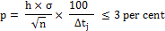
where:
is the statistical accuracy;
is the number of pairs of measurements;
is the mean coastdown time at reference speed , in seconds, given by the equation , where is the harmonized average coastdown time of the i^{th} pair of measurements at velocity , seconds (s), given by the equation: 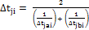. and are the coastdown times of the i^{th} measurement at reference speed , in seconds (s),in each direction, respectively;
is the standard deviation, expressed in seconds (s), defined by: 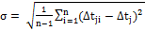
is a coefficient given in Table A4/3.
Table A4/3
Coefficient as function of
n | h | h/ | n | h | h/
3 | 4.3 | 2.48 | 10 | 2.2 | 0.73
4 | 3.2 | 1.60 | 11 | 2.2 | 0.66
5 | 2.8 | 1.25 | 12 | 2.2 | 0.64
6 | 2.6 | 1.06 | 13 | 2.2 | 0.61
7 | 2.5 | 0.94 | 14 | 2.2 | 0.59
8 | 2.4 | 0.85 | 15 | 2.2 | 0.57
9 | 2.3 | 0.77

4.3.1.4.3. If during a measurement in one direction any external factor or driver action occurs which influences the road load test, that measurement and the corresponding measurement in the opposite direction shall be rejected.
4.3.1.4.4. The total resistances, and at reference speed in directions a and b, in Newton (N), are determined by the equations:
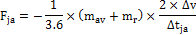
and
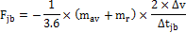
where:
is the total resistance at reference speed (j) in direction a, in Newton (N);
is the total resistance at reference speed (j) in direction b, in Newton (N);
is the average of the test vehicle masses at the beginning and end of road load determination, kg;
is the equivalent effective mass of all the wheels and vehicle components rotating with the wheels during coastdowns on the road, in kilograms (kg); shall be measured or calculated using an appropriate technique agreed by the responsible authority. Alternatively, may be estimated to be three per cent of the unladen vehicle mass in running order plus 25 kg for the CO₂ vehicle family;
and are the mean coastdown times in directions a and b, respectively, corresponding to reference speed , seconds (s), given by the equations and .
4.3.1.4.5. The following equation shall be used to compute the average total resistance where the harmonized average of the alternate coastdown times shall be used.
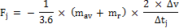
where:
is the harmonized average of alternate coastdown time measurements at velocity , seconds (s), given by 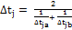 where and are the coastdown times at velocity , seconds (s),in each direction, respectively;
is the average of the test vehicle masses at the beginning and end of road load determination, kg;
is the equivalent effective mass of all the wheels and vehicle components rotating with the wheels during coastdowns on the road, in kilograms (kg); shall be measured or calculated using an appropriate technique. Alternatively, may be estimated to be three per cent of the mass in running order plus 25 kg for the vehicle family.
The coefficients , and in the total resistance equation shall be calculated with a least squares regression analysis.
4.3.2. On-board anemometer-based coastdown method
The vehicle shall be warmed up and stabilised according to paragraph 4.2.4. of this annex. Calibration of instrumentation will take place during this time.
4.3.2.1. Additional instrumentation for on-board anemometry
The anemometer shall be calibrated by means of operation on the test vehicle where such calibration occurs during the warm-up for the test.
4.3.2.1.1. Relative wind speed shall be measured to an accuracy of 0.3 m/s and shall be recorded at a minimum of 1 Hz. Calibration of the anemometer shall include corrections for vehicle blockage.
4.3.2.1.2. Wind direction shall be relative to the direction of the vehicle. Relative wind direction (yaw) shall be measured to an accuracy of 3 degrees and recorded to a resolution of 1 degree; the "dead band" of the instrument shall not exceed 10 degrees and shall be directed toward the rear of the vehicle.
4.3.2.1.3. Before the coastdown, the anemometer shall be calibrated for speed and yaw offset as specified in IS0 10521 Annex A.
4.3.2.1.4. Anemometer blockage shall be corrected for in the calibration procedure as described in ISO 10521-1:2006(E) Annex A.
4.3.2.2. Selection of speed range for road load curve determination
The test speed range as specified in paragraph 4.3.1.1. above shall be selected.
4.3.2.3. Data collection
Various data shall be measured and recorded during the procedure. Elapsed time, vehicle speed, and air velocity (speed, direction) relative to the vehicle, shall be measured at 5 Hz. Ambient temperature shall be synchronised and sampled at a minimum of 1 Hz.
4.3.2.4. Vehicle coastdown procedure
Vehicle coastdown shall be conducted as specified in paragraphs 4.3.1.3.1. to 4.3.1.3.4. above with an on-board anemometer installed on the vehicle. A minimum of ten runs shall be made in alternating directions; five runs in each direction. Wind-corrected coastdown data must satisfy the statistical accuracy requirements as specified in paragraph 4.3.1.4.2. above. The anemometer shall be installed in a position such that the effect on the operating characteristics of the vehicle is minimised.
The anemometer shall be installed according to (a) or (b) below:
(a) Using a boom approximately 2 m in front of the vehicle’s forward aerodynamic stagnation point.
(b) On the roof of the vehicle at its centreline. If possible, the anemometer shall be mounted within 15 cm. from the top of the windshield.
In the event that position (b) is used, the coastdown results shall be analytically adjusted for the additional aerodynamic drag induced by the anemometer. The adjustment shall be made by testing the coastdown vehicle in a wind tunnel both with and without the anemometer installed (same position as used on the track), where the calculated difference will be the incremental drag coefficient (), which combined with the frontal area can be used to correct the coastdown results.
4.3.2.5. Determination of the equation of motion
Symbols used in the on-board anemometer equations of motion are listed in Table A4/4.
Table A4/4
Symbols used in the on-board anemometer equations of motion
Symbol | Units | Description
 | m² | frontal area
… | degrees⁻¹ | coefficients for aerodynamic drag, as a function of yaw angle
 | N | coefficient of mechanical drag
 | N/(km/h) | coefficient of mechanical drag
 | N/(km/h)² | coefficient of mechanical drag
 | kPa | barometric pressure
 |  | coefficient of aerodynamic drag at yaw angle Y
 | N | drag
 | N | aerodynamic drag
 | N | front axle drag (including driveline)
 | N | gravitational drag
 | N | mechanical drag
 | N | rear axle drag (including driveline)
 | N | tyre rolling resistance
 | m/s² | acceleration
 | m/s² | gravitational constant
 | kg | mass of vehicle
 | kg | effective vehicle mass (including rotating components)
 | kg/m3 | air density
 | s | Time
 | K | Temperature
 | km/h | vehicle speed
 | km/h | apparent wind speed relative to vehicle
 | degrees | yaw angle of apparent wind relative to direction of vehicle travel
4.3.2.5.1. General form
The general form of the equation of motion can be written as shown in the equation below:
where:
;
;
effective vehicle mass.
4.3.2.5.2. Mechanical drag modelling
Although mechanical drag consists of separate components representing tire (), front and rear axle frictional losses ( and , including transmissions losses), it can be modelled as a three-term polynomial with respect to speed (), as in the equation below:
where:
, , and are determined in the data analysis using the least squares method. These constants reflect the combined driveline and tyre drag.
4.3.2.5.3. Aerodynamic drag modelling
The aerodynamic drag coefficient, (Y), is modelled as a four-term polynomial with respect to yaw angle (, deg), as in the equation below:
where to are constant coefficients whose values are determined in the data analysis. The aerodynamic drag coefficient is combined with the vehicle frontal area (), and the relative wind velocity () to determine the aerodynamic drag () according to the following two equations:
4.3.2.5.4. Substituting, the final form of the equation of motion becomes:
4.3.2.6. Data reduction
Techniques for analysing coastdown data shall be employed in the determination of the coefficients used to describe the road load force. A three-term equation shall be generated to describe the road load force as a function of velocity, , corrected to standard ambient temperature and pressure conditions, and still air.
4.3.2.6.1. Determining calibration coefficients
If not previously determined, calibration factors to correct for vehicle blockage shall be determined for relative wind speed and yaw angle. Vehicle speed (), relative wind velocity (and yaw () measurements during the warm-up phase of the test procedure shall be recorded. Paired runs in alternate directions on the test track at a constant velocity of 80 km/h shall be performed, and averages for , and for each run shall be determined. Calibration factors that minimize the total errors in head and cross winds over all the run pairs, i.e. the sum of , etc., shall be selected where and refer to wind speed and wind direction from the paired test runs in opposing directions during the vehicle warm-up/stabilization prior to testing.
4.3.2.6.2. Deriving second by second observations
From the periodic data collected during the coastdown runs, values for , , , and shall be determined by applying calibration factors and data filtering to adjust samples to 1 Hz.
4.3.2.6.3. Preliminary analysis
Using a linear least squares regression technique, all data points shall be analysed at once. , , , , , , and given and shall be determined.
4.3.2.6.4. Identifying "outliers"
For each data point, a predicted force, , shall be calculated and compared to that observed. Data points with excessive deviations, e.g., over three standard deviations, shall be flagged.
4.3.2.6.5. Data filtering
If desired, appropriate data filtering techniques may be employed. Remaining data points shall be smoothed out.
4.3.2.6.6. Elimination of extreme data points
Data points with yaw angles greater than ±20 degrees from the direction of vehicle travel shall be flagged. Data points with relative winds less than +5 km/h (to avoid backwind conditions) shall also be flagged. Data analysis shall be restricted to vehicle speeds from 115 to 15 km/h.
4.3.2.6.7. Final data analysis
All data which has not been flagged shall be analysed using a linear least squares regression technique. Given and , and shall be determined.
4.3.2.6.8. Constrained analysis option
In a constrained analysis, the vehicle frontal area and the drag coefficient, , are those values which have been previously determined.
4.3.2.6.9. Correction to reference conditions
Equations of motion shall be corrected to reference conditions as specified in paragraph 4.5. of this annex.
4.4. Measurement of running resistance using the torque meter method
As an alternative to the coastdown methods, the torque meter method may also be used in which the running resistance is determined by measuring wheel torque on the driven wheels at various constant speeds with time periods of at least five seconds.
4.4.1. Installation of torque meter
Wheel torque meters shall be installed between the wheel hub and the rim of each driven wheel, measuring the required torque to keep the vehicle at a constant speed.
4.4.2. Procedure and data sampling
4.4.2.1. Speed selection
The range of selected reference speeds (, , etc.) where the running resistance is to be measured shall start at 15 km/h and cover the entire speed range of the applicable test cycle, while the difference between and is 20 km/h or less.
4.4.2.2. Start of data collection
Data collection shall be started after a vehicle warm-up according to paragraph 4.2.4. of this annex.
The reference speeds will be measured in a descending order. Upon the request of the manufacturer, stabilization periods are allowed between measurements but the stabilization speed shall not exceed the speed of the next reference speed.
4.4.2.3. Data collection
Data sets consisting of actual speed , actual torque and time over a period of at least 5 s shall be recorded for every at a sampling frequency of at least 10 Hz. The data sets collected over one time period for a reference speed will be referred to as one measurement.
4.4.2.4. Velocity deviation
The velocity deviation from the mean velocity (paragraph 4.4.3. of this annex) shall be within the values in Table A4/5.
Table A4/5
Velocity deviation
Time period, seconds | Velocity deviation, km/h
5 - 10 | ±0.2
10 - 15 | ±0.4
15 - 20 | ±0.6
20 - 25 | ±0.8
25 - 30 | ±1.0
≥ 30 | ±1.2
4.4.3. Calculation of mean velocity and mean torque
4.4.3.1. Calculation process
Mean velocity , km/h, and mean torque , Nm, over a time period, shall be calculated from the data sets collected in paragraph 4.4.2.3. above as follows:
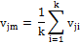
and
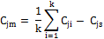
where:
is vehicle speed of the i^{th} data set, km/h;
is the number of data sets;
is torque of the i^{th} data set, Nm;
is the compensation term for speed drift, Nm, given by the following equation .
shall be no greater than five per cent of the mean torque before compensation, and may be neglected if is not greater than ± 0.005 m/s².
and are the average test vehicle mass and the equivalent effective mass, in kg, , respectively, defined in paragraph 4.3.1.4.4. above.
is the dynamic radius of the tyre, in meters (m), given by the equation , where is the rotational frequency of the driven tyre, in s⁻¹;
is the mean acceleration, in metres per second squared (m/s²), which shall be calculated by the equation
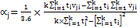, where is the time at which the i^{th} data set was sampled, seconds (s).
4.4.3.2. Accuracy of measurement
These measurements shall be carried out in opposite directions until a minimum of four consecutive figures at each and in both directions (a and b) have been obtained, for which satisfies the accuracy ρ, in per cent, according to the equation:
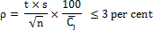
where:
is the number pairs of measurements for ;
is the running resistance at the speed , expressed in Nm, given by the equation, whereis the average torque of the i^{th} pair of measurements at speed , expressed in Nm and given by where and are the mean torques of the i^{th} measurement at speed determined in paragraph 4.4.3.1. above for each direction, a and b respectively, expressed in Nm);
is the standard deviation, expressed in Nm, defined by the equation 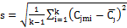;
is a coefficient from Table A4/3 in paragraph 4.3.1.4.2. above.
4.4.3.3. Validity of the measured average speed
The average speed, , shall not deviate from its mean, , by more than ± 1 km/h or two per cent of the average speed , whichever is greater. The values of and shall be calculated as follows:
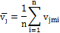
where and are the mean speeds of the i^{th} pair of measurements at velocity determined in paragraph 4.4.3.1. above for each direction, a and b respectively, expressed in km/h.
4.4.4. Running resistance curve determination
The following least squares regression curves for each direction a and b shall be fitted to all the data pairs (, ) and (,, ) at all at all reference speeds ,(, , etc.) described in paragraph 4.3.1.1. above to determine the coefficients , , , , and :
where:
and are the running resistances in directions a and b, Nm;
and are constant terms in directions a and b, Nm;
and are the coefficients of the first-order term in directions a and b, Nm (h/km);
and are the coefficients of the second-order term in directions a and b, Nm (h/km)²;
is vehicle velocity, km/h.
The average total torque equation is calculated by the following equation:
where the average coefficients , and shall be calculated using the following equations:
The coefficient may be assumed to be zero if the value of is no greater than three per cent of at the reference speed(s); in this case, the coefficients and shall be recalculated according to the least squares method.
The coefficients , and as well as the coastdown times measured at the chassis dynamometer (see paragraph 8.2.3.3. of this annex) shall be recorded.
4.5. Correction to reference conditions
4.5.1. Air resistance correction factor
The correction factor for air resistance K₂ shall be determined as follows:
where:
is the mean atmospheric temperature, Kelvin (K);
is the mean atmospheric pressure, in kPa.
4.5.2. Rolling resistance correction factor
The correction factor, , for rolling resistance, in Kelvin⁻¹ (K⁻¹), may be determined based on empirical data and approved by the responsible authority for the particular vehicle and tyre test, or may be assumed as follows:
4.5.3. Wind correction with stationary anemometry
4.5.3.1. Wind correction, for absolute wind speed alongside the test road, shall be made by subtracting the difference that cannot be cancelled out by alternate runs from the constant term given in paragraph 4.3.1.4.5. above, or from given in paragraph 4.4.4. above. The wind correction shall not apply to the on-board anemometer-based coastdown method.
4.5.3.2. The wind correction resistance for the coastdown method or for the torque meter method shall be calculated by the equations:
or
where:
is the wind correction resistance for the coastdown method, N;
is the coefficient of the aerodynamic term determined in paragraph 4.3.1.4.5. of this annex;
is the lower average wind speed of both directions alongside the test road during the test, m/s;
is the wind correction resistance for the torque meter method, Nm;
is the coefficient of the aerodynamic term determined in paragraph 4.4.4. of this annex.
4.5.4. Test mass correction factor
4.5.4.1. Test vehicle H
The correction factor for the test mass of test vehicle H shall be determined as follows:
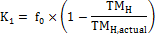
where:
is a constant term, N;
is test mass of the test vehicle H, kg;
is the actual test mass of test vehicle H (the average mass ; (see paragraph 4.3.1.4.4. of this annex), kg.
4.5.4.2. Test vehicle L
The correction factor for the test mass of test vehicle L shall be determined as follows:
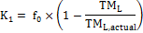
where:
is a constant term, N;
is test mass of test vehicle L, kg;
is the actual test mass of the test vehicle L (the average mass , see paragraph 4.3.1.4.4. of this annex), kg.
4.5.5. Road load curve correction
4.5.5.1. The curve determined in paragraph 4.3.1.4.5. of this annex shall be corrected to reference conditions as follows and shall be used as the target coefficients in paragraph 8.1.1.:
where:
is the corrected total resistance, N;
is the constant term, N;
is the coefficient of the first-order term, N (h/km);
is the coefficient of the second-order term, N (h/km)²;
is the correction factor for rolling resistance as defined in paragraph 4.5.2.of this annex;
is the test mass correction as defined in paragraph 4.5.4.of this annex;
is the correction factor for air resistance as defined in paragraph 4.5.1.of this annex;
is vehicle velocity, km/h;
is the wind resistance correction as defined in paragraph 4.5.3. of this annex.
4.5.5.2. The curve determined in paragraph 4.4.4. above shall be corrected to reference conditions as follows:
where:
is the corrected total running resistance, Nm;
is the constant term, Nm;
is the coefficient of the first-order term, Nm (h/km);
is the coefficient of the second-order term, Nm (h/km)²;
is the correction factor for rolling resistance as defined in paragraph 4.5.2.of this annex;
is the test mass correction as defined in paragraph 4.5.4.;
is the correction factor for air resistance as defined in paragraph 4.5.1.of this annex;
is vehicle velocity, km/h;
is the wind correction resistance as defined in paragraph 4.5.3. of this annex.
5. Method for the calculation of default road load based on vehicle parameters
5.1. As an alternative for determining road load with the coastdown or torque meter method, a calculation method for default road load may be used.
For the calculation of a default road load, several parameters such as test mass, width and height of the vehicle shall be used. The default road load () for several speeds , in km/h, shall be calculated. Reference speeds shall be selected according to paragraph 4.3.1.1 above and the default road load (), in N, for these reference speeds , in km/h, shall be calculated. The results of the calculated default road load values shall be used for the setting of the chassis dynamometer. A coastdown test on a chassis dynamometer shall be conducted to ensure the correct settings of the chassis dynamometer.
5.2. The default road load force shall be calculated using the following equation:
where:
is the calculated default road load force for a given vehicle velocity , and it is expressed in Newton (N);
is the constant road load coefficient, in N, defined by the equation:
is the first order road load coefficient and shall be equal to zero;
is the second order road load coefficient, in N·(h/km)², defined by the equation:
;
is vehicle velocity, km/h;
test mass, kg;
vehicle width, m,as defined in 6.2. of Standard ISO 612:1978;
vehicle height, m, as defined in 6.3. of Standard ISO 612:1978.
6. [RESERVED: Road load measurement using a combination of a wind tunnel and chassis dynamometer]
7. Transferring road load to a chassis dynamometer
7.1. Preparation for chassis dynamometer test
7.1.1. Laboratory condition
7.1.1.1. Roller
The chassis dynamometer roller(s) shall be clean, dry and free from foreign material which might cause tyre slippage. For chassis dynamometers with multiple rollers, the dynamometer shall be run in the same coupled or uncoupled state as the subsequent Type 1 test. Chassis dynamometer speed shall be measured from the roller coupled to the power-absorption unit.
7.1.1.1.1. Tyre slip
Additional weight may be placed on or in the vehicle to eliminate tyre slip. The manufacturer shall perform the load setting on the chassis dynamometer with the additional weight. The additional weight shall be present for both load setting and the emissions and fuel consumption tests. The use of any additional weight shall be recorded.
7.1.1.2. Room temperature
The laboratory atmospheric temperature shall be at a set point of 296 K and shall not deviate by more than ±5 K during the test as the standard condition, unless otherwise required by the subsequent test(s).
7.2. Preparation of chassis dynamometer
7.2.1. Inertia mass setting
The equivalent inertia mass of the chassis dynamometer shall be set to the test mass used at the corresponding road load determination if a dual-axis chassis dynamometer is used. In case a single-axis chassis dynamometer is used, the equivalent inertia mass shall be increased by the inertia of the wheels and connected vehicle parts which are not rotating. If is estimated at 3 per cent of the mass in running order plus 25 kg, , the mass added to the inertia setting shall be 1.5 per cent of . If the chassis dynamometer is not capable to meet the inertia setting exactly, the next higher inertia setting shall be applied with a maximum increase of 10 kg.
7.2.2. Chassis dynamometer warm-up
The chassis dynamometer shall be warmed up in accordance with the dynamometer manufacturer’s recommendations, or as appropriate, so that friction losses of the dynamometer can be stabilized.
7.3. Vehicle preparation
7.3.1. Tyre pressure adjustment
The tyre pressure at the soak temperature of a Type 1 test shall be set to no more than 50 per cent (see paragraph 4.2.2.3. of this annex) above the lower limit of the tyre pressure range for the selected tyre, as specified by the vehicle manufacturer, and shall be recorded.
7.3.2. If the determination of dynamometer settings cannot meet the criteria described in paragraph 8.1.3. of this annex due to non-reproducible forces, the vehicle shall be equipped with a vehicle coastdown mode. The coasting mode shall be approved and recorded by the responsible authority.
7.3.2.1. If a vehicle is equipped with a vehicle coastdown mode, it shall be engaged both during road load determination and on the chassis dynamometer.
7.3.3. Vehicle setting
The tested vehicle shall be installed on the chassis dynamometer roller in a straight position and restrained in a safe manner. In case of a single roller, the tyre contact point shall be within ± 25 mm or ± 2 per cent of the roller diameter, whichever is smaller, measured from the top of the roller.
7.3.4. Vehicle warm-up
7.3.4.1. The vehicle shall be warmed up with the applicable WLTC. In case the vehicle was warmed up at 90 per cent of the maximum speed of the next higher phase during the procedure defined in paragraph 4.2.4.1.2.of this annex, this higher phase shall be added to the applicable WLTC.
Table A4/6
Vehicle warm-up
Vehicle class | Applicable WLTC | Adopt next higher phase | Warm-up cycle
Class 1 | Low₁+ Medium₁ | NA | Low₁+ Medium₁
Class 2 | Low₂+ Medium₂+ High₂+ Extra High₂ | NA | Low₂+ Medium₂ + High₂+ Extra High₂
Class 2 | Low₂+ Medium₂+ High₂ | Yes (Extra High₂) | Low₂+ Medium₂ + High₂+ Extra High₂
Class 2 |  | No | Low₂+ Medium₂+ High₂
Class 3 | Low₃+ Medium₃+ High₃+ Extra High₃ | Low₃+ Medium₃ + High₃+ Extra High₃ | Low₃+ Medium₃+ High₃+ Extra High₃
Class 3 | Low₃+ Medium₃+ High₃ | Yes(Extra High₃) | Low₃+ Medium₃+ High₃+ Extra High₃
Class 3 |  | No | Low₃+ Medium₃ + High₃
7.3.4.2. If the vehicle is already warmed up, the WLTC phase applied in paragraph 7.3.4.1. above, with the highest speed, shall be driven.
[RESERVED: alternative warm-up procedure]
8. Chassis dynamometer load setting
8.1. Chassis dynamometer setting by coastdown method
This method is applicable when the road load is determined using the coastdown method as specified in paragraph 4.3. of this annex.
8.1.1. Initial load setting
For a chassis dynamometer with coefficient control, the chassis dynamometer power-absorption unit shall be adjusted with the arbitrary initial coefficients, , and , of the following equation:
where:
is the chassis dynamometer setting load, N;
is the speed of the chassis dynamometer roller, km/h.
The following are recommended coefficients to be used for the initial load setting:
(a) for single-axis chassis dynamometers, or for dual-axis chassis dynamometers, where , and are the target road load coefficients;
(b) empirical values, such as those used for the setting for a similar type of vehicle.
For a chassis dynamometer of polygonal control, adequate load values at each reference speed shall be set to the chassis dynamometer power-absorption unit.
8.1.2. Coastdown
The coastdown test on the chassis dynamometer shall be performed with the procedure given in paragraphs 4.3.1.3.1. and 4.3.1.3.2. of this annex.
8.1.3. Verification
8.1.3.1. The target road load value shall be calculated using the target road load coefficient , and for each reference speed :
where:
is the target road load at reference speed , N;
is the j^{th} reference speed, km/h.
8.1.3.2. For dynamometer load setting, two different methods may be used. If the vehicle is accelerated by the dynamometer, the methods described in paragraph 8.1.3.2.1. below shall be used. If the vehicle is accelerated under its own power, the methods in paragraphs 8.1.3.2.1. or 8.1.3.2.2. below shall be used. The acceleration multiplied by speed shall be approximately 6 m²/sec³.
8.1.3.2.1. Fixed run method
For the fixed-run procedure, the dynamometer software shall automatically run three coastdowns adjusting the set coefficients for each run using the difference between the previous run's measured and target coefficients. The final set coefficients shall be calculated by subtracting the average of the vehicle coefficients obtained from the last two runs from the target coefficients. Optionally, a single stabilization coastdown may be performed before beginning the 2 run averaging sequence.
8.1.3.2.2. Iterative method
The calculated forces in the specified speed ranges shall be within a tolerance of ±10 N after a least squares regression of the forces for two consecutive coastdowns.
If an error at any reference speed does not satisfy the criteria of the method described in this paragraph, paragraph 8.1.4. below shall be used to adjust the chassis dynamometer load setting.
8.1.4. Adjustment
The chassis dynamometer setting load shall be adjusted in accordance with the procedure specified in Appendix 2 to this annex, paragraph 1. Paragraphs 8.1.2. and 8.1.3. above (including subparagraphs) shall be repeated.
8.2. Chassis dynamometer load setting using torque meter method
This method is applicable when the road load is determined using the torque meter method, as specified in paragraph 4.4. of this annex.
8.2.1. Initial load setting
For a chassis dynamometer of coefficient control, the chassis dynamometer power absorption unit shall be adjusted with the arbitrary initial coefficients, , and , of the following equation:
where:
is the chassis dynamometer setting load, N;
is the speed of the chassis dynamometer roller, km/h.
The following coefficients are recommended for the initial load setting:
(a) for single-axis chassis dynamometers, or for dual-axis chassis dynamometers, where: , and are the coefficients for the target torque; is the dynamic radius of the tyre on the chassis dynamometer, m, obtained by averaging the values calculated in Appendix 1 to this annex, paragraph 2.1;
(b) Empirical values, such as those used for the setting for a similar type of vehicle.
For a chassis dynamometer of polygonal control, adequate load values at each reference speed shall be set for the chassis dynamometer power-absorption unit.
8.2.2. Wheel torque measurement
The torque measurement test on the chassis dynamometer shall be performed with the procedure defined in 4.4.2. The torque meter(s) shall be identical to the one(s) used in the preceding road test.
8.2.3. Verification
8.2.3.1. The target road load value shall be calculated using the target torque coefficients , and for each reference speed .
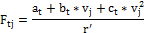
where:
is the target road load at reference speed , N;
is the j^{th} reference speed, km/h;
is the dynamic radius of the tyre on the chassis dynamometer, m, obtained by averaging the values calculated in Appendix 1 to this annex, paragraph 2.1.
8.2.3.2. The error, , in per cent of the simulated road load shall be calculated. is determined according to the method specified in Appendix 1 to this annex, paragraph 2, for target road load at each reference speed.
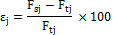
obtained in Appendix 1 to this annex, paragraph 2.1. and paragraph 8.2.3., respectively, may be used in the above equation instead of .
Errors at all reference speeds shall satisfy the following error criteria in two consecutive coastdown runs, unless otherwise specified by regulations.
per cent for km/h
per cent for 20 km/h km/h
per cent for km/h.
8.2.3.3. Adjustment
The chassis dynamometer setting load shall be adjusted according to the procedure specified in Appendix 2 to Annex 4, paragraph 2. Paragraphs 8.2.2. and 8.2.3. above shall be repeated.
Once the chassis dynamometer has been set within the specified tolerances, a vehicle coastdown shall be performed on the chassis dynamometer as outlined in paragraph 4.3.1.3. The coastdown times shall be recorded.
Annex 4 - Appendix 1
Calculation of road load for the dynamometer test
1. Calculation of simulated road load using the coastdown method
When the road load is measured by the coastdown method as specified in paragraph 4.3. of this annex, calculation of the simulated road load for each reference speed , in km per hour, shall be conducted as described in paragraphs 1.1. to 1.3. of this appendix.
1.1. The measured road load shall be calculated using the following equation:
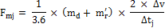
where:
is the measured road load for each reference speed , N;
is the equivalent inertia-mass of the chassis dynamometer, kg;
is the equivalent effective mass of drive wheels and vehicle components rotating with the wheels during coastdown on the road, kg; may be measured or calculated by an appropriate technique. As an alternative, may be estimated as 3 per cent of the mass in running order plus 25 kg ;
is the coastdown time corresponding to speed , s.
1.2. The coefficients , and of the following approximate equation shall be determined using a least-square regression using the calculated values of :
1.3. The simulated road load for each reference speed shall be determined using the following equation, using the calculated , and :
2. Calculation of simulated road load using the torque meter method
When the road load is measured by the torque meter method as specified in paragraph 4.4. of Annex 4, calculation of the simulated road load for each reference speed , in km per hour, shall be conducted as described in paragraphs 2.1. to 2.3. of this appendix.
2.1. The mean speed , in km per hour, and the mean torque , in Nm, for each reference speed shall be calculated using the following equations:
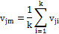
and
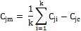
where:
is the vehicle speed of the i^{th} data set, km/h;
is the number of data sets;
is the torque of the i^{th} data set, Nm;
is the compensation term for the speed drift, Nm, given by the following equation:
shall be no greater than five per cent of the mean torque before compensation, and may be neglected if || is no greater than 0.005 m/s².
is the equivalent inertia mass of the chassis dynamometer, kg;
is the equivalent effective mass of drive wheels and vehicle components rotating with the wheels during coastdown on the dynamometer, kg; may be measured or calculated by an appropriatetechnique. As an alternative, may be estimated as three per cent of the unladen vehicle mass for a permanent four-wheel-drive vehicle, and 1.5 per cent of the unladen vehicle mass for a two-wheel drive vehicle;
is the mean acceleration, in metres per second squared (m/s²), which shall be calculated by the equation:
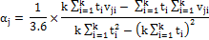
where is the time at which the i^{th} data set was sampled, seconds (s);
is the dynamic radius of the tyre, m, for the j^{th} reference speed given by the equation:
where is the rotational frequency of the driven tyre, s⁻¹.
2.2. The coefficients , and of the following approximate equation shall be determined by the least-square regression using the calculated and the .
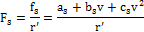
2.3. The simulated road load for each reference speed shall be determined using the following equation and the calculated , and :
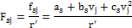
Annex 4 - Appendix 2
Adjustment of chassis dynamometer load setting
1. Adjustment of chassis dynamometer load setting using the coastdown method
The chassis dynamometer load setting shall be adjusted using the following equations:
Therefore:
The parameters used in these equations are the following:
is the initial chassis dynamometer setting load, N;
is the adjusted chassis dynamometer setting load, N;
is the adjustment road load, which is equal to , N;
is the simulated road load at reference speed , N;
is the target road load at reference speed , N;
, and are the new chassis dynamometer setting coefficients.
2. Adjustment of chassis dynamometer load setting using the torque meter method
The chassis dynamometer load setting shall be adjusted using the following equation:
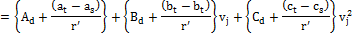
Therefore:
where:
is the new chassis dynamometer setting load, N;
is the adjustment road load, which is equal to , Nm;
is the simulated road load at reference speed , Nm;
is the target road load at reference speed , Nm;
, and are the new chassis dynamometer setting coefficients;
is the dynamic radius of the tyre on the chassis dynamometer, m, that is obtained by averaging the values calculated in Appendix 1 to Annex 4, paragraph 2.1.
Annex 5
Test equipment and calibrations
1. Test bench specifications and settings
1.1. Cooling fan specifications
1.1.1. A current of air of variable speed shall be blown towards the vehicle. The set point of the linear velocity of the air at the blower outlet shall be equal to the corresponding roller speed above roller speeds of 5 km/h. The deviation of the linear velocity of the air at the blower outlet shall remain within ±5 km/h or ±10 per cent of the corresponding roller speed, whichever is greater.
1.1.2. The above-mentioned air velocity shall be determined as an averaged value of a number of measuring points which:
(a) For fans with rectangular outlets, are located at the centre of each rectangle dividing the whole of the fan outlet into 9 areas (dividing both horizontal and vertical sides of the fan outlet into 3 equal parts). The centre area shall not be measured (as shown in Figure A5/1);
Figure A5/1
Fan with rectangular outlet
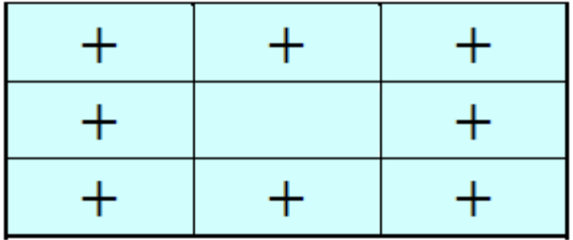
(b) For circular fan outlets, the outlet shall be divided into 8 equal sections by vertical, horizontal and 45° lines. The measurement points lie on the radial centre line of each arc (22.5°) at two thirds of the outlet radius (as shown in Figure A5/2).
Figure A5/2
Fan with circular outlet
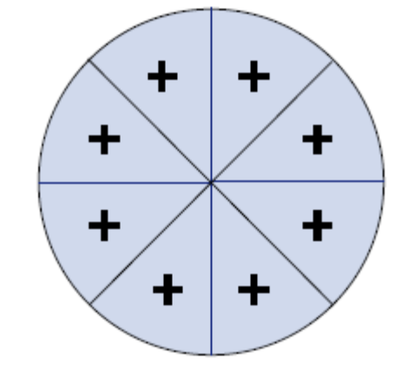
These measurements shall be made with no vehicle or other obstruction in front of the fan. The device used to measure the linear velocity of the air shall be located between 0 and 20 cm from the air outlet.
1.1.3. The outlet of the fan shall have the following characteristics:
(a) An area of at least 0.3 m², and
(b) A width/diameter of at least 0.8 m.
1.1.4. The position of the fan shall be as follows:
(a) Height of the lower edge above ground: approximately 20 cm;
(b) Distance from the front of the vehicle: approximately 30 cm.
1.1.5. The height and lateral position of the cooling fan may be modified at the request of the manufacturer and if considered appropriate by the responsible authority.
1.1.6. In the cases described above, the cooling fan position (height and distance) shall be recorded and shall be used for any subsequent testing.
2. Chassis dynamometer
2.1. General requirements
2.1.1. The dynamometer shall be capable of simulating road load with at least three road load parameters that can be adjusted to shape the load curve.
2.1.2. The chassis dynamometer may have one or two rollers. In the case of twin-roll dynamometers, the rollers shall be permanently coupled or the front roller shall drive, directly or indirectly, any inertial masses and the power absorption device.
2.2. Specific requirements
The following specific requirements relate to the dynamometer manufacturer's specifications.
2.2.1. The roll run-out shall be less than 0.25 mm at all measured locations.
2.2.2. The roller diameter shall be within ±1.0 mm of the specified nominal value at all measurement locations.
2.2.3. The dynamometer shall have a time measurement system for use in determining acceleration rates and for measuring vehicle/dynamometer coastdown times. This time measurement system shall have an accuracy of ±0.001 per cent or better. This shall be verified upon initial installation.
2.2.4. The dynamometer shall have a speed measurement system with an accuracy of ±0.080 km/h or better. This shall be verified upon initial installation.
2.2.5. The dynamometer shall have a response time (90 per cent response to a tractive effort step change) of less than 100 ms with instantaneous accelerations which are at least 3 m/s². This shall be verified upon initial installation and after major maintenance.
2.2.6. The base inertia weight of the dynamometer shall be stated by the dynamometer manufacturer, and must be confirmed to within ±0.5 per cent for each measured base inertia and ±0.2 per cent relative to any mean value by dynamic derivation from trials at constant acceleration, deceleration and force.
2.2.7. Roller speed shall be recorded at a frequency of not less than 1 Hz.
2.3. Additional specific requirements for chassis dynamometers for vehicles to be tested in four wheel drive (4WD) mode
2.3.1. The 4WD control system shall be designed such that the following requirements are met when tested with a vehicle driven over the WLTC.
2.3.1.1. Road load simulation shall be applied such that operation in 4WD mode reproduces the same proportioning of forces as would be encountered when driving the vehicle on a smooth, dry, level road surface.
2.3.1.2. The difference in distance covered by the front and rear rolls shall be less than 0.1 m in any 200 ms time period. If it can be demonstrated that this criteria is met, the speed synchronization requirement in paragraph 2.3.1.3. below is not required. This must be checked for new dynamometer instalments and after major repairs or maintenance.
2.3.1.3. All roll speeds shall be synchronous to within ±0.16 km/h. This may be assessed by applying a 1s moving average filter to roll speed data acquired at a minimum of 20 Hz. This must be checked for new dynamometer instalments and after major repairs or maintenance.
2.3.1.4. The difference in distance covered by the front and rear rolls shall be less than 0.2 per cent of the driven distance over the WLTC. The absolute number shall be integrated for the calculation of the total difference in distance over the WLTC.
2.4. Chassis dynamometer calibration
2.4.1. Force measurement system
The accuracy and linearity of the force transducer shall be at least ±10 N for all measured increments. This shall be verified upon initial installation, after major maintenance and within 370 days before testing.
2.4.2. Dynamometer parasitic loss calibration
The dynamometer's parasitic losses shall be measured and updated if any measured value differs from the current loss curve by more than 2.5 N. This shall be verified upon initial installation, after major maintenance and within 35 days before testing.
2.4.3. Verification of road load simulation without a vehicle
The dynamometer performance shall be verified by performing an unloaded coastdown test upon initial installation, after major maintenance, and within 7 days before testing. The average coastdown force error shall be less than 10 N or 2 per cent, whichever is greater, at each measured point (10 km/h speed intervals) in the speed range..
3. Exhaust gas dilution system
3.1. System specification
3.1.1. Overview
3.1.1.1. A full-flow exhaust gas dilution system shall be used. The total vehicle exhaust shall be continuously diluted with ambient air under controlled conditions using a constant volume sampler. A critical flow venturi (CFV) or multiple critical flow venturis arranged in parallel, a positive displacement pump (PDP), a subsonic venturi (SSV), or an ultrasonic flow meter (USM) may be used. The total volume of the mixture of exhaust and dilution air shall be measured and a continuously proportional sample of the volume shall be collected for analysis. The quantities of exhaust gas compounds are determined from the sample concentrations, corrected for their respective content of the dilution air and the totalised flow over the test period.
3.1.1.2. The exhaust dilution system shall consist of a connecting tube, a mixing device and dilution tunnel, dilution air conditioning, a suction device and a flow measurement device. Sampling probes shall be fitted in the dilution tunnel as specified in paragraphs 4.1., 4.2. and 4.3. of this annex.
3.1.1.3. The mixing device described in paragraph 3.1.1.2. above shall be a vessel such as that illustrated in Figure A5/3 in which vehicle exhaust gases and the dilution air are combined so as to produce a homogeneous mixture at the sampling position.
3.2. General requirements
3.2.1. The vehicle exhaust gases shall be diluted with a sufficient amount of ambient air to prevent any water condensation in the sampling and measuring system at all conditions which may occur during a test.
3.2.2. The mixture of air and exhaust gases shall be homogeneous at the point where the sampling probes are located (paragraph 3.3.3. below). The sampling probes shall extract representative samples of the diluted exhaust gas.
3.2.3. The system shall enable the total volume of the diluted exhaust gases to be measured.
3.2.4. The sampling system shall be gas-tight. The design of the variable-dilution sampling system and the materials used in its construction shall be such that they do not affect the compound concentration in the diluted exhaust gases. If any component in the system (heat exchanger, cyclone separator, suction device, etc.) changes the concentration of any of the exhaust gas compounds in the diluted exhaust gases and the systematic error cannot be corrected, sampling for that compound shall be carried out upstream from that component.
3.2.5. All parts of the dilution system in contact with raw or diluted exhaust gas shall be designed to minimise deposition or alteration of the particulates or particles. All parts shall be made of electrically conductive materials that do not react with exhaust gas components, and shall be electrically grounded to prevent electrostatic effects.
3.2.6. If the vehicle being tested is equipped with an exhaust pipe comprising several branches, the connecting tubes shall be connected as near as possible to the vehicle without adversely affecting their operation.
3.3. Specific requirements
3.3.1. Connection to vehicle exhaust
3.3.1.1. The start of the connecting tube is the exit of the tailpipe. The end of the connecting tube is the sample point, or first point of dilution. For multiple tailpipe configurations where all the tailpipes are combined, the start of the connecting tube may be taken at the last joint of where all the tailpipes are combined.
3.3.1.2. The connecting tube between the vehicle and dilution system shall be designed so as to minimize heat loss.
3.3.1.3. The connecting tube shall satisfy the following requirements:
(a) Be less than 3.6 m long, or less than 6.1 m long if heat-insulated. Its internal diameter shall not exceed 105 mm; the insulating materials shall have a thickness of at least 25 mm and thermal conductivity not exceeding 0.1 W/m⁻¹K⁻¹ at 400°C. Optionally, the tube may be heated to a temperature above the dew point. This may be assumed to be achieved if the tube is heated to 70 °C;
(b) Not cause the static pressure at the exhaust outlets on the vehicle being tested to differ by more than ±0.75 kPa at 50 km/h, or more than ±1.25 kPa for the duration of the test from the static pressures recorded when nothing is connected to the vehicle exhaust pipes. The pressure shall be measured in the exhaust outlet or in an extension having the same diameter, as near as possible to the end of the tailpipe. Sampling systems capable of maintaining the static pressure to within ±0.25 kPa may be used if a written request from a manufacturer to the responsible authority substantiates the need for the closer tolerance;
(c) No component of the connecting tube shall be of a material which might affect the gaseous or solid composition of the exhaust gas. To avoid generation of any particles from elastomer connectors, elastomers employed shall be as thermally stable as possible and have minimum exposure to the exhaust gas. It is recommended not to use elastomer connectors to bridge the connection between the vehicle exhaust and the connecting tube.
3.3.2. Dilution air conditioning
3.3.2.1. The dilution air used for the primary dilution of the exhaust in the CVS tunnel shall be passed through a medium capable of reducing particles of the most penetrating particle size in the filter material by ≤ 99.95 per cent, or through a filter of at least class H13 of EN 1822:2009. This represents the specification of High Efficiency Particulate Air (HEPA) filters. The dilution air may optionally be charcoal scrubbed before being passed to the HEPA filter. It is recommended that an additional coarse particle filter be situated before the HEPA filter and after the charcoal scrubber, if used.
3.3.2.2. At the vehicle manufacturer's request, the dilution air may be sampled according to good engineering practice to determine the tunnel contribution to background particulate mass and particle number levels, which can then be subtracted from the values measured in the diluted exhaust. See paragraph 1.2.1.3. of Annex 6.
3.3.3. Dilution tunnel
3.3.3.1. Provision shall be made for the vehicle exhaust gases and the dilution air to be mixed. A mixing device may be used.
3.3.3.2. The homogeneity of the mixture in any cross-section at the location of the sampling probe shall not vary by more than ±2 per cent from the average of the values obtained for at least five points located at equal intervals on the diameter of the gas stream.
3.3.3.3. For particulate and particle emissions sampling, a dilution tunnel shall be used which:
(a) Consists of a straight tube of electrically-conductive material, which shall be grounded;
(b) Shall cause turbulent flow (Reynolds number ≥ 4,000) and be of sufficient length to cause complete mixing of the exhaust and dilution air;
(c) Shall be at least 200 mm in diameter;
(d) May be insulated and/or heated.
3.3.4. Suction device
3.3.4.1. This device may have a range of fixed speeds to ensure sufficient flow to prevent any water condensation. This result is obtained if the flow is either:
(a) Twice as high as the maximum flow of exhaust gas produced by accelerations of the driving cycle; or
(b) Sufficient to ensure that the CO₂ concentration in the dilute exhaust sample bag is less than 3 per cent by volume for petrol and diesel, less than 2.2 per cent by volume for LPG and less than 1.5 per cent by volume for NG/biomethane.
3.3.4.2. Compliance with the above requirements may not be necessary if the CVS system is designed to inhibit condensation by such techniques, or combination of techniques, as:
(a) Reducing water content in the dilution air (dilution air dehumidification);
(b) Heating of the CVS dilution air and of all components up to the diluted exhaust flow measurement device, and optionally, the bag sampling system including the sample bags and also the system for the measurement of the bag concentrations.
In such cases, the selection of the CVS flow rate for the test shall be justified by showing that condensation of water cannot occur at any point within the CVS, bag sampling or analytical system.
3.3.5. Volume measurement in the primary dilution system
3.3.5.1. The method of measuring total dilute exhaust volume incorporated in the constant volume sampler shall be such that measurement is accurate to ±2 per cent under all operating conditions. If the device cannot compensate for variations in the temperature of the mixture of exhaust gases and dilution air at the measuring point, a heat exchanger shall be used to maintain the temperature to within ±6 K of the specified operating temperature for a PDP-CVS, ±11 K for a CFV CVS, ±6 K for a USM CVS, and ±11 K for an SSV CVS.
3.3.5.2. If necessary, some form of protection for the volume measuring device may be used e.g. a cyclone separator, bulk stream filter, etc.
3.3.5.3. A temperature sensor shall be installed immediately before the volume measuring device. This temperature sensor shall have an accuracy and a precision of ±1 K and a response time of 0.1 s at 62 per cent of a given temperature variation (value measured in silicone oil).
3.3.5.4. Measurement of the pressure difference from atmospheric pressure shall be taken upstream from and, if necessary, downstream from the volume measuring device.
3.3.5.5. The pressure measurements shall have a precision and an accuracy of ±0.4 kPa during the test.
3.3.6. Recommended system description
Figure A5/3 is a schematic drawing of exhaust dilution systems which meet the requirements of this annex.
The following components are recommended:
(a) A dilution air filter, which can be preheated if necessary. This filter shall consist of the following filters in sequence: an optional activated charcoal filter (inlet side), and a HEPA filter (outlet side). It is recommended that an additional coarse particle filter is situated before the HEPA filter and after the charcoal filter, if used. The purpose of the charcoal filter is to reduce and stabilize the hydrocarbon concentrations of ambient emissions in the dilution air;
(b) A connecting tube by which vehicle exhaust is admitted into a dilution tunnel;
(c) An optional heat exchanger as described in paragraph 3.3.5.1. above;
(d) A mixing device in which exhaust gas and dilution air are mixed homogeneously, and which may be located close to the vehicle so that the length of the connecting tube is minimized;
(e) A dilution tunnel from which particulates and particles are sampled;
(f) Some form of protection for the measurement system may be used e.g. a cyclone separator, bulk stream filter, etc.;
(g) A suction device of sufficient capacity to handle the total volume of diluted exhaust gas.
Since various configurations can produce accurate results, exact conformity with these figures is not essential. Additional components such as instruments, valves, solenoids and switches may be used to provide additional information and co-ordinate the functions of the component system.

Figure A5/3

Exhaust Dilution System
Dilution air
filters
Vehicle
exhaust
Dilution tunnel
Heat exchanger
(optional)
Vent
MC
Flow meter and suction device
Mixing device
Dilution air
PDP, CFV, SSV, UFM
Connecting tube
3.3.6.1. Positive displacement pump (PDP)
3.3.6.1.1. A positive displacement pump (PDP) full flow dilution system satisfies the requirements of this annex by metering the flow of gas through the pump at constant temperature and pressure. The total volume is measured by counting the revolutions made by the calibrated positive displacement pump. The proportional sample is achieved by sampling with pump, flow meter and flow control valve at a constant flow rate.
3.3.6.2. Critical flow venturi (CFV)
3.3.6.2.1. The use of a critical flow venturi (CFV) for the full-flow dilution system is based on the principles of flow mechanics for critical flow. The variable mixture flow rate of dilution and exhaust gas is maintained at sonic velocity which is directly proportional to the square root of the gas temperature. Flow is continually monitored, computed and integrated throughout the test.
3.3.6.2.2. The use of an additional critical flow sampling venturi ensures the proportionality of the gas samples taken from the dilution tunnel. As both pressure and temperature are equal at the two venturi inlets, the volume of the gas flow diverted for sampling is proportional to the total volume of diluted exhaust-gas mixture produced, and thus the requirements of this annex are met.
3.3.6.2.3. A measuring critical flow venturi (CFV) tube shall measure the flow volume of the diluted exhaust gas.
3.3.6.3. Subsonic flow venturi (SSV)
3.3.6.3.1. The use of a subsonic venturi (SSV) for a full-flow dilution system is based on the principles of flow mechanics. The variable mixture flow rate of dilution and exhaust gas is maintained at a subsonic velocity which is calculated from the physical dimensions of the subsonic venturi and measurement of the absolute temperature and pressure at the venturi inlet and the pressure in the throat of the venturi. Flow is continually monitored, computed and integrated throughout the test.
3.3.6.3.2. An SSV shall measure the flow volume of the diluted exhaust gas.

Figure A5/4

Schematic of a supersonic venture tube (SSV)
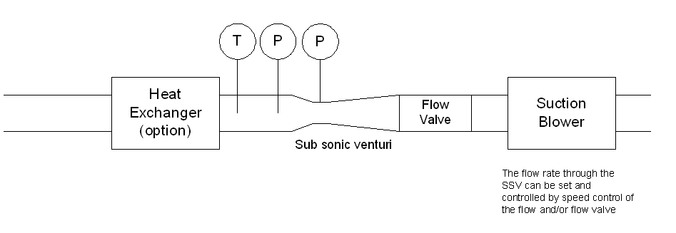
Suction device
3.3.6.4. Ultrasonic flow meter (USM)
3.3.6.4.1. A USM measures the velocity of the diluted exhaust gas using ultra-sonic transmitters/detectors as in Figure A5/5. The gas velocity is converted to standard volumetric flow using a calibration factor for the tube diameter with real time corrections for the diluted exhaust temperature and absolute pressure.
3.3.6.4.2. Components of the system include:
(a) A suction device fitted with speed control, flow valve or other method for setting the CVS flow rate and also for maintaining constant volumetric flow at standard conditions;
(b) A USM;
(c) Temperature (T) and pressure (P) measurement devices required for flow correction;
(d) An optional heat exchanger for controlling the temperature of the diluted exhaust to the USM. If installed, the heat exchanger should be capable of controlling the temperature of the diluted exhaust to that specified in paragraph 3.3.5.1. above. Throughout the test, the temperature of the air/exhaust gas mixture measured at a point immediately upstream of the suction device shall be within ±6 K of the average operating temperature during the test.

Figure A5/5

Schematic of an ultrasonic flow meter (USM)
Heat
Exchanger
(
option
)
Ultrasonic
Flow Meter
Suction
Device
P
T
3.3.6.4.3. The following conditions shall apply to the design and use of the USM type CVS:
(a) The velocity of the diluted exhaust gas shall provide a Reynolds number higher than 4,000 in order to maintain a consistent turbulent flow before the ultrasonic flow meter;
(b) An ultrasonic flow meter shall be installed in a pipe of constant diameter with a length of 10 times the internal diameter upstream and 5 times the diameter downstream;
(c) A temperature sensor for the diluted exhaust shall be installed immediately before the ultrasonic flow meter. This sensor shall have an accuracy and a precision of ±1 K and a response time of 0.1 s at 62 per cent of a given temperature variation (value measured in silicone oil);
(d) The absolute pressure of the diluted exhaust shall be measured immediately before the ultrasonic flow meter to an accuracy of less than ±0.3 kPa;
(e) If a heat exchanger is not installed upstream of the ultrasonic flow meter, the flow rate of the diluted exhaust, corrected to standard conditions shall be maintained at a constant level during the test. This may be achieved by control of the suction device, flow valve or other method.
3.4. CVS calibration procedure
3.4.1. General requirements
3.4.1.1. The CVS system shall be calibrated by using an accurate flow meter and a restricting device. The flow through the system shall be measured at various pressure readings and the control parameters of the system measured and related to the flows. The flow metering device (e.g. calibrated venturi, laminar flow element, calibrated turbine meter) shall be dynamic and suitable for the high flow rate encountered in constant volume sampler testing. The device shall be of certified accuracy traceable to an approved national or international standard.
3.4.1.2. The following paragraphs give details of methods of calibrating PDP, CFV, SSV and UFM units, using a laminar flow meter, which gives the required accuracy, together with a statistical check on the calibration validity.
3.4.2. Calibration of a positive displacement pump (PDP)
3.4.2.1. The following calibration procedure outlines the equipment, the test configuration and the various parameters that are measured to establish the flow rate of the CVS pump. All the parameters related to the pump are simultaneously measured with the parameters related to the flow meter which is connected in series with the pump. The calculated flow rate (given in m³/min at pump inlet for the measured absolute pressure and temperature) can subsequently be plotted versus a correlation function which includes the relevant pump parameters. The linear equation that relates the pump flow and the correlation function shall then be determined. In the event that a CVS has a multiple speed drive, a calibration for each range used shall be performed.
3.4.2.2. This calibration procedure is based on the measurement of the absolute values of the pump and flow meter parameters that relate the flow rate at each point. The following conditions shall be maintained to ensure the accuracy and integrity of the calibration curve:
3.4.2.2.1. The pump pressures shall be measured at tappings on the pump rather than at the external piping on the pump inlet and outlet. Pressure taps that are mounted at the top centre and bottom centre of the pump drive head plate are exposed to the actual pump cavity pressures, and therefore reflect the absolute pressure differentials.
3.4.2.2.2. Temperature stability shall be maintained during the calibration. The laminar flow meter is sensitive to inlet temperature oscillations which cause the data points to be scattered. Gradual changes of ±1 K in temperature are acceptable as long as they occur over a period of several minutes.
3.4.2.2.3. All connections between the flow meter and the CVS pump shall be free of leakage.
3.4.2.3. During an exhaust emission test, the measured pump parameters shall be used to calculate the flow rate from the calibration equation.
3.4.2.4. Figure A5/6 of this annex shows an example of a calibration set-up. Variations are permissible, provided that the responsible authority approves them as being of comparable accuracy. If the set-up shown in Figure A5/6 is used, the following data shall be found within the limits of accuracy given:
Barometric pressure (corrected) () ±0.03 kPa;
Ambient temperature () ±0.2 K;
Air temperature at LFE (ETI) ±0.15 K;
Pressure depression upstream of LFE (EPI) ±0.01 kPa;
Pressure drop across the LFE matrix (EDP) ±0.0015 kPa;
Air temperature at CVS pump inlet (PTI) ±0.2 K;
Air temperature at CVS pump outlet (PTO) ±0.2 K;
Pressure depression at CVS pump inlet (PPI) ±0.22 kPa;
Pressure head at CVS pump outlet (PPO) ±0.22 kPa;
Pump revolutions during test period () ±1 min⁻¹;
Elapsed time for period (minimum 250 s) (t) ±0.1 s.

Figure A5/6

PDP Calibration Configuration
Manometer
Surge control valve (scrubber)
PPI
PPO
Revolutions
Elapsed time
n
t
Temperature indicator
PTI
PTO
Variable-flow restrictor
Laminar flow element, LFE
ETI
EPI
EDP
Filter
3.4.2.5. After the system has been connected as shown in Figure A5/6 of this annex, the variable restrictor shall be set in the wide-open position and the CVS pump shall run for 20 minutes before starting the calibration.
3.4.2.5.1. The restrictor valve shall be reset to a more restricted condition in increments of pump inlet depression (about 1 kPa) that will yield a minimum of six data points for the total calibration. The system shall be allowed to stabilize for three minutes and before the data acquisition is repeated.
3.4.2.5.2. The air flow rate () at each test point shall be calculated in standard m³/min from the flow meter data using the manufacturer's prescribed method.
3.4.2.5.3. The air flow rate shall then be converted to pump flow () in m³/rev at absolute pump inlet temperature and pressure.
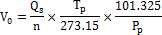
where:
is the pump flow rate at and , m³/rev;
is the air flow at 101.325 kPa and 273.15 K, m³/min;
is the pump inlet temperature, Kelvin (K);
is the absolute pump inlet pressure, kPa;
is the pump speed, min⁻¹.
3.4.2.5.4. To compensate for the interaction of pump speed pressure variations at the pump and the pump slip rate, the correlation function () between the pump speed (), the pressure differential from pump inlet to pump outlet and the absolute pump outlet pressure shall be calculated as follows:
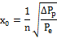
where:
is the correlation function;
is the pressure differential from pump inlet to pump outlet, kPa;
absolute outlet pressure , kPa.
A linear least-square fit is performed to generate the calibration equations having the following form:
,, and are the slopes and intercepts describing the lines.
3.4.2.6. A CVS system having multiple speeds shall be calibrated at each speed used. The calibration curves generated for the ranges shall be approximately parallel and the intercept values () shall increase as the pump flow range decreases.
3.4.2.7. The calculated values from the equation shall be within 0.5 per cent of the measured value of . Values of will vary from one pump to another. A calibration shall be performed at pump start-up and after major maintenance.
3.4.3. Calibration of a critical flow venturi (CFV)
3.4.3.1. Calibration of the CFV is based upon the flow equation for a critical venturi:
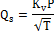
where:
is the flow, m³/min;
is the calibration coefficient;
is the absolute pressure, kPa;
is the absolute temperature, Kelvin (K).
Gas flow is a function of inlet pressure and temperature.
The calibration procedure described below establishes the value of the calibration coefficient at measured values of pressure, temperature and air flow.
3.4.3.2. Measurements for flow calibration of the critical flow venturi are required and the following data shall be found within the limits of precision given:
Barometric pressure (corrected) () ±0.03 kPa;
LFE air temperature, flow meter (ETI) ±0.15 K;
Pressure depression upstream of LFE (EPI) ±0.01 kPa;
Pressure drop across LFE matrix (EDP) ±0.0015 kPa;
Air flow (Q_{s}) ±0.5 per cent;
CFV inlet depression (PPI) ±0.02 kPa;
Temperature at venturi inlet () ±0.2 K.
3.4.3.3. The equipment shall be set up as shown in Figure A5/7 and checked for leaks. Any leaks between the flow-measuring device and the critical flow venturi will seriously affect the accuracy of the calibration and shall therefore be prevented.

Figure A5/7

CFV Calibration Configuration
Variable-flow restrictor
LFE
Thermometer
Filter
EDP
ETI
EPI
CFV
T_{v}
PPI
3.4.3.3.1. The variable-flow restrictor shall be set to the open position, the suction device shall be started and the system stabilized. Data from all instruments shall be recorded.
3.4.3.3.2. The flow restrictor shall be varied and at least eight readings across the critical flow range of the venturi shall be made.
3.4.3.3.3. The data recorded during the calibration shall be used in the following calculation:
3.4.3.3.3.1. The air flow rate (Q_{s}) at each test point shall be calculated from the flow meter data using the manufacturer's prescribed method.
Calculate values of the calibration coefficient for each test point:
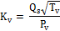
where:
is the flow rate, m³/min at 273.15 K and 101.325, kPa;
is the temperature at the venturi inlet, Kelvin (K);
is the absolute pressure at the venturi inlet, kPa..
3.4.3.3.3.2. shall be plotted as a function of venturi inlet pressure. For sonic flow, will have a relatively constant value. As pressure decreases (vacuum increases), the venturi becomes unchoked and decreases. These values of shall not be used for further calculations.
3.4.3.3.3.3. For a minimum of eight points in the critical region, an average and the standard deviation shall be calculated.
3.4.3.3.3.4. If the standard deviation exceeds 0.3 per cent of the average , corrective action must be taken.
3.4.4. Calibration of a subsonic venturi (SSV)
3.4.4.1. Calibration of the SSV is based upon the flow equation for a subsonic venturi. Gas flow is a function of inlet pressure and temperature, and the pressure drop between the SSV inlet and throat.
3.4.4.2. Data analysis
3.4.4.2.1. The airflow rate () at each restriction setting (minimum 16 settings) shall be calculated in standard m³/s from the flow meter data using the manufacturer's prescribed method. The discharge coefficient, , shall be calculated from the calibration data for each setting as follows:
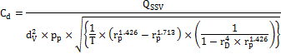
where:
Q_{SSV} is the airflow rate at standard conditions (101.325 kPa, 273.15 K), m³/s;
T is the temperature at the venturi inlet, Kelvin (K);
is the diameter of the SSV throat, m;
is the ratio of the SSV throat to inlet absolute static pressure, ;
is the ratio of the SSV throat diameter, d_{V}, to the inlet pipe inner diameter ;
is the discharge coefficient of the SSV;
is the absolute pressure at venturi inlet, kPa.
To determine the range of subsonic flow, shall be plotted as a function of Reynoldsnumber , at the SSV throat. The Re at the SSV throat shall be calculated with the following equation:
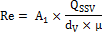
where:
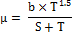
is 25.55152 in SI, ;
is the airflow rate at standard conditions (101.325 kPa, 273.15 K), m³/s;
is the diameter of the SSV throat, m;
is the absolute or dynamic viscosity of the gas, kg/ms;
is (empirical constant), kg/ms K^{0.5};
is 110.4 (empirical constant), Kelvin (K).
3.4.4.2.2. Because Q_{SSV} is an input to the Re equation, the calculations must be started with an initial guess for Q_{SSV} or C_{d} of the calibration venturi, and repeated until Q_{SSV} converges. The convergence method shall be accurate to 0.1 per cent or better.
3.4.4.2.3. For a minimum of sixteen points in the region of subsonic flow, the calculated values of C_{d} from the resulting calibration curve fit equation must be within ±0.5 per cent of the measured C_{d} for each calibration point.
3.4.5. Calibration of an ultrasonic flow meter (UFM)
3.4.5.1. The UFM must be calibrated against a suitable reference flow meter.
3.4.5.2. The UFM must be calibrated in the CVS configuration which will be used in the test cell (diluted exhaust piping, suction device) and checked for leaks. See Figure A5/8.
3.4.5.3. A heater shall be installed to condition the calibration flow in the event that the UFM system does not include a heat exchanger.
3.4.5.4. For each CVS flow setting that will be used, the calibration shall be performed at temperatures from room temperature to the maximum that will be experienced during vehicle testing.
3.4.5.5. The manufacturer's recommended procedure shall be followed for calibrating the electronic portions of the UFM.
3.4.5.6. Measurements for flow calibration of the ultrasonic flow meter are required and the following data (in the case of the use of a laminar flow element) shall be found within the limits of precision given:
Barometric pressure (corrected) () ±0.03 kPa;
LFE air temperature, flow meter (ETI) ±0.15 K;
Pressure depression upstream of LFE (EPI) ±0.01 kPa;
Pressure drop across (EDP) LFE matrix ±0.0015 kPa;
Air flow () ±0.5 per cent;
UFM inlet depression () ±0.02 kPa;
Temperature at UFM inlet () ±0.2 K.
3.4.5.7. Procedure
3.4.5.7.1. The equipment shall be set up as shown in Figure A5/8 and checked for leaks. Any leaks between the flow-measuring device and the UFM will seriously affect the accuracy of the calibration.

Figure A5/8

USM Calibration Configuration
Calibration flow meter (LFE, SSV)
Heater
UFM
Suction device
Including the necessary temperature and pressure sensors
P
T
Flow valve
The flow rate through the UFM can be set and controlled by speed control of the flow and/or flow valve
3.4.5.7.2. The suction device shall be started. The suction device speed and/or the flow valve should be adjusted to provide the set flow for the validation and the system stabilised. Data from all instruments shall be recorded.
3.4.5.7.3. For UFM systems without heat exchanger, the heater shall be operated to increase the temperature of the calibration air, allowed to stabilise and data from all the instruments recorded. The temperature shall be increased in reasonable steps until the maximum expected diluted exhaust temperature expected during the emissions test is reached.
3.4.5.7.4. The heater shall then be turned off and the suction device speed and/or flow valve shall be adjusted to the next flow setting that might be used for vehicle emissions testing after which the calibration sequence shall be repeated.
3.4.5.8. The data recorded during the calibration shall be used in the following calculations. The air flow rate (Q_{s}) at each test point is calculated from the flow meter data using the manufacturer's prescribed method.
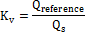
where:
is the air flow rate at standard conditions (101.325 kPa, 273.15 K), m³/s;
is the air flow rate of the calibration flow meter at standard conditions (101.325 kPa, 273.15 K), m³/s;
is the calibration coefficient.
For UFM systems without a heat exchanger, shall be plotted as a function of T_{act}.
The maximum variation in shall not exceed 0.3 per cent of the mean value of all the measurements taken at the different temperatures.
3.5. System verification procedure
3.5.1. General requirements
3.5.1.1. The total accuracy of the CVS sampling system and analytical system shall be determined by introducing a known mass of an emissions gas compound into the system whilst it is being operated as if during a normal test and subsequently analysing and calculating the emission gas compounds according to the equations of Annex 7 except that the density of propane shall be taken as 1.967 grams per litre at standard conditions. The CFO (paragraph 3.5.1.1.1. of this annex) and gravimetric methods (paragraph 3.5.1.1.2. of this annex) are known to give sufficient accuracy.
The maximum permissible deviation between the quantity of gas introduced and the quantity of gas measured is 2 per cent.
3.5.1.1.1. Critical flow orifice (CFO) method
The CFO method meters a constant flow of pure gas (CO, CO₂, or C₃H₈) using a critical flow orifice device.
3.5.1.1.1.1. A known quantity of pure gas (CO, CO₂ or C₃H₈) shall be fed into the CVS system through the calibrated critical orifice. If the inlet pressure is high enough, the flow rate (q), which is restricted by means of the critical flow orifice, is independent of orifice outlet pressure (critical flow). If deviations exceed 2 per cent, the cause of the malfunction shall be determined and corrected. The CVS system shall be operated as in a normal exhaust emission test and enough time shall be allowed for subsequent analysis. The gas collected in the sampling bag is analysed by the usual equipment and the results compared to the concentration of the gas samples which was known beforehand.
3.5.1.1.2. Gravimetric method
The gravimetric method weighs a limited quantity of pure gas (CO, CO₂, or C₃H₈).
3.5.1.1.2.1. The weight of a small cylinder filled with either pure carbon monoxide, carbon dioxide or propane shall be determined with a precision of ±0.01 g. The CVS system shall operate as in a normal exhaust emission test while the pure gas is injected into the system for a time sufficient for subsequent analysis. The quantity of pure gas involved shall be determined by means of differential weighing. The gas accumulated in the bag shall be analysed by means of the equipment normally used for exhaust gas analysis. The results shall then be compared to the concentration figures computed previously.
4. Emissions measurement equipment
4.1. Gaseous emissions measurement equipment
4.1.1. System overview
4.1.1.1. A continuously proportional sample of the diluted exhaust gases and the dilution air shall be collected for analysis.
4.1.1.2. Mass of gaseous emissions shall be determined from the proportional sample concentrations and the total volume measured during the test. The sample concentrations shall be corrected to take into account the respective compound concentrations in dilution air.
4.1.2. Sampling system requirements
4.1.2.1. The sample of diluted exhaust gases shall be taken upstream from the suction device.
4.1.2.1.1. With the exception of paragraph 4.1.3.1. (hydrocarbon sampling system), paragraph 4.2. (particulate mass emissions measurement equipment) and paragraph 4.3. (particle number emissions measurement equipment) of this annex, the dilute exhaust gas sample may be taken downstream of the conditioning devices (if any).
4.1.2.2. The bag sampling flow rate shall be set to provide sufficient volumes of dilution air and diluted exhaust in the CVS bags to allow concentration measurement and shall not exceed 0.3 per cent of the flow rate of the dilute exhaust gases, unless the diluted exhaust bag fill volume is added to the integrated CVS volume.
4.1.2.3. A sample of the dilution air shall be taken near the dilution air inlet (after the filter if one is fitted).
4.1.2.4. The dilution air sample shall not be contaminated by exhaust gases from the mixing area.
4.1.2.5. The sampling rate for the dilution air shall be comparable to that used for the dilute exhaust gases.
4.1.2.6. The materials used for the sampling operations shall be such as not to change the concentration of the emissions compounds.
4.1.2.7. Filters may be used in order to extract the solid particles from the sample.
4.1.2.8. Any valve used to direct the exhaust gases shall be of a quick-adjustment, quick-acting type.
4.1.2.9. Quick-fastening, gas-tight connections may be used between three-way valves and the sampling bags, the connections sealing themselves automatically on the bag side. Other systems may be used for conveying the samples to the analyser (three-way stop valves, for example).
4.1.2.10. Sample storage
4.1.2.10.1. The gas samples shall be collected in sampling bags of sufficient capacity not to impede the sample flow.
4.1.2.10.2. The bag material shall be such as to affect neither the measurements themselves nor the chemical composition of the gas samples by more than ±2 per cent after 30 minutes (e.g.: laminated polyethylene/polyamide films, or fluorinated polyhydrocarbons).
4.1.3. Sampling systems
4.1.3.1. Hydrocarbon sampling system (heated flame ionisation detector (HFID))
4.1.3.1.1. The hydrocarbon sampling system shall consist of a heated sampling probe, line, filter and pump. The sample shall be taken upstream of the heat exchanger (if fitted). The sampling probe shall be installed at the same distance from the exhaust gas inlet as the particulate sampling probe, in such a way that neither interferes with samples taken by the other. It shall have a minimum internal diameter of 4 mm.
4.1.3.1.2. All heated parts shall be maintained at a temperature of 463 K (190 °C) ± 10 K by the heating system.
4.1.3.1.3. The average concentration of the measured hydrocarbons shall be determined by integration of the second-by-second data divided by the phase or test duration.
4.1.3.1.4. The heated sampling line shall be fitted with a heated filter (F_{H}) having a 99 per cent efficiency for particles ≥ 0.3 μm to extract any solid particles from the continuous flow of gas required for analysis.
4.1.3.1.5. The sampling system delay time (from the probe to the analyser inlet) shall be no more than 4 seconds.
4.1.3.1.6. The HFID shall be used with a constant mass flow (heat exchanger) system to ensure a representative sample, unless compensation for varying CFV or CFO flow is made.
4.1.3.2. NO or NO₂ sampling system (if applicable)
4.1.3.2.1. A continuous sample flow of diluted exhaust gas shall be supplied to the analyser.
4.1.3.2.2. The average concentration of the NO or NO₂ shall be determined by integration of the second-by-second data divided by the phase or test duration.
4.1.3.2.3. The continuous NO or NO₂ measurement shall be used with a constant flow (heat exchanger) system to ensure a representative sample, unless compensation for varying CFV or CFO flow is made.
4.1.4. Analysers
4.1.4.1. General requirements for gas analysis
4.1.4.1.1. The analysers shall have a measuring range compatible with the accuracy required to measure the concentrations of the exhaust gas sample compounds.
4.1.4.1.2. If not defined otherwise, measurement errors shall not exceed ± 2 per cent (intrinsic error of analyser) disregarding the reference value for the calibration gases.
4.1.4.1.3. The ambient air sample shall be measured on the same analyser with the same range.
4.1.4.1.4. No gas drying device shall be used before the analysers unless it is shown to have no effect on the content of the compound in the gas stream.
4.1.4.2. Carbon monoxide (CO) and carbon dioxide (CO₂) analysis
4.1.4.2.1. Analysers shall be of the non-dispersive infrared (NDIR) absorption type.
4.1.4.3. Hydrocarbons (HC) analysis for all fuels other than diesel fuel
4.1.4.3.1. The analyser shall be of the flame ionization (FID) type calibrated with propane gas expressed in equivalent carbon atoms (C₁).
4.1.4.4. Hydrocarbons (HC) analysis for diesel fuel and optionally for other fuels
4.1.4.4.1. The analyser shall be of the heated flame ionization type with detector, valves, pipework, etc., heated to 463 K (190 °C) ±10 K. It shall be calibrated with propane gas expressed equivalent to carbon atoms (C₁).
4.1.4.5. Methane (CH₄) analysis
4.1.4.5.1. The analyser shall be either a gas chromatograph combined with a flame ionization detector (FID), or a flame ionization detector (FID) with a non-methane cutter, calibrated with methane or propane gas expressed equivalent to carbon atoms (C₁).
4.1.4.6. Nitrogen oxide (NO_{x}) analysis
4.1.4.6.1. The analysers shall be of chemiluminescent (CLA) or non-dispersive ultra-violet resonance absorption (NDUV) types.
4.1.4.7. Nitrogen oxide (NO) analysis (where applicable)
4.1.4.7.1. The analysers shall be of chemiluminescent (CLA) or non-dispersive ultra-violet resonance absorption (NDUV) types.
4.1.4.8. Nitrogen dioxide (NO₂) analysis (where applicable)
4.1.4.8.1. Measurement of NO from continuously diluted exhausts
4.1.4.8.1.1. A CLA analyser may be used to measure the NO concentration continuously from diluted exhaust.
4.1.4.8.1.2. The CLA analyser shall be calibrated (zero/calibrated) in the NO mode using the NO certified concentration in the calibration gas cylinder with the NO_{x} converter bypassed (if installed).
4.1.4.8.1.3. The NO₂ concentration shall be determined by subtracting the NO concentration from the NO_{x} concentration in the CVS sample bags.
4.1.4.8.2. Measurement of NO₂ from continuously diluted exhausts
4.1.4.8.2.1. A specific NO₂ analyser (NDUV, QCL) may be used to measure the NO₂ concentration continuously from diluted exhaust.
4.1.4.8.2.2. The analyser shall be calibrated (zeroed/ calibrated) in the NO₂ mode using the NO2 certified concentration in the calibration gas cylinder.
4.1.4.9. Nitrous oxide (N₂O) analysis with GC ECD (where applicable)
4.1.4.9.1. A gas chromatograph with an electron-capture detector (GC–ECD) may be used to measure N₂O concentrations of diluted exhaust by batch sampling from exhaust and ambient bags. Refer to paragraph 7.2. of this annex.
4.1.4.10. Nitrous oxide (N₂O) analysis with IR-absorption spectrometry (where applicable)
The analyser shall be a laser infrared spectrometer defined as modulated high resolution narrow band infrared analyser. An NDIR or FTIR may also be used but water, CO and CO₂ interference must be taken into consideration.
4.1.4.10.1. If the analyser shows interference to compounds present in the sample, this interference shall be corrected. Analysers must have combined interference that is within 0.0 ± 0.1 ppm.
4.1.5. Recommended system descriptions
4.1.5.1. Figure A5/9 is a schematic drawing of the gaseous emissions sampling system.

Figure A5/9

Full Flow Dilution System Schematic
Dilution air
filters
Vehicle
exhaust
Dilution tunnel
Heat exchanger
(optional)
Vent
MC
Flow meter and suction device
Mixing device
Dilution air
PDP, CFV, SSV, UFM
Connecting tube
4.1.5.2. Examples of system components are as listed in the subparagraphs below.
4.1.5.2.1. Two sampling probes for continuous sampling of the dilution air and of the diluted exhaust gas/air mixture.
4.1.5.2.2. A filter to extract solid particles from the flows of gas collected for analysis.
4.1.5.2.3. Pumps and flow controller to ensure a constant uniform flow of diluted exhaust gas and dilution air samples taken during the course of the test from sampling probes and flow of the gas samples shall be such that, at the end of each test, the quantity of the samples is sufficient for analysis.
4.1.5.2.4. Quick-acting valves to divert a constant flow of gas samples into the sampling bags or to the outside vent.
4.1.5.2.5. Gas-tight, quick-lock coupling elements between the quick-acting valves and the sampling bags. The coupling shall close automatically on the sampling-bag side. As an alternative, other ways of transporting the samples to the analyser may be used (three-way stopcocks, for instance).
4.1.5.2.6. Bags for collecting samples of the diluted exhaust gas and of the dilution air during the test.
4.1.5.2.7. A sampling critical flow venturi to take proportional samples of the diluted exhaust gas (CFV-CVS only).
4.1.5.3. Additional components required for hydrocarbon sampling using a heated flame ionization detector (HFID) as shown in Figure A5/10 below.
4.1.5.3.1. Heated sample probe in the dilution tunnel located in the same vertical plane as the PM and PN sample probes.
4.1.5.3.2. Heated filter located after the sampling point and before the HFID.
4.1.5.3.3. Heated selection valves between the zero/calibration gas supplies and the HFID.
4.1.5.3.4. Means of integrating and recording instantaneous hydrocarbon concentrations.
4.1.5.3.5. Heated sampling lines and heated components from the heated probe to the HFID.
Figure A5/10
Components required for hydrocarbon sampling using an HFID
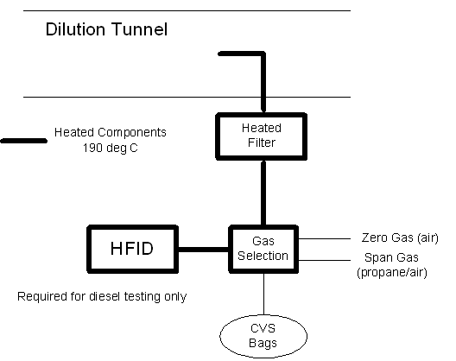
4.2. Particulate mass emissions measurement equipment
4.2.1. Specification
4.2.1.1. System overview
4.2.1.1.1. The particulate sampling unit shall consist of a sampling probe (PSP) located in the dilution tunnel, a particle transfer tube (PTT), a filter holder(s) (FH), pump(s), flow rate regulators and measuring units. See Figures A5/11 and A5/12.
4.2.1.1.2. A particle size pre-classifier (PCF) (e.g. cyclone or impactor) may be used. In such case, it is recommended that it be employed upstream of the filter holder. However, a sampling probe, acting as an appropriate size-classification device such as that shown in Figure A5/13, is acceptable.
4.2.1.2. General requirements
4.2.1.2.1. The sampling probe for the test gas flow for particulates shall be so arranged within the dilution tunnel that a representative sample gas flow can be taken from the homogeneous air/exhaust mixture and shall be upstream of a heat exchanger (if any).
4.2.1.2.2. The particulate sample flow rate shall be proportional to the total mass flow of diluted exhaust gas in the dilution tunnel to within a tolerance of ±5 per cent of the particulate sample flow rate. The verification of the proportionality of the PM sampling should be made during the commissioning of the system and as required by the responsible authority.
4.2.1.2.3. The sampled dilute exhaust gas shall be maintained at a temperature above 293 K (20 °C) and below 325 K (52 °C) within 20 cm upstream or downstream of the particulate filter face. Heating or insulation of components of the PM sampling system to achieve this is permissible.
In the event that the 52 °C limit is exceeded during a test where periodic regeneration event does not occur, the CVS flow rate should be increased or double dilution should be applied (assuming that the CVS flow rate is already sufficient so as not to cause condensation within the CVS, sample bags or analytical system).
4.2.1.2.4. The particulate sample shall be collected on a single filter mounted within a holder in the sampled dilute exhaust gas flow.
4.2.1.2.5. All parts of the dilution system and the sampling system from the exhaust pipe up to the filter holder, which are in contact with raw and diluted exhaust gas, shall be designed to minimise deposition or alteration of the particulates. All parts shall be made of electrically conductive materials that do not react with exhaust gas components, and shall be electrically grounded to prevent electrostatic effects.
4.2.1.2.6. If it is not possible to compensate for variations in the flow rate, provision shall be made for a heat exchanger and a temperature control device as specified in paragraphs 3.3.5.1. or 3.3.6.4.2. above, so as to ensure that the flow rate in the system is constant and the sampling rate accordingly proportional.
4.2.1.2.7. Temperatures required for the PM mass measurement shall be measured with an accuracy of ±1 °C and a response time () of fifteen seconds or less.
4.2.1.2.8. The PM sample flow from the dilution tunnel shall be measured with an accuracy of ±2.5 per cent of reading or ±1.5 per cent full scale, whichever is the least.
The above accuracy of the PM sample flow from the CVS tunnel is also applicable where double dilution is used. Consequently, the measurement and control of the secondary dilution air flow and diluted exhaust flow rates through the PM filter must be of a higher accuracy.
4.2.1.2.9. All data channels required for the PM mass measurement shall be logged at a frequency of 1 Hz or faster. Typically these would include:
(a) Diluted exhaust temperature at the PM filter;
(b) PM sampling flow rate;
(c) PM secondary dilution air flow rate (if secondary dilution is used);
(d) PM secondary dilution air temperature (if secondary dilution is used).
4.2.1.2.10. For double dilution systems, the accuracy of the diluted exhaust transferred from the dilution tunnel, in the equation is not measured directly but determined by differential flow measurement:
where:
is the volume of diluted exhaust gas flowing through particulate filter under standard conditions;
is the volume of the double diluted exhaust gas passing through the particulate collection filters;
is the volume of secondary dilution air.
The accuracy of the flow meters used for the measurement and control of the double diluted exhaust passing through the particulate collection filters and for the measurement/control of secondary dilution air shall be sufficient so that the differential volume () shall meet the accuracy and proportional sampling requirements specified for single dilution.
The requirement that no condensation of the exhaust gas should occur in the CVS dilution tunnel, diluted exhaust flow rate measurement system, CVS bag collection or analysis systems shall also apply in the case of double dilution systems.
4.2.1.2.11. Each flow meter used in a particulate sampling and double dilution system shall be subjected to a linearity verification as required by the instrument manufacturer.
Figure A5/11
Particulate Sampling System
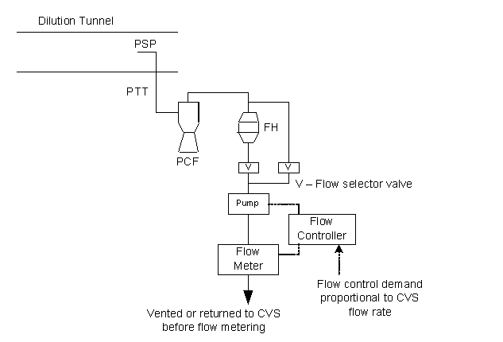
Figure A5/12
Double Dilution Particulate Sampling System
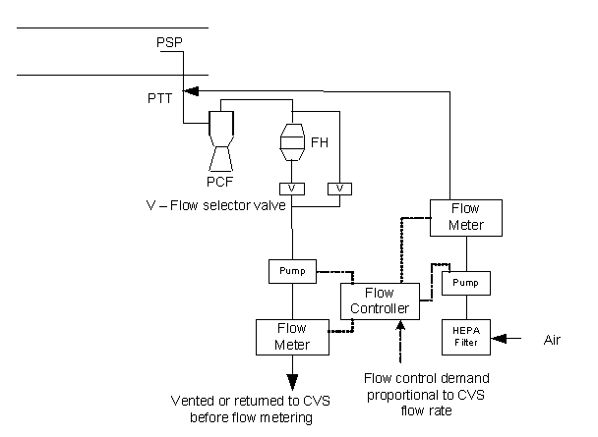
4.2.1.3. Specific requirements
4.2.1.3.1. PM sampling probe
4.2.1.3.1.1. The sample probe shall deliver the particle-size classification performance described in paragraph 4.2.1.3.1.4. below. It is recommended that this performance be achieved by the use of a sharp-edged, open-ended probe facing directly into the direction of flow plus a preclassifier (cyclone impactor, etc.). An appropriate sampling probe, such as that indicated in Figure A5/13, may alternatively be used provided it achieves the preclassification performance described in paragraph 4.2.1.3.1.4. below.

Figure A5/13

Alternative particulate sampling probe configuration
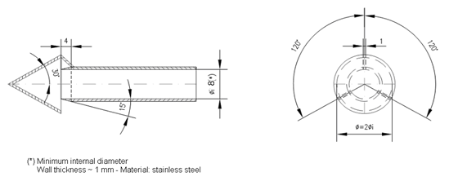
4.2.1.3.1.2. The sample probe shall be installed at least 10 tunnel diameters downstream of the exhaust gas inlet to the tunnel and have an internal diameter of at least 8 mm.
If more than one simultaneous sample is drawn from a single sample probe, the flow drawn from that probe shall be split into identical sub-flows to avoid sampling artifacts.
If multiple probes are used, each probe shall be sharp-edged, open-ended and facing directly into the direction of flow. Probes shall be equally spaced around the central longitudinal axis of the dilution tunnel, with the spacing between probes at least 5 cm.
4.2.1.3.1.3. The distance from the sampling tip to the filter mount shall be at least five probe diameters, but shall not exceed 2,000 mm.
4.2.1.3.1.4. The pre-classifier (e.g. cyclone, impactor, etc.) shall be located upstream of the filter holder assembly. The pre-classifier 50 per cent cut point particle diameter shall be between 2.5 μm and 10 μm at the volumetric flow rate selected for sampling particulate mass emissions. The pre-classifier shall allow at least 99 per cent of the mass concentration of 1 μm particles entering the pre-classifier to pass through the exit of the pre-classifier at the volumetric flow rate selected for sampling particulate mass emissions. However, a sampling probe, acting as an appropriate size-classification device, such as that shown in Figure A5/13, is acceptable as an alternative to a separate preclassifier.
4.2.1.3.2. Particle transfer tube (PTT)
4.2.1.3.2.1. Any bends in the PTT shall be smooth and have the largest possible radii.
4.2.1.3.3. Secondary dilution
4.2.1.3.3.1. As an option, the sample extracted from the CVS for the purpose of PM measurement may be diluted at a second stage, subject to the following requirements:
4.2.1.3.3.1.1. Secondary dilution air shall be filtered through a medium capable of reducing particles in the most penetrating particle size of the filter material by ≥ 99.95 per cent, or through a HEPA filter of at least class H13 of EN 1822:2009. The dilution air may optionally be charcoal scrubbed before being passed to the HEPA filter. It is recommended that an additional coarse particle filter is situated before the HEPA filter and after the charcoal scrubber, if used.
4.2.1.3.3.1.2. The secondary dilution air should be injected into the PTT as close to the outlet of the diluted exhaust from the dilution tunnel as possible.
4.2.1.3.3.1.3. The residence time from the point of secondary diluted air injection to the filter face shall be at least 0.25 seconds (s), but no longer than five seconds.
4.2.1.3.3.1.4. The diluted exhaust flow extracted from the dilution tunnel shall remain proportional to the CVS flow rate, as required for the single dilution method.
4.2.1.3.3.1.5. If the double diluted PM sample is returned to the CVS, the location of the sample return shall be selected so that it does not interfere with the extraction of other samples from the CVS.
4.2.1.3.4. Sample pump and flow meter
4.2.1.3.4.1. The sample gas flow measurement unit shall consist of pumps, gas flow regulators and flow measuring units.
4.2.1.3.4.2. The temperature of the gas flow in the flow meter may not fluctuate by more than ±3 K except:
(a) When the PM sampling flow meter has real time monitoring and flow control operating at 1 Hz or faster;
(b) During regeneration tests on vehicles equipped with periodically regenerating after-treatment devices.
In addition, the sample mass flow rate shall remain proportional to the total flow of diluted exhaust gas to within a tolerance of ±5 per cent of the particulate sample mass flow rate. Should the volume of flow change unacceptably as a result of excessive filter loading, the test shall be invalidated. When it is repeated, the rate of flow shall be decreased.
4.2.1.3.5. Filter and filter holder
4.2.1.3.5.1. A valve shall be located downstream of the filter in the direction of flow. The valve shall open and close within 1 s of the start and end of test.
4.2.1.3.5.2. For a given test, the gas filter face velocity shall be set to a single value within the range 20 cm/s to 105 cm/s and should be set at the start of the test so that 105 cm/s will not be exceeded when the dilution system is being operated with sampling flow proportional to CVS flow rate.
4.2.1.3.5.3. Fluorocarbon coated glass fibre filters or fluorocarbon membrane filters are required.
All filter types shall have a 0.3 μm DOP (di-octylphthalate) or PAO (poly-alpha-olefin) CS 68649-12-7 or CS 68037-01-4 collection efficiency of at least 99 per cent at a gas filter face velocity of 5.33cm/s measured according to one of the following standards:
(a) U.S.A. Department of Defense Test Method Standard, MIL-STD-282 method 102.8: DOP-Smoke Penetration of Aerosol-Filter Element
(b) U.S.A. Department of Defense Test Method Standard, MIL-STD-282 method 502.1.1: DOP-Smoke Penetration of Gas-Mask Canisters
(c) Institute of Environmental Sciences and Technology, IEST-RP-CC021: Testing HEPA and ULPA Filter Media.
4.2.1.3.5.4. The filter holder assembly shall be of a design that provides an even flow distribution across the filter stain area. The filter shall be round and have a stain area of at least 1075 mm².
4.2.2. Weighing chamber and analytical balance specifications
4.2.2.1. Weighing chamber conditions
(a) The temperature of the chamber (or room) in which the particulate filters are conditioned and weighed shall be maintained to within 295 K ± 2 K (22 °C ± 2 °C, 22 °C ± 1 °C if possible) during all filter conditioning and weighing.
(b) Humidity shall be maintained to a dew point of less than 283.5 K (10.5 °C) and a relative humidity of 45 per cent ± 8 per cent.
(c) The levels of ambient contaminants in the chamber (or room) environment that would settle on the particulate filters during their stabilization shall be minimised. Limited deviations from weighing room temperature and humidity specifications will be allowed provided their total duration does not exceed 30 minutes in any one filter conditioning period.
(d) During the weighing operation no deviations from the specified conditions are permitted.
4.2.2.2. Analytical balance
The analytical balance used to determine the filter weight shall meet the linearity verification criterion of Table A5/1 below. This implies a precision (standard deviation) of at least 2 µg and a resolution of at least 1 µg (1 digit = 1 µg).
Table A5/1
Analytical balance verification criteria
Measurement system | Intercept b | Slope m | Standard error SEE | Coefficient of determination r²
PM Balance | ≤ 1per cent max | 0.99 – 1.01 | ≤ 1per cent max | ≥ 0.998
4.2.2.3. Elimination of static electricity effects
The effects of static electricity shall be nullified. This may be achieved by grounding the balance through placement upon an antistatic mat and neutralization of the particulate filters prior to weighing using a polonium neutraliser or a device of similar effect. Alternatively, nullification of static effects may be achieved through equalization of the static charge.
4.2.2.4. Buoyancy correction
The sample and reference filter weights shall be corrected for their buoyancy in air. The buoyancy correction is a function of sampling filter density, air density and the density of the balance calibration weight, and does not account for the buoyancy of the PM itself.
If the density of the filter material is not known, the following densities shall be used:
(a) PTFE coated glass fiber filter: 2,300 kg/m³;
(b) PTFE membrane filter: 2,144 kg/m³;
(c) PTFE membrane filter with polymethylpentene support ring: 920 kg/m³.
For stainless steel calibration weights, a density of 8,000 kg/m³ shall be used. If the material of the calibration weight is different, its density must be known. International Recommendation OIML R 111-1 Edition 2004(E) from International Organization of Legal Metrology on calibration weights should be followed.
The following equation shall be used:
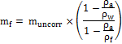
where:
is the corrected particulate sample mass, mg;
is the uncorrected particulate sample mass, mg;
is the density of the air, kg/m³;
is the density of balance calibration weight, kg/m³;
is the density of the particulate sampling filter, kg/m³.
The density of the air shall be calculated as follows:
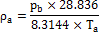
is the total atmospheric pressure, kPa;
is the air temperature in the balance environment, Kelvin (K).
4.3. Particle number emissions measurement equipment
4.3.1. Specification
4.3.1.1. System overview
4.3.1.1.1. The particle sampling system shall consist of a probe or sampling point extracting a sample from a homogenously mixed flow in a dilution system, a volatile particle remover (VPR) upstream of a particle number counter (PNC) and suitable transfer tubing.
4.3.1.1.2. It is recommended that a particle size pre-classifier (e.g. cyclone, impactor, etc.) be located prior to the inlet of the VPR. However, a sample probe acting as an appropriate size-classification device, such as that shown in Figure A5/13, is an acceptable alternative to the use of a particle size pre-classifier.
4.3.1.2. General requirements
4.3.1.2.1. The particle sampling point shall be located within a dilution system. In the case of double dilution systems, the particle sampling point shall be located within the primary dilution system.
4.3.1.2.1.1. The sampling probe tip or particle sampling point (PSP) and particle transfer tube (PTT) together comprise the particle transfer system (PTS). The PTS conducts the sample from the dilution tunnel to the entrance of the VPR. The PTS shall meet the following conditions:
(a) The sampling probe shall be installed at least 10 tunnel diameters downstream of the exhaust gas inlet, facing upstream into the tunnel gas flow with its axis at the tip parallel to that of the dilution tunnel;
(b) The sampling probe shall be upstream of any conditioning device (e.g. heat exchanger);
(c) The sampling probe shall be positioned within the dilution tunnel so that the sample is taken from a homogeneous diluent/exhaust mixture.
4.3.1.2.1.2. Sample gas drawn through the PTS shall meet the following conditions:
(a) In the case of full flow dilution systems, it shall have a flow Reynolds number, Re, lower than 1,700;
(b) In the case of double dilution systems, it shall have a flow Reynolds number (Re) lower than 1,700 in the PTT i.e. downstream of the sampling probe or point;
(c) Shall have a residence time ≤ 3 seconds (s).
4.3.1.2.1.3. Any other sampling configuration for the PTS for which equivalent particle penetration at 30 nm can be demonstrated will be considered acceptable.
4.3.1.2.1.4. The outlet tube (OT) conducting the diluted sample from the VPR to the inlet of the PNC shall have the following properties:
(a) An internal diameter ≥ 4mm;
(b) A sample gas flow residence time of ≤ 0.8 seconds (s).
4.3.1.2.1.5. Any other sampling configuration for the OT for which equivalent particle penetration at 30 nm can be demonstrated will be considered acceptable.
4.3.1.2.2. The VPR shall include devices for sample dilution and for volatile particle removal.
4.3.1.2.3. All parts of the dilution system and the sampling system from the exhaust pipe up to the PNC, which are in contact with raw and diluted exhaust gas, shall be designed to minimize deposition of the particles. All parts shall be made of electrically conductive materials that do not react with exhaust gas components, and shall be electrically grounded to prevent electrostatic effects.
4.3.1.2.4. The particle sampling system shall incorporate good aerosol sampling practice that includes the avoidance of sharp bends and abrupt changes in cross-section, the use of smooth internal surfaces and the minimization of the length of the sampling line. Gradual changes in the cross-section are permissible.
4.3.1.3. Specific requirements
4.3.1.3.1. The particle sample shall not pass through a pump before passing through the PNC.
4.3.1.3.2. A sample pre-classifier is recommended.
4.3.1.3.3. The sample preconditioning unit shall:
(a) Be capable of diluting the sample in one or more stages to achieve a particle number concentration below the upper threshold of the single particle count mode of the PNC and a gas temperature below 35 °C at the inlet to the PNC;
(b) Include an initial heated dilution stage which outputs a sample at a temperature of ≥ 150 °C and ≤ 350 ± 10 °C, and dilutes by a factor of at least ten;
(c) Control heated stages to constant nominal operating temperatures, within the range ≥ 150 °C and ≤ 400 °C, to a tolerance of ± 10 °C;
(d) Provide an indication of whether or not heated stages are at their correct operating temperatures;
(e) Be designed to achieve a solid particle penetration efficiency of at least 70 per cent for particles of 100 nm electrical mobility diameter;
(f) Achieve a particle concentration reduction factor ((), as calculated below, for particles of 30 nm and 50 nm electrical mobility diameters, that is no more than 30 per cent and 20 per cent respectively higher, and no more than 5 per cent lower than that for particles of 100 nm electrical mobility diameter for the VPR as a whole;
The particle concentration reduction factor at each particle size () shall be calculated as follows:
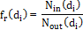
where:
is the upstream particle number concentration for particles of diameter ;
is the downstream particle number concentration for particles of diameter ;
is the particle electrical mobility diameter (30, 50 or 100 nm).
and shall be corrected to the same conditions.
The mean particle concentration reduction, , at a given dilution setting shall be calculated as follows:
It is recommended that the VPR is calibrated and validated as a complete unit;
(g) Be designed according to good engineering practice to ensure particle concentration reduction factors are stable across a test;
(h) Also achieve > 99.0 per cent vaporization of 30 nm tetracontane (CH₃(CH₂)₃₈CH₃) particles, with an inlet concentration of ≥ 10,000 cm⁻³, by means of heating and reduction of partial pressures of the tetracontane.
4.3.1.3.4. The PNC shall:
(a) Operate under full flow operating conditions;
(b) Have a counting accuracy of ± 10 per cent across the range 1 cm⁻³ to the upper threshold of the single particle count mode of the PNC against a traceable standard. At concentrations below 100 cm⁻³ measurements averaged over extended sampling periods may be required to demonstrate the accuracy of the PNC with a high degree of statistical confidence;
(c) Have a readability of at least 0.1 particles cm⁻³ at concentrations below 100 cm⁻³;
(d) Have a linear response to particle concentrations over the full measurement range in single particle count mode;
(e) Have a data reporting frequency equal to or greater than 0.5 Hz;
(f) Have a t₉₀ response time over the measured concentration range of less than 5 s;
(g) Incorporate a coincidence correction function up to a maximum 10 per cent correction, and may make use of an internal calibration factor as determined in paragraph 5.7.1.3.of this annex but shall not make use of any other algorithm to correct for or define the counting efficiency;
(h) Have counting efficiencies at the different particle sized as specified in Table A5/2.
Table A5/2
Condensation Particle Counter (CPC) counting efficiency
Particle size electrical mobility diameter (nm) | Condensation Particle Counter (CPC) counting efficiency(per cent)
23 ± 1 | 50 ± 12
41 ± 1 | > 90
4.3.1.3.5. If the PNC makes use of a working liquid, it shall be replaced at the frequency specified by the instrument manufacturer.
4.3.1.3.6. Where they are not held at a known constant level at the point at which PNC flow rate is controlled, the pressure and/or temperature at inlet to the PNC shall be measured and recorded for the purposes of correcting particle concentration measurements to standard conditions.
4.3.1.3.7. The sum of the residence time of the PTS, VPR and OT plus the t₉₀ response time of the PNC shall be no greater than 20 s.
4.3.1.4. Recommended system description
The following paragraph contains the recommended practice for measurement of particle number. However, systems meeting the performance specifications in paragraphs 4.3.1.2. and 4.3.1.3. of this annex are acceptable.
Figure A5/14
A recommended particle sampling system
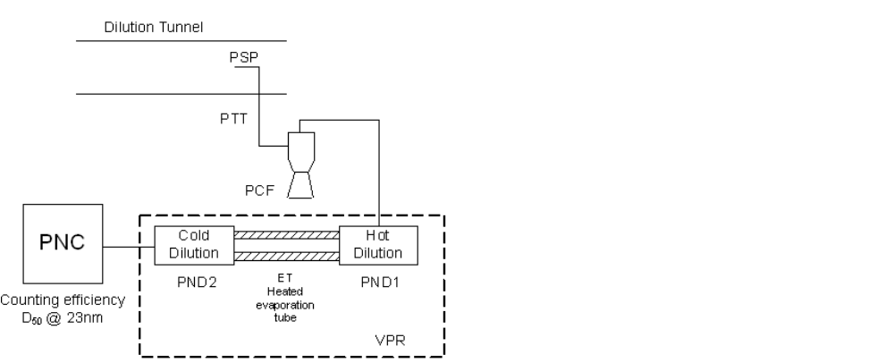
OT
4.3.1.4.1. Sampling system description
4.3.1.4.1.1. The particle sampling system shall consist of a sampling probe tip or particle sampling point in the dilution system, a particle transfer tube (PTT), a particle pre-classifier (PCF) and a volatile particle remover (VPR) upstream of the particle number counter (PNC) unit.
4.3.1.4.1.2. The VPR shall include devices for sample dilution (particle number diluters: PND₁ and PND₂) and particle evaporation (evaporation tube, ET).
4.3.1.4.1.3. The sampling probe or sampling point for the test gas flow shall be so arranged within the dilution tunnel that a representative sample gas flow is taken from a homogeneous diluent/exhaust mixture.
4.3.1.4.1.4. The sum of the residence time of the system plus the t₉₀ response time of the PNC shall be no greater than 20 s.
4.3.1.4.2. Particle transfer system (PTS)
The PTS shall fulfil the requirements of paragraph 4.3.1.2.1.1. of this annex.
4.3.1.4.3. Particle pre-classifier (PCF)
4.3.1.4.3.1. The recommended particle pre-classifier shall be located upstream of the VPR.
4.3.1.4.3.2. The pre-classifier 50 per cent cut point particle diameter shall be between 2.5 µm and 10 µm at the volumetric flow rate selected for sampling particle number emissions.
4.3.1.4.3.3. The pre-classifier shall allow at least 99 per cent of the mass concentration of 1 µm particles entering the pre-classifier to pass through the exit of the pre-classifier at the volumetric flow rate selected for sampling particle number emissions.
4.3.1.4.4. Volatile particle remover (VPR)
4.3.1.4.4.1. The VPR shall comprise one particle number diluter (PND₁), an evaporation tube and a second diluter (PND₂) in series. This dilution function is to reduce the number concentration of the sample entering the particle concentration measurement unit to less than the upper threshold of the single particle count mode of the PNC and to suppress nucleation within the sample.
4.3.1.4.4.2. The VPR shall provide an indication of whether or not PND₁ and the evaporation tube are at their correct operating temperatures.
4.3.1.4.4.3. The VPR shall achieve > 99.0 per cent vaporization of 30 nm tetracontane (CH₃(CH₂)₃₈CH₃) particles, with an inlet concentration of ≥ 10,000 cm⁻³, by means of heating and reduction of partial pressures of the tetracontane.
4.3.1.4.4.4. The VPR shall be designed to achieve a solid particle penetration efficiency of at least 70 per cent for particles of 100 nm electrical mobility diameter.
4.3.1.4.4.5. The VPR shall also achieve a particle concentration reduction factor (fr) for particles of 30 nm and 50 nm electrical mobility diameters, that is no more than 30 per cent and 20 per cent respectively higher, and no more than 5 per cent lower than that for particles of 100 nm electrical mobility diameter for the VPR as a whole. It shall be designed according to good engineering practice to ensure particle concentration reduction factors are stable across a test.
4.3.1.4.5. First particle number dilution device (PND₁)
4.3.1.4.5.1. The first particle number dilution device shall be specifically designed to dilute particle number concentration and operate at a (wall) temperature of 150 °C to 350 °C.
4.3.1.4.5.1.1. The wall temperature set point should be held at a constant nominal operating temperature, within this range, to a tolerance of ±10 °C and not exceed the wall temperature of the ET described in paragraph 4.3.1.4.6.of this annex.
4.3.1.4.5.1.2. The diluter should be supplied with HEPA filtered dilution air and be capable of a dilution factor of 10 to 200 times.
4.3.1.4.6. Evaporation tube (ET)
4.3.1.4.6.1. The entire length of the ET shall be controlled to a wall temperature greater than or equal to that of the first particle number dilution device and the wall temperature held at a fixed nominal operating temperature of 350 °C, to a tolerance of ±10 °C.
4.3.1.4.6.2. The residence time within the ET shall be in the range 0.25 - 0.4 seconds (s).
4.3.1.4.7. Second particle number dilution device (PND₂)
4.3.1.4.7.1. PND₂ shall be specifically designed to dilute particle number concentration. The diluter shall be supplied with HEPA filtered dilution air and be capable of maintaining a single dilution factor within a range of 10 to 30 times.
4.3.1.4.7.2. The dilution factor of PND₂ shall be selected in the range between 10 and 15 such that particle number concentration downstream of the second diluter is less than the upper threshold of the single particle count mode of the PNC and the gas temperature prior to entry to the PNC is < 35 °C.
5. Calibration intervals and procedures
5.1. Calibration intervals
Table A5/3
Instrument calibration intervals
Instrument checks | Interval | Criteria
Gas analyser linearization (calibration) | Every 6 months | ±2 per cent of reading
Mid span | Every 6 months | ±2 per cent
CO NDIR:  CO₂/H₂O interference | Monthly | -1 to 3 ppm
NO_{x} converter check | Monthly | > 95 per cent
CH₄ cutter check | Yearly | 98per cent of Ethane
FID CH₄ response | Yearly | See 5.4.3.
FID air/fuel flow | At major maintenance | According to instrument mfr.
NO/NO₂ NDUV:  H₂O, HC interference | At major maintenance | According to instrument mfr.
Laser infrared spectrometers (modulated high resolution narrow band infrared analysers): interference check | Yearly or at major maintenance | According to instrument mfr.
GC methods | See paragraph 7.2. | See paragraph 7.2.
FTIR: linearity verification | Within 370 days before testing and after major maintenance | See paragraph 7.1.
Microgram balance linearity | Yearly or at major maintenance | See paragraph 4.2.2.2.
PNC (particle number counter) | See paragraph 5.7.1.1. | See paragraph 5.7.1.3.
VPR (volatile particle remover) | See paragraph 5.7.2.1. | See paragraph 5.7.2.
Table A5/4
Constant volume sampler (CVS) calibration intervals
CVS | Interval | Criteria
CVS flow | After overhaul | ±2 per cent
Dilution flow | Yearly | ±2 per cent
Temperature sensor | Yearly | ±1 °C
Pressure sensor | Yearly | ±0.4 kPa
Injection check | Weekly | ±2 per cent
Table A5/5
Environmental data calibration intervals
Climate | Interval | Criteria
Temperature | Yearly | ±1 °C
Moisture dew | Yearly | ±5 per cent RH
Ambient pressure | Yearly | ±0.4 kPa
Cooling fan | After overhaul | According to paragraph 1.1.1.
5.2. Analyser calibration procedures
5.2.1. Each analyser shall be calibrated as specified by the instrument manufacturer or at least as often as described in Table A5/3.
5.2.2. Each normally used operating range shall be linearized by the following procedure:
5.2.2.1. The analyser linearization curve shall be established by at least five calibration points spaced as uniformly as possible. The nominal concentration of the calibration gas of the highest concentration shall be not less than 80 per cent of the full scale.
5.2.2.2. The calibration gas concentration required may be obtained by means of a gas divider, diluting with purified N₂ or with purified synthetic air.
5.2.2.3. The linearization curve shall be calculated by the least squares method. If the resulting polynomial degree is greater than 3, the number of calibration points shall be at least equal to this polynomial degree plus 2.
5.2.2.4. The linearization curve shall not differ by more than ±2 per cent from the nominal value of each calibration gas.
5.2.2.5. From the trace of the linearization curve and the linearization points, it is possible to verify that the calibration has been carried out correctly. The different characteristic parameters of the analyser shall be indicated, particularly:
(a) Scale;
(b) Sensitivity;
(c) Zero point;
(d) Date of the linearization.
5.2.2.6. If it can be shown to the satisfaction of the responsible authority that alternative technologies (e.g. computer, electronically controlled range switch, etc.) can give equivalent accuracy, these alternatives may be used.
5.3. Analyser zero and calibration verification procedure
5.3.1. Each normally used operating range shall be checked prior to each analysis in accordance with the following subparagraphs.
5.3.1.1. The calibration shall be checked by use of a zero gas and by use of a calibration gas according to Annex 6, paragraph 1.2.14.2.3.
5.3.1.2. After testing, zero gas and the same calibration gas shall be used for re-checking according to Annex 6, paragraph 1.2.14.2.4.
5.4. FID hydrocarbon response check procedure
5.4.1. Detector response optimization
The FID shall be adjusted as specified by the instrument manufacturer. Propane in air should be used on the most common operating range.
5.4.2. Calibration of the HC analyser
5.4.2.1. The analyser shall be calibrated using propane in air and purified synthetic air.
5.4.2.2. A calibration curve as described in paragraph 5.2.2.of this annex shall be established.
5.4.3. Response factors of different hydrocarbons and recommended limits
5.4.3.1. The response factor (), for a particular hydrocarbon compound is the ratio of the FID C₁ reading to the gas cylinder concentration, expressed as ppm C₁.
The concentration of the test gas shall be at a level to give a response of approximately 80 per cent of full-scale deflection, for the operating range. The concentration shall be known to an accuracy of ±2 per cent in reference to a gravimetric standard expressed in volume. In addition, the gas cylinder shall be pre-conditioned for 24 hours at a temperature between 293 K and 303 K (20 and 30 °C).
5.4.3.2. Response factors shall be determined when introducing an analyser into service and at major service intervals thereafter. The test gases to be used and the recommended response factors are:
Methane and purified air: ;
Propylene and purified air: ;
Toluene and purified air: .
These are relative to a response factor () of 1.00 for propane and purifiedair.
5.5. NO_{x} converter efficiency test procedure
5.5.1. Using the test set up as shown in Figure A5/15 and the procedure described below, the efficiency of converters for the conversion of NO₂ into NO shall be tested by means of an ozonator as follows:
5.5.1.1. The analyser shall be calibrated in the most common operating range following the manufacturer's specifications using zero and calibration gas (the NO content of which shall amount to approximately 80 per cent of the operating range and the NO₂ concentration of the gas mixture shall be less than 5 per cent of the NO concentration). The NO_{x} analyser shall be in the NO mode so that the calibration gas does not pass through the converter. The indicated concentration shall be recorded.
5.5.1.2. Via a T-fitting, oxygen or synthetic air shall be added continuously to the calibration gas flow until the concentration indicated is approximately 10 per cent less than the indicated calibration concentration given in paragraph 5.5.1.1. above. The indicated concentration (c) shall be recorded. The ozonator shall be kept deactivated throughout this process.
5.5.1.3. The ozonator shall now be activated to generate enough ozone to bring the NO concentration down to 20 per cent (minimum 10 per cent) of the calibration concentration given in paragraph 5.5.1.1. above. The indicated concentration (d) shall be recorded.
5.5.1.4. The NO_{x} analyser shall then be switched to the NO_{x} mode, whereby the gas mixture (consisting of NO, NO₂, O₂ and N₂) now passes through the converter. The indicated concentration (a) shall be recorded.
5.5.1.5. The ozonator shall now be deactivated. The mixture of gases described in paragraph 5.5.1.2. above shall pass through the converter into the detector. The indicated concentration (b) shall be recorded.
Figure A5/15
NO_{x} converter efficiency test configuration
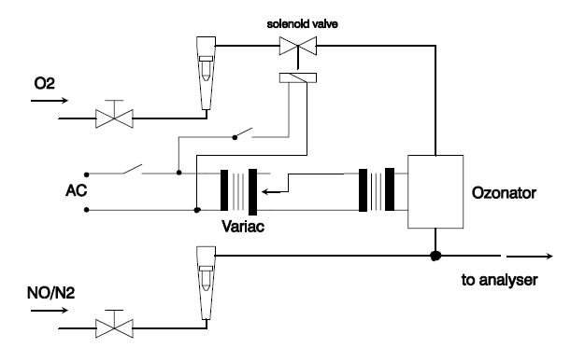
5.5.1.6. With the ozonator deactivated, the flow of oxygen or synthetic air shall be shut off. The NO₂ reading of the analyser shall then be no more than 5 per cent above the figure given in paragraph 5.5.1.1. above.
5.5.1.7. The efficiency of the NO_{x} converter shall be calculated using the concentrations a, b, c and d determined in paragraphs 5.5.1.2. through 5.5.1.5. above as follows:
5.5.1.7.1. The efficiency of the converter shall not be less than 95 per cent. The efficiency of the converter shall be tested in the frequency defined in Table A5/3.
5.6. Calibration of the microgram balance
5.6.1. The calibration of the microgram balance used for particulate filter weighing shall be traceable to a national or international standard. The balance shall comply with the linearity requirements given in paragraph 4.2.2.2.of this annex. The linearity verification shall be performed at least every 12 months or whenever a system repair or change is made that could influence the calibration.
5.7. Calibration and validation of the particle sampling system
Examples of calibration/validation methods are available at: http://www.unece.org/trans/main/wp29/wp29wgs/wp29grpe/pmpFCP.html.
5.7.1. Calibration of the particle number counter
5.7.1.1. The responsible authority shall ensure the existence of a calibration certificate for the PNC demonstrating compliance with a traceable standard within a 13-month period prior to the emissions test. Between calibrations either the counting efficiency of the PNC should be monitored for deterioration or the PNC wick should be routinely changed every 6 months. See Figures A5/16 and A5/17 below. PNC counting efficiency may be monitored against a reference PNC or against at least two other measurement PNCs. If the PNC reports particle concentrations within ±10 per cent of the average of the concentrations from the reference PNC, or group of two or more PNCs, then the PNC shall be considered stable, otherwise maintenance of the PNC is required. Where the PNC is monitored against two or more other measurement PNCs it is permissible to use a reference vehicle running sequentially in different test cells each with its own PNC.

Figure A5/16

Nominal PNC Annual Sequence

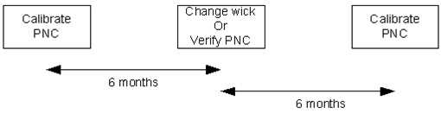

Figure A5/17

Extended PNC annual sequence (in the case where full PNC calibration is delayed)

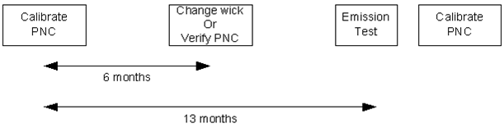
5.7.1.2. The PNC shall also be recalibrated and a new calibration certificate issued following any major maintenance.
5.7.1.3. Calibration shall be traceable to a standard calibration method by comparing the response of the PNC under calibration with that of:
(a) A calibrated aerosol electrometer when simultaneously sampling electrostatically classified calibration particles; or
(b) A second PNC which has been directly calibrated by the above method.
5.7.1.3.1. In paragraph 5.7.1.3. (a) above, calibration shall be undertaken using at least six standard concentrations spaced as uniformly as possible across the PNC’s measurement range.
5.7.1.3.2. In case paragraph 5.7.1.3. (b) above , calibration shall be undertaken using at least six standard concentrations across the PNC’s measurement range. At least 3 points shall be at concentrations below 1,000 cm⁻³, the remaining concentrations shall be linearly spaced between 1,000 cm⁻³ and the maximum of the PNC’s range in single particle count mode.
5.7.1.3.3. In cases of paragraphs 5.7.1.3. (a) and 5.7.1.3. (b) above, the selected points shall include a nominal zero concentration point produced by attaching HEPA filters of at least class H13 of EN 1822:2008, or equivalent performance, to the inlet of each instrument. With no calibration factor applied to the PNC under calibration, measured concentrations shall be within ±10 per cent of the standard concentration for each concentration, with the exception of the zero point, otherwise the PNC under calibration shall be rejected. The gradient from a linear least squares regression of the two data sets shall be calculated and recorded. A calibration factor equal to the reciprocal of the gradient shall be applied to the PNC under calibration. Linearity of response is calculated as the square of the Pearson product moment correlation coefficient (R²) of the two data sets and shall be equal to or greater than 0.97. In calculating both the gradient and R², the linear regression shall be forced through the origin (zero concentration on both instruments).
5.7.1.4. Calibration shall also include a check, according to the requirements in paragraph 4.3.1.3.4.(h) of this annex, on the PNC’s detection efficiency with particles of 23 nm electrical mobility diameter. A check of the counting efficiency with 41 nm particles is not required.
5.7.2. Calibration/validation of the volatile particle remover
5.7.2.1. Calibration of the VPR’s particle concentration reduction factors across its full range of dilution settings, at the instrument’s fixed nominal operating temperatures, shall be required when the unit is new and following any major maintenance. The periodic validation requirement for the VPR’s particle concentration reduction factor is limited to a check at a single setting, typical of that used for measurement on particulate filter-equipped vehicles. The responsible authority shall ensure the existence of a calibration or validation certificate for the volatile particle remover within a 6-month period prior to the emissions test. If the volatile particle remover incorporates temperature monitoring alarms, a 13-month validation interval shall be permissible.
It is recommended that the VPR is calibrated and validated as a complete unit.
The VPR shall be characterised for particle concentration reduction factor with solid particles of 30 nm, 50 nm and 100 nm electrical mobility diameter. Particle concentration reduction factors () for particles of 30 nm and 50 nm electrical mobility diameters shall be no more than 30 per cent and 20 per cent higher respectively, and no more than 5 per cent lower than that for particles of 100 nm electrical mobility diameter. For the purposes of validation, the mean particle concentration reduction factor shall be within ±10 per cent of the mean particle concentration reduction factor () determined during the primary calibration of the VPR.
5.7.2.2. The test aerosol for these measurements shall be solid particles of 30, 50 and 100 nm electrical mobility diameter and a minimum concentration of 5,000 particles cm⁻³ at the VPR inlet. As an option, a polydisperse aerosol with an electrical mobility median diameter of 50 nm may be used for validation. The test aerosol shall be thermally stable at the VPR operating temperatures. Particle concentrations shall be measured upstream and downstream of the components.
The particle concentration reduction factor for each monodisperse particle size () shall be calculated as follows:
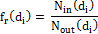
where:
is the upstream particle number concentration for particles of diameter ;
is the downstream particle number concentration for particles of diameter ;
is the particle electrical mobility diameter (30, 50 or 100 nm).
and shall be corrected to the same conditions.
The mean particle concentration reduction factor, , at a given dilution setting shall be calculated as follows:
Where a polydisperse 50 nm aerosol is used for validation, the mean particle concentration reduction factor () at the dilution setting used for validation shall be calculated as follows:
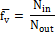
where:
is the upstream particle number concentration;
is the downstream particle number concentration.
5.7.2.3. A validation certificate for the VPR demonstrating effective volatile particle removal efficiency within a 6 month period prior to the emissions test shall be presented upon request. If the volatile particle remover incorporates temperature monitoring alarms, a 13 month validation interval shall be permissible.
5.7.2.3.1. The VPR shall demonstrate greater than 99.0 per cent removal of tetracontane (CH₃(CH₂)₃₈CH₃) particles of at least 30 nm electrical mobility diameter with an inlet concentration ≥ 10,000 cm⁻³ when operated at its minimum dilution setting and manufacturers recommended operating temperature.
5.7.3. Particle number system check procedures
5.7.3.1. On a monthly basis, the flow into the particle counter shall report a measured value within 5 per cent of the particle counter nominal flow rate when checked with a calibrated flow meter.
5.8. Accuracy of the mixing device
If a gas divider is used to perform the calibrations as defined in paragraph 5.2., the accuracy of the mixing device shall be such that the concentrations of the diluted calibration gases may be determined to within ±2 per cent. A calibration curve must be verified by a mid-span check as described in paragraph 5.3. A calibration gas with a concentration below 50 per cent of the analyser range shall be within 2 per cent of its certified concentration.
6. Reference gases
6.1. Pure gases
6.1.1. All values in ppm mean V-ppm (vpm)
6.1.2. The following pure gases shall be available, if necessary, for calibration and operation:
6.1.2.1. Nitrogen: (purity: ≤ 1 ppm C, ≤1 ppm CO, ≤ 400 ppm CO₂, ≤ 0.1 ppm NO, <0.1 ppm NO₂, <0.1 ppm N₂O, <0.1 ppm NH₃);
6.1.2.2. Synthetic air: (purity: ≤1 ppm C, ≤1 ppm CO, ≤400 ppm CO₂, ≤0.1 ppm NO); oxygen content between 18 and 21 per cent volume;
6.1.2.3. Oxygen: (purity: > 99.5 per cent vol. O₂);
6.1.2.4. Hydrogen (and mixture containing helium or nitrogen): (purity: ≤ 1 ppm C, ≤ 400 ppm CO₂);
6.1.2.5. Carbon monoxide: (minimum purity 99.5 per cent);
6.1.2.6. Propane: (minimum purity 99.5 per cent).
6.2. Calibration gases
6.2.1. The true concentration of a calibration gas shall be within ±1 per cent of the stated value or as given below.
Mixtures of gases having the following compositions shall be available with a bulk gas specifications according to paragraphs 6.1.2.1. or 6.1.2.2. of this annex:
(a) C₃H₈ in synthetic air (see paragraph 6.1.2.2. above);
(b) CO in nitrogen;
(c) CO₂ in nitrogen;
(d) CH₄ in synthetic air;
(e) NO in nitrogen (the amount of NO₂ contained in this calibration gas shall not exceed 5 per cent of the NO content);
(f) NO₂ in nitrogen (tolerance ±2 per cent);
(g) N₂O in nitrogen (tolerance ±2 per cent);
(h) C₂H₅OH in synthetic air or nitrogen (tolerance ±2 per cent).
7. Additional sampling and analysis methods
7.1. Fourier transform infrared (FTIR) analyser
7.1.1. Measurement principle
7.1.1.1. An FTIR employs the broad waveband infrared spectroscopy principle. It allows simultaneous measurement of exhaust components whose standardized spectra are available in the instrument. The absorption spectrum (intensity/wavelength) is calculated from the measured interferogram (intensity/time) by means of the Fourier transform method.
7.1.1.2. The internal analyser sample stream up to the measurement cell and the cell itself shall be heated.
7.1.1.3. Measurement cross interference
7.1.1.3.1. The spectral resolution of the target wavelength shall be within 0.5 cm⁻¹ in order to minimize cross interference from other gases present in the exhaust gas.
7.1.1.3.2. Analyser response should not exceed ±2 ppm at the maximum CO₂ and H₂O concentration expected during the vehicle test.
7.2. Sampling and analysis methods for N₂O
7.2.1. Gas chromatographic method
7.2.1.1. General description
Followed by the gas chromatographic separation, N₂O shall be analysed by an appropriate detector. This shall be an electron-capture detector (ECD).
7.2.1.2. Sampling
From each phase of the test, a gas sample shall be taken from the corresponding diluted exhaust bag and dilution air bag for analysis. A single composite dilution background sample can be analysed instead (not possible for phase weighing).
7.2.1.2.1. Sample transfer
Secondary sample storage media may be used to transfer samples from the test cell to the GC lab. Good engineering judgement shall be used to avoid additional dilution when transferring the sample from sample bags to secondary sample bags.
7.2.1.2.1.1. Secondary sample storage media.
Gas volumes shall be stored in sufficiently clean containers that minimally off-gas or allow permeation of gases. Good engineering judgment shall be used to determine acceptable thresholds of storage media cleanliness and permeation. In order to clean a container, it may be repeatedly purged, evacuated and heated.
7.2.1.2.2. Sample storage
Secondary sample storage bags must be analysed within 24 hours and must be stored at room temperature.
7.2.1.3. Instrumentation and apparatus
7.2.1.3.1. A gas chromatograph with an electron-capture detector (GC-ECD) may be used to measure N₂O concentrations of diluted exhaust for batch sampling.
7.2.1.3.2. The sample may be injected directly into the GC or an appropriate preconcentrator may be used. In case of preconcentration, this must be used for all necessary verifications and quality checks.
7.2.1.3.3. A packed or porous layer open tubular (PLOT) column phase of suitable polarity and length may be used to achieve adequate resolution of the N₂O peak for analysis.
7.2.1.3.4. Column temperature profile and carrier gas selection must be taken into consideration when setting up the method to achieve adequate N₂O peak resolution. Whenever possible, the operator must aim for baseline separated peaks.
7.2.1.3.5. Good engineering judgement shall be used to zero the instrument and to correct for drift.
Example: A calibration gas measurement may be performed before and after sample analysis without zeroing and using the average area counts of the pre-calibration and post-calibration measurements to generate a response factor (area counts/calibration gas concentration), which is then multiplied by the area counts from the sample to generate the sample concentration.
7.2.1.4. Reagents and material
All reagents, carrier and make up gases shall be of 99.995 per cent purity. Make up gas shall be N₂ or Ar/CH₄
7.2.1.5. Peak integration procedure
7.2.1.5.1. Peak integrations are corrected as necessary in the data system. Any misplaced baseline segments are corrected in the reconstructed chromatogram.
7.2.1.5.2. Peak identifications provided by a computer shall be checked and corrected if necessary.
7.2.1.5.3. Peak areas shall be used for all evaluations. Peak heights may be used alternatively with approval of the responsible authority.
7.2.1.6. Linearity
A multipoint calibration to confirm instrument linearity shall be performed for the target compound:
(a) For new instruments;
(b) After doing instrument modifications that can affect linearity; and
(c) At least once per year.
7.2.1.6.1. The multipoint calibration consists of at least 3 concentrations, each above the limit of detection (LoD), distributed over the range of expected sample concentration.
7.2.1.6.2. Each concentration level is measured at least twice.
7.2.1.6.3. A linear least squares regression analysis is performed using concentration and average area counts to determine the regression correlation coefficient (r). The regression correlation coefficient must be greater than 0.995 to be considered linear for one point calibrations.
If the weekly check of the instrument response indicates that the linearity may have changed, a multipoint calibration must be done.
7.2.1.7. Quality control
7.2.1.7.1. The calibration standard shall be analysed each day of analysis to generate the response factors used to quantify the sample concentrations.
7.2.1.7.2. A quality control standard shall be analysed within 24 hours before the analysis of the sample.
7.2.1.8. Calculations
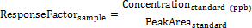
7.2.1.9. Limit of detection, limit of quantification
The detection limit is based on the noise measurement close to the retention time of N₂O (reference DIN 32645, 01.11.2008):
Limit of Detection:
where is considered to be equal to noise.
Limit of Quantification:
For the purpose of calculating the mass of N₂O, the concentration below LoD is considered to be zero.
7.2.1.10. Interference verification.
Interference is any component present in the sample with a retention time similar to that of the target compound described in this method. To reduce interference error, proof of chemical identity may require periodic confirmations using an alternate method or instrumentation.

Annex 6
Type 1 test procedure and test conditions
1. Test procedures and test conditions
1.1 Description of tests
1.1.1. The tests verify the emissions of gaseous compounds, particulate matter, particle number, CO₂ emissions, and fuel consumption, in a characteristic driving cycle.
1.1.1.1. The tests shall be carried out by the method described in paragraph 1.2. of this annex. Gases, particulate matter and particle number shall be sampled and analysed by the prescribed methods.
1.1.1.2. The number of tests shall be determined as shown in Figure A6/1. R_{i1} to R_{i3} describe the final measurement results of three tests to determine gaseous compounds, particulate matter, particle number, CO₂ emissions, and fuel consumption where applicable. L are limit values as defined by the Contracting Parties. If a vehicle configuration must be driven more than once to show compliance with regional limits (as defined in FigureA6/1), the average CO₂ value must be calculated for type approval.

Figure A6/1
Flowchart for the number of Type 1 tests
no
First Test
no
Second Test

and
and

or
and
Third Test

and
and
no
no
no
no

and
or
no
rejected
accepted
accepted
accepted
accepted
yes
yes
yes
yes
yes
yes
yes
yes

1.2. Type 1 test conditions
1.2.1. Overview
1.2.1.1. The Type 1 test shall consist of prescribed sequences of dynamometer preparation, fuelling, soaking, and operating conditions.
1.2.1.2. The Type 1 test shall consist of engine start-ups and vehicle operation on a chassis dynamometer on the applicable WLTC for the CO₂ vehicle family. A proportional part of the diluted exhaust emissions shall be collected continuously for subsequent analysis using a constant volume sampler.
1.2.1.3. Background concentrations shall be measured for all compounds for which dilute mass emissions measurements are conducted. For exhaust emission testing, this requires sampling and analysis of the dilution air.
1.2.1.3.1. Background particulate mass measurement
1.2.1.3.1.1. Where the manufacturer requests and the Contracting Party permits subtraction of either dilution air or dilution tunnel particulate matter background from emissions measurements, these background levels shall be determined according to the procedures listed in the following subparagraphs.
1.2.1.3.1.1.1. The maximum permissible background correction shall be a mass on the filter equivalent to 1 mg/km at the flow rate of the test.
1.2.1.3.1.1.2. If the background exceeds this level, the default figure of 1 mg/km shall be subtracted.
1.2.1.3.1.1.3. Where subtraction of the background contribution gives a negative result, the particulate mass result shall be considered to be zero.
1.2.1.3.1.2. Dilution air particulate matter background level shall be determined by passing filtered dilution air through the particulate filter. This shall be drawn from a point immediately downstream of the dilution air filters. Background levels in μg/m³ shall be determined as a rolling average of at least 14 measurements with at least one measurement per week.
1.2.1.3.1.3. Dilution tunnel particulate matter background level shall be determined by passing filtered dilution air through the particulate filter. This shall be drawn from the same point as the particulate matter sample. Where secondary dilution is used for the test, the secondary dilution system shall be active for the purposes of background measurement. One measurement may be performed on the day of test, either prior to or after the test.
1.2.1.3.2. Background particle number determination
1.2.1.3.2.1. Where the Contracting Party permits subtraction of either dilution air or dilution tunnel particle number background from emissions measurements or a manufacturer requests a background correction, these background levels shall be determined as follows:
1.2.1.3.2.1.1. The background value can be calculated or measured. The maximum permissible background correction shall be related to the maximum allowable leak rate of the particle number measurement system (0.5 particles/cm³ ) scaled from the particle concentration reduction factor (PCRF) and the CVS flow rate used in the actual test;
1.2.1.3.2.1.2. Either the Contracting Party or the manufacturer can request that actual background measurements are used instead of calculated ones.
1.2.1.3.2.1.3. Where subtraction of the background contribution gives a negative result, the particle number result shall be considered to be zero.
1.2.1.3.2.2. Dilution air particle number background level shall be determined by sampling filtered dilution air. This shall be drawn from a point immediately downstream of the dilution air filters into the particle number measurement system. Background levels in #/cm³ shall be determined as a rolling average of least 14 measurements with at least one measurement per week.
1.2.1.3.2.3. Dilution tunnel particle number background level shall be determined by sampling filtered dilution air. This shall be drawn from the same point as the particle number sample. Where secondary dilution is used for the test the secondary dilution system should be active for the purposes of background measurement. One measurement may be performed on the day of test, either prior to or after the test using the actual PCRF and the CVS flow rate utilised during the test.
1.2.2. General test cell equipment
1.2.2.1. Parameters to be measured
1.2.2.1.1. The following temperatures shall be measured with an accuracy of ±1.5 K:
(a) Test cell ambient air
(b) Dilution and sampling system temperatures as required for emissions measurement systems defined in Annex 5.
1.2.2.1.2. Atmospheric pressure shall be measurable with a resolution of ±0.1 kPa.
1.2.2.1.3. Absolute humidity (H_{a}) shall be measurable with a resolution of ±1 g H₂O/kg dry air.
1.2.2.2. Test cell and soak area
1.2.2.2.1. Test cell
1.2.2.2.1.1. The test cell shall have a temperature set point of 296 K. The tolerance of the actual value shall be within ±5 K. The air temperature and humidity shall be measured at the vehicle cooling fan outlet at a minimum of 1 Hz. For temperature at the start of the test, see paragraph 1.2.8.1. in Annex 6.
1.2.2.2.1.2. The absolute humidity (H_{a}) of either the air in the test cell or the intake air of the engine shall be such that:
(g H₂O/kg dry air)
1.2.2.2.1.3. Humidity shall be measured continuously at a minimum of 1 Hz.
1.2.2.2.2. Soak area
The soak area shall have a temperature set point of 296 K and the tolerance of the actual value shall be within ±3 K on a 5 minute running average and shall not show a systematic deviation from the set point. The temperature shall be measured continuously at a minimum of 1 Hz.
1.2.3. Test vehicle
1.2.3.1. General
The test vehicle shall conform in all its components with the production series, or, if the vehicle is different from the production series, a full description shall be recorded. In selecting the test vehicle, the manufacturer and responsible technical authority shall agree which vehicle model is representative for the CO₂ vehicle family. For the measurement of emissions the road load as determined with test vehicle H shall be applied. If at the request of the manufacturer the CO₂ interpolation method is used (see paragraph 3.2.3.2 of Annex 7), an additional measurement of emissions shall be performed with the road load as determined at test vehicle L. Both vehicle H and L shall be tested with the shortest final transmission ratio within the CO₂ vehicle family. The CO₂ interpolation method shall only be applied on those road load relevant characteristics that were chosen to be different between test vehicle L and test vehicle H; for the other road load relevant characteristic(s), the value of test vehicle H shall be applied in the CO₂ interpolation method. The manufacturer may also choose not to apply the interpolation method for road load relevant characteristics between test vehicles L and H; in that case the value of the test vehicle H shall be applied in the CO₂ interpolation method.
1.2.3.2. CO₂ interpolation range
The CO₂ interpolation method shall only be used if the difference in CO₂ between test vehicles L and H is between a minimum of 5 and a maximum of 30 g/km or 20 per cent of the CO₂ for vehicle H, whichever value is the lower.
At the request of the manufacturer, and with approval of the responsible authority, the CO₂ interpolation line may be extrapolated to a maximum of 3 g/km above the CO₂ emission of vehicle H or below the CO₂ emission of vehicle L. This extension is only valid within the absolute boundaries of the above specified interpolation range.
1.2.3.3. Run-in
The vehicle must be presented in good technical condition. It must have been run-in and driven between 3,000 and 15,000 km before the test. The engine, transmission and vehicle shall be run-in in accordance with the manufacturer’s recommendations.
1.2.4. Settings
1.2.4.1. Dynamometer settings and verification shall be done according to Annex 4.
1.2.4.2. Dynamometer operation mode
1.2.4.2.1. Dynamometer operation mode can be activated at the manufacturer's request.
1.2.4.2.2. A dynamometer operation mode, if any, shall be activated by using the manufacturer's instruction (e.g. using vehicle steering wheel buttons in a special sequence, using the manufacturer’s workshop tester, removing a fuse).
The manufacturer shall provide the responsible authority a list of the deactivated devices and justification of the deactivation.
Auxiliaries shall be switched off or deactivated during dynamometer operation.
1.2.4.2.3. Dynamometer operation mode shall not activate, modulate, delay or deactivate the operation of any part that affects the emissions and fuel consumption under the test conditions. Any device that affects the operation on a chassis dynamometer shall be set to ensure a proper operation.
Activation or deactivation of the mode shall be recorded.
1.2.4.3. The vehicle’s exhaust system shall not exhibit any leak likely to reduce the quantity of gas collected.
1.2.4.4. The settings of the engine and of the vehicle's controls shall be those prescribed by the manufacturer.
1.2.4.5. Tyres shall be of a type specified as original equipment by the vehicle manufacturer. Tyre pressure may be increased by up to 50 per cent above the pressure specified in paragraph 4.2.2.3. of Annex 4. The same tyre pressure shall be used for the setting of the dynamometer and for all subsequent testing. The tyre pressure used shall be recorded.
1.2.4.6. Reference fuel
1.2.4.6.1. The appropriate reference fuel as defined of Annex 3 shall be used for testing.
1.2.4.7. Test vehicle preparation
1.2.4.7.1. The vehicle shall be approximately horizontal during the test so as to avoid any abnormal distribution of the fuel.
1.2.4.7.2. If necessary, the manufacturer shall provide additional fittings and adapters, as required to accommodate a fuel drain at the lowest point possible in the tank(s) as installed on the vehicle, and to provide for exhaust sample collection.
1.2.5. Preliminary testing cycles
1.2.5.1. Preliminary testing cycles may be carried out if requested by the manufacturer to follow the speed trace within the prescribed limits.
1.2.6. Test vehicle preconditioning
1.2.6.1. The fuel tank or fuel tanks shall be filled with the specified test fuel. If the existing fuel in the fuel tank or fuel tanks does not meet the specifications contained in paragraph 1.2.4.6. above, the existing fuel shall be drained prior to the fuel fill. For the above operations, the evaporative emission control system shall neither be abnormally purged nor abnormally loaded.
1.2.6.2. Battery charging
Before the preconditioning test cycle, the batteries shall be fully charged. At the request of the manufacturer, charging may be omitted before preconditioning. The batteries shall not be charged again before official testing.
1.2.6.3. The test vehicle shall be moved to the test cell and the operations listed in the following subparagraphs shall be performed.
1.2.6.3.1. The test vehicle shall be placed, either by being driven or pushed, on a dynamometer and operated through the applicable WLTCs . The vehicle need not be cold, and may be used to set dynamometer load.
1.2.6.3.2. The dynamometer load shall be set according to paragraphs 7. and 8. of Annex 4.
1.2.6.3.3. During preconditioning, the test cell temperature shall be the same as defined for the Type 1 test (paragraph 1.2.2.2.1. of this annex).
1.2.6.3.4. The drive-wheel tyre pressure shall be set in accordance with paragraph 1.2.4.5. of this annex.
1.2.6.3.5. Between the tests on the first gaseous reference fuel and the second gaseous reference fuel, for positive ignition-engined vehicles fuelled with LPG or NG/biomethane or so equipped that they can be fuelled with either petrol or LPG or NG/biomethane, the vehicle shall be preconditioned again before the test on the second reference fuel.
1.2.6.3.6. For preconditioning, the applicable WLTC shall be driven. Starting the engine and driving shall be performed according to paragraph 1.2.6.4. below.
The dynamometer setting shall be indicated as in paragraph 1.2.4.1. above.
1.2.6.3.7. At request of the manufacturer or responsible authority, additional WLTCs may be performed in order to bring the vehicle and its control systems to a stabilized condition.
1.2.6.3.8. The extent of such additional preconditioning shall be recorded by the responsible authority.
1.2.6.3.9. In a test facility in which there may be possible contamination of a low particulate emitting vehicle test with residue from a previous test on a high particulate emitting vehicle, it is recommended, for the purpose of sampling equipment pre-conditioning, that a 120 km/h steady state drive cycle of 20 minutes duration be driven by a low particulate emitting vehicle. Longer and/or higher speed running is permissible for sampling equipment pre-conditioning if required. Dilution tunnel background measurements, where applicable, shall be taken after the tunnel pre-conditioning running, and prior to any subsequent vehicle testing.
1.2.6.4. The engine shall be started up by means of the devices provided for this purpose according to the manufacturer's instructions.
The switch of the predominant mode to another available mode after the vehicle has been started shall only be possible by an intentional action of the driver having no impact on any other functionality of the vehicle.
1.2.6.4.1. If the vehicle does not start, the test is void, preconditioning tests must be repeated and a new test must be driven.
1.2.6.4.2. The cycle starts on the initiation of the engine start-up procedure.
1.2.6.4.3. In cases where LPG or NG/biomethane is used as a fuel, it is permissible that the engine is started on petrol and switched automatically to LPG or NG/biomethane after a predetermined period of time which cannot be changed by the driver.
1.2.6.4.4. During stationary/idling vehicle phases, the brakes shall be applied with appropriate force to prevent the drive wheels from turning.
1.2.6.4.5. During the test, speed shall be recorded against time or collected by the data acquisition system at a rate of no less than 1 Hz so that the actual driven speed can be assessed.
1.2.6.4.6. The distance actually driven by the vehicle shall be recorded for each WLTC phase.
1.2.6.5. Use of the transmission
1.2.6.5.1. Manual shift transmission
The gear shift prescriptions described in Annex 2 shall be followed. Vehicles tested according to Annex 8 shall be driven according to paragraph 1.6. of that Annex.
Vehicles which cannot attain the acceleration and maximum speed values required in the applicable WLTC shall be operated with the accelerator control fully activated until they once again reach the required driving curve. Speed trace violations under these circumstances shall not void a test. Deviations from the driving cycle shall be recorded.
1.2.6.5.1.1. The tolerances given in paragraph 1.2.6.6.below shall apply.
1.2.6.5.1.2. The gear change must be started and completed within ±1.0 s of the prescribed gear shift point.
1.2.6.5.1.3. The clutch must be depressed within ±1.0 s of the prescribed clutch operating point.
1.2.6.5.2. Automatic shift transmission
1.2.6.5.2.1. Vehicles equipped with automatic shift transmissions shall be tested in the predominant drive mode. The accelerator control shall be used in such a way as to accurately follow the speed trace.
1.2.6.5.2.2. Vehicles equipped with automatic shift transmissions with driver-selectable modes shall fulfill the limits of criteria emissions in all automatic shift modes used for forward driving. The manufacturer shall give respective evidence to the responsible authority. Provided the manufacturer can give technical evidence with the agreement of the responsible authority, the dedicated driver-selectable modes for very special limited purposes shall not be considered (e.g. maintenance mode, crawler mode).
1.2.6.5.2.3. The manufacturer shall give evidence to the responsible authority of the existence of a predominant mode that fulfils the requirements of 3.5.10. in section B of this gtr. With the agreement of the responsible authority, the predominant mode may be used as the only mode for the determination of criteria emissions, CO₂ emissions, and fuel consumption. Notwithstanding the existence of a predominant mode, the criteria emission limits shall be fulfilled in all considered automatic shift modes used for forward driving as described in paragraph 1.2.6.5.2.2. above.
1.2.6.5.2.4. If the vehicle has no predominant mode or the requested predominant mode is not agreed by the responsible authority as a predominant mode, the vehicle shall be tested in the best case mode and worst case mode for criteria emissions, CO₂ emissions, and fuel consumption. Best and worst case modes shall be identified by the given evidence on the CO₂ emissions and fuel consumption in all modes. CO₂ emissions and fuel consumption shall be the average of the test results in both modes. Test results for both modes shall be recorded. Notwithstanding the usage of the best and worst case modes for testing, the criteria emission limits shall be fulfilled in all considered automatic shift modes used for forward driving as described in paragraph 1.2.6.5.2.2. above.
1.2.6.5.2.5. The tolerances given in paragraph 1.2.6.6. below shall apply.
After initial engagement, the selector shall not be operated at any time during the test. Initial engagement shall be done one second before beginning of the first acceleration.
1.2.6.5.3. Use of multi-mode transmissions
1.2.6.5.3.1. In the case of emissions testing, emission standards shall be fulfilled in all modes.
1.2.6.5.3.2. In the case of CO₂/fuel consumption testing, the vehicle shall be tested in the predominant mode.
If the vehicle has no predominant mode, the vehicle shall be tested in the best case mode and worst case mode, and the CO₂ and fuel consumption results shall be the average of both modes.
Vehicles with an automatic transmission with a manual mode shall be tested according paragraph 1.2.6.5.2. of this annex.
1.2.6.6. Speed trace tolerances
The following tolerances shall be allowed between the indicated speed and the theoretical speed of the respective WLTC:
(a) The upper limit is 2.0 km/h higher than the highest point of the trace within ±1.0 s of the given point in time;
(b) The lower limit is 2.0 km/h lower than the lowest point of the trace within ±1.0 s of the given time.
Speed tolerances greater than those prescribed shall be accepted provided the tolerances are never exceeded for more than 1 s on any one occasion.
There shall be no more than 10 such deviations per test.

Figure A6/2

Speed trace tolerances
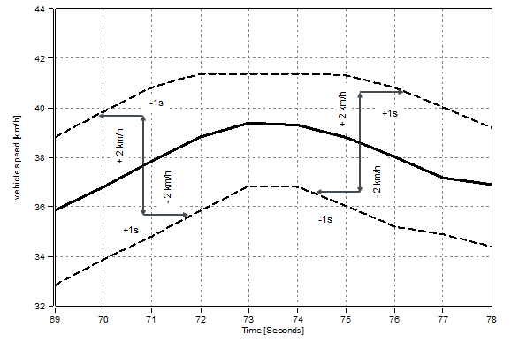
1.2.6.7. Accelerations
The vehicle shall be operated with the appropriate accelerator control movement necessary to accurately follow the speed trace.
The vehicle shall be operated smoothly, following representative shift speeds and procedures.
For manual transmissions, the accelerator controller shall be released during each shift and the shift shall be accomplished in minimum time.
If the vehicle cannot follow the speed trace, it shall be operated at maximum available power until the vehicle speed reaches the speed prescribed for that time in the driving schedule.
1.2.6.8. Decelerations
1.2.6.8.1. During decelerations of the cycle, the driver shall deactivate the accelerator control but shall not manually disengage the clutch until the point described in Annex 2, paragraph 4 (c).
1.2.6.8.1.1. If the vehicle decelerates faster than prescribed by the speed trace, the accelerator control shall be operated such that the vehicle accurately follows the speed trace.
1.2.6.8.1.2. If the vehicle decelerates too slowly to follow the intended deceleration, the brakes shall be applied such, that it is possible to accurately follow the speed trace.
1.2.6.9. Unexpected engine stop
1.2.6.9.1. If the engine stops unexpectedly, the preconditioning or Type 1 test shall be declared void.
1.2.6.10. After completion of the cycle, the engine shall be switched off.
1.2.7. Soaking
1.2.7.1. After preconditioning, and before testing, vehicles shall be kept in an area in with ambient conditions as described in paragraph 1.2.2.2.2.
1.2.7.2. The vehicle shall be soaked for a minimum of 6 hours and a maximum of 36 hours with the bonnet opened or closed until the engine oil temperature and coolant temperature, if any, are within ±2 K of the set point. If not excluded by specific provisions for a particular vehicle, cooling may be accomplished by forced cooling down to within ±2 K of the set point temperature. If cooling is accelerated by fans, the fans shall be placed so that the maximum cooling of the drive train, engine and exhaust after-treatment system is achieved in a homogeneous manner.
1.2.8. Emissions test (Type 1 test)
1.2.8.1. The test cell temperature at the start of the test shall be 296 K ± 3 K measured at a frequency of minimum 1 Hz.
1.2.8.2. The test vehicle shall be pushed onto a dynamometer.
1.2.8.2.1. The drive wheels of the vehicle shall be placed on the dynamometer without starting the engine.
1.2.8.2.2. The drive-wheel tyre pressures shall be set in accordance with the provisions of paragraph 1.2.6.3.4. above.
1.2.8.2.3. The bonnet shall be closed.
1.2.8.2.4. An exhaust connecting tube shall be attached to the vehicle tailpipe(s) immediately before starting the engine.
1.2.8.3. Engine starting and driving
1.2.8.3.1. The engine shall be started up by means of the devices provided for this purpose according to the manufacturer's instructions.
1.2.8.3.2. The vehicle shall be driven as described in paragraph 1.2.6.4. of this annex, up to and including paragraph 1.2.6.10., over the applicable WLTC, as described in Annex 1.
1.2.8.6. RCB data shall be recorded for each phase of the WLTC as defined in Appendix 2 to this annex.
1.2.9. Gaseous sampling
Gaseous samples shall be collected in bags and the compounds analysed at the end of the test or a test phase, or the compounds may be analysed continuously and integrated over the cycle.
1.2.9.1. The steps listed in the following paragraphs shall be taken prior to each test.
1.2.9.1.1. The purged, evacuated sample bags shall be connected to the dilute exhaust and dilution air sample collection systems.
1.2.9.1.2. Measuring instruments shall be started according to the instrument manufacturers’ instructions.
1.2.9.1.3. The CVS heat exchanger (if installed) shall be pre-heated or pre-cooled to within its operating test temperature tolerance as specified in paragraph 3.3.5.1. of Annex 5.
1.2.9.1.4. Components such as sample lines, filters, chillers and pumps shall be heated or cooled as required until stabilised operating temperatures are reached.
1.2.9.1.5. CVS flow rates shall be set according to paragraph 3.3.4. of Annex 5, and sample flow rates shall be set to the appropriate levels.
1.2.9.1.6. Any electronic integrating device shall be zeroed and may be re-zeroed before the start of any cycle phase.
1.2.9.1.7. For all continuous gas analysers, the appropriate ranges shall be selected. These may be switched during a test only if switching is performed by changing the calibration over which the digital resolution of the instrument is applied. The gains of an analyser’s analogue operational amplifiers may not be switched during a test.
1.2.9.1.8. All continuous gas analysers shall be zeroed and calibrated using gases fulfilling the requirements of paragraph 6. of Annex 5.
1.2.10. Particulate mass sampling
1.2.10.1. The following steps shall be taken prior to each test.
1.2.10.1.1. Filter selection
1.2.10.1.1.1. A single particulate filter without back-up shall be employed for the complete applicable WLTC. In order to accommodate regional cycle variations, a single filter may be employed for the first three phases and a separate filter for the fourth phase.
1.2.10.1.2. Filter preparation
1.2.10.1.2.1. At least one hour before the test, the filter shall be placed in a petri dish protecting against dust contamination and allowing air exchange, and placed in a weighing chamber for stabilization.
At the end of the stabilization period, the filter shall be weighed and its weight shall be recorded. The filter shall then be stored in a closed petri dish or sealed filter holder until needed for testing. The filter shall be used within eight hours of its removal from the weighing chamber.
The filter shall be returned to the stabilization room within one hour after the test and shall be conditioned for at least one hour before weighing.
1.2.10.1.2.2. The particulate sample filter shall be carefully installed into the filter holder. The filter shall be handled only with forceps or tongs. Rough or abrasive filter handling will result in erroneous weight determination. The filter holder assembly shall be placed in a sample line through which there is no flow.
1.2.10.1.2.3. It is recommended that the microbalance be checked at the start of each weighing session within 24 hours of the sample weighing by weighing one reference weight of approximately 100 mg. This weight shall be weighed three times and the average result recorded. If the average result of the weighings is ±5 μg of the result from the previous weighing session then the weighing session and balance are considered valid.
1.2.11. Particle number sampling
1.2.11.1. The following steps shall be taken prior to each test:
1.2.11.1.1. The particle specific dilution system and measurement equipment shall be started and made ready for sampling;
1.2.11.1.2. The correct function of the particle counter and volatile particle remover elements of the particle sampling system shall be confirmed according to the procedures listed in the following subparagraphs.
1.2.11.1.2.1. A leak check, using a filter of appropriate performance attached to the inlet of the entire particle number measurement system (VPR and PNC), shall report a measured concentration of less than 0.5 particles cm⁻³.
1.2.11.1.2.2. Each day, a zero check on the particle counter, using a filter of appropriate performance at the counter inlet, shall report a concentration of ≤ 0.2 particles cm⁻³. Upon removal of the filter, the particle counter shall show an increase in measured concentration to at least 100 particles cm⁻³ when sampling ambient air and a return to ≤ 0.2 particles cm⁻³ on replacement of the filter.
1.2.11.1.2.3. It shall be confirmed that the measurement system indicates that the evaporation tube, where featured in the system, has reached its correct operating temperature.
1.2.11.1.2.4. It shall be confirmed that the measurement system indicates that the diluter PND₁ has reached its correct operating temperature.
1.2.12. Sampling during the test
1.2.12.1. The dilution system, sample pumps and data collection system shall be started.
1.2.12.2. The particulate mass and particle number sampling systems shall be started.
1.2.12.3. Particle number shall be measured continuously. The average concentrations shall be determined by integrating the analyser signals over each phase.
1.2. 12.4. Sampling shall begin before or at the initiation of the engine start up procedure and end on conclusion of the cycle.
1.2.12.5. Sample switching
1.2.12.5.1. Gaseous emissions
1.2.12.5.1.1. Sampling from the diluted exhaust and dilution air shall be switched from one pair of sample bags to subsequent bag pairs, if necessary, at the end of each phase of the applicable WLTC to be driven.
1.2.12.5.2. Particulate matter
1.2.12.5.2.1. A single particulate filter without back-up shall be employed for the complete applicable WLTC. In order to accommodate regional cycle variations, a single filter may be employed for the first three phases and a separate filter for the fourth phase.
1.2.12.6. Dynamometer distance shall be recorded for each phase.
1.2.13. Ending the test
1.2.13.1. The engine shall be turned off immediately after the end of the last part of the test.
1.2.13.2. The constant volume sampler (CVS) or other suction device shall be turned off, or the exhaust tube from the tailpipe or tailpipes of the vehicle shall be disconnected.
1.2.13.3. The vehicle may be removed from the dynamometer.
1.2.14. Post-test procedures
1.2.14.1. Gas analyser check
1.2.14.1.1. Zero and calibration gas reading of the analysers used for continuous diluted measurement shall be checked. The test shall be considered acceptable if the difference between the pre-test and post-test results is less than 2 per cent of the calibration gas value.
1.2.14.2. Bag analysis
1.2.14.2.1. Exhaust gases and dilution air contained in the bags shall be analysed as soon as possible and exhaust gases in any event not later than 30 minutes after the end of the cycle phase.
The gas reactivity time for compounds in the bag shall be taken into consideration.
1.2.14.2.2. As soon as practical prior to analysis, the analyser range to be used for each compound shall be set to zero with the appropriate zero gas.
1.2.14.2.3. The calibration curves of the analysers shall be set by means of calibration gases of nominal concentrations of 70 to 100 per cent of the range.
1.2.14.2.4. The analysers zero settings shall then be rechecked: if any reading differs by more than 2 per cent of the range from that set in paragraph 1.2.14.2.2. above, the procedure shall be repeated for that analyser.
1.2.14.2.5. The samples shall then be analysed.
1.2.14.2.6. After the analysis, zero and calibration points shall be rechecked using the same gases. The test shall be considered acceptable if the difference is less than 2 per cent of the calibration gas value. .
1.2.14.2.7. At all points in paragraph 1.2.14.2. above, the flow rates and pressures of the various gases through analysers shall be the same as those used during calibration of the analysers.
1.2.14.2.8. The content of each of the compounds measured shall be recorded after stabilization of the measuring device.
1.2.14.2.9. The mass and number of all emissions, where applicable, shall be calculated according to Annex 7.
1.2.14.3. Particulate filter weighing
1.2.14.3.1. The particulate filter shall be returned to the weighing chamber no later than one hour after completion of the test. It shall be conditioned in a petri dish, which is protected against dust contamination and allows air exchange, for at least one hour, and then weighed. The gross weight of the filter shall be recorded.
1.2.14.3.2. At least two unused reference filters shall be weighed within 8 hours of, but preferably at the same time as, the sample filter weighings. Reference filters shall be of the same size and material as the sample filter.
1.2.14.3.3. If the specific weight of any reference filter changes by more than ±5μg between sample filter weighings, then the sample filter and reference filters shall be reconditioned in the weighing room and then reweighed.
1.2.14.3.4. The comparison of reference filter weighings shall be made between the specific weights and the rolling average of that reference filter's specific weights. The rolling average shall be calculated from the specific weights collected in the period since the reference filters were placed in the weighing room. The averaging period shall be at least one day but not exceed 15 days.
1.2.14.3.5. Multiple reconditionings and reweighings of the sample and reference filters are permissible until a period of 80 hours has elapsed following the measurement of gases from the emissions test. If, prior to or at the 80 hour point, more than half the number of reference filters meet the ±5 μg criterion, then the sample filter weighing can be considered valid. If, at the 80 hour point, two reference filters are employed and one filter fails the ±5 μg criterion, the sample filter weighing can be considered valid under the condition that the sum of the absolute differences between specific and rolling averages from the two reference filters must be less than or equal to 10 μg.
1.2.14.3.6. In case less than half of the reference filters meet the ±5 μg criterion, the sample filter shall be discarded, and the emissions test repeated. All reference filters must be discarded and replaced within 48 hours. In all other cases, reference filters must be replaced at least every 30 days and in such a manner that no sample filter is weighed without comparison to a reference filter that has been present in the weighing room for at least one day.
1.2.14.3.7. If the weighing room stability criteria outlined in paragraph 4.2.2.1. of Annex 5 are not met, but the reference filter weighings meet the above criteria, the vehicle manufacturer has the option of accepting the sample filter weights or voiding the tests, fixing the weighing room control system and re-running the test.
Annex 6 -Appendix 1
Emissions test procedure for all vehicles equipped with periodically regenerating systems
1. General
1.1. This appendix defines the specific provisions regarding testing a vehicle equipped with periodically regenerating systems as defined in paragraph 3.8.1. of Part B of this global technical regulation.
1.2. During cycles where regeneration occurs, emission standards can be exceeded. If a periodic regeneration occurs at least once per Type 1 test and has already regenerated at least once during vehicle preparation cycle, it will be considered as a continuously regenerating system which does not require a special test procedure. This appendix (Annex 6, Appendix 1) does not apply to continuously regenerating systems.
1.3. At the request of the manufacturer, and subject to the agreement of the responsible technical authority, the test procedure specific to periodically regenerating systems will not apply to a regenerative device if the manufacturer provides data demonstrating that, during cycles where regeneration occurs, emissions remain below the emissions limits applied by the Contracting Party for the relevant vehicle category.
1.4. At the option of the Contracting Party, the Extra High₂ phase may be excluded for determining the regenerative factor () for Class 2 vehicles.
1.5. At the option of the Contracting Party, the Extra High₃ phase may be excluded for determining the regenerative factor () for Class 3 vehicles.
2. Test Procedure
The test vehicle shall be capable of inhibiting or permitting the regeneration process provided that this operation has no effect on original engine calibrations. Prevention of regeneration shall only be permitted during loading of the regeneration system and during the pre-conditioning cycles. It shall not be permitted during the measurement of emissions during the regeneration phase. The emission test shall be carried out with the unchanged original equipment manufacturer's (OEM) control unit.
2.1. Exhaust emission measurement between two WLTCs with regeneration events.
2.1.1. Average emissions between regeneration events and during loading of the regenerative device shall be determined from the arithmetic mean of several approximately equidistant (if more than 2) Type 1 tests. As an alternative, the manufacturer may provide data to show that the emissions remain constant (±15 per cent) on WLTCs between regeneration events. In this case, the emissions measured during the Type 1 test may be used. In any other case, emissions measurement for at least two Type 1cycles must be completed: one immediately after regeneration (before new loading) and one as close as possible prior to a regeneration phase. All emissions measurements shall be carried out according to this annex and all calculations shall be carried out according to paragraph 3. of this appendix.
2.1.2. The loading process and determination shall be made during the Type 1 driving cycle on a chassis dynamometer or on an engine test bench using an equivalent test cycle. These cycles may be run continuously (i.e. without the need to switch the engine off between cycles). After any number of completed cycles, the vehicle may be removed from the chassis dynamometer and the test continued at a later time.
2.1.3. The number of cycles (D) between two WLTCs where regeneration events occur, the number of cycles over which emission measurements are made (n), and mass emissions measurement () for each compound (i) over each cycle (j) shall be recorded.
2.2. Measurement of emissions during regeneration events
2.2.1. Preparation of the vehicle, if required, for the emissions test during a regeneration phase, may be completed using the preconditioning cycles in paragraph 1.2.6. of this annex or equivalent engine test bench cycles, depending on the loading procedure chosen in paragraph 2.1.2. above.
2.2.2. The test and vehicle conditions for the Type 1 test described in this gtr apply before the first valid emission test is carried out.
2.2.3. Regeneration shall not occur during the preparation of the vehicle. This may be ensured by one of the following methods:
2.2.3.1. A "dummy" regenerating system or partial system may be fitted for the pre-conditioning cycles.
2.2.3.2. Any other method agreed between the manufacturer and the responsible authority.
2.2.4. A cold start exhaust emission test including a regeneration process shall be performed according to the applicable WLTC.
2.2.5. If the regeneration process requires more than one WLTC, each WLTC shall be completed. Use of a single particulate matter filter for multiple cycles required to complete regeneration is permissible.
2.2.5.1. If more than one WLTC is required, subsequent Type 1 cycle(s) shall be driven immediately, without switching the engine off, until complete regeneration has been achieved. In the case where the number of gaseous emission bags required for the multiple cycles would exceed the number of bags available, the time necessary to set up a new test should be as short as possible. The engine must be switched off during this period.
2.2.6. The emission values during regeneration () for each compound (i) shall be calculated according to paragraph 3. below. The number of operating cycles () measured for complete regeneration shall be recorded.
3. Calculations
3.1. Calculation of the exhaust and CO₂ emissions, and fuel consumption of a single regenerative system
(1)
(2)
(3)
where for each compound (i) considered:
are the mass emissions of compound (i) over test cycle (j) without regeneration, g/km;
are the mass emissions of compound (i) over test cycle (j) during regeneration, g/km (if , the first WLTC test shall be run cold and subsequent cycles hot);
are the mean mass emissions of compound (i) without regeneration, g/km;
are the mean mass emissions of compound (i) during regeneration, g/km;
are the mean mass emissions of compound (i), g/km;
is the number of test cycles, between cycles where regenerative events occur, during which emissions measurements on Type 1 WLTCs are made, ≥ 1;
is the number of complete operating cycles required for regeneration;
is the number of complete operating cycles between two cycles where regeneration events occur.
The calculation of is shown graphically in Figure A6. App1/1.

Figure A6.App1/1

Parameters measured during emissions test during and between cycles where regeneration occurs (schematic example, the emissions during D may increase or decrease)

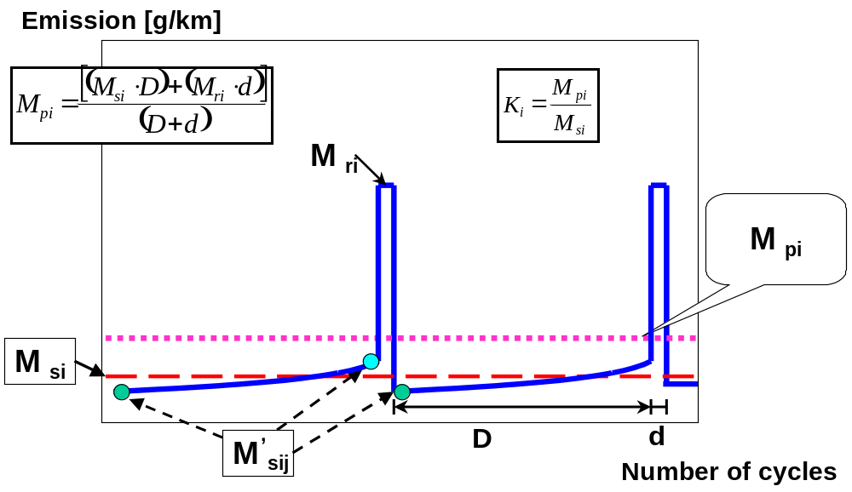
3.1.1. Calculation of the regeneration factor for each compound (i) considered.
The manufacturer may elect to determine for each compound independently either additive offsets or multiplicative factors.
factor:
offset:
, and results, and the manufacturer’s choice of type of factor shall be recorded.
may be determined following the completion of a single regeneration sequence comprising measurements before, during and after regeneration events as shown in Figure A6. App1/1.
3.2. Calculation of exhaust and CO₂ emissions, and fuel consumption of multiple periodic regenerating systems
The following calculation shall be done over one Type 1 operation cycle for exhaust emissions and over each individual phase for CO₂ emission and fuel consumption
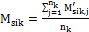 for (4)
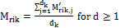 (5)
(6)
(7)
(8)
(9)
factor:
offset:
where:
are the mean mass emissions of all events k of compound (i) without regeneration, g/km;
are the mean mass emissions of all events k of compound (i) during regeneration, g/km;
are the mean mass emission of all events k of compound (i), g/km;
are the mean mass emissions of event k of compound (i) without regeneration, g/km;
are the mean mass emissions of event k of compound (i) during regeneration, g/km;
are the mass emissions of event k of compound (i) in g/km without regeneration measured at point j where , g/km;
are the mass emissions of event k of compound (i) during regeneration (when , the first Type 1 test is run cold, and subsequent cycles are hot) measured at operating cycle j where , g/km;
are the number of complete test cycles of event k, between two cycles where regenerative phases occur, during which emissions measurements (Type 1 WLTCs or equivalent engine test bench cycles) are made, ≥ 2;
is the number of complete operating cycles of event k required for complete regeneration;
is the number of complete operating cycles of event k between two cycles where regenerative phases occur;
is the number of complete regeneration events.
The calculation of is shown graphically in Figure A6.App1/2.

Figure A6.App1/2

Parameters measured during emissions test during and between cycles where regeneration occurs (schematic example)
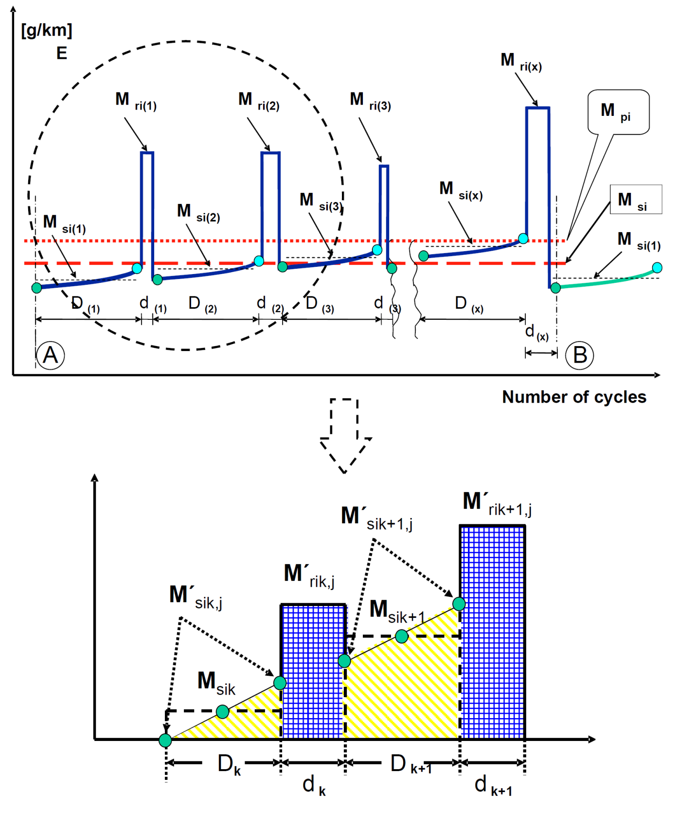
The calculation of for multiple periodic regenerating systems is only possible after a certain number of regeneration events for each system.
After performing the complete procedure (A to B, see Figure A6.App1/2), the original starting condition A should be reached again.
Annex 6 -Appendix 2
Test procedure for electric power supply system monitoring
1. General
This appendix defines the specific provisions regarding the correction of test results for fuel consumption (l/100 km) and CO₂ emissions (g/km) as a function of the energy balance for the vehicle batteries.
The corrected values for fuel consumption and CO₂ emissions should correspond to a zero energy balance (), and are calculated using a correction coefficient determined as defined below.
2. Measurement equipment and instrumentation
2.1. Current transducer
2.1.1. The battery current shall be measured during the tests using a clamp-on or closed type current transducer. The current transducer (i.e. a current sensor without data acquisition equipment) shall have a minimum accuracy of 0.5 per cent of the measured value (in A) or 0.1 per cent of full scale deflection, whichever is smaller.
2.1.2. The current transducer shall be fitted on one of the cables connected directly to the battery. In order to easily measure battery current using external measuring equipment, manufacturers should preferably integrate appropriate, safe and accessible connection points in the vehicle. If this is not feasible, the manufacturer shall support the responsible authority by providing the means to connect a current transducer to the battery cables in the above described manner.
2.1.3. Current transducer output shall be sampled with a minimum frequency of 5 Hz. The measured current shall be integrated over time, yielding the measured value of Q, expressed in ampere-hours (Ah).
2.2. Vehicle on-board data
2.2.1. Alternatively, the battery current shall be determined using vehicle-based data. In order to use this measurement method, the following information shall be accessible from the test vehicle:
(a) Integrated charging balance value since last ignition run in Ah;
(b) Integrated on-board data charging balance value calculated with a minimum sample frequency of 5 Hz;
(c) The charging balance value via an OBD connector as described in SAE J1962.
2.2.2. The accuracy of the vehicle on-board battery charging and discharging data shall be demonstrated by the manufacturer to the responsible authority.
The manufacturer may create a battery monitoring vehicle family to prove that the vehicle on-board battery charging and discharging data are correct. The accuracy of the data shall be demonstrated on a representative vehicle.
The following family criteria shall be valid:
(a) Identical combustion processes;
(b) Identical charge and/or recuperation strategy (software battery data module);
(c) On-board data availability;
(d) Identical charging balance measured by battery data module;
(e) Identical on-board charging balance simulation.
3. Measurement procedure
3.1. External battery charging
Before the preconditioning test cycle, the battery shall be fully charged. The battery shall not be charged again before the official testing according to paragraph 1.2.6.2. of this annex.
3.2. Measurement of the battery current shall start at the same time as the test starts and shall end immediately after the vehicle has driven the complete driving cycle.
3.3. The electricity balance, Q, measured in the electric power supply system, is used as a measure of the difference in the REESS energy content at the end of the cycle compared to the beginning of the cycle. The electricity balance is to be determined for the total WLTC for the applicable vehicle class.
3.4. Separate values of shall be logged over the cycle phases required to be driven for the applicable vehicle class.
3.5. and test results shall be corrected as a function of the REESS energy balance RCB.
3.6. The test results shall be the uncorrected measured values of and in case any of the following applies:
(a) The manufacturer can prove that there is no relation between the energy balance and fuel consumption;
(b) as calculated from the test result corresponds to REESS charging;
(c) as calculated from the test result corresponds to REESS charging and discharging. , expressed as a percentage of the energy content of the fuel consumed over the cycle, is calculated in the equation below:
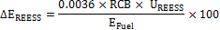
where:
is the change in the REESS energy content, per cent;
is the nominal REESS voltage, V;
RCB is REESS charging balance over the whole cycle, Ah;
is the energy content of the consumed fuel, MJ.
is lower than the RCB correction criteria, according to the equation below and Table 1:
Table A6.App2/1
RCB correction criteria
Cycle | WLTC city(low + medium) | WLTC (low + medium + high) | WLTC(low + medium + high + extra high)
RCB correction criteria (%) | 1.5 | 1 | 0.5
4. Correction method
4.1. To apply the correction function, the electric power to the battery must be calculated from the measured current and the nominal voltage value for each phase of the WLTC test:
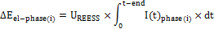
where:
is the change in the electrical REESS energy content of phase i, MJ;
is the nominal REESS voltage, V;
is the electric current in phase (i), A;
is the time at the end of phase (i), seconds (s).
4.2. For correction of fuel consumption, l/100 km, and CO₂ emissions, g/km, combustion process-dependent Willans factors from Table A6.App2/2 (paragraph 4.8. below) shall be used.
4.3. The resulting fuel consumption difference of the engine for each WLTC phase due to load behaviour of the alternator for charging a battery shall be calculated as shown below:
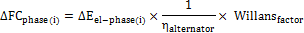
where:
is the resulting fuel consumption difference of phase (i), l;
is the change in the electrical REESS energy content of phase (i), MJ;
is the efficiency of the alternator;
is the combustion process specific Willans factor as defined in Table A6.App2/2.
4.4. The resulting CO₂ emissions difference of the engine for each WLTC phase due to load behaviour of the alternator for charging a battery shall be calculated as shown below:
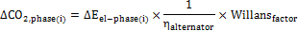
where:
is the resulting CO₂-emission difference of phase (i), g;
is the change in the electrical REESS energy content of phase (i), MJ;
is the efficiency of the alternator;
is the combustion process specific Willans factor as defined in Table A6.App2/2.
4.5. For this specific calculation, a fixed electric power supply system alternator efficiency shall be used:
4.6. The consumption difference of the engine for the WLTC test is the sum over the (i) single phases as shown below:
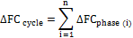
where:
is the change in consumption over the whole cycle, l.
4.7. The CO₂ emissions difference of the engine for the WLTC test is the sum over the (i) single phases as shown below:
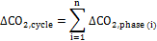
where:
is the change in CO₂-emission over the whole cycle, g.
4.8. For correction of the fuel consumption, l/100 km, and CO₂ emission, g/km, the Willans factors in Table A6.App2/2 shall be used.
Table A6.App2/2
Willans factors
 |  |  | Naturally aspirated | Pressure charged
Positive ignition | Gasoline (E0) | l/kWh | 0.264 | 0.28
Positive ignition | Gasoline (E0) | gCO₂/kWh | 630 | 668
Positive ignition | Gasoline (E5) | l/kWh | 0.268 | 0.284
Positive ignition | Gasoline (E5) | gCO₂/kWh | 628 | 666
Positive ignition | CNG (G20) | m³/kWh | 0.259 | 0.275
Positive ignition | CNG (G20) | gCO₂/kWh | 465 | 493
Positive ignition | LPG | l/kWh | 0.342 | 0.363
Positive ignition | LPG | gCO₂/kWh | 557 | 591
Positive ignition | E85 | l/kWh | 0.367 | 0.389
Positive ignition | E85 | gCO₂/kWh | 608 | 645
Compression ignition | Diesel (B0) | l/kWh | 0.22 | 0.22
Compression ignition | Diesel (B0) | gCO₂/kWh | 581 | 581
Compression ignition | Diesel (B5) | l/kWh | 0.22 | 0.22
Compression ignition | Diesel (B5) | gCO₂/kWh | 581 | 581

Annex 7
Calculations
1. General requirements
1.1. Calculations related specifically to hybrid and pure electric vehicles are described in Annex 8.
1.2. The calculations described in this annex shall be used for vehicles using combustion engines.
1.3.. The final test results shall be rounded in one step to the number of places to the right of the decimal point indicated by the applicable emission standard plus one additional significant figure. Intermediate steps in the calculations shall not be rounded.
1.4. The NO_{x} correction factor, , shall be rounded to 2 decimal places.
1.5. The dilution factor, , shall be rounded to 2 decimal places.
1.6. For information not related to standards, good engineering judgement shall be used.
2. Determination of diluted exhaust gas volume
2.1. Diluted exhaust gas volume calculation for a variable dilution device capable of operating at a constant or variable flow rate.
2.1.1. The parameters showing the volumetric flow shall be recorded continuously. The total volume shall be recorded for the duration of the test.
2.2. Volume calculation for a variable dilution device using a positive displacement pump
2.2.1. The volume shall be calculated using the following equation:
(1)
where:
is the volume of the diluted gas, in litres per test (prior to correction);
is the volume of gas delivered by the positive displacement pump in testing conditions, N⁻¹;
is the number of revolutions per test.
2.2.1.1. Correcting the volume to standard conditions
2.2.1.1.1. The diluted exhaust gas volume, V, shall be corrected to standard conditions according to the following equation:
(2)
where:
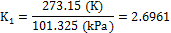
is the test room barometric pressure, kPa;
is the vacuum at the inlet to the positive displacement pump relative to the ambient barometric pressure, kPa;
is the average temperature of the diluted exhaust gas entering the positive displacement pump during the test, Kelvin (K).
3. Mass emissions
3.1. General requirements
3.1.1. Assuming no compressibility effects, all gases involved in the engine intake/combustion/exhaust process can be considered to be ideal according to Avogadro’s hypothesis.
3.1.2. The mass of gaseous compounds emitted by the vehicle during the test shall be determined by obtaining the product of the volumetric concentration of the gas in question and the volume of the diluted exhaust gas with due regard for the following densities under the reference conditions of 273.15 K and 101.325 kPa:
Carbon monoxide (CO) g/l
Carbon dioxide (CO₂) g/l
Hydrocarbons:
for petrol (E0) (C₁H_{1.85}) g/1
for petrol (E5) (C₁H_{1.89}O_{0.016}) g/1
for diesel (B0) (C₁H_{l.86}) g/1
for diesel (B5) (C₁H_{l.86}O_{0.005}) g/1
for LPG (C₁H_{2.525}) g/l
for NG/biomethane (CH₄) g/l
for ethanol (E85) (C₁H_{2,74}O_{0.385}) g/l
Nitrogen oxides (NO_{x}) g/1
Nitrogen dioxide (NO₂) g/1
Nitrous oxide (N₂O) g/1
The density for NMHC mass calculations shall be equal to that of total hydrocarbons at 273.15 K and 101.325 kPa and is fuel-dependent.
3.2. Mass emissions calculation
3.2.1. Mass emissions of gaseous compounds shall be calculated using the following equation:
(3)
where:
is the mass emissions of compound (i), g/km;
is the volume of the diluted exhaust gas expressed in litres per test and corrected to standard conditions (273.15 K and 101.325 kPa);
is the density of compound (i) in grams per litre at normal temperature and pressure (273.15 K and 101.325 kPa);
is a humidity correction factor applicable only to the mass emissions of oxides of nitrogen (NO₂ and NO_{x});
is the concentration of compound (i) in the diluted exhaust gas expressed in ppm and corrected by the amount of the compound (i) contained in the dilution air;
is the distance driven over the corresponding WLTC, km.
3.2.1.1. The concentration of a gaseous compound in the diluted exhaust gas shall be corrected by the amount of the gaseous compound in the dilution air as follows:
(4)
where:
is the concentration of gaseous compound (i) in the diluted exhaust gas corrected by the amount of gaseous compound (i) contained in the dilution air, ppm;
is the measured concentration of gaseous compound (i) in the diluted exhaust gas, ppm;
is the concentration of gaseous compound (i) in the air used for dilution, ppm;
is the dilution factor.
3.2.1.1.1. The dilution factor, , is calculated as follows:
for petrol (E0, E5 and B0) (5a)
for diesel (B5) (5b)
for LPG (5c)
for NG/biomethane (5d)
for ethanol (E85) (5e)
3.2.1.1.2. General equation for the dilution factor (DF) for each reference fuel with an average composition of C_{x}H_{y}O_{z} is:
(6)
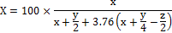
where:
is the concentration of CO₂ in the diluted exhaust gas contained in the sampling bag, per cent volume;
is the concentration of HC in the diluted exhaust gas contained in the sampling bag, ppm carbon equivalent;
is the concentration of CO in the diluted exhaust gas contained in the sampling bag, ppm.
3.2.1.1.3. Methane measurement
3.2.1.1.3.1. For methane measurement using a GC-FID, NMHC is calculated as follows:
(7)
where:
is the corrected concentration of NMHC in the diluted exhaust gas, ppm carbon equivalent;
is the concentration of THC in the diluted exhaust gas, ppm carbon equivalent and corrected by the amount of THC contained in the dilution air;
is the concentration of CH₄ in the diluted exhaust gas, ppm carbon equivalent and corrected by the amount of CH₄ contained in the dilution air;
is the FID response factor to methane as defined in paragraph 5.4.3.2. of Annex5.
3.2.1.1.3.2. For methane measurement using a NMC-FID, the calculation of NMHC depends on the calibration gas/method used for the zero/calibration adjustment.
The FID used for the THC measurement (without NMC) shall be calibrated with propane/air in the normal manner.
For the calibration of the FID in series with NMC, the following methods are permitted :
(a) The calibration gas consisting of propane/air bypasses the NMC;
(b) The calibration gas consisting of methane/air passes through the NMC.
It is strongly recommended to calibrate the methane FID with methane/air through the NMC.
In case (a), the concentration of CH₄ and NMHC shall be calculated as follows:
(8)
(9)
In case (b), the concentration of CH₄ and NMHC shall be calculated as follows:
(10)
(11)
where:
is the HC concentration with sample gas flowing through the NMC, ppm C;
is the HC concentration with sample gas bypassing the NMC, ppm C;
is the methane response factor as determined per paragraph 5.4.3.2 of Annex 5;
is the methane efficiency as determined per paragraph 3.2.1.1.3.3.1. below;
is the ethane efficiency as determined per paragraph 3.2.1.1.3.3.2. below.
If < 1.05, it may be omitted in equations 8, 10 and 11.
3.2.1.1.3.3. Conversion efficiencies of the non-methane cutter (NMC)
The NMC is used for the removal of the non-methane hydrocarbons from the sample gas by oxidizing all hydrocarbons except methane. Ideally, the conversion for methane is 0 per cent, and for the other hydrocarbons represented by ethane is 100 per cent. For the accurate measurement of NMHC, the two efficiencies shall be determined and used for the calculation of the NMHC emission.
3.2.1.1.3.3.1. Methane conversion efficiency
The methane/air calibration gas shall be flowed to the FID through the NMC and bypassing the NMC and the two concentrations recorded. The efficiency shall be determined as follows:
(12)
where:
is the HC concentration with CH₄ flowing through the NMC, ppm C;
is the HC concentration with CH₄ bypassing the NMC, ppm C.
3.2.1.1.3.3.2. Ethane conversion efficiency
The ethane/air calibration gas shall be flowed to the FID through the NMC and bypassing the NMC and the two concentrations recorded. The efficiency shall be determined as follows:
(13)
where:
is the HC concentration with C₂H₆ flowing through the NMC, ppm C;
is the HC concentration with C₂H₆ bypassing the NMC in ppm C.
If the ethane conversion efficiency of the NMC is 0.98 or above, E_{E} shall be set to 1 for any subsequent calculation.
3.2.1.1.3.4. If the methane FID is calibrated through the cutter, then E_{M} is 0.
Equation (10) from above becomes:
(14)
Equation (11) from above becomes:
(15)
The density used for NMHC mass calculations shall be equal to that of total hydrocarbons at 273.15 K and 101.325 kPa and is fuel-dependent.
3.2.1.1.4. Flow weighted average concentration calculation
The following calculation method shall only be applied for CVS systems that are not equipped with a heat exchanger or for CVS systems with a heat exchanger that do not comply with paragraph 3.3.5.1. of Annex 5.
When the CVS flow rate over the test varies more than ±3 per cent of the average flow rate, a flow weighted average shall be used for all continuous diluted measurements including PN:
(16)
where:
is the flow-weighted average concentration;
is the CVS flow rate at time , m³/min;
is the concentration at time , ppm;
sampling interval, seconds (s);
total CVS volume, m³.
3.2.1.2. Calculation of the NO_{x} humidity correction factor
In order to correct the influence of humidity on the results of oxides of nitrogen, the following calculations apply:
(17)
where:
(18)
and:
is the absolute humidity, grams of water per kilogram of dry air;
is the relative humidity of the ambient air, per cent;
is the saturation vapour pressure at ambient temperature, kPa;
is the atmospheric pressure in the room, kPa.
The KH factor shall be calculated for each phase of the test cycle.
The ambient temperature and relative humidity shall be defined as the average of the continuously measured values during each phase.
3.2.1.3. Determination of NO₂ concentration from NO and NO_{x}
NO₂ is determined by the difference between NO_{x} concentration from the bag corrected for dilution air concentration and NO concentration from continuous measurement corrected for dilution air concentration
3.2.1.3.1. NO concentrations
3.2.1.3.1.1. NO concentrations shall be calculated from the integrated NO analyser reading, corrected for varying flow if necessary.
3.2.1.3.1.2. The average NO concentration is calculated as follows:
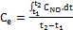 (19)
where:
is the integral of the recording of the modal NO analyser over the test (t₂-t₁);
is the concentration of NO measured in the diluted exhaust, ppm;
3.2.1.3.1.3. Dilution air concentration of NO is determined from the dilution air bag. Correction is carried out according to paragraph 3.2.1.1. of this annex.
3.2.1.3.2. NO₂ concentrations
3.2.1.3.2.1. Determination NO₂ concentration from direct diluted measurement
3.2.1.3.2.2. NO₂ concentrations shall be calculated from the integrated NO₂ analyser reading, corrected for varying flow if necessary.
3.2.1.3.2.3. The average NO₂ concentration is calculated as follows:
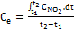 (20)
where:
is the integral of the recording of the modal NO₂ analyser over the test (t₂-t₁);
is the concentration of NO₂ measured in the diluted exhaust, ppm.
3.2.1.3.2.4. Dilution air concentration of NO₂ is determined from the dilution air bags. Correction is carried out according to paragraph 3.2.1.1. of this annex.
3.2.2. Determination of the HC mass emissions from compression-ignition engines
3.2.2.1. To calculate HC mass emission for compression-ignition engines, the average HC concentration is calculated as follows:
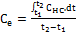 (21)
where:
is the integral of the recording of the heated FID over the test (t₁ to t₂);
is the concentration of HC measured in the diluted exhaust in ppm of and is substituted for in all relevant equations.
3.2.2.1.1. Dilution air concentration of HC shall be determined from the dilution air bags. Correction shall be carried out according to paragraph 3.2.1.1. of this annex.
3.2.3. CO₂ calculation for individual vehicles in a CO₂ vehicle family
3.2.3.1. CO₂ emissions without using the interpolation method
If the road load and emissions have been not been measured on test vehicle L in addition to test vehicle H, the value , as calculated in paragraph 3.2.1. above, shall be attributed to all individual vehicles in the CO₂ vehicle family and the CO₂ interpolation method is not applicable.
3.2.3.2. CO₂ emissions using the interpolation method
If the road load and emissions are measured on test vehicles L and H, the CO₂ emission for each individual vehicle in the CO₂ vehicle family may be calculated according to the CO₂ interpolation method outlined in the following paragraphs.
3.2.3.2.1. Determination of CO₂ emissions test vehicles L and H
The mass of CO₂ emissions, , for test vehicles L and H shall be determined according to the calculation in paragraph 3.2.1. above for the individual cycle phases p of the WLTC applicable for the class of the CO₂ vehicle family. and are referred to as and respectively.
3.2.3.2.2. Road load calculation for an individual vehicle
3.2.3.2.2.1. Mass of the individual vehicle
The selected test masses TM_{L} and TM_{H} as determined in paragraph 4.2.1.3.1. of Annex 4 shall be used as input for the interpolation method.
The mass of the optional equipment shall be calculated for the individual vehicle according to the following equation:
(22)
where:
is the difference in mass between the individual vehicle and ;
is the mass of an individual option i on the vehicle ( is positive for an option that adds mass with respect to and vice versa);
is the number of options that are different between the individual vehicle and test vehicle L.
The value of for test vehicle H shall be the same as the difference between and .
The mass of the individual vehicle is calculated according to the following equation:
(23)
where is the mass of the individual vehicle used as input for the CO₂interpolation method.
If the same test mass was used for test vehicles L and H, the value of shall be set to for the interpolation method.
3.2.3.2.2.2. Rolling resistance of the individual vehicle
According to paragraph 4.2.2.1. of Annex 4, the actual rolling resistance values for the selected tyres on test vehicle L, RR_{L}, and test vehicle H, RR_{H}, shall be used as input for the interpolation method.
For the tyres fitted to the individual vehicle, the value of the rolling resistance shall be set to the class value of the applicable tyre rolling resistance class, according to Table A4/1of Annex 4.
If the same tyres were fitted to test vehicles L and H, the value of for the interpolation method shall be set to
3.2.3.2.2.3. Aerodynamic drag of the individual vehicle
The aerodynamic drag shall be measured for each of the drag influencing options at a certified wind tunnel fulfilling the requirements of paragraph 3.2. of Annex 4.
The responsible authority shall verify if the wind tunnel facility is qualified to accurately determine the for options and/or body shapes that differ between test vehicle L and H. If the wind tunnel facility is not qualified, the for vehicle H shall apply for the whole CO₂ vehicle family.The aerodynamic drag of options on the exterior of the individual vehicle shall be calculated according to the following equation:
(24)
where:
is the aerodynamic drag coefficient;
is the frontal area of the vehicle, m²;
is the difference in aerodynamic drag between the individual vehicle and the test vehicle L, due to options on the vehicle that differ from those installed on the test vehicle L, m²;
is the aerodynamic drag difference by an individual feature i on the vehicle ( is positive for an option that adds aerodynamic drag with respect to test vehicle L and vice versa), m²;
is the number of options on the vehicle that are different between the individual and the test vehicle L.
The sum of all between options installed on the test vehicles L and H shall correspond to the total difference between the values for the test vehicles L and H, referred to as.
The sum of all, expressed as , between options installed on the test vehicles L and H shall correspond to the difference in between the test vehicles L and H.
If the same options on the vehicle were also installed on test vehicles L and H, the value of for the interpolation method shall be set to zero.
3.2.3.2.2.4. Calculation of road load for individual vehicles in the CO₂ vehicle family
The road load coefficients , and (as defined of Annex 4) for the test vehicles H and L are referred to as , and and , and respectively. An adjusted road load curve for the test vehicle L is defined as follows:
(25)
Applying the least squares regression method, adjusted road load coefficients and shall be determined for with the linear coefficient set to . The road load coefficients , and for the individual vehicle in the CO₂ vehicle family are calculated as follows:
(26)
or, if = 0,
(27)
(28)
(29)
or, if = 0,
(30)
where:
(31)
(32)
3.2.3.2.2.5. Calculation of cycle energy per phase
The cycle energy demand and distance per cycle phase p applicable for individual vehicles in the CO₂ vehicle family shall be calculated according to the procedure in paragraph 5. of this annex, for the following sets k of road load coefficients and masses:
k=1: (33)
(test vehicle L)
k=2: (34)
(test vehicle H)
k=3: (35)
(individual vehicle in the CO₂ vehicle family)
3.2.3.2.2.6. Calculation of the CO₂ value for an individual vehicle by the CO₂ interpolation method
For each cycle phase p of the WLTC applicable for individual vehicles in the CO₂ vehicle family, the contribution to the total mass of CO₂ for the individual vehicle shall be calculated as follows:
(36)
The CO₂ mass emissions attributed to the individual vehicle of the CO₂ vehicle family shall be calculated by the following equation:
(37)
for all of the applicable cycle phases .
3.3. Mass of particulate emissions
3.3.1. Calculation of particulate mass emissions using the double dilution method Particulate emission (g/km) is calculated as follows:
(38)
where exhaust gases are vented outside tunnel;
and:
(39)
where exhaust gases are returned to the tunnel;
where:
is the volume of diluted exhaust gases (see paragraph 2. of this annex), under standard conditions;
is the volume of diluted exhaust gas flowing through the particulate filter under standard conditions;
is the particulate mass collected by one or more filters, mg;
is the distance corresponding to the operating cycle, km;
is the particulate emission, g/km.
3.3.1.1. Where correction for the particulate background level from the dilution system has been used, this shall be determined in accordance with paragraph 1.2.1.3.1. of Annex 6. In this case, the particulate mass (g/km) shall be calculated as follows:
(40)
in the case where exhaust gases are vented outside tunnel;
(41)
in the case where exhaust gases are returned to the tunnel;
where:
is the volume of tunnel air flowing through the background particulate filter under standard conditions;
is the rolling average of the particulate mass collected from the dilution tunnel as specified in this gtr up to a maximum equivalent of 1mg/km at the same CVS and particulate sampling flow rates;
is the dilution factor determined in paragraph 3.2.1.1.1. of this annex.
Where application of a background correction results in a negative particulate mass (in g/km), the result shall be considered to be zero g/km particulate mass.
3.3.2. Calculation of particulate mass emissions using the double dilution method
(42)
where:
is the volume of diluted exhaust gas flowing through the particulate filter under standard conditions;
is the volume of the double diluted exhaust gas passing through the particulate collection filters;
is the volume of the secondary dilution air.
Where the secondary diluted PM sample gas is not returned to the tunnel, the CVS volume shall be calculated as in single dilution, i.e.:
(43)
where is the measured volume of diluted exhaust gas in the dilution system following extraction of particulate sample under standard conditions.
4. Determination of particle numbers
4.1. Number emission of particles shall be calculated by means of the following equation:
(44)
where:
is the particle number emission, particles per kilometre;
is the volume of the diluted exhaust gas in litres per test (after primary dilution only in the case of double dilution) and corrected to standard conditions (273.15 K and 101.325 kPa);
is a calibration factor to correct the particle number counter measurements to the level of the reference instrument where this is not applied internally within the particle number counter. Where the calibration factor is applied internally within the particle number counter, the calibration factor shall be 1;
is the corrected concentration of particles from the diluted exhaust gas expressed as the average number of particles per cubic centimetre figure from the emissions test including the full duration of the drive cycle. If the volumetric mean concentration results () from the particle number counter are not measured at standard conditions (273.15 K and 101.325 kPa), the concentrations shall be corrected to those conditions ();
is either the dilution air or the dilution tunnel background particle concentration, as permitted by the responsible authority, in particles per cubic centimeter, corrected for coincidence and to standard conditions (273.15 K and 101.325 kPa);
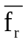 is the mean particle concentration reduction factor of the volatile particle remover at the dilution setting used for the test;
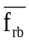 is the mean particle concentration reduction factor of the volatile particle remover at the dilution setting used for the background measurement;
is the distance corresponding to the operating cycle, km
shall be calculated from the following equation:
(45)
where:
is a discrete measurement of particle concentration in the diluted gas exhaust from the particle counter; particles per cubic centimetre and corrected for coincidence;
is the total number of discrete particle concentration measurements made during the operating cycle and shall be calculated using the following equation:
(46)
where:
is the time duration of the operating cycle, s;
is the data logging frequency of the particle counter, Hz.
5. Calculation of cycle energy demand
Basis of the calculation is the target speed trace given in discrete time sample points between and . In case of the Class 2 and Class 3 cycles, s and s. For a specific cycle phase, and shall be taken from Annex 1.
For the calculation, each time sample point is interpreted as time period. The duration ∆t of these periods depends on the sampling frequency (1 s for 1 Hz, 0.5 s for 2 Hz or 0.1 s for 10 Hz).
The total energy demand E for the whole cycle or a specific cycle phase shall be calculated by summing over the corresponding cycle time between t_{start} and t_{end} according to the following equation:
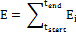
where:
if (47a)
if (47b)
and:
is the energy demand during time period (i-1) to (i), Ws;
is the driving force during time period (i-1) to (i), N;
is the distance travelled during time period (i-1) to (i), m.
(48)
where:
is the driving force during time period (i-1) to (i), N;
is the target velocity at time t_{i} km/h;
is the test mass, kg;
is the acceleration during time period (i-1) to (i), m/s²;
, , are the road load coefficients for the test vehicle under consideration (, or ) in N, N/km/h and in N/(km/h)² respectively.
(49)
where:
is the distance travelled in time period (i-1) to (i), m;
is the target velocity at time , km/h;
is time, s.
(50)
where:
is the acceleration during time period (i-1) to (i), m/s²;
is the target velocity at time , km/h;
is time, s.
6. Calculation of fuel consumption
6.1. The fuel characteristics required for the calculation of fuel consumption values shall be taken from Annex 3 to this global technical regulation.
6.2. The fuel consumption values shall be calculated from the emissions of hydrocarbons, carbon monoxide, and carbon dioxide determined from the measurement results using the provisions defined in this global technical regulation.
6.3. For a vehicle with a positive ignition engine fuelled with petrol (E0)
6.4. For a vehicle with a positive ignition engine fuelled with petrol (E5)
6.5. For a vehicle with a positive ignition engine fuelled with petrol (E10)
6.6. For a vehicle with a positive ignition engine fuelled with LPG
6.6.1. If the composition of the fuel used for the test differs from the composition that is assumed for the calculation of the normalised consumption, on the manufacturer's request a correction factor cf may be applied, as follows:
The correction factor , which may be applied, is determined as follows
where:
is the actual H/C ratio of the fuel used.
6.7. For a vehicle with a positive ignition engine fuelled with NG/biomethane
6.8. For a vehicle with a compression engine fuelled with diesel (B0)
6.9. For a vehicle with a compression engine fuelled with diesel (B5)
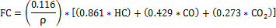
6.10. For a vehicle with a compression engine fuelled with diesel (B7)
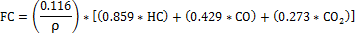
6.11. For a vehicle with a positive ignition engine fuelled with ethanol (E85)
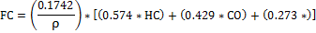
where for all equations in paragraph 6:
is fuel consumption in l/100 km (or m³ per km in the case of natural gas);
are the measured emissions of hydrocarbons, g/km;
are the measured emissions of carbon monoxide, g/km;
are the measured emissions of carbon dioxide, g/km;
is the density of the test fuel.
Annex 8
Pure and hybrid electric vehicles
1. General requirements
In the case of testing NOVC-HEV and OVC-HEV vehicles, Appendix 2 to this annex replaces Appendix 2 to Annex 6.
1.1. Energy balance
The energy balance shall be the sum of the ∆E_{REESS} of all rechargeable electric energy storage systems (REESS), i.e. the sum of the RCB values multiplied by the respective nominal V_{REESS} for each REESS.
1.2. Electric energy consumption and range testing
Parameters, units and accuracy of measurements shall be as in Table A8/1.
Table A8/1
Parameters, units and accuracy of measurements
Parameter | Units | Accuracy | Resolution
Electrical energy ⁽¹⁾ | Wh | ±1 per cent | 0.001 Wh⁽²⁾
Electrical current | A | ±0.3 per cent FSD or ±1 per cent of reading ^{(3,4)} | 0.01 A
⁽¹⁾ Equipment: static meter for active energy.
⁽²⁾ AC watt-hour meter, Class 1 according to IEC 62053-21 or equivalent.
⁽³⁾ Whichever is greater.
⁽⁴⁾ Current integration frequency 10 Hz or more.
1.3. Emission and fuel consumption testing
Parameters, units and accuracy of measurements shall be the same as those required for conventional combustion engine-powered vehicles as found of Annex 5 (test equipment and calibrations).
1.4. Measurement units and presentation of results
The accuracy of measurement units and the presentation of the results shall follow the indications given in Table A8/2.
Table A8/2
Accuracy of measurement units and presentation of the results
Parameter | Units | Communication of test result
AER, AERcity | km | Rounded to nearest whole number
EAER | km | Rounded to nearest whole number
R_{CDA} | km | Rounded to nearest whole number
R_{CDC} | km | Rounded to nearest whole number
Distance | km | Rounded to nearest whole number;  for calculation purposes: 0.1 km
Electric energy consumption | Wh/km | Rounded to nearest whole number
NEC | Wh | Rounded to first decimal place
NEC ratio | per cent | Rounded to first decimal place
E_{AC} recharge E | Wh | Rounded to nearest whole number
FC correction factor | l/100 km/(Wh/km) | Rounded to 4 significant digits
CO₂ correction factor | g/km/(Wh/km) | Rounded to 4 significant digits
Utility factor |  | Rounded to 3 decimal places
1.5. Type 1 test cycles to be driven according to Table A8/3.
1.5.1. All OVC-HEVs, NOVC-HEVs and PEVs with and without driver-selectable operating modes shall be classified as Class 3 vehicles.
1.5.1.1. OVC-HEV and PEV
1.5.1.1.1. WLTC test
1.5.1.1.1.1. Class 3a vehicles shall drive a cycle consisting of a low phase (Low₃), a medium phase (Medium₃₋₁), a high phase (High₃₋₁) and an extra high phase (Extra High₃).
1.5.1.1.1.2. Class 3b vehicles shall drive a cycle consisting of a low phase (Low₃), a medium phase (Medium₃₋₂), a high phase (High₃₋₂) and an extra high phase (Extra High₃).
1.5.1.1.1.3. At the option of the Contracting Party, the Extra High₃ phase may be excluded.
1.5.1.1.2. WLTC city test
1.5.1.1.2.1. Class 3a vehicles shall drive a cycle consisting of a low phase (Low₃) and a medium phase (Medium₃₋₁)
1.5.1.1.2.2. Class 3b vehicles shall drive a cycle consisting of a low phase (Low₃) and a medium phase (Medium₃₋₂)
1.5.1.2. NOVC-HEV
1.5.1.2.1. WLTC test
1.5.1.2.1.1. Class 3a vehicles shall drive a cycle consisting of a low phase (Low₃), a medium phase (Medium₃₋₁), a high phase (High₃₋₁) and an extra high phase (Extra High₃).
1.5.1.2.1.2. Class 3b vehicles shall drive a cycle consisting of a low phase (Low₃), a medium phase (Medium₃₋₂), a high phase (High₃₋₂) and an extra high phase (Extra High₃).
1.5.1.2.1.3. At the option of the Contracting Party, the Extra High₃ phase may be excluded.
Table A8/3
Test matrix
 |  | WLTP |  | WLTP city
 |  | Criteria Emissions, FC, CO₂, AER, EAER, R_{CDC}, R_{CDA}, E_{AC} | Criteria Emissions, FC, CO₂ | AERcity, E_{AC}city
 |  | Charge-depleting | Charge-sustaining | Charge-depleting
OVC-HEV | Class 3a | Low₃ + Medium₃₋₁ + High₃₋₁ + (ExtraHigh₃) | Low₃ + Medium₃₋₁ + High₃₋₁ + (ExtraHigh₃) | Low₃ + Medium₃₋₁
OVC-HEV | Class 3b | Low₃ + Medium₃₋₂ + High₃₋₂ + (ExtraHigh₃) | Low₃ + Medium₃₋₂ + High₃₋₂ + (ExtraHigh₃) | Low₃ + Medium₃₋₂
NOVC-HEV | Class 3a | -- | Low₃ + Medium₃₋₁ + High₃₋₁ + (ExtraHigh₃) | --
NOVC-HEV | Class 3b | -- | Low₃ + Medium₃₋₂ + High₃₋₂ + (ExtraHigh₃) | --
PEV | Class 3a | Low₃ + Medium₃₋₁ + High₃₋₁ + (ExtraHigh₃) | -- | Low₃ + Medium₃₋₁
PEV | Class 3b | Low₃ + Medium₃₋₂ + High₃₋₂ + (ExtraHigh₃) | -- | Low₃ + Medium₃₋₂
1.6. OVC-HEVs. NOVC-HEVs and PEVs with manual transmissions shall be driven according to the manufacturer’s instructions, as incorporated in the manufacturer's handbook of production vehicles and indicated by a technical gear shift instrument.
2. REESS Preparation
2.1. For all OVC-HEVs, NOVC-HEVs, and PEVs with and without driver-selectable operating modes, the following shall apply:
(a) Without prejudice to the requirements of paragraph 1.2.3.3. of Annex 6, the vehicles tested to this annex must have been driven at least 300 km with those batteries installed in the test vehicle;
(b) If the batteries are operated above the ambient temperature, the operator shall follow the procedure recommended by the car manufacturer in order to keep the temperature of the REESS in its normal operating range. The manufacturer's agent shall be in a position to demonstrate that the thermal management system of the REESS is neither disabled nor reduced.
3. Test procedure
3.1. General requirements
3.1.1. For all OVC-HEVs, NOVC-HEVs, and PEVs with and without driver-selectable operating modes, the following shall apply where applicable:
3.1.1.1. Vehicles shall be conditioned, soaked and tested according to the test procedures applicable to vehicles powered solely by a combustion engine described in Annex 6 to this gtr unless modified by this annex.
3.1.1.2. If the vehicles cannot follow the speed trace, the acceleration control shall be fully activated until the required speed trace is reached again. Power to mass calculations and classification methods shall not apply to these vehicle types.
3.1.1.3. The vehicle shall be started by the means provided for normal use to the driver.
3.1.1.4. Exhaust emission sampling and electricity measuring shall begin for each test cycle before or at the initiation of the vehicle start up procedure and end on conclusion of each test cycle.
3.1.1.5. Emissions compounds shall be sampled and analysed for each individual WLTC phase when the combustion engine starts consuming fuel.
3.1.2. Forced cooling as per paragraph 1.2.7.2. of Annex 6 shall apply only for the charge-sustaining test and for the testing of NOVC-HEVs.
3.2. OVC-HEV, with and without driver-selectable operating modes
3.2.1. Vehicles shall be tested under charge-depleting (CD) and charge-sustaining (CS) conditions according to the cycles described in paragraph 1.5.1.1.1. of this annex.
3.2.2. Vehicles may be tested according to four possible test sequences:
3.2.2.1. Option 1: charge-depleting test with a subsequent charge-sustaining test (CD + CS test).
3.2.2.2. Option 2: charge-sustaining test with a subsequent charge-depleting test (CS + CD test).
3.2.2.3. Option 3: charge-depleting test with no subsequent charge-sustaining test (CD test).
3.2.2.4. Option 4: charge-sustaining test with no subsequent charge-depleting test (CS test).

Figure A8/1

Possible test sequences in case of OVC-HEV testing
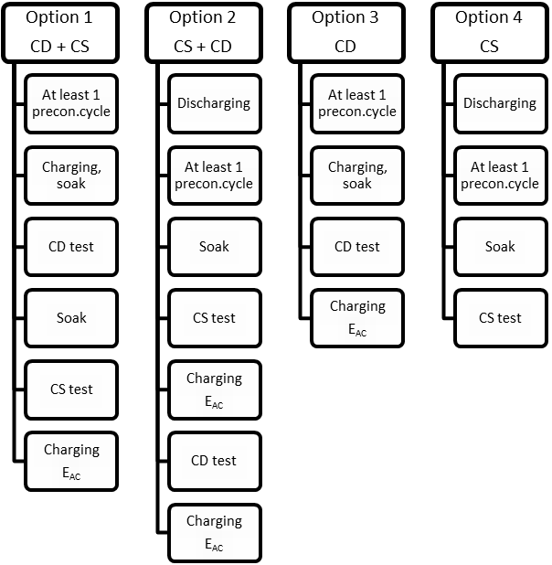
3.2.3. The driver selectable operating mode switch shall be set according to the test conditions.
3.2.4. Charge-depleting (CD) test with no subsequent charge-sustaining (CS) test (option 3)
3.2.4.1. Preconditioning
The vehicle shall be prepared according to the procedures in Appendix 4, paragraph 2.2. of this annex.
3.2.4.2. Test conditions
3.2.4.2.1. The test shall be carried out with a fully charged REESS according the charging requirements as described in 2.2.5. of Appendix 4 to this annex.
3.2.4.2.2. Operation mode selection
3.2.4.2.2.1. The charge-depleting test shall be performed by using the most electric energy consuming mode that best matches the driving cycle. If the vehicle cannot follow the trace, other installed propulsion systems shall be used to allow the vehicle to best follow the cycle.
3.2.4.2.2.2. Dedicated driver-selectable modes such as "mountain mode" or "maintenance mode" which are not intended for normal daily operation but only for special limited purposes shall not be considered for charge-depleting condition testing.
3.2.4.3. Type 1 test procedure
3.2.4.3.1. The charge-depleting test procedure shall consist of a number of consecutive cycles, each followed by a maximum of 30 minute soak period until charge-sustaining operation is achieved.
3.2.4.3.2. During soaking between individual WLTCs, the key switch shall be in the "off" position, and the REESS shall not be recharged from an external electric energy source. The RCB instrumentation shall not be turned off between test cycle phases. In the case of ampere-hour meter measurement, the integration shall remain active throughout the entire test until the test is concluded.
Restarting after soak, the vehicle shall be operated in the required driver-selectable operation mode.
3.2.4.3.3. In deviation from paragraph 5.3.1. of Annex 5 and without prejudice to paragraph 5.3.1.3., analysers may be calibrated and zero checked before and after the charge-depleting test.
3.2.4.4. End of the charge-depleting test
The end of the charge-depleting test is considered to have been reached at the end of WLTC n (defined as the transition cycle) when the break-off criteria during cycle n + 1 is reached for the first time.
3.2.4.4.1. For vehicles without charge-sustaining capability on the complete WLTC, end of test is reached by an indication on a standard on-board instrument panel to stop the vehicle, or when the vehicle deviates from the prescribed driving tolerance for four seconds or more. The acceleration controller shall be deactivated. The vehicle shall be braked to a standstill within sixty seconds.
3.2.4.5. Break-off criteria
3.2.4.5.1. The break-off criteria for the charge-depleting test is reached when the relative net energy change, , as shown in the equation below is less than 4 per cent.
where:
is the net energy change, per cent;
is the REESS charge balance, Ah;
nominal REESS voltage is the voltage of an electrochemical system according to DIN EN 60050-482.
3.2.4.6. REESS charging and measuring electric energy consumption
The vehicle shall be connected to the mains within 120 minutes after the conclusion of the charge-depleting Type 1 test. The energy measurement equipment, placed before the vehicle charger, shall measure the charge energy, E_{AC}, delivered from the mains, as well as its duration. Electric energy measurement can be stopped when the state of charge after the CD test is at least equal to the state of charge measured before the CD test. The state of charge can be determined by on-board or external instruments.
3.2.4.7. Each individual full WLTC within the charge-depleting test shall fulfil the applicable exhaust emission limits according to paragraph 1.1.1.2. of Annex 6.
3.2.5. CS test with no subsequent CD test (option 4)
3.2.5.1. Preconditioning
The vehicle shall be prepared according to the procedures in paragraph 2.1. of Appendix 4 to this annex.
3.2.5.2. Test conditions
3.2.5.2.1. Tests shall be carried out with the vehicle operated in charge-sustaining operation condition in which the energy stored in the REESS may fluctuate but, on average, is maintained at a charging neutral balance level while the vehicle is driven.
3.2.5.2.2. For vehicles equipped with a driver-selectable operating mode, the charge-sustaining test shall be performed in the charging balance neutral hybrid mode that best matches the target curve.
3.2.5.2.3. The profile of the state of charge of the REESS during different stages of the Type 1 test in CD and CS mode respectively is given in Appendices 1a and 1b to this annex.
3.2.5.2.4. Upon request of the manufacturer and with approval of the responsible authority, the manufacturer may set the start state of charge of the traction REESS for the charge-sustaining test.
3.2.5.3. Type 1 test procedure
3.2.5.3.1. If required by paragraph 4.2.1.3. of this annex, CO₂, emissions and fuel consumption results shall be corrected according to the RCB correction as described in Appendix 2 of this annex.
3.2.5.3.2. The charge-sustaining test shall fulfil the applicable exhaust emission limits according to paragraph 1.1.1.2. of Annex 6.
3.2.6. CD test with a subsequent CS test (option 1)
3.2.6.1. The procedures for the CD test from paragraph 3.2.4.1. up to and including paragraph 3.2.4.5. of this annex shall be followed.
3.2.6.2. Subsequently, the procedures for the CS test from paragraph 3.2.5.1. up to and including paragraph 3.2.5.3. (except paragraph 3.2.5.2.5.) in this annex shall be followed.
3.2.6.3. REESS charging and measuring electric energy consumption
The vehicle shall be connected to the mains within 120 minutes after the conclusion of the charge-sustaining Type 1 test. The energy measurement equipment, placed before the vehicle charger, shall measure the charge energy, E, delivered from the mains, as well as its duration. Electric energy measurement may be stopped when the state of charge after the CS test is at least equal to the state of charge measured before the CD test. The state of charge shall be determined by on-board or external instruments.
3.2.7. CS test with a subsequent CD test (option 2)
3.2.7.1. The procedures for the CS test from paragraph 3.2.5.1. to paragraph 3.2.5.3. and paragraph 3.2.6.3. in this annex shall be followed.
3.2.7.2. Subsequently, the procedures for the CD test from paragraph 3.2.4.3. to paragraph 3.2.4.7. of this annex shall be followed.
3.2.8. Cycle energy demand
3.2.8.1. Cycle energy demand of the test vehicle shall be calculated according to paragraph 5 of Annex 7.
3.2.9. Electric range determination
3.2.9.1. The charge-depleting test procedure as described in paragraph 3.2.4. of this annex shall apply to electric range measurements.
3.2.9.2. All-electric range (AER, AERcity)
3.2.9.2.1. The total distance travelled over the test cycles from the beginning of the charge-depleting test to the point in time during the test when the combustion engine starts to consume fuel shall be measured.
3.2.9.2.2. At the option of the Contracting Party, the determination of AERcity may be excluded.
3.2.9.3. Equivalent all-electric range (EAER)
3.2.9.3.1. The range shall be calculated according to paragraph 4.4.1.2. below.
3.2.9.4. Charge-depleting cycle range (R_{CDC} )
3.2.9.4.1. The distance from the beginning of the charge-depleting test to the end of the last cycle prior to the cycle or cycles satisfying the break-off criteria shall be measured. This shall include the distance travelled during the transition cycle where the vehicle operates in both depleting and sustaining modes. If the charge-depleting test possesses a transition range, the shall include those transition cycles or cycles.
3.2.9.5. Actual charge-depleting range (R_{CDA})
3.2.9.5.1. The range shall be calculated according to paragraph 4.4.1.4. below.
3.3. NOVC-HEV, with and without driver-selectable operating modes
3.3.1. Vehicles shall be tested under charge-sustaining (CS) conditions according to the cycles described in paragraph 1.5.1.2.1. of this annex.
3.3.2. Vehicle and REESS Conditioning
3.3.2.1. Alternatively, at the request of the manufacturer, the level of the state of charge of the traction REESS for the charge-sustaining test may be set according to manufacturer’s recommendation in order to achieve a charge balance neutral charge-sustaining test.
3.3.3. Type 1 Test
3.3.3.1. If required by paragraph 4.2.2. of this annex, CO₂ emissions and fuel consumption results shall be corrected according to the RCB correction described in Appendix 2 to this annex.
3.4. PEV, with and without driver-selectable operating mode
3.4.1. Vehicles shall be tested under charge-depleting (CD) conditions according to the cycles described in paragraph 1.5.1.1. of this annex.
3.4.2. The total distance travelled over the test cycles from the beginning of the charge-depleting test until the break-off criteria is reached shall be recorded.
3.4.3. Breaks for the driver and/or operator shall be permitted only between test cycles as described in Table A8/4.
Table A8/4
Breaks for the driver and/or test operator
Distance driven (km) | Maximum total break time (min)
Up to 100 | 10
Up to 150 | 20
Up to 200 | 30
Up to 300 | 60
More than 300 | Shall be based on the manufacturer’s recommendation
Note: During a break, the propulsion system switch shall be in the "OFF" position.
3.4.4. Testing
3.4.4.1. If the vehicle is equipped with a driver-selectable operating mode, the charge-depleting test shall be performed in the highest electric energy consumption mode that best matches the speed trace.
3.4.4.2. The measurement of all-electric range AER and electric energy consumption shall be performed during the same test.
3.4.4.3. All-electric range test
3.4.4.3.1. The test method shall include the following steps:
(a) Initial charging of the traction REESS;
(b) Driving consecutive WLTCs until the break-off criteria is reached and measuring AER;
(c) Recharging the traction REESS and measuring electric energy consumption.
3.4.4.3.1.1. The all-electric range test shall be carried out with a fully charged traction REESS according to the charging requirements as described in paragraph 3. of Appendix 4 to this annex.
3.4.4.3.1.2. WLTCs shall be driven and the all-electric range (AER) distance shall be measured.
3.4.4.3.1.3. The end of the test occurs when the break-off criteria is reached.
The break-off criteria shall have been reached when the vehicle deviates from the prescribed driving tolerance for four seconds or more. The acceleration controller shall be deactivated. The vehicle shall be braked to a standstill within sixty seconds.
3.4.4.3.1.4. The vehicle shall be connected to the mains within 120 minutes after the conclusion of the all-electric range AER determination. The energy measurement equipment, placed before the vehicle charger, shall measure the charge energy, E_{AC}, delivered from the mains, as well as its duration. Electric energy measurement may be stopped when the state of charge after the range test is at least equal to the state of charge measured before the range test. The state of charge shall be determined by on-board or external instruments.
3.4.4.4. All-electric range city (AERcity) test
3.4.4.4.1. The test method includes the following steps:
(a) Initial charging of the traction REESS;
(b) Driving consecutive WLTC city cycles until the break-off criteria is reached and measuring AERcity;
(c) Recharging the traction REESS and measuring electric energy
3.4.4.4.1.1. The initial charging procedure of the traction REESS shall start with a normal charging and the end of charge criteria shall be as defined in paragraph 3.4.4.3.1.5. above and in Appendix 4 of this annex.
3.4.4.4.1.2. City cycles shall be driven and the all-electric range city (AERcity) distance shall be measured.
3.4.4.4.1.3. The end of the test occurs when the break-off criteria is reached according to paragraph 3.4.4.3.1.3. above.
4. Calculations
4.1. Emission compound calculations
Exhaust gases shall be analysed according to Annex 6. All equations shall apply to WLTC tests.
4.1.1. OVC-HEV with and without operating mode switch
4.1.1.1. Charge-depleting mode emissions
The level of the emission compounds at charge-depleting, , shall be calculated as follows:
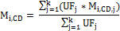
where:
is the mass of the emissions compound measured during the j^{th} phase, g/km;
is the emissions compound;
is the fractional utility factor of the j^{th} phase;
is the index number of the phases up to the end of the transition cycle n:
is the number of phases driven until the end of transition cycle n.
4.1.1.2. Charge-sustaining mode emissions
4.1.1.2.1. The charging balance correction (RCB) calculation is not required for the determination of emissions compounds.
4.1.1.3. Weighted emissions compounds
The weighted emissions compounds , from the charge-depleting and charge-sustaining test results shall be calculated using the equation below:
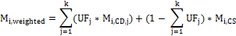
where:
is the utility factor-weighted exhaust emissions of each measured emission compound, g/km;
is the emissions compound;
is the fractional utility factor of the j^{th} phase;
are the compound mass emissions measured during the j^{th} charge-depleting phase, g/km;
are the compound mass emissions for the charge-sustaining test according to 3.2.5., g/km;
is the index number of the phases up to the end of the transition cycle n;
is the number of phases driven until the end of transition cycle n.
4.1.2. NOVC-HEV with and without driver-selectable operating modes
4.1.2.1. Exhaust emissions shall be calculated as required for conventional vehicles according to Annex 7.
4.1.2.2. The charging balance correction (RCB) calculation is not required for the determination of emissions compounds.
4.2. CO₂ and fuel consumption calculations
Exhaust gases shall be analysed according to Annex 6.
4.2.1. OVC-HEV with and without an operating mode switch
All equations shall apply to the WLTC tests.
4.2.1.1. Weighted charge-depleting CO₂ Emissions
The CO₂ values at charge-depleting, , shall be calculated as follows:
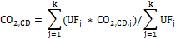
where:
is the utility factor-adjusted mass of CO₂ emissions during charge-depleting mode, g/km;
are the CO₂ emissions measured during the j^{th} charge-depleting phase, g/km;
the driving cycle and phase-specific utility factor according to Appendix 5 to this annex;
is the index number of each phase up to the end of the transition cycle n;
is the number of phases driven up to the end of transition cycle n.
4.2.1.2. Weighted charge-depleting fuel consumption
The fuel consumption values, , at charge-depleting shall be calculated as follows:
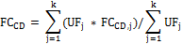
where:
is the utility factor-adjusted fuel consumption charge-depleting mode, l/100 km;
is the fuel consumption measured during the j^{th} charge-depletion phase, l/100 km;
is the driving cycle and phase-specific utility factor according to Appendix 5 to this annex;
is the index number of each phase up to the end of the transition cycle n;
is the number of phases driven up to the end of transition cycle n.
4.2.1.3. Charge-sustaining fuel consumption and CO₂ emissions
4.2.1.3.1. Test result correction as a function of REESS charging balance
The corrected values and shall correspond to a zero charging balance (), and shall be determined according to Appendix 2 to this annex.
4.2.1.3.2. The electricity balance, measured using the procedure specified in Appendix 3 to this annex, is used as a measure of the difference in the vehicle REESS’s energy content at the end of the cycle compared to the beginning of the cycle. The electricity balance is to be determined for the WLTC driven.
4.2.1.3.3. The test results shall be the uncorrected measured values of and in case any of the following applies:
(a) The manufacturer can prove that there is no relation between the energy balance and CO₂ emissions/fuel consumption;
(b) as calculated from the test result corresponds to REESS charging,
(c) as calculated from the test result corresponds to REESS discharging. , expressed as a percentage of the energy content of the fuel consumed over the cycle, is calculated in the equation below:
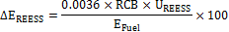
where:
is the change in the REESS energy content, per cent;
is the nominal REESS voltage, V;
is REESS charging balance over the whole cycle, Ah;
is the energy content of the consumed fuel, Wh.
is lower than the RCB correction criteria, according to the equation below and Table A8/5:
Table A8/5
RCB correction criteria
Cycle |  | WLTC  (Low + Medium + High) | WLTC  (Low + Medium + High + Extra High)
RCB correction criteria (%) |  | 1 | 0.5
4.2.1.4. Weighted CO₂ emissions
The weighted CO₂ emissions from the charge-depleting and charge-sustaining test results shall be calculated using the equation below:
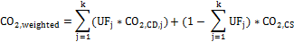
where:
are the utility factor-weighted CO₂ emissions, g/km;
is the fractional utility factor of the j^{th} phase;
are the CO₂ emissions measured during the j^{th} charge-depleting phase, g/km;
are the CO₂ emissions for the charge-sustaining test according to paragraph 4.2.1.3. above, g/km;
is the index number of each phase up to the end of the transition cycle n;
is the number of phases driven up to the end of transition cycle n.
4.2.1.5. Weighted fuel consumption
The weighted fuel consumption from the charge-depleting and charge-sustaining test results shall be calculated using the equation below:
where:
is the utility factor-weighted fuel consumption, l/100 km;
is the fractional utility factor of the j^{th} phase;
is the fuel consumption measured during the j^{th} charge-depleting phase, l/100 km;
is the fuel consumption measured during the charge-sustaining test according to paragraph 4.2.1.3. above, l/100 km;
is the index number of each phase up to the end of the transition cycle n;
is the number of phases driven up to the end of transition cycle n.
4.2.2. NOVC-HEV with and without driver-selectable operating modes
4.2.2.1. Exhaust gases shall be analysed according to Annex 6.
4.2.2.2. Charge-sustaining fuel consumption and CO₂ emissions shall be calculated according to paragraph 4.2.1.3. of this annex.
4.2.2.3. Test result correction as a function of REESS charging balance
The corrected values and shall correspond to a zero energy balance (), and shall be determined according to Appendix 2 to this annex.
4.2.2.3.1. The electricity balance, measured using the procedure specified in Appendix 3 to this annex, is used as a measure of the difference in the vehicle REESS’s energy content at the end of the cycle compared to the beginning of the cycle. The electricity balance is to be determined for the WLTC driven.
4.2.2.3.2. The test results shall be the uncorrected measured values of and in case any of the following applies:
(a) The manufacturer can prove that there is no relation between the energy balance and fuel consumption;
(b) as calculated from the test result corresponds to REESS charging;
(c) as calculated from the test result corresponds to REESS discharging. , expressed as a percentage of the energy content of the fuel consumed over the cycle, is calculated in the equation below:
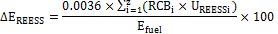
where:
is the nominal REESS voltage for i^{th} REESS, V;
is the charging balance over the whole cycle for the i^{th} REESS, Ah;
is the energy content of the consumed fuel, MJ.
index of REESS
number of installed REESS
is smaller than the RCB correction criteria, according to the following equation and Table A8/6 :
Table A8/6
RCB correction criteria
Cycle |  | WLTC  (Low + Medium + High) | WLTC  (Low + Medium + High + Extra High)
RCB correction criteria (%) |  | 1 | 0.5
4.2.2.3.3. Where RCB corrections of CO₂ and fuel consumption measurement values are required, the procedure described in Appendix 2 to this annex shall be used.
4.3. Electric energy consumption calculations
4.3.1. OVC-HEV
4.3.1.1. Utility factor-weighted total AC electric energy consumption including charging losses shall be calculated using the following equations:
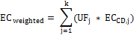
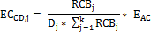
where:
is the utility factor-weighted total energy consumption, Wh/km;
is the driving cycle and phase-specific utility factor according to Appendix 5 to this annex;
is the calculated fraction of E_{AC} used in the j^{th} phase during the charge-depleting test, Wh/km;
is the measured charge balance of the traction REESS of the j^{th} phase during the charge-depleting test, Ah;
is the distance driven in the j^{th} phase during the charge-depleting test, km;
is the measured recharged electric energy from the mains, Wh;
is the index number of each phase up to the end of transition cycle n;
is the number of phases driven up to the end of transition cycle n.
4.3.1.2. Electric energy consumption including charging losses
4.3.1.2.1. Recharged electric energy E in Wh and charging time measurements shall be recorded.
4.3.1.2.2. Electric energy consumption EC is defined by the equation:
where:
is the electric energy consumption, Wh/km;
is the recharged electric energy from the mains, Wh;
is the equivalent all-electric range according to paragraph 4.4.1.3. below, km.
4.3.1.3. Charge-depleting AC electric energy consumption, , including charging losses
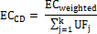
where:
is the electric energy consumption, Wh/km;
is the recharged electric energy from the grid including charging losses, Wh;
is the driving cycle and phase-specific utility factor according to Appendix 5 to this annex;
is the index number of each phase up to the end of transition cycle n;
is the number of phases driven up to the end of transition cycle n.
4.3.2. Pure electric vehicle (PEV)
4.3.2.1. Recharged electric energy E in Wh and charging time measurements shall be recorded.
4.3.2.2. The electric energy consumption EC including charging losses is defined by the equation:
where:
is the electric energy consumption, Wh/km;
is the recharged electric energy from the mains, Wh;
is the all-electric range as defined in paragraph 4.4.2.1. of this annex.
4.4. Electric Range
4.4.1. OVC-HEV
4.4.1.1. All-electric range, AER, and all-electric range city, AERcity
The distance driven over consecutive test cycles according to paragraph 1.5.1.1. using only the REESS until the combustion engine starts consuming fuel for the first time shall be measured and be rounded to the nearest whole number.
4.4.1.2. Equivalent all-electric range, EAER
4.4.1.2.1. EAER shall be calculated as follows:
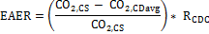
where:
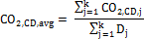
and:
is the equivalent all-electric range EAER, km;
are the CO₂ emissions during the charge-sustaining test, g/km;
are the CO₂ emissions in the j^{th} phase during the charge-depleting test, g;
is the distance driven in the j^{th} phase during the charge-depleting test, km;
is the charge-depleting cycle range, km;
is the index number of each phase up to the end of the transition cycle n;
is the number of phases driven up to the end of the transition cyclen.
4.4.1.3. Charge-depleting cycle range (
The distance from the beginning of the charge-depleting test to the end of the last cycle prior to the cycle or cycles satisfying the break-off criteria shall be measured. This shall include the distance travelled during the transition cycle where the vehicle operates in both depleting and sustaining modes. If the charge-depleting test possesses a transition range, the shall include those transition cycles or cycles.
4.4.1.4. Actual charge-depleting cycle range ()
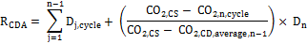
where:
is the actual charge-depleting range, km;
are the CO₂ emissions during the charge-sustaining test, g/km;
are the CO₂ emissions over the n^{th} drive cycle in charge-depleting operating condition, g/km;
are the average CO₂ emissions in charge-depleting operating condition until the n-1th drive cycle, g/km;
is the test distance travelled during j^{th} drive cycle, km;
is the test distance travelled during the n^{th} drive cycle in charge-depleting operating condition, km;
is the index number of each whole cycle up to the end of the transition cycle n;
is the number of whole cycles driven including the transition cycle n.
4.4.2. PEV
4.4.2.1. All-electric range, AER
The distance driven over consecutive WLTCs until the break-off criterion is reached shall be measured and be rounded to the nearest whole number according to paragraph 3.4.2.4.1.3. above.
4.4.2.2. All-electric city range, AERcity
The distance driven over consecutive WLTC city cycles until the break-off criteria is reached shall be measured and be rounded to the nearest whole number.
[RESERVED : Combined approach]
Annex 8 - Appendix 1a
RCB profile OVC-HEV, charge-depleting and charge-sustaining tests
1. RCB profile OVC-HEV, charge-depleting test (Figure A8.App1a/1) followed by a charge-sustaining test (Figure A8.App1a/2)

Figure A8.App1a/1

OVC-HEV, charge-depleting test
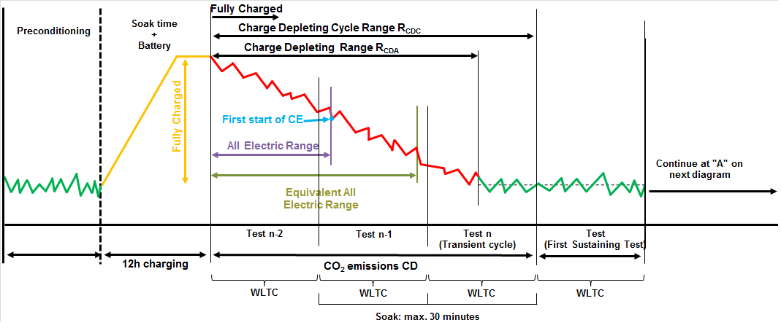

2. RCB profile OVC-HEV, charge-sustaining test (Figure A8.App1a/2) preceded by a charge-depleting test (Figure A8.App1a/1)

Figure A8.App1a/2

OVC-HEV, charge-sustaining test
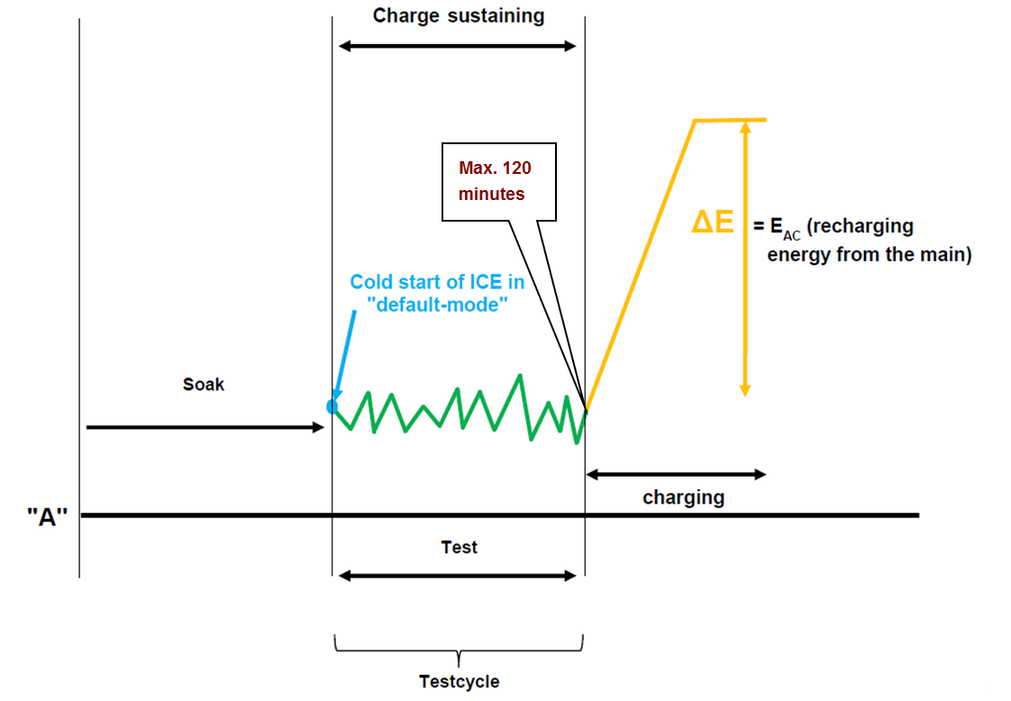

Annex 8 - Appendix 1b
RCB profile, OVC-HEV and NOVC-HEV charge-sustaining test
1. RCB profile OVC-HEV, charge-sustaining test (Figure A8.App1b/1)

Figure A8.App1b/1

OVC-HEV, charge-sustaining test
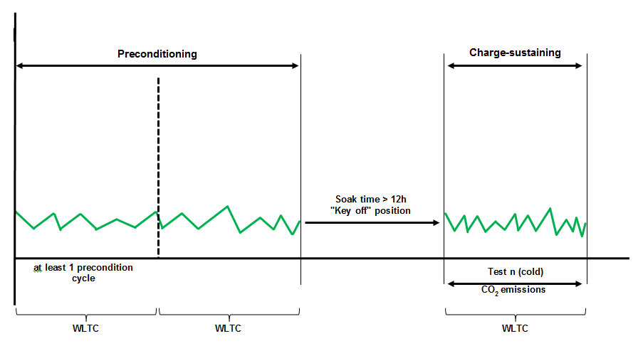

Annex 8 - Appendix 1c
RCB profile, PEV, electric range and electric energy consumption test
1. RCB profile, PEV, electric range and electric energy consumption test (Figure A8.App1c/1)

Figure A8.App1c/1

PEV, electric range and electric energy consumption test
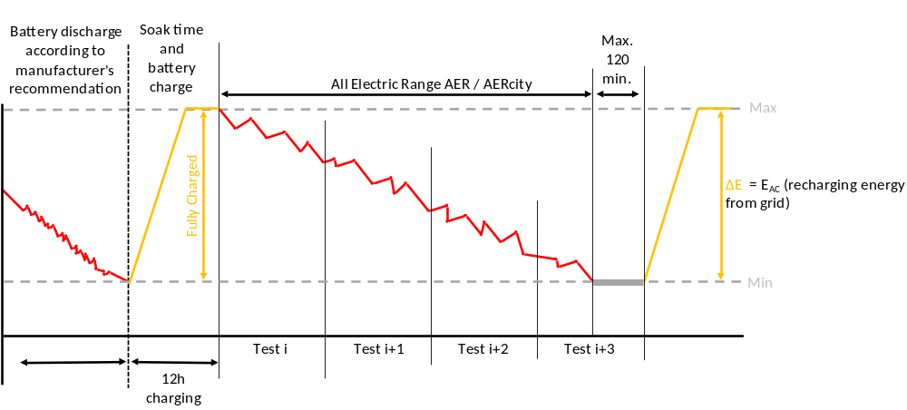

Annex 8 - Appendix 2
REESS charge balance (RCB) correction
1. This appendix describes the test procedure for RCB compensation of CO₂ and fuel consumption measurement results when testing NOVC-HEV and OVC-HEV vehicles.
1.1. Separate CO₂ emission and fuel consumption correction coefficients shall be calculated separately for each phase of the WLTC and corrected to zero over each WLTC phase.
2. The fuel consumption correction coefficients () shall be defined as follows and might be supplied by the manufacturer :
2.1. The fuel consumption correction coefficient () shall be determined from a set of n measurements performed by the manufacturer. This set shall contain at least one measurement with and at least one with over the complete test cycle.
If the latter condition cannot be realised on the driving cycle used in this test, the responsible authority shall evaluate the statistical significance of the extrapolation necessary to determine the fuel consumption value at .
2.1.1. The fuel consumption correction coefficients () for the individual phases as well as for the complete test cycle are defined as:
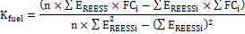
where:
are the fuel consumption correction coefficients, l/100 km/Wh/km;
are the fuel consumptions measured during the i^{th} test, l/100 km;
are the electricity balances measured during the i^{th} test, Wh/km;
is the number of measurements.
The fuel consumption correction coefficient shall be rounded to four significant figures. The statistical significance of the fuel consumption correction coefficient is to be evaluated by the responsible authority.
2.2. The fuel consumption correction coefficient shall be determined for the fuel consumption values measured over WLTC. This coefficient can be applied for each individual WLTC phase correction.
2.2.1. Without prejudice to the requirements of paragraph 2.1 of this appendix, at the manufacturer’s request, separate fuel consumption correction coefficients for each individual WLTC phase may be developed.
2.3. Fuel consumption at zero REESS energy balance ()
2.3.1. The fuel consumption at shall be determined by the following equation:
where:
is the fuel consumption at ∆E_{REESS} = 0, l/100 km;
is the fuel consumption measured during the test, l/100 km;
is the electricity balance measured during test, Wh/km.
2.3.2. Fuel consumption at zero REESS energy balance shall be calculated separately for each phase of the WLTC and corrected to zero over each WLTC phase.
2.3.3. Fuel consumption at zero REESS energy balance shall also be calculated for the complete WLTC and corrected to zero.
3. CO₂ emission correction coefficient () shall be defined as follows and may be supplied by the manufacturer
3.1. The CO₂ emission correction coefficient () shall be determined from a set of n measurements performed by the manufacturer. This set shall contain at least one measurement with and at least one with over the complete test cycle.
If the latter condition cannot be realised on the driving cycle used in this test, the responsible authority shall evaluate the statistical significance of the extrapolation necessary to determine the fuel consumption value at .
3.1.1. The CO₂ emission correction coefficient () is defined as:
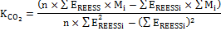
where:
are the CO₂ emissions correction coefficient, g/km/Wh/km;
are the CO₂ emissions measured during the i^{th} test, g/km;
is the electricity balance during the i^{th} test, Wh/km;
is the number of measurements.
3.1.2. The CO₂ emission correction coefficient shall be rounded to four significant figures. The statistical significance of the CO₂ emission correction coefficient is to be judged by the responsible authority.
3.1.3. The CO₂ emission correction coefficient shall be determined for the CO₂ emission values measured over the WLTC. This coefficient may be applied for each individual WLTC phase correction.
3.1.3.1 Without prejudice to the requirements of paragraph 2.1 of this appendix, at the manufacturer’s request, separate CO₂ emission correction coefficients for each individual WLTC phase may be developed.
3.1.4. CO₂ emissions at zero REESS energy balance shall be also calculated for complete WLTC and corrected to zero.
3.2. CO₂ emission at zero REESS energy balance (M₀)
3.2.1. The CO₂ emission M₀ at shall be determined by the following equation:
where:
are the CO₂ emissions at zero REESS energy balance, g/km;
are the CO₂ emissions correction coefficient, g/km/Wh/km;
is the electricity balance measured during test, Wh/km.
Annex 8 - Appendix 3
Measuring the electricity balance of NOVC-HEV and OVC-HEV batteries
1. Introduction
1.1. This appendix defines the method and required instrumentation to measure the electricity balance of OVC-HEVs and NOVC-HEVs.
2. Measurement equipment and instrumentation
2.1. During the tests described in paragraph 3. of this annex, the REESS current can be measured using a current transducer of the clamp-on or closed type. The current transducer (i.e. a current sensor without data acquisition equipment) shall have a minimum accuracy specified in paragraph 2.1.1. of Appendix 2 to Annex 6.
2.1.1. Alternatively to 2.1 above, the RCB determination method described in Annex 6, Appendix 2, paragraph 2.2. shall be applicable for all vehicle REESSs.
2.1.2. The current transducer shall be fitted on one of the cables directly connected to the REESS. In order to easily measure REESS current using external measuring equipment, manufacturers should preferably integrate appropriate, safe and accessible connection points in the vehicle. If that is not feasible, the manufacturer is obliged to support the responsible authority by providing the means to connect a current transducer to the wires connected to the REESS in the above described manner.
2.1.3. Output of the current transducer shall be sampled with a minimum sample frequency of 5 Hz. The measured current shall be integrated over time, yielding the measured value of RCB, expressed in ampere-hours (Ah).
2.2. A list of the instrumentation (manufacturer, model no., serial no.) used by the manufacturer to determine:
(a) When the minimum state of charge of the REESS has been reached during the test procedure defined in paragraph 3. of this annex;
(b) The correction factors and (as defined in Appendix 2 to this annex);
(c) The last calibration dates of the instruments (where applicable) shall be provided to the responsible technical authority.
3. Measurement procedure
3.1. Measurement of the REESS current shall start at the same time as the test starts and shall end immediately after the vehicle has driven the complete driving cycle.
3.2. The RCB values of each phase shall be recorded.
Annex 8 - Appendix 4
Preconditioning of PEVs and OVC-HEVs
1. This appendix describes the test procedure for REESS and combustion engine preconditioning in preparation for:
(a) Electric range, charge-depleting and charge-sustaining measurements when testing OVC-HEV; and
(b) Electric range measurements as well as electric energy consumption measurements when testing PEV vehicles.
2. OVC-HEV combustion engine and REESS preconditioning
When testing in charge-sustaining condition is followed by testing in charge-depleting condition, the charge-sustaining condition test and the charge-depleting test may be driven independently of one another. In that case, the vehicle shall be prepared as prescribed in paragraph 2.1.1. below before the charge-depleting test or the charge-sustaining test starts.
2.1. OVC-HEV combustion engine and REESS preconditioning when the test procedure starts with a charge-sustaining test
2.1.1. For preconditioning of the combustion engine, the OVC-HEV shall be driven over at least one WLTC. The manufacturer shall guarantee that the vehicle operates in a charge-sustaining condition.
2.1.2. When testing an OVC-HEV with driver-selectable operation mode, the preconditioning cycles shall be performed in the same operation condition as the charge-sustaining test as described in paragraph 3.2.5. of this annex.
2.1.3. During the preconditioning cycle in paragraph 2.1.2. above, the charging balance of the traction REESS shall be recorded. The preconditioning shall be stopped at the end of the cycle when the break-off criteria is fulfilled according to paragraph 3.2.4.5. of this annex.
2.1.4. Alternatively, at the request of the manufacturer, the state of charge of the REESS for the charge-sustaining test can be set according to the manufacturer’s recommendation in order to achieve a charge balance neutral charge-sustaining test.
In such a case, an additional ICE preconditioning procedure as applicable to conventional vehicles in paragraph 1.2.6. of Annex 6 may be applied.
2.1.5. Soaking of the vehicle shall be performed according to paragraph 1.2.7. of Annex 6. Forced cooling down shall not be applied to vehicles preconditioned for the charge-depleting test.
2.2. OVC-HEV combustion engine and REESS preconditioning when the test procedure starts with a charge-depleting test
2.2.1. For preconditioning of the combustion engine, the OVC-HEV shall be driven over at least one WLTC. The manufacturer shall guarantee that the vehicle operates in a charge-sustaining condition.
2.2.2.. When testing an OVC-HEV with driver-selectable operation mode, the preconditioning cycles shall be performed in the same operation condition as the charge-sustaining test as described in paragraph 3.2.5. of this annex.
2.2.3.. Soaking of the vehicle shall be performed according to paragraph 1.2.7. of Annex 6. Forced cooling down shall not be applied to vehicles preconditioned for the test.
2.2.4. During soak, the electrical energy storage device shall be charged, using the normal charging procedure as defined in paragraph 2.2.5. below.
2.2.5. Application of a normal charge
2.2.5.1. The electrical energy storage device shall be charged:
(a) With the on-board charger if fitted; or
(b) With an external charger recommended by the manufacturer using the charging pattern prescribed for normal charging;
(c) In an ambient temperature comprised according to paragraph 1.2.2.2.2. of Annex 6. This procedure excludes all types of special charges that could be automatically or manually initiated, e.g. equalization charges or servicing charges. The manufacturer shall declare that during the test, a special charge procedure has not occurred.
2.2.5.2. End of charge criteria
The end of charge criteria is reached when a fully charged REESS is detected by the on-board or external instruments.
3. PEV REESS conditioning
3.1. Initial charging of the REESS
Charging the REESS consists of discharging the REESS and applying a normal charge.
3.1.1. Discharging the REESS
Discharge test procedure shall be performed according to the manufacturer’s recommendation. The manufacturer will guarantee that the REESS is as fully depleted as is possible by the discharge test procedure.
3.1.2. Application of a normal charge
The REESS shall be charged:
(a) With the on-board charger if fitted; or
(b) With an external charger recommended by the manufacturer using the charging pattern prescribed for normal charging;
(c) In an ambient temperature comprised according to paragraph 1.2.2.2.2. of Annex 6. This procedure excludes all types of special charges that could be automatically or manually initiated, e.g. equalization charges or servicing charges. The manufacturer shall declare that during the test, a special charge procedure has not occurred.
3.1.3. End of charge criteria
The end of charge criteria is reached when a fully charged REESS is detected by the on-board or external instruments.
Annex 8 - Appendix 5
Utility factor (UF) for OVC-HEVs
1. Utility Factor (UF) are ratios based on driver statistics and the ranges achieved in charge-depleting mode and charge-sustaining modes for OVC-HEVs and are used for weighting emissions, CO₂ emissions and fuel consumptions.
2. Each Contracting Party may develop its own UFs.
[RESERVED:
Annex 8 - Appendix 6
Determining the range of PEVs on a per-phase basis]

[RESERVED:
Annex 9
Determination of system equivalence]

