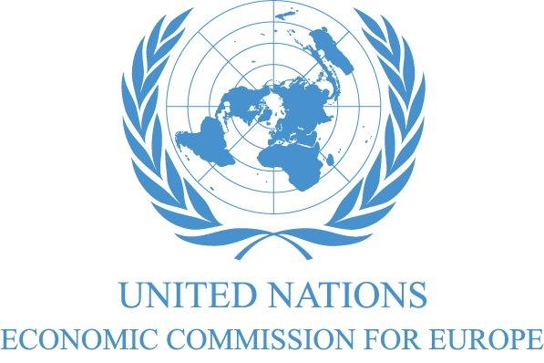
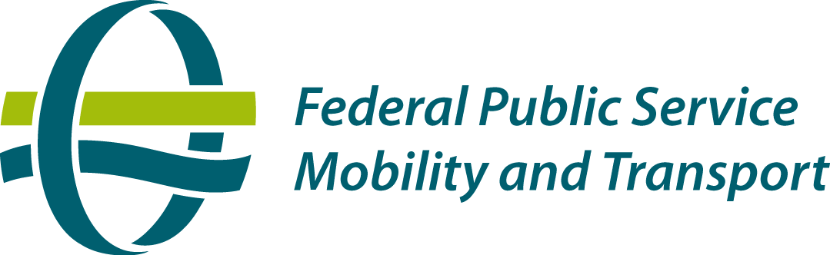

REGISTRATION FORM

Joint BELGIUM - UNECE Inland Transport Committee (ITC) workshop on Intelligent Transport Systems
Towards a new transportation culture: technology innovations for safe, efficient and sustainable mobility
17-18 November 2014, Brussels

Please send the form by fax or e-mail to UNECE (fax: +41-22-917 0039; email: anastasia.barinova@unece.org with cc to heini.salonen@unece.org). The LAST DAY for registration is 10 November.
FAMILY NAME |  | Ms.
 |  | Mrs.
 |  | Mr.
First Name |  |  |  |  |  | Country
Enterprise / Organization

Title/ Official function

Professional Address
I wish to participate (✓):
Monday, 17 November 2014: Workshop, morning session □ Workshop, afternoon session □
Dinner (€ 50) □
Tuesday, 18 November 2014: Workshop, morning session □
or alternatively: Visit to MOBIRIS, morning session (max. 20 participants) □
Workshop, afternoon session □
Telephone No.: |  |  |  |  | Email:
Mobile No.
Fax No.:
Date: |  |  |  |  | Signature
Participation in the workshop is free of charge. Your registration will only be valid after confirmation.
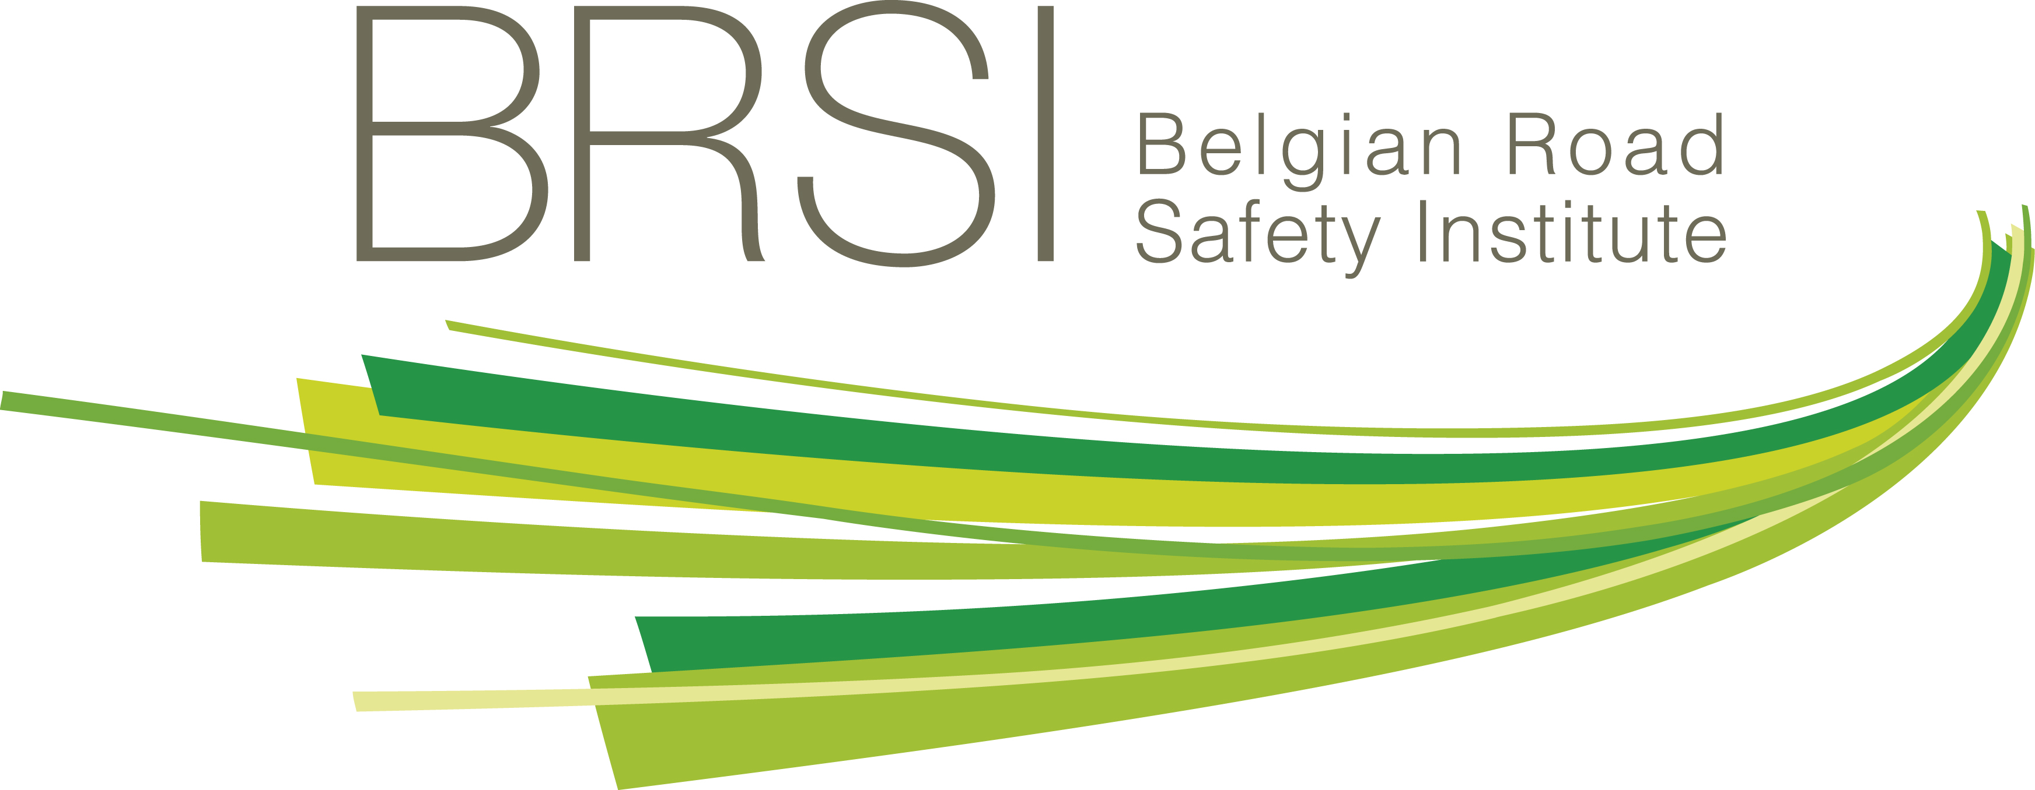


Places for the visit to MOBIRIS (Mobility Center of Mobiel Brussel) are available on a first come, first served basis.

