Proposal for amendments to ECE/TRANS/WP.29/GRVA/2020/32, ECE/TRANS/WP.29/GRVA/2020/32 and comments on real world tests

The experts from the European Commission would like to thank Germany for the two proposals to cover automated lane keeping systems above 60 km/h and automated lane changing functions. We welcome the objectives of these two proposals and would like to share the following general comments at this stage.

First of all, we believe that the discussion should start with the scenarios that are expected within the new operational domain proposed in these 2 proposals. The scenarios at 130 km/h and lane change are much more complex than what was already agreed for an automated lane keeping below 60 km/h which was always presented to be used under traffic jam conditions. In this regard, we wonder if the two proposals (ALKS until 130 km/h and lane change) can be adopted separately. It seems to us that traffic scenarios relevant for ALKS until 130 km/h would require to include a lane change function (e.g. to avoid an obstacle on the road,)

We would suggest to avoid setting minimum requirements for the ADS (in terms of time headway, minimum gap, etc.) without defining a proper underlying conceptual and analytical framework by means of which the requirement can be calculated. Let's take the minimum headway as an example. One thing is to just set a minimum value on the basis of past applications or regulations and another thing is to determine it on the basis of the conditions that allow the ADS to safely brake whatever the action of the vehicle ahead. By parametrising the requirement on the basis of physical properties of the vehicle such as reaction time, maximum deceleration, etc., as technology will improve and the parameters will achieve different values, also the original requirement will be automatically updated. In spite of the initial difficulty to agree on a specific analytical framework to define the safety of the vehicle, such an approach would allow the simplification of future work, especially in order not to jeopardise the added value of connectivity on the safety and efficiency of the transport system. In addition this would increase transparency of the legislative framework and would avoid the introduction of contradicting or heterogenous logics among the different requirements (as in the case of the ALKS and the Lane-Changing System).

As the amendments aim at allowing full motorway automation we believe it is urgent to introduce string stability as a requirement for the future ALKS systems. String stability can be described as the capability of the ADS to react to a perturbation in the speed profile of the leading vehicle with a perturbation in its speed profile of lower or equal absolute magnitude independently from the driving conditions. The attached paper shows what happens with current ACC systems and the implications that string instability has on safety, energy consumption, road capacity. Although we believe that ALKS will use a different logic than ACC, we also believe that from a precautionary perspective it would be very important to introduce this additional requirement.

More detailed explanation supporting the above comments is provided in Annex I.

The adopted version of Regulation 157 mandates that real-world testing is conducted or performed by the Technical Service, as part of the Test Specifications for ALKS listed in Annex 5, Section 5.4.. The Experts from the European Commission believe that like for emissions, the regulators shall engage in a paradigm change for the regulations addressing vehicle safety, whith the objectives to foster a fair and competitive development of automated/autonomous vehicle, and to facilitate the approval of systems by independent bodies. This change is on the critical path for improving the public’s trust in driving automation technology, and has already started in the adoption of Regulation 157. With this scope in mind, we would suggest to refine Real-world tests requirements, taking into account the principles of complementarity of safety demonstration approaches and transparency of the approval process:
1. How will real-world tests complement simulation and track testing?
Real world testing could be used to detect issues that may not be well captured by track tests and simulation, such as perception quality limitation (e.g. due to light conditions, rain, etc.) and normal operation in real traffic environment; to confirm the vehicle behaviour on track; to support validation of simulation results.

2. How to define, execute and evaluate such tests?
The current ALKS Regulation does not define any specific list of requirements to be verified on-road, nor testing protocols. Real world testing could be used to assess aspects of the ADS performance related to its capability to drive in real traffic conditions, e.g. smooth driving, capability to deal with dense traffic, interaction with other road users, maintaining flow of traffic, being considerate and courteous to other vehicles. It could also be used to assess part of the ADS performance at some ODD boundaries (nominal and complex scenarios), i.e. whether the system is triggering transition demands to the driver when it is supposed to (e.g. end of the ODD, weather conditions) and with an effective procedure. The same testing could be used to confirm the performance related to human factors under these conditions. At the same time, it is important to consider that when the exact test conditions are known in advance, there is a higher chance that engineers will focus primarily on passing the test and not on ensuring the performance and functioning under real driving conditions.

The European Commission experts suggest a generic multi-step approach for the definition of real-world safety tests, as described in Annex II.

Annex I

Going into more details for what concerns the proposed amendments we propose the following comments to the amendment to paragraph 5.2.3.3 concerning the safety distance from the vehicle in front (for the ALKS 130), and the assessment of the target lane (paragraph 5.2.6.6 in the ALKS lane changing):
- Par 5.2.3.3 ALKS 130.
The amendment extends the requirement to keep a minimum safety distance from the vehicle ahead to the speed range [60, 130] km/h.
While it is obvious that with the increase in the speed the distance has to increase, it is not so obvious that also the time-gap has to increase. We therefore compared the relationship between speed and time-gap introduced by the amendment with what observed by human drivers (derived from the highD database of traffic data collected on German motorways).

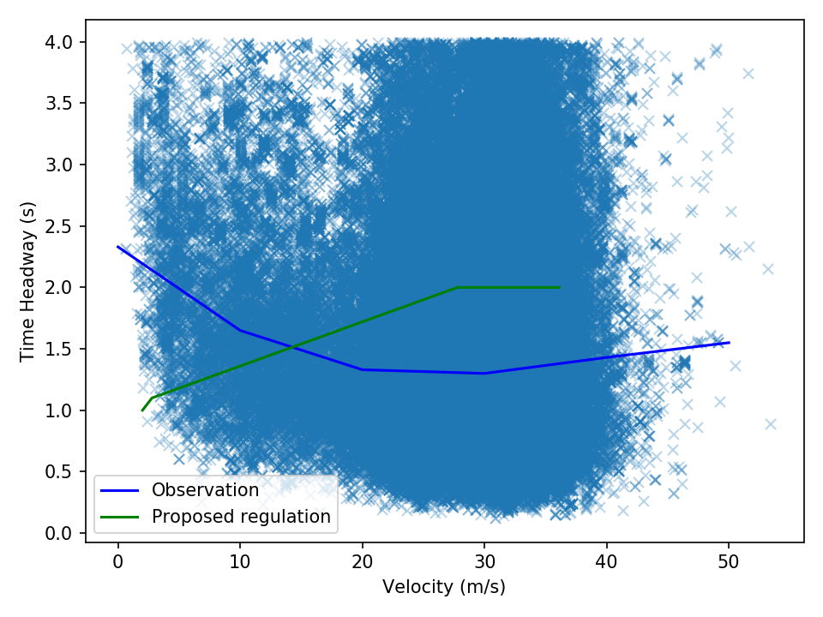The comparison is showed in the figure above in which the blue line is the median line from all the observations (represented by the blue dots) while the green line is the regulation requirement. The two lines show an opposite trend. It is worth noticing that the increase of the blue line in the right part of the diagram is due to the fact at high speed the vehicle is not always affected by the vehicle ahead. So this part of the diagram include cases in which the vehicle ahead is very far away ad this contributes to the new increase in the time-gap.
While AVs do not necessarily have to reproduce human behaviour, it would be important to understand the reason to chose those specific values.
We have also calculated the maximum theoretical road capacity generated by a traffic of ALKS130 vehicles fulfilling the aforementioned requirement. The maximum theoretical flow is almost 1950 veh/h which is not bad. The problem is that such a value is achieved for a speed of 40km/h and it drops to below 1700 veh/h for higher speed resulting in quite unnatural traffic behavior. Without proper traffic consideration the flow of AVs will generate a sensibly lower road capacity.
- Par 5.2.6.6.1 ALKS lane changing
The amendment introduces the definition of a minimum gap to initiate the lane changing. The minimum gap is defined on the basis of a maximum deceleration imposed to the following vehicle in the target lane, by an assumed reaction time of 1.4s of the same vehicle and by a residual time gap of 1s between the ego vehicle and again the following vehicle in the target lane.
It seems strange that while the ALKS is required to keep always a time-gap higher than 1s to the vehicle ahead, a vehicle behind can accept a time gap of 1s. This is the result of the choice to introduce requirements not linked by a unique conceptual framework. Eventually we accept consider for human drivers a lower safety than what is requested to the ADS.
- Additional considerations on string-stability
String stability for an ADS implies that the system is able not to amplify a perturbation generated by the downstream traffic. It means that when the vehicle ahead of the ADS decelerates, the response of the ADS should not only be able to avoid a crash but also to do so with a deceleration at most equal to that applied by the vehicle ahead. This is very important to avoid that when the ADS is immersed in a string unstable traffic stream (due for example by non attentive drivers) it does not risk to generate danger to itself and to the vehicles further upstream. This recommendation comes as a result of the test campaigns carried out on ACC vehicles during the last year which have proven to be string unstable for a wide range of their possible settings. As already mentioned, the complete assessment of the results of the last test campaign has been summarised into the scientific paper attached to the present note

Annex II

Summary of a generic multi-step approach for the definition of real-world safety (RWS) tests.

Step 1 – Identification of the parameters defining the ODD and their ranges

The ODD defines the conditions under which an automated/autonomous vehicle will be operational, therefore will have a direct impact on test conditions. The parameters can be measurable or discrete values, but should be known prior to the test definition. Non measurable elements could be assessed using video recording.
During the RWS test, all the parameters defining the ODD have to be recorded continuously, in order to be able to determine whether:
- The vehicle operates within the ODD;
- The declared ODD corresponds to the one observed/measured during the test;
- No system activation is possible outside ODD.

This requirement should in principle become obsolete for Level 5 (full autonomy).

Step 2 - Definition of test scenarios and test cases (for both test track and RWS)

The set of abstract (functional) scenarios relevant to the considered automated driving application (use-case) should be identified. This set of scenarios will constitute the minimum non-exhaustive common baseline for safety validation testing by the manufacturers and for independent verification by the authority. Input to this step is already being addressed by VMAD.

There will also be the need to identify specific scenarios relevant to local conditions (e.g. categories of other road users allowed, possible presence of wild animals, etc…), but the common baseline mentioned above will ensure a minimum level of interoperability among the different Countries.

Step 3 - "Scoring" or "Pass-Fail" strategy

As first step, we can imagine a mixed automatic/human approach for the evaluation of the three different aspects defining the capability of the ADS, as summarized in the table below:

REQUIREMENT TO BE VERIFIED DURING TESTING | EVALUATION CRITERIA | EVALUATION METHOD
- Respect traffic rules | Pass/fail | Human Assessor on-board and/or ex-post camera images post-processing
- Safety: Does not cause accidents (avoid foreseeable and preventable accidents) | Pass/fail | Algorithm implementing safety requirement on distance/time to collision
- Can drive in real world traffic conditions  (ROADMANSHIP) | Scoring | Human Assessor on-board and/or ex-post images post-processing

Safety remains the priority in situations involving vulnerable road users and in critical/emergency conditions, and can be evaluated only with a pass-fail approach.

Respect of traffic rules in principle is also assessed on a pass-fail base, but in some Countries law infringement might be allowed in case of need to ensure safety.

Roadmanship (i.e. how “normally” the ADS drives compared to humans) is also an important aspect to be considered, as it could introduce additional safety risks (e.g. in case of frequent disengagements, sudden braking, aggressive driving style, etc...). This aspect can be evaluated with a grading approach, based on the human assessor judgement. Even if subjective, the scoring will indeed depend on human perception of safety related to the ADS "driving style".

Furthermore, human factors during transition demand could also be evaluated by the human assessor during real world testing.

Suitable guidelines and training should be provided to the human assessors and operators involved in the testing activity, in order to ensure transparency and uniformity of the evaluation criteria. A standard approach to the overall evaluation of RWS tests results should also be established.

Step 4 - Selection of RWS test scenarios and test cases

Real World Safety testing should address the behavioural performance of the vehicle within its ODD, including at the ODD boundaries and possibly also outside the ODD. Testing of the most common risky driving situation should be assessed otherwise (e.g. simulation or track testing), as well as scenarios where avoiding accidents is difficult or impossible. A selection of tests could also be repeated on track in order to compare results with on-road performance.

The first step for the selection of scenarios is therefore filtering of ODD-related and realistic situations. Then, scenarios should be categorized based on the challenge level. Finally, criteria for the test parameters selection should be defined (e.g. randomized, probability-based, severity-based, etc…).

Step 5 - Execution and ex-post analysis of RWS test data (including test validity)

Test procedures should clearly describe how the test should be prepared and performed, including requirements on instrumentation and test participants involved (e.g. safety driver, assessor, etc…).

Another fundamental aspect to be clarified is the definition of test validity criteria, i.e. requirements on the duration and characteristics of the performed test that guarantee a significant representativeness of ADS real world normal operation can be assessed. For example, a range of average speed could be established, as well as limitation on the stop time of the ADS during the testing, and requirements on a minimum number of relevant scenarios met (including transition demand).

RWS recorded data will be processed to eliminate possible errors or inconsistencies (e.g. due to instrumentation malfunctioning); next steps will include:
- monitoring of testing within ODD ranges,
- verification of test validity criteria,
- automatic assessment of safety requirements,
- human assessment of compliance with traffic rules,
- human assessment of vehicle roadmanship.

Test repetition criteria should also be defined. Consequences and actions needed in case of failed tests must be clearly stated in the Regulation.

