Proposal for amendments to ECE/TRANS/WP.29/GRVA/2020/32 and ECE/TRANS/WP.29/GRVA/2020/33

The experts from the European Commission would like to thank Germany for the two proposals to cover automated lane keeping systems above 60 km/h and automated lane changing functions. We welcome the objectives of these two proposals and would like to share the following general comments at this stage.

First of all, we believe that the discussion should start with the scenarios that are expected within the new operational domain proposed in these 2 proposals. The scenarios at 130 km/h and lane change are much more complex than what was already agreed for an automated lane keeping below 60 km/h which was always presented to be used under traffic jam conditions. In this regard, we wonder if the two proposals (ALKS until 130 km/h and lane change) can be adopted separately. It seems to us that traffic scenarios relevant for ALKS until 130 km/h would require to include a lane change function (e.g. to avoid an obstacle on the road,)

We would suggest to avoid setting minimum requirements for the ADS (in terms of time headway, minimum gap, etc.) without defining a proper underlying conceptual and analytical framework by means of which the requirement can be calculated. Let's take the minimum headway as an example. One thing is to just set a minimum value on the basis of past applications or regulations and another thing is to determine it on the basis of the conditions that allow the ADS to safely brake whatever the action of the vehicle ahead. By parametrising the requirement on the basis of physical properties of the vehicle such as reaction time, maximum deceleration, etc., as technology will improve and the parameters will achieve different values, also the original requirement will be automatically updated. In spite of the initial difficulty to agree on a specific analytical framework to define the safety of the vehicle, such an approach would allow the simplification of future work, especially in order not to jeopardise the added value of connectivity on the safety and efficiency of the transport system. In addition this would increase transparency of the legislative framework and would avoid the introduction of contradicting or heterogenous logics among the different requirements (as in the case of the ALKS and the Lane-Changing System).

As the amendments aim at allowing full motorway automation we believes it is urgent to introduce string stability as a requirement for the future ALKS systems. String stability can be described as the capability of the ADS to react to a perturbation in the speed profile of the leading vehicle with a perturbation in its speed profile of lower or equal absolute magnitude independently from the driving conditions. The attached paper shows what happens with current ACC systems and the implications that string instability has on safety, energy consumption, road capacity. Although we believe that ALKS will use a different logic than ACC, we also believe that from a precautionary perspective it would be very important to introduce this additional requirement.

Going into more details for what concerns the proposed amendments we propose the following comments to the amendment to paragraph 5.2.3.3 concerning the safety distance from the vehicle in front (for the ALKS 130), and the assessment of the target lane (paragraph 5.2.6.6 in the ALKS lane changing):
- Par 5.2.3.3 ALKS 130.
The amendment extends the requirement to keep a minimum safety distance from the vehicle ahead to the speed range [60, 130] km/h.
While it is obvious that with the increase in the speed the distance has to increase, it is not so obvious that also the time-gap has to increase. We therefore compared the relationship between speed and time-gap introduced by the amendment with what observed by human drivers (derived from the highD database of traffic data collected on German motorways).

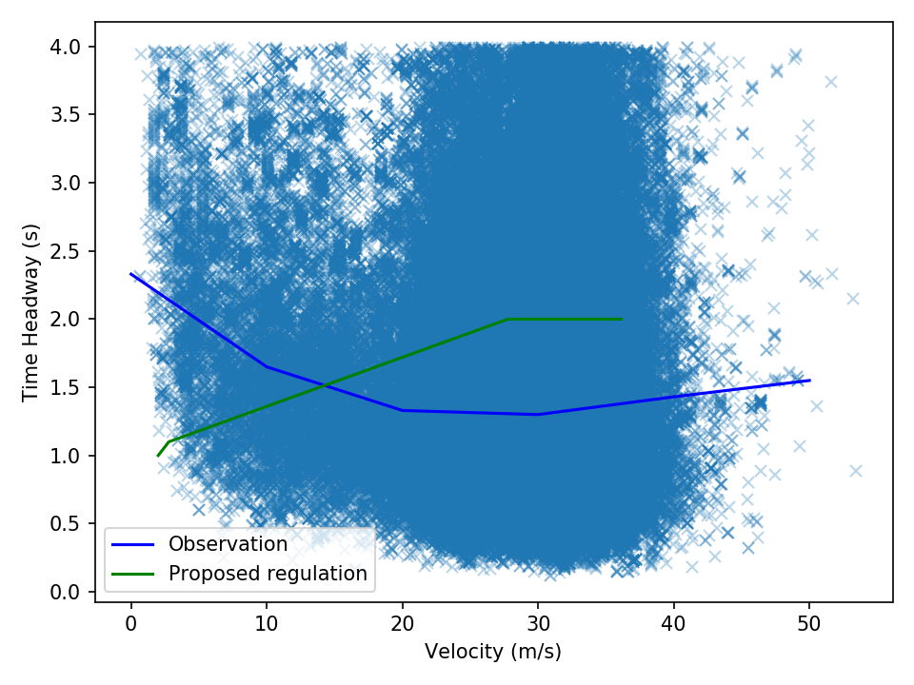The comparison is showed in the figure above in which the blue line is the median line from all the observations (represented by the blue dots) while the green line is the regulation requirement. The two lines show an opposite trend. It is worth noticing that the increase of the blue line in the right part of the diagram is due to the fact at high speed the vehicle is not always affected by the vehicle ahead. So this part of the diagram include cases in which the vehicle ahead is very far away ad this contributes to the new increase in the time-gap.
While AVs do not necessarily have to reproduce human behaviour, it would be important to understand the reason to chose those specific values.
We have also calculated the maximum theoretical road capacity generated by a traffic of ALKS130 vehicles fulfilling the aforementioned requirement. The maximum theoretical flow is almost 1950 veh/h which is not bad. The problem is that such a value is achieved for a speed of 40km/h and it drops to below 1700 veh/h for higher speed resulting in quite unnatural traffic behavior. Without proper traffic consideration the flow of AVs will generate a sensibly lower road capacity.
- Par 5.2.6.6.1 ALKS lane changing

The amendment introduces the definition of a minimum gap to initiate the lane changing. The minimum gap is defined on the basis of a maximum deceleration imposed to the following vehicle in the target lane, by an assumed reaction time of 1.4s of the same vehicle and by a residual time gap of 1s between the ego vehicle and again the following vehicle in the target lane.
It seems strange that while the ALKS is required to keep always a time-gap higher than 1s to the vehicle ahead, a vehicle behind can accept a time gap of 1s. This is the result of the choice to introduce requirements not linked by a unique conceptual framework. Eventually we accept consider for human drivers a lower safety than what is requested to the ADS.

- Additional considerations on string-stability
String stability for an ADS implies that the system is able not to amplify a perturbation generated by the downstream traffic. It means that when the vehicle ahead of the ADS decelerates, the response of the ADS should not only be able to avoid a crash but also to do so with a deceleration at most equal to that applied by the vehicle ahead. This is very important to avoid that when the ADS is immersed in a string unstable traffic stream (due for example by non attentive drivers) it does not risk to generate danger to itself and to the vehicles further upstream. This recommendation comes as a result of the test campaigns carried out on ACC vehicles during the last year which have proven to be string unstable for a wide range of their possible settings. As already mentioned, the complete assessment of the results of the last test campaign has been summarised into the scientific paper attached to the present note

