Draft Appendix on Traffic Disturbance Critical Scenarios
to the Annex on audit/assessment to the new UN Regulation on Automated Lane Keeping systems (ALKS)
Based on GRVA-05-19
I. Justification
This informal document was drafted as an Appendix to the Annex 4 to the regulation on Automated Lane Keeping systems (ALKS) to address the critical traffic disturbance scenarios for the ‘scenarios” pillar of the new test and assessment methods.
[This document reflects the ongoing work of the VMAD group to develop an approach to scenario—based testing and. The scenarios developed within this document attempt to set the minimum performance criteria at the level of an attentive skilled driver. The reactions of an attentive skilled driver are simulated using known reaction times of drivers reacting to objects in simulated environments. VMAD will continue to investigate requirements for the validation of more complex vehicle-environment interaction, transition of control and the possibilities of various types of simulation methods to validate specific requirements of the AD-functions.]
This document defines traffic disturbance critical scenarios for Annex 4 of the regulation and has been divided into preventable and unpreventable collision outcomes, according to the requirement in the regulation which stipulates:
“The activated system shall not cause any collisions that are reasonably foreseeable and preventable.”
Preventable scenarios are those where the validation should demonstrate that ALKS can avoid a collision.
Unpreventable scenarios are those where the validation should demonstrate that collision mitigation strategies of ALKS are implemented during the scenario.

II. Proposal

Appendix
Traffic disturbance critical scenarios for ALKS

- General
This document clarifies derivation process to define conditions under which Automated Lane Keeping Systems (ALKS) shall avoid a collision. Conditions under which Automated Lane Keeping Systems (ALKS) shall avoid a collision are determined by a general simulation program with following attentive human driver performance model and related parameters in the traffic critical disturbance scenarios.

- Traffic critical scenarios
Traffic disturbance critical scenarios are those which have conditions under which Automated Lane Keeping Systems (ALKS) may not be able to avoid a collision.
Following four are traffic critical scenarios:
- Cut-in: the ‘other vehicle’ suddenly merges in front of the ‘ego vehicle’
- Cut-out: the ‘other vehicle’ suddenly exits the lane of the ‘ego vehicle’
- Deceleration: the ‘other vehicle’ suddenly decelerates in front of the ‘ego vehicle’
Each of these traffic critical scenarios can be created using the following parameters/elements:
- Road geometry
- Other vehicles’ behavior/ maneuver

- Performance model of ALKS
Traffic critical scenarios of ALKS are divided into preventable and unpreventable scenarios. The threshold for preventable/unpreventable is based on the simulated performance of a skilled and attentive human driver. It is expected that some of the “unpreventable” scenarios by human standards may actually be preventable by the ALKS system.
In a low-speed ALKS scenario, the avoidance capability of the driver model is assumed to be only by braking. The driver model is separated into the following three segments: “Perception”; “Decision”; and, “Reaction”. The following diagram is a visual representation of these segments:
To determine conditions under which Automated Lane Keeping Systems (ALKS) shall avoid a collision, performance model factors for these three segments in the following table should be used as the performance model of ALKS considering attentive human drivers’ behavior with ADAS.
〇Skilled human performance model
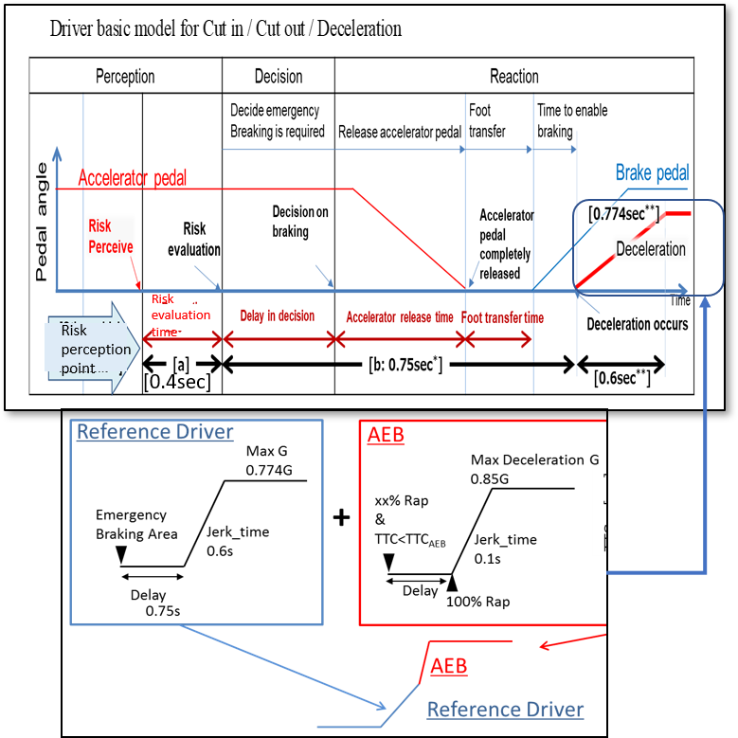
#
#
#
#
#
#
#
***
G

[ ]
[ ]
[ ]
[ ]
[ ]
0.6s
Decide emergency braking is required
_________________________________________________________________
*/ = 0.75sec is a common data in Japan. for decision/response time.
**/ = 0.6sec to full braking and 0.774G are a data from experiments of NHTSA and Japan. (Coefficient of road friction is 1.0.)
***/= The time at which the other vehicle starts moving from lane keep to cut-in (or cut-out) is determined when the lateral movement distance of the other vehicle exceeds the wandering threshold.
・Performance model factors for vehicles
 |  | Factors
Risk perception point | Lane change (cutting in, cutting out) | Deviation of the center of a vehicle over [0.375m]# from the center of the driving lane  (derived from research by Japan)
 | Deceleration | Deceleration ratio of preceding vehicle and following distance of ego vehicle
Risk evaluation time |  | [0.4 seconds]#  (from research by Japan)
Time duration from having finished perception until starting deceleration |  | [0.75 seconds]#  (common data in Japan)
Jerking time to full deceleration (road friction 1.0) |  | [0.6 seconds to 0.774G]#  (from experiments by NHTSA and Japan)
Jerking time to full deceleration (after full wrap of ego vehicle and cut-in vehicle, road friction 1.0) |  | [0.6 seconds to 0.85G]#  (derived from UN Reg. No.152 for AEB)

  - Driver model for the three ALKS scenarios:

3.1.1. For Cut in scenario:
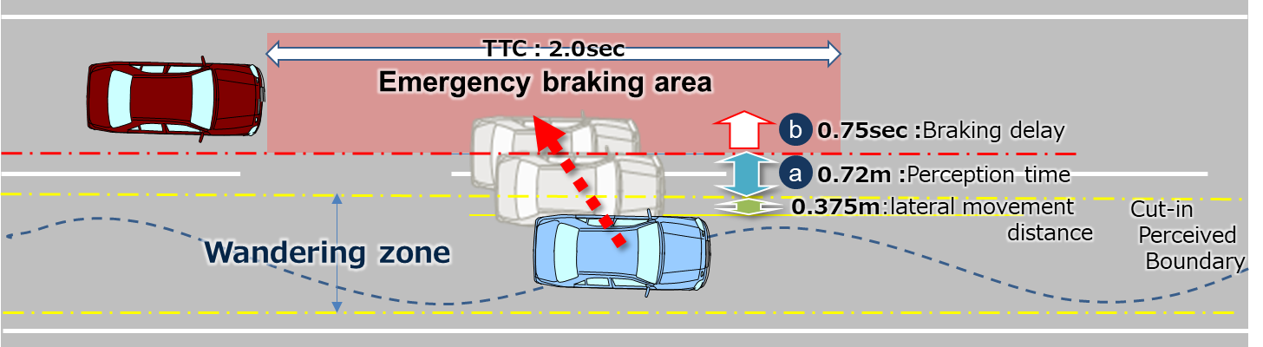
#
#
#
[ ]
[ ]
0.4sec

[ ]
The lateral wandering distance the vehicle will normally wander within the lane is [0.375m]# .
The perceived boundary for cut-in occurs when the vehicle exceeds the normal lateral wandering distance (possibly prior to actual lane change)
The distance a. is the perception distance based on the perception time [a]. It defines the lateral distance required to perceive that a vehicle is executing a cut-in manoeuvre a. is obtained from the following formula;
a.= lateral movement speed x Risk perception time [a] ([0.4sec]#)
The risk perception time begins when the leading vehicle exceeds the cut-in boundary threshold.
Max lateral movement speed is real world data in Japan.
Risk perception time [a] is driving simulator data in Japan.
[2sec*] is specified as the maximum Time To Collision (TTC) below which we conclude that there is a danger of collision in the longitudinal direction.
[*/=TTC 2.0sec is based on the UNR guidelines on warning signals.]#

3.1.2. For Cut out scenario:
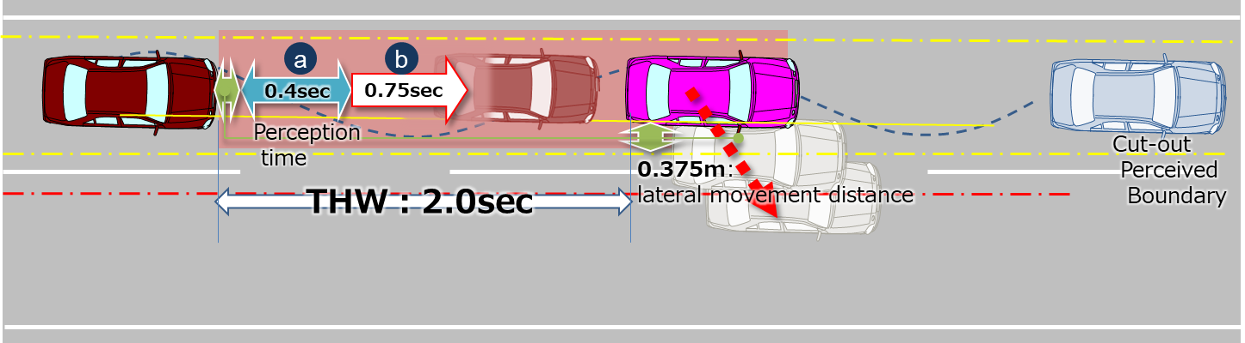
#
#
#
[ ]
[ ]
[ ]
The lateral wandering distance the vehicle will normally wander within the lane is [0.375m] #.
The perceived boundary for cut-out occurs when the vehicle exceeds the normal lateral wandering distance (possibly prior to actual lane change)
The risk perception time [a] is[0.4 seconds ]#and begins when the leading vehicle exceeds the cut-out boundary threshold.
[2sec**] is specified as the maximum Time Head Way (THW) for which we conclude that there is a danger in longitudinal direction.
[**/=THW 2.0sec is according to other countries’ regulations and guidelines.]

3.1.3. For Deceleration scenario:
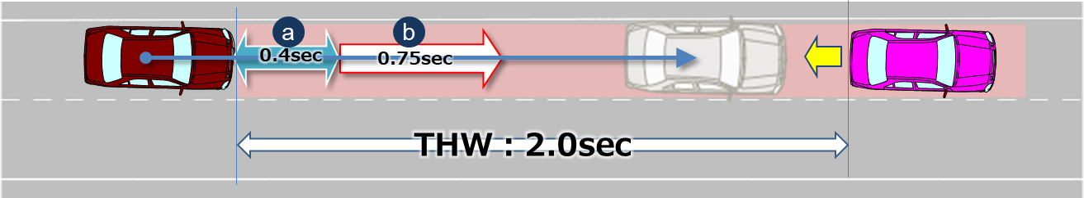
#
#
[ ]
[ ]
The risk perception time [a] is [0.4 seconds]#. The risk perception time [a] begins when the leading vehicle exceeds a deceleration threshold [5m/s²].※#

- Parameters
Parameters below are essential when describing the pattern of the traffic critical scenarios in section 2.1.
Additional parameters could be added according to the operating environment (e.g. friction rate of the road, road curvature, lighting conditions).
Operating conditions | Roadway | #of lanes = The number of parallel and adjacent lanes in the same direction of travel  Lane Width = The width of each lane  Roadway grade = The grade of the roadway in the area of test  Roadway condition = the condition of the roadway (dry, wet, icy, snow, new, worn) including coefficient of friction  Lane markings = the type, colour, width, visibility of lane markings
 | Environmental conditions | Lighting conditions = The amount of light and direction (ie, day, night, sunny, cloudy)  Weather conditions = The amount, type and intensity of wind, rain, snow etc.
Initial condition | Initial velocity | Ve0 = Ego vehicle
 |  | Vo0 = Leading vehicle in lane or in adjacent lane
 |  | Vf0 = Vehicle in front of leading vehicle in lane
 | Initial distance | dx0 = Distance in Longitudinal direction between the front end of the ego vehicle and the rear end of the leading vehicle in ego vehicle’s lane or in adjacent lane
 |  | dy0 = Inside Lateral distance between outside edge line of ego vehicle in parallel to the vehicle's median longitudinal plane within lanes and outside edge line of leading vehicle in parallel to the vehicle's median longitudinal plane in adjacent lines.
 |  | dy0_f = Inside Lateral distance between outside edge line of leading vehicle in parallel to the vehicle's median longitudinal plane within lanes and outside edge line of vehicle in front of the leading vehicle in parallel to the vehicle's median longitudinal plane in adjacent lines.
 |  | dx0_f = Distance in longitudinal direction between front end of leading vehicle and rear end of vehicle in front of leading vehicle
 |  | dfy = Width of vehicle in front of leading vehicle
 |  | doy = Width of leading vehicle
 |  | dox = Length of the leading vehicle
Vehicle motion | Lateral motion | Vy =Leading vehicle lateral velocity
 | Deceleration | Gx_max = Maximum deceleration of the leading vehicle in G
 |  | dG/dt = Deceleration rate (Jerk) of the leading vehicle

Following are visual representations of parameters for the three types of scenarios
Cut in | 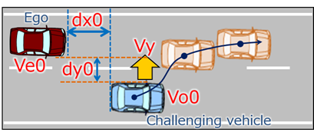
Cut out | 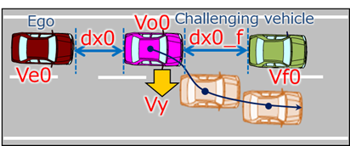
Deceleration | 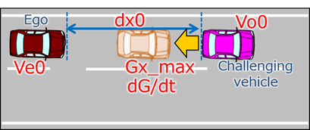

- Reference
Following data sheets are pictorial examples of simulations which determines conditions under which Automated Lane Keeping Systems (ALKS) shall avoid a collision, taking into account the combination of every parameter at, and below the maximum permitted ALKS vehicle speed.

5.1. Cut in

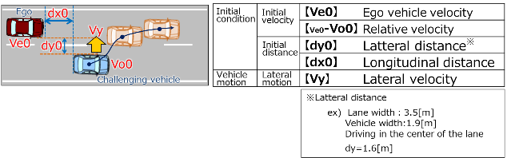

(Data sheets image)

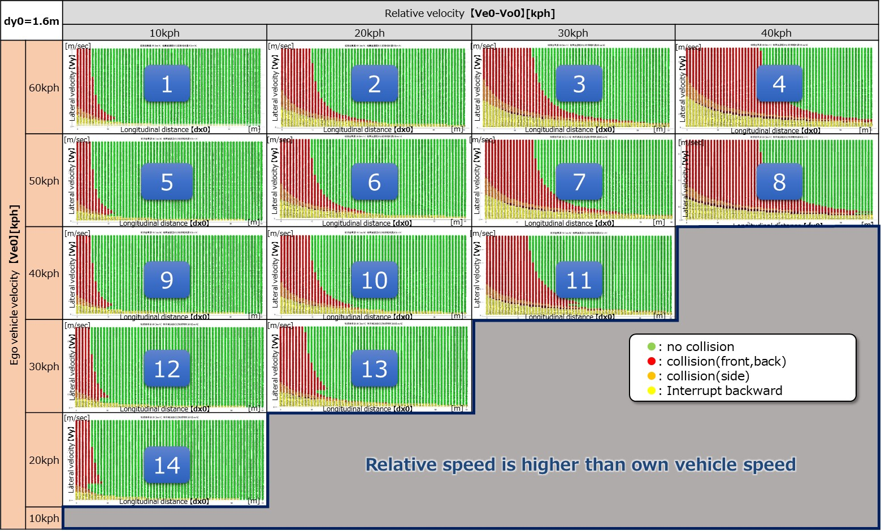
Ve0：60[kph]
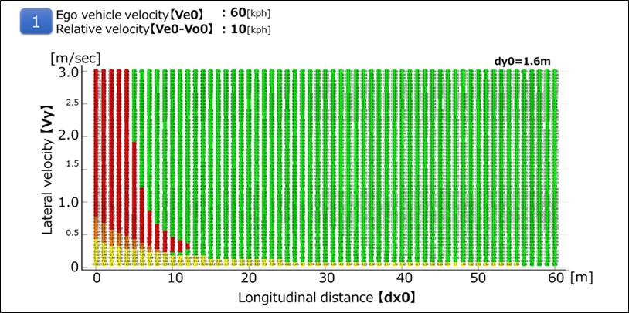

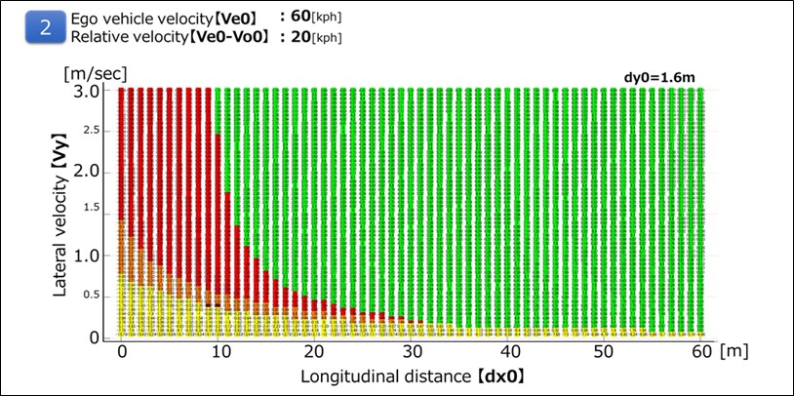
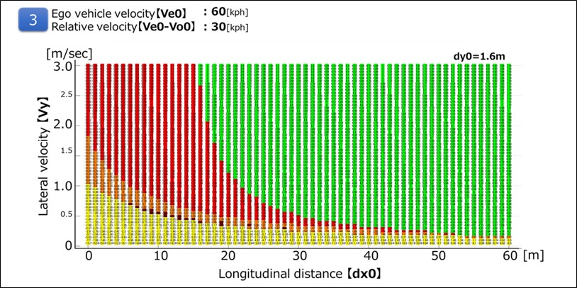

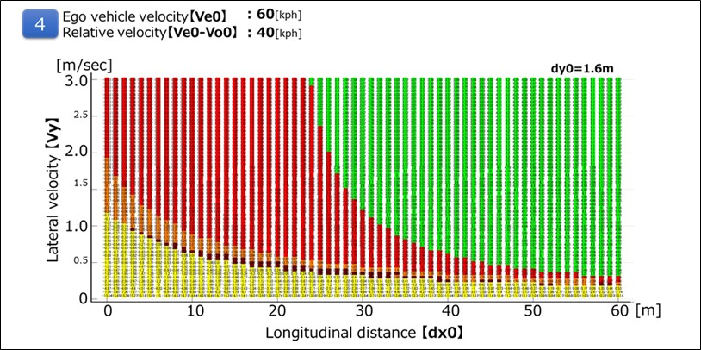

Ve0：50[kph]
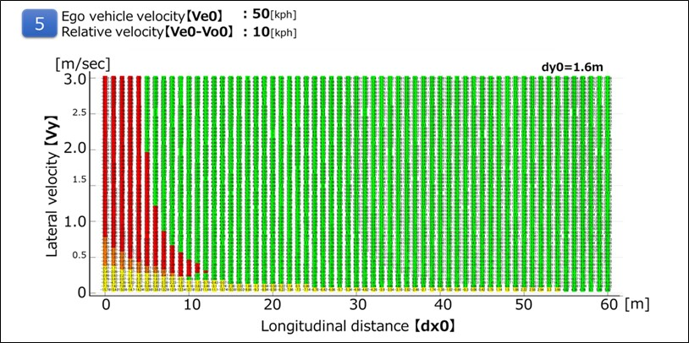

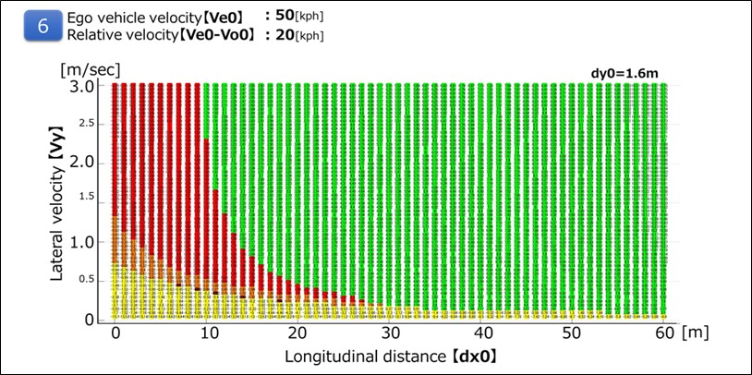

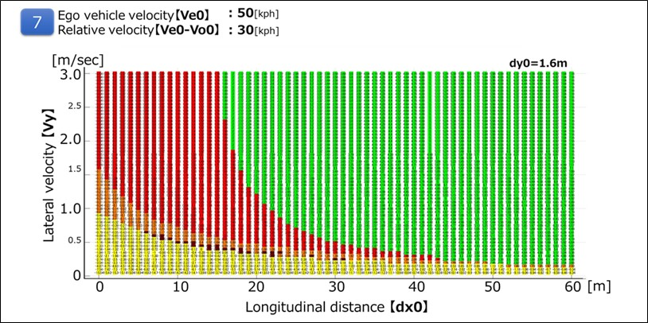

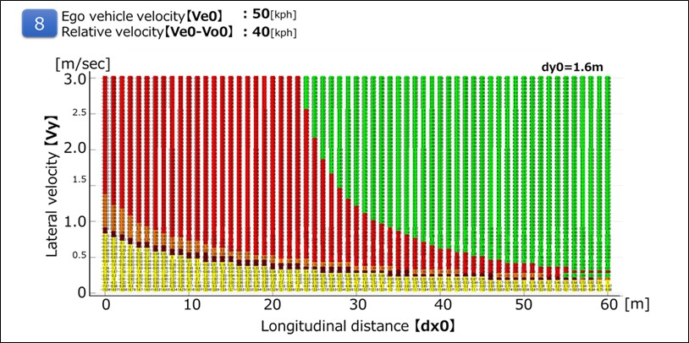

Ve0：40[kph]
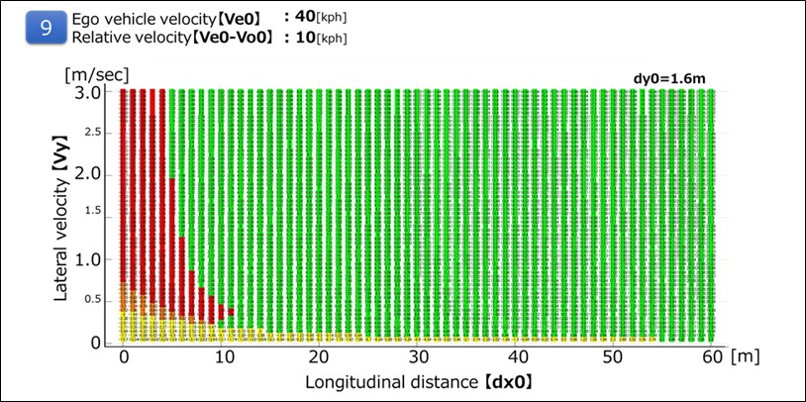

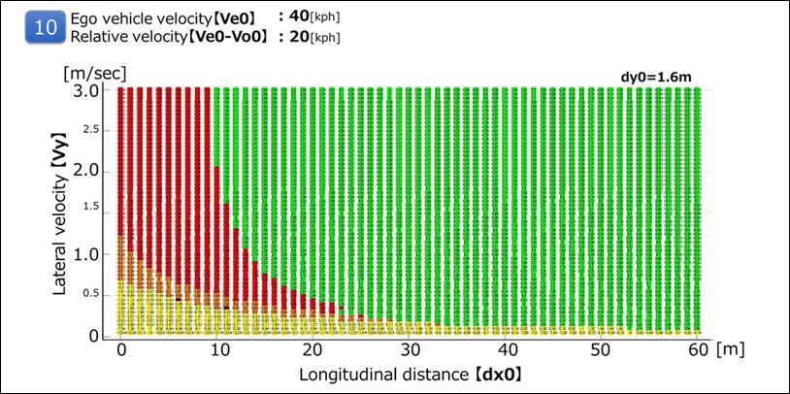

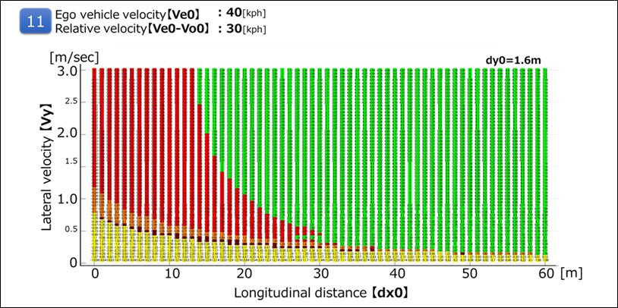

Ve0：30[kph]
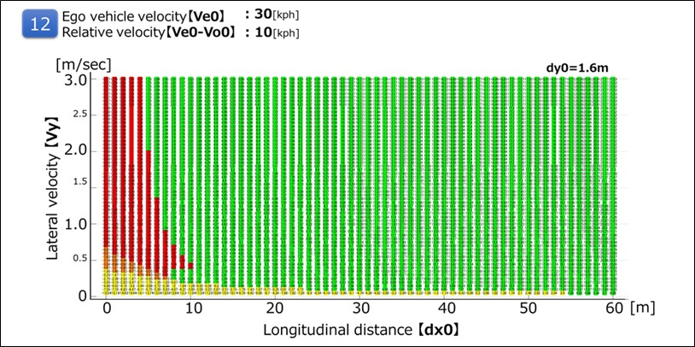

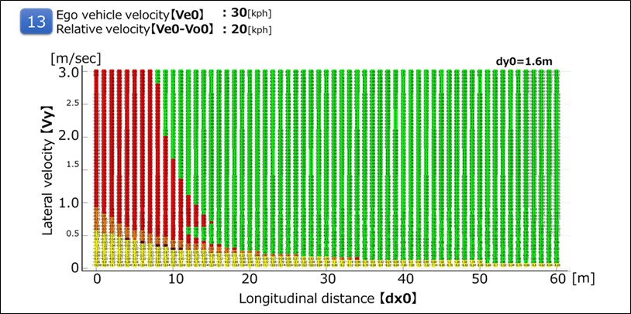

Ve0：20[kph]
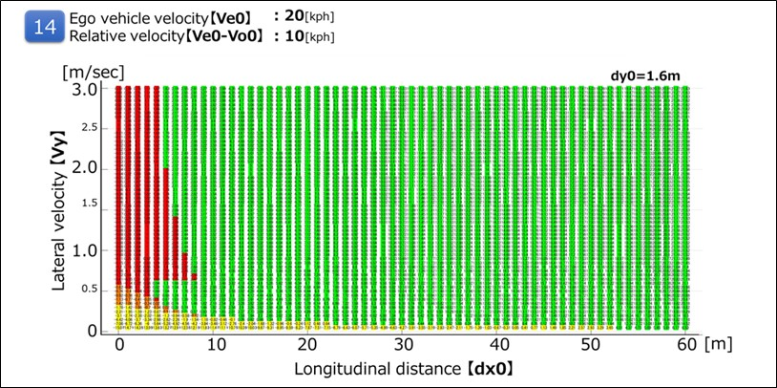

5.2 Cut out
It is possible to avoid all the deceleration (stop) vehicles ahead of the preceding vehicle cut-out in the following running condition at THW 2.0 sec.

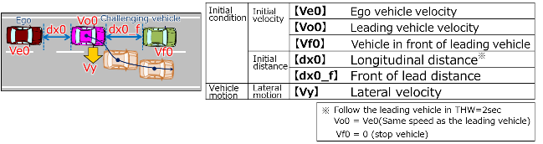
(Data sheets image)
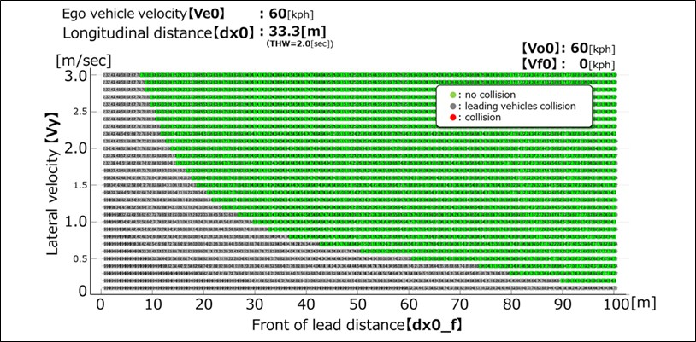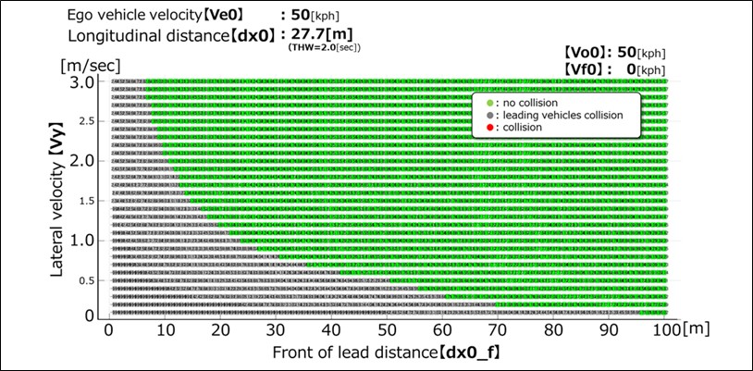
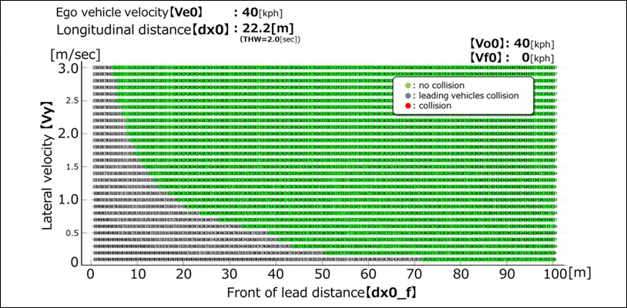
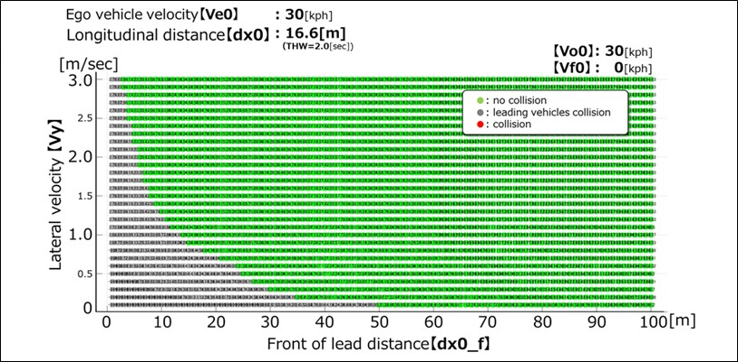

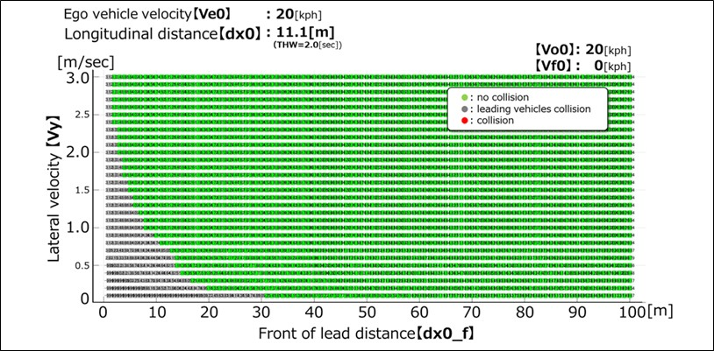
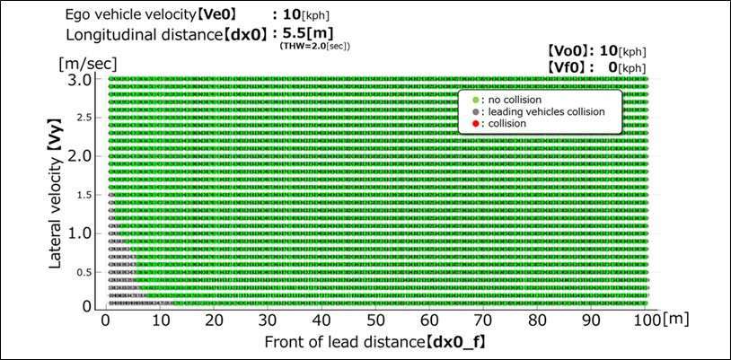

5.3. Deceleration
It is possible to avoid sudden deceleration of -1.0G or less in the follow-up driving situation at THW 2.0sec.
(Data sheet image)
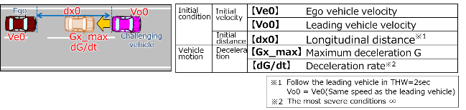
(Data sheets image)
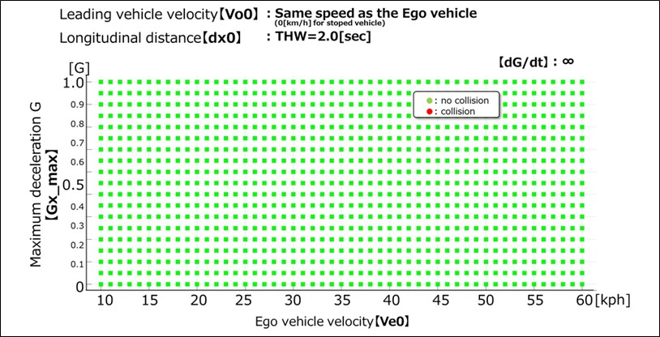

# These numbers were requested to put in the square brackets by some particular stakeholders. As a reminder, VMAD IWG members were requested to propose these quantitative parameters in last October meeting held in Ottawa (see the summary of VMAD04-04) and ever since SG1a has been working on these figures and result of the SG1 consideration on these figures was presented in Tokyo in January.
# These numbers were requested to put in the square brackets by some particular stakeholders. As a reminder, VMAD IWG members were requested to propose these quantitative parameters in last October meeting held in Ottawa (see the summary of VMAD04-04) and ever since SG1a has been working on these figures and result of the SG1 consideration on these figures was presented in Tokyo in January.
# These numbers were requested to put in the square brackets by some particular stakeholders. As a reminder, VMAD IWG members were requested to propose these quantitative parameters in last October meeting held in Ottawa (see the summary of VMAD04-04) and ever since SG1a has been working on these figures and result of the SG1 consideration on these figures was presented in Tokyo in January.

