**Proposal for the 03 series of amendments to UN Regulation No. 127 (Pedestrian safety) – document GRSP/2019/18**

The text reproduced below was prepared by the experts from OICA to amend the definitions and specifications as well as the Annex 1, Part 1. It is a revised counterproposal to document ECE/TRANS/WP.29/GRSP/2019/18 submitted by Germany and the OICA informal document GRSP-67-07. The modifications to the current text of the UN Regulations are marked in bold for new or strikethrough for deleted characters.

I. Proposal

*Paragraph 2.26.*, amend to read:

"2.26. "*Normal ride attitude*" means the vehicle positioned on a flat horizontal surface with its mass in running order, with the tyres inflated to manufacturer recommended pressures, the front wheels in the straight-ahead position and with a passenger mass placed on the front passenger seat. The front seats are placed at the nominal mid-track position. The suspension shall be set in normal running condition as specified by the manufacturer for a speed of 40 km/h. **If the vehicle is equipped with an adjustable suspension system, which could change the vehicle height while driving (e.g. active suspension) additional specifications according to paragraph 5.3. shall be applied."**

*Insert new paragraph 5.3*., to read:

"**5.3***.* **In the case of a vehicle fitted with an adjustable suspension system, which could change the vehicle height at the front axle more than 20 mm, the provisions of paragraph 5.1 and 5.2. shall, in addition to the normal running condition as specified by the manufacturer for a vehicle speed of 40 km/h, be met for all adjustable vehicle steady heights corresponding to vehicle speeds from 25 up to 40 km/h.**

**For these tests, on request of the manufacturer and agreed by the technical service, either the impact speeds defined in paragraph 5.1. and 5.2. or the impact speed corresponding to the adjusted vehicle height shall be used. In the latter case, the ratio of the head impact vs. the corresponding vehicle velocity shall be 0.875.**

**[The above requirements shall not apply to vehicles equipped with ride height adjustment for e.g. off-road conditions, where the car manufacturer can demonstrate to the satisfaction of the Technical Service that it is ensured by technical means that the ride height adjustment cannot be engaged, be left engaged or automatically become engaged when used on public roads.]**

**Vehicles equipped with a manual override ride height adjustment system designed for use in exceptional cases such as rescue, emergency (e.g. for flood/heavy snow); the normal ride height of the vehicle shall reset when the system is manually switched off. In all cases the height adjustment system shall automatically reset at the next ignition cycle.**

**In all case where the manual override adjustment system is engaged it shall be indicated to the driver by an optical warning signal.**

*Insert new paragraphs 5.3.1 to 5.3.3*., to read:

**5.3.1. The legform impactor to be used is the legform impactor as used for the legform to bumper test in normal running condition for a speed of 40 km/h.**

**5.3.2. With the agreement of the technical service, compliance shall be demonstrated by a limited number of legform tests or by numerical simulation according to the specification set out in paragraph 5.3, so that the biomechanical limits set out in paragraph 5.1.1 and paragraph 5.1.2 respectively are met.**

**5.3.3. With the agreement of the technical service, compliance shall be demonstrated by a limited number of head impact tests or by numerical simulation showing compliance to the HIC 1,700 requirement on the additional head test area**".

*Insert new paragraphs 11.5. to 11.8.,* to read:

**11.5. As from the official date of entry into force of the 03 series of amendments, no Contracting Party applying this Regulation shall refuse to grant or refuse to accept type-approvals under this Regulation as amended by the 03 series of amendments.**

**11.6. As from 7 July 2024, Contracting Parties applying this Regulation shall not be obliged to accept type-approvals to the preceding series of amendments first issued after 7 July 2024.**

**11.7. Contracting Parties applying this Regulation shall continue to accept type approvals issued according to the preceding series of amendments to this Regulation first issued before 7 July 2024**

**11.8. Contracting Parties applying this Regulation shall not refuse to grant type-approvals according to any preceding series of amendments to this Regulation or extensions thereof.**

*Annex 1*, *Part 1, paragraph 9.23.1*., amend to read:

"9.23.1. A detailed description, including photographs and/or drawings, of the vehicle with respect to the structure, the dimensions, the relevant reference lines and the constituent materials of the frontal part of the vehicle (interior and exterior) shall be provided. This description shall include detail of any active protection system installed **and any system, which could change the vehicle height at the front axle while driving (e.g. active suspension).**"

II. Justification

1. UN Regulation No. 127 addresses impacts with a pedestrian up to 40 km/h. Therefore, an impact velocity of 11.1 m/s (40 km/h) has been chosen to address a large amount of Maximum Abbreviated Injury Scale 1+ pedestrian accidents (see diagram below).

2. The availability of active suspensions allows the development of a system which could change the vehicle height while driving (up to a defined driving speed, e.g. up to 39 km/h). Such a system would allow raising of the suspension for driving off road (SUVs mostly) or driving in a car park (sports cars). In this context, there have been discussions with some manufacturers about the relevance to pedestrian protection. Since the vehicle height has an influence on the headform test area (WAD) and on the test results for legform tests, all possible vehicle heights up to a driving speed of 11.1 m/s (40 km/h) should be considered to be relevant for impact with a pedestrian. The proposal clarifies this issue.

3. To ensure, that such an active suspension system is considered for type approval in any case, there should be a detailed description in the information document.

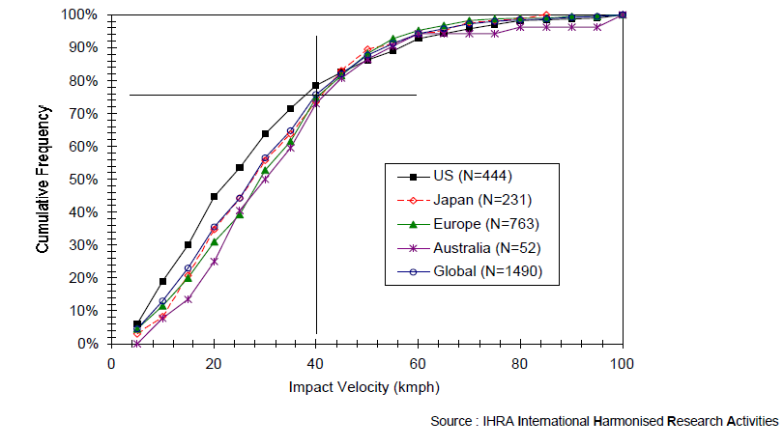

*:*

Source: Informal Group on Pedestrian Safety – 1st meeting (4-5 September 2002)  
INF GR / PS / 3. IHRA accident study

4. For tests with active suspensions the same legform impactor shall be used as for the tests at 40km/h. i.e. no change between FlexPLI and Upper legform (§5.3.1). The additional head tested area does not relate to the distribution of HIC 1000/1700 areas (§5.3.3).