Proposal for supplement 1 to UN Regulation No. 145
Submitted by the expert from the Netherlands *
The text reproduced below was prepared by the expert from the Netherlands, aiming to clarify the requirements for the location of ISOFIX systems in case the vehicle type is equipped with rearward facing seats. The modifications to the current text of the UN Regulation are marked in bold for new or strikethrough for deleted characters.
- Proposal
Paragraph 5.3.3.., amend to read:
"5.3.3. Notwithstanding paragraph 5.3.1. at least one of the two ISOFIX positions systems shall be installed at the second seat row. In case the second seat row consists of a seat or seats permanently facing rearwards, they are disregarded and this requirement then applies to the first consecutive forward facing seat row, if available.”
II. Justification
The situation may occur, where the second seat row consists of rearward facing seats, either with or without the possibility to turn or be mounted in forward facing direction. This proposal aims to clarify the minimum required number of ISOFIX positions systems for this situation.
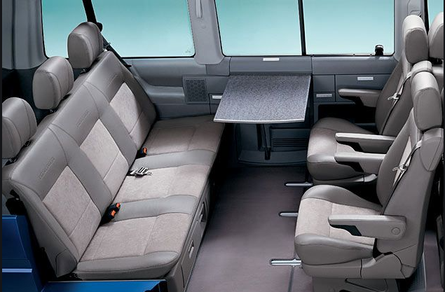
example of 2nd row seats which can be turned in the forward facing direction
- In the situation where the 2nd row seats can be turned or mounted in forward facing direction, it is OK to have ISOFIX systems in these seats. The owner’s manual shall make it clear in what position the seats have to be turned or mounted in order to be used in combination with (different types of) Child Restraint Systems.
- In a situation where the 2nd seat row seats cannot be turned or mounted in forward facing direction, the ISOFIX systems shall be available in the 3rd row, if there is any. In the unlikely situation where there is no 3rd row, it means that only the front passenger seat(s) shall have (an) ISOFIX system(s) installed.
- In ECE R129, there is a definition of rear seats, being “fixed, forward-facing seats situated behind another group of vehicle seats”. ECE R145 seems to take only forward facing seats into consideration, but this is nowhere stated.

* In accordance with the programme of work of the Inland Transport Committee for 2006–2010 (ECE/TRANS/166/Add.1, programme activity 02.4), the World Forum will develop, harmonize and update Regulations in order to enhance the performance of vehicles. The present document is submitted in conformity with that mandate.

