What can we do in GRSP to get the same protection level for female occupants as for male?
In Sweden female whiplash injurys is a huge problem, so we have a very high priority on addressing this issue together in GRSP.

A study with the purpose to identify about how well todays crash test dummies represent the adult population has been has been done.

This study has been funded and carried through in Sweden through an inventory of available knowledge.

Results
In this study it becomes clear that female occupants faces a much higher, doubled risk to obtain an injury due to whiplays.

Male and females have different sizes, different seated posture. As examples females tend to have a different arm position, shorter head restraint distance, different leg position when driving.

Below you can see the crash test dummies available today, it is clear that the average female is missing.
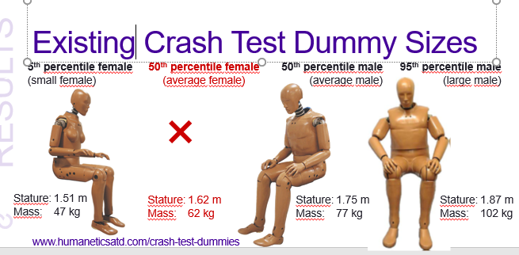
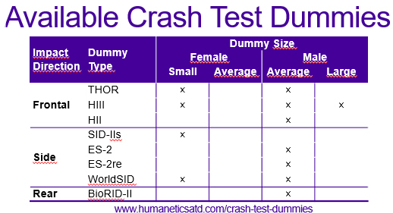

This study has also shown that:
- Crash related injury risks are higher in females.
- Females are poorly represented by existing dummies.
- Information about body size (stature and mass) should be included in traffic injury databases.
- Injury data need to be reported for females and males separately.
Is the head restraint systems and the seats safety construction based on male anatomy? Do they protect females equally good for a whiplash?
Pernilla Bremer
Senior Administrative Officer

