Submitted by the expert from the European Commission | Informal document GRSP-67-31  (67th GRSP, 20-23 July 2020  agenda item 17(b))

The text reproduced below proposes amendments to ECE/TRANS/WP.29/2020/53 as a follow up of the last session of WP.29.
PROPOSAL:
Insert a new paragraph 1.2., to read:
"1.2. This Regulation explicitly forbids child restraint systems in the form of belt guides and other sitting devices that are dangerous and can harm children in the event of a vehicle collision irrespective of any test results obtained in accordance with paragraph 8.
In particular, it concerns belt guides and sitting devices meant for children of a mass from 15 kg to 36 kg that connect to or attach onto the lap belt portion as well as the torso belt portion of a 3-point adult safety belt system with the aim to alter the adult safety belt routing by for example pulling down the torso belt portion or squeezing together the torso belt portion and lap belt portion. Examples of such non-compliant devices are shown below.
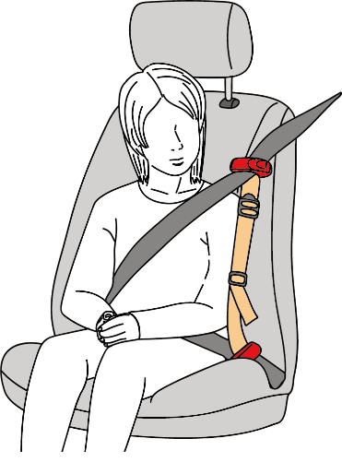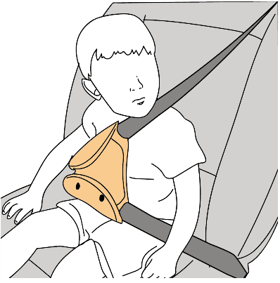
It also concerns sitting devices that are unusable by a child unless they are properly inflated or other compact sitting devices that attempt to guide the lap belt portion by keeping it down or forward, just above the seat cushion, rather than to significantly elevate the child in relation to the vehicle’s normal seating position and the corresponding adult safety belt effective lower anchorages."

Paragraph 6.1.3., amend to read:
"6.1.3. According to the category which it belongs to, the child restraint shall be secured to the vehicle structure or to the seat structure.

Possible configurations for approval Groups / categories table
Group category |  | Universal (1) |  | Semi-universal (2) |  | Restricted |  | Specific vehicle
 |  | CRS | ISOFIXCRS | CRS | ISOFIXCRS | CRS | ISOFIXCRS | CRS | ISOFIXCRS
0 | Carry-cot | A(3) | NA | A(3) | A(3) | A(3) | NA | A(3) | A(3)
 | Rearward facing | A(3) | NA | A(3) | A (3) | A(3) | NA | A(3) | A(3)
0+ | Rearward facing | A(3) | NA | A(3) | A(3) | A(3) | NA | A(3) | A(3)
I | Rearward facing | A(3) | NA | A(3) | A(3) | A(3) | NA | A(3) | A(3)
 | Forward facing (integral) | A(3) | A(3) | A(3) | A(3) | A(3) | NA | A(3) | A(3)
 | Forward facing  (non-integral) | NA | NA | NA | NA | NA | NA | NA | NA
 | Forward facing  (non-integral – see paragraph 6.1.12.) | A(3) | NA | A(3) | NA | A(3) | NA | A(3) | A(3)
II | Rearward facing | A(3) | NA | A(3) | NA | A(3) | NA | A(3) | A(3)
 | Forward facing  (integral) | A(3) | NA | A(3) | NA | A(3) | NA | A(3) | A(3)
 | Forward facing  (non-integral) | A(3) | NA | A(3) | NA | A(3) | NA | A(3) | A(3)
III | Rearward facing | A(3) | NA | A(3) | NA | A(3) | NA | A(3) | A(3)
 | Forward facing (integral) | A(3) | NA | A(3) | NA | A(3) | NA | A(3) | A(3)
 | Forward facing  (non-integral) | A(3) | NA | A(3) | NA | A(3) | NA | A(3) | A(3)
With:
CRS: Child restraint system
A: Applicable
NA: Not Applicable
______________________
⁽¹⁾ ISOFIX universal CRS means forward facing restraints for use in vehicles with positions equipped with ISOFIX anchorages system and a top tether anchorage.
⁽²⁾ ISOFIX semi universal CRS means:
• Forward facing restraints equipped with support leg or
• Rearward facing restraints equipped with a support leg or a top tether strap for use in vehicles with positions equipped with ISOFIX anchorages system and a top tether anchorage if needed
• Or rearward facing restraints, supported by the vehicle dashboard, for use in the front passenger seat equipped with ISOFIX anchorages system,
• Or lateral facing position restraint equipped if needed with an anti-rotation device for use in vehicles with positions equipped with ISOFIX anchorages system and top tether anchorage if needed.
…
⁽³⁾ New approvals and extensions will be granted in accordance with paragraphs 17.16 to 17.23.
"
Amend paragraph 17.15., to read:
"17.15. As from the official date of entry into force of Supplement 18 to the 04 series of Amendments of this Regulation, Contracting Parties applying this Regulation may prohibit the placing on the market of non-compliant devices and child restraint systems which do not meet the requirements of the 04 series of Amendments of this Regulation."
Insert new paragraphs 17.22. to 17.25., to read:
"17.22. As from 1 September 2021, Contracting Parties applying this Regulation shall not be obliged to accept type approvals issued according to this Regulation, first issued after 1 September 2021.
17.23. Until 1 September 2023, Contracting Parties applying this Regulation shall accept type approvals issued according to the 04 series of amendments to this Regulation, first issued before 1 September 2021.
17.24. As from 1 September 2023, Contracting Parties applying this Regulation shall not be obliged to accept type approvals issued in accordance with this Regulation.
17.25. Notwithstanding paragraphs 17.22. and 17.24., Contracting Parties applying this Regulation shall continue to accept type approvals of vehicle specific "built in" or specific vehicle "built in" child restraint systems issued according to the 04 series of amendments to this Regulation."
JUSTIFICATION:

At the last GRSP in December 2019, the Commission proposed to amend the scope of UN Regulation No 44 (Child restraint systems) to clarify that belt guide cannot be approved under Regulation 44 without being part of a child restraints system (paragraph 1.2). The amendment was agreed by the GRSP and sent to WP.29 together with the proposal from IC/ANEC on the phase out of the Regulation No 44 (ECE/TRANS/WP.29/GRSP/2019/28) for consideration at its June 2020 session.
Upon further examination, the Commission identified that the text of the amendment in paragraph 1.2 was not in line with the General Guidelines for UN regulatory procedures and transitional provisions in UN Regulations. In reconsidering the drafting according to the above Guidelines, the Commission concluded that de jure the change proposed to paragraph 1.2 would not imply any changes to the current requirements of the Regulation, in particular that a ‘guide strap’ and similar devices cannot be separately approved as a child restraint system already under the current wording of Regulation No 44 as applicable since March 2012 (Interpretation by GRSP in December 2011 and endorsed by WP29 at its 156th session of WP.29 of March 2012).
For that reason, the Commission proposes to withdraw its initial draft amendment. The draft amendment by IC/ANEC regarding the phasing out of the Regulation is kept.
The Commission would like to underline that the withdrawal of its draft amendment does not change its understanding of paragraph 2.8.8. of Regulation 44 that approvals granted to guide straps that are not part of a child restraints systems are not valid.
Taking into account the above interpretation of the Regulation 44, the Commission has been following up at the EU level cases of acceptance of such invalid approvals and has committed to carry out own tests (by Joint Research Centre) to assess the risk raised by such products so that appropriate market restriction measures can be taken if needed. The Commission will share more information regarding these actions, including tests results, with GRSP at the next session.
The assessment by the Commission of the Regulation 44 and the on-going discussions on its scope in GRSP, made it clear that systemic and more profound changes and more clarity is needed with regard to the contents of the rules regarding Child Restraint Systems in order to make them more robust and up to date. The Commission would like to invite GRSP to engage in such activity.

