Proposal for the 01 series of amendments to Regulation No. 134

The text reproduced below was prepared by the expert from OICA, proposing modifications to the informal document GRSP-67-12 from the Netherlands. The modifications to the current text of GRSP-67-12 are marked in bold and strike-through.

I. Proposal

Paragraph 7.1.1.2., amend to read:
"7.1.1.2. Fuelling receptacle label: A label shall be affixed close to the fuelling receptacle; for instance inside a refilling hatch, showing the following information: fuel type (e.g. "CHG" for gaseous hydrogen), MFP, NWP, date of removal from service of containers. In addition or on a separate label, the following information shall be permanently affixed on each container: Name of the Manufacturer, Serial Number, Date of Manufacture

Paragraphs 7.1.7 to 7.1.7.3, replace by :
"7.1.7. Identification of hydrogen fuelled vehicles.
7.1.7.1. On vehicles of the categories M₂/N₂ and M₃/N₃, equipped with a compressed hydrogen system, labels shall be installed as specified in Annex 6
7.1.7.2. These labels shall be installed on the front and rear of the vehicle, and on the outside of the doors on the right-hand side (left hand drive vehicles) and left-hand side (right-hand drive vehicles) (if available, on a front door) and on top of the vehicle.
7.1.7.3. A label shall be placed adjacent to the H₂ fill receptacle; for instance inside a refilling hatch, showing the following information: fuel type (using label shape and zones, colour definitions and pictogram as designated in Annex 6, MFP, NWP, date of removal from service of containers.”

Insert a new paragraph 13.6., to read:
"13.6 Contracting Parties applying this Regulation shall not refuse to grant type approvals according to any preceding series of amendments to this Regulation or extension thereof."

Annex 6, replace by:
“Annex 6 - Provisions for a label for compressed hydrogen vehicles of categories M₂/N₂ and M₃/N_{3.}
(Paragraph 7.1.7.1 and 7.1.7.3. of this Regulation)

The label consists of a sticker which shall be weather resistant.
The centre zone indicates the first energy source
The upper zone indicates the second energy source
The left zone indicates the gas behaviour due to density
The right zone indicates the state of aggregation of stored gaseous fuel (this sample shows compressed gaseous hydrogen, for liquid hydrogen, the corresponding symbol shall be used)
Layout and symbols shall be in accordance with ISO 17840-4:2018
Location of the sticker: front and rear, left side and right side (if available, on a front door),
on top of the vehicle

The colour and dimensions of the sticker shall fulfil the following requirements:
Colours:
Background: Light-blue, RGB code 0, 176, 240
Border: white or white reflecting
Letters and symbols: white or white reflecting
Dimensions:
Sticker width: 200 110 - 150 mm (front and rear, left- and right side of vehicle)
297 mm (top of vehicle)
Sticker height: 150 80 - 110 mm (front and rear, left- and right side of
vehicle)
210 mm (top of vehicle)

II. Justification
- Provisions for identification of Gaseous and Liquefied fuels have been laid down in UN Reg. 67 and UN Reg. 110 for vehicles of category M2 and M3.
- The labelling of hydrogen fuels today are part of regional/national provisions (as example 79/2009 for the European Union or their recently published draft revision)
- OICA understands the background of the draft amendment as issued by the Netherlands in general but asks to review some specific topics.
- Labelling LPG/CNG/LNG is currently required under the 58-agreement only for buses. An extension to vehicles of category N2 and N3 has to be further reviewed, especially with regard to the size of the label and the available space on small cabs.
- Regulation 134 covers only compressed hydrogen, not liquid hydrogen. All references to liquid hydrogen ae deleted in the OICA proposal
- NL asks for a label with a size 1.8 to 3.4 times higher than the size of current labels in UN Reg. 67 and UN Reg. 110. OICA thinks that readability of current labels is given to the rescue services and that a larger and more prominent label will most likely reduce the recognition of labels already attached to commercial vehicles, e.g. the marking of special purpose vehicles or special information to disabled or elderly people

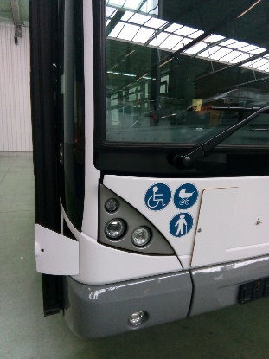

Furthermore, vehicles of category M2/N2 are very often derived from vehicles of category M1/N1 and may not have sufficient space on the front of the vehicle to accommodate large labels. If this will be done e.g. on the windscreen, the field of vision of the driver will be reduced. OICA therefore proposes not to add provisions on the size of the label

- Labels on the vehicle roof could be covered by racks or the vehicle body itself and will not be recognized. In addition, a damaged, dirty or lost label on the vehicle roof will not be recognized by users and could lead to misleading actions by the rescue service.
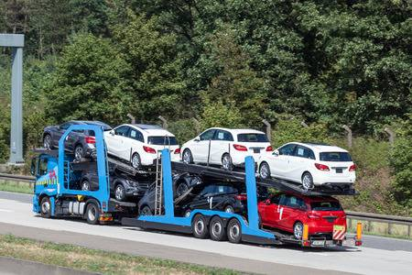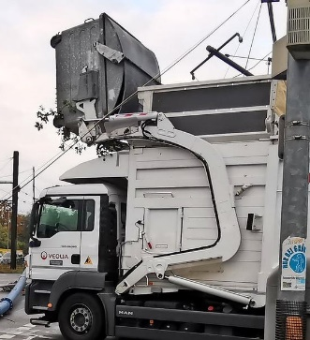
A tipped vehicle will be recognised by the labels on front/rear or side. The field of view of a camera on a drone should also allow a detection of stickers at the front/rear or side of the vehicle.
OICA therefore proposes not to add a label on the vehicle roof. OICA also asks to review the request to label the rear of a commercial vehicle (see example above)
- OICA proposes not to change paragraph 7.1.1.2 as the labeling of the container is covered by paragraph 5.6

