|  |  |  |  |
| --- | --- | --- | --- |
|  | United Nations | ECE/TRANS/WP.29/GRSP/2020/18 | |
| _unlogo | **Economic and Social Council** | | Distr.: General  24 September 2020  Original: English |

**Economic Commission for Europe**

Inland Transport Committee

**World Forum for Harmonization of Vehicle Regulations**

**Working Party on Passive Safety Provisions**

**Sixty-eighth session**

Geneva, 7-11 December 2020

Item 12 of the provisional agenda

**UN Regulation No. 129 (Enhanced Child Restraint Systems)**

**Proposal for Supplement 5 to the 03 series of amendments to UN Regulation No. 129 (****Enhanced Child Restraint Systems)**

**Submitted by the expert from the European Association of Automotive Suppliers[[1]](#footnote-1)\***

The text reproduced below was prepared by the expert from the European Association of Automotive Suppliers (CLEPA) aimed to clarify that specific vehicle belted Enhanced Child Restraint Systems (ECRS) may be fitted with a support leg, top tether and lower tether attachments. This proposal also amends the existing support leg volume to improve the compatibility between the support leg volume and the Child Restraint Fixtures used for accessing the external dimensions of an ECRS. The modifications to the current text of the UN Regulation are marked in bold for new or strikethrough for deleted characters.

I. Proposal

*Paragraph 2.7.3.,* amend to read:

"2.7.3.    "Specific *vehicle Belted*" is a category of Integral Enhanced Child Restraint System connected to specific vehicle types by using the vehicle safety belt**, possibly in combination with other attachment methods**. ~~Additional vehicle anchorage points approved by UN Regulation No. [144] may be used. Any attachment points required for securing rearward facing Enhanced Child Restraint System shall be checked according to Annex  25. Enhanced Child Restraint Systems that use the vehicle dashboard as a contact zone are permitted.~~"

*Paragraph 6.1.2.4.,* amend to read:

"[6.1.2.4](https://eur01.safelinks.protection.outlook.com/?url=http%3A%2F%2F6.1.2.4%2F&data=02%7C01%7Cmark.pitcher%40britax.com%7C8c85da8e9da24bd91c7408d84ff5649f%7C6d56f05648d84e5aa5280e2df50d29ac%7C0%7C0%7C637347262677448930&sdata=EIik5u3VXu6bzAgjHwrnlIcgvRbq5w9%2Bdq1R%2FJtQu0I%3D&reserved=0).         For the "Specific vehicle Belted" category, this shall be primarily by means of the adult safety-belt, **possibly in combination with other attachment methods that use vehicle anchorage points and/or floor contact surfaces that are approved to UN Regulation No. 145 (e.g. top tethers, support legs or other). Lower tether attachments are also permitted for rear-facing Enhanced Child Restraint Systems, provided the requirements of Annex 24 are met.**"

*Paragraph 6.3.5.1.,* amend to read:

"6.3.5.1. Support-legand support-leg foot geometricalrequirements

The support leg, including its attachment to the Enhanced child restraint systems and the support-leg foot shall lie completely within the support leg dimension assessment volume (see also figures 1 and 2 of annex 19 of this Regulation), which is defined as follows:

(a) In width by two planes parallel to the X'-Z' plane separated by 200 mm, and centered around the origin; and

(b) In length by two planes parallel to the Z'-Y' plane and positioned at distances of 585 mm and 695 mm forward of the origin along the X' axis; and

(c) In height by a plane parallel to the X'-Y' plane, positioned at a distance of ~~70~~ **185** mm above the origin and measured perpendicular to the X'-Y' plane. Rigid, non-adjustable parts of the support leg shall not extend beyond a plane parallel to the X'-Y' plane, positioned at a distance of 285 mm below the origin and perpendicular to the X'-Y' plane.

The support-leg may protrude the support-leg dimension assessment volume, providing it remains within the volume of the relevant CRF. "

*Annex 19.,* amend Figure 1 to read:

"Figure 1

**Side view of the support leg dimension assessment volume**

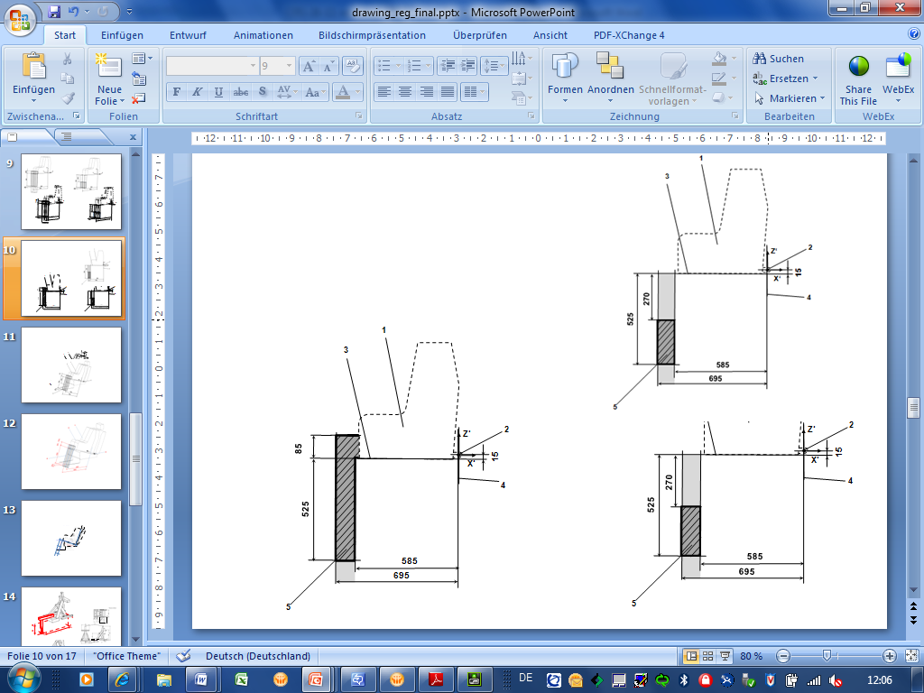

**200**

**~~85~~**

*Key:*

1. Enhanced Child Restraint Fixture (CRF).

2. ISOFIX low anchorages bar.

3. Plane formed by the bottom surface of the CRF, which is parallel to and 15 mm below the X'-Y' plane of the coordinate system.

4. Z'-Y' plane of the coordinate system.

5. Upper part of the support-leg dimension assessment volume, which shows the dimensional limitations in X' and Y' direction, the upper height limit in Z' direction, as well as the lower height limitation in Z' direction for rigid, not in Z' direction adjustable support leg components.

*Note*:

1. Drawing not to scale."

*Annex 19.,* amend Figure 2 to read:

"Figure 2  
**3D view of the support leg dimension assessment volume**

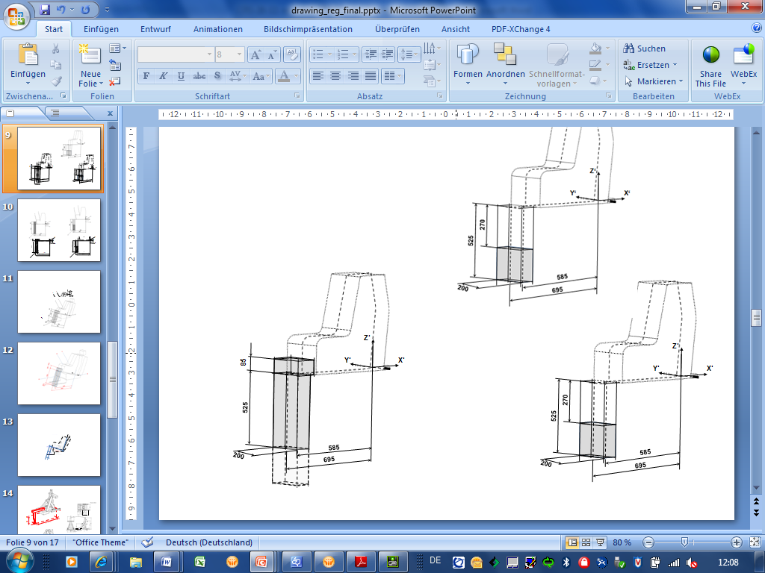

**200**

**~~85~~**

*Note*:

1. Drawing not to scale."

II. Justification

1. During the original drafting of UN Regulation No. 129, 03 series of amendments the informal working group of the Working Party on Passive Safety (GRSP) agreed that a specific vehicle belted ECRS may be fitted with a combination of a support leg, top tether and lower tethers. The guiding principles document for UN Regulation No. 129, 03 series of amendments, created by the informal working group at the sixty-sixth session of GRSP (CRS-66-05) states that support-legs and top-tether are accepted only for Specific vehicle belted ECRS (not allowed for universal belted).

2. This proposal amends the text to clarify that support legs, top tethers, and lower tethers are allowed to be fitted to a specific vehicle belted ECRS.

3. UN Regulation No. 16 defines the envelope dimensions of ISO/R2 and ISO/F2X CRF envelopes. The dashed line 2) represents the area where a support leg or similar may protrude. For the ISO/F2X envelope, this is indicated with a height of 200 mm.

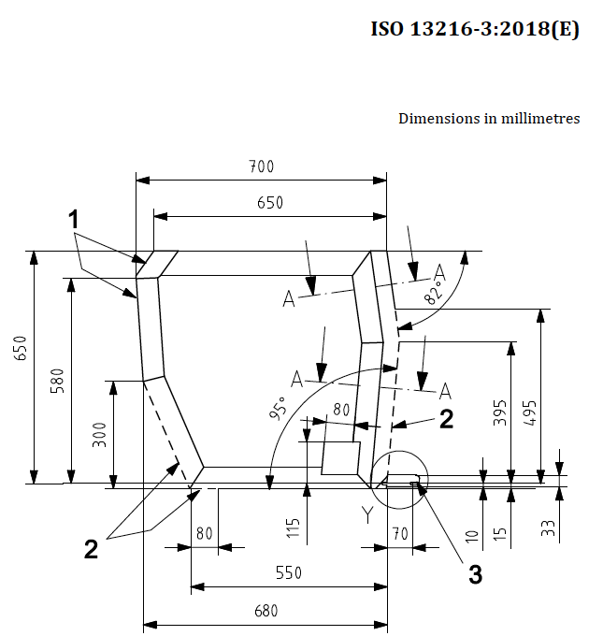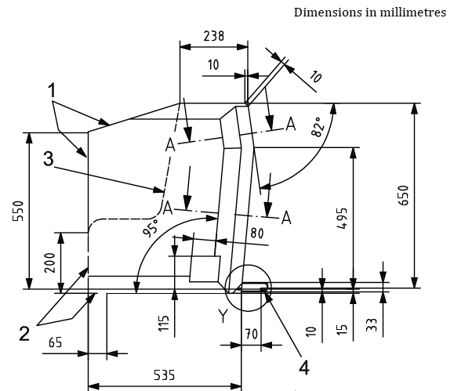

In our proposal, the top surface of the support leg volume has been raised upwards to match the support leg opening in the ISO envelopes to facilitate more space for support legs. The majority of the new support leg space already overlaps with ISO/R2 volume and therefore this space is always available in i-Size vehicle positions.

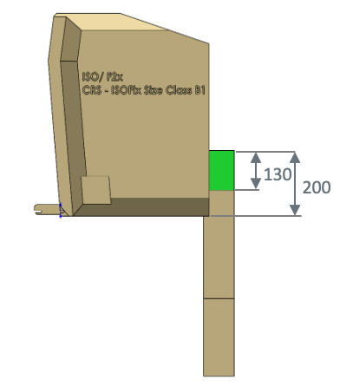

200

115

**ISO/F2X**

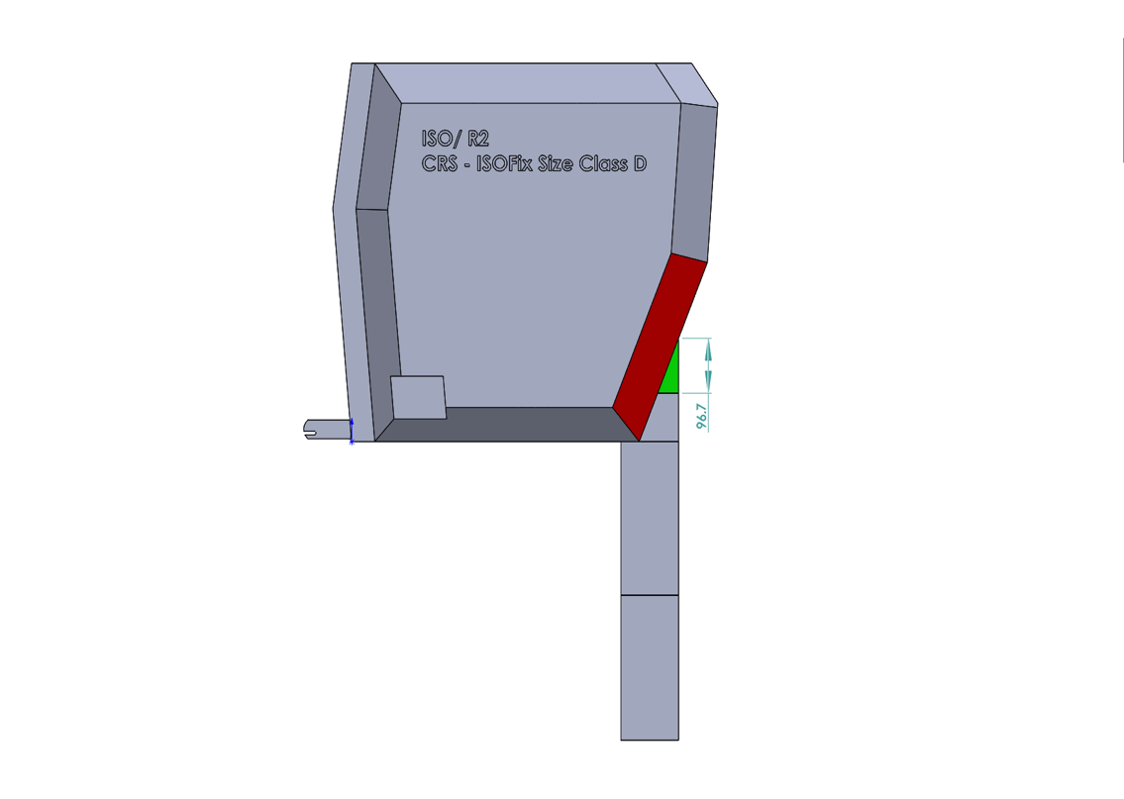

**ISO/R2**

200

115

1. \* In accordance with the programme of work of the Inland Transport Committee for 2020 as outlined in proposed programme budget for 2020 (A/74/6 (part V sect. 20) para 20.37), the World Forum will develop, harmonize and update UN Regulations in order to enhance the performance of vehicles. The present document is submitted in conformity with that mandate. [↑](#footnote-ref-1)