Proposal for changes to document GRSG/2020/14
Consolidated Resolution R.E.3

Submitted by the experts of OICA

The text reproduced below was prepared by the experts from OICA. This proposal amends the working document referenced ECE/TRANS/WP.29/GRSG/2020/14. The modifications to the current proposal ECE/TRANS/WP.29/GRSG/2020/14 are marked in red characters.
I. Proposal
Proposed new paragraph 1.14, delete
“1.14. "Manufacturer’s representative" means any natural or legal person established in the Community who is duly appointed by the manufacturer to represent him to the approval authority and to act on his behalf in matters covered by the UN Regulations requirements for approval ,and where reference is made to the term ‘manufacturer’, it is to be understood as indicating either the manufacturer or his representative;”

Proposed new paragraph 1.17, delete
“1.17. "Original parts or equipment" means parts or equipment which are manufactured according to the specifications and production standards provided by the vehicle manufacturer for the production of parts or equipment for the assembly of the vehicle in question. This includes parts or equipment which are manufactured on the same production line as these parts or equipment. It is presumed unless the contrary is proven, that parts constitute original parts if the part manufacturer certifies that the parts match the quality of the components used for the assembly of the vehicle in question and have been manufactured according to the Un regulations requirements and specifications and production standards of the vehicle manufacturer;”

Proposed paragraphs 2.8.3.1., 2.8.3.2. and 2.8.3.3., amend to read (keep the reference to the year)
“2.8.3.1. "Approach angle" – see Standard ISO 612:1978 term No. 6.10.
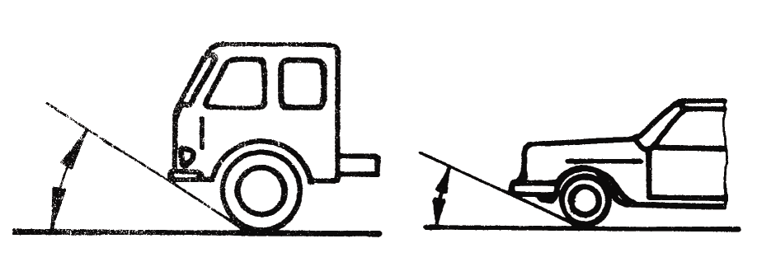

2.8.3.2. "Departure angle" – see Standard ISO 612:1978 term No. 6.11.
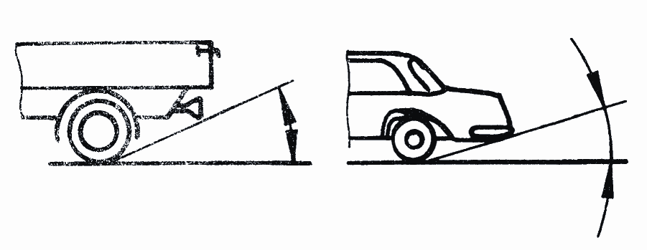
2.8.3.3. "Ramp angle" – see Standard ISO 612:1978 term No. 6.9.
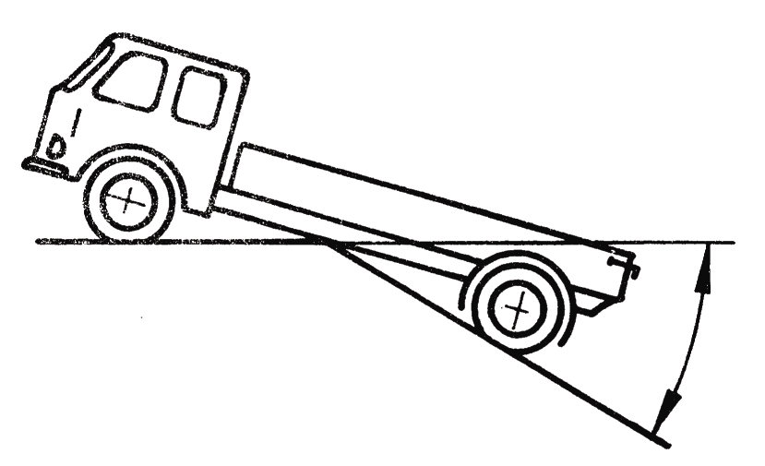”

Paragraph 2.9.1.1., amend to read (keep the reference to the year)
“2.9.1.1 AA Saloon:
Standard ISO 3833:1977 term No. 3.1.1.1., but including also vehicles with more than 4 side windows.”

Paragraphs 2.9.1.3, 2.1.9.4, 2.1.9.5, amend to read (keep the reference to the year)
“2.9.1.3. AC Station Wagon (Estate car)
Standard ISO 3833:1977, term No. 3.1.1.4.
2.9.1.4. AD Coupé
Standard ISO 3833:1977 term No. 3.1.1.5.
2.9.1.5. AE Convertible
Standard ISO 3833:1977 term No. 3.1.1.6.”

Proposed paragraph 2.10, delete:
“2.10. Vehicle Identification Number (VIN):
The content and structure of a vehicle identification number (VIN) in order to establish, on a world-wide basis, a uniform identification numbering system applied for vehicles categories (M, N, O1, O2, L, T, etc.)
VIN is a structured combination of characters assigned to a vehicle by the manufacturer for identification purposes, according to ISO 3779, ISO 4033, ISO 3780.”

II. Justification
- Paragraph 1.14: Whilst “manufacturer’s representative” is seldom used in UN Regulations, beside the expression “applicant”, there is no such definition in the 58 Agreement. The wording “legal person established in the Community” seems strange in the UNECE context.
- paragraph 1.17: this proposed definition is in contradiction with those of UN R90 for “original brake lining”, “original brake lining assembly”, "original drum brake lining", “original brake disc/brake drum” and “original replacement brake discs and brake drums”.
- Paragraphs 2.8.3.1., 2.8.3.2., 2.8.3.3.: the references to the ISO standards should remain with the information on the revision since this makes a stable reference as needed in a reference document like RE3. It is indeed important that the UN regulations keep some autonomy versus the ISO standards, and that the regulators at UNECE have a visibility on the standards they are referring to.
- paragraphs 2.9.1.1, 2.9.1.3, 2.1.9.4, 2.1.9.5: see item 3 above
- Paragraph 2.10: while there indeed exist an ISO definition for the Vehicle Identification Number (VIN), it is regulated domestically at national level. Some international harmonization of these domestic rules should be first established before introducing provisions for VIN into the RE3. The reference to ISO 4033 in the document GRSG/2020/14 should also be revisited (should be ISO 4030)

