|  |  |  |  |
| --- | --- | --- | --- |
|  | United Nations | ECE/TRANS/WP.29/GRSG/2020/8/Rev.1 | |
| _unlogo | **Economic and Social Council** | | Distr.: General  XX December 2019  Original: English |

**Economic Commission for Europe**

Inland Transport Committee

**World Forum for Harmonization of Vehicle Regulations**

**Working Party on General Safety Provisions**

**118th session**

Geneva, 30 March – 3 April 2020

Item X of the provisional agenda

**UN Regulation No. 55 (Mechanical couplings)**

Proposal for Supplement 1 to the 02 series of amendments to UN Regulation No. 55 (Mechanical couplings)

Revision

Submitted by the expert from Finland[[1]](#footnote-2)\*

The text reproduced below was prepared by the expert from Finland to amend provisions of Class D50-X drawbar eyes. It is based on informal document GRSG-117-06 presented at the 117th session of the Working Party on General Safety Provisions (GRSG). The modifications to the current text of UN Regulation No. 55 are marked in bold characters for new and strikethrough for deleted characters.

**I. Proposal**

*Insert new paragraphs 13.5. and 13.6.,* to read:

"**13.5.** **Notwithstanding paragraph 13.3., until 1 September 2023, Contracting Parties applying this Regulation shall accept type approvals of Class D50-X drawbar eyes to the preceding series of amendments, first issued before 1 September 2021.**

**13.6. Notwithstanding paragraph 13.3., as from 1 September 2023, Contracting Parties applying this Regulation shall not be obliged to accept type approvals of Class D50-X drawbar eyes issued to the preceding series of amendments to this Regulation.**"

*Renumber paragraph 13.5.,* to read:

"13.~~5~~**7**. Contracting Parties applying this Regulation shall not refuse to grant type approvals according to any preceding series of amendments to this Regulation or extensions thereof."

*Annex 5, paragraph 4.1.*, amend to read:

"4.1. General requirements for drawbar eyes of Class D50:

All drawbar eyes of Class D50 shall be able to satisfy the test stated in Annex 6, paragraph 3.4.

Class D50 drawbar eyes are intended for use with C50 drawbar couplings. Drawbar eyes shall not be able to rotate axially (because the respective couplings can rotate).

If Class D50 drawbar eyes are fitted with sleeves, they shall comply with the dimensions shown in Figure 9 (not permitted for Class D50-C) or Figure 10. The sleeves shall not be welded into the drawbar eyes. Class D50 drawbar eyes shall have the dimensions given in paragraph 4.2. The form of shank for drawbar eyes of Class D50-X ~~is not specified, but~~ **shall be** **limited by the form drawn in Figure 11 and**for a distance of 210 mm from the centre of the eye the height "h" and the width "b" shall be within the limits given in Table 6."

II. Justification

High capacity vehicle combinations made possible in Finland require high D-value coupling devices. This means the dimensions of the coupling devices are often very near to the limits of the current regulations. In Finland incompatible type-approved drawbar eyes and drawbar couplings has been found in the market surveillance. The main issue is the vertical thickness of the shank of the drawbar eye. Maximum dimensioned D50-X shank cannot fully articulate inside of C50 drawbar couplings as shown in the photographs below.

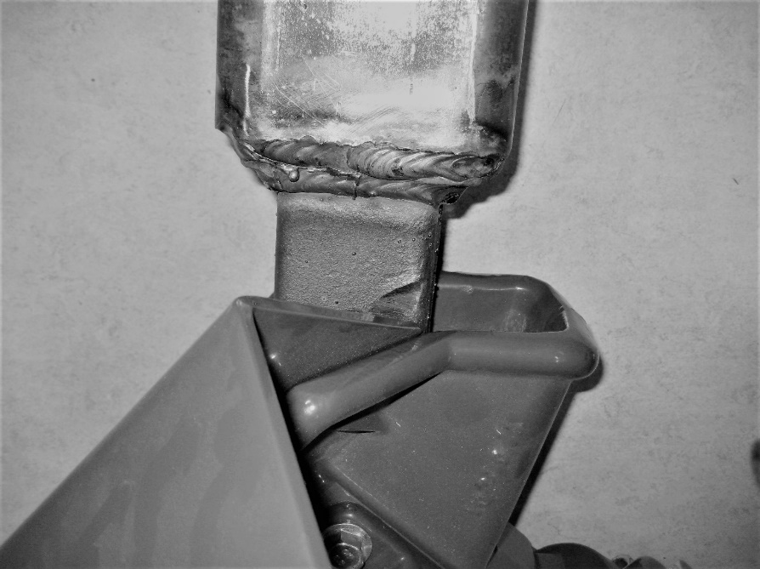

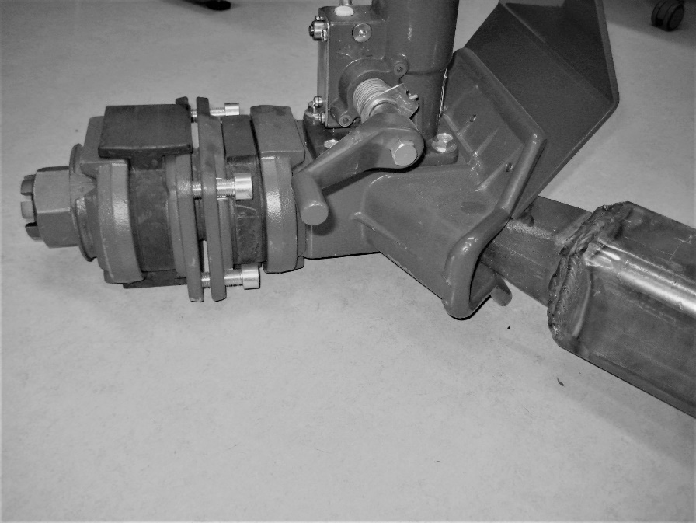

Clarified dimensioning of the D50-X shank would ensure the compatibility with the C50 couplings.

See examples:

**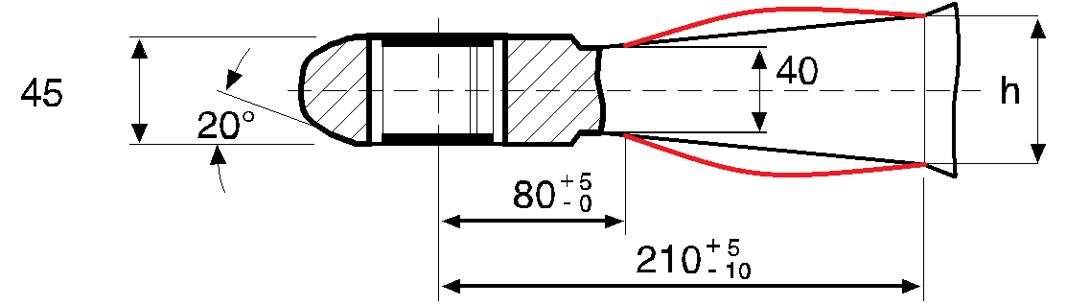** **NOT OK**

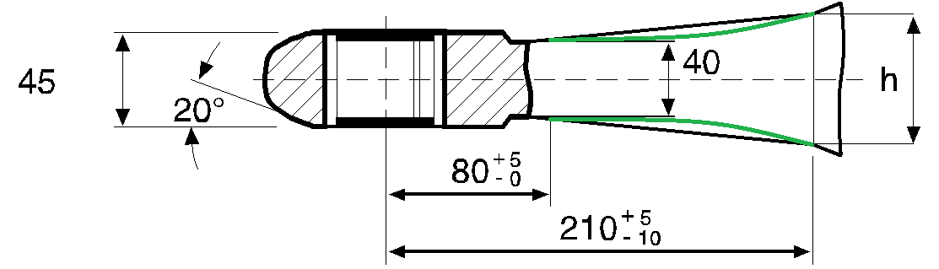 **OK**

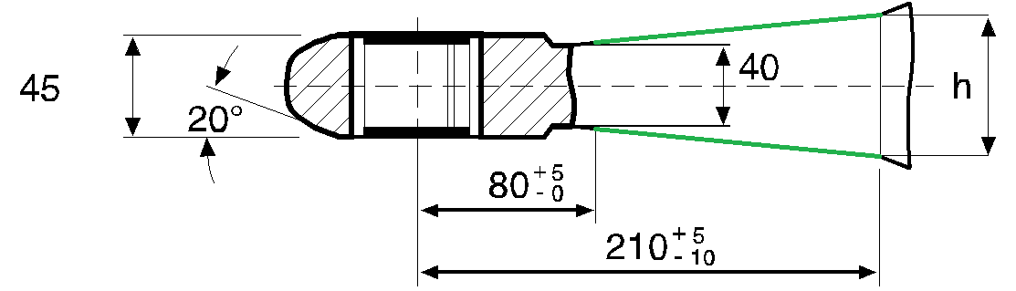 **OK**

The transitional provisions for the 02 series of amendments were adopted at the previous session of the GRSG according to the informal document GRSG-117-25 submitted by the European Commission. The proposed new paragraphs 13.5. and 13.6. to the transitional provisions would only be applied for Class D50-X drawbar eyes.

1. \* In accordance with the programme of work of the Inland Transport Committee for 2020 as outlined in proposed programme budget for 2020 (A/74/6 (part V sect. 20) para 20.37), the World Forum will develop, harmonize and update UN Regulations in order to enhance the performance of vehicles. The present document is submitted in conformity with that mandate. [↑](#footnote-ref-2)