Proposal for Supplement 2 to UN Regulation No. 151 (Blind Spot Information Systems (BSIS))
Submitted by the Informal Working Group on Awareness of Vulnerable Road Users proximity in low speed manoeuvres
The text reproduced below was prepared by the experts from the IWG VRU-Proxi to modify the scope of the Regulation along with appropriate requirements. The informal document is based on ECE/TRANS/WP.29/GRSG/2020/7. The modifications to the current text of the UN Regulations are marked in bold for new or strikethrough for deleted characters. The modifications to the document ECE/TRANS/WP.29/GRSG/2020/7 are marked in yellow.

- Proposal
Paragraph 1.1., amend to read:
"1.1. This Regulation applies to the blind spot information system of vehicles of categories N₂, (> 8 t of technically permissible maximum mass) and N₃. Vehicles of categories N₂ (≤ 8 t of technically permissible maximum mass), M₂ and M₃ may be approved at the request of the manufacturer."
Paragraph 5.3.1., last sentence amend to read:
An optical information signal shall be maintained only for as long as the conditions specified in paragraph 5.3.1.4. below are fulfilled. For vehicles of categories N₂ with a technically permissible maximum mass exceeding 8 tonnes, N₃ and M₃ the Ddeactivation of the information signal as a result of the vehicle turning away from the bicycle trajectory is not allowed as long as a collision between vehicle and bicycle is still possible, in case the driver would steer back towards the bicycle trajectory.
Insert new paragraphs 5.3.1.4.1. and 5.3.1.4.2., to read:
5.3.1.4.1 For vehicles of categories N₂ with a technically permissible maximum mass not exceeding 8 tons and M₂ the Blind Spot Information signal shall be activated for a bicycle target moving longitudinally forward with a speed between 5 km/h and 20 km/h, entering in the zone as specified in paragraph 6.5.11. when the vehicle is moving forward.

5.3.1.4.2. In addition, the Blind Spot Information signal shall be activated for a bicycle target moving longitudinally forward with a speed between 5 km/h and 20 km/h from the rear entering the zone as specified in paragraph 6.6.3. when the vehicle is stationary. In such case, the information signal shall be maintained as long as the biycle is in the defined zone or as long as it would be in the zone considering a constant speed of the bicycle target until it reaches the front right corner of the vehicle. The constant speed is based on the speed of the byclist when entering the zone.

Insert a new paragraph 5.5.4., to read:
"5.5.4. The warning signal referred to in paragraph 5.3.1.2. is not required for vehicles of categories N₂ with a technically permissible maximum mass not exceeding 8 tonnes and M₂."
Insert a new paragraph 6.5.11., to read:
"6.5.11. Vehicles of categories N₂ with a technically permissible maximum mass not exceeding 8 tonnes and M₂ are deemed to meet the requirements of paragraph 6.5. if the Blind Spot Information signal has been activated when the bicycle target is moved forward, rearward or transverse moving forward as specified in paragraph 5.3.1.4.1. and entering a zone on the nearside of the moving vehicle into a zone adjacent to the moving or stationary vehicle. In such case, the specification of the relevant zone and the activation of the information signal shall be in accordance with the manufacturer’s specifications. These specifications shall however cover both the entry from the front and from the rear of the manufacturer defined zone."
Insert a new paragraph 6.6.3., to read:
"6.6.3. Vehicles of categories N₂ with a technically permissible maximum mass not exceeding 8 tonnes and M₂ are deemed to meet the requirements of paragraph 6.6. if the Blind Spot Information signal has been activated when the bicycle target is entering moved longitudinally forward from the rear into a 3.0 m wide zone adjacent to the vehicle. The zone shall cover a lateral separation between bicycle and vehicle of 0.9 to 3.0 meters and from the vehicle front right corner to the rear of the motor-vehicle. if it is more than 5.0 m rearward of the vehicle front right corner. In such case the activation shall occur before the entire bicycle target has entered the zone."

II. Justification
- Paragraph 5.3.1 : The vehicle trajectory for smaller N2/M2 is not using a further left turn than 2 m, therefore with the 3 m coverage the cyclists remains covers.
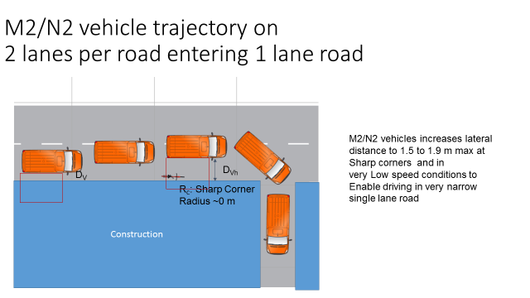
- Paragraphs 5.3.1.4.1 and 5.3.1.4.2: Clarify the required the information signal in alignment with the N2<8t and M2 test cases in 6.5.11 and 6.6.3.
- Paragraph 5.5.4 : Paragraph 5.3.1 includes in other paragraphs than 5.3.1.2 requirements to the warning signal. Clarification, that these warning signal requirements do also not apply.
- Paragraph 6.5.11 : Clarification that 6.5 is the dynamic test case. Clarification that the zone and the activation of the signal shall occur in accordance with the manufacturers specifications. The transversal VRU movement is not covered for N3 vehicles in the original UN R151.
- Paragraph 6.6.3 : Clarification that the zone is not starting at a seperation of 0 m, due sensor systems are not able to sense anything at 0 m (see zone for N3 vehicles starting at 0.9 m).

