|  |  |  |  |
| --- | --- | --- | --- |
|  | United Nations | ECE/TRANS/WP.29/GRSG/2020/20 | |
| _unlogo | **Economic and Social Council** | | Distr.: General  27 July 2020  Original: English |

**Economic Commission for Europe**

Inland Transport Committee

**World Forum for Harmonization of Vehicle Regulations**

**Working Party on General Safety Provisions**

**119th session**

Geneva, 6-9 October 2020

Item 2 (a) of the provisional agenda

**Amendments to regulations on buses and coaches:**

**UN Regulation No. 107 (M2 and M3 vehicles)**

Proposal for the 09 series of amendments to UN Regulation No. 107 (M2 and M3 vehicles)

Submitted by the expert from Spain[[1]](#footnote-1)\*

The text reproduced below is prepared by the expert from Spain to amend the provisions concerning the approval of Category M2 or M3 vehicles with regard to their general construction. It is based on ECE/TRANS/WP.29/GRSG/2020/2 as amended by informal documents GRSG-118-03 and GRSG-118-30. The modifications to the current text of UN Regulation No. 107 are marked in bold characters.

I. Proposal

*After paragraph 10.24., insert new paragraphs 10.25. to 10.28.,* to read:

*“***10.25. As from the official date of entry into force of the 09 series of amendments, no Contracting Party applying this Regulation shall refuse to grant or refuse to accept type-approvals under this Regulation as amended by the 09 series of amendments.**

**10.26. As from 1 September 2023, Contracting Parties applying this Regulation shall not be obliged to accept type-approvals to the preceding series of amendments, first issued after 1 September 2023.**

**10.27. Until 1 September 2025, Contracting Parties applying this Regulation shall accept type-approvals to the preceding series of amendments, first issued before 1 September 2023.**

**10.28. As from 1 September 2025, Contracting Parties applying this Regulation shall not be obliged to accept type-approvals issued to the preceding series of amendments to this Regulation.**”

*Annex 2,* amend to read:

*“*Annex 2

Arrangements of approval marks

# Model A

(See paragraph 4.4. of this Regulation)

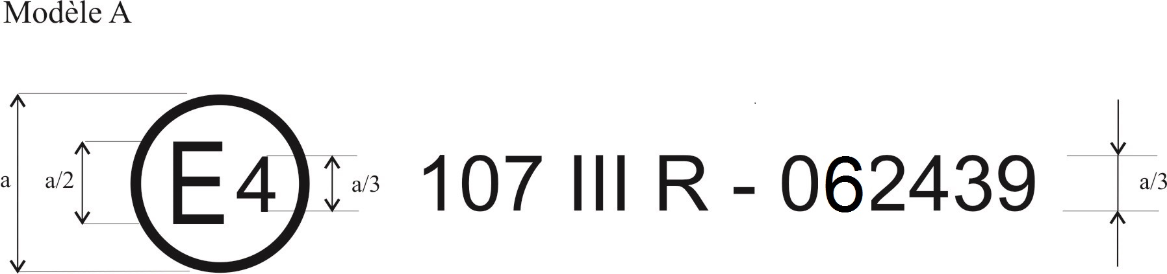

092439

a = 8 mm min

The above approval mark affixed to a vehicle shows that the vehicle type concerned has, with regard to its constructional features, been approved in the Netherlands (E 4) for Class III, pursuant to Regulation No. 107 under approval number 092439. The approval number indicates that the approval was granted according to the requirements of Regulation No. 107 as amended by the 09 series of amendments.

# Model B

(See paragraph 4.5. of this Regulation)

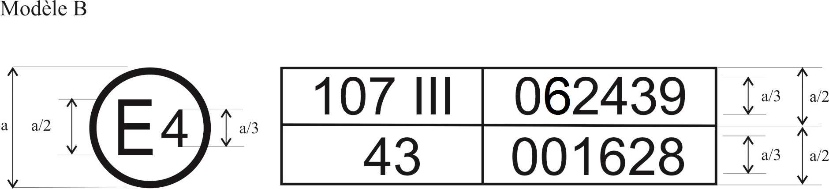

a = 8 mm min

The above approval mark affixed to a vehicle shows that the vehicle type concerned has been approved in the Netherlands (E 4) pursuant to Regulations Nos. 107 and 43[[2]](#footnote-2)\*. The first two digits of the approval numbers indicate that, on the dates on which these approvals were granted Regulation No. 107 included the 09 series of amendments and Regulation No. 43 was in its original form.

# Model C

(See paragraph 4.4.3. of this Regulation)

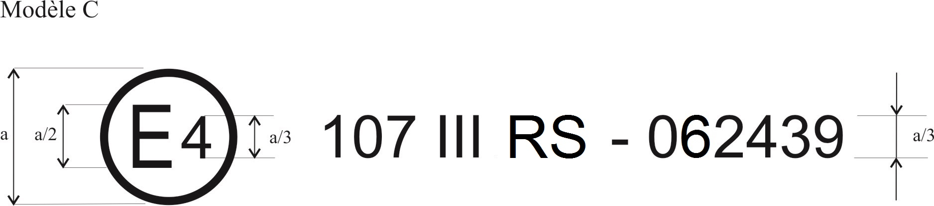

a = 8 mm min

The above approval mark affixed to a vehicle bodywork shows that the bodywork type concerned has, with regard to its constructional features, been approved separately in the Netherlands (E 4) for Class III as a separate bodywork (letter S), pursuant to Regulation No. 107 under approval number 092439. The approval number indicates that the approval was granted according to the requirements of Regulation No. 107 as amended by the 09 series of amendments."

*Annex 8*

*Paragraph 3.11.3.1.1.,* amend to read:

"3.11.3.1.1. Lifts shall only be capable of operation when the vehicle is at standstill. **The vehicle shall have a starting prevention device that remains active until the lift is in its stowed position. If the lift gives access to the vehicle through a door that is not a service or emergency door, the starting prevention device shall remain active until the door is fully closed.** Any movement of the platform shall be prevented unless a device preventing the wheelchair from rolling off has been activated or has automatically come into operation."

*Paragraph 3.11.4.1.1.*, amend to read:

"3.11.4.1.1. The ramp shall only be capable of operation when the vehicle is at standstill. **The vehicle shall have a starting prevention device that remains active until the ramp is in its stowed position or completely disconnected from the vehicle.** "

II. Justification

1. The objective of the proposal is to improve both Regulation 107 paragraphs with the aim of guaranteeing that the vehicle remains stopped whilst the lifts or the ramps are being used. Currently it can be found vehicles that can be moved with the elevator, or the ramp, at other positions than the stowed one.

2. Additionally, it is proposed that any door specifically dedicated to give access to the vehicle by using the lifts, and not covered by the requirements stablished for service doors or for emergency doors, must be closed before starting the movement of the vehicle. Service and emergency doors are regulated by Annex 3 in the paragraphs 7.6.5.9. and 7.6.7.6. that require an alarm system if the vehicle is not fitted with a starting prevention device. A similar requirement for doors specifically dedicated to give access using the lifts could entail risks of falls and, consequently, the alarm requirement could not be enough and the complete close of the door is proposed.

3. New paragraphs 10.25 – 10.28 are added with new transitional provisions for the 09 series of amendments

1. \* In accordance with the programme of work of the Inland Transport Committee for 2020 as outlined in proposed programme budget for 2020 (A/74/6 (part V sect. 20) para 20.37), the World Forum will develop, harmonize and update UN Regulations in order to enhance the performance of vehicles. The present document is submitted in conformity with that mandate. [↑](#footnote-ref-1)
2. \* This number is given merely as an example. [↑](#footnote-ref-2)