Revised proposal for a new [0x] series of amendments to UN Regulation No. 48

For a more efficient discussion during the 83rd session of GRE the experts from the International Organization of Motor Vehicle Manufacturers merged documents GRE/2020/08-Rev.1 (SLR) and GRE/2020/23 into one document.

This document is been structured as follows;
- Proposal
- Justification of GRE/2020/08-Rev.1
- Justification of GRE/2020/23

Furthermore, a failure is been corrected. Document GRE/2020/23 is amending the proposal for a new [0x] series of amendments to UN Regulation No. 48 and is not a proposal for a Supplement to the 06 and 07 series of UN R48.
I. Proposal
Paragraph 6.2.4.2., amend to read:
“6.2.4.2. In height: not less than 500 mm and not more than 1,200 mm above the ground. For category N₂G (off-road) and N₃G (off-road) vehicles, the maximum height may be increased to 1,500 mm.”
Paragraph 6.2.6.1. and related sub-paragraphs, amend to read:
“6.2.6.1. Vertical orientation
6.2.6.1.1. The initial downward inclination of the cut-off of the dipped-beam to be set in the unladen vehicle state with one person in the driver's seat shall be specified within an accuracy of 0.1 per cent by the manufacturer and indicated in a clearly legible and indelible manner on each vehicle close to either headlamp or the manufacturer's plate by the symbol shown in Annex 7.
Initial downward inclination
The initial downward inclination of the cut-off of the passing beam (dipped-beam) shall be:
- set in the unladen vehicle state with one person in the driver's seat,
- specified within an accuracy of 0.1 per cent by the manufacturer,
- equal or lower than -0.5 per cent, as indicated in the diagram of paragraph 6.2.6.1.2. and
- indicated in a clearly legible and indelible manner on each vehicle close to either headlamp or the manufacturer's plate by the symbol shown in Annex 7.
The value of this indicated initial downward inclination shall be defined by the vehicle manufacturer in the range prescribed in paragraph 6.2.6.1.2. in relation to the passing beam (dipped-beam) headlamp mounting height.
Different values of initial downward inclination for different variants/versions of the same vehicle type can be defined, provided that only the pertinent value is indicated on each variant/version.
6.2.6.1.2. Vertical inclination limits of the cut-off
Depending on the mounting height in meters (h) of the lower edge of the apparent surface in the direction of the reference axis of the passing beam (dipped-beam) headlamp, measured on the unladen vehicles, the vertical inclination of the cut-off of the passing beam (dipped-beam), starting from the initial downward inclination value set by the vehicle manufacturer as prescribed in paragraph 6.2.6.1.1., shall under all the static conditions of Annex 5, remain between the following limits and the initial aiming shall have the following values:, under all the static loading conditions of Annex 5:
h < 0.8
limits: between -0.5 per cent and -2.5 per cent
initial aiming: between -1.0 per cent and -1.5 per cent
0.8 < h < 1.0
limits: between -0.5 per cent and -2.5 per cent
initial aiming: between -1.0 per cent and -1.5 per cent
or, at the discretion of the manufacturer,
limits: between -1.0 per cent and -3.0 per cent
initial aiming: between -1.5 per cent and -2.0 per cent
The application for the vehicle type-approval shall, in this case, contain information as to which of the two alternatives is to be used.
h > 1.0
limits: between -1.0 per cent and -3.0 per cent
initial aiming: between -1.5 per cent and -2.0 per cent
Mounting height h [m] | Upper inclination limit  [per cent] | Lower inclination limit  [per cent]
0.5 ≤ h ≤ 0.9 | -0.20 | -1.40 to -1.80*
0.9 < h ≤ 1.2 | -0.20 to -0.85* | -1.80 to -2.45*
1.2 < h ≤ 1.5** | -0.85 to -1.50* | -2.45 to -3.10*
* increasing linearly, in relation to the dipped beam headlamp mounting height
** for categories N₂G and N₃G (off-road) vehicles only

The above limits and the initial aiming values are summarized in the diagram below.
For category N₃G (off-road) vehicles, where the headlamps exceed a height of 1,200 mm the limits for the vertical inclination of the cut-off shall be between: -1.5 per cent and -3.5 per cent
The initial aim shall be set between:-2 per cent and -2.5 per cent.

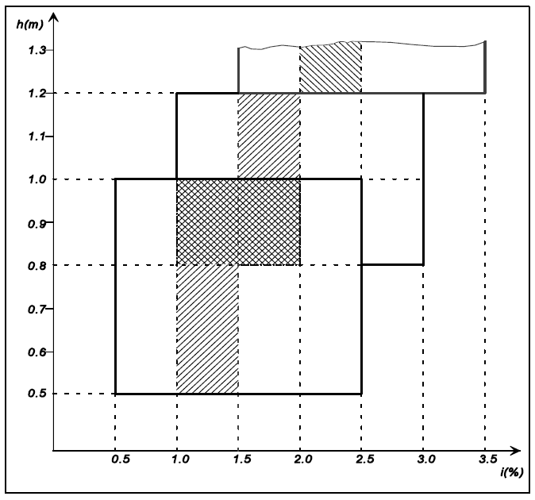

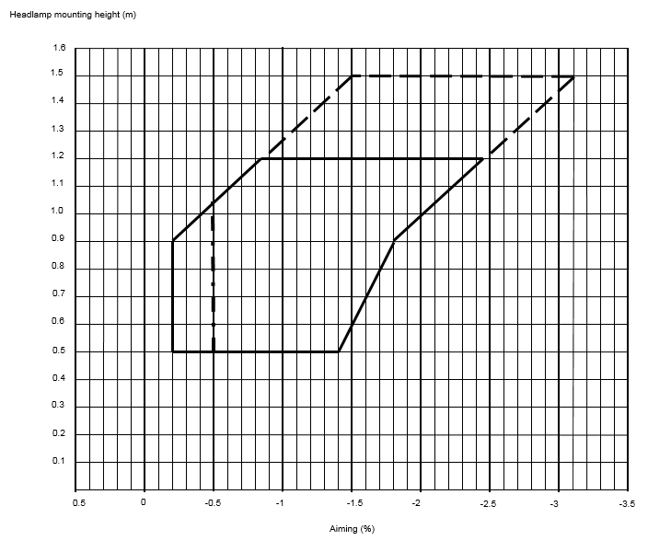…”

Paragraph 6.2.6.2. and related sub-paragraphs, amend to read:
“6.2.6.2. Headlamp levelling device
6.2.6.2.1. In the case where a headlamp levelling device is necessary to satisfy the requirements of paragraphs 6.2.6.1.1. and 6.2.6.1.2., the device shall be automatic.
Paragraph 6.2.6.2.2., amend to read:
“6.2.6.2.2. However, devices, which are adjusted manually, either continuously or non-continuously, shall only be permitted, provided they have a stop position at which the lamps can be returned to the initial inclination defined in paragraph 6.2.6.1.1. by means of the usual adjusting screws or similar means, provided they have a stop position at which the lamps can be returned to the initial inclination defined in paragraph 6.2.6.1.1. by means of the usual adjusting screws or similar means. where these systems also incorporate:
(a) a warning signal or message to the driver requesting that the vertical inclination of the dipped-beam headlamps shall be checked. The characteristics of this warning signal or message are defined in paragraph 6.2.6.2.2.1. below.
(b) in addition, a visual inclination status to the driver indicating the current setting of the vertical inclination of the cut-off of the dipped-beam is shown. The characteristics of this visual inclination status are defined in paragraph 6.2.6.2.2.2. below.
6.2.6.2.2.1. The warning signal or message shall be shown when the device which starts or stops the engine (propulsion system) is in a position which makes it possible to start the propulsion system and when the dipped-beam headlamps are switched ON (manually or automatically relative to the ambient light conditions according to the requirements of Annex 13).
The warning signal or message shall be shown until one of the following conditions is met:
(a) it is manually confirmed or whenever the inclination status is changed by the driver;
(b) it has been shown for at least 10 seconds;
(c) the vehicle speed has reached at least 15 km/h.
6.2.6.2.2.2. The visual inclination status shall be shown every time the engine (propulsion system) is started.
Furthermore, the visual inclination status shall be shown:
(a) at each switching ON of dipped-beam headlamp;
and
(b) whenever the visual inclination status is changed by the driver.
The visual inclination status shall be shown unless:
- it is manually confirmed by the driver or
- it has been shown for at least 10 seconds.
6.2.6.2.2.3. Automatic stop-starts of the propulsion system initiated by a vehicle control system, do not need to show the warning signal and the visual inclination status as specified in paragraphs 6.2.6.2.2.1. and 6.2.6.2.2.2. above.
6.2.6.2.2.4. These manually adjustable devices shall be operable from the driver's seat easily visible, reachable and identifiable by the driver in accordance with the requirements of UN Regulation No. 121.
Continually adjustable devices shall have reference marks indicating the loading conditions that require adjustment of the dipped-beam.
The number of positions on devices which are not continuously adjustable to adjust the dipped-beam headlamps shall be such as to ensure compliance with the range of values prescribed in paragraph 6.2.6.1.2. in all the loading conditions defined in Annex 5.
For these devices also, the loading conditions of Annex 5 that require adjustment of the dipped-beam shall be clearly marked near the control of the device (Annex 8).
Requirements of controls for the headlamps leveling devices are specified in Annex 8.
6.2.6.2.2.5. The different positions to adjust the dipped-beam headlamps shall be explained in the owner's handbook.
6.2.6.2.3. In the event of a failure of devices described prescribed in paragraphs 6.2.6.2.1. and 6.2.6.2.2., the passing beam (dipped-beam) shall not assume a position in which the dip vertical orientation is less downward than it was at the time when the failure of the device occurred.”
Paragraph 6.2.6.3. and related sub-paragraphs, amend to read:
“6.2.6.3. Measuring procedure
6.2.6.3.1. After adjustment of the initial downward vertical inclination, the vertical inclination of the passing-beam (dipped-beam), expressed in per cent, shall be measured in static conditions under all the loading conditions defined in Annex 5.
6.2.6.3.2. The measurement of the variation of passing-beam (dipped-beam) downward vertical inclination as a function of load shall be carried out in accordance with the test procedure set out in Annex 6.”
Paragraph 6.2.9.3., amend to read:
“6.2.9.3. With respect to vertical inclination the provisions of paragraph 6.2.6.2.2. above shall not be applied for dipped-beam headlamps with a light source or LED module(s) producing the principal dipped beam and having an objective luminous flux which exceeds 2,000 lumens.
In the case of filament lamps for which more than one test voltage is specified, the objective luminous flux which produces the principal passing beam (dipped-beam), as indicated in the communication form for the type approval of the device, is applied.
In the case of passing beam (dipped-beam) headlamps equipped with an approved light source, the applicable objective luminous flux is the value at the relevant test voltage as given in the relevant data sheet in the Regulation, according to which the applied light source was approved, without taking into account the tolerances to the objective luminous flux specified on this datasheet.”
Paragraph 6.22.6.1. and related sub-paragraphs, amend to read:

“6.22.6.1. Vertical orientation:
6.22.6.1.1. The initial downward inclination of the cut-off of the basic passing-beam (dipped-beam) to be set in the unladen vehicle state with one person in the driver's seat shall be specified within an precision accuracy of 0.1 per cent by the manufacturer and indicated in a clearly legible and indelible manner on each vehicle, close to either the front lighting system or the manufacturer's plate, by the symbol shown in Annex 7.
Where differing initial downward inclination are specified by the manufacturer for different lighting units that provide or contribute to the cut-off of the basic passing beam (dipped-beam), these values of downward inclination shall be specified within an precision accuracy of 0.1 per cent by the manufacturer and indicated in a clearly legible and indelible manner on each vehicle, close to either the relevant lighting units or on the manufacturer's plate, by the symbol shown in Annex 7 in such a way that all the lighting units concerned can be unambiguously identified.
The value(s) of this (these) indicated vertical orientation(s) shall be defined by the vehicle manufacturer in the range prescribed in paragraph 6.2.6.1.2. in relation to the mounting height of the lighting units that provide or contribute to the cut-off of the basic passing beam (dipped-beam).
Different values of initial downward vertical orientation for different variants/versions of the same vehicle type can be defined, provided that only the pertinent value is indicated on each variant/version.
6.22.6.1.2. The downward inclination of the horizontal part of the "cut-off" of the basic passing beam (dipped-beam) shall remain between the limits indicated in paragraph 6.2.6.1.2. of this Regulation under all the static loading conditions of the vehicle of Annex 5 of this Regulation; and the initial aiming shall be within the specified values.
6.22.6.1.2.1. In case the passing beam (dipped-beam) is generated by several beams from different lighting units, the relevant requirements provisions according to paragraph 6.22.6.1.2. as above indicated apply to each said beam's "cut-off" (if any), which is designed to project into the angular zone, as indicated under item 9.3. of the communication form conforming to the model in Annex 1 to UN Regulation No. 123 or item 9.3.3. in Annex 1 to UN Regulation No. 149.
6.22.6.2. Headlamp levelling device
6.22.6.2.1. In the case where a headlamp levelling device is necessary to satisfy the requirements of paragraph 6.22.6.1.2., the device shall be automatic.
6.22.6.2.2. In the event of a failure of this the device prescribed in paragraphs 6.22.6.2.1., the basic passing beam (dipped-beam) shall not assume a position in which the downward inclination dip vertical orientation is less downward than it was at the time when the failure of the device occurred.”
At the end of paragraph 12., add a new paragraph 12.8. and its subparagraphs to read:

“12.8. Transitional provisions applicable to [0x] series of amendments.
12.8.1. As from the official date of entry into force of the [0x] series of amendments, no Contracting Party applying this UN Regulation shall refuse to grant or refuse to accept UN type approvals under this UN Regulation as amended by the [0x] series of amendments.
12.8.2. As of 1 September [2024] Contracting Parties applying this UN Regulation shall not be obliged to accept UN type approvals to the preceding series of amendments, first issued after 1 September [2024].
12.8.3. Until 1 September [2027], Contracting Parties applying this UN Regulation shall accept UN type-approvals to the preceding series of amendments, first issued before 1 September [2024].
12.8.4. As from 1 September [2027], Contracting Parties applying this UN Regulation shall not be obliged to accept type-approvals issued to the preceding series of amendments to this UN Regulation.
12.8.5. Notwithstanding the transitional provisions above, Contracting Parties who start to apply this UN Regulation after the date of entry into force of the most recent series of amendments are not obliged to accept UN type-approvals which were granted in accordance with any of the preceding series of amendments to this UN Regulation.
12.8.6. Notwithstanding paragraph 12.8.4. Contracting Parties applying this UN Regulation shall continue to accept UN type-approvals to the preceding series of amendments to this UN Regulation, for the vehicle types which are not affected by the changes introduced by the [0x] series of amendments.
12.8.7. Contracting Parties applying this UN Regulation shall not refuse to grant UN type-approvals according to any preceding series of amendments to this UN Regulation or extensions thereof.”
Annex 2, amend to read:
“Arrangements of approval marks
Model A
(See paragraph 4.4. of this UN Regulation)

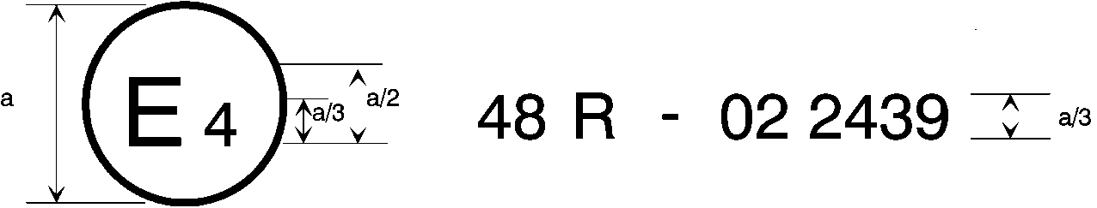
[0x]
a = 8 mm min.

The above approval mark affixed to a vehicle shows that the vehicle type concerned has, with regard to the installation of lighting and light-signalling devices, been approved in the Netherlands (E 4) pursuant to UN Regulation No. 48 as amended by the [0x] series of amendments. The approval number indicates that the approval was granted in accordance with the requirements of UN Regulation No. 48 as amended by the [0x] series of amendments.
Model B
(See paragraph 4.5. of this UN Regulation)

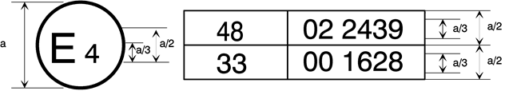
[0x]
a = 8 mm min.
The above approval mark affixed to a vehicle shows that the vehicle type concerned has been approved in the Netherlands (E 4) pursuant to UN Regulation No. 48 as amended by the [0x] series of amendments and UN Regulation No. 33.1 The approval number indicates that, at the dates when the respective approvals were given, UN Regulation No. 48 was amended by the 0x series of amendments and UN Regulation No. 33 was still in its original form.”
Annex 9, paragraph 1.3.2., amend to read:
“1.3.2. Variation of inclination with load
The variation of the passing beam (dipped-beam) downward inclination as a function of the loading conditions specified within this section shall remain within the range:
0.2 per cent to 2.8 per cent for headlamp mounting height h < 0.8;
0.2 per cent to 2.8 per cent for headlamp mounting height 0.8 ≤ h ≤ 1.0;
or
0.7 per cent to 3.3 per cent (according to the aiming range chosen by the manufacturer at the approval);
0.7 per cent to 3.3 per cent for headlamp mounting height 1.0 < h ≤ 1.2 m;
1.2 per cent to 3.8 per cent for headlamp mounting height h > 1.2 m.
Mounting height h [m] | Upper inclination limit  [per cent] | Lower inclination limit  [per cent]
0.5 ≤ h ≤ 0.9 | -0.20 | -1.40 to -1.80*
0.9 < h ≤ 1.2 | -0.20 to -0.85* | -1.80 to -2.45*
1.2 < h ≤ 1.5** | -0.85 to -1.50* | -2.45 to -3.10*
* increasing linearly, in relation to the dipped beam headlamp mounting height
** for categories N₂G and N₃G (off-road) vehicles only
In the case of a class "F3" front fog lamp with (a) light source(s) having a total objective luminous flux which exceeds 2,000 lumens, the variation of the downward inclination as a function of the loading conditions specified within this section shall remain within the range:
0.7 per cent to 3.3 per cent for front fog lamp mounting height h ≤ 0.8 ;
1.2 per cent to 3.8 per cent for front fog lamp mounting height h > 0.8 m.
h < 0.8: 0.7 per cent minimum vertical inclination and 3.3 per cent maximum vertical inclination;
h > 0,8: 1.2 per cent minimum vertical inclination and 3.8 per cent maximum vertical inclination.
The states of loading to be used shall be as follows, as indicated in Annex 5 of this UN Regulation, for every system adjusted accordingly.”

“Annex 8
The controls for the headlamp-levelling devices referred to in paragraph 6.2.6.2.2. of this Regulation
1. Specifications
1.1. Downward Inclination of the dipped-beam shall in all cases be produced by a simple control, the operation of which is clearly described in the owner’s handbook. in one of the following ways:
- by moving a control downwards or to the left;
- by rotating a control in a counter clockwise direction;
- by depressing a button (push-pull control).
If several buttons are used to adjust the beam, the button which gives the greatest downward inclination shall be installed to the left or below the button(s) for other dipped-beam positions.
A rotary control that is installed edge-on, or with only the edge visible, should follow the operating principles of control of types (a) or (c).
1.1.1. This control shall carry symbol(s) indicating clearly the movements corresponding to the downward and upward inclination of the dipped beam.
1.2. The "0" position corresponds to the initial inclination according to paragraph 6.2.6.1.1. of this Regulation.
1.3. [The marks used on control shall be explained in the owner's handbook.]
1.4. Only the following symbols may be used to identify the controls:
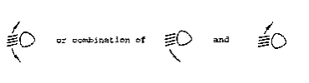
Symbols employing five lines instead of four may also be used

Example 1:

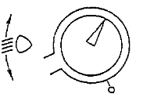
Example 2:
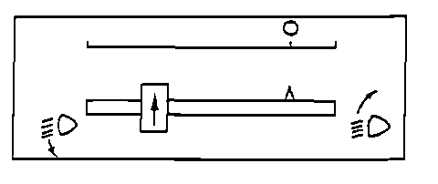
Example 3:
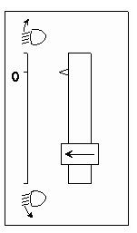
II. Justification of GRE/2020/08-Rev.1
A. General
1. The Informal Working Group on Visibility, Glare and Levelling (IWG VGL) was established at the seventy-fourth session of GRE in October 2015. Its first task was to “define technology neutral requirements, as instructed by WP.29, in particular to find a general solution for glare and visibility issues, and to review all levelling requirements” (ECE/TRANS/WP.29/GRE/74, Annex III).
2. This proposal is based on the concepts finally agreed at the tenth meeting of IWG VGL. The main technical changes apply to paragraph 6.2.6. and related sub-paragraphs for the dipped beam headlamps vertical orientation. The corresponding paragraph 6.22.6.1. and related sub-paragraphs for the adaptive front-lighting systems (AFS) dipped beam vertical orientation have been changed accordingly. Due to the basic changes agreed by IWG VGL, also some other paragraphs needed to be changed or added.
3. GRE, at its seventy-ninth session, decided that elements of the objectives of IWG VGL (ECE/TRANS/WP.29/GRE/76, Annex III) would be transferred to IWG SLR, in order to avoid duplication of work and since both groups had converging goals (ECE/TRANS/WP.29/GRE/79, para. 31).
4. As indicated in its adopted Terms of Reference (ECE/TRANS/WP.29/GRE/79, Annex II), IWG SLR shall take over and consider the outcome of IWG VGL (based on the discussion document GRE-79-29) as recommended at the seventy-ninth session of GRE (ECE/TRANS/WP.29/GRE/79, para. 31).
5. IWG SLR, at its twenty-seventh session, considered informal document GRE-79-29 and decided to submit it without modifications to the eighty-first GRE session for comments (ECE/TRANS/WP.29/GRE/2019/3).
6. Following an in-depth consideration during the eighty-first GRE session, GRE agreed on a modified diagram (GRE-81-21 and Annex II) and requested IWG SLR to prepare, on the basis of the new diagram, a revised proposal for consideration at the next session (ECE/TRANS/WP.29/GRE/81, para. 10).
7. IWG SLR, in line with the GRE request, submitted to the eighty-second GRE session a revised proposal (GRE-82-25) which has been extensively discussed during the meeting. Eventually GRE requested IWG SLR to prepare a revised document for the next session, taking into account the comments made at the eighty-second GRE session (ECE/TRANS/WP.29/GRE/82, para. 31).
8. The current proposal reflects the text that IWG SLR agreed upon by majority.
B. Detailed technical explanations
- In paragraph 6.2.4.2., the category of vehicles N₂G (off-road) is added allowing a maximum height of 1,5 m for installation of the dipped-beam headlamp in addition to the N₃G category of vehicles. This is done in order to align with the proposal for an amendment to the 04, 05 and 06 series of amendments to UN Regulation No. 48 (ECE/TRANS/WP.29/GRE/2020/3), submitted by the experts from the Russian Federation.
- Paragraph 6.2.6.1.1., which provides the requirements for initial downward inclination, has been rearranged to improve readability. An additional requirement is introduced to limit the initial downward vertical inclination to the value of -0.5 per cent or less. The goal is to take into account the tolerances which have to be considered during the Periodical Technical Inspection (PTI) of headlamps. This topic was addressed during the IWG SLR Ad-hoc meeting on “Headlamp levelling”, held in Bonn on 28 November 2019 (the meeting minutes can be found in informal document Ad-hoc 04-Rev.1, based on presentation Ad-hoc 03).
- The decision to add this requirement was taken during the thirty-fifth meeting of IWG SLR (11-13 December 2019) (see report SLR-35-22).
- For the initial downward inclination, the proposal also gives a possibility of defining different values of initial downward inclination for different variants/versions of the same vehicle type. As the new requirements for the vertical inclination according to the installation are more stringent, it will allow all variants/versions of the same vehicle type to meet these provisions.
- The titles of sub-paragraphs 6.2.6.1.1. and 6.2.6.1.2. are added for clarification, namely 6.2.6.1.1. "Initial downward inclination" and 6.2.6.1.2. "Vertical inclination limits of the cut-off".
- Paragraph 6.2.6.1.2. describes the new requirements for the vertical inclination limits of the cut-off, the provisions of which have been reorganised to improve readability. The vertical inclination values according to the installation height are presented in a table. A new diagram has been inserted providing an illustration of the requirements (aiming in per cent on the horizontal axis and headlamp mounting height in meters on the vertical axis).
- Explanations of the lines in the diagram are given below.

- The vertical line on the left was initially defined at 0 per cent and derived from the GTB study based on the ‘Klettwitz study’ (informal document GRE-71-32). However, some Contracting Parties were reluctant to have the horizontal cut-off with no downward inclination. At its seventy-eighth session, GRE experts decided to keep the previous vertical limit of - 0.2 per cent.
- The inclined line on the left (starting from 0.9 m* in height), results from a mathematical calculation based on the position of the oncoming driver’s eyes (at 0.94 m high) for headlamps up to a height of 1.2 m, measured at a distance of 25 m and with an initial aim of 1 per cent down. Using this calculation, it is possible to increase the inclination proportionally to the installation height and still guarantee that glare remains under control; the cut-off line will always stay under 0.94 m at 25 m distance (informal document VGL-10-03, sheet 13).
* Note: Initially defined at a height of 0.95 m, it was rounded down to 0.9 m.
- In addition, the line on the left side of the diagram was extended from a height of 1.2 m to 1.5 m in spite of the fact that, during the Klettwitz tests, no vehicles of categories M₂/M₃/N₂/N₃ were tested. This is the reason the lines above a height of 1.2 m are shown as dotted lines.
- To cover all possible cases of a same type of vehicle (aiming tolerances / chassis deviation / cut-off-line stability / tyre deviation / full or empty tank / levelling device), a range of 1.6 per cent was agreed (see a survey of the International Organization of Motor Vehicle Manufacturers (OICA), informal document VGL-10-10) and used to define the right hand limit and the point (-1.8 / 0.9), based on line defined in item 16.
- Starting from 0.9 m high, the range of 1.6 per cent is applied to define the line on the right side of the diagram and up to 1.5m.
- On the right side, under 0.9 m high, there was a compromise to reduce the range progressively to 1.4 per cent at a height of 0.5 m (ECE/TRANS/WP.29/GRE/81, para. 10 and Annex II).
- The vertical dotted line at -0.5 per cent is already explained in item 10 to address the PTI concerns.
- The paragraph 6.2.6.2.2. (containing the requirements for manual levelling devices) is proposed to be deleted; however, the outcome of the thirty-fifth meeting of IWG SLR (Brussels 11-13 December 2019) was to keep it in square brackets, as it is still subject to discussion (see report SLR-35-22).
- Amendments to paragraphs 6.2.6.2.3. and 6.2.6.3 (including its sub-paragraphs) are clarifications of the existing requirements only.
- In this proposal, the first sentence in paragraph 6.2.9.3. mandating automatic levelling device in case of objective luminous flux exceeding 2,000 lm is deleted. This requirement is recognized neither performance based nor technologically neutral, as suggested by IWG VGL (informal document GRE-78-32).
- Furthermore, an editorial correction is done in paragraph 6.2.9.3. by adding ‘passing beam’.
- The paragraph 6.22.6.1.1. dealing with provisions for initial downward inclination for Adaptive Front lighting System (AFS) is also amended. As for the passing-beam (dipped-beam) headlamps, this value shall meet the same requirements and values for different variants/versions of the same vehicle type.
- Editorial corrections and clarifications are made in paragraphs 6.22.6.1.2., 6.22.6.1.2.1. and 6.22.6.2.2.
- Some editorial corrections are made to Annex 2 (Arrangements of approval marks)
- In Annex 9 (Conformity of Production), paragraph 1.3.2., containing the requirements for the variation of inclination with load, is amended to align with the new provisions of paragraph 6.2.6.1.2. There are no additional tolerances for control of conformity of production, as decided at the thirty-fifth session of IWG SLR in December 2019.
III. Justification of GRE/2020/23
- General
- ECE/TRANS/WP.29/GRE/2020/8 currently proposes to delete paragraph 6.2.6.2.2. which describes the conditions where a manual levelling device may be used as an alternative to automatic levelling.
- However, the report of the Informal Working Group "Simplification of the Lighting and Light-Signalling Regulations" (IWG SLR) at its thirty-fifth session ( informal document SLR-35-22) keeps the possibility of manual levelling open, provided that improvements are made to the human machine interface (HMI) and ergonomics of the control:
"Concerning the manual option for levelling device (paragraph 6.2.6.2.2.), France recommended to keep both possibilities (automatic and manual) because it is important to stay within the “box” regardless of the specific technological solution. France added that, in case of manual levelling the HMI/ergonomics of the device shall be improved (e.g. more visible location of the levelling control) as well as the communication to the driver (e.g. information on the dashboard similar to the “Gear Shift Indicator”)".
- Vehicle manufacturers believe that manual adjustment of the dipped beam should continue to be permitted for a number of reasons, as outlined below:
- For all classes of vehicles, a manual levelling device is a highly reliable and cost-effective solution.
- Failure analysis indicates manual levelling is a very robust solution with a negligible number of customer complaints.
- Manual levelling has a high accuracy to provide light on the road independent of the engine type, body work and use conditions.
- The cost of calibration is also lower when compared with an automatic levelling system.
- For vehicles of сategories N₂ and N₃:
- On and off-road vehicles used for special purposes are usually equipped with a steel suspension at the front and rear axles.
- Placement of the sensor in the suitable location on the vehicle is critical for the operation of the system, this position is difficult to protect against mud and spray water (see the pictures below).
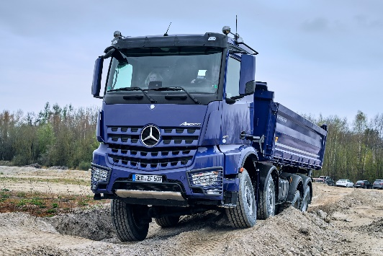

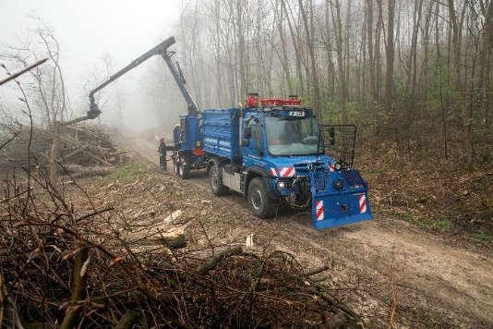

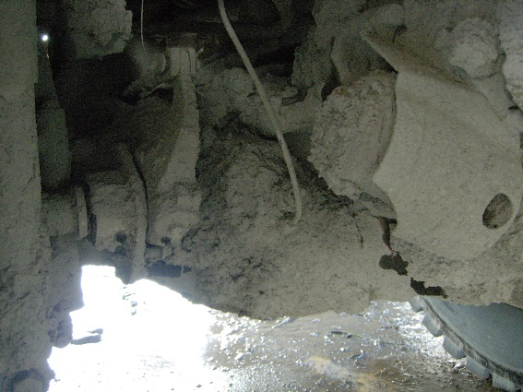

Figure
Examples where the position of the sensor may be affected by mud and water
- For vehicles are operating in a very harsh environment adding sensors for automatic levelling systems is a reliability risk. Finding usable positions for the sensors with the different vehicle configurations is not always possible.
- There are factors contributing to a large tolerance span for automatic levelling systems for trucks (frame bending, tire compression etc). The influences of those factors are difficult to calculate, in particular since many vehicles are finalized by body builders who may provide the vehicle with additional frame members, different axles and wheels. An automatic levelling system will in those cases not provide an accurate headlamp aim.
B. Improvements to HMI/ergonomics
- In 6.2.6.2.2.(a) a warning signal or message is proposed in order to ask the driver to check the aim of their headlights. The conditions for activating the warning signal are given in 6.2.6.2.2.1.
- In 6.2.6.2.2.(b) a visual status of the vertical inclination will be provided to the driver shown every time the engine (propulsion system) is started, at each switching ON of dipped-beam headlamp and whenever the inclination status is changed by the driver.
- To improve the ergonomics / accessibility of controls, paragraph 6.2.6.2.2.4. introduces requirements that manually adjustable devices shall be easily visible, reachable and identifiable by the driver in accordance with the requirements of UN Regulation No. 121.
C. Justification of the changes to Annex 8
- ‘Downward’ should be deleted. In the old text it referring to the direction of the control device. For trucks we are adjusting the dipped beam both upwards and downwards due to different loading characteristics of different vehicle configurations.
- In order for the requirements to be technology neutral, the prescription of control methods (downwards, rotary, push-pull) have been deleted.
- Requirement 1.3 referring to the owner’s handbook has been moved into the main regulatory text (see paragraph 6.2.6.2.2.5.) and therefore can be deleted.
- Requirement 1.4. specifying the symbols, which can be used, has been deleted as these are already prescribed in UN Regulation No. 121.
- Examples of controls 1, 2 and 3 have been deleted as the illustrations are considered outdated.

As defined in the Consolidated Resolution on the Construction of Vehicles (R.E.3.), document ECE/TRANS/WP.29/78/Rev.3, para. 2 - www.unece.org/trans/main/wp29/wp29wgs/wp29gen/wp29resolutions.html
1 The second number is given merely as an example.

