Transmitted by the GRE-IWG SLR | Informal document GRE-83-07  83rd GRE, 19-23 October 2020  Agenda item 9

Proposal for corrections to UN Regulations Nos. 113 and 149

I. Proposal
A. Supplement 7 to the 01 series of amendments to UN Regulation No. 113
Annex 3, Figure C; amend to read:

“Figure C
Passing beam test points and zones for Class B headlamp(s):
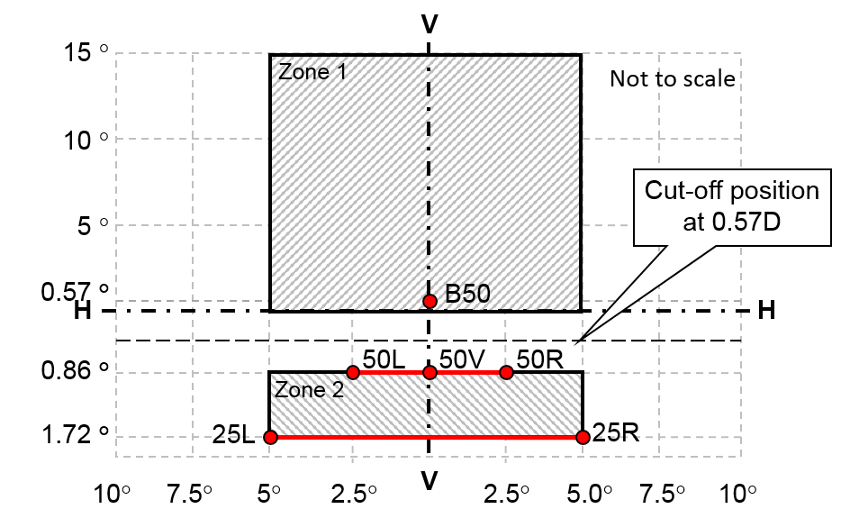
…”
B. Supplement 1 to the 02 series of amendments to UN Regulation No. 113
Annex 3, Figure C; amend to read:

“Figure C

Passing beam test points and zones for Class B headlamp(s):
…”
C. Supplement 2 to the 03 series of amendments to UN Regulation No. 113
Annex 3, Figure C; amend to read:

“Figure C
Passing beam test points and zones for Class B headlamp(s):
…”

D. Supplement 3 to the 00 series of amendments to UN Regulation No. 149
Annex 4, Figure A4-IX; amend to read:

“Figure A4-IX

Passing beam test points and zones for Class BS headlamp(s)
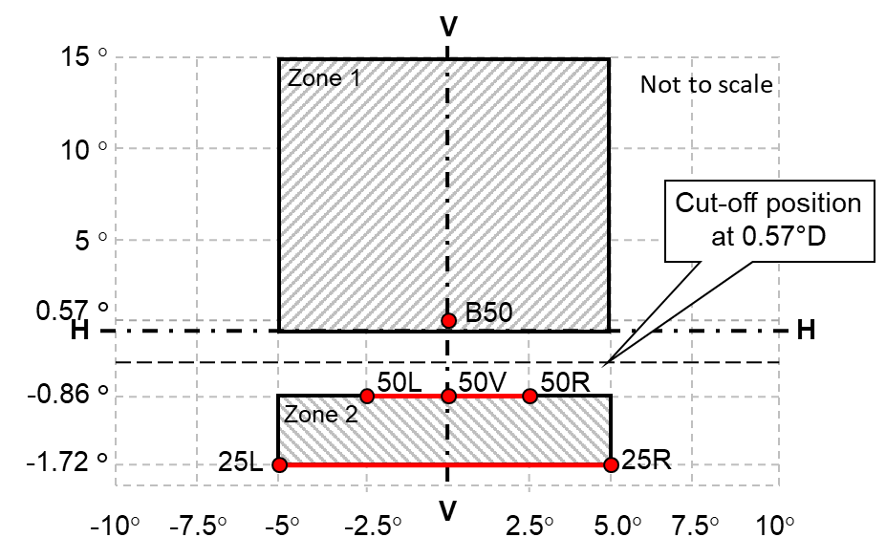
…”

II. Justification
1. This proposal to amend UN Regulation No. 113 corrects a mistake introduced by the 01 series of amendments to UN Regulation No. 113 when angular coordinates were introduced instead of dimensions in mm with screen at 25m.
2. The same correction applies to the 02 and 03 series of amendments to UN Regulation No. 113 as well as to UN Regulation No. 149.
3. In UN Regulation No. 113, Annex 3, Figure C, the description of the zone 1 is not in line with the photometric requirements set in paragraph 6.2.5.2. which defines the horizontal angles to 5° to the left and 5° to the right.
4. In UN Regulation No. 149, Annex 4, Figure A4-IX, the description of the zone 1 is not in line with the photometric requirements set in paragraph 5.4.4.2. Table 34 which defines the horizontal angles to 5° to the left and 5° to the right for the class BS headlamps.

