|  |  |  |  |
| --- | --- | --- | --- |
|  | United Nations | ECE/TRANS/WP.29/GRE/2020/22 | |
| _unlogo | **Economic and Social Council** | | Distr.: General  5 August 2020  Original: English |

**Economic Commission for Europe**

Inland Transport Committee

**World Forum for Harmonization of Vehicle Regulations**

**Working Party on Lighting and Light-Signalling**

**Eighty-third session**

Geneva, 19–23 October 2020

Item 5 of the provisional agenda

**Regulations Nos. 37 (Filament lamps), 99 (Gas discharge light sources), 128 (Light emitting diodes light sources) and the Consolidated Resolution on the common specification of light source categories**

Proposal for amendment to the Consolidated Resolution on the common specification of light source categories

Submitted by the expert from the International Automotive Lighting and Light-Signalling Expert Group[[1]](#footnote-2)\*

The text reproduced below was prepared by the expert from the International Automotive Lighting and Light-Signalling Expert Group (GTB) with the aim to amend the Consolidated Resolution on the common specification of light source categories (R.E.5). There are no associated amendments to UN Regulations Nos. 37, 99 or 128. The modifications to the existing text of the Resolution are marked in bold for new or strikethrough for deleted characters.

**I. Proposal**

*The Status table*, amendto read:

"**Status table**

This consolidated version of this Resolution contains all provisions and amendments adopted so far by the World Forum for Harmonization of Vehicle Regulations (WP.29) and is valid from the date as indicated in the following table until the date on which the next revision of this Resolution becomes valid:

|  |  |  |  |  |
| --- | --- | --- | --- | --- |
| *Version of the Resolution* | *Date \* as from which the version is valid* | *Adopted by WP.29* | | *Clarification* |
| *Session No.* | *Amendment document No.* |
| **1 (**Original**)** | [2017-xx-xx] | 170 | ECE/TRANS/WP.29/2016/111 | Based upon Annexes 1 of UN Regulations:   * No. 37, up to and including Supplement 44 * No. 99, up to and including Supplement 11 * No. 128, up to and including Supplement 5 |
| **[x]** | **[2021-xx-xx]** | **[18x]** | **[ECE/TRANS/WP.29/2021/xx]** | **Amended details concerning measuring luminous flux and internal shield in paragraph 3.1, and sheets H4/2, H15/1, H15/5, H17/1, H17/6, H19/1, H19/5, HS1/2**  **Amend the definition for light centre and associated amended detail in sheet LR4/2**  **Introduction of use restriction for LED light source categories LW2, LW3, and LW5**  **Amended detail in filament light source sheets H7/3, H8/3, H11/3, H14/2, H16/3, H18/3, H19/2, H20/3, H27W/1, P21/5W/2, S1/S2/1 and WY21W/1**  **Amended detail in LED light source sheets L1/2, L1/4, L1/5, LR1/2, LR1/4, LW2/1, Lx3/1, Lx3/2, Lx3/5, LR4/1, LR4/2, LR4/4, Lx5/1, Lx5/2 and Lx5/5** |

\* This date is the date of adoption of the amendment to the Resolution by WP.29 or the date of entering into force of an amendment to UN Regulation No. 37, 99 or 128 adopted by AC.1 as a package with the amendment to the Resolution in the same session of WP.29.

”

*Paragraph 2.2.3.,* amendto read:

“2.2.3. "*Light centre*" means a point that represents the **apparent (virtual)** origin of the light emitted.”

*Paragraph 3.1., note \*,* amend to read:

“\* Tables, Electrical and Photometric characteristics:

Voltage is expressed in V;

Wattage is expressed in W;

Luminous flux is expressed in lm.

In a case of a category of filament light source where more than one value of reference luminous flux is specified, the value at approximately 12 V **or 13.2 V** for a lighting device and 13.5 V for a light-signalling device shall be applied unless otherwise specified by the regulation used for the device. ”

*Paragraph 3.1., notes \*4 and \*5,* amend to read*:*

“\*4 Not for use in UN Regulation No. 112 headlamps **and not for use in headlamps of Class A and Class B of UN Regulation No. 149**.

\*5 Not for use in headlamps other than UN Regulation No. 113 class C **and UN Regulation No. 149 Class CS** headlamps.”

*Paragraph 3.3., Group 2,* amend to read:

“

| *Group 2* | | | | |
| --- | --- | --- | --- | --- |
| *LED light source categories only for use in signalling lamps, cornering lamps, reversing lamps and rear registration plate lamps:* | | | | |
|  | *Category* |  | *Sheet number(s)* |  |
|  | LR1 |  | LR1/1 to 5 |  |
|  | LW2 | **2** | LW2/1 to 5 |  |
|  | LR3A |  | L3/1 to 6 |  |
|  | LR3B |  | L3/1 to 6 |  |
|  | LW3A | **2** | L3/1 to 6 |  |
|  | LW3B | **2** | L3/1 to 6 |  |
|  | LY3A |  | L3/1 to 6 |  |
|  | LY3B |  | L3/1 to 6 |  |
|  | LR4A |  | LR4/1 to 5 |  |
|  | LR4B |  | LR4/1 to 5 |  |
|  | LR5A |  | L5/1 to 6 |  |
|  | LR5B |  | L5/1 to 6 |  |
|  | LW5A | **2** | L5/1 to 6 |  |
|  | LW5B | **2** | L5/1 to 6 |  |
|  | LY5A |  | L5/1 to 6 |  |
|  | LY5B |  | L5/1 to 6 |  |

1 Not for use in conformity of production control of lamps.

**2 Not for use behind red and amber lenses**”

*Annex 1,*

*Sheet H4/2*, *table*, amend to read:

“

| *Dimensions in mm* | | | *Filament light sources of normal production* | | | | | *Standard filament light source* | | |
| --- | --- | --- | --- | --- | --- | --- | --- | --- | --- | --- |
| *12 V* | | *24 V* | | | *12 V* | | |
| e | | | 28.5 +0.35/-0.25 | | 29.0 ± 0.35 | | | 28.5 + 0.20 / -0.00 | | |
| p | | | 28.95 | | 29.25 | | | 28.95 | | |
| α | | | max. 40° | | | | | max. 40° | | |
| Cap P43t in accordance with IEC Publication 60061 (sheet 7004-39-6) | | | | | | | | | | |
| Electrical and photometric characteristics | | | | | | | | | | |
| Rated values | | Volts | 12 6/ | | 24 6/ | | | 12 6/ | | |
| Watts | 60 | 55 | 75 | | 70 | 60 | 55 | |
| Test voltage | | Volts | 13.2 | | 28.0 | | | 13.2 | | |
| Objective  values | Watts | | 75 max. | 68 max. | 85 max. | | 80 max. | 75 max. | 68 max. | |
| Luminous flux  ± % | | 1,650 | 1,000 | 1,900 | | 1,200 |  | | |
| 15 | | | | |  | | |
| Measuring flux 7/ lm | | | - | ~~750~~ **1,000** | - | | ~~800~~ **1,200** |  | | |
| Reference luminous flux at approximately | | | | | | 12 V | | 1,250 | | 750 |
| 13.2 V | | 1,650 | | 1,000 |

”

*Sheet H7/3, table,* amend to read:

“…

| *Dimensions in mm* | *Filament light sources of normal production* | | *Standard filament light source* |
| --- | --- | --- | --- |
| *12 V* | *24 V* | *12 V* |
| … | … | | … |
| … | … | … | … |
| g 12/ | 0.5 min. | | ~~u.c.~~ **0.5 min.** |
| … | … | | … |

”

*Sheet H8/3, table,* amend to read:

“…

| *Dimensions in mm* | *Filament light sources of normal production* | *Standard filament light source* |
| --- | --- | --- |
| *12 V* | *12 V* |
| … | … | … |
| … | … | … |
| g | 0.5 min. | ~~u.c.~~ **0.5 min.** |
| … | … | … |

”

*Sheet H11/3, table,* amend to read:

“…

| *Dimensions in mm* | *Filament light sources of normal production* | | *Standard filament light source* |
| --- | --- | --- | --- |
| *12 V* | *24 V* | *12 V* |
| … | … | | … |
| … | … | … | … |
| g | 0.5 min. | | ~~u.c.~~ **0.5 min.** |
| … | … | | … |

”

*Sheet H14/2, figures 3, 4 and 5,* amend to read:

“

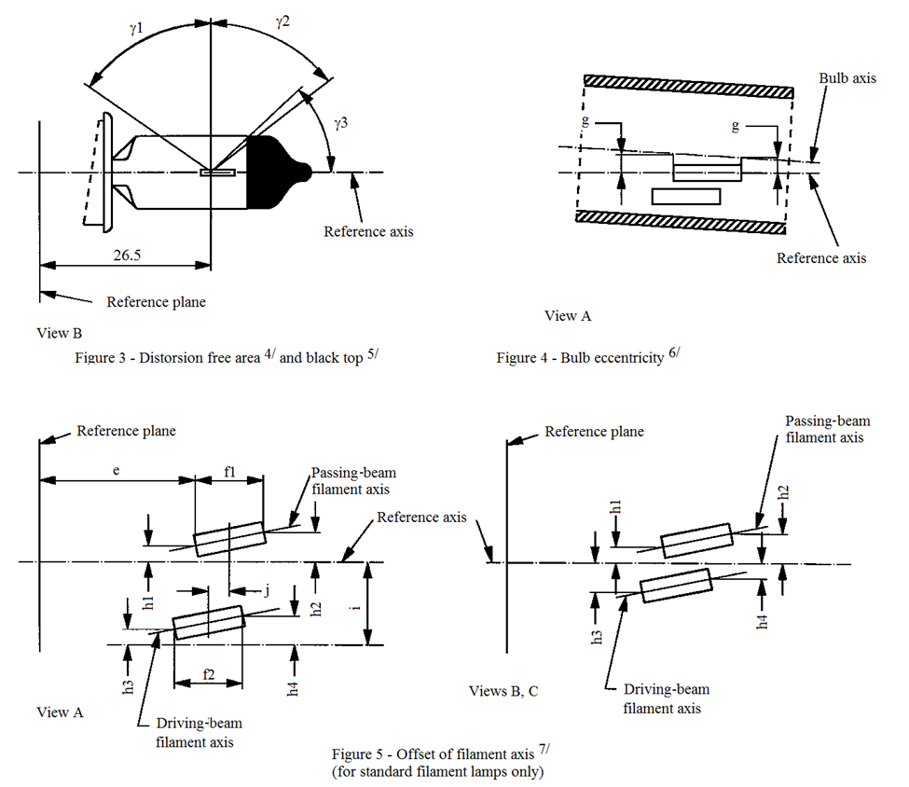

Reference axis

View B

Reference plane

View A

Reference axis

Bulb axis

Reference plane

Figure 3 – Distortion free area4/ and black top5/

Figure 4 – Bulb eccentricity6/

Passing-beam

filament axis

Passing-beam

filament axis

Driving-beam

filament axis

Driving-beam

filament axis

View A

Views B, C

Reference axis

Reference plane

Figure 5 – Offset of filament axis7/

(for standard filament light sources only)

ɣ1

ɣ2

ɣ3

g

g

e

f1

h1

h1

h3

h4

h2

h3

h2

h4

i

j

26.5

f2

”

*Sheet H15/1, figure 1*, amend to read (insert an arrow to the inner shield labelled with a footnote 14):

“

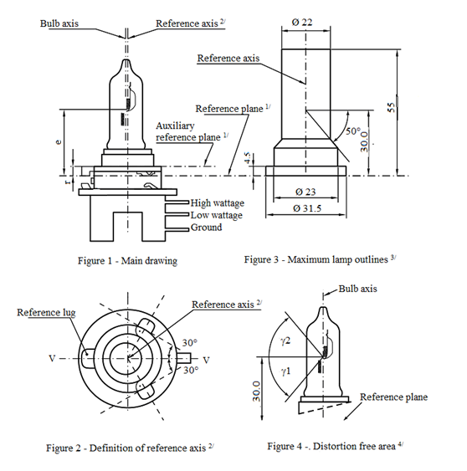

Reference axis2/

Reference plane1/

Bulb axis

Reference axis

Auxiliary

reference plane1/

High wattage

Low wattage

Ground

Figure 1 – Main drawing

Figure 3 - Maximum filament light source outlines3/

Ø 22

Bulb axis

Reference axis2/

Reference lug

Ø 31.5

Ø 23

50°

30.0

55

4.5

e

r

30°

30°

30.0

ɣ1

ɣ2

Reference plane

V

V

Figure 2 – Definition of reference axis7/

Figure 4 - Distortion free area4/

14/

”

*Sheet H15/5*, insert a new footnote 14:

“…

**14/ Internal shield, not intended for producing the cut-off-line.**”

*Sheet H16/3, table,* amend to read:

“…

| *Dimensions in mm* | *Filament light sources of normal production* | *Standard filament light source* |
| --- | --- | --- |
| *12 V* | *12 V* |
| … | … | … |
| … | … | … |
| g | 0.5 min. | ~~u.c.~~ **0.5 min.** |
| … | … | … |

”

*Sheet H17/1, figure 1*, amend to read (insert an arrow to the inner shield labelled with a new footnote 13):

“

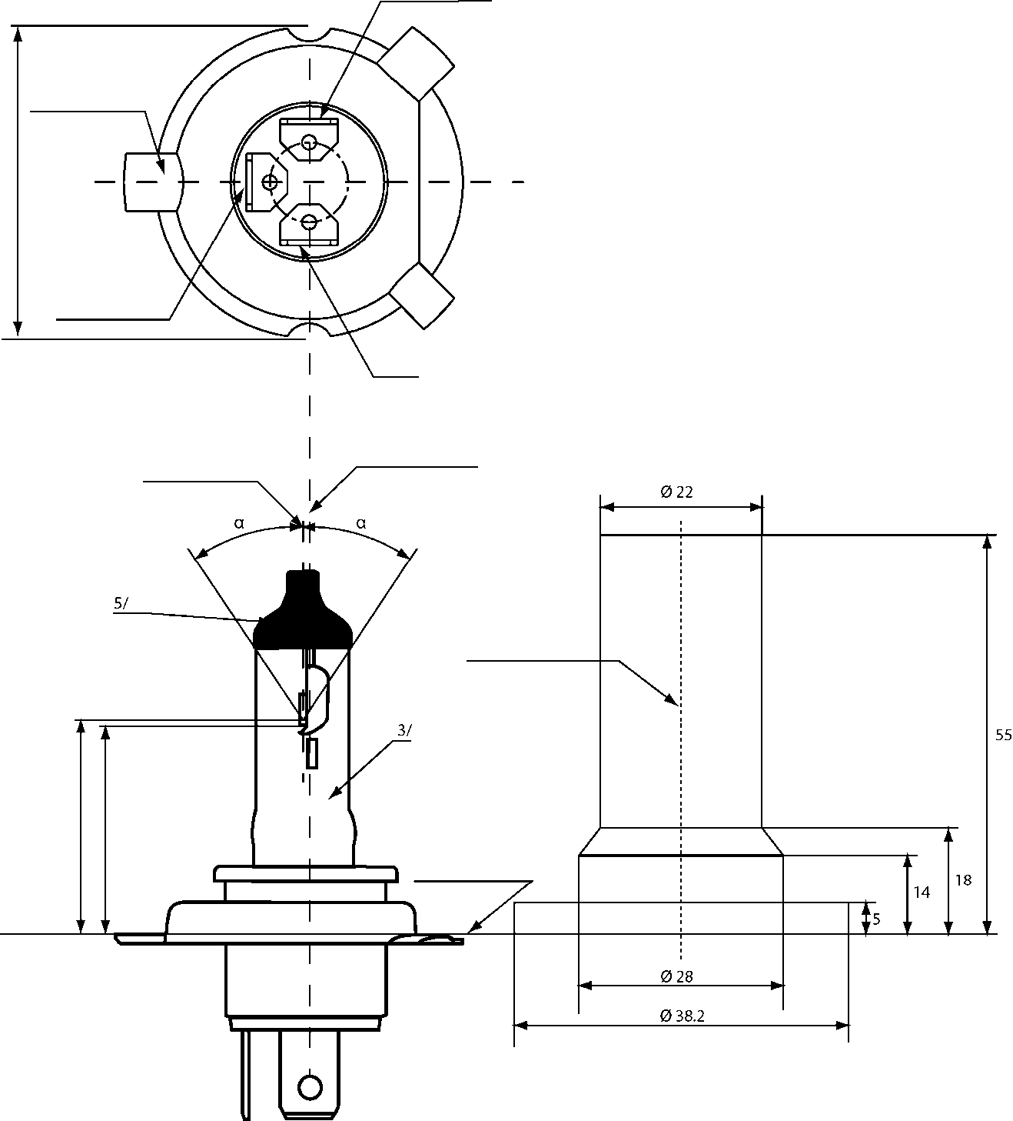

Driving-beam

Reference lug

Passing-beam

M

Earth

Axis of the bulb

Reference axis2/

Reference axis

Reference plane1/

Figure 1 –

Maindrawing

Figure 2 - Maximum filament light source outlines4/

Ø 38.2

Ø 28

Ø 22

5/

3/

55

18

14

5

α

α

e

p

13/

”

*Sheet H17/6*, insert a new footnote 13:

“…

**13/ Internal shield, not intended for producing the cut-off-line.**”

*Sheet H18/3, table,* amend to read:

“…

|  |  |  |
| --- | --- | --- |
|  | *Filaments light sources of normal production* | *Standard filament light source* |
| *12 V* | *12 V* |
| … | … | … |
| … | … | … |
| g 12/ | 0.5 min. | ~~u.c.~~ **0.5 min.** |
| … | … | … |

”

*Sheet H19/1, figure 1*, amend to read insert an arrow to the inner shield labelled with a new footnote 13):

“



13

”

*Sheet H19/2, table,* amend to read:

“…

|  |  |  |  |  |  |
| --- | --- | --- | --- | --- | --- |
| *Dimensions in mm* | | *Filament lamps of normal production* | | *Standard filament lamps* | |
| *12 V* | | *12 V* | |
| e | | 28.5 + 0.35 / - 0.15 | | 28.5 + 0.20 / - 0.0 | |
| p | | 28.95 | | 28.95 | |
| α | | max. 45° | | max. 45° | |
| Cap PU43t-3 in accordance with IEC Publication 60061 (sheet 7004-171-~~1~~ **2**) | | | | | |
| Electrical and photometric characteristics | | | | | |
| Rated values | Volts | 126 | | 126 | |
| Watts | 60 | 55 | 60 | 55 |
| Test ~~values~~ **voltage** | Volts | 13.2 | 13.2 | 13.2 | 13.2 |
| Objective values | Watts | 72 max | 68 max. | 72 max. | 68 max. |
| Luminous flux | 1**,**750 ± 10% | 1**,**200 ± 10% |  |  |
| Reference luminous flux at approximately | | | 13.2 V | 1**,**750 | 1**,**200 |

”

*Sheet H19/5*, insert a new footnote 13:

“…

**13 Internal shield, not intended for producing the cut-off-line.**”

*Sheet H20/3, table,* amend to read:

“

|  |  |  |  |  |  |
| --- | --- | --- | --- | --- | --- |
| … | | … | | … | … |
| … | | … | … |
| … | | … | | … | … |
| Objective values | | Watts | | 75 max. | 75 max. |
| Luminous flux | | 1**,**250 ± 10 % |  |
| Reference luminous flux at approximately | | | | 12 V | 900 |
| 13.2 V | 1**,**250 |
| … | … | | | … | … |
| … | | … | … | … |
| … | … |
| … | … | … |
| … | … |
| … | … |
| … | … |

”

*Sheet H21W/2,* insert a page break after paragraph 3.2. and start sheet H27W/1at the next page.

*Sheet HS1/2, table,* amend to read:

“

| *Dimensions in mm* | | | *Filament light sources of normal production* | | | | | *Standard filament light source* | |
| --- | --- | --- | --- | --- | --- | --- | --- | --- | --- |
| *6 V* | | *12 V* | | | *12 V* | |
| e | | | 28.5 + 0.45 / -0.25 | | | | | 28.5 + 0.20 / -0.00 | |
| p | | | 28.95 | | | | | 28.95 | |
| α | | | max. 40° | | | | | max. 40° | |
| Cap PX43t in accordance with IEC Publication 60061 (sheet 7004-34-2) | | | | | | | | | |
| Electrical and photometric characteristics | | | | | | | | | |
| Rated values | | Volts | 6 6/ | | 12 6/ | | | 12 6/ | |
| Watts | 35 | 35 | 35 | | 35 | 35 | 35 |
| Test voltage | | Volts | 6.3 | | 13.2 | | | 13.2 | |
| Objective values | Watts | | 35 | 35 | 35 | | 35 | 35 | 35 |
| ± % | | 5 | | | | | 5 | |
| Luminous flux | | 700 | 440 | 825 | | 525 |  | |
| ± % | | 15 | | | | |  | |
| Measuring flux 7/ lm | | | - |  | - | | ~~450~~ **525** |  | |
| Reference luminous flux at approximately | | | | | | 12 V | | 700 | 450 |
| 13.2 V | | 825 | 525 |

”

*Sheet P21/5W/1,* insert a page break after the table and start sheet P21/5W/1 at the next page.

*Sheet S1/S2/1,* *the introductory text above the figures,* amend to read:

“The drawings are intended only to illustrate the essential dimensions (in mm) of the filament light source.

~~Filament lamps for motorcycles~~”

*Sheet WY21W/1, table*, amend to read:

“…

| *Dimensions in mm* | *Filament light sources of normal production* | | | *Standard filament light source* |
| --- | --- | --- | --- | --- |
| *Min.* | *Nom.* | *Max.* |
| e |  | 29.0 ~~2/~~ **3/** |  | 29.0 ± 0.3 |
| f |  |  | 7.5 | 7.5 + 0 / -2 |
| Lateral deviation 1/ |  |  | ~~2/~~ **3/** | 0.5 max. |
| … | … | … | … | … |

”

*Annex 3,*

*Sheet L1/2, table 1,* amend to read:

“

|  |  |  |  |  |  |  |  |  |  |
| --- | --- | --- | --- | --- | --- | --- | --- | --- | --- |
| *Dimensions* | | | *Production*  *LED light sources* | | | *Standard*  *LED light sources* | | | |
| a | | mm | 6.0 max. | | | | | | |
| b | | mm | c + 10.0 min.  38.0 max. | | | | | | |
| c | | mm | 18.60 | | | | | | |
| d | | mm | 28.0 max. | | | | | | |
| e | | mm | 3.00 ± 0.30 | | | 3.00 ± 0.10 | | | |
| h8 | | mm | 4.88 | | | | | | |
| k9 | | mm | 7 min. | | | | | | |
| m9 | | mm | 4.5 max. | | | | | | |
| Cap PGJ18.5d-29 in accordance with IEC Publication 60061 (sheet 7004-185-~~[~~2~~]~~) 10 | | | | | | | | | |
| *Electrical and photometric characteristics5* | | | | | | | | | |
| Rated Values | Voltage (in Volts) | | 12 | | | | | | |
| Power (in Watts) |  | 4.0 | | | | | | |
|  |  |  |  | | | | | | |
| **Test voltage** | **Volts (DC)** |  | **13.2** | | **13.5** | | **13.2** | | **13.5** |
| Objective values 6 | Power (in Watts) at **test voltage** ~~13.2V DC~~  ~~at 13.5V DC~~ |  | 6.0 max  ~~6.0 max~~ | | | | | | |
| **Luminous Flux (in lumen)**  **at test voltage** |  | **350 ± 20%** | **355 ± 20%** | | **350 ± 10%7** | | **355 ± 10%** | |
| ~~Luminous Flux (in lumen) at 13.2V DC~~  ~~at 13.5V DC~~ |  | ~~350 ± 20%~~  ~~355 ± 20%~~ | | | ~~350 ± 10%~~~~7~~  ~~355 ± 10%~~ | | | |
| Luminous Flux (in lumen)  at 9V DC |  | 70 min. | | | | | | |
| *Characteristics of the light-emitting area* | | | | | | | | | |
| Contrast | | | 200 min. | | | 200 min.  400 max. | | | |
| Size of light emitting area in relation to size of nominal emitter box 3 | | | 75% min. | | | 75% min. | | | |
| Uniformity R0.1 – surface ratio with luminance exceeding 10% of average luminance | | | 75% min. | | | 85% min. | | | |
| Uniformity R0.7 – surface ratio with luminance exceeding 70% of average luminance | | | 55% min. | | | 65% min. | | | |
| *Specific thermal test conditions* | | | | | | | | | |
| Maximum test temperature | | | 65 °C | | | 65 °C | | | |

”

*Sheet L1/4, the introductory text above Figure 4,* amend to read:

“…

The following test is intended to determine the normalized luminous intensity distribution of the light source in an arbitrary plane containing the reference axis. The intersection of the reference axis and the upper edge of the box is used as the coordinate system origin.

The light source is mounted on a flat plate with the corresponding mounting lug features. The plate is mounted to the goniometer table by a bracket, so that the reference axis of the light **source lines up with one of the rotating axis of the goniometer. The corresponding measurement set-up** ~~set- up~~ is described in Figure 4.

Luminous intensity data is recorded ~~for the major function~~ with a standard photo-goniometer. The measurement distance should be chosen appropriately, to make sure that the detector is located in the far field of the light distribution.

The measurements shall be performed in C-planes C0, C90, C180 and C270, which contain the reference axis of the light source. The test points for each plane for multiple polar angles γ are specified in Table 3.

After measurement the data shall be normalized to 1000 lm according to paragraph ~~3.1.11~~ **2.4.4.** using the luminous flux of the individual light source under test. The data shall comply with the tolerance band as defined in Table 3.

The drawings are intended only to illustrate the essential set-up for measurement of the LED light source.…”

*Sheet L1/5, the text above table 3*, amend to read:

“ The light pattern as described in Table ~~4~~ **3** shall be substantially uniform, i.e. in between two adjacent grid points the relative luminous intensity requirement is calculated by linear interpolation using the two adjacent grid points. In case of doubt this may be checked in addition to verification of the grid points given in ~~t~~**T**able ~~4~~ **3**.”

*Sheet L1/5, table 3*, *title,* amend to read:

“Test point values of normalized intensities of normal production and standard ~~lamps~~ **light sources**, respectively”

*Sheet LR1/2, table,* amend to read:

“…

|  |  |  |  |  |  |
| --- | --- | --- | --- | --- | --- |
| *Dimensions in mm* | | *Tolerance* | | | |
| *LED light sources of normal production* | | *Standard LED light source* | |
| e 3/ 7/ | 24.0 | 0.2 | | 0.1 | |
| Cap PGJ21t-1 in accordance with IEC Publication 60061 (sheet 7004-165-1) | | | | | |
| Electrical and photometric characteristics 5/ | | | | | |
| Rated values |  | *Minor function* | *Major function* | *Minor function* | *Major function* |
| Volts | 12 | | 12 | |
| **Test voltage** | **Volts (DC)** | **13.5** | | **13.5** | |
| Objective  Values 6/ | Watts  (at **test voltage** ~~13.5 V DC~~) | 0.75 max. | 3.5 max. 1.4 min. | 0.75 max. | 3.5 max. 1.4 min. |
| Luminous flux  (in lm at **test voltage** ~~13.5V DC~~) |  |  | 3.5 ± 10% | 47 ± 10% |
| Luminous flux  (in lm at 10-16 V DC) | 3.5 ± 20% | 47 ± 20% |  |  |

”

*Sheet LR1/4, penultimate paragraph*, amend to read:

“~~The measured luminous intensity values, normalised to the measured luminous flux of the individual LED light source under test, shall be converted to normalised luminous intensity values of a 1000 lm LED light source.~~ **After measurement the data shall be normalized to 1,000 lm according to paragraph 2.4.4. using the luminous flux of the individual light source under test.** The data shall comply with the tolerance band as defined in Table 3.

…”

*Sheet LW2/1, table,* amend to read:

“…

|  |  |  |  |  |  |  |  |
| --- | --- | --- | --- | --- | --- | --- | --- |
| *Dimensions in mm* | | *Tolerances* | | | | | |
| *LED light sources of normal production* | | *Standard LED light sources* | | | |
| e 8/ | 26.4 | 0.2 | | 0.1 | | | |
| Cap PGJY50 in accordance with IEC Publication 60061 (sheet 7004-182-1) | | | | | | | |
| Electrical and photometric characteristics 5/ | | | | | | | |
| Rated values |  | *Minor function* | *Major function* | | *Minor function* | *Major function* | |
| Volts | 12 | | | 12 | | |
| **Test voltage** | **Volts (DC)** | **13.5** | | | **13.5** | | |
| Objective  Values 6/ 7/ | Watts  (at **test voltage** ~~13.5 V DC~~) | 1 max. | 12 max. 4 min. | | 1 max. | | 12 max. 4 min. |
| Luminous flux  (in lm at **test voltage** ~~13.5V DC~~) |  |  | | 50 ± 10% | | 725 ± 10% |
| Luminous flux  (in lm at 10-16 V DC) | 50 ± 15% | 725 ± 15% | |  | |  |
| Corresponding base temperature Tb in °C | | 30 ± 2 | 55 ± 2 | | 30 ± 0.5 | | 55 ± 0.5 |

”

*Sheet Lx3/1, figure 1,* amend to read:

“

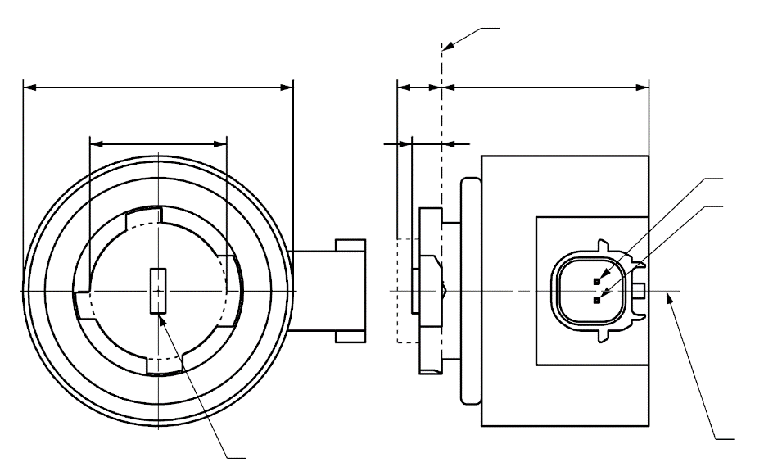

b

c

a

d

e

4

Reference plane1

V+

Light emitting area3

Reference axis2

Ground

**LR3A, LW3A, LY3A**

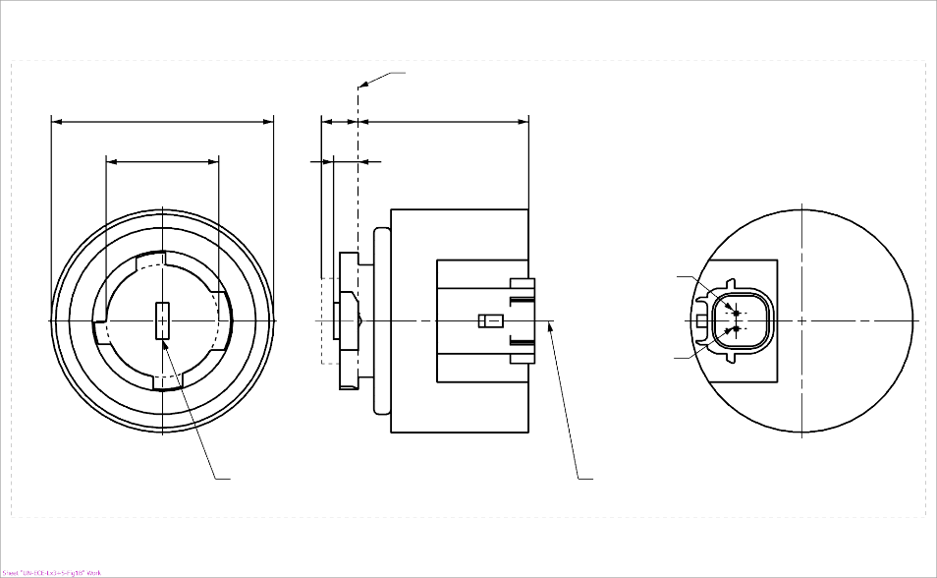

4

b

c

a

e

d

Light emitting area3

Reference axis2

Reference plane1

**LR3B, LW3B, LY3B**

Ground

V+

”

*Sheet Lx3/2, table 1 and footnote 4*, amend to read:

“….….

|  |  |  |  |  |  |  |  |
| --- | --- | --- | --- | --- | --- | --- | --- |
| *Dimensions* | | | | | | *Production LED light sources* | *Standard LED light sources* |
| a | | | | | mm | 6.0 max. | |
| b | | | | | mm | c + 10.0 min.  38.0 max. | |
| c | | | | | mm | 18.5 ± 0.1 | |
| d | | | | | mm | 28.0 max. | |
| e 13/ | | | | | mm | 3.0 ± 0.30 | 3.0 ± 0.15 |
| ~~h~~ | | | | | ~~mm~~ | ~~5.5 + 0.0/ – 0.1~~ | |
| Cap | LR3A, LR3B  LW3A, LW3B  LY3A, LY3B | | PGJ18**.**5d-1  PGJ18.5d-24 PGJ18.5d-15 | | in accordance with IEC Publication 60061 (sheet 7004-185-~~1~~**2**) | | |
| *Electrical and photometric characteristics* | | | | | | | |
| Rated values | | Volts | |  | | 12 | |
| Watts | |  | LR3A, LR3B | 3 | |
|  | LW3A, LW3B  LY3A, LY3B | 4 | |
| **Test voltage** | | **Volts (DC)** | | | | **13.5** | |
| Objective Values8 | | Watts  (at **test voltage** ~~13.5 V DC~~) | |  | LR3A, LR3B | 3.5 max. | |
|  | LW3A, LW3B | 5 max. | |
| 12 | LY3A, LY3B |
| Luminous flux  (in lm at **test voltage** ~~13.5 V DC~~) | | 5 | LR3A, LR3B | 80 ± 20%9 | 80 ± 10%10 |
| 6 | LW3A, LW3B | 250 ± 20% | 250 ± 10%11 |
| 7, 12 | LY3A, LY3B | 150 ± 20%9 | 150 ± 10%10 |
| Luminous flux  (in lm at 9 V DC) | | 5 | LR3A, LR3B | 19 min |  |
| 6 | LW3A, LW3B | 50 min. |  |
| 7, 12 | LY3A, LY3B | 30 min |  |

1/ …

2/ …

3/ …

4/ A minimum free air space of 5 mm around the light source shall be respected for convection~~.~~**; the connector interface can be neglected.**

5/ …

6/ …

…”

*Sheet Lx3/5, fifth indent*, amend to read:

“ ~~The measured luminous intensity values, normalised to the measured luminous flux of the individual light source under test, shall be converted to normalised luminous intensity values of a 1,000 lm light source.~~ **After measurement the data shall be normalized to 1,000 lm according to paragraph 2.4.4. using the luminous flux of the individual light source under test.** The data shall comply with the tolerance band as defined in Tables 4a and 4b.…”

*Sheet Lx3/5, figure 3,* amend to read:

“

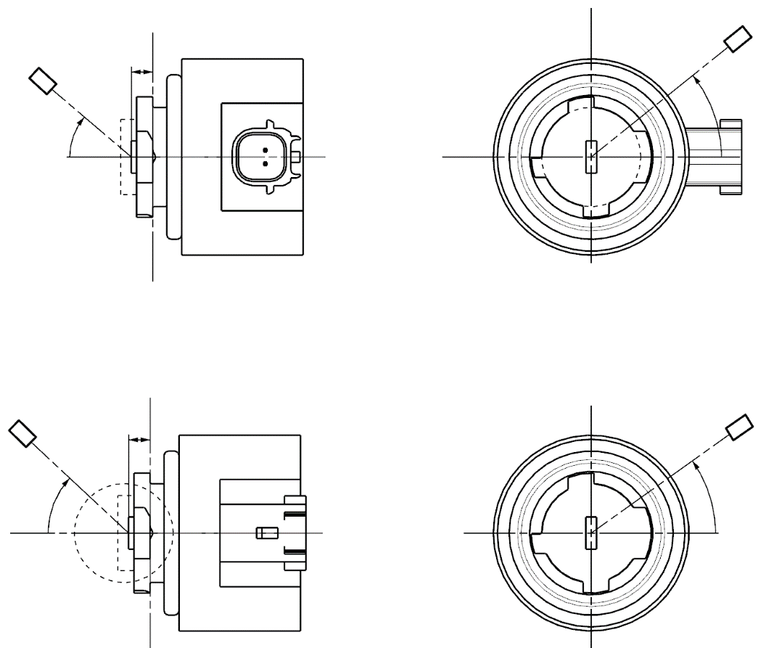

C

γ

e

C0

Reference axis

Reference plane

C-plane definition

Viewing direction along reference axis

Photo-Detector of Goniometer

**LR3A, LW3A, LY3A**

C

γ

e

C0

Reference axis

Reference plane

Photo-Detector of Goniometer

C-plane definition

Viewing direction along reference axis

**LR3B, LW3B, LY3B**

”

*Sheet LR4/1, figure 1,* amend to read:

“

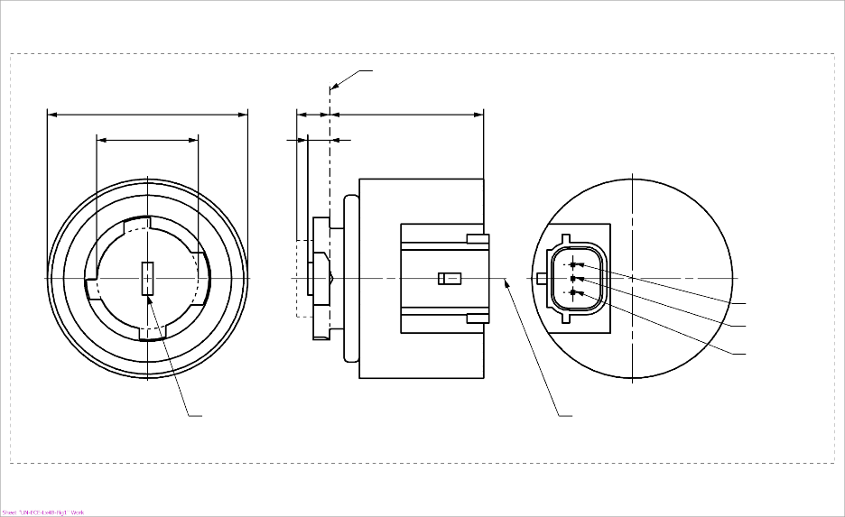

b

c

d

e

a

**LR4B**

Major Function

Reference axis2

Ground

Minor Function

Reference plane1

Light emitting area3

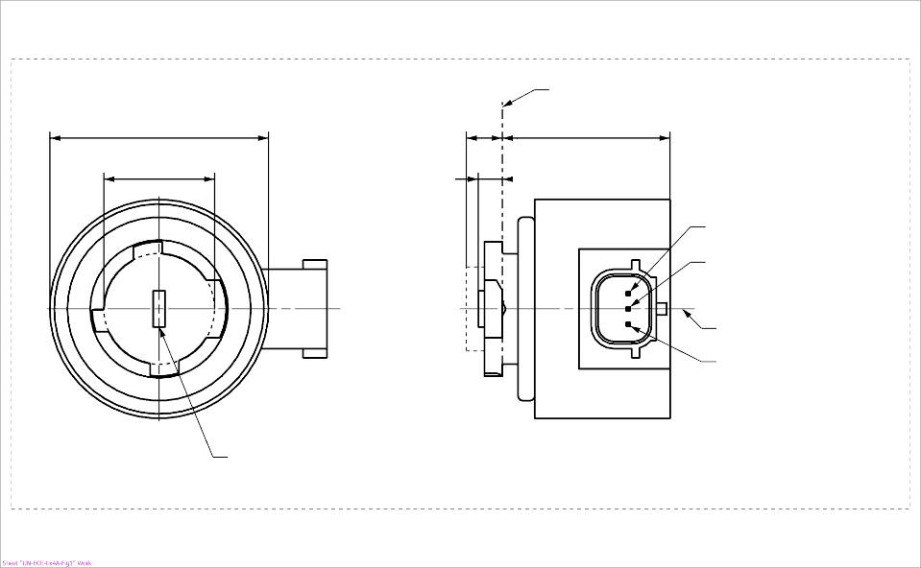

c

a

e

d

Reference plane1

Major Function

Minor Function

Reference axis2

Ground

b

Light emitting area3

**LR4A**

4

4

*Sheet LR4/2, table 1* *and footnotes 4 and 9*, amend to read:

“…

|  |  |  |  |  |  |  |
| --- | --- | --- | --- | --- | --- | --- |
| *Dimensions* | |  | *Production LED light sources* | | *Standard LED light sources* | |
| a | | mm | 6.0 max. | | | |
| b | | mm | c + 10.0 min.  38.0 max. | | | |
| c | | mm | 18.5 ± 0.1 | | | |
| d | | mm | 28.0 max. | | | |
| e 9/ | | mm | 3.0 ± 0.30 | | 3.0 ± 0.15 | |
| ~~h~~ | | ~~mm~~ | ~~5.5 + 0.0/ – 0.1~~ | | | |
| Cap PGJ18.5t-5 in accordance with IEC Publication 60061 (sheet 7004-185-~~1~~**2**) | | | | | | |
| Electrical and photometric characteristics 5 | | | | | | |
| Rated values |  | | *Minor function* | *Major function* | *Minor function* | *Major function* |
| Volts | | 12 | | 12 | |
| Watts | | 0.75 | 3 | 0.75 | 3 |
| **Test voltage** | **Volts (DC)** | | **13.5** | | **13.5** | |
| Objective  Values 6 | Watts  (at **test voltage** ~~13.5 V DC~~) | | 1.0 max. | 3.5 max. | 1.0 max. | 3.5 max. |
| Luminous flux  (in lm at **test voltage** ~~13.5 V DC~~) | | 6 ± 20% | 80 ± 20% 7 | 6 ± 10% | 80 ± 10% 8 |
| Luminous flux  (in lm at 9 V DC) | | 1.5 min. | 19 min. |  |  |

1/ The reference plane is the plane defined by the contact points of the cap-holder fit.

2/ The reference axis is perpendicular to the reference plane and passing through the centre of the Bayonet core.

3/ Light emitting area: to be checked by means of the box system in Figure 2

4/ A minimum free air space of 5 mm around the LEDlight source shall be respected for convection~~.~~**; the connector interface can be neglected.**

5/ The emitted light shall be red.

6/ After continuous operation for 30 minutes at 23 ± 2.5° C.

7/ The measured value shall be in between 100 per cent and 70 per cent of the value measured after 1 minute.

8/ The measured value shall be in between 85 per cent and 75 per cent of the value measured after 1 minute.

9/ Light centre length**,** **both functions are operated at the same time during the measurement; for the method of measurement, see Annex K of IEC Publication 60809, Edition 3.3.**

10/ The measured value shall be in between 100 per cent and 80 per cent of the value measured after 1 minute

”

*Sheet LR4/4, fifth indent,* amend to read:

“ After measurement the data shall be normalized to 1,000 lm according to paragraph ~~3.1.11~~ **2.4.4.** using the luminous flux of the individual light source under test. The data shall comply with the tolerance band as defined in Table 4.”

*Sheet LR4/4, figure 3,* amend to read:

“

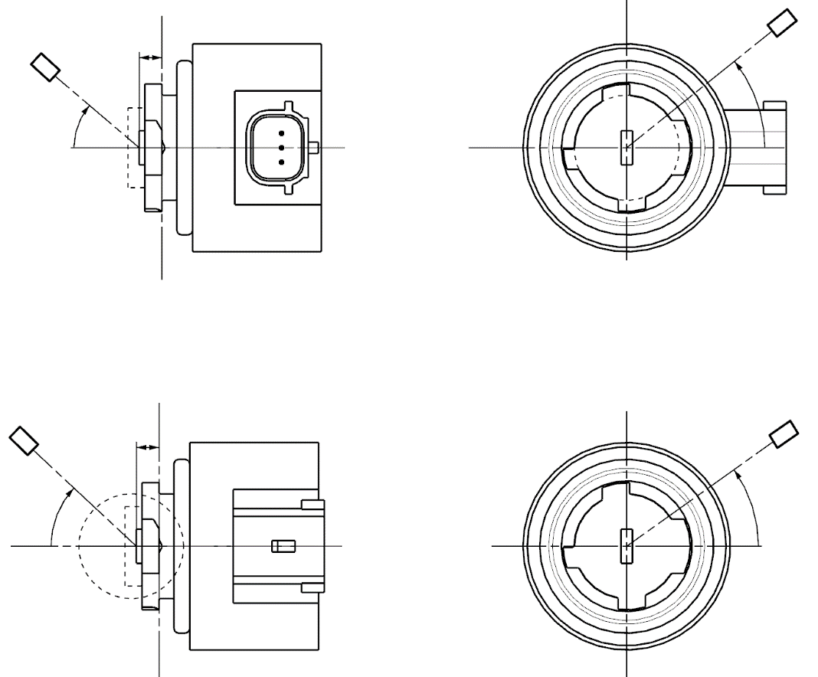

Reference axis

Reference plane

Photo-Detector of Goniometer

C-plane definition

Viewing direction along reference axis

**LR4B**

Reference axis

Reference plane

C-plane definition

Viewing direction along reference axis

Photo-Detector of Goniometer

**LR4A**

C

γ

e

C0

C

γ

e

C0

”

*Sheet Lx5/1, figure 1,* amend to read:

a

d

e

c

b

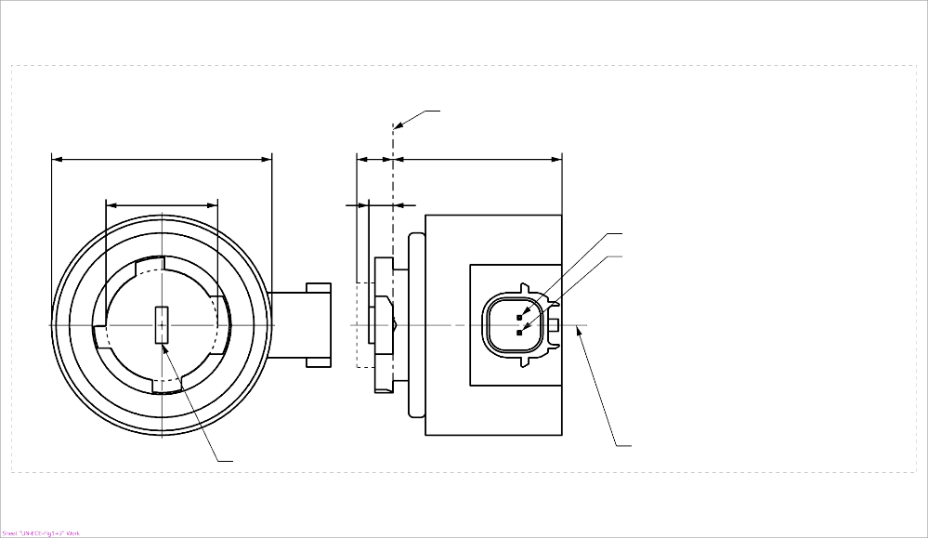

b

c

a

d

e

Reference plane1

V+

Light emitting area3

Reference axis2

Ground

4

**LR5A, LW5A, LY5A**



V+

Light emitting area3

Reference axis2

Ground

Reference plane1

4

**LR5B, LW5B, LY5B**

”

*Sheet Lx5/2, table 1 and footnote 4*, amend to read:

“…

|  |  |  |  |  |  |  |  |
| --- | --- | --- | --- | --- | --- | --- | --- |
| *Dimensions* | | | | | | *Production LED light sources* | *Standard LED light sources* |
| a | | | | | mm | 6.0 max. | |
| b | | | | | mm | c + 10.0 min.  38.0 max. | |
| c | | | | | mm | 18.5 ± 0.1 | |
| d | | | | | mm | 28.0 max. | |
| e 11/ | | | | | mm | 3.0 ± 0.30 | 3.0 ± 0.15 |
| ~~h~~ | | | | | ~~mm~~ | ~~5.5 + 0.0/ – 0.1~~ | |
| Cap | LR5A, LR5B  LW5A, LW5B  LY5A, LY5B | | PGJ18.5d-10  PGJ18.5d-28  PGJ18.5d-19 | | in accordance with IEC Publication 60061 (sheet 7004-185-~~1~~**2**) | | |
| *Electrical and photometric characteristics* | | | | | | | |
| Rated values | | Volts | |  | | 12 | |
| Watts | |  | LR5A, LR5B | 3 | |
|  | LW5A, LW5B  LY5A, LY5B | 6 | |
| **Test voltage** | | **Volts (DC)** | | | | **13.5** | |
| Objective Values8 | | Watts  (at **test voltage** ~~13.5 V DC~~) | |  | LR5A, LR5B | 3.5 max. | |
|  | LW5A, LW5B | 8 max. | |
| 10 | LY5A, LY5B |
| Luminous flux  (in lm at **test voltage** ~~13.5 V DC~~) | | 5 | LR5A, LR5B | 120 ± 15% | 120 ± 5% 9 |
| 6 | LW5A, LW5B | 350 ± 20% | 350 ± 10% 9 |
| 7, 10 | LY5A, LY5B | 280 ± 20% | 280 ± 10% 9 |
| Luminous flux  (in lm at 9 V DC) | | 5 | LR5A, LR5B | 28 min. |  |
| 6 | LW5A, LW5B | 65 min. |  |
| 7, 10 | LY5A, LY5B | 55 min. |  |

1/ …

2/ …

3/ …

4/ A minimum free air space of 5 mm around the light source shall be respected for convection~~.~~**; the connector interface can be neglected.**

5/ …

6/ …

…”

*Sheet Lx5/5, fifth indent,* amend to read:

“ ~~The measured luminous intensity values, normalised to the measured luminous flux of the individual light source under test, shall be converted to normalised luminous intensity values of a 1,000 lm light source.~~ **After measurement the data shall be normalized to 1,000 lm according to paragraph 2.4.4. using the luminous flux of the individual light source under test.** The data shall comply with the tolerance band as defined in Table 4.…”

*Sheet Lx5/5, figure 3,* amend to read:

“

”



C

γ

e

C0

Reference axis

Reference plane

C-plane definition

Viewing direction along reference axis

Photo-Detector of Goniometer

**LR5A, LW5A, LY5A**

C

γ

e

C0

Reference axis

Reference plane

Photo-Detector of Goniometer

C-plane definition

Viewing direction along reference axis

**LR5B, LW5B, LY5B**

II. Justification

1. This document is a consolidation of proposed amendments by experts in GTB to the Consolidated Resolution on the common specification of light source categories (R.E.5) (ECE/TRANS/WP.29/1127). The amendments cover a number of topics and for clarity the justification for the document is structured to provide the justifications by topic under their respective topic headers.

1. Amendment of the measuring luminous flux and references to the internal shield for applicable filament light source categories

2. With the introduction of R.E.5 there has been a change in the text of paragraph 3.9. in UN Regulation No. 37, “Check of the optical quality”. Up to supplement 44 of UN Regulation No. 37, the regulatory text explicitly mentions the three filament light sources (R2, H4, HS1) for which this test is required. With the introduction of R.E.5 the list of the three light sources was replaced in UN Regulation No. 37, supplement 45 by the remark “(Applies only to filament light sources with an internal shield to produce the cut-off)”. At the moment the data sheets of light sources with an internal shield do not contain information for which light sources the inner shield is intended to produce the cut-off. With the creation of R.E.5, the three filament light sources, R2, H4, HS1, for which the optical quality test is necessary can only be identified because of the presence of an extra row in the table in the data sheet with the parameter “measuring luminous flux”, a value that is required to be set for the measurements involved with the optical quality check. The extra row in the table of the data sheet with the parameter “measuring luminous flux” is not present for the other category data sheets of light sources with an internal shield.

3. Footnote \* of paragraph 3.1. includes the case where more than one value of the reference luminous flux is specified for a category of filament light source. According to the footnote, the value of reference luminous flux at approximately 12 V is used for a lighting device, and the value at approximately 13.5 V is used for a light-signalling device. However, the reference luminous flux at approximately 13.2 V is not listed in the footnote. While the 13.2 V value is absent from the footnote, some sheets of filament light sources list values of the reference luminous flux at approximately 13.2 V.

4. According to UN Regulation No. 37, checking of optical quality shall be carried out for filament light sources with an internal shield to produce the cut-off. When checking on optical quality, a value of the measuring luminous flux is needed. For 12 V types of light source categories H4 and HS1, the current value of the measuring luminous flux is the same as the value of reference luminous flux at approximately 12 V. However, the reference luminous flux used for measuring the light distribution of passing beam of headlamps had been changed from the value at 12 V to the value at 13.2 V in UN Regulation No. 112. Then, when checking on optical quality of a 12 V type of H4 or HS1 with the current value of measuring luminous flux, the measured value of luminous intensity shall be multiplied by a correction factor in order to verify the compliance with the photometric requirements. For the 24 V type of H4, the current value of measuring luminous flux is the luminous flux value at approximately 24 V. When checking on optical quality of the 24 V type of H4 with the current value of measuring luminous flux, the measured value of luminous intensity shall be corrected relative to the objective luminous flux at 28.0 V.

5. In this document GTB proposes to introduce a note in the light source data sheets of light sources with an internal shield to specify whether the internal shield is not intended for producing the cut-off. Through the inclusion of such a note all necessary information about the necessity to do the optical check can be obtained from the relevant data sheet. The addition of this note eliminates confusion, because in combination with the parameter “measuring luminous flux” it will be unambiguous for which of the filament light sources with an internal shield the optical quality test is required.

6. GTB further proposes to amend footnote \* of paragraph 3.1., to include the reference luminous flux at approximately 13.2 V.

7. This document also includes proposed amendments of the category sheets of H4 and HS1, to update the values of the measuring luminous flux to the respective values of the objective luminous flux at 13.2 V, in order to meet the current practice for passing beam headlamps in UN Regulation No. 149. This will eliminate the need for a correction of the measured values of luminous intensity when doing the check for the optical quality.

1. Amendment of the specifications for H7, H8/H8B, H11/H11B, H16/H16B and H18 light source categories with respect to the “g” parameter

8. The value of the “g” parameter of standard bulbs for categories H7, H8/H8B, H11/H11B, H16/H16B and H18 has been listed as “u.c.” (“under consideration”) pending experience in determining “g” for these light sources by light source manufacturers.

9. Experts from light source manufacturers have now confirmed that, based on experience and in-house practice, it is supported to adopt the (g = 0.5 min.) value specified for light sources of normal production of these categories also for the standard light source of these categories.

10. This proposal introduces the value for dimension g (g = 0.5 min.) for the standard light source of categories H7, H8/H8B, H11/H11B, H16/16B and H18, in the respective tables of sheets H7/3, H8/3, H11/3, H16/3, and H18/3.

1. Amendment of the definition for light centre and associated amendment to the specification of the LR4 light source category

11. Since the adoption of the LED light sources experience has been gained with the measurement of such light sources. As a result of this the need was identified to improve the definition for the light centre in the Consolidated Resolution on the common specification of light source categories (R.E.5). Furthermore, a clarification of the light centre length (LCL) requirement for the dual-mode category LR4 was needed, as it was not specified to which function (minor, major, or both) this requirement applies.

12. Experts from GTB determined that for LED light sources the LCL refers to the apparent (virtual) origin instead of the physical origin. It was further clarified that for the LR4 light source category both minor and major functions are operated at the same time during the measurement of the light centre length.

13. In this document GTB proposes to improve the definition of light centre (paragraph 2.2.3.) in the Consolidated Resolution on the common specification of light source categories (R.E.5).

14. GTB further proposes to amend footnote 9 of category LR4 to provide the clarification that both minor and major functions are operated at the same time during the measurement of the light centre length. A normative reference to the method of measurement in Annex K of IEC Publication 60809, Edition 3.3 is added.

1. Amendment with the aim to clarify the use restriction for light emitting diode (LED) light source categories LW2, LW3, and LW5.

15. This is a proposal for the insertion of a use restriction for the white LED light source categories LW2, LW3, and LW5 in R.E.5. The need to add this use restriction was identified following the introduction of footnote 2 for the substitute light source categories C5W/LEDK and W5W/LEDK. In this proposal the same footnote 2 is added to categories LW2, LW3, and LW5 to indicate that there is no correlated color temperature restriction on the white light for these categories.

1. Amendment of the specifications for Lx3, LR4 and Lx5 light source categories with respect to the cap/holder interface.

16. Since the adoption of the LR3 category sheet some fundamental changes in the concept have been implemented. One of the changes is the requirement of a seal function on the cap/holder interface. Therefore, the figures in the category sheets established for (and derived from) the LR3 are no longer representing the products with respect to the details for the cap holder interface as in detail defined in the IEC standard IEC 60061 Sheets 7004-185 and 7005-185.

17. With respect to the dimension “h” in the related category sheets there is no longer a need to restrict the dimension in its maximum. Motivation: the function to hold the light source in its axial position on het reference plane is granted by the combination of:

- The limits in het holder (sheet 7005-185, dimension E, E1 and B1) and,

- The requirements of the sealing-feature of the cap (sheet 7004-185, dimension E and note 6).

18. Since the introduction of the L1/6 category sheet a more realistic image is used, in combination with the removal of the dimension “h” (as considered an over-constrained requirement), and an amendment for the IEC Cap sheet is prepared to add the related requirement for the maximum material on the related section.

19. Current figures in category sheet Lx3/1, Lx3/4, LR4/1, LR4/5, Lx5/1, and Lx5/4 in combination with the limitation of the maximum value for dimension h give rise to unnecessary discussion and confusion with respect to the dimensions mentioned on the related IEC cap sheet. A parallel process is started to embed the minimum value related to the section defined by current dimension h form the category sheet to complete the cap definition as this dimension shall be mentioned on the cap sheet to match the related holder definition.

20. It is proposed to amend the following categories (sheet no.):

* LR3A, LR3B, LW3A, LW3B, LY3A and LY3B (Sheet Lx3/1, Lx3/2 and Lx3/5);
* LR4A and LR4B (Sheet LR4/1, LR4/2 and LR4/4);
* LR5A, LR5B, LW5A, LW5B, LY5A, LY5B (Sheet Lx5/1, Lx5/2 and Lx5/5).

For each of the listed sheets, the amendments include:

(i) Replacement of Figure 1 with figures similar to the figures used for category L1/6;

(ii) Deletion of the row with the dimension h from in Table 1;

(iii) Alignment of the Figure 3 “Set-up to measure the luminous intensity distribution” with the Figure 1 to avoid confusion.

1. Amendment of the specifications for specifications for LR1, LW2, L3, LR4, L5, and L1/6 light source categories with respect to test voltage

21. Unlike category sheets for filament light sources and gas-discharge light sources, the category sheets for LED light sources do not explicitly name the term “test voltage” (defined under 2.3.1. in R.E.5). This could lead to misinterpretations especially in combination with the 9V-requirement (introduced for the sheets L3, LR4 and L5) and the definition of “objective values” (under 2.1.4. in R.E.5).

22. Experts from GTB evaluated this situation and concluded that the term “test voltage” needed to be introduced for all existing LED category sheets to avoid misinterpretations.

23. In this document GTB proposes to introduce the “test voltage” for categories LR1, LW2, L3, LR4, L5, and L1/6 in the respective tables of sheets LR1/2, LW2/1, L3/2, LR4/2, L5/2, and L1/2. As there is more than one test voltage for the categories L1/6, it is proposed to adjust the format of the table in conjunction with the introduction of the test voltage, for clarity.

1. Amendments to correct some details of light source category specifications in the Consolidated Resolution on the common specification of light source categories

24. With the publication of Revision 8 of UN Regulation No. 37 and the subsequent adoption of R.E.5 (ECE/TRANS/WP.29/1127) and its subsequent amendment (ECE/TRANS/WP.29/2018/33/Rev.1), light source experts and users of light source Regulations have made the correct linkages between the Resolution and third party documents. As links are established, the content of R.E.5 is continuously reviewed.

25. This proposal is to correct a number of minor editorial errors in category sheets of filament and LED light sources that were uncovered while making such linkages and which have not been detected before. Some of the errors were already present at introduction of the respective light source category; others appeared after revisions of the regulation documents. Some of the corrections are intended to avoid misinterpretation but do not change the substance. All corrections speak for themselves.

26. The corrections include minor editorial errors in category sheets of filament light source categories H14, H19, H20, H27W/1, P21/5W, S1/S2 and WY21W, and LED light source categories L1 and LR4.

27. The amendment to sheet S1/S2/1 is a consequence of the light source simplification process. Before simplification of UN Regulations Nos. 37, 99 and 128 there were use restrictions on light sources in the grouping and in the category sheets, e.g. in S3-sheet it was said “filament lamp for moped” and in HS5-sheet, S1/S2-sheet it was said “filament lamp for motorcycles”. At the time of the creation of R.E.5 all use restrictions have been moved to the table, in the form of footnotes. These use restrictions now concern lamps, rather than vehicles, as it is not known where a lamp will be applied. So, the restriction for S1 and S2 concerning motorcycles was changed into a restriction that referred to a lamp since a vehicle restriction could no longer be enforced. In the context of this the former text “filament lamp for motorcycles” in sheet S1/S2/1 is now covered by footnote 5 in paragraph 3.1. of R.E.5.

28. Furthermore, proposed amendments to make the description of normalized luminous intensity in category sheets LR1/4, Lx3/5 and Lx5/5 consistent with category sheets L1/4 and LR4/4 are presented.

29. While some of the errors were already present at the introduction of the respective light source category and could be considered to be corrigenda, all corrections are presented as an amendment because corrections to older revisions of UN Regulation No. 37 would create an enormous administrative issue while these errors were not essential for approval. For this reason, the corrections are presented as amendments to the Consolidated Resolution.

1. Amendments to make the administrative updates of IEC cap sheet references in light source category specifications

30. This proposal includes a customary administrative update of an IEC cap sheet number in the IEC cap sheet reference (sheet 7004-171-2) for light source category H19.

31. This proposal also includes an administrative update of an IEC cap sheet number in the IEC cap sheet reference (sheet 7004-185-2) for light source categories Lx3, LR4, and Lx5.

32. This proposal further includes an administrative update of an IEC cap sheet number in the IEC cap sheet reference for the categories L1/6. The square brackets around the cap sheet version number were removed (sheet 7004-185-2).

1. \* In accordance with the programme of work of the Inland Transport Committee for 2020 as outlined in proposed programme budget for 2020 (A/74/6 (part V sect. 20) para 20.37), the World Forum will develop, harmonize and update UN Regulations in order to enhance the performance of vehicles. The present document is submitted in conformity with that mandate. [↑](#footnote-ref-2)