Transmitted by the Chairman of the IWG MU Informal document GRBP-72-11
(72nd GRBP, 7-9 September 2020,
Agenda item 3)

GRBP Informal Working Group on
Measurement Uncertainties (IWG MU) under the 1958 Agreement

Status Report

Since the 71st meeting of GRBP 28-31 January 2020, the IWG MU (formerly Task Force MU) has arranged a half-day WebEx meeting on April 28th. The full agenda for the 5th meeting can be found on the website for the IWG MU (GRBP-TFMU-05-01). Due to the limited time available, only these four items were discussed during the meeting:
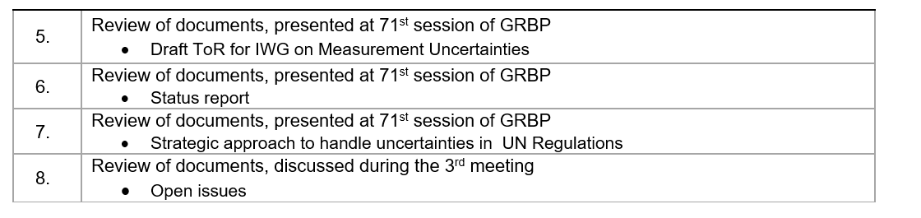
The following documents were distributed and presented during the meeting:
- GRBP- TFMU-05-02 20200306_ISO 362_Method B_Renault-PSA-UTAC_synthesis+corr
- GRBP-TFMU-05-03 20200424_status_justification_quantities_values v3
- GRBP-TFMU-05-04 Chair List of uncertainty contributions Reg.117

TFMU-05-02 presented the effect of implementing a correction procedure for track and temperature for ECE Reg.51-03 measurements. The procedure was implemented on a selection of M1 vehicles, measured in be "third party" in different countries, compared to type approval measurements. Both same physical vehicle and same tyres was part of the comparison, as well as same model and PWT, but different tyres were included. The method worked well for 5 out of 6 cars. The method could be difficult to implement for EVs.
TFMU-05-03 presented a table listing all quantities influencing the uncertainty when measuring according to Reg.51.03. They were categorized in 4 situations: Run-to-run, Day-to-day, Sit-to-site and Vehicle-to-vehicle. For each input quantity, the estimated uncertainty on L_{wot} and L_{crs} was listed and its impact on L_{urban}. For most of these quantities, the impact is known, and the status listed as "done". However, there are still some open issues, like the influence of air temperature on the tyre noise contribution, that need to be investigated and verified.
TFMU-05-04 presented a table, listing 8 uncertainty groups (like equipment, experimental set-up, measurement, test vehicle, test tyres, etc.) where the uncertainty contribution to testing according to Reg.117 needs to be quantified. For each of the groups, the sources of uncertainty, nature and probability distribution were listed.
IWG MU originally planned for the 6th and 7th meeting prior to this 72nd GRBP meeting. However, due to the Covid-19 situation, both these meeting were cancelled. The progress of the group relies heavily on the contribution from both OICA and ETRTO to finalise a procedure how to deal with uncertainty when testing is performed by a third party. The current situation has made it impossible to prioritize the work of IWG MU in the last 6 months. This then makes it impossible to meet the proposed timeline as given in the Terms of Reference, as approved by GRBP at its 71st session (GRBP-71-31e TOR IWG MU). The chair of the IWG MU has therefore proposed a revised timeline as presented in the Informal document (GRBP-72-10). The proposal is to shift all dates with approximately a 6 months delay:
D. Timeline
- The aim of the Informal Working Group is to present
  - during the 73rd GRBP in January 2021 a Draft document for Reference and an Informal document for amendments to UN Regulation No 51 and No 117
  - during 74th GRBP in September 2021 a Working document for amendments to UN Regulation No 51 and No 117 for consideration and adoption
  - during 74th GRBP in September 2021 an Informal Working document containing general Guidelines for how to improve test procedures in other UN Regulations to reduce measurement uncertainties for consideration.
  - during 75th GRBP in January 2022 a Working document containing general Guidelines for how to improve test procedures in other UN Regulations to reduce measurement uncertainties for consideration and adoption.
The 6th meeting of the IWG MU has yet to be decided, but is planned as a WebEx meeting this autumn (preliminary 6th to 7th of October), as the current Covid-19 situation world-wide still prevent any physical meetings.

